A
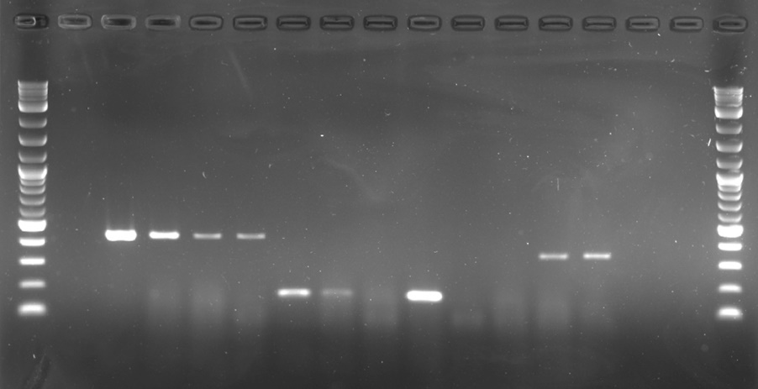
MSTRG_1141.1
M
24
48
72
MSTRG_14182.1
M
24
48
72
MSTRG_1779.3
M
24
48
72
L
L
500 bp -
400 bp -
300 bp -
200 bp -
100 bp -

B
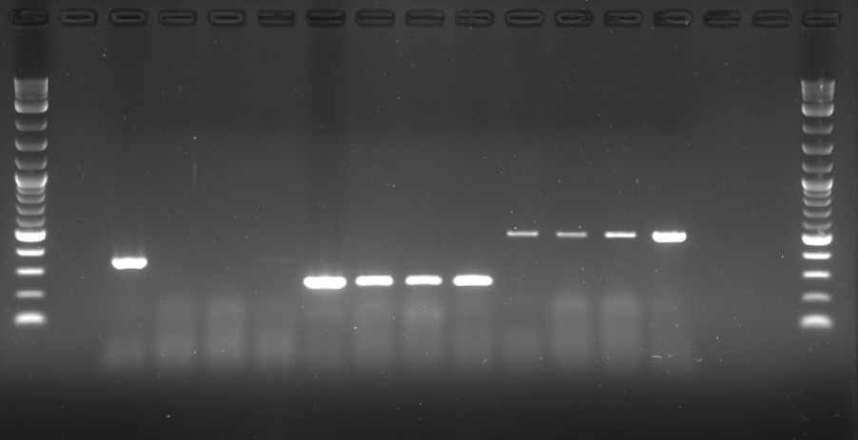
M
24
48
72
MSTRG_9578.3
M
24
48
72
MSTR_7417.5
M
24
48
72
MSTRG_1314.1
L
L
500 bp -
400 bp -
300 bp -
200 bp -
100 bp -
600 bp -

C
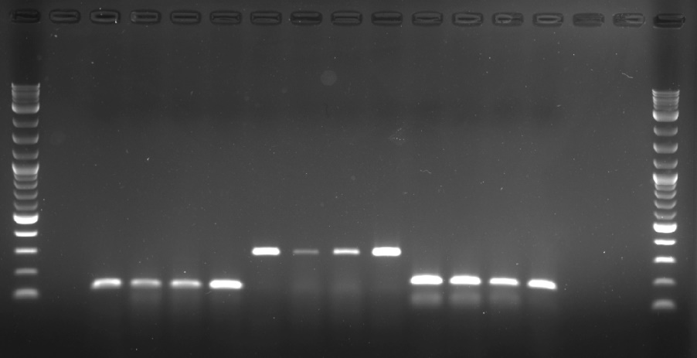
M
24
48
72
MSTRG_5588.1
M
24
48
72
MSTRG_7770.1
M
24
48
72
MSTRG_7581.1
L
L
400 bp -
300 bp -
200 bp -
100 bp -

D
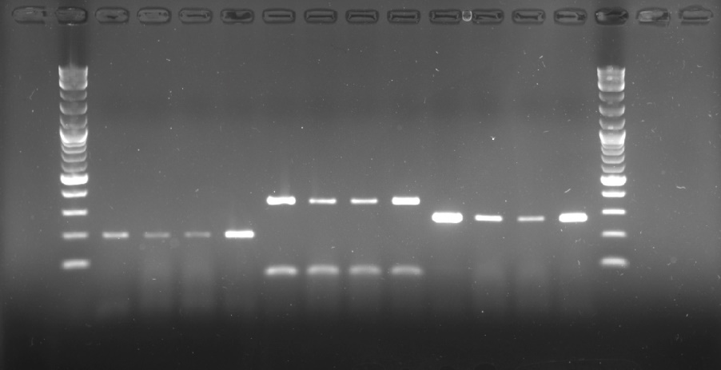
MSTRG_10154.1
M
24
48
72
MSTRG_5505.1
M
24
48
72
MSTRG_980.1
M
24
48
72
L
L
400 bp -
300 bp -
200 bp -
100 bp -

E
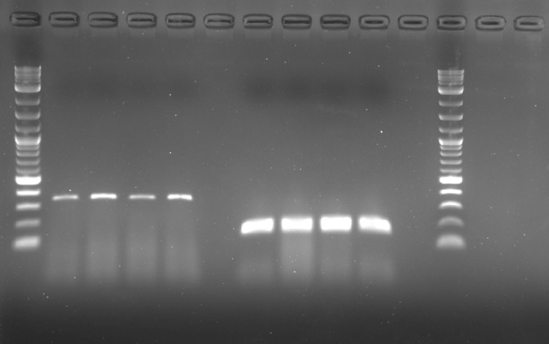
M
24
48
72
MSTRG_9719.3
M
24
48
72
β-tubulin
L
L
400 bp -
300 bp -
200 bp -
100 bp -

Figure S2. Full-length gel pictures for strand-specific RT-PCR data of each lncRNA expression in Fig. 5.

