Table 1. Patient characteristics
Variable | Result
Age (years), mean (range) | 59 (22–82)
Body weight (kg), mean (range) | 51.25 (29.4–105.0)
Body mass index (kg/m²), mean (range) | 22.3 (15.4–41.0)

History of delivery, n
Null | 13
Multiple | 41
Unknown | 2
SCC Ag (ng/mL), mean (range) | 4.25 (0.5–285), unknown 6
CA125 (U/mL), mean (range) | 48.9 (6.6–315), unknown 5
Tumor size (cm), mean (range) | 12 (3–24), unknown 1

Figo stage, n
I | 30
II | 7
III | 18
IV | 1
Follow-up period (month), mean (range) | 25.15 (0.9–168.6)

SCC Ag: squamous cell carcinoma antigen, CA125: cancer antigen 125.

Table 2. Therapy components
Variable | n
Contents of surgery
SO | 18
SO, TAH | 17
SO, TAH, LND | 21
Plus merged incision of other organs | 7
Residual tumor after surgery
R0 | 40
R1 | 16
Adjuvant therapy
Chemotherapy | 27
Concurrent chemoradiotherapy | 5
None | 24
SO: salpingo-oophorectomy, TAH: total abdominal hysterectomy, LND: lymph node dissection, R0: complete surgery, R1: surgery with residual tumor. Other organs include the small bowel, colon, and abdominal wall.

Table 3. Chemotherapy regimens
Regimen | N
Platinum + taxane | 16
Platinum + non-taxane | 4
BEP | 4
Others | 3
BEP: bleomycin, etoposide, and cisplatin.

Table 4. Recurrence site
Site | n
Abdominal cavity | 12
Regional lymph node | 5
Distant metastases | 8
Increase in residual tumor size | 5
Total | 26
Some sites overlapped.

Table 5. Results of the univariable and multivariable analyses of prognostic factors for progression-free survival.
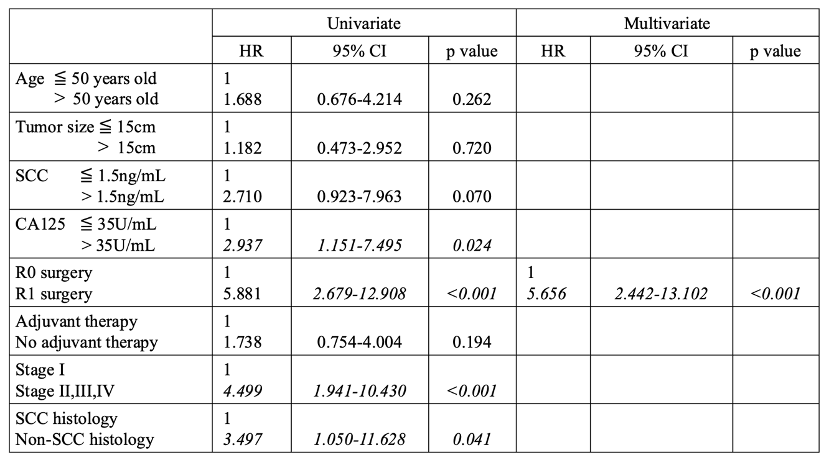

SCC: squamous cell carcinoma, CA125: cancer antigen 125, R0: complete surgery, R1: surgery with residual tumor, HR: hazard ratio, CI: confidence interval.

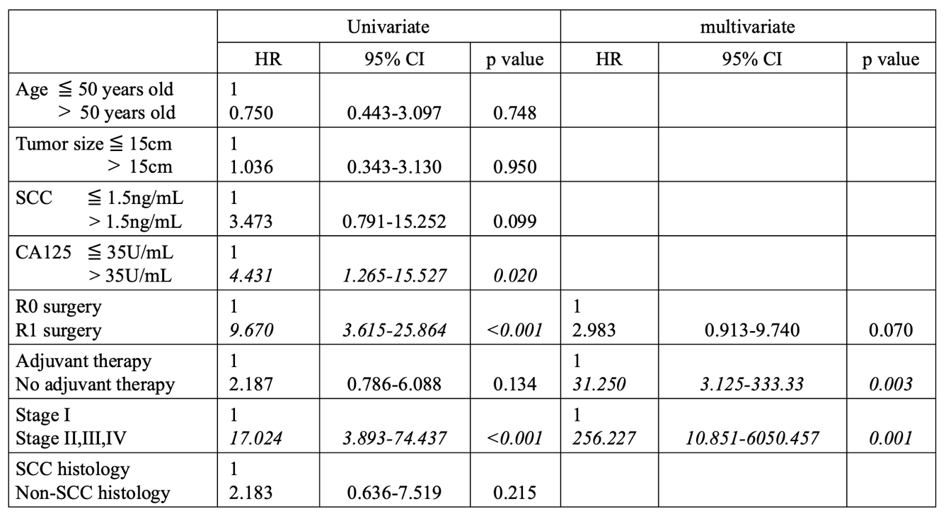
Table 6. Results of the univariable and multivariable analyses of prognostic factors for overall survival.

SCC: squamous cell carcinoma, CA125: cancer antigen 125, R0: complete surgery, R1: surgery with residual tumor, HR: hazard ratio, CI: confidence interval.

