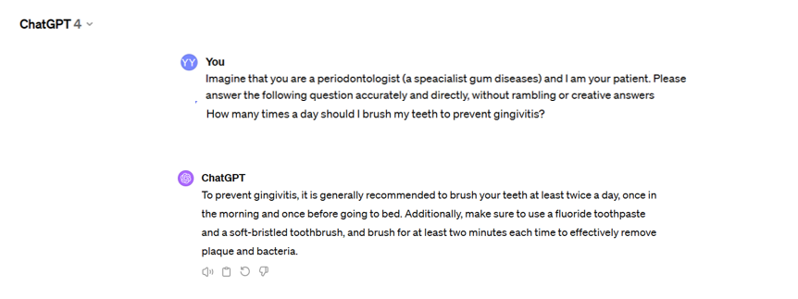
- A screenshot of the question-and-answer application in ChatGPT-4.

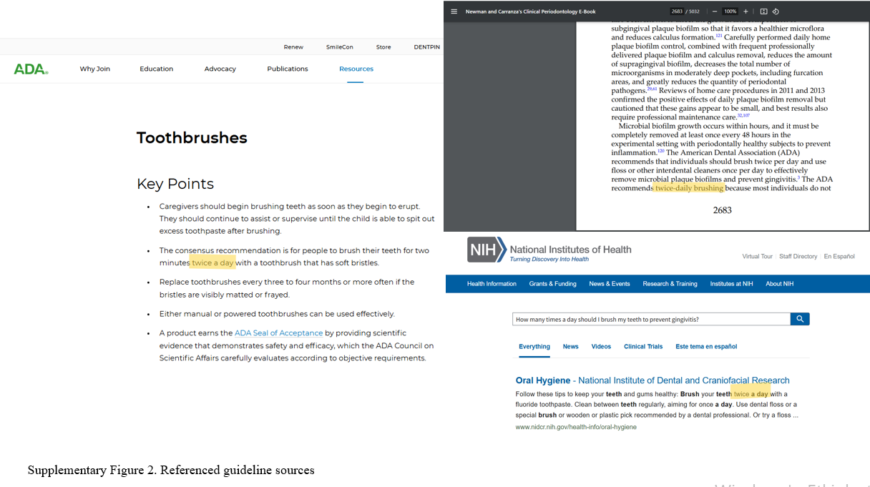
- A screenshot of the reference guideline sources

Supplementary Figure 1. Workflow demonstrating the use of questions directed to ChatGPT 4 and dental guides.
An example of the question template submitted to ChatGPT 4, the response received, and the use of guidelines referenced during question preparation and evaluation of responses is provided in Supplementary Figure 1.

