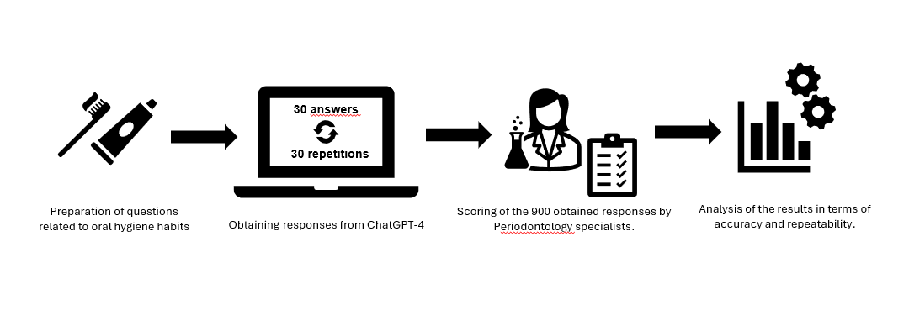
Supplementary Figure 2. Graphical workflow illustrating ChatGPT-4’s performance in answering questions related to oral hygiene habits.
The methodological approaches used in the study evaluating ChatGPT 4's performance as a virtual assistant in answering questions related to oral hygiene habits are presented sequentially (Supplementary Figure 2).

