Supplementary Material

Supplementary Table 1
Supplementary Figure 1

Supplementary Table 1. Thresholds for Defining Low Bone Mass Conditions Based on Skeletal Site-Specific BMD Distributions
Skeletal Site(g/cm^2) | Mean | SD | Mean-2.5SD | Mean-SD | Osteoporosis | Osteopenia | Normal BMD
Lumbar Spine BMD | 0.98 | 0.16 | 0.58 | 0.82 | ≤0.58 | 0.58<且<0.82 | ≥0.82
Pelvis BMD | 1.19 | 0.19 | 0.72 | 1.00 | ≤0.72 | 0.72<且<1.00 | ≥1.00
Total Bone Mineral Density | 1.04 | 0.12 | 0.74 | 0.92 | ≤0.74 | 0.74<且<0.92 | ≥0.92

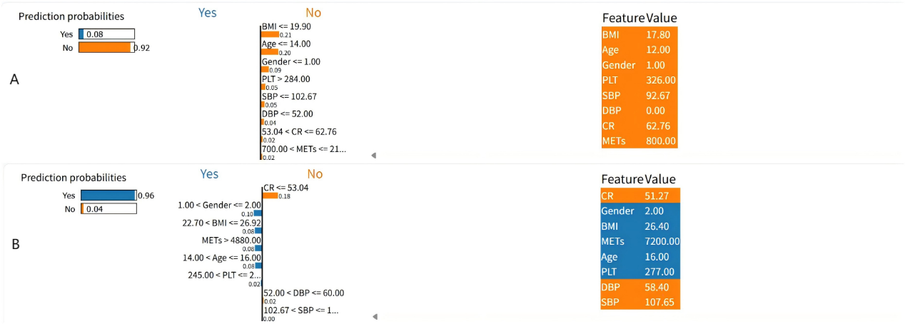
Supplementary Figure 1. LIME-based individual prediction explanations for low bone mass risk. (A) Prediction interpretation for an individual classified as low risk (predicted probability = 0.08), illustrating protective factors such as low BMI, young age, male gender, and high physical activity; (B) Prediction interpretation for an individual classified as high risk (predicted probability = 0.96), highlighting risk factors including higher creatinine, female gender, older age, and elevated BMI.

