Extended Data Table 1. Classification performance between decoders on the validation cohort
Condition | Decoder | ACC (%) |  | Sens (%) |  | Spec (%) |  | Effect | P
 |  |  | SD |  | CI |  | CI | size
Validation cohort (n=33)
NV vs. NeutV | NNES | 100 | 0 | 100 | 100–100 | 100 | 100–100 | 3.55 | 2.33×10⁻¹⁰
 | PINES | 91 | 5 | 91 | 80–100 | 91 | 79–100 | 1.16 | 1.40×10⁻⁶
 | NERS-A | 70 | 8 | 70 | 53–85 | 70 | 53–85 | 0.95 | 0.035
 | NERS-R | 3 | 3 | 3 | 0–10 | 3 | 0–10 | -33.03 | 7.92×10⁻⁹
NA vs. NV | NNES | 48 | 8.7 | 48 | 31–66 | 48 | 32–67 | -0.3 | 1
 | PINES | 36 | 8.4 | 36 | 20–54 | 36 | 21–53 | -0.12 | 0.1628
 | NERS-A | 70 | 8 | 70 | 53–86 | 70 | 53–85 | 0.47 | 0.0351
 | NERS-R | 61 | 8.5 | 36 | 19–53 | 36 | 21–53 | 0.61 | 0.2962
NR vs. NV | NNES | 15 | 6.2 | 15 | 3–29 | 15 | 3–28 | -0.95 | 6.60×10⁻⁵
 | PINES | 45 | 8.7 | 45 | 30–63 | 45 | 29–63 | -0.02 | 0.7283
 | NERS-A | 70 | 8 | 70 | 54–85 | 70 | 53–85 | 0.72 | 0.0351
 | NERS-R | 88 | 5.7 | 88 | 75–97 | 88 | 76–97 | 1.42 | 1.10×10⁻⁵

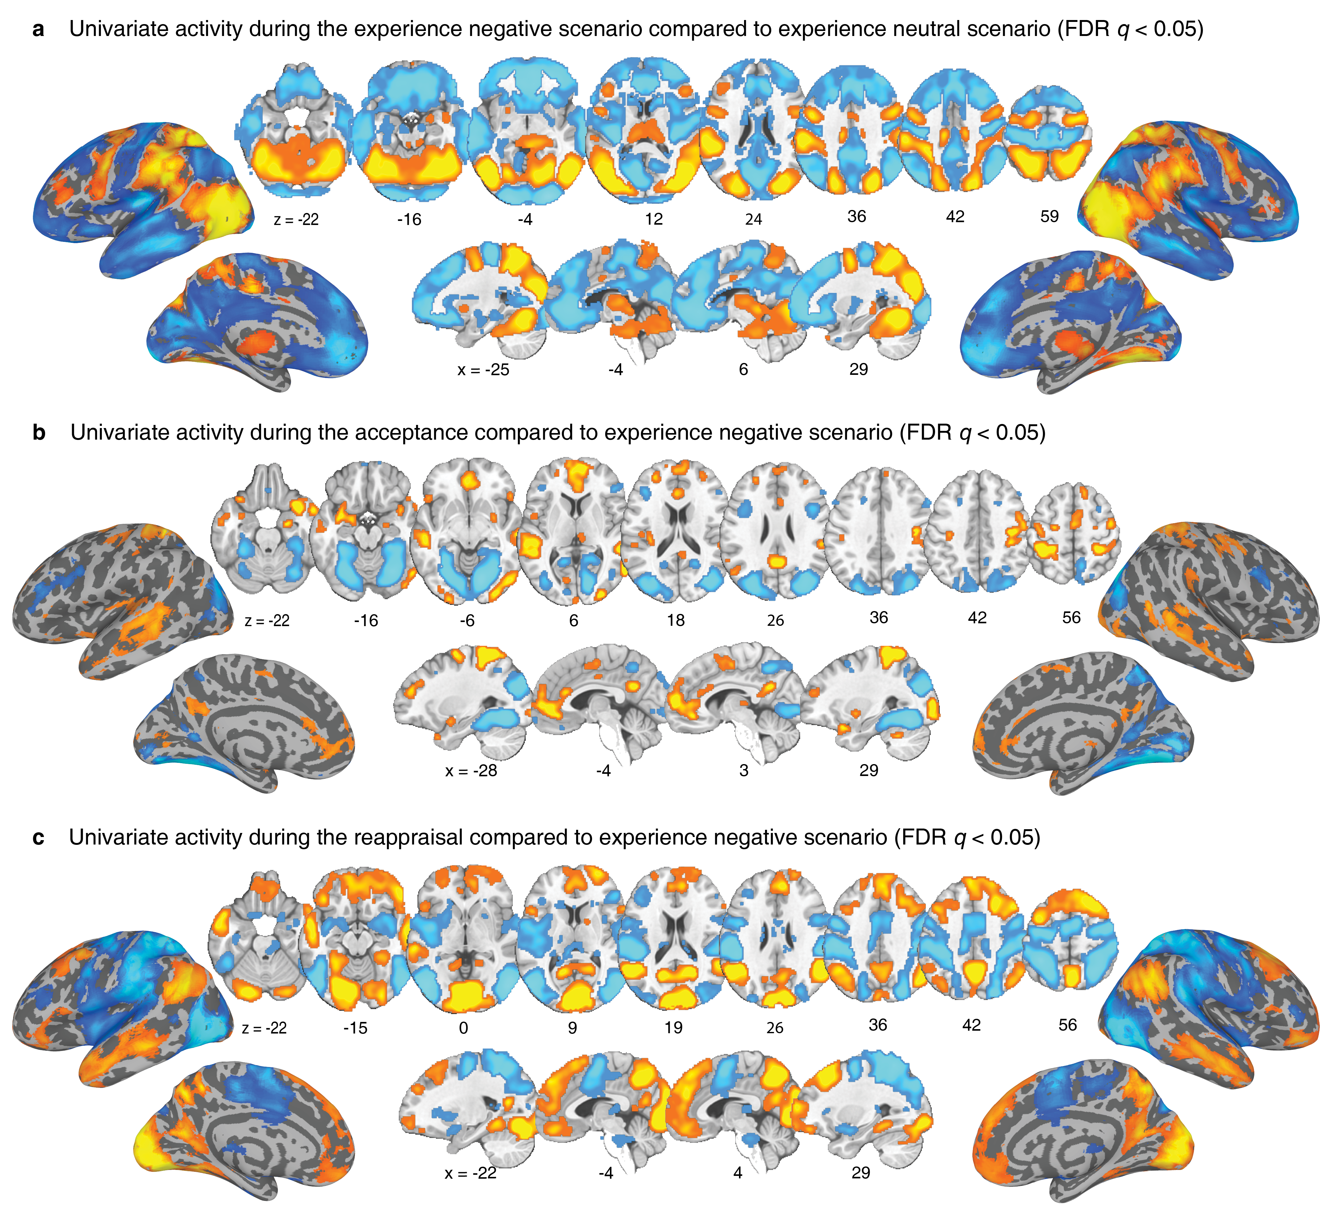
Extended Data Fig.1 | Brain activation from mass-univariate analysis. Contrast images representing the response to naturalistic negative scenario (view negative scenario (NV) vs. view neutral scenario (NeutV) (a), accept negative scenario (NA) vs. NV (b), and reappraisal negative scenario (NR) vs. NV (b) (FDR q<0.05).

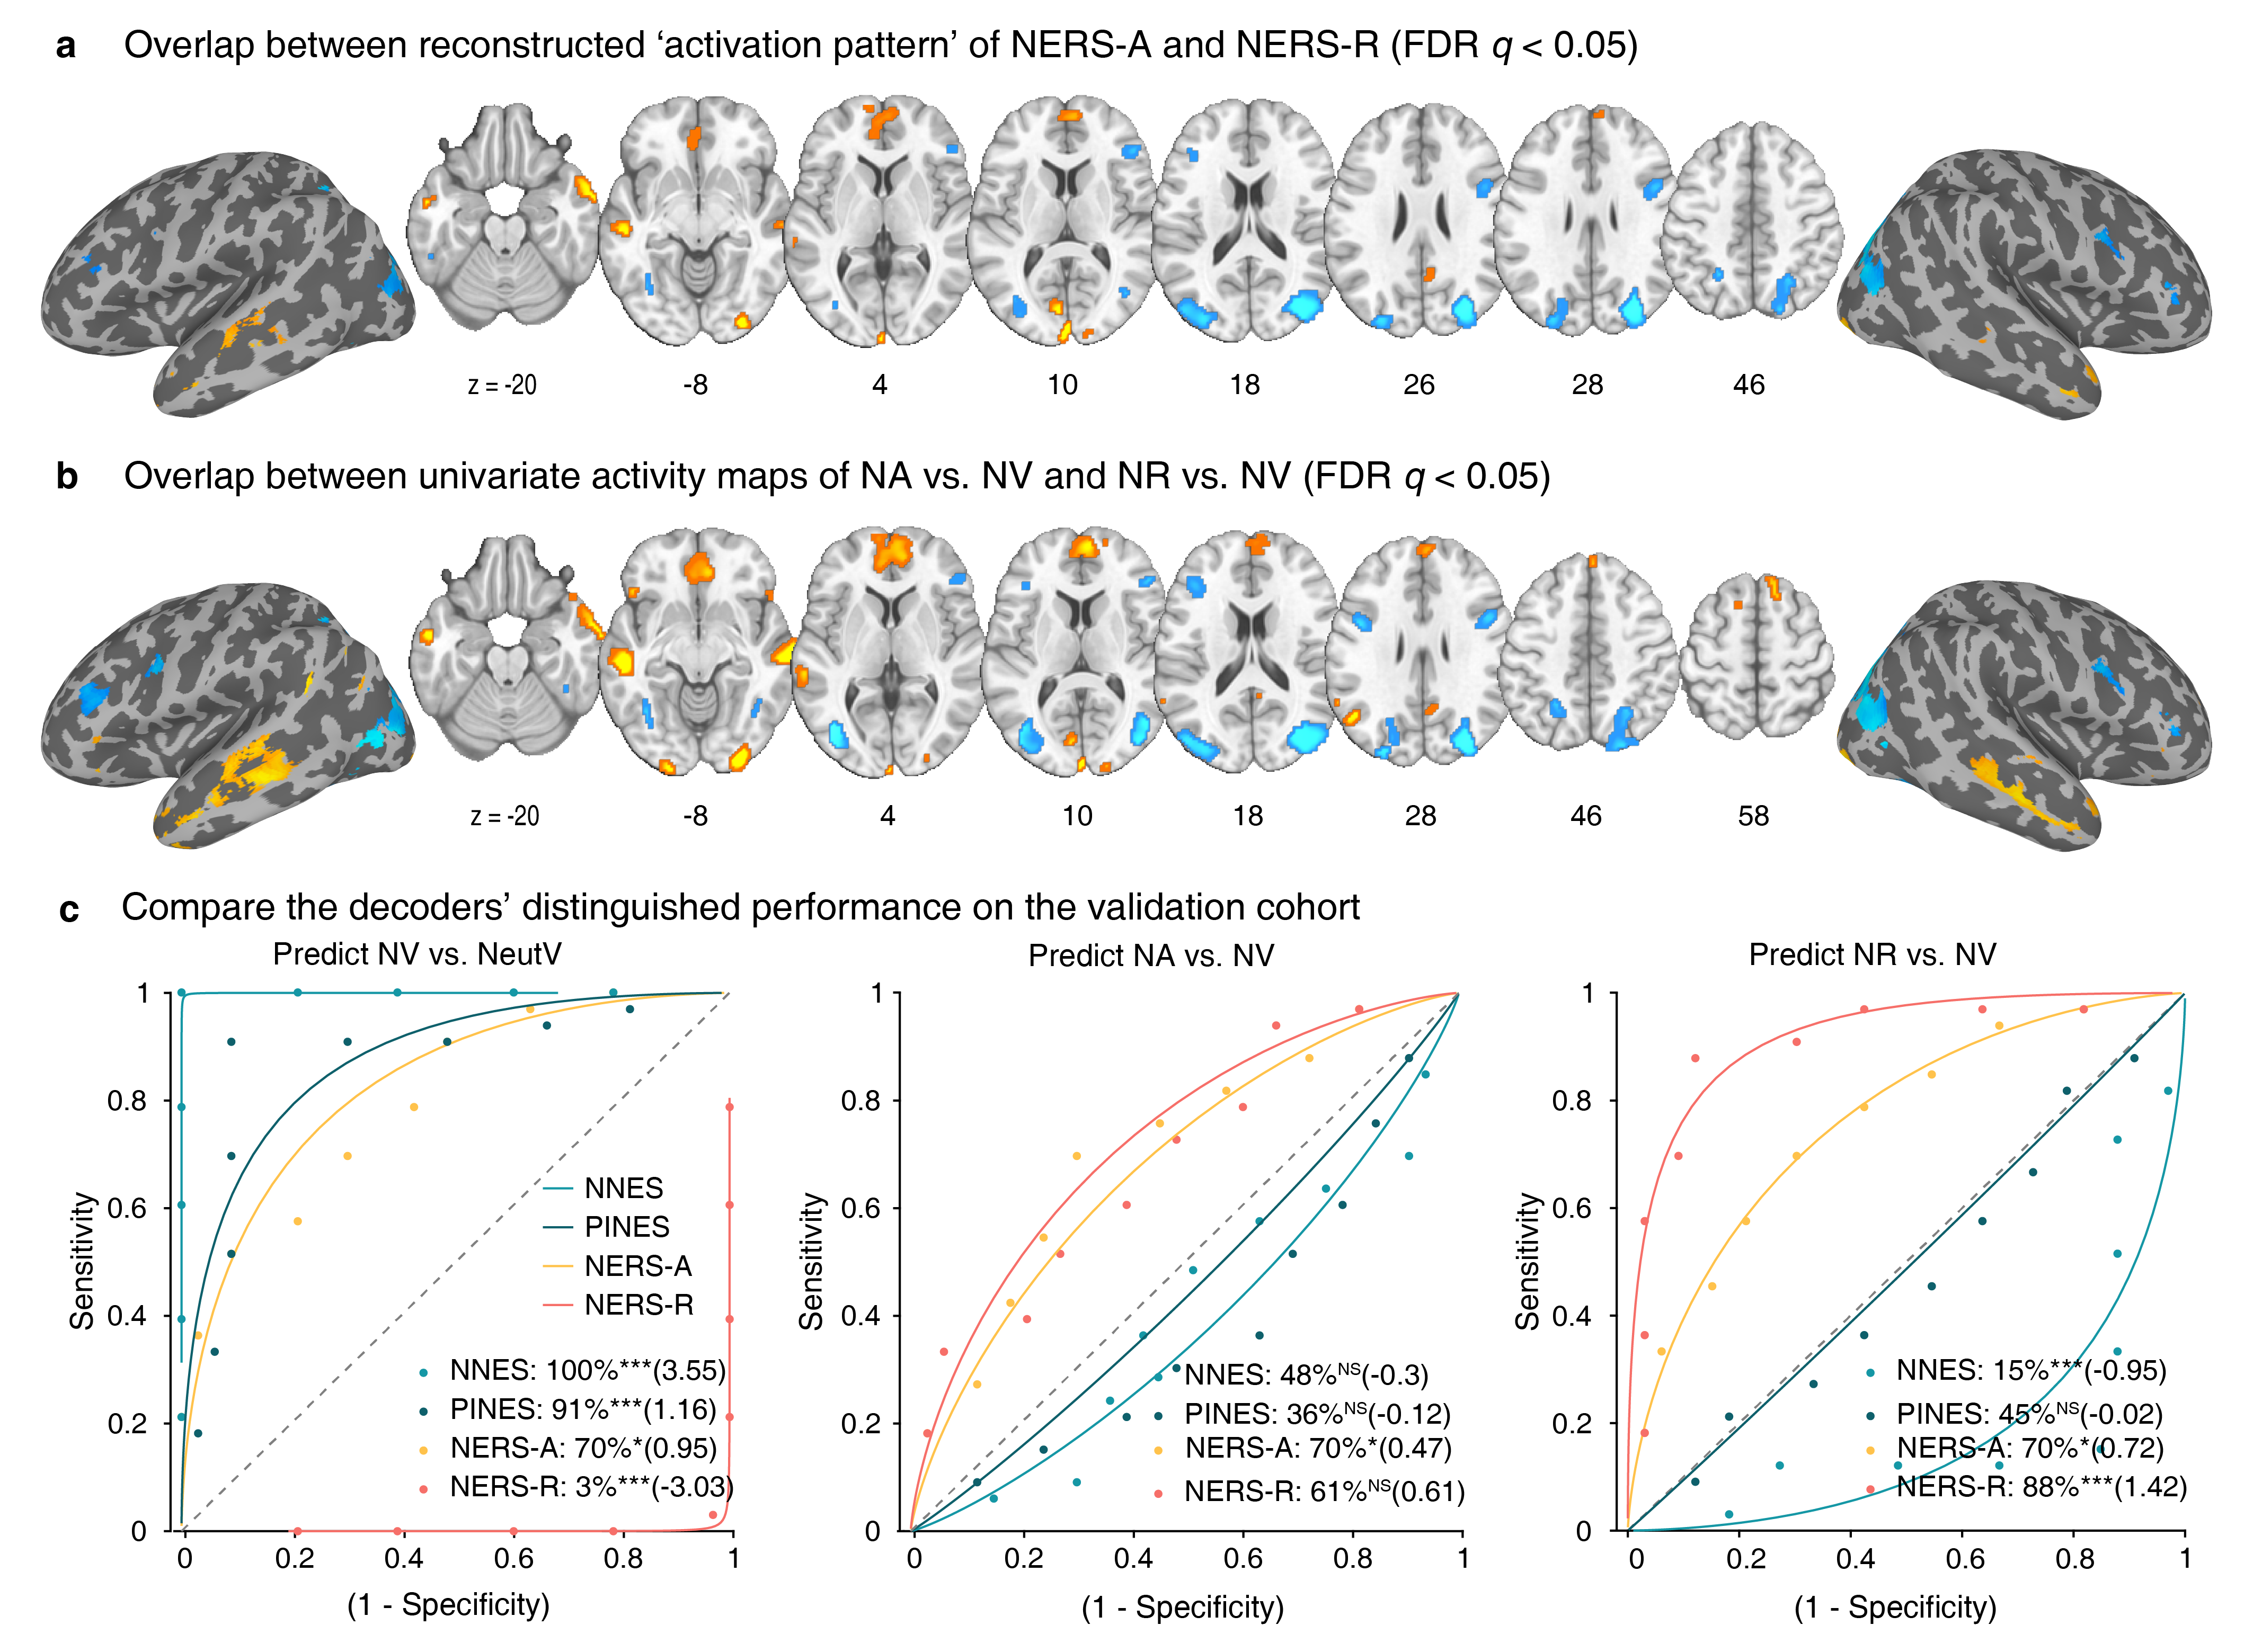
Extended Data Fig.2 | Common brain regions identified by conjunction analysis and comparison of decoders’ predictive performance. The conjunction of the FDR corrected (q<0.05) reconstructed ‘activation patterns’ between NERS-A and NERS-R (a) as well as univariate activity maps between NA vs. NV and NR vs. NV (b). c, Forced-choice classification accuracy and Cohen’s d indicate the NNES, NERS-A, and NERS-R could accurately predict the targeted mental processing during discrimination at NV vs. NeutV, NA vs. NV (left), and NR vs. NV (middle), respectively, based on the validation cohort. PINES could distinguish NV vs. NeutV but not ER strategies vs. NV.

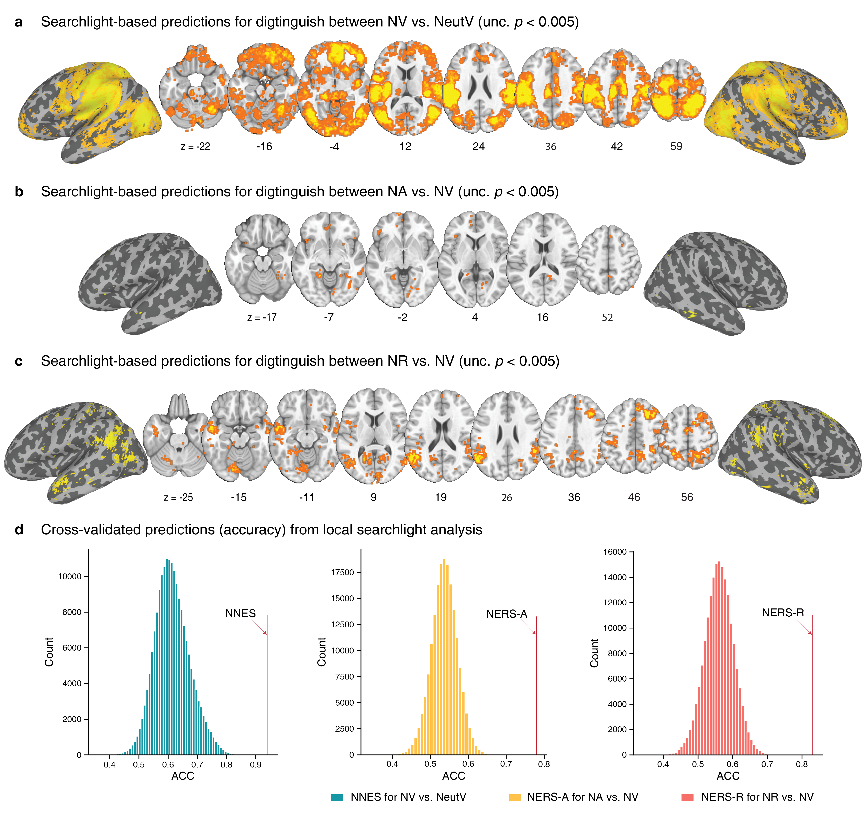
Extended Data Fig.3 | Searchlight-based predictions in the discovery cohort. Brain regions that significantly predict the response (a), acceptance (b), and reappraisal (c) to naturalistic stimuli that are revealed by searchlight-based analyses. d, Histograms: cross-validated predictions from local searchlights.

