Supplementary Material
Document S1: Variable Selection and Model Evaluation for AGB Estimation
1. Introduction. To refine the accuracy of our aboveground biomass (AGB) estimation model, we conducted an in-depth variable selection process using the Mean Decrease in Accuracy (MDA) method. The objective was to identify the most significant predictors and eliminate redundant or non-contributory features. In addition to MDA, we performed multiple model evaluations, including comparisons between feature-reduced models, alternative machine learning algorithms, and dimensionality reduction techniques. The following sections outline the rationale behind our feature selection decisions and the impact on model performance.
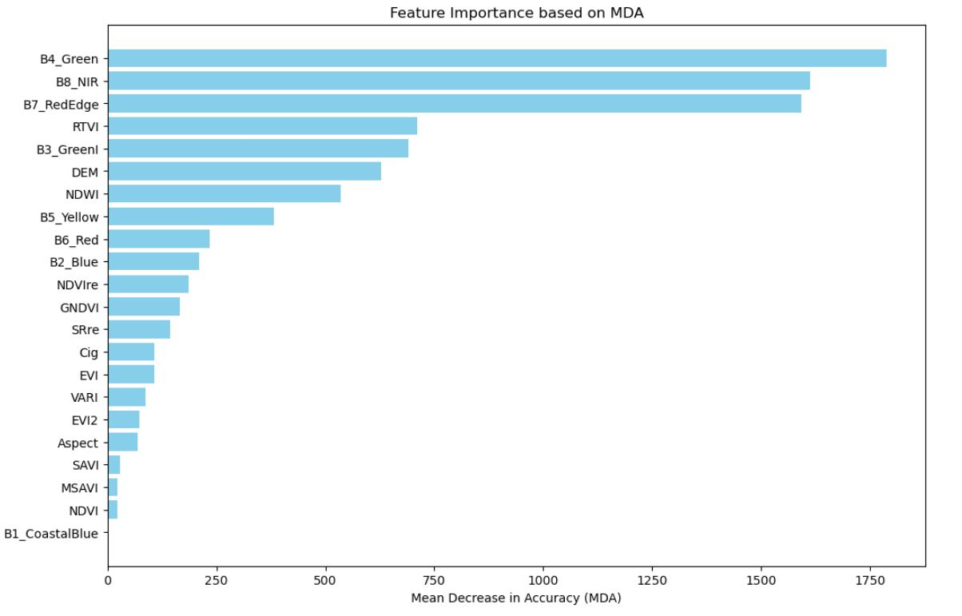
2. Variable Importance and Feature Selection through MDA. MDA 1 was initially employed to assess the importance of each predictor used in the initial Random Forest model (before reviewing). Firstly, all potential explanatory variables were included, ranging from 8 spectral bands, spectral indices (e.g., NDVI, EVI, GNDVI, RTVI, etc.) and topographic parameters (e.g., DEM and Aspect) (see Table S1). While B4_Green, B7_RedEdge, and B8_NIR initially showed high MDA values (Figure 1, Table 1, and MDA1.ipynb). Therefore, a correlation matrix has been conducted (Figure 2), as high MDA does not necessarily mean a variable is essential if other features contain similar information. Therefore, the correlation heatmap (Figure 2) highlights the strong multicollinearity between several spectral bands, particularly B4_Green, B7_RedEdge, and B8_NIR, with other variables. These bands exhibited high correlation coefficients with adjacent spectral features, indicating redundancy rather than unique contributions to AGB prediction. Their removal was justified as their predictive information was already captured by other spectral indices, ensuring a more parsimonious model without compromising performance. This aligns with the principle that highly correlated variables can inflate model complexity without enhancing predictive accuracy, ultimately leading to overfitting rather than meaningful improvements.
Figure 1. Feature Importance based on MDA values
Feature | MDA Value
B4_Green | 1788.244
B8_NIR | 1613.57
B7_RedEdge | 1593.218
RTVI | 711.1434
B3_GreenI | 690.6529
DEM | 628.4392
NDWI | 534.1104
B5_Yellow | 382.6472
B6_Red | 233.9449
B2_Blue | 209.4752
NDVRE | 178.3183
GNDVI | 165.4999
SRre | 143.9766
Cig_MDA | 106.3405
EVI | 106.3405
VARI | 87.12821
EVI2 | 82.90773
Aspect | 68.32173
SAVI | 27.96121
MSAVI | 26.67888
NDVI | 21.31206
B1_CoastalBlue | 0.304893
Table 1. MDA value for each feature
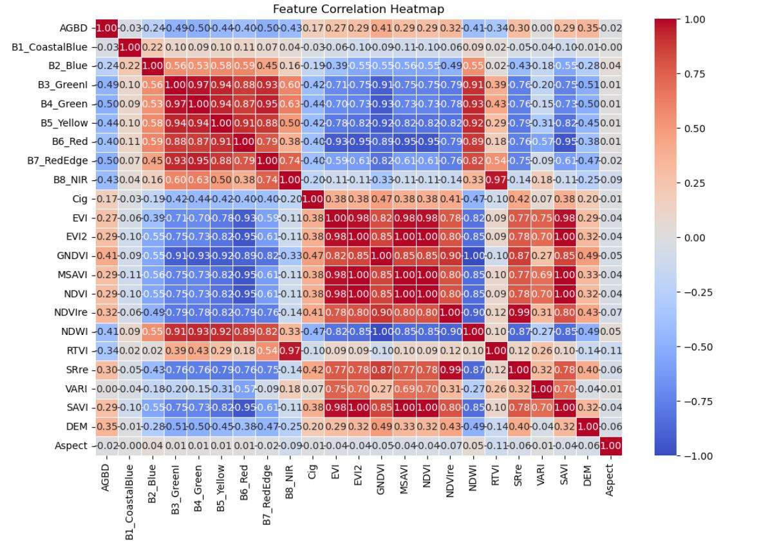
Figure 2. Correlation Matrix Heatmap
As a result, these variables/bands (B4_Green, B7_RedEdge and B8_NIR) were removed in the first step of feature reduction (Figure 3, Table 2 and MDA2.ipynb). To ensure that removing these bands did not negatively impact model performance, we conducted additional tests. The baseline Random Forest model, using all available features, yielded a Mean Squared Error (MSE) of 8160.41. After removing B4_Green, B7_RedEdge and B8_NIR, the model exhibited stable performance, confirming that these bands were not contributing significantly to predictive accuracy. Further removal of NDVI led to a minimal change in MSE, reinforcing the conclusion that its predictive value was limited in this dataset. To ensure robustness across different modelling approaches, we also trained an XGBoost model, which produced an MSE of 8208.49. The similarity in error rates between Random Forest and XGBoost indicates that the key predictors identified through MDA hold relevance across different machine learning frameworks.
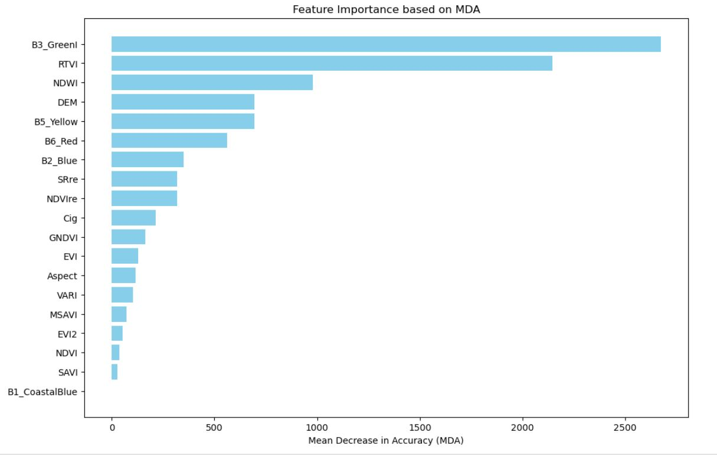
Furthermore, we applied Principal Component Analysis (PCA) to explore the potential of dimensionality reduction. While PCA successfully reduced the number of features while preserving 95% of variance, the resulting Random Forest model exhibited an MSE of 14,271.86, substantially higher than the models trained on selected features. This suggests that direct feature selection via MDA was more effective for AGB estimation than feature transformation via PCA (provided in MDA1.ipynb).
Feature | MDA value
B3_GreenI | 2673.002
RTVI | 2146.189
NDWI | 978.6918
DEM | 696.1885
B5_Yellow | 693.8058
B6_Red | 563.3905
B2_Blue | 349.3698
SRe | 319.7644
NDVIre | 318.6533
Cig | 215.1242
GNDVI | 163.8713
EVI | 128.3093
Aspect | 116.5353
VARI | 102.2021
MSAVI | 72.00767
EVI2 | 51.19413
NDVI | 36.28062
SAVI | 27.51179
B1_CoastalBlue | -0.2259
Table 2. MDA values
Figure 3. Feature importance based on MDA (where B4_Green, B7_RedEdge and B8_NIR were removed)
In addition, NDVI, despite its widespread use in AGB estimation, was also flagged for low importance in the MDA 1 and 2 analyses. The distribution of NDVI values, shown in Figure 4, indicates a strong clustering around 1.0, suggesting low variability within the dataset. This finding implies that NDVI may not be providing additional differentiation across forest structures, especially when other vegetation indices such as EVI and RTVI are available. Given the redundancy of information captured by these indices, NDVI was removed in a subsequent step of model refinement. Additionally, B1_CoastalBlue values were removed due to their extremely low MDA score, indicating negligible influence on model performance. Further, the correlation heatmap (Figure 2) showed that it had a very weak correlation with AGB while maintaining a moderate correlation with other spectral bands. This suggests that B1_CoastalBlue did not provide unique predictive value but rather introduced unnecessary complexity in the model. Given its limited contribution to AGB estimation and potential redundancy, it was excluded in the final feature selection process.
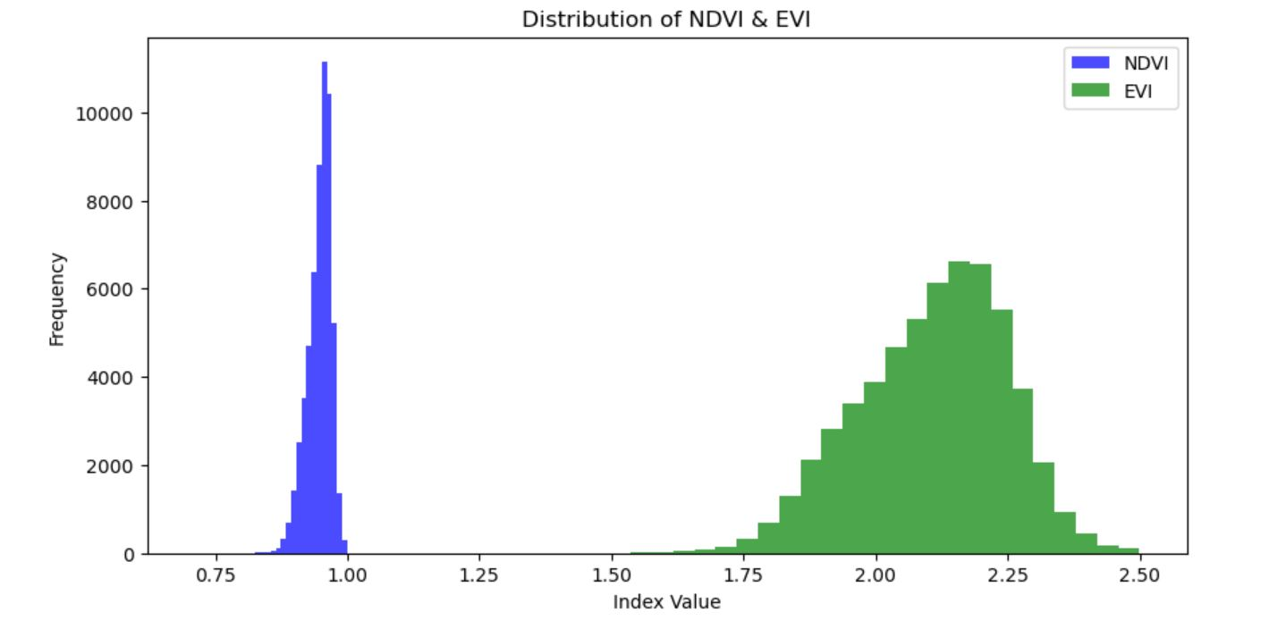
Figure 4. Distribution of NDVI and EVI values.
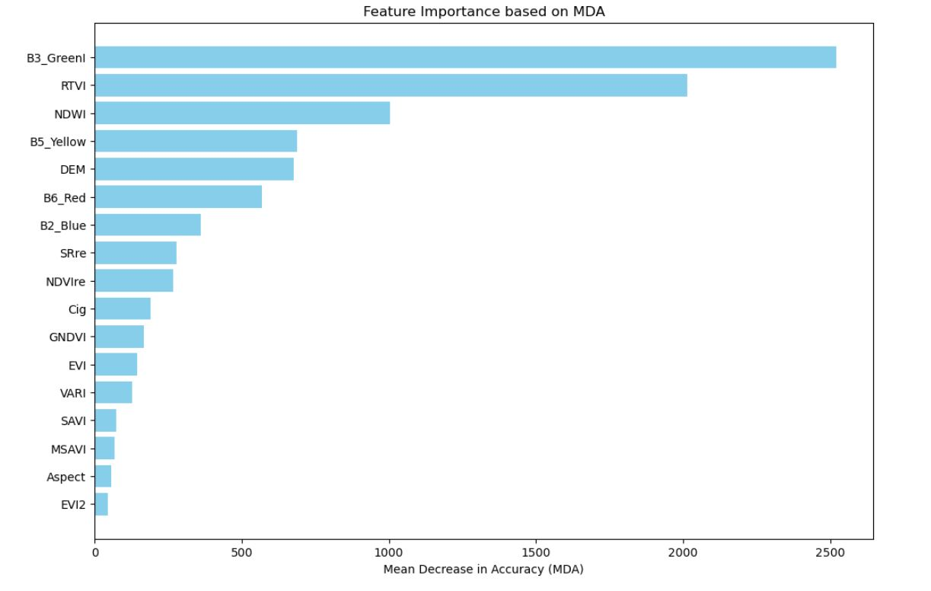
Therefore, our results align with the argument that high-resolution satellite data may better capture AGB through spatial heterogeneity and textural features rather than solely relying on spectral vegetation indices. The improved performance of variables such as B3_GreenI, RTVI, NDWI, etc, in our MDA analysis suggests that certain spectral and topographic features contribute more meaningfully to AGB estimation in our study area (Figure 5, Table 3 and MDA3.ipynb).
Feature | MDA Value
B3_GreenI | 2520.827
RTVI | 2014.514
NDWI | 1004.087
B5_Yellow | 687.153
DEM | 676.1742
B6_Red | 568.6297
B2_Blue | 360.6548
SRre | 279.527
NDVIre | 266.5817
Cig_MDA | 189.3403
GNDVI | 166.9934
EVI | 143.7207
VARI | 127.4086
SAVI | 72.13997
MSAVI | 68.00664
Aspect | 56.20589
EVI2 | 44.95788
Table 3. MDA values

Figure 5. Feature importance based on MDA (where NDVI, B1_CoastalBlue, B4_Green, B7_RedEdge, B8_NIR were removed)
This supplementary analysis highlights the systematic approach used for variable selection and model validation. Through MDA, model comparisons, and dimensionality reduction techniques, we established a refined feature set that optimises AGB prediction accuracy. The findings emphasise the importance of considering spectral-textural interactions and validate the removal of redundant features such as NDVI, B1_CoastalBlue, B4_Green, B7_RedEdge and B8_NIR. The dataset used for this analysis is provided in the accompanying CSV file and jupyter file for further reference.

