Table S1.Physical and chemical characteristics of soil in experimental field
Organic matter | Total N | Available P | Available K | pH
g kg−1 | g kg−1 | mg kg−1 | mg kg−1
25.85 | 1.6 | 99.6 | 64.5 | 7.37

Table S2. Sequences of the q-PCR primers used in this study
Gene ID | primer_F | primer_R
EF1α | CTTGGTGTGAAGCAGATG | GGTGGACCTCTCAATCAT
LOC4330034-PAL | ATCACCAAGTTCGAGGAG | GAACACCTTGTTGCACTC
LOC4330407-4CL | GACGACGAGGTCTTCATC | CCTTGTGTAGCCTCTTGT

Table S3. Information of 108 anthocyanins
Number | Compounds | Class | Molecular Weight | Ion mode | Ionization model | Formula
1 | Cyanidin-3-O-glucoside | Cyanidin | 449.1083865 | Positive | [M]+ | C21H21O11+
2 | Cyanidin-3-O-(6-O-malonyl-beta-D-glucoside) | Cyanidin | 535.1087804 | Positive | [M]+ | C24H23O14+
3 | Cyanidin-3-O-sambubioside-5-O-glucoside | Cyanidin | 743.2034686 | Positive | [M]+ | C32H39O20+
4 | Cyanidin-3-O-5-O-(6-O-coumaroyl)-diglucoside | Cyanidin | 757.1979893 | Positive | [M]+ | C36H37O18+
5 | Cyanidin-3,5,3'-O-triglucoside | Cyanidin | 773.2140333 | Positive | [M]+ | C33H41O21+
6 | Cyanidin-3-(6-O-p-caffeoyl)-glucoside | Cyanidin | 611.1400805 | Positive | [M]+ | C30H27O14+
7 | Cyanidin-3-O-rutinoside-5-O-glucoside | Cyanidin | 757.2191187 | Positive | [M]+ | C33H41O20+
8 | Cyanidin-3-O-rutinoside | Cyanidin | 595.1662953 | Positive | [M]+ | C27H31O15+
9 | Cyanidin-3-O-(6-O-p-coumaroyl)-glucoside | Cyanidin | 595.1451659 | Positive | [M]+ | C30H27O13+
10 | Cyanidin-3-O-(6''-ferulylsophoroside)-5-glucoside | Cyanidin | 949.2613774 | Positive | [M]+ | C43H49O24+
11 | Cyanidin-3,5-O-diglucoside | Cyanidin | 611.1612099 | Positive | [M]+ | C27H31O16+
12 | Cyanidin-3-O-xyloside | Cyanidin | 419.0978218 | Positive | [M]+ | C20H19O10+
13 | Cyanidin-3-O-sophoroside | Cyanidin | 611.1612099 | Positive | [M]+ | C27H31O16+
14 | Cyanidin-3-O-sambubioside | Cyanidin | 581.1506452 | Positive | [M]+ | C26H29O15+
15 | Cyanidin-3-(6''-caffeylsophoroside)-5-glucoside | Cyanidin | 935.2457274 | Positive | [M]+ | C42H47O24+
16 | Cyanidin-3-O-galactoside | Cyanidin | 449.1083865 | Positive | [M]+ | C21H21O11+
17 | Cyanidin-3-O-arabinoside | Cyanidin | 419.0978218 | Positive | [M]+ | C20H19O10+
18 | Delphinidin-3-O-glucoside | Delphinidin | 465.1033011 | Positive | [M]+ | C21H21O12+
19 | Delphinidin-3-O-galactoside | Delphinidin | 465.1033011 | Positive | [M]+ | C21H21O12+
20 | Delphinidin-3,5-O-diglucoside | Delphinidin | 627.1561245 | Positive | [M]+ | C27H31O17+
21 | Delphinidin-3-O-rutinoside-5-O-glucoside | Delphinidin | 773.2140333 | Positive | [M]+ | C33H41O21+
22 | Delphinidin | Delphinidin | 303.0504777 | Positive | [M]+ | C15H11O7+
23 | Delphinidin-3-O-(6-O-malonyl)-glucoside-3'-glucoside | Delphinidin | 713.1565184 | Positive | [M]+ | C30H33O20+
24 | Delphinidin-3-O-arabinoside | Delphinidin | 435.0927364 | Positive | [M]+ | C20H19O11+
25 | Delphinidin-3-O-(6-O-p-coumaroyl)-glucoside | Delphinidin | 611.1400805 | Positive | [M]+ | C30H27O14+
26 | Delphinidin-3-O-(6-O-acetyl)-glucoside | Delphinidin | 507.1138658 | Positive | [M]+ | C23H23O13+
27 | Delphinidin-3-O-sambubioside-5-O-glucoside | Delphinidin | 759.1983833 | Positive | [M]+ | C32H39O21+
28 | Delphinidin-3-O-sambubioside | Delphinidin | 597.1455598 | Positive | [M]+ | C26H29O16+
29 | Delphinidin-3-O-rutinoside | Delphinidin | 611.1612099 | Positive | [M]+ | C27H31O16+
30 | Delphinidin-3-O-rhamnoside | Delphinidin | 449.10839 | Positive | [M]+ | C21H21O11+
31 | Delphinidin-3-O-(6-O-malonyl-beta-D-glucoside) | Delphinidin | 551.103695 | Positive | [M]+ | C24H23O15+
32 | Delphinidin-3-O-5-O-(6-O-coumaroyl)-diglucoside | Delphinidin | 773.192904 | Positive | [M]+ | C36H37O19+
33 | Delphinidin-3-O-sophoroside | Delphinidin | 627.1561245 | Positive | [M]+ | C27H31O17+
34 | Malvidin-3-O-(6''-acetylglucoside)-5-glucoside | Malvidin | 697.1979893 | Positive | [M]+ | C31H37O18+
35 | Malvidin | Malvidin | 331.0817778 | Positive | [M]+ | C17H15O7+
36 | Malvidin-3-O-(6-O-malonyl-beta-D-glucoside) | Malvidin | 579.1349952 | Positive | [M]+ | C26H27O15+
37 | Malvidin-3-O-sambubioside | Malvidin | 625.17686 | Positive | [M]+ | C28H33O16+
38 | Malvidin-3-O-sophoroside | Malvidin | 655.1874246 | Positive | [M]+ | C29H35O17+
39 | Malvidin-3-O-5-O-(6-O-coumaroyl)-diglucoside | Malvidin | 801.2242041 | Positive | [M]+ | C38H41O19+
40 | Malvidin-3,5-O-diglucoside | Malvidin | 655.1874246 | Positive | [M]+ | C29H35O17+
41 | Malvidin-3-O-sambubioside-5-O-glucoside | Malvidin | 787.22969 | Positive | [M]+ | C34H43O21+
42 | Malvidin-3-O-arabinoside | Malvidin | 463.1240366 | Positive | [M]+ | C22H23O11+
43 | Malvidin-3-O-galactoside | Malvidin | 493.1346012 | Positive | [M]+ | C23H25O12+
44 | Malvidin-3-O-glucoside | Malvidin | 493.1346012 | Positive | [M]+ | C23H25O12+
45 | Malvidin-3-O-rutinoside | Malvidin | 639.19251 | Positive | [M]+ | C29H35O16+
46 | Malvidin-3-O-(6-O-p-coumaroyl)-glucoside | Malvidin | 639.1713807 | Positive | [M]+ | C32H31O14+
47 | Pelargonidin-3-O-arabinoside | Pelargonidin | 403.1029072 | Positive | [M]+ | C20H19O9+
48 | Pelargonidin-3-O-(6-O-p-coumaroyl)-glucoside | Pelargonidin | 579.1502513 | Positive | [M]+ | C30H27O12+
49 | Pelargonidin-3-O-sambubioside | Pelargonidin | 565.1557306 | Positive | [M]+ | C26H29O14+
50 | Pelargonidin-3-O-sambubioside-5-O-glucoside | Pelargonidin | 727.208554 | Positive | [M]+ | C32H39O19+
51 | Pelargonidin-3-O-rutinoside-5-O-glucoside | Pelargonidin | 741.2242041 | Positive | [M]+ | C33H41O19+
52 | Pelargonidin-3-O-sophoroside | Pelargonidin | 595.1662953 | Positive | [M]+ | C27H31O15+
53 | Pelargonidin-3-O-[6-O-feruloyl-2-O-glucosyl-glucoside]-5-O-glucoside | Pelargonidin | 933.2664628 | Positive | [M]+ | C43H49O23+
54 | Pelargonidin-3-O-(6''-ferulylsambubioside)-5-O-(malonyl)-glucoside | Pelargonidin | 989.256292 | Positive | [M]+ | C45H49O25+
55 | Pelargonidin-3-(6''-caffeylsophoroside)-5-glucoside | Pelargonidin | 919.2508127 | Positive | [M]+ | C42H47O23+
56 | Pelargonidin | Pelargonidin | 271.0606485 | Positive | [M]+ | C15H11O5+
57 | Pelargonidin-3-O-glucoside | Pelargonidin | 433.1134719 | Positive | [M]+ | C21H21O10+
58 | Pelargonidin-3-O-rutinoside | Pelargonidin | 579.1713807 | Positive | [M]+ | C27H31O14+
59 | Pelargonidin-3-O-sophoroside-5-O-(malonyl)-glucoside | Pelargonidin | 843.21952 | Positive | [M]+ | C36H43O23+
60 | Pelargonidin-3-O-galactoside | Pelargonidin | 433.1134719 | Positive | [M]+ | C21H21O10+
61 | Pelargonidin-3-O-5-O-(6-O-coumaroyl)-diglucoside | Pelargonidin | 741.2030747 | Positive | [M]+ | C36H37O17+
62 | Pelargonidin-3-sophoroside-5-glucoside | Pelargonidin | 757.2191187 | Positive | [M]+ | C33H41O20+
63 | Pelargonidin-3-O-[2-O-glucosyl-6-O-p-coumaroyl-glucoside]-5-O-glucoside | Pelargonidin | 903.2558981 | Positive | [M]+ | C42H47O22+
64 | Pelargonidin-3,5-O-diglucoside | Pelargonidin | 595.1662953 | Positive | [M]+ | C27H31O15+
65 | Pelargonidin-3-O-(6-O-malonyl-beta-D-glucoside) | Pelargonidin | 519.1138658 | Positive | [M]+ | C24H23O13+
66 | Peonidin-3-O-(6-O-p-coumaroyl)-glucoside | Peonidin | 609.160816 | Positive | [M]+ | C31H29O13+
67 | Peonidin-3-O-sambubioside-5-O-glucoside | Peonidin | 757.2191187 | Positive | [M]+ | C33H41O20+
68 | Peonidin-3-O-arabinoside | Peonidin | 433.1134719 | Positive | [M]+ | C21H21O10+
69 | Peonidin-3-O-galactoside | Peonidin | 463.1240366 | Positive | [M]+ | C22H23O11+
70 | Peonidin-3-O-rutinoside | Peonidin | 609.1819453 | Positive | [M]+ | C28H33O15+
71 | Peonidin-3-O-glucoside | Peonidin | 463.1240366 | Positive | [M]+ | C22H23O11+
72 | Peonidin-3-O-sophoroside | Peonidin | 625.17686 | Positive | [M]+ | C28H33O16+
73 | Peonidin-3-O-(6''-ferulylsophoroside)-5-glucoside | Peonidin | 963.2770275 | Positive | [M]+ | C44H51O24+
74 | Peonidin-3-O-(6-O-malonyl-beta-D-glucoside) | Peonidin | 549.1244305 | Positive | [M]+ | C25H25O14+
75 | Peonidin-3,5-O-diglucoside | Peonidin | 625.17686 | Positive | [M]+ | C28H33O16+
76 | Peonidin-3-(caffeoyl-glucosyl-glucoside)-5-glucoside | Peonidin | 949.2613774 | Positive | [M]+ | C43H49O24+
77 | Peonidin-3-sophoroside-5-glucoside | Peonidin | 787.2296834 | Positive | [M]+ | C34H43O21+
78 | Peonidin-3-O-P-hydroxybenzoylsophoroside-5-glucoside | Peonidin | 907.25082 | Positive | [M]+ | C41H47O23+
79 | Peonidin-3-O-sambubioside | Peonidin | 595.1662953 | Positive | [M]+ | C27H31O15+
80 | Peonidin | Peonidin | 301.0712131 | Positive | [M]+ | C16H13O6+
81 | Peonidin-3-O-caffeoyl-feruloyl-sophoroside-5-glucoside | Peonidin | 1125.30873 | Positive | [M]+ | C53H57O27+
82 | Peonidin-3-O-5-O-(6-O-coumaroyl)-diglucoside | Peonidin | 771.2136394 | Positive | [M]+ | C37H39O18+
83 | Petunidin-3,5-O-diglucoside | Petunidin | 641.1717746 | Positive | [M]+ | C28H33O17+
84 | Petunidin-3-O-sambubioside-5-O-glucoside | Petunidin | 773.21404 | Positive | [M]+ | C33H41O21+
85 | Petunidin-3-O-sophoroside | Petunidin | 641.1717746 | Positive | [M]+ | C28H33O17+
86 | Petunidin-3-O-(6-O-p-coumaroyl)-glucoside | Petunidin | 625.1557306 | Positive | [M]+ | C31H29O14+
87 | Petunidin-3-O-galactoside | Petunidin | 479.1189512 | Positive | [M]+ | C22H23O12+
88 | Petunidin-3-O-sambubioside | Petunidin | 611.1612099 | Positive | [M]+ | C27H31O16+
89 | Petunidin-3-O-arabinoside | Petunidin | 449.1083865 | Positive | [M]+ | C21H21O11+
90 | Petunidin-3-O-glucoside | Petunidin | 479.1189512 | Positive | [M]+ | C22H23O12+
91 | Petunidin-3-O-rutinoside | Petunidin | 625.17686 | Positive | [M]+ | C28H33O16+
92 | Petunidin-3-O-(6-O-malonyl-beta-D-glucoside) | Petunidin | 565.1193451 | Positive | [M]+ | C25H25O15+
93 | Petunidin-3-O-5-O-(6-O-coumaroyl)-diglucoside | Petunidin | 787.208554 | Positive | [M]+ | C37H39O19+
94 | Procyanidin A1 | Procyanidin | 576.1267762 | Positive | [M+H]+ | C30H24O12
95 | Procyanidin B3 | Procyanidin | 578.1424263 | Positive | [M+H]+ | C30H26O12
96 | Procyanidin B2 | Procyanidin | 578.1424263 | Positive | [M+H]+ | C30H26O12
97 | Procyanidin B1 | Procyanidin | 578.1424263 | Positive | [M+H]+ | C30H26O12
98 | Procyanidin C1 | Procyanidin | 866.2058144 | Positive | [M+H]+ | C45H38O18
99 | Procyanidin A2 | Procyanidin | 576.1267762 | Positive | [M+H]+ | C30H24O12
100 | Rutin | flavonoid | 610.1533849 | Positive | [M+H]+ | C27H30O16
101 | Dihydromyricetin | flavonoid | 320.0532173 | Positive | [M+H]+ | C15H12O8
102 | Afzelin | flavonoid | 432.1056468 | Positive | [M+H]+ | C21H20O10
103 | Kaempferol-3-O-rutinoside | flavonoid | 594.1584703 | Positive | [M+H]+ | C27H30O15
104 | Naringenin | flavonoid | 272.0684735 | Positive | [M+H]+ | C15H12O5
105 | Naringenin-7-O-glucoside | flavonoid | 434.1212969 | Positive | [M+H]+ | C21H22O10
106 | Dihydrokaempferol | flavonoid | 288.0633881 | Positive | [M+H]+ | C15H12O6
107 | Chalcone | flavonoid | 208.088815 | Positive | [M+H]+ | C15H12O
108 | Quercetin-3-O-glucoside | flavonoid | 464.0954761 | Positive | [M+H]+ | C21H20O12

Table S4. Statistics on the quality and output of the RNA-Seq
Sample | Raw reads | Clean reads | clean data | Error rate | Q20 | Q30 | GC
 |  |  | Gbases | % | % | % | %
YXHD-CK-1 | 43272856 | 42282432 | 6.37 | 0.009028 | 98.58 | 96.15 | 49.17
YXHD-CK-2 | 45577712 | 44550404 | 6.71 | 0.009855 | 98.6 | 96.23 | 49.32
YXHD-CK-3 | 39902920 | 38938900 | 5.87 | 0.009918 | 98.5 | 95.95 | 49.29
TDH2-CK-1 | 42174414 | 41229594 | 6.21 | 0.009939 | 98.49 | 95.86 | 50.97
TDH2-CK-2 | 54268178 | 53228716 | 8.02 | 0.009655 | 98.67 | 96.33 | 50.34
TDH2-CK-3 | 49379876 | 48213534 | 7.26 | 0.008857 | 98.44 | 95.73 | 50.69
YXHD-T1-1 | 40155132 | 39151676 | 5.89 | 0.009791 | 98.45 | 95.81 | 50.42
YXHD-T1-2 | 41998938 | 41096602 | 6.19 | 0.008344 | 98.69 | 96.47 | 50.03
YXHD-T1-3 | 45273248 | 44225832 | 6.65 | 0.010057 | 98.53 | 96.05 | 49.96
TDH2-T1-1 | 42163384 | 41167056 | 6.2 | 0.006914 | 98.51 | 95.99 | 49.4
TDH2-T1-2 | 41431306 | 40539900 | 6.11 | 0.006823 | 98.62 | 96.25 | 49.1
TDH2-T1-3 | 40339714 | 39484678 | 5.95 | 0.006879 | 98.61 | 96.18 | 49.41
YXHD-T2-1 | 45161100 | 44156100 | 6.65 | 0.009604 | 98.62 | 96.27 | 49.68
YXHD-T2-2 | 44812342 | 43629678 | 6.57 | 0.010125 | 98.43 | 95.8 | 49.97
YXHD-T2-3 | 43291206 | 42319728 | 6.37 | 0.009814 | 98.58 | 96.16 | 50.23
TDH2-T2-1 | 54458696 | 53314178 | 8.03 | 0.006828 | 98.55 | 96.04 | 50.22
TDH2-T2-2 | 46675222 | 45646464 | 6.87 | 0.006854 | 98.48 | 95.84 | 50.37
TDH2-T2-3 | 42955732 | 42095118 | 6.34 | 0.006879 | 98.58 | 96.08 | 50.08
YXHD, Youxianghongdao; TDH2, Tiandaohong2. CK, T1, and T2 represent freshwater irrigation and brine irrigation with salinity of 2.0‰ and 4.0‰, respectively

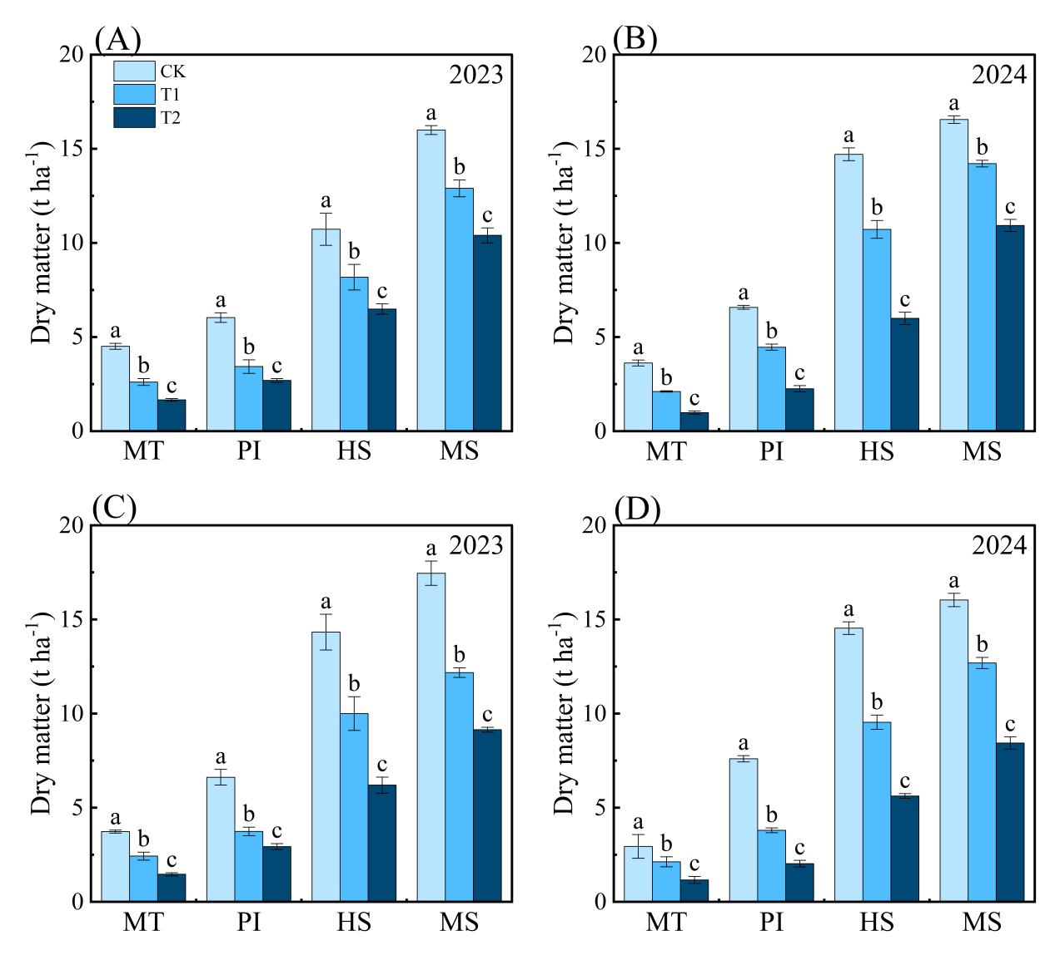
Fig. S1. Effects of salt stress on dry matter accumulation of YXHD (A-B) and TDH2 (C-D) at main growth stages in 2023 and 2024
Mean values with the same letters are significantly different at P < 0.05 according to the LSD test. YXHD, Youxianghongdao; TDH2, Tiandaohong2. MT, middle tillering stage; PI, panicle initiation stage; HS, full heading stage; MS, maturity stage. The CK, T1 and T2 represent freshwater irrigation, seawater and freshwater mixtures with salinity of 2‰ and 4‰, respectively.

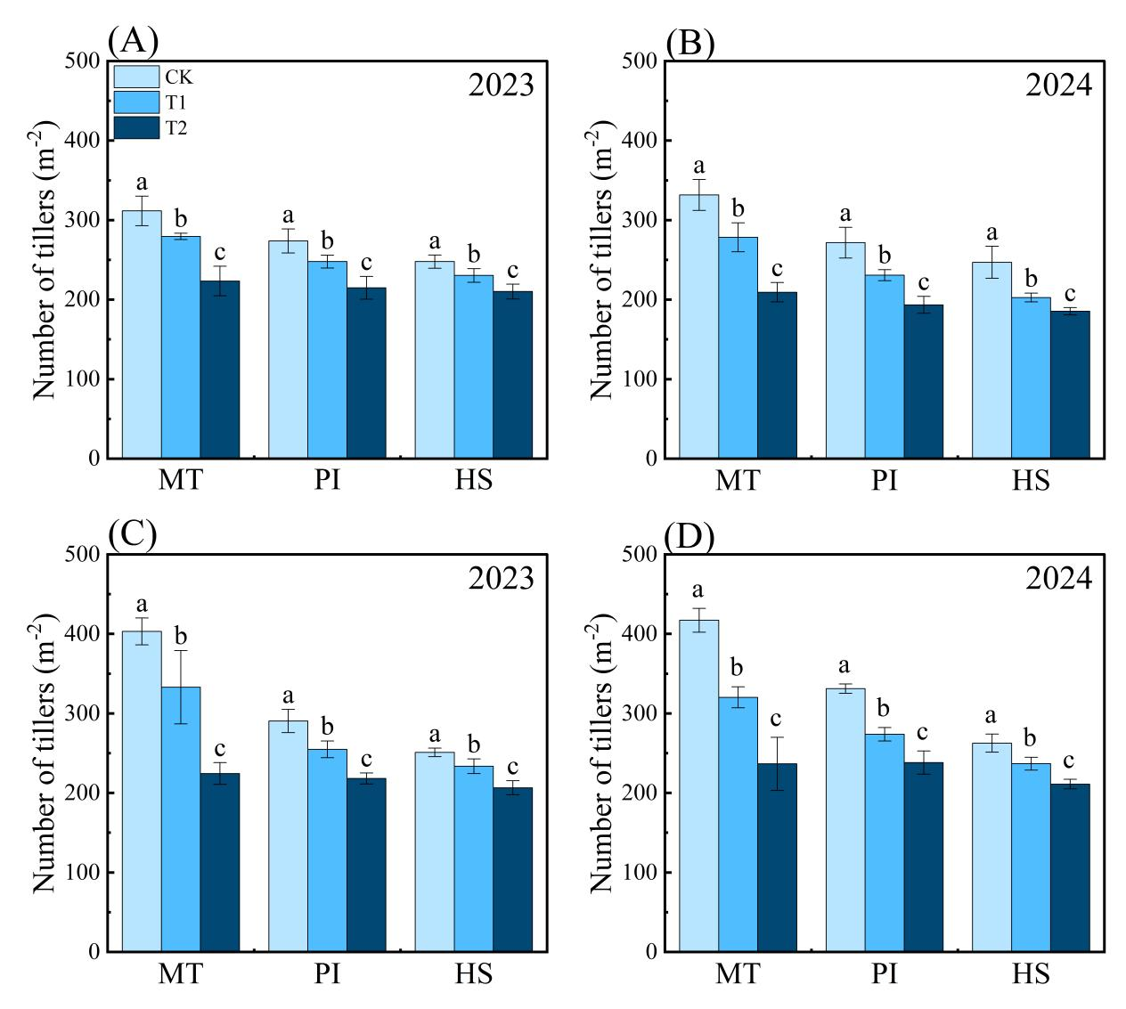
Fig. S2. Effects of salt stress on tiller number of YXHD (A-B) and TDH2 (C-D) at main growth stages in 2023 and 2024
Mean values with the same letters are significantly different at P < 0.05 according to the LSD test. YXHD, Youxianghongdao; TDH2, Tiandaohong2. MT, middle tillering stage; PI, panicle initiation stage; HS, full heading stage. The CK, T1 and T2 represent freshwater irrigation, seawater and freshwater mixtures with salinity of 2‰ and 4‰, respectively.

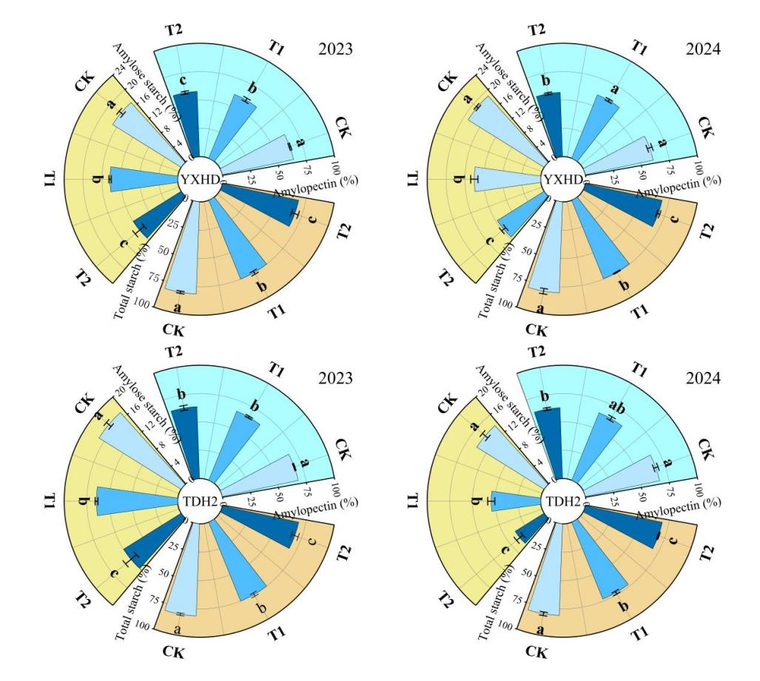
Fig. S3. Effects of brine irrigation on the contents of starch and its components in red grains. Mean values of different lowercase letters were significantly different at the P < 0.05 level by LSD test. YXHD, Youxianghongdao; TDH2, Tiandaohong2. CK, T1, and T2 represent freshwater irrigation and brine irrigation with salinity of 2.0‰ and 4.0‰, respectively

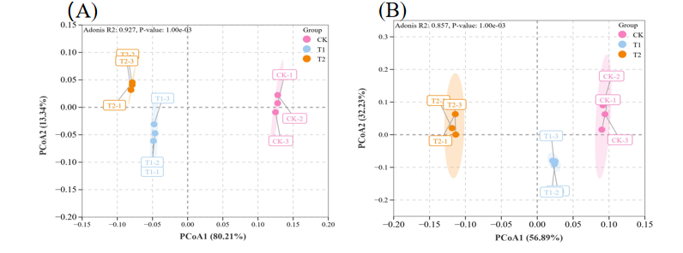
Fig. S4. Principal component analysis of transcriptome data of YXHD (Youxianghongdao) and TDH2 (Tiandaohong 2). A and B are the PCoA diagrams of YXHD (Youxianghongdao) and TDH2 (Tiandaohong2), respectively. CK, T1, and T2 represent freshwater irrigation and brine irrigation with salinity of 2.0‰ and 4.0‰, respectively

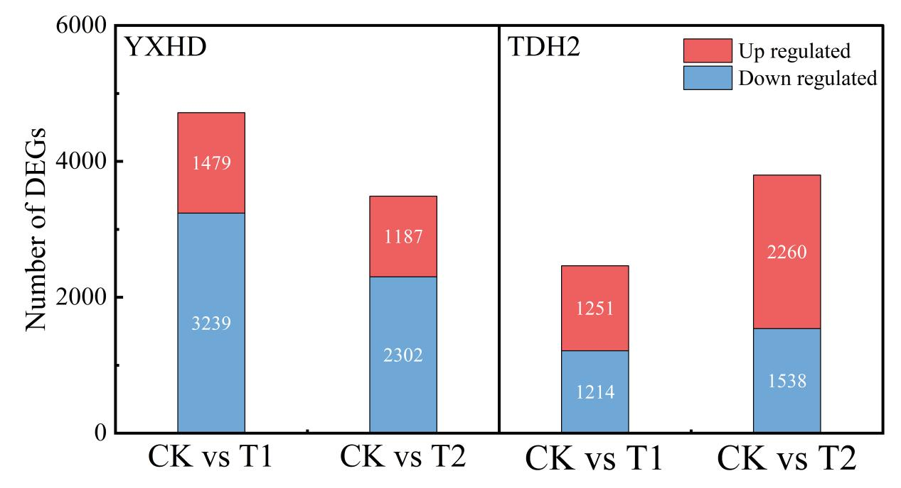
Fig. S5. Statistics of differential genes in red rice under brine irrigation. YXHD, Youxianghongdao; TDH2, Tiandaohong2. CK, T1, and T2 represent freshwater irrigation and brine irrigation with salinity of 2.0‰ and 4.0‰, respectively.

Fig. S6. KEGG pathway enrichment of differentially expressed gene (DEGs) of YXHD (Youxianghongdao) and TDH2 (Tiandaohong2). (A and B) KEGG pathways analysis of DEGs in YXHD (Youxianghongdao) treated with 2.0‰ brine irrigation (T1) and 4.0‰ brine irrigation (T2) compared with freshwater irrigation (CK). (C and D) KEGG pathways analysis of DEGs in TDH2 (Tiandaohong2) treated with 2.0‰ brine irrigation (T1) and 4.0‰ brine irrigation (T2) compared with freshwater irrigation (CK)

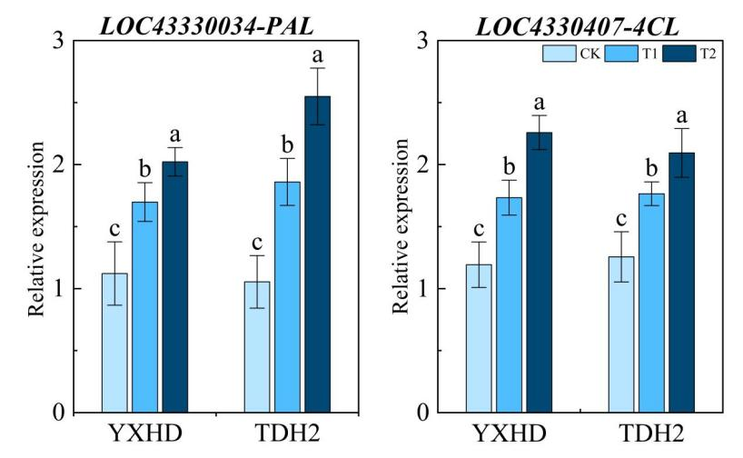
Fig. S7. Effects of brine irrigation on the relative expression of PAL and 4CL in YXHD (Youxianghongdao) and TDH2 (Tiandaohong2). Mean values of different lowercase letters were significantly different at the P < 0.05 level by LSD test. PAL, phenylalanine ammonia lyase gene; 4CL, 4-coumaroyl-coenzyme A ligase gene. CK, T1, and T2 represent freshwater irrigation and brine irrigation with salinity of 2.0‰ and 4.0‰, respectively.

