SUPPORTING INFORMATION

Aromatic sesquiterpenes isolated from high-trichome sun-cured tobacco as potential activators for powdery mildew

Hua-Yin Liu ^{1,2}, Yan-Qun Zhang ¹, Feng-Xian Yang ^{1,3}, Xin-Yao Huang ¹, Rong Zhang ^{1,3}, Wei-Guang Wang ¹, Guang-Yu Yang ^{1,3}, Qiu-Fen Hu ^{1,2*}, and Shi-Ping Zhou ^{2*}
¹ Key Laboratory of Natural Products Synthetic Biology of Ethnic Medicinal Resources, State Ethnic Affairs Commission, Yunnan Minzu University, Kunming 650504, P. R. China;
² College of Materials and Chemical Engineering, Southwest Forestry University, Kunming 650224, P. R. China;
³ Yunnan Key Laboratory of Tobacco Chemistry, China Tobacco Yunnan Industrial Co., Ltd, Kunming 650231, P. R. China.
*Correspondence Qiu-Fen Hu, E-mail: huqf_tg@163.com; Shi-Ping Zhou, kmzhoushiping@163.com

Contents of supporting information
SI-1 General Experimental Procedures
SI-2 Extraction and isolation
SI-3 Antifungal activity assays
SI-4 Sample preparation with metabolomic, data preprocessing and analysis
SI-5 Analysis of Defense Enzymes Activities
SI-6 Analysis of SA, JA, MDA, and CHL Accumulation
SI-7 Quantitative real-time PCR analysis of defense-related genes
SI-8 Molecular docking
SI-9 Structure characterization of compounds 1-4
Table S1 RNA-seq data statistics
Table S2 The binding energy between compounds 1-7, 9, 11 and Tubulin protein
Supplementary Figure
Fig. S1 ¹³C and DEPT NMR spectrum of 1.
Fig. S2 ¹H NMR spectrum of 1.
Fig. S3 HSQC NMR spectrum of 1.
Fig. S4 HMBC NMR spectrum of 1.
Fig. S5 ¹³C and DEPT NMR spectrum of 2.
Fig. S6 ¹H NMR spectrum of 2.
Fig. S7 ¹³C and DEPT NMR spectrum of 3.
Fig. S8 ¹H NMR spectrum of 3.
Fig. S9 HSQC NMR spectrum of 3.
Fig. S10 HMBC NMR spectrum of 3.
Fig. S11 ¹³C and DEPT NMR spectrum of 4.
Fig. S12 ¹H NMR spectrum of 4.
Fig. S13 ¹³C and DEPT NMR spectrum of 5.
Fig. S14 ¹H NMR spectrum of 5.
Fig. S15 HSQC NMR spectrum of 5.
Fig. S16 HMBC NMR spectrum of 5.
Fig. S17 ¹³C and DEPT NMR spectrum of 6.
Fig. S18 ¹H NMR spectrum of 6.
Fig. S19 ¹³C and DEPT NMR spectrum of 7.
Fig. S20 ¹H NMR spectrum of 7.
Fig. S21 HSQC NMR spectrum of 7.
Fig. S22 HMBC NMR spectrum of 7.
Fig. S23. The inhibitory effects of compounds 1-7, 9, and 11 on G. cichoracearum.
Fig. S24. The protective effects of compounds 6, 7, and 11 on tobacco plants.
Fig. S25. SEM images of the leaf surface structure of tobacco.
Fig. S26. SEM images of the leaf surface hyphal structure of tobacco.
Fig. S27. The expression levels of partial DGEs between the com 7 group and the CK group.
Fig. S28. The accumulation levels of partial DAMs between the com 7 group and the CK group.
Fig. S29 The relative expression levels of defense-related genes (PR-1, PR-5, PAL, and Chit1) in tobacco plants at 1-, 3-, 5-, and 7 -dpt with compound 7.
Fig. S30 The enzyme activities of SOD, PAL, POD, PPO, CTA, and PAX in tobacco leaves at 1-, 3-, 5-, and 7-dpt with compound 7.
Fig. S31 The accumulations of SA, JA, MDA, and CHL in tobacco leaves at 1-, 3-, 5-, and 7-dpt with compound 7.
Fig. S32 The binding mode between compounds 1-6, 9, and 11 with Tubulin protein.

SI-1 General Experimental Procedures
Ultraviolet (UV) and infrared IR (KBr) spectra were measured with a UV-1900 spectrophotometer (Shimadzu, Kyoto, Japan) and an FTS185 spectrophotometer (Bio-Rad, California, USA), respectively. NMR experiments were conducted on a Bruker DRX-500 NMR spectrometer (Bruker, Karlsruhe, Germany), with TMS serving as the internal standard. ESIMS and HR-ESI-MS analyses were carried out on a 6540 Q-TOF mass spectrometer integrated with an Agilent 1290 UPLC system (Agilent Technologies, Wilmington, DE, USA). For normal column chromatography, 80-100 Mesh or 200-300 mesh Silica gel Qingdao Marine Chemical, Inc., Qingdao, China) and 75 - 150 μm MCI CHP20P gel (Mitsubishi Chemical Corporation, Tokyo, Japan) were utilized. The progress of fractionation was monitored via thin-layer chromatography (TLC, Qingdao Marine Chemical, Inc., Qingdao, China). After spraying with 5% H2SO4 in ethanol, the spots on the silica gel plates were visualized by heating them at around 120 °C. Semi-preparative HPLC was performed on an Agilent 1260 preparative liquid chromatography (Agilent Technologies, Wilmington, DE, USA) using a Venusil MP C18 column (5 μm, 2.0 cm × 25 cm, Bonna-Agela, Tianjin, China) or a Zorbax PrepHT GF C18 column (5 μm, 2.12 cm × 25 cm, Agilent, Palo Alto, USA).
SI-2 Structure characterization of compounds 1-4
Compound 1 was isolated in the form of a pale-yellow gum. The quasimolecular ion peak observed in HR-ESI-MS at m/z 251.1415 [M+Na] ⁺ (calcd for 251.1412) confirmed its molecular formula (C₁₆H₂₀O), indicating the presence of seven degrees of unsaturation. The UV spectrum exhibited absorption maxima at wavelengths of 215, 252, and 294 nm, while the IR spectrum displayed absorption bands at 1617, 1572, and 1459 cm⁻¹, which signifies the existence of an aromatic ring. The ¹H NMR spectrum (Table 1) displayed signals corresponding to four aromatic protons at δ [7.14 (d, J = 1.8 Hz), 7.52 (d, J = 1.8 Hz), 7.05 (d, J = 8.2 Hz), 6.84 (d, J = 8.2 Hz)], as well as two methyl group at δ [2.41 s (3H) and 2.65 s (3H)], Additionally, there was a combined signal for two methyl groups at δ 1.35 (6H, d, J = 6.8 Hz), one methoxy group at δ 3.80 (s), and one methine proton at δ 3.23 (m). The data from the 13C and HSQC NMR spectra of compound 1, along with the previously mentioned ¹H NMR signals, indicated the presence of one tetrasubstituted naphthalene nucleus (C-1–C10, H-2, H-4, H-6, and H-7) (Zhang et al., 2023; Cai et al., 2023), one isopropyl group (C-12–C-14, H-12, and H₆-13, 14) (Yang et al., 2022), two methyl group (C-11 and C-15), and one methoxy group (δ_{C} 56.3 s). Furthermore, the presence of the tetrasubstituted naphthalene nucleus can be confirmed by the HMBC correlations (Fig. 3) from H-4 to C-2, C-3, C-5, C-9, C-10, from H-6 to C-10, and from H-7 to C-9. The isopropyl group was confirmed through HMBC correlations from H₆-13, 14 to C-12, and from H-12 to C-7, C-13,14. With the identification of the nucleus and the key substituent, further analysis of the HMBC correlations permitted the determination of the substituent's position. Correlations from H-12 and H6-13, 14 to C-8 indicated that the isopropyl group resided at C-8. The HMBC correlations confirming the two methyl groups at C-1 and C-5 involved H₃-11 linking to C-5 and C-6, and H₃-15 to C-1, C-2, and C-9, respectively. Finally, the methoxy group at C-3 was validated through correlations from the methoxy proton (δ_{H} 3.80 s) to C-3. Consequently, the structure of compound 1 was elucidated, leading to the systematic name of 8-isopropyl-3-methoxy-1,5-dimethylnaphthalene.
1-Isopropyl-6-methoxy-3,8-dimethylnaphthalene (2) is also a pale-yellow gum. Its molecular formula C₁₆H₂₀O was confirmed by HR-ESI-MS (m/z 251.1408 [M+Na] ⁺, calcd C₁₆H₂₀NaO for 251.1412). The ¹H and ¹³C NMR spectral data for compound 2 exhibited strong similarities to those of compound 1 within the A ring of the naphthalene structure. Notable variations arose from the transformation of a pair of doublets (δ_{H} 7.05 (d, J = 8.6 Hz) and 6.84 (d, J = 8.6 Hz)) into another pair of doublets (7.75 (d, J = 2.2 Hz) and 7.43 (d, J = 2.2 Hz)), indicating a change in the substituent on ring B of the naphthalene. The HMBC correlations (Fig. 3) from H₃-11 to C-5, C-6, C-7, and from H₆-13,14 to C-8 suggested that the methyl and isopropyl were located at C-6 and C-8, respectively. Moreover, this substitution group change was also confirmed by the appearance of typical proton signals (7.75 (d, J = 2.2 Hz) and 7.43 (d, J = 2.2 Hz)). Thus, the structure of compound 2 was established.
Compound 3 was obtained as a pale yellow oil, with its molecular formula determined to be C₁₅H₂₀O₂, based on HR-ESI-MS measurements showing an m/z of 255.1362 [M+Na]⁺ (calcd C₁₆H₂₂NaO₂ for 255.1356), indicating the presence of six degrees of unsaturation. The UV spectrum showed maximum absorption peaks at 215, 271, and 344 nm, suggesting an aromatic ring. Signals in the ¹H, ¹³C and DEPT NMR spectra accounted for 15 carbon atoms and 20 hydrogen atoms. These signals were indicative of a 1,2,3,5-tetrasubstituted benzene ring (C-5–C-10, H-6 and H-8), an isopropyl group (-CH(CH3)₂, C-14–C-16, H-14, and H₆-15,16) (Yang et al., 2022), a prenyl group incorporated with the benzene ring to form gem-dimethylchromene moiety (-CH=CH-C(CH₃)₂-O-, C-2–C-4, C-11,12; H-3, H-4, and H₆-11,12) (Hu et al., 2023), and a hydroxymethyl group (C-13 and H₂-13). The presence of two O-bearing quaternary carbons (C-2 and C-9), alongside the six degrees of unsaturation, indicated that the prenyl group was attached to the benzene ring, forming the gem-dimethylchromene structure. Long-range correlations (Fig. 3) were observed from H-4 to C-5, C-9, and C-10; from H-3 to C-10, C-11,12; and from H₆-11,12 to C-2, C-3, corroborating that the gem-dimethylchromene moiety was fused at C-9 and C-10, with C-4 linked to C-10. The existence of the isopropyl group was clarified through HMBC correlations from H₆-15,16 to C-14, as well as from H-14 to C-15,16. Additional HMBC correlations indicated that the isopropyl group is located at C-7, as seen from H-14 to C-6, C-7, and C-8, and from H6-15,16 to C-7. HMBC correlations (Fig. 3) from H-4 to C-5, C-9, C-10 and from H-3 to C-10 were again noted, reinforcing the conclusion regarding the fusion of the gem-dimethylchromene moiety at C-9 and C-10, with C-4 being linked to C-10. Ultimately, the hydroxymethyl group positioned at C-5 was confirmed by HMBC correlations originating from H₂-13 to C-5, C-6, C-10, and from H-6 to C-13. Consequently, the structure of compound 3 was elucidated and assigned the systematic name (7-isopropyl-2,2-dimethyl-2H-chromen-5-yl) methanol.
The compound 4 ((8-isopropyl-2,2-dimethyl-2H-chromen-6-yl) methanol) was isolated as a pale yellow oil, with a molecular formula of C₁₅H₂₀O₂ determined from HR-ESI-MS data. Comprehensive NMR spectroscopic investigations revealed that the structural distinctions between compounds 4 and 3 arose from the differences in substituents present on the benzene ring. The HMBC correlations from H₂-13 to C-5, C-6, C-7, from H-14 to C-7, C-8, C-9, and from H₆-15,16 to C-8 indicated that the hydroxymethyl and isopropyl group was located at C-6 and C-8, respectively. Therefore, the structure of 4 was elucidated.
SI-3 Extraction and isolation
The crushed tobacco leaves (approximately 10.0 kg) were extracted with 95% ethanol and filtered, and then the solvent was removed under reduced pressure to yield the crude extract (1.38 kg). The crude extract was partitioned between water and ethyl acetate and then decolorized with MCI GELCHP20P The purified extract (328 g) was separated on a silica gel (80–100 mesh) column with a trichloromethane/methanol (CHCl₃/MeOH) gradient system (10:0, 9:1, 8:2, 7:3, 6:4, and 5:5) to afford six fractions (A–F). Fraction A (9:1, 54.6 g) was separated by silica gel column (200-300 mesh), eluted with CHCl3/MeOH (9:1 to 2:1) to yield subfractions–B7. Sub-fraction B2 (8:2, 7.42 g) was further subjected to silica gel column (200-300 mesh), and then semi-preparative HPLC (65% methanol/water, 12 mL/min) separation to yield 1 (18.0 mg), 2 (23.5 mg), and 8 (26.4 mg). Sub-fraction B3 (7:3, 6.94 g) was separated by another silica gel column (200-300 mesh) and subsequently separated by semi-preparative HPLC (56% methanol/water, 12 mL/min) to give 3 (15.4 mg), 4 (11.8 mg), 5 (23.4 mg), 9 (16.4 mg), 10 (16.3 (mg), and 11 (25.4 mg). Fraction C (8:2, 33.8 g) was separated by silica gel column (200-300 mesh), eluted with trichloromethane/acetone (8:2 to 2:1) to yield subfractions–C6. Subfraction C3 (6:4, 5.86 g) was further subjected to silica gel column (200-300 mesh), and then semi-preparative HPLC (48% methanol/water, 12 mL/min) separation to yield 6 (20.8 mg) and 7 (23.4 mg).
8-Isopropyl-3-methoxy-1,5-dimethylnaphthalene (1): C₁₆H₂₀O, obtained as pale-yellow gum; UV (MeOH), λ_{max} (log ε) 294 (3.49), 252 (3.68), 215 (4.09) nm; IR (KBr) λ_{max} 3068, 2962, 1617, 1572, 1459, 1376, 1275, 1230, 1163, 927 cm⁻¹; ¹H NMR and ¹³C NMR data (CDC_{l3}, 500 and 125 MHz, respectively), Table 1; ESIMS (positive ion mode) m/z 251 [M+Na]⁺; HR-ESI-MS (positive ion mode) m/z 251.1415 [M+Na]⁺ (calcd C₁₆H₂₀NaO for 251.1412)
1-Isopropyl-6-methoxy-3,8-dimethylnaphthalene (2): C₁₆H₂₀O, obtained as pale-yellow gum; UV (MeOH), λ_{max} (log ε) 297 (3.45), 256 (3.62), 215 (4.14) nm; IR (KBr) λ_{max} 3057, 2965, 1612, 1576, 1473, 1369, 1266, 1226, 1169, 862 cm⁻¹; ¹H NMR and ¹³C NMR data (CDC_{l3}, 500 and 125 MHz, respectively), Table 1; ESIMS (positive ion mode) m/z 251 [M+Na]⁺; HR-ESI-MS (positive ion mode) m/z 251.1408 [M+Na]⁺ (calcd C₁₆H₂₀O for 251.1412)
(7-Isopropyl-2,2-dimethyl-2H-chromen-5-yl)methanol (3): C₁₅H₂₀O₂, Obtained as a pale yellow oil; UV (MeOH) λ_{max} (log ε) 215 (3.93), 268 (3.70), 340 (3.61) nm; IR (KBr) ν_{max} 3410, 3068, 2936, 2869, 1620, 1532, 1479, 1362, 1157, 1036, 857 cm^{–1}; ¹H and ¹³C NMR (500 and 125 MHz, in CDC_{l3} see Table 1; ESIMS m/z (positive ion mode) 255 [M+Na]⁺; HR-ESI-MS (positive ion mode) m/z 255.1362 [M+Na]⁺ (calcd C₁₆H₂₂NaO₂ for 255.1356).
(8-Isopropyl-2,2-dimethyl-2H-chromen-6-yl)methanol (4): C₁₅H₂₀O₂, Obtained as a pale yellow oil; UV (MeOH) λ_{max} (log ε) 215 (3.87), 271 (3.69), 344 (3.57) nm; IR (KBr) ν_{max} 3406, 3072, 2943, 2860, 1625, 1547, 1473, 1342, 1165, 1040, 906 cm^{–1}; ¹H and ¹³C NMR (500 and 125 MHz, in CDC_{l3,} see Table 1; ESIMS m/z (positive ion mode) 255 [M+Na]⁺; HR-ESI-MS (positive ion mode) m/z 255.1353 [M+Na]⁺ (calcd C₁₆H₂₂NaO₂ for 255.1356).
2-(5-isopropyl-2-methoxy-3-methylphenyl)-4-methylfuran (5): C₁₆H₂₀O₂, obtained as pale-yellow; UV (MeOH), λ_{max} (log ε) 285 (3.72), 215 (4.06) nm; IR (KBr) λ_{max} 3065, 2962, 1618, 1560, 1438, 1375, 1240, 1167, 862 cm⁻¹; ¹H NMR and ¹³C NMR data (CDC_{l3}, 500 and 125 MHz, respectively), Table 1; ESIMS (positive ion mode) m/z 267 [M+Na]⁺; HR-ESI-MS (positive ion mode) m/z 267.1350 [M+Na]⁺ (calcd 267.1356 for C₁₅H₂₀NaO₂).
(5-isopropyl-2-methyl-3-(4-methylfuran-2-yl)phenyl)methanol (6): C₁₆H₂₀O₃, obtained as pale-yellow; UV (MeOH), λ_{max} (log ε) 288 (3.75), 215 (4.10) nm; IR (KBr) λ_{max} 3398, 3064, 2967, 1615, 1566, 1432, 1371, 1245, 1174, 890 cm⁻¹; ¹H NMR and ¹³C NMR data (CDC_{l3}, 500 and 125 MHz, respectively), Table 1; ESIMS (positive ion mode) m/z 267 [M+Na]⁺; HR-ESI-MS (positive ion mode) m/z 283.1302 [M+Na]⁺ (calcd C₁₆H₂₀NaO₃ for 283.1305).
6-Isopropyl-4,8-dimethyl-2,3,5a,9a-tetrahydro-1H-benzo[c]azepin-1-one (7): C₁₅H₁₉NO, obtained as a pale yellow gum; UV (MeOH) λ_{max} (log ε) 212 (4.12), 259 (3.43), 282 (3.67) nm; IR (KBr) ν_{max} 3368, 3052, 2969, 1680, 1658, 1616, 1547, 1460, 1338, 1263, 1137, 1061, 825 cm⁻¹; ¹H NMR and ¹³C NMR data (CDC_{l3}, 500 and 125 MHz), see Table 1; positive ESIMS m/z 252 [M+Na]⁺; positive HR-ESI-MS m/z 252.1356 [M+Na]⁺ (calcd for C₁₅H₁₉NNaO, 252.1359).
SI-4 Antifungal activity assays
The fungus G. cichoracearum was isolated from a tobacco plant displaying disease symptoms in a greenhouse situated in Kunming, P. R. China. Morphological identification of the fungus was conducted by Dr. W.L. Yang from the Yunnan Academy of Tobacco Agricultural Sciences. To cultivate the fungi, N. tabacum cv. HD, which is a tobacco variety widely grown in China, was used as the host plant under sterile seedling conditions. Additionally, a separate batch of sterile seedlings was cultivated, and 4–5 fully developed tobacco plants with true leaves were selected for the antifungal test.
Investigation of inhibition rate against G. Cichoracearum. The propagated fungi were collected from tobacco leaves using an ultra-clean workbench and diluted in a 0.1% Tween-20 aqueous solution to prepare a pathogen conidial suspension at a concentration of 1 × 10⁵ conidia/mL. This pathogen solution was then sprayed onto 4–5 true-leaf-stage sterile tobacco seedlings, with each plant receiving 1.0 mL of the spray. After a 6-hour incubation period, 1.0 mL of the test compound (250 μg/mL, dissolved in a 0.1% Tween-20 aqueous solution) was evenly applied to the tobacco leaves using a fine brush. The tissue culture bottle cap was resealed, and the tobacco seedlings were incubated under a tissue culture light system. After 7 days, the seedlings were harvested and processed, with leaves of similar size and growth stage selected for assessing the infected area. A 0.1% Tween-20 aqueous solution served as the negative control, while carbendazim (C₉H₉N₃O₂, CAS No. 10605–21-7)—a commercially available antifungal pesticide widely used in China for powdery mildew control—was employed as the positive control. The inhibition rates were calculated using the following formula:
inhibition rate (%) = [(C-T)/C] ×100%
where C is the (average infected spot area)/ (total leaf area) of negative control, and T is the (infected spot area of the treatment)/ (total leaf area). All results are presented as the mean of three parallel treatments.
Investigation of protection activities against G. Cichoracearum. For the protective effects assay, sterile tobacco seedlings were potted, and 1.0 mL of the tested compounds (250 μg/mL) and carbendazim (dissolved in 0.1% Tween-20 aqueous solution) were evenly applied to the entire leaves of 4–5 true-leaf-stage tobacco plants as the treatment groups. A 0.1% Tween-20 aqueous solution served as the negative control. After a 24-hour incubation period, 1.0 mL of the pathogen suspension (1 × 10⁵ conidia/mL) was sprayed onto the pre-treated tobacco plants’ leaves. Following a 7-day incubation, the tobacco seedlings were evaluated, and the infected spot area was quantified. The inhibition rate was calculated using Formula I. All results are presented as the average of three parallel treatments.
Investigation of curative activities against G. Cichoracearum. For the curative effects assay, sterile tobacco seedlings were potted. Tobacco plants exhibiting uniform severity of powdery mildew infection were selected for the experiment. A 250 μg/mL concentration of the test compound (dissolved in a 0.1% Tween-20 aqueous solution) was evenly applied to the entire leaf surface of the infected tobacco plants using 1.0 mL per plant. A 0.1% Tween-20 aqueous solution served as the negative control. Disease progression and remission were observed on days 1, 3, 5, and 7 post-treatment, and efficacy was documented through photography.
SI-5 Sample preparation, data preprocessing and analysis with metabolomic
Sample preparation. Collect plant samples (control group: CK_1, CK_2, CK_3; com 7 group: com7_1, com7_2, com7_3), with each sample weighing 25 mg, and perform freeze-drying treatment. The CK group consisted of plants infected with G. cichoracearum but untreated with compound 7, while the com7 group received compound 7 treatment. After mixing the samples with beads, add 1000 microliters of extraction solution (methanol: acetonitrile: water with a volume ratio of 2:2:1). The extraction solution contains deuterated internal standards. The mixed solution was vortexed for 30 seconds. Then the mixed samples were homogenized (35 Hz,4 min) and sonicated for 5 min in a 4℃ water bath, this step was repeated three times. The samples were incubated for 1 h at -40℃ to precipitate proteins. Then the samples were centrifuged at 12000 rpm (RCF=13800(×g), R= 8.6cm) for 15 min at 4℃. Transfer 400 μl of liquid to the well of a protein precipitation plate. Place the plate on the manifold. Apply vacuum, 6 psi, 120 seconds. Take the plate from the positive pressure device for analysis. The quality control (QC) sample was prepared by mixing an equal aliquot of the supernatant of the samples for non-polar metabolites. LC-MS/MS analyses were performed using a UHPLC system (Vanquish, Thermo Fisher Scientific) with a Phenomenex Kinetex C18 (2.1 mm × 100 mm, 2.6 μm) coupled to Orbitrap Exploris 120 mass spectrometer (Orbitrap MS, Thermo).
Data preprocessing and analysis. The raw data were converted to the mzXML format using ProteoWizard and processed with an in-house program. This was developed using R and based on XCMS, for feature detection, extraction, alignment, and integration. The R package was applied in metabolite identification. Initial datasets comprising 78,540 detected features were preprocessed using relative standard deviation (RSD) denoising, retaining 78,534 metabolites (RSD < 30%). Missing values were imputed with half-minimum substitution, followed by internal standard normalization. The normalized dataset (feature number, sample name, feature area) underwent multivariate analysis in SIMCA 18.0.1. Data were log-transformed and Pareto-scaled to minimize variance heterogeneity. Principal component analysis (PCA) was first applied to assess sample clustering and identify outliers (95% confidence ellipse). Supervised orthogonal projections to latent structures-discriminant analysis (OPLS-DA) were then performed to maximize group discrimination. Model validity was confirmed via 7-fold cross-validation (R² = explained variance, Q² = predictive accuracy) and 200 permutation tests (Q² intercept < 0.05). Significantly altered metabolites were identified by variable importance in projection (VIP > 1.0) from the OPLS-DA model and Student’s t-test (p < 0.05). Enriched pathways were annotated using KEGG (http://www.genome.jp/kegg/) and MetaboAnalyst (http://www.metaboanalyst.ca/) databases with hypergeometric testing.
SI-6 Analysis of Defense Enzyme Activities
The enzymatic activities of phenylalanine ammonia-lyase (PAL), peroxidase (POD), polyphenol oxidase (PPO), superoxide dismutase (SOD), catalase (CAT), and ascorbate peroxidase (APX) were measured using commercial assay kits (Jiancheng Bioengineering Research Institute, Nanjing, P.R. China), following the manufacturer’s instructions. The experimental protocols were based on a previously described method (Ma al., 2024).N. tabacum cv. HD plants were used as the host organisms. Sterile seedlings were inoculated with 1.0 mL of a spore suspension at a concentration of 1 × 10⁵ conidia/mL. After a 24-hour infection period with G. cichoracearum, the tobacco leaves were treated with 1.0 mL of a spray solution containing 250 μg/mL of the tested compounds. Healthy tobacco plants (mock treatment), plants inoculated with G. cichoracearum in a 0.1% Tween-20 aqueous solution (negative control, T + G), and plants treated with carbendazim (positive control, C + G) served as controls, while the (7 + G) group represented the treatment groups. Leaf samples were collected on days 1, 3, 5, and 7 post-treatment, and the activities of the aforementioned enzymes were analyzed.
SI-7 Analysis of SA, JA, MDA, and CHL Accumulation
Levels of salicylic acid (SA), jasmonic acid (JA), malondialdehyde (MDA), and chlorophyll (CHL) were measured using commercial assay kits specific for SA, JA, MDA, and CHL (Comin Bioengineering Institute, Suzhou, P.R. China), following the manufacturer’s instructions. The pretreatment process was identical to that described in Section 2.8. Subsequent analysis evaluated the contents of SA, JA, MDA, and CHL in leaves collected on days 1, 3, 5, and 7. Chlorophyll content was quantified as the combined concentration of chlorophyll-a and chlorophyll-b.
SI-8 Quantitative real-time PCR analysis of defense-related genes
Quantitative real-time PCR (qRT-PCR) analysis of defense-related genes (PR-1, PR-5, PAL, and Chit1) was performed according to previously reported methods. (Yan et al., 2022) For qRT-PCR analysis of defense-related genes, total RNA was extracted from 0.3 g of fresh tobacco leaves using the RNA Easy kit (TianGen Biotech Co., Ltd., Beijing, P.R. China), following the manufacturer’s instructions. The purified RNA was then subjected to reverse transcription using oligo (dT) primers and SuperScript III Reverse Transcriptase (Invitrogen) according to the manufacturer’s protocol. To quantify the expression levels of PR-1, PR-5, PAL, and Chit1, qRT-PCR was conducted with the TaKaRa SYBR Premix Ex Taq kit on an ABI PRISM 7500 system (Applied Biosystems)
SI-9 Molecular docking
The 3D structure of the target protein was determined using AlphaFold3. The amino acid sequence of the target protein (tubulin; GenBank: RKF84170.1) was retrieved from the NCBI database and input into AlphaFold3, which generated a high-accuracy predicted structure. The quality of the prediction was assessed using the predicted local distance difference test (pLDDT) score and template modeling score (TM-score). Regions exhibiting low pLDDT values were flagged for further refinement in subsequent molecular dynamics simulations. Small-molecule compounds were sourced from the PubChem database, and their geometries were optimized using Chem3D. Hydrogen atoms were added, and partial atomic charges were assigned using AutoDockTools. Both the protein and ligands underwent molecular docking simulations in AutoDock Vina, utilizing a global search mode with 10 independent runs to ensure the identification of the optimal binding pose. The grid box dimensions and coordinates were optimized to encompass potential binding pockets within the protein. The docking score, expressed in kcal/mol, was employed to evaluate the binding affinity between ligands and the protein. Key binding modes were further analyzed by assessing hydrogen bonding, hydrophobic interactions, and other non-covalent interactions using PyMOL and Discovery Studio.
Reference
Ma YY, Pu G, Liu HY, Yao S, Kong GH, Wu YP, et al. Indole alkaloids isolated from the Nicotiana tabacum-derived Aspergillus fumigatus 0338 as potential inhibitors for tobacco powdery mildew and their mode of action. Pestic Biochem Physiol 200:105814 (2024). https://doi.org/10.1016/j.pestbp.2024.105814.
Zhang GH, Zhang CX, Yang WL, Bao MF, Shen JR, Tang XB, et al. Two New Antifungal Aromatic Sesquiterpenes from the Leaves of Cigar Tobacco. Chem Nat Compds 59: 1097-1101 (2023). https://doi.org/10.1007/s10600-023-04204-3.
Cai JY, Dai JM, Xiong W, Wang HP, Zhao W, Qin SC, et al. Two New Sesquiterpenes from Leaves of Nicotiana tabacum and their Antibacterial Activity. Chem Nat Compds 59: 497-501 (2023). https://doi.org/10.1007/s10600-023-04034-3.
Yang GY, Dai JM, Mi QL, Li ZJ, Li XM, Zhang JD, et al. Cyclopiazonic acid type indole alkaloids from Nicotiana tabacum-derived fungus Aspergillus versicolor and their anti-tobacco mosaic virus activities. Phytochemistry 198: 113137 (2022).https://doi.org/10.1016/j.phytochem.2022.113137.
Hu QF, Yao S, Ma YY, Xiong RF, Kong GH, Wu YP, et al. Prenylated flavonoids isolated from the twigs of Artocarpus champeden as potential activators for tobacco powdery mildew and their mode of actions. Chem Biol Technol Agric. Chem. Biol. Technol. Agric 10: 94 (2023). https://doi.org/10.1186/s40538-023-00457-w.

Table S1. RNA-seq data statistics
Sample | Raw Reads | Raw Bases | Clean Reads | Clean Bases | Effective Rate (%) | GC  (%) | Q20  (%) | Q30  (%)
CK_1 | 49,987,864 | 7,498,179,600 | 48,106,722 | 7,187,974,069 | 95.86 | 42.55 | 99.46 | 97.02
CK_2 | 51,620,462 | 7,743,069,300 | 49,909,444 | 7,467,656,454 | 96.44 | 42.44 | 99.46 | 97.04
CK_3 | 57,171,230 | 8,575,684,500 | 55,187,066 | 8,251,853,114 | 96.22 | 42.45 | 99.46 | 97.06
com7_1 | 42,767,708 | 6,415,156,200 | 41,302,440 | 6,178,225,804 | 96.31 | 42.46 | 99.47 | 97.18
com7_2 | 57,642,750 | 8,646,412,500 | 55,802,280 | 8,345,673,823 | 96.52 | 42.57 | 99.49 | 97.29
com7_3 | 42,240,062 | 6,336,009,300 | 40,786,180 | 6,094,193,557 | 96.18 | 42.56 | 99.49 | 97.23

Table S2. The binding energy between compounds 1-7, 9, 11 and tubulin protein
No. | △Evdw（kJ/mol） | △Eelec  (kJ/mol） | △GGB（kJ/mol） | △Gsurf（kJ/mol） | △Gbind（kJ/mol）
1 | -30.32 | -3.66 | 24.62 | -26.64 | -36
3 | -37.02 | -4.32 | 26.2 | -20.35 | -35.49
4 | -26.92 | -1.28 | 17.56 | -26.11 | -36.75
5 | -30.5 | -7.27 | 24.67 | -23.75 | -36.85
6 | -28.82 | -1.05 | 24.98 | -34.28 | -39.17
7 | -27.17 | -0.91 | 23.88 | -37.43 | -41.63
9 | -38.2 | -13.31 | 27.89 | -13.92 | -37.54
11 | -30.67 | -1.47 | 19.75 | -29.71 | -42.1
△Evdw: Van der Waals interactions; △Eelec: Electrostatic interactions; △GGB: Polar solvation energy; △Gsurf: Non-polar solvation energy; △Gbind: Total binding free energy of the complex.

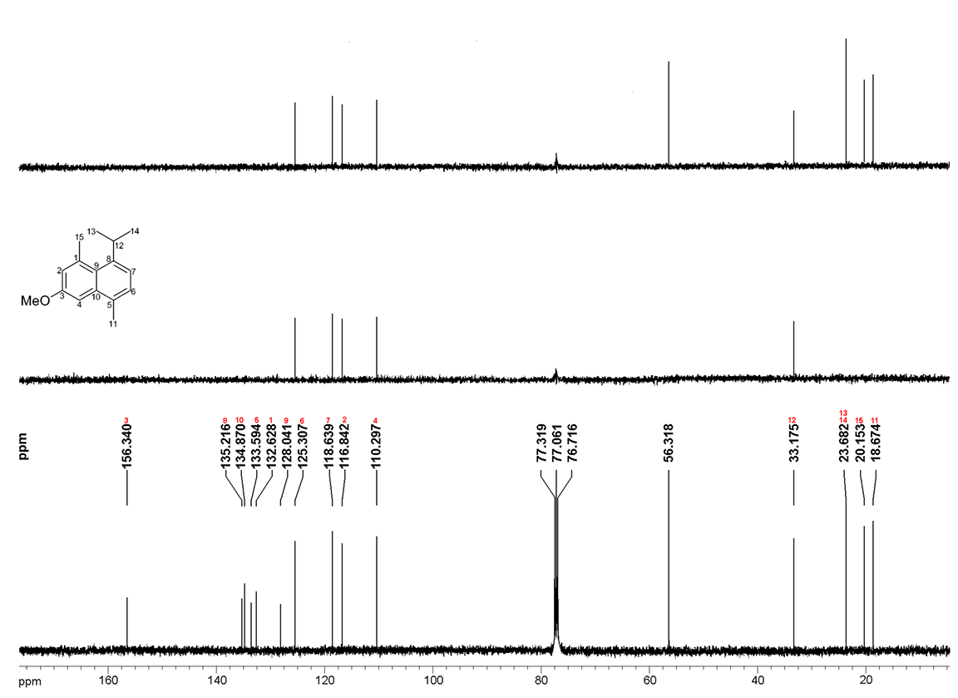
Fig. S1. ¹³C and DEPT NMR spectrum of 1.
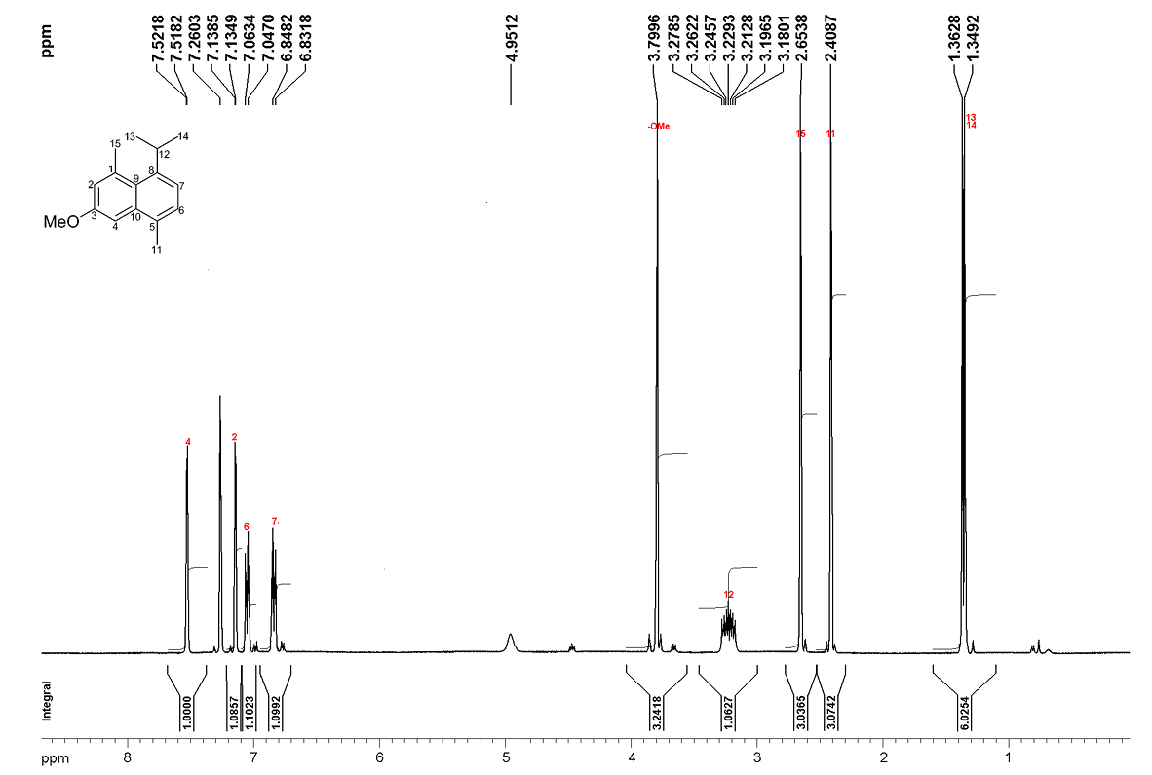
Fig. S2. ¹H NMR spectrum of 1.
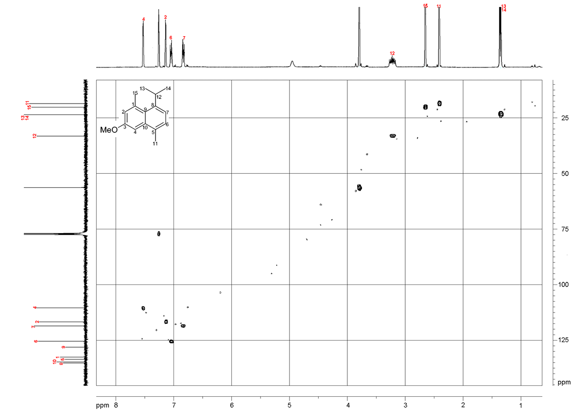
Fig. S3. HSQC NMR spectrum of 1.
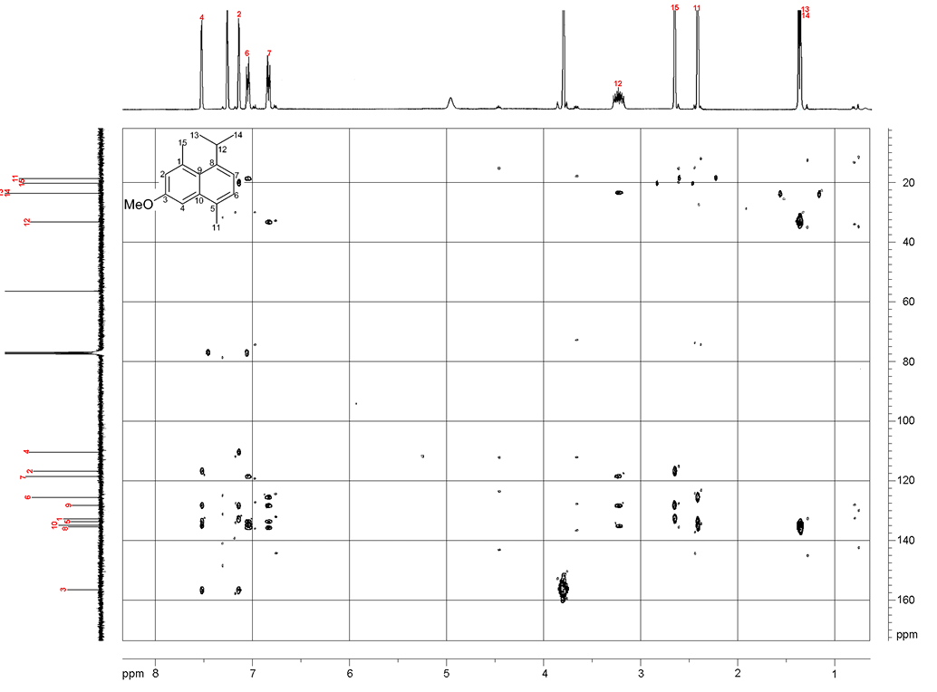
Fig. S4. HMBC NMR spectrum of 1.
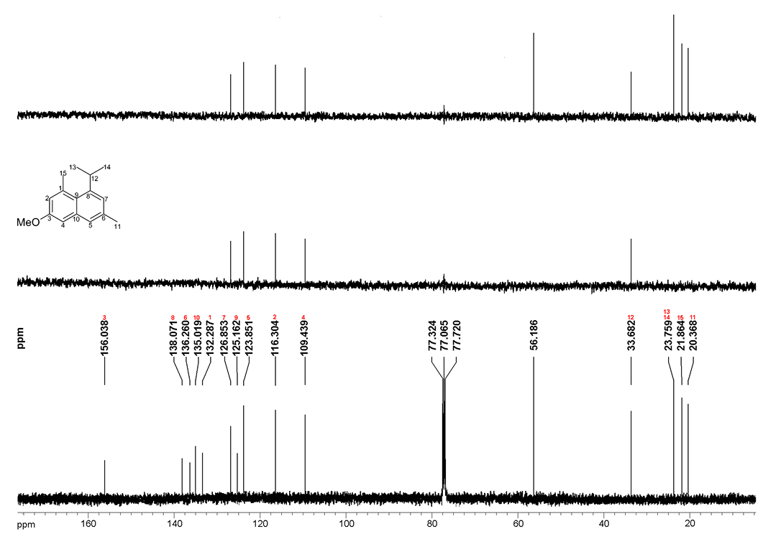
Fig. S5. ¹³C and DEPT NMR spectrum of 2.
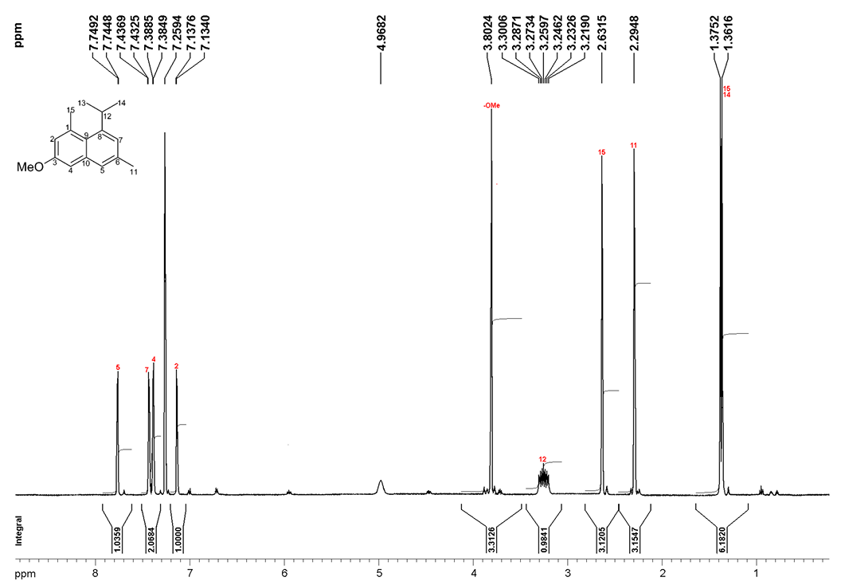
Fig. S6. ¹H NMR spectrum of 2.
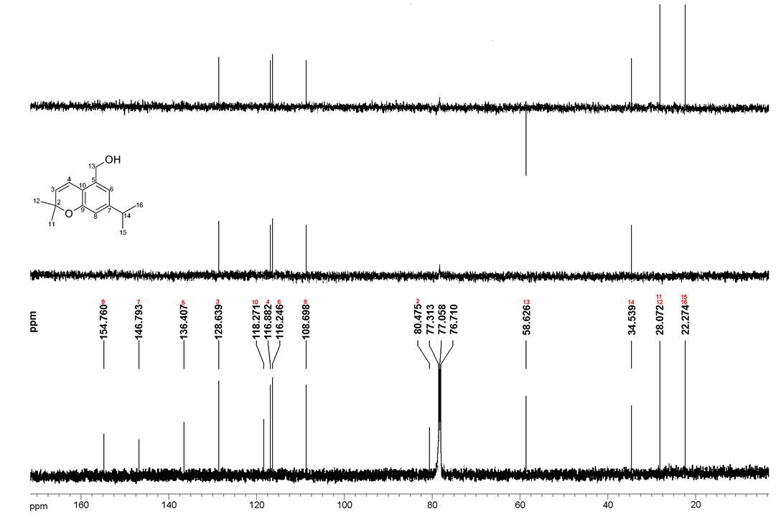
Fig. S7. ¹³C and DEPT NMR spectrum of 3.
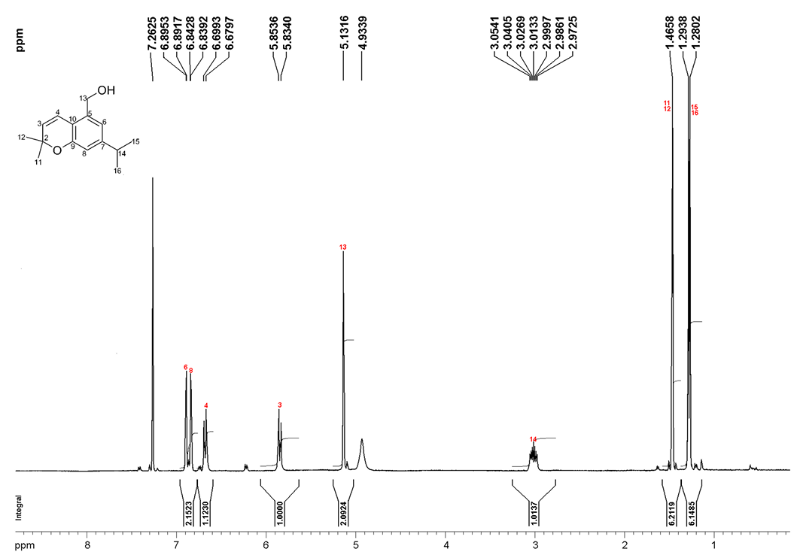
Fig. S8. ¹H NMR spectrum of 3.
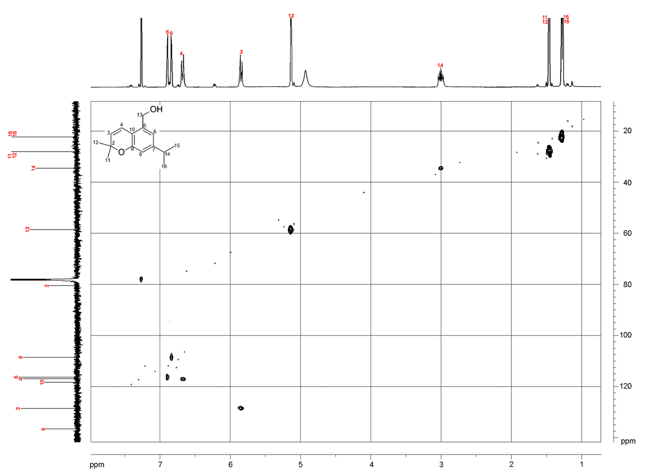
Fig. S9 .HSQC NMR spectrum of 3.
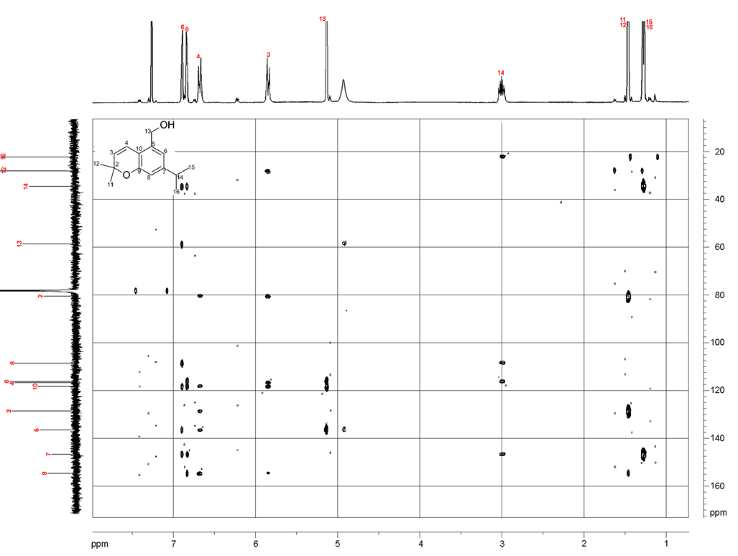
Fig. S10. HMBC NMR spectrum of 3.
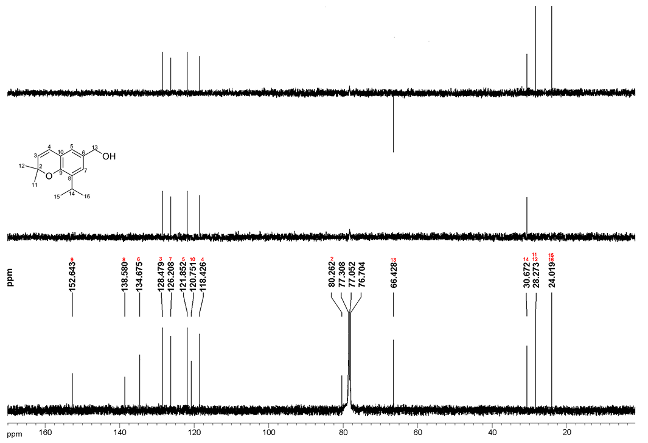
Fig. S11. ¹³C and DEPT NMR spectrum of 4.
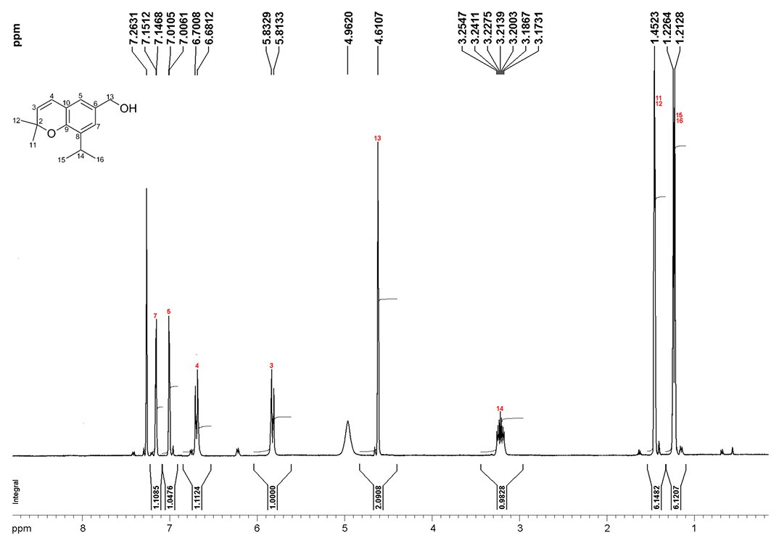
Fig. S12. ¹H NMR spectrum of 4.
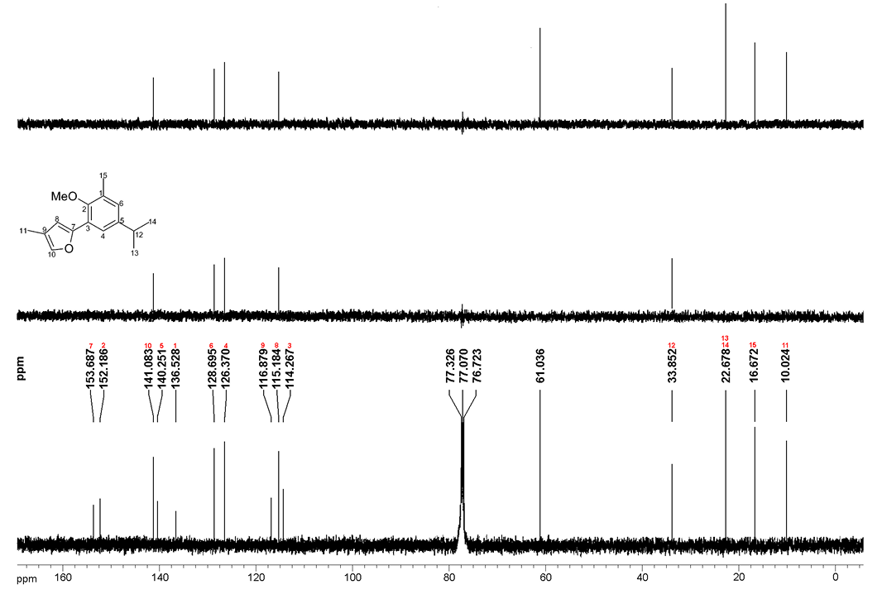
Fig. S13. ¹³C and DEPT NMR spectrum of 5.
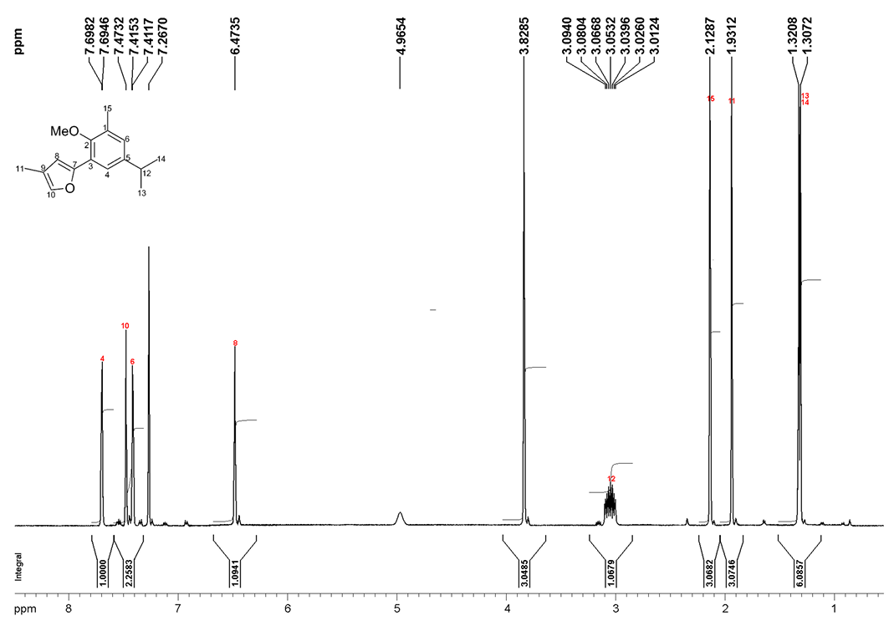
Fig. S14. ¹H NMR spectrum of 5.
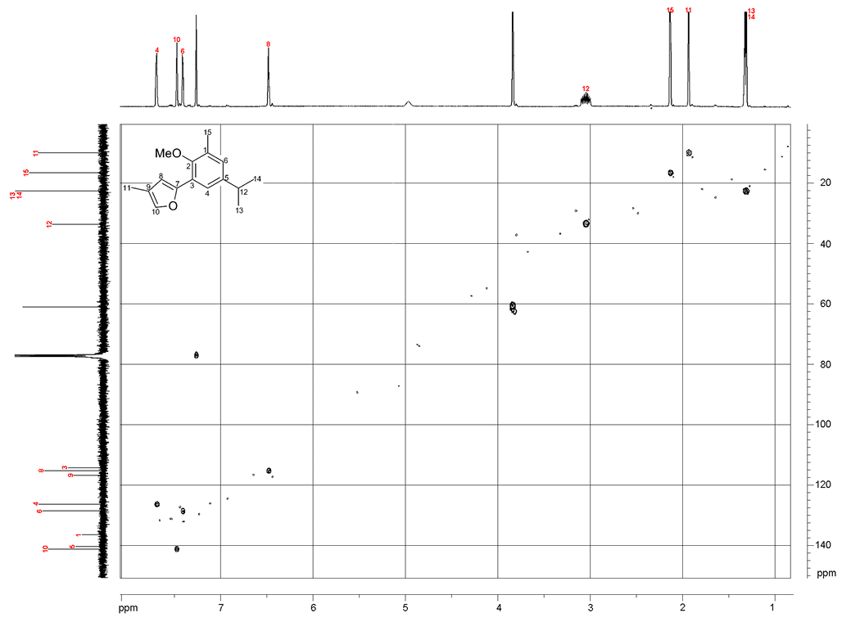
Fig. S15. HSQC NMR spectrum of 5.
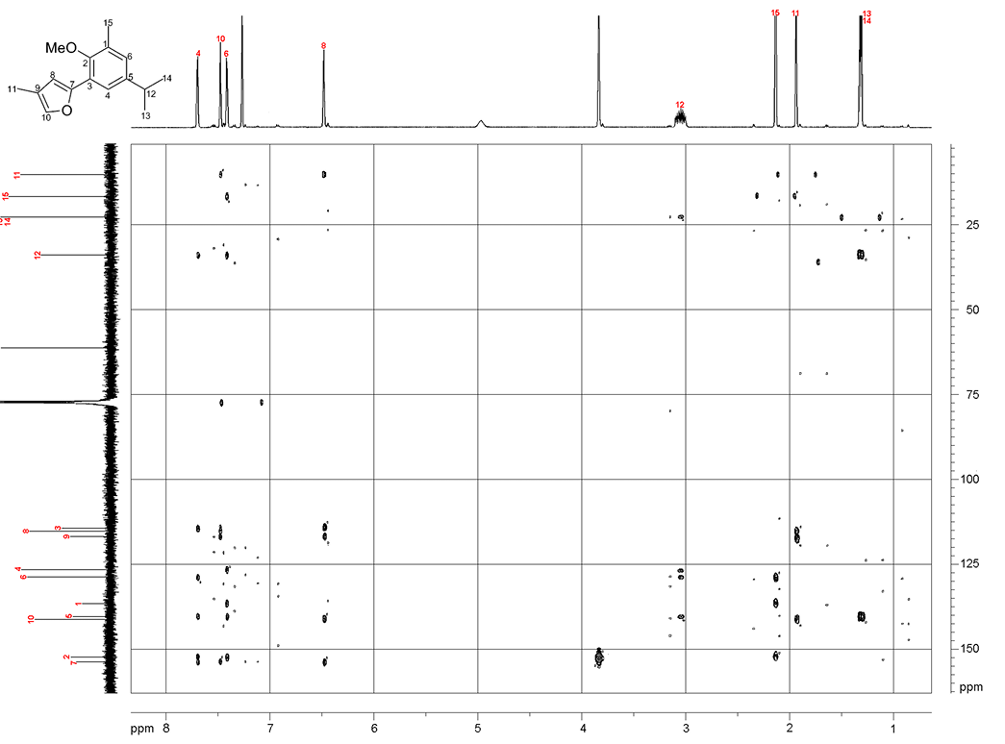
Fig. S16. HMBC NMR spectrum of 5.
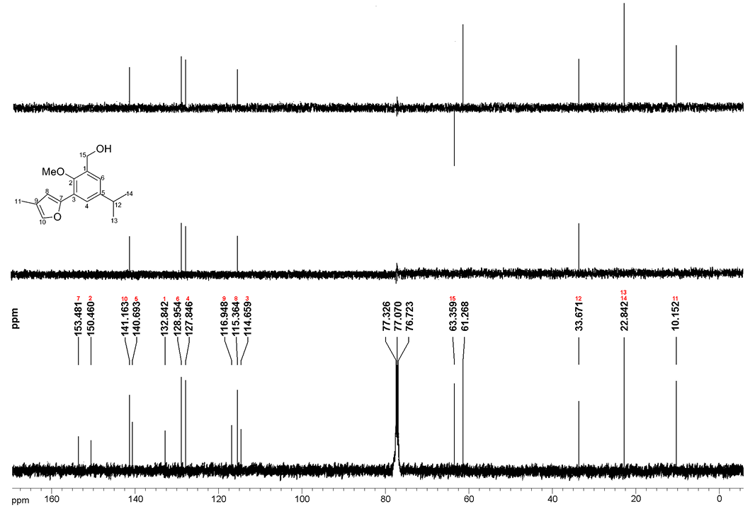
Fig. S17. ¹³C and DEPT NMR spectrum of 6.
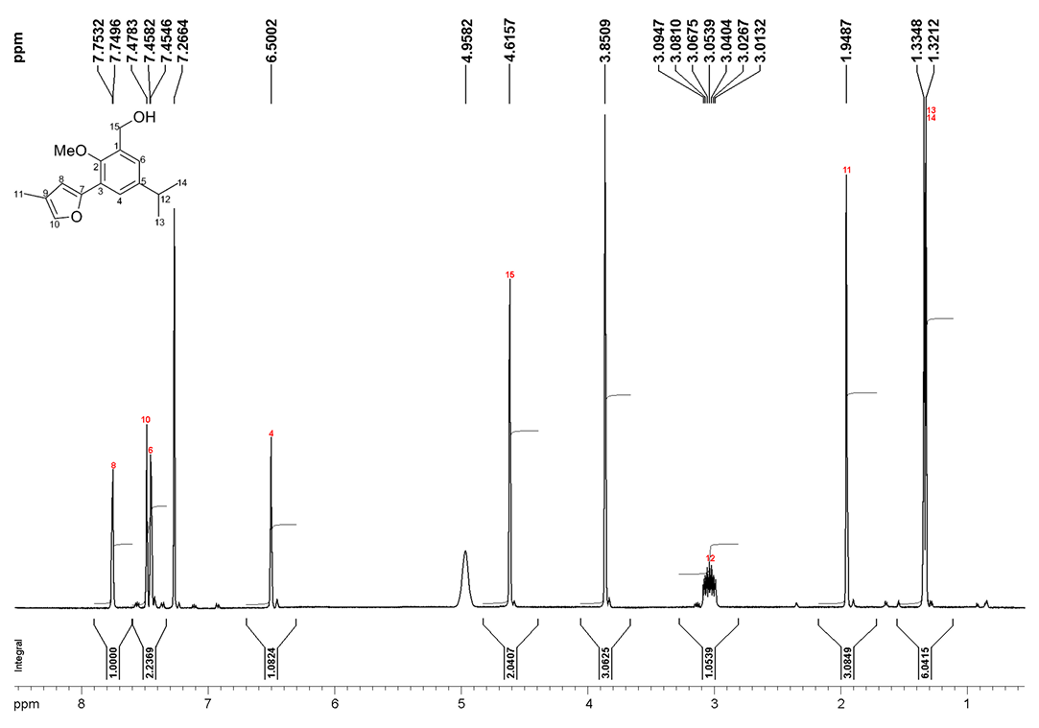
Fig. S18. ¹H NMR spectrum of 6.
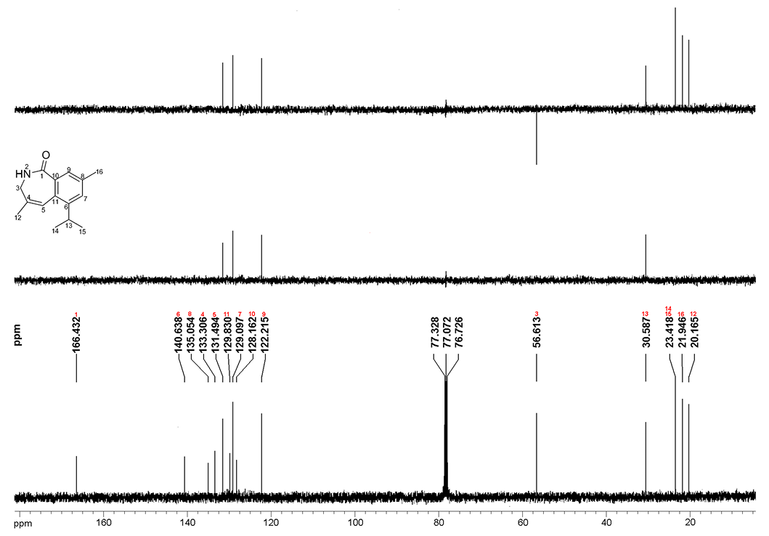
Fig. S19. ¹³C and DEPT NMR spectrum of 7.
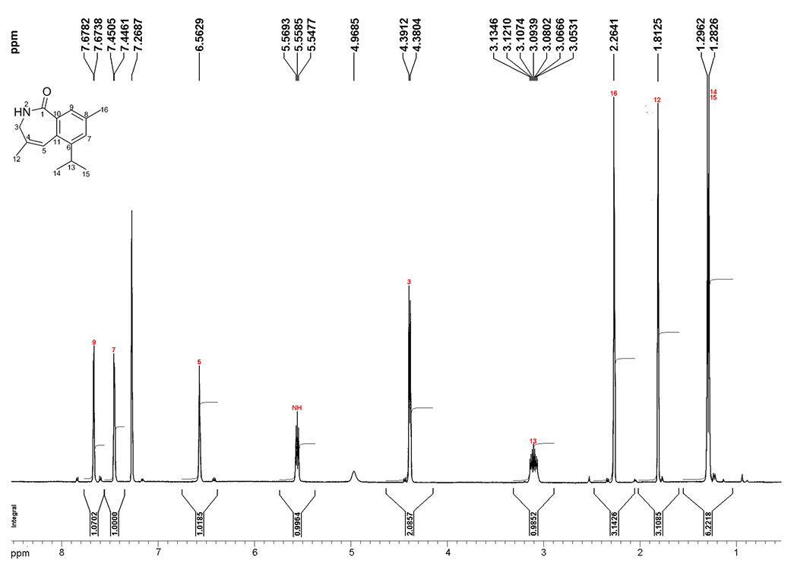
Fig. S20. ¹H NMR spectrum of 7.
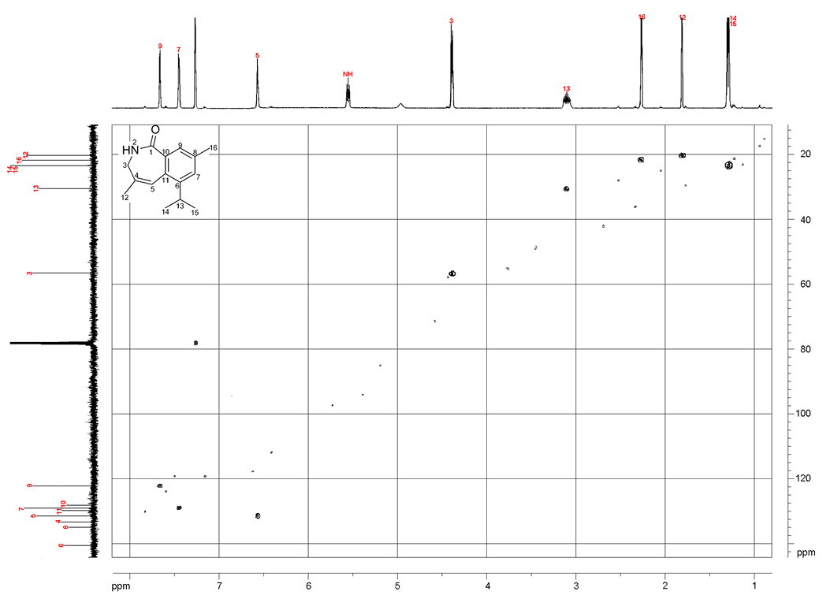
Fig. S21. HSQC NMR spectrum of 7.
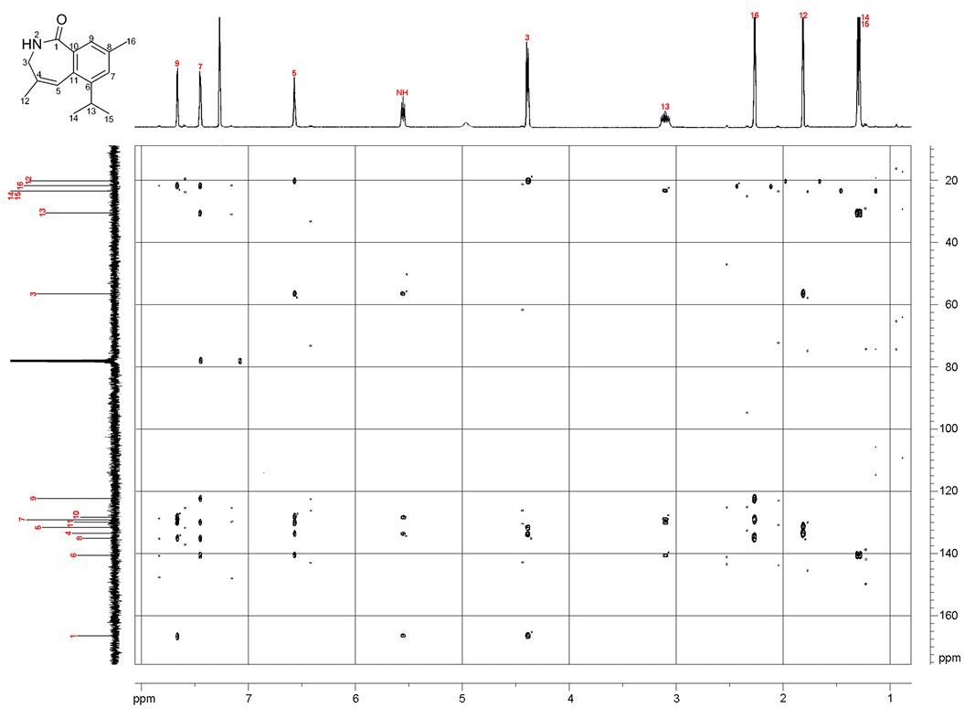
Fig. S22. HMBC NMR spectrum of 7.
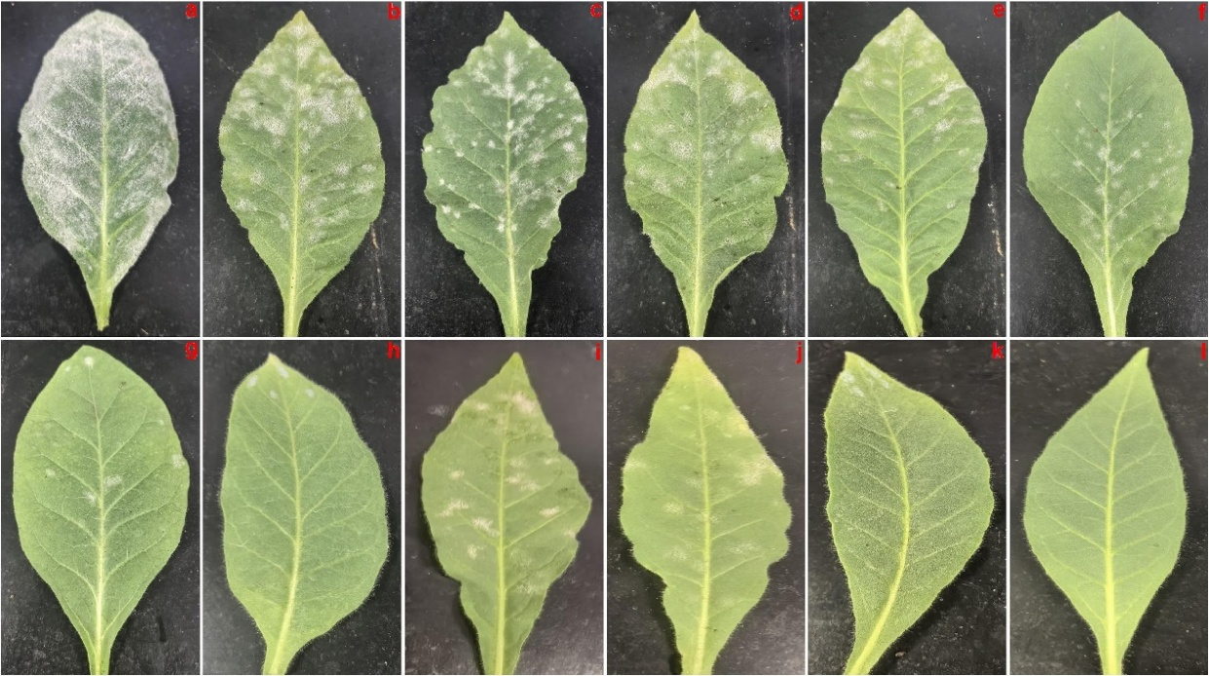
Fig. S23. The inhibitory effects of compounds 1-7, 9, and 11 on G. cichoracearum. (a) Treated with 0.1% Tween-20 aqueous solution (negative control); (b~j) Treated with 250 μg/mL of compounds 1-7, 9, and 11; (k) Treated with 250 μg/mL of carbendazim (positive control), (l) Mock (healthy tobacco). The photos were taken on day 7 after inoculation and compared the third true leaf for each treatment. All results are expressed as the average of three parallel treatments.

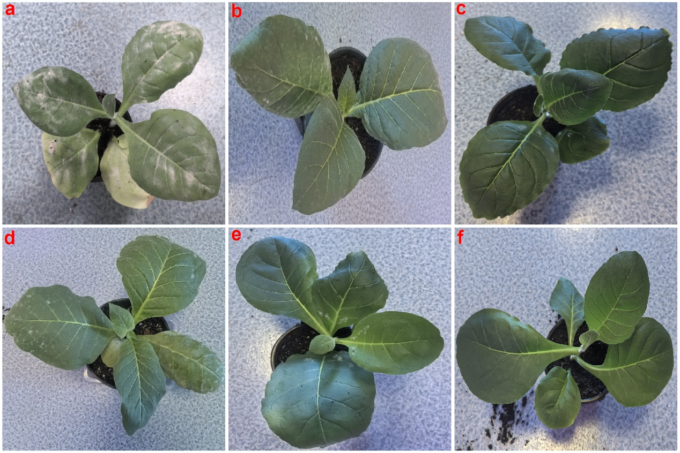
Fig. S24. The protective effects of compounds 6, 7, and 11 on tobacco plants. (a) Treated with 0.1% Tween-20 (negative control); (b-d) Treated with 250 μg/mL of compounds 6, 7, 11; (f) Mock (healthy tobacco); (e) Treated with 250 μg/mL of carbendazim (positive control). inhibition rates：(b) 69.4%, (c) 88.5%, (d) 66.7%, (e) 80.2%.

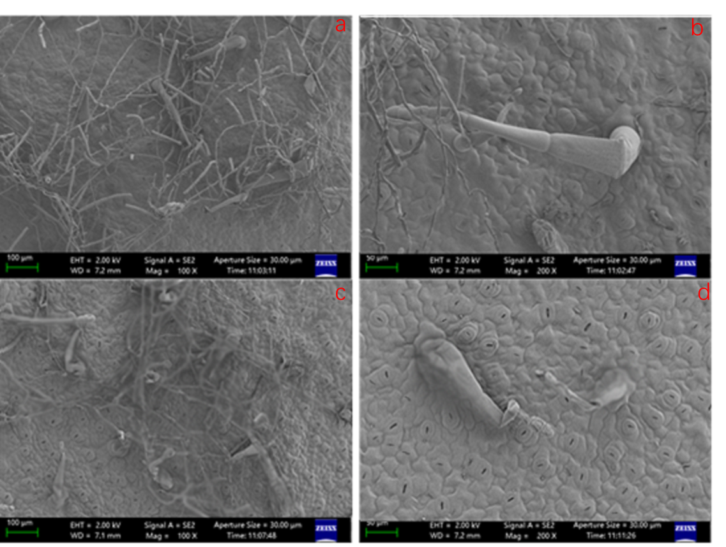
Fig. S25. SEM images of the leaf surface structure of tobacco. (a, b) The control group (treated without compound 7) ; (c, d) Treated with 250 μg/mL of compound 7 (5-dpt). Side bar, 100 μm in a,c, 50 μm in b,d.

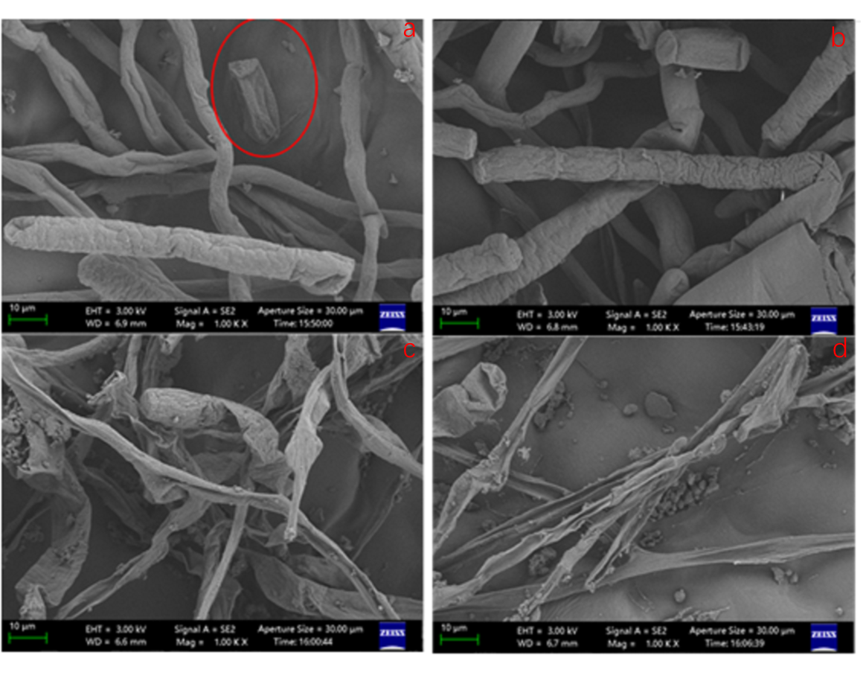
Fig. S26. SEM images of the leaf surface hyphal structure of tobacco. (a, b) The control group (treated without compound 7); (c, d) Treated with 250 μg/mL of compound 7 (5-dpt). All images were taken at a magnification of 2000x (scale bar = 10 μm).

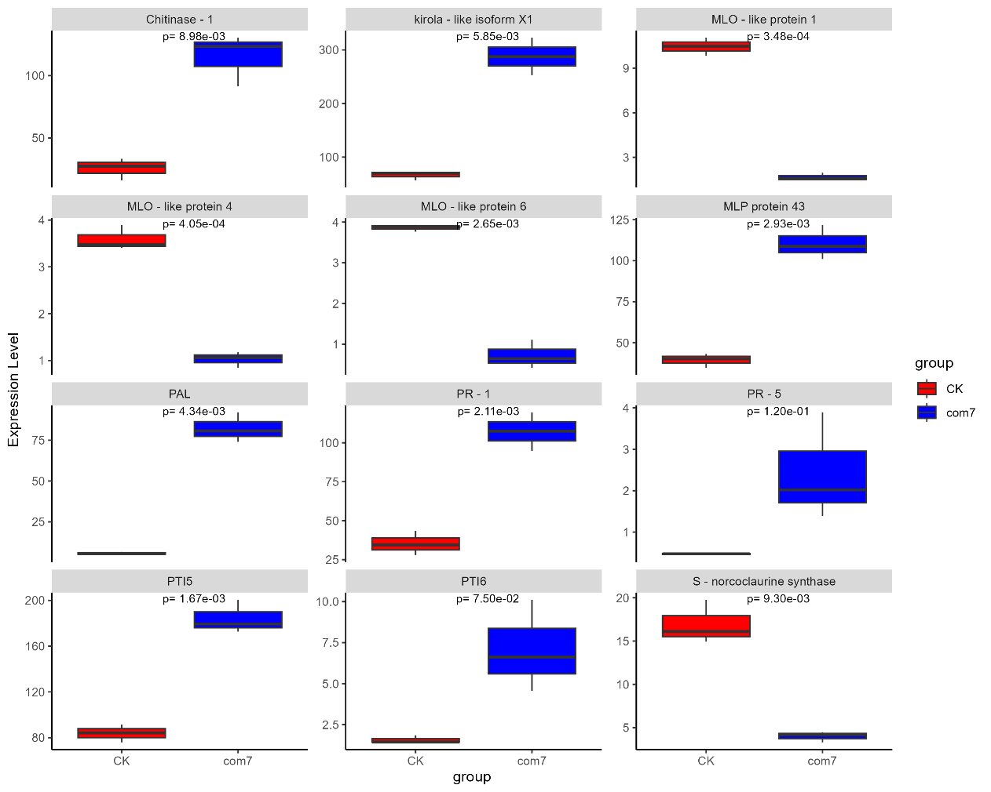
Fig. S27. The expression levels of partial DGEs between the com7 group and the CK group.

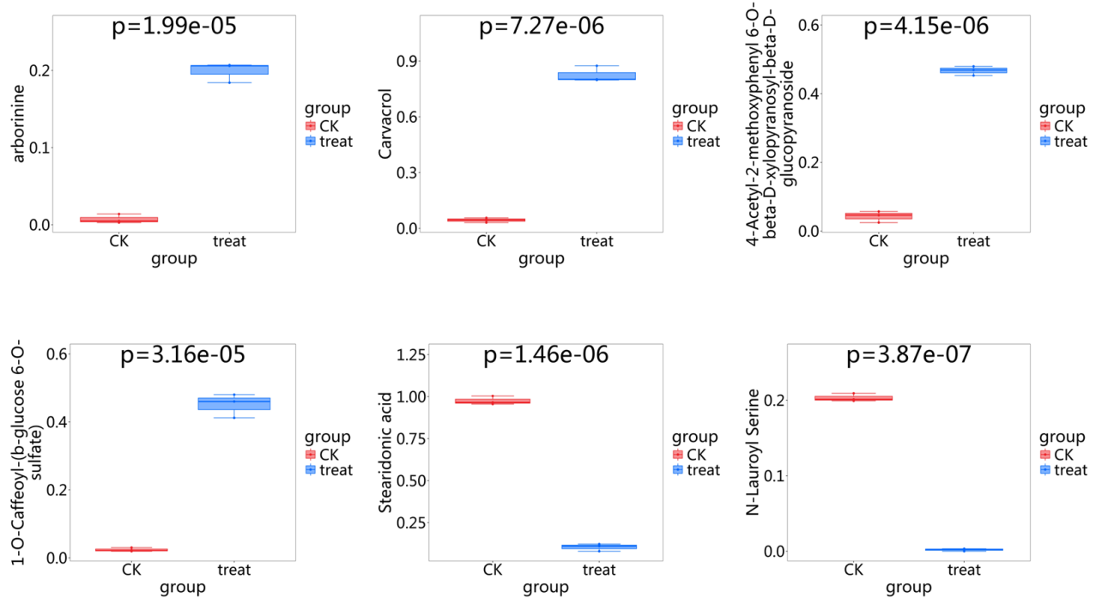 Fig. S28. The accumulation levels of partial DAMs between the treat (com7) group and the CK group.

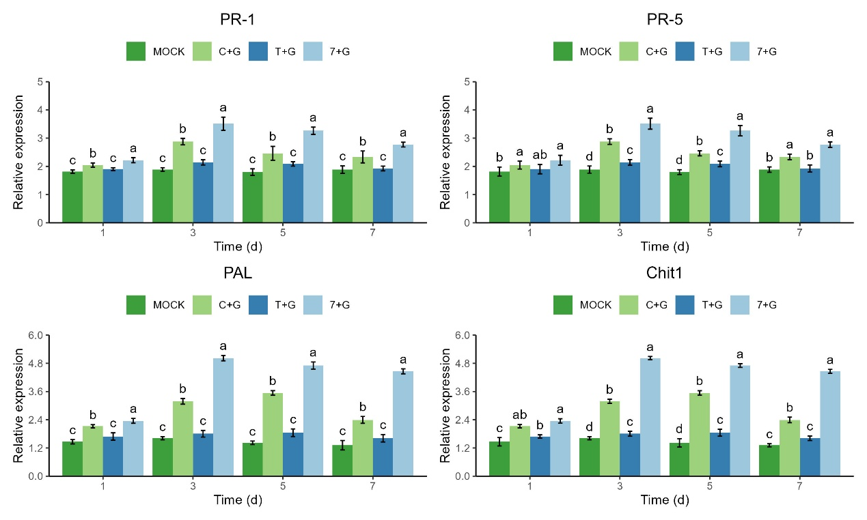
Fig. S29. The relative expression levels of defense-related genes (PR-1, PR-5, PAL, and Chit1) in tobacco plants at 1-, 3-, 5-, and 7-dpt with compound 7. (Three independent biological replicates were included in this analysis. Statistical significance between groups was determined by one-way ANOVA followed by Tukey’s post-hoc test (p < 0.05). Distinct lowercase superscript letters (e.g., "a", "b") denote significant differences among groups at each time point. Mock: healthy tobacco (Negative control); T+G: G. cichoracearum in 0.1% of Tween-20 solution; C+G: 250 μg /mL of carbendazim in 0.1% of Tween-20 solution. 7+G: 250 μg /mL of compound 7 in 0.1% of Tween-20 solution).

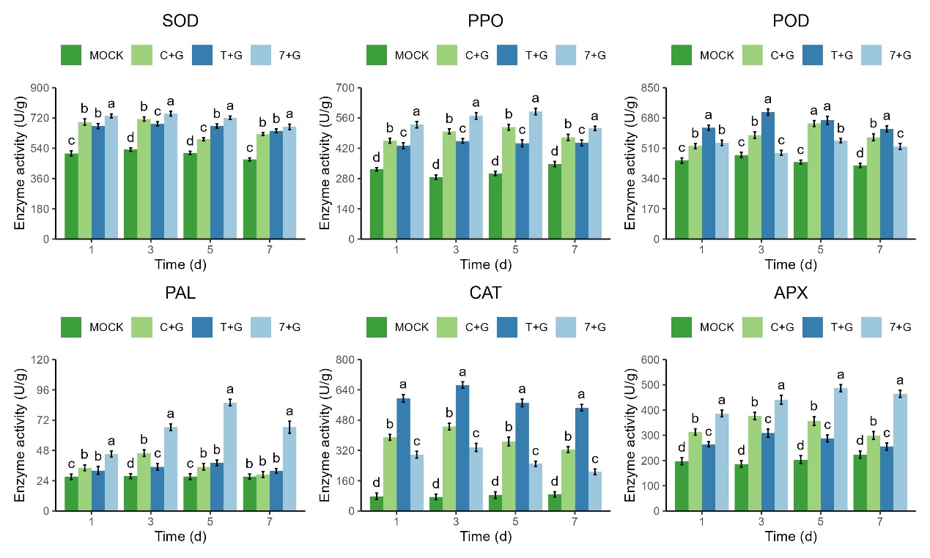Fig. S30. The enzyme activities of SOD, PAL, POD, PPO, CTA, and PAX in tobacco leaves at 1-, 3-, 5-, and 7-dpt with compound 7. (Three independent biological replicates were included in this analysis. Statistical significance between groups was determined by one-way ANOVA followed by Tukey’s post-hoc test (p < 0.05). Distinct lowercase superscript letters (e.g., "a", "b") denote significant differences among groups at each time point. Mock: healthy tobacco (Negative control); T+G: G. cichoracearum in 0.1% of Tween-20 solution; C+G: 250 μg/mL of carbendazim in 0.1% of Tween-20 solution. 7+G: 250 μg/mL of compound 7 in 0.1% of Tween-20 solution).

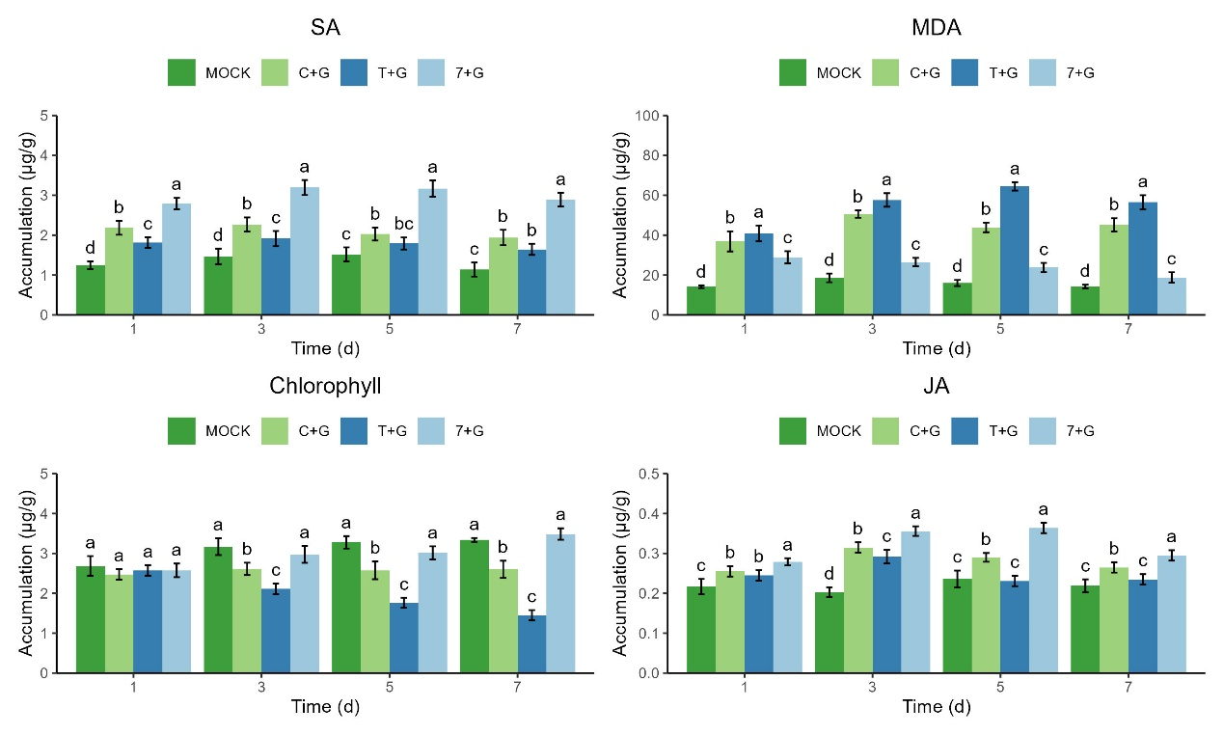Fig. S31. The accumulations of SA, JA, MDA, and CHL in tobacco leaves at 1-, 3-, 5-, and 7-dpt with compound 7. (Three independent biological replicates were included in this analysis. Statistical significance between groups was determined by one-way ANOVA followed by Tukey’s post-hoc test (p < 0.05). Distinct lowercase superscript letters (e.g., "a", "b") denote significant differences among groups at each time point. Mock: healthy tobacco (Negative control); T+G: G. cichoracearum in 0.1% of Tween-20 solution; C+G: 250 μg/mL of carbendazim in 0.1% of Tween-20 solution. 7+G: 250 μg /mL of compound 7 in 0.1% of Tween-20 solution).

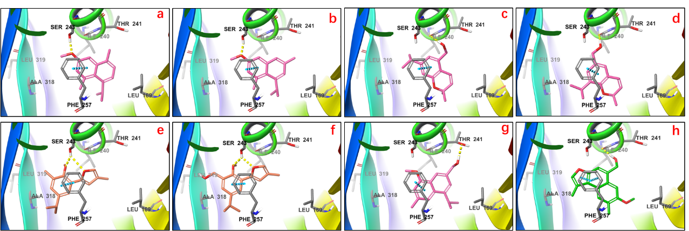
Fig. S32. The binding mode between compounds 1-6, 9, and 11 with Tubulin protein. (a-f) The binding modes of compounds 1-6 with Tubulin protein; (g) The binding mode of compound 9 with Tubulin protein; (h) The binding mode of compound 11 with Tubulin protein.

