Supplementary Information

Supplementary Annex 1

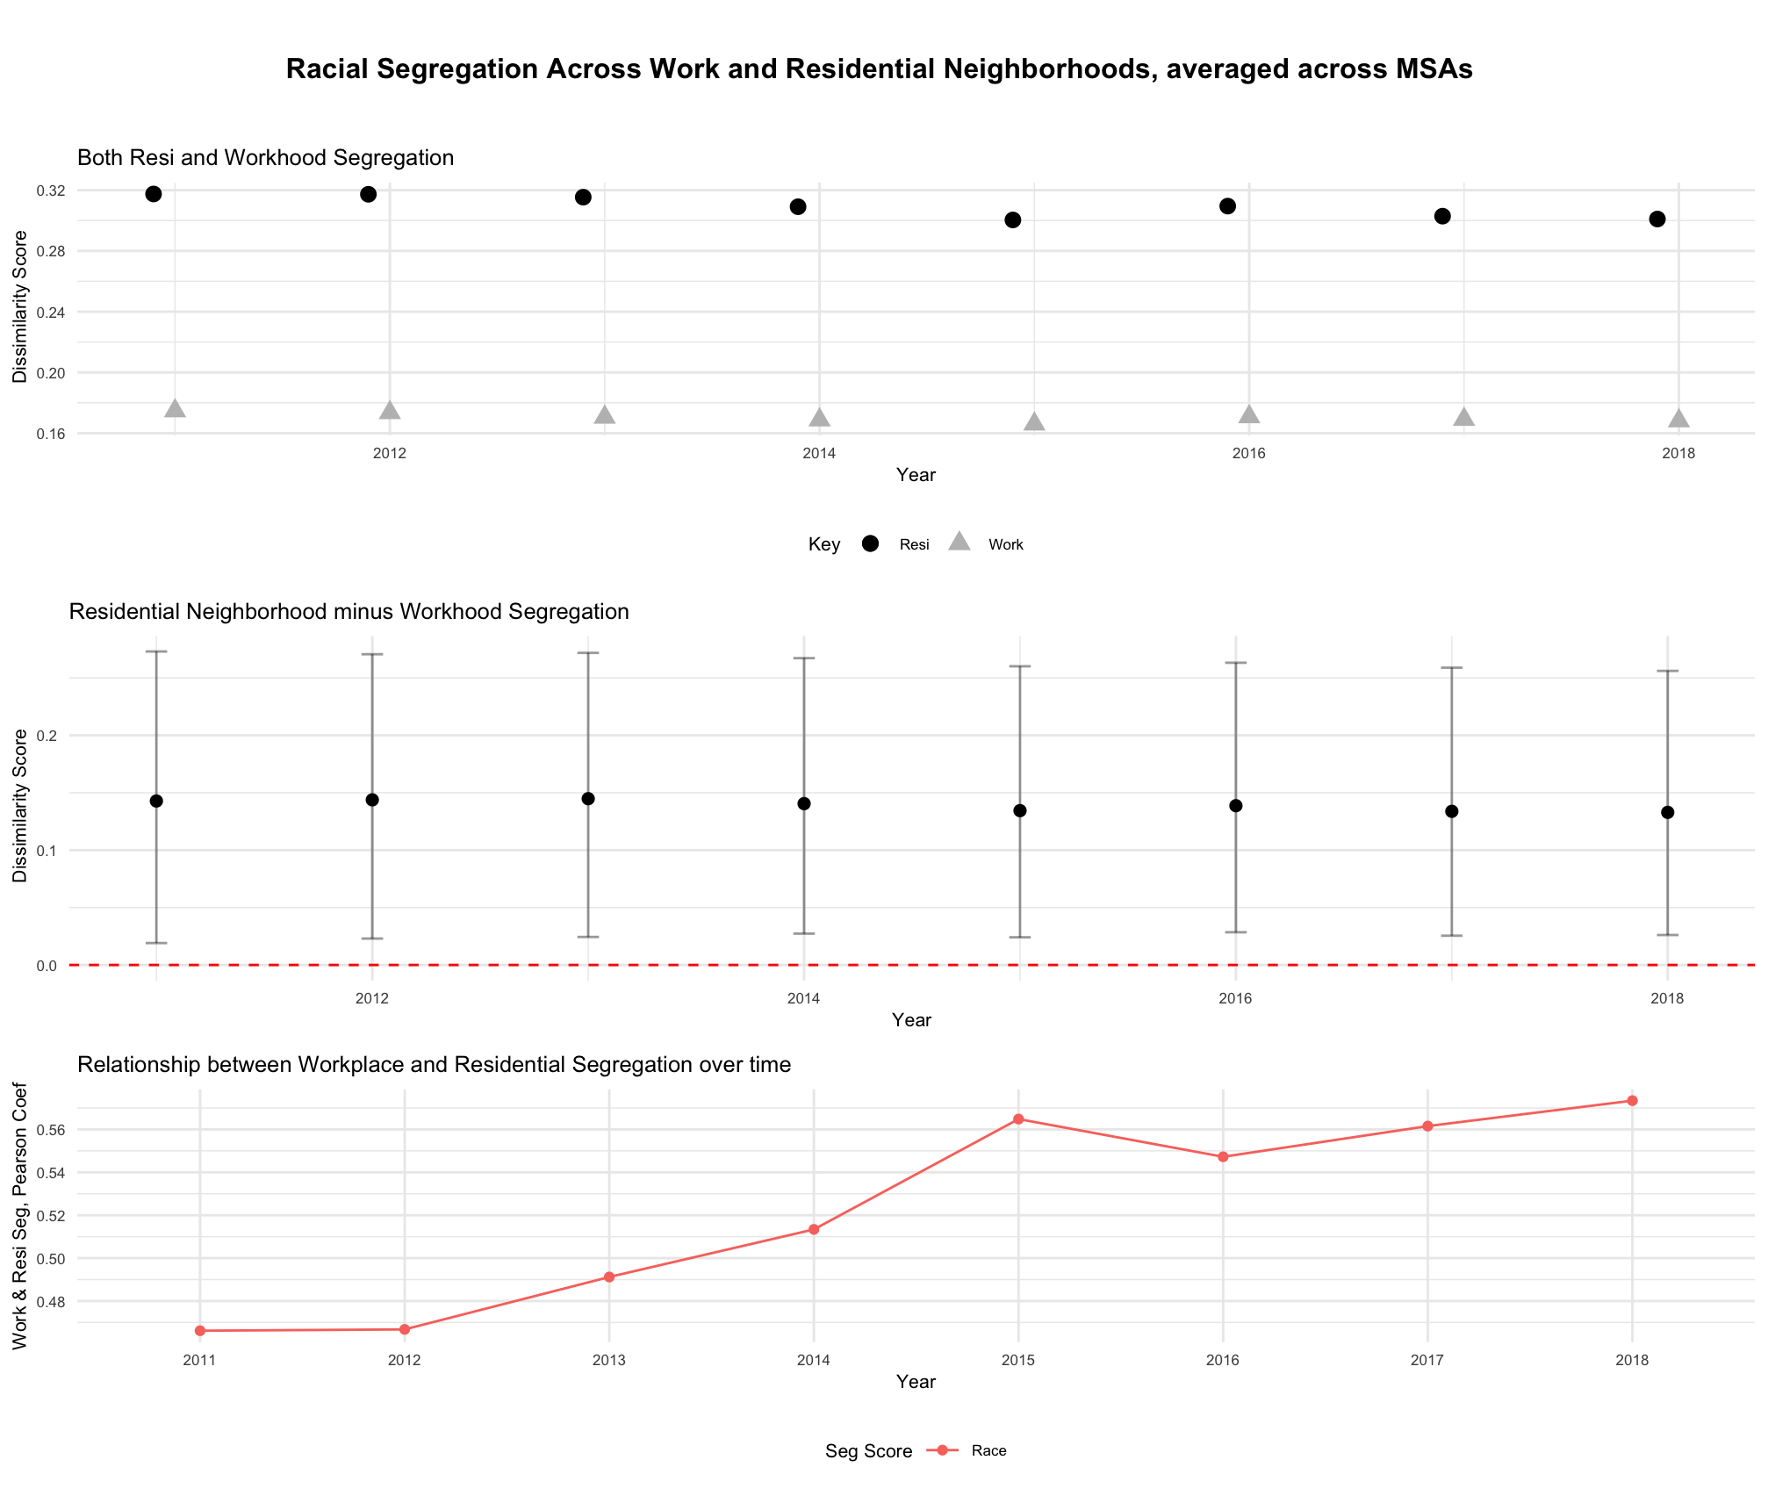
Bars: 10th to 90th percentile of scores

Figure 1.1: Relationship between racial residential neighborhood and workhood racial segregation, 2011 to 2018

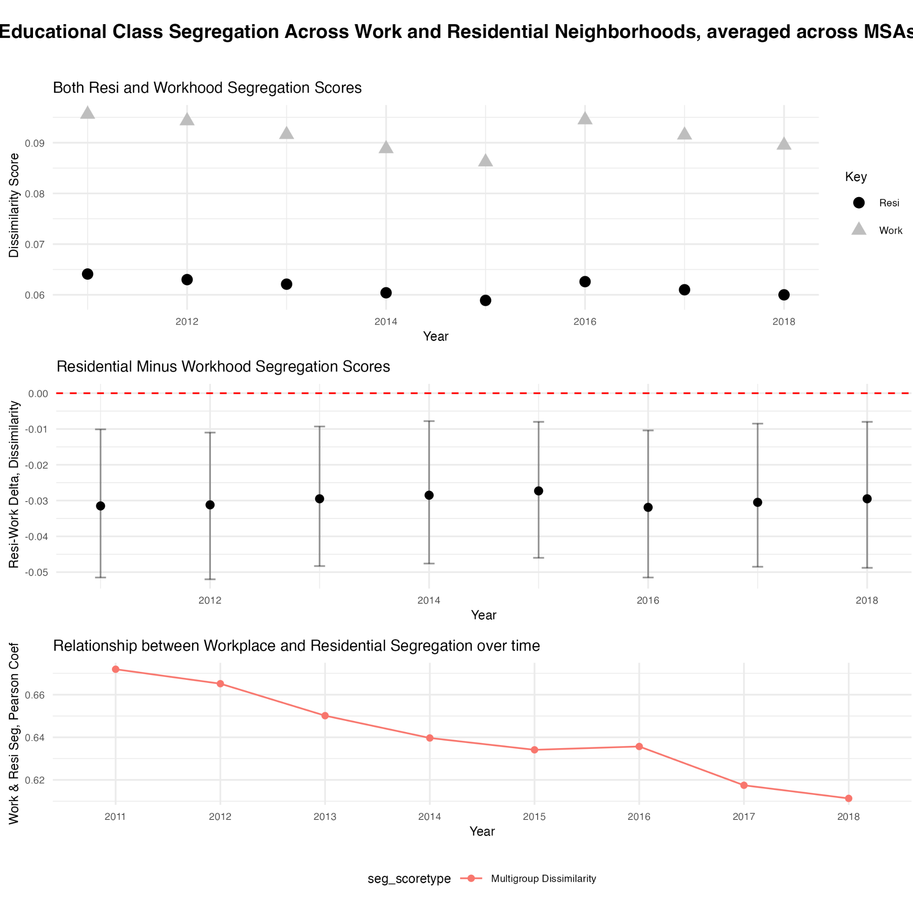
Bars: 10th to 90th percentile of scores
Figure 1.2: Relationship between residential neighborhood and workhood class segregation, 2011 to 2018

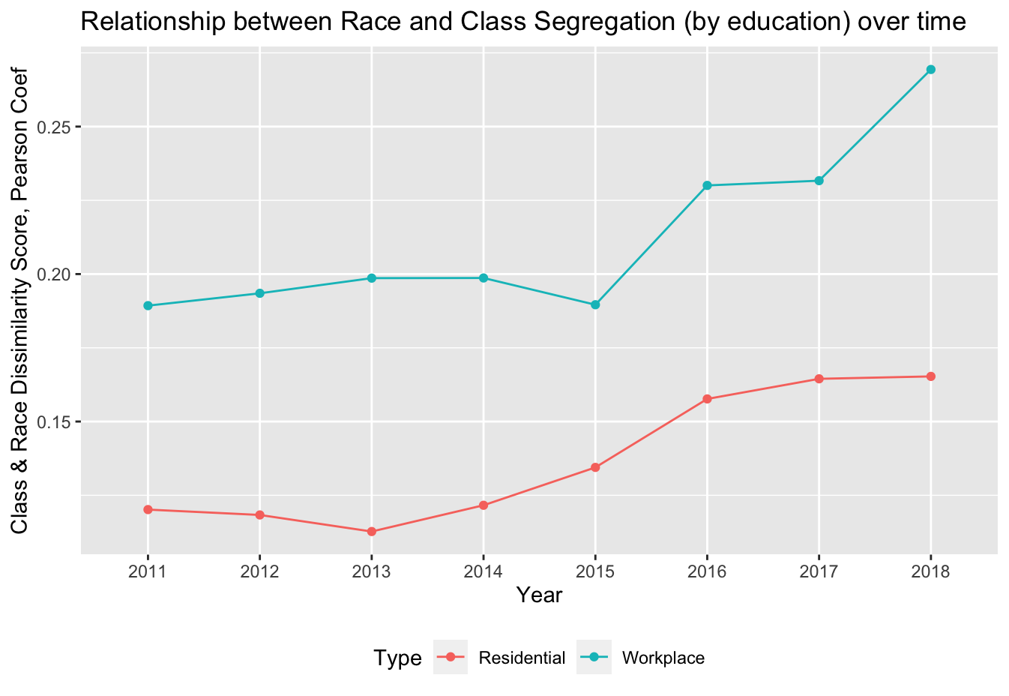
Figure 1.3: Pearson correlations between racial and class-based segregation, for residential neighborhoods and for workhoods, from 2011 to 2018

Supplementary Annex 2
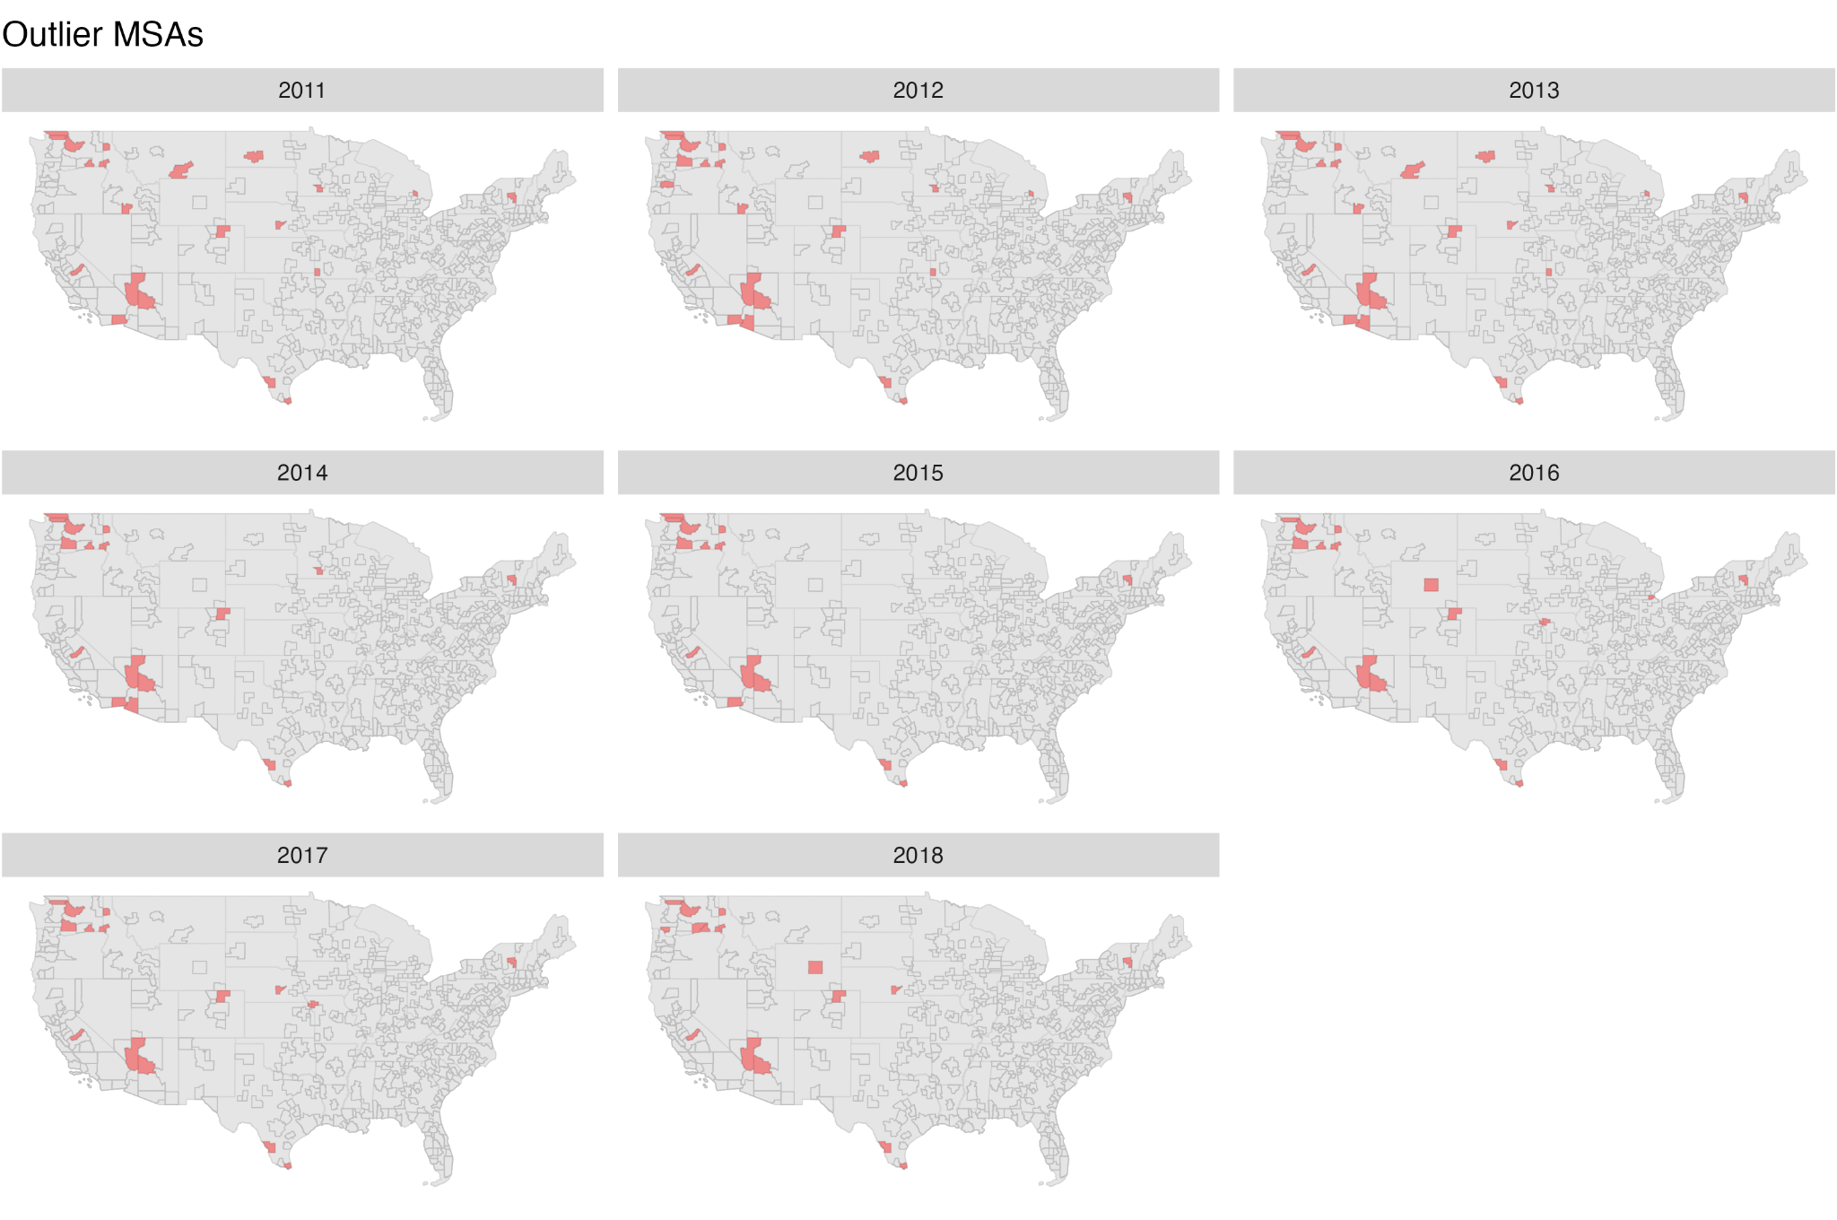

Figure 2.1: Maps showing the MSAs where racial segregation was higher in workhoods than neighborhoods over the years, in red fill.

Table 2.1 : MSA-level characteristics of racial segregation outliers vs the non-outlier MSAs, for year 2018.
Variable | Non-Outlier MSAs, 2018 (n=364) | Outlier MSAs, 2018 (n=16) | Names of Outliers, 2018
 | Mean(SD) | Mean(SD) | - Brownsville-Harlingen, TX  - Casper, WY  - Coeur d'Alene, ID  - Glens Falls, NY  - Grand Island, NE  - Greeley, CO  - Kennewick-Richland, WA  - Lake Havasu City-Kingman, AZ  - Laredo, TX  - Lewiston, ID-WA  - Longview, WA  - Madera, CA  - Mount Vernon-Anacortes, WA  - Prescott Valley-Prescott, AZ  - Walla Walla, WA  - Wenatchee, WA
Residential Racial Seg | 0.31 (0.1) | 0.15 (0.05)
Workhood Racial Seg Score | 0.17 (0.04) | 0.19 (0.06)
Residential Class Seg | 0.06 (0.02) | 0.06 (0.02)
Workhood Class Seg Score | 0.09 (0.02) | 0.09 (0.02)
Percent commuters using transit | 1.71 (2.74) | 0.67 (0.31)
% public transport commutes >=45min | 37.42 (18.21) | 39.88 (21.34)
% car commutes >=45min | 11.76 (4.99) | 11.3 (5.17)
Population Density('000/km2) | 0.11 (0.13) | 0.03 (0.04)
Percent White of Resi Pop | 69.79 (17.01) | 66.09 (27.37)
Difference in NonWhite-White Unemployment Rates | 3.37 (2.14) | 2.38 (1.77)
Gini Income Inequality Score | 1.41 (1.52) | 0.6 (0.25)
Percent Labor Force Unemployed | 5.44 (1.59) | 5.29 (1.44)
% Work in Agriculture/Mining etc | 7.79 (4.3) | 13.05 (7.21)
% Work in Manufacturing | 10.95 (6.73) | 10.02 (5.94)
% Work in Trade/Commerce/Transport | 18.62 (2.96) | 18.48 (4.54)
% Work in Professional Services | 17.99 (5.48) | 13.29 (3.9)
% Work in Public/Social Services | 30.77 (6.29) | 31.68 (5.88)
% Work in Entertainment/Recreation | 10.99 (3.25) | 10.96 (2.35)
% 55+years | 24.04 (2.37) | 24.68 (2.68)
% Income<1250 | 19.76 (2.93) | 18.99 (3.59)
% College Educated | 19.55 (3.94) | 16.41 (2.74)
% Female | 50.02 (2.56) | 48.66 (2.8)
% Population Suburban | 8.07 (10.99) | 1.18 (4.71)
GDP ('000) per capita, chained 2017 | 51.84 (15.15) | 46.56 (13.31)
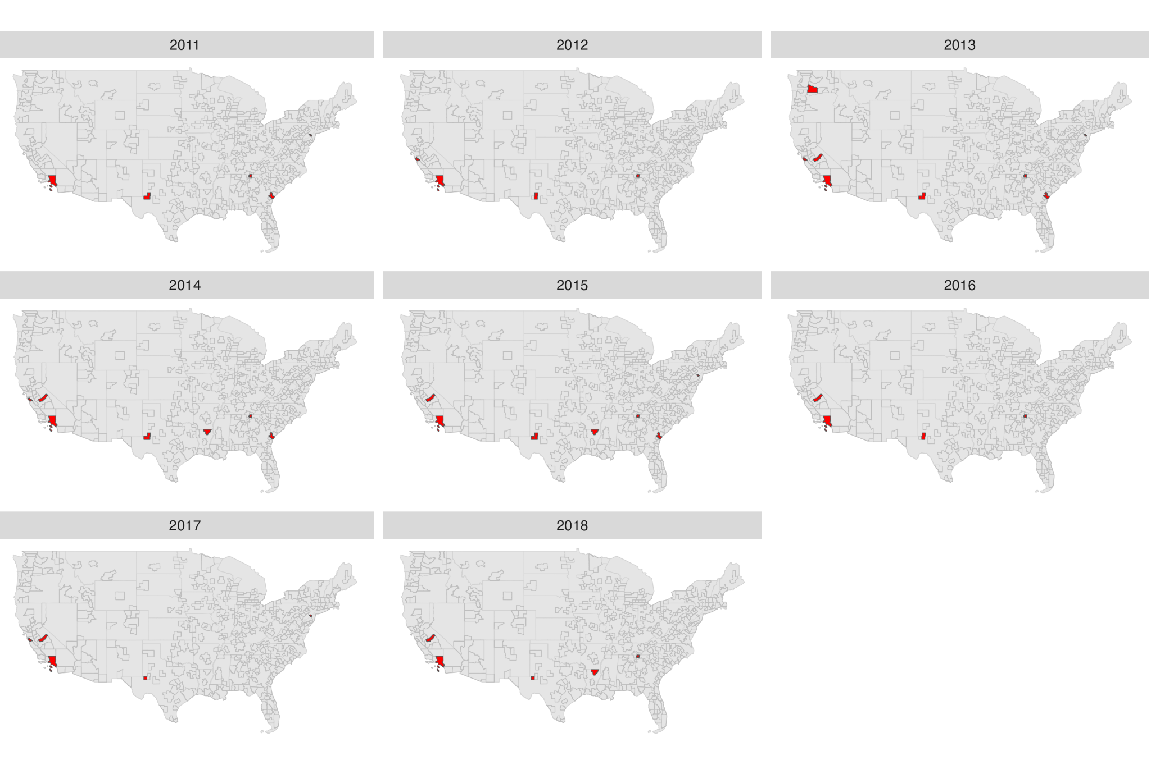
Figure 2.2: Maps showing the MSAs where class segregation was lower in workhoods than neighborhoods over the years, in red fill.

Table 2.2 : MSA-level characteristics of class segregation outliers vs the non-outlier MSAs, for year 2018.
Variable | Non-Outlier MSAs, (n=375) | Outlier MSAs, (n=5) | Names of Outliers
 | Mean(SD) | Mean(SD) | - Dalton, GA  - Los Angeles-Long Beach-Anaheim, CA  - Madera, CA  - Monroe, LA  - Odessa, TX
Residential Racial Seg | 0.3 (0.1) | 0.26 (0.16)
Workhood Racial Seg Score | 0.17 (0.04) | 0.14 (0.04)
Residential Class Seg | 0.06 (0.02) | 0.09 (0.02)
Workhood Class Seg Score | 0.09 (0.02) | 0.08 (0.02)
Percent commuters using transit | 1.67 (2.69) | 1.42 (2.11)
% public transport commutes >=45min | 37.58 (18.36) | 33.1 (17.48)
% car commutes >=45min | 11.71 (4.97) | 14.23 (6.73)
Population Density('000/km2) | 0.11 (0.12) | 0.25 (0.45)
Percent White of Resi Pop | 69.98 (17.31) | 43.83 (16.44)
Difference in NonWhite-White Unemployment Rates | 3.34 (2.13) | 1.94 (2.22)
Gini Income Inequality Score | 1.38 (1.51) | 0.85 (0.43)
Percent Labor Force Unemployed | 5.42 (1.58) | 6.42 (1.28)
% Work in Agriculture/Mining etc | 7.95 (4.4) | 13.2 (11.47)
% Work in Manufacturing | 10.87 (6.57) | 14.09 (14.1)
% Work in Trade/Commerce/Transport | 18.63 (3.01) | 18.12 (4.62)
% Work in Professional Services | 17.82 (5.47) | 15.71 (8.04)
% Work in Public/Social Services | 30.87 (6.23) | 26.37 (8.56)
% Work in Entertainment/Recreation | 11 (3.23) | 9.95 (2.38)
% 55+years | 24.08 (2.39) | 22.68 (1.23)
% Income<1250 | 19.76 (2.94) | 17.87 (4.09)
% College Educated | 19.45 (3.93) | 16.29 (4.79)
% Female | 50 (2.51) | 47.4 (5.57)
% Population Suburban | 7.83 (10.9) | 4.7 (10.5)
GDP ('000) per capita, chained 2017 | 51.56 (15.07) | 55.99 (18.92)

Supplementary Annex 3
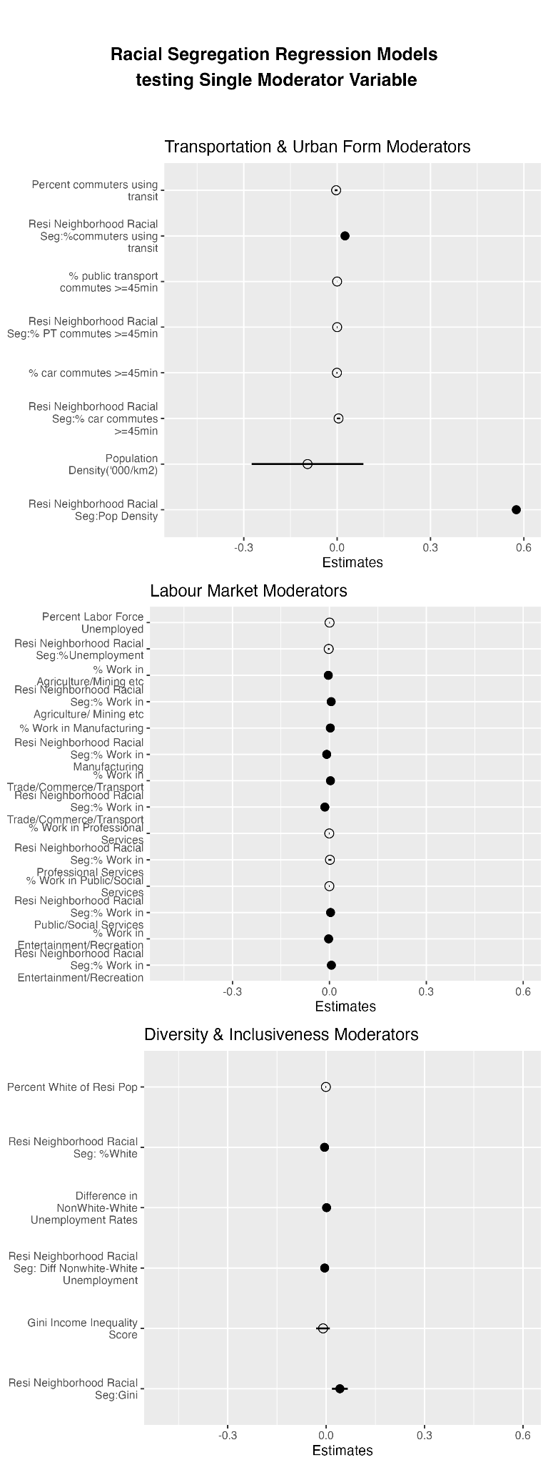 | 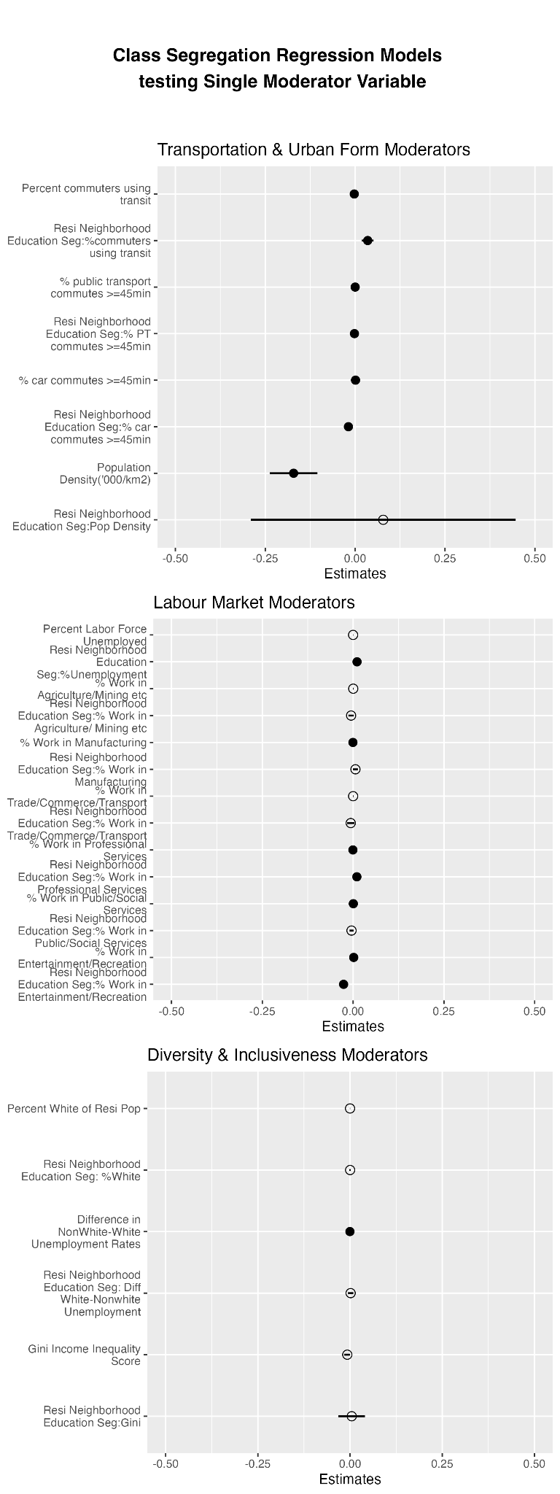 | 
Figure 3.1: Forest Plots showing results from two-way fixed effects models that include single moderator variables and their interactions with residential segregation
Table 3.1: Two-way fixed effects regression results, showing the associations between workhood racial segregation, residential racial segregation, potential moderators and other covariates
 | Workhood Racial Segregation Score
 | Model 1 | Model 2 | Model 3 | Model 4
Residential Neighborhood Racial Segregation | 0.245 (0.230) | 0.625*** (0.090) | 0.609*** (0.092) | 0.590*** (0.089)
Residential Neighborhood Class Segregation |  |  | 0.080 (0.077)
Workhood Class Segregation |  |  |  | 0.448*** (0.049)
Transportation & Urban Form
Percent commuters using transit | 0.004 (0.003)
Population Density('000/km2) | -0.110 (0.102) | -0.103 (0.093) | -0.097 (0.093) | -0.017 (0.092)
Residential Racial Seg:%commuters using transit | -0.003 (0.009)
Residential Racial Seg:Pop Density | 0.676** (0.218) | 0.557*** (0.165) | 0.561*** (0.165) | 0.565*** (0.163)
Labour Market Conditions and Profile
% Work in Agriculture/Mining etc | -0.003** (0.001) | -0.002*** (0.0004) | -0.002*** (0.0004) | -0.002*** (0.0004)
% Work in Manufacturing | 0.001 (0.001)
% Work in Trade/Commerce/Transport | 0.002 (0.001) | 0.003** (0.001) | 0.003** (0.001) | 0.003** (0.001)
% Work in Public/Social Services | -0.0003 (0.001)
% Work in Entertainment/Recreation | -0.002 (0.001)
Residential Racial Seg:% Work in Agriculture/ Mining etc | 0.004 (0.003)
Residential Racial Seg:% Work in Manufacturing | -0.002 (0.003)
Residential Racial Seg:% Work in Trade/Commerce/Transport | -0.009* (0.004) | -0.013*** (0.003) | -0.013*** (0.003) | -0.012*** (0.003)
Residential Racial Seg:% Work in Public/Social Services | 0.003 (0.003)
Diversity and Inclusiveness
Residential Racial Seg:% Work in Entertainment/Recreation | 0.005 (0.004)
Percent White of Resi Pop | -0.002** (0.001) | -0.002** (0.001) | -0.002** (0.001) | -0.002** (0.001)
Difference in NonWhite-White Unemployment Rates | 0.001 (0.001)
Gini Income Inequality Score | -0.011 (0.011)
Residential Racial Seg: %White | -0.002* (0.001) | -0.004*** (0.001) | -0.004*** (0.001) | -0.004*** (0.001)
Residential Racial Seg: Diff Nonwhite-White Unemployment | -0.002 (0.002)
Control Variables
Residential Racial Seg:Gini | 0.028 (0.015)
% 55+years | -0.001* (0.001) | -0.001 (0.001) | -0.001 (0.001) | -0.001 (0.001)
% Income<1250 | 0.002*** (0.0004) | 0.002*** (0.0003) | 0.002*** (0.0003) | 0.002*** (0.0003)
% College Educated | 0.0004 (0.001) | 0.001 (0.001) | 0.001 (0.001) | -0.0004 (0.001)
% Female | -0.001* (0.001) | -0.001 (0.0005) | -0.001 (0.0005) | -0.001 (0.0005)
% Population Suburban | 0.001 (0.001) | 0.001 (0.001) | 0.001 (0.001) | 0.001 (0.001)
GDP ('000) per capita, chained 2017 | -0.0003** (0.0001) | -0.0003** (0.0001) | -0.0003** (0.0001) | -0.0003** (0.0001)
Observations | 3,040 | 3,040 | 3,040 | 3,040
R2 | 0.09 | 0.08 | 0.08 | 0.11
F Statistic | 9.354*** (df = 27; 2626) | 15.818*** (df = 14; 2639) | 14.836*** (df = 15; 2638) | 20.734*** (df = 15; 2638)
Note: | *p<0.05; **p<0.01; ***p<0.001

Table 3.2: Two-way fixed effects regression results, showing the associations between workhood class segregation, residential class segregation, potential moderators and other covariates
WorkhoodClass Segregation Score
 | Model 1 | Model 2 | Model 3 | Model 4
Residential Class Seg | 0.631*** (0.114) | 0.702*** (0.078) | 0.697*** (0.079) | 0.674*** (0.077)
Residential Racial Seg |  |  | -0.008 (0.007)
Workhood Racial Seg Score |  |  |  | 0.061*** (0.007)
Transportation & Urban Form
Percent commuters using transit | -0.002** (0.001) | -0.002* (0.001) | -0.002** (0.001) | -0.002** (0.001)
% public transport commutes >=45min | 0.0001* (0.00004) | 0.0001* (0.00004) | 0.0001* (0.00004) | 0.0001* (0.00004)
% car commutes >=45min | 0.001*** (0.0003) | 0.001*** (0.0003) | 0.001*** (0.0003) | 0.001*** (0.0003)
Population Density('000/km2) | -0.127*** (0.036) | -0.145*** (0.035) | -0.147*** (0.035) | -0.144*** (0.035)
Residential Education Seg:%commuters using transit | 0.032*** (0.009) | 0.032*** (0.008) | 0.033*** (0.008) | 0.031*** (0.008)
Residential Education Seg:% PT commutes >=45min | -0.001* (0.001) | -0.001* (0.001) | -0.001* (0.001) | -0.001* (0.001)
Residential Education Seg:% car commutes >=45min | -0.015** (0.005) | -0.014** (0.004) | -0.014** (0.004) | -0.013** (0.004)
Labour Market Conditions and Profile
% Work in Manufacturing | -0.00003 (0.0001)
% Work in Professional Services | 0.00004 (0.0003)
% Work in Public/Social Services | 0.0002 (0.0001)
% Work in Entertainment/Recreation | 0.001** (0.0005) | 0.001** (0.0004) | 0.001** (0.0004) | 0.001** (0.0004)
Residential Education Seg:% Work in Professional Services | 0.003 (0.004)
Residential Education Seg:% Work in Entertainment/Recreation | -0.019** (0.007) | -0.020** (0.006) | -0.019** (0.006) | -0.019** (0.006)
Difference in NonWhite-White Unemployment Rates | -0.0004*** (0.0001) | -0.0003*** (0.0001) | -0.0003*** (0.0001) | -0.0003*** (0.0001)
Diversity and Inclusiveness
Percent Labor Force Unemployed | 0.0002 (0.0002)
Residential Education Seg:%Unemployment | 0.003 (0.003)
% 55+years | -0.0001 (0.0002) | -0.0001 (0.0002) | -0.0001 (0.0002) | -0.0001 (0.0002)
Control Variables
% Income<1250 | -0.0002 (0.0001) | -0.0001 (0.0001) | -0.0001 (0.0001) | -0.0002 (0.0001)
% College Educated | 0.002*** (0.0003) | 0.002*** (0.0002) | 0.002*** (0.0002) | 0.002*** (0.0002)
% Female | 0.00004 (0.0002) | 0.0002 (0.0002) | 0.0002 (0.0002) | 0.0002 (0.0002)
% Population Suburban | 0.0002 (0.0004) | 0.0001 (0.0004) | 0.00004 (0.0004) | 0.0001 (0.0004)
GDP ('000) per capita, chained 2017 | 0.0001 (0.00003) | 0.0001 (0.00003) | 0.0001 (0.00003) | 0.0001* (0.00003)
R2 | 0.15 | 0.15 | 0.15 | 0.17
F Statistic | 20.665*** (df = 23; 2630) | 26.874*** (df = 17; 2636) | 25.443*** (df = 18; 2635) | 30.329*** (df = 18; 2635)
Note: | *p<0.05; **p<0.01; ***p<0.001

To aid with the interpretation of the significant interaction effects in our models, we plotted predicted relationships between residential and workplace class segregation. Each plot is based on the maximum, mean and minimum differences of each significant moderator variable from 2011 to 2018. For instance, between the years 2011 to 2018, the largest increase in proportion of population categorised as White was 1.9 percentage points, the mean change was -2.1 percentage points, whereas the largest decrease was 7.2 percentage points (Figure 3.2).

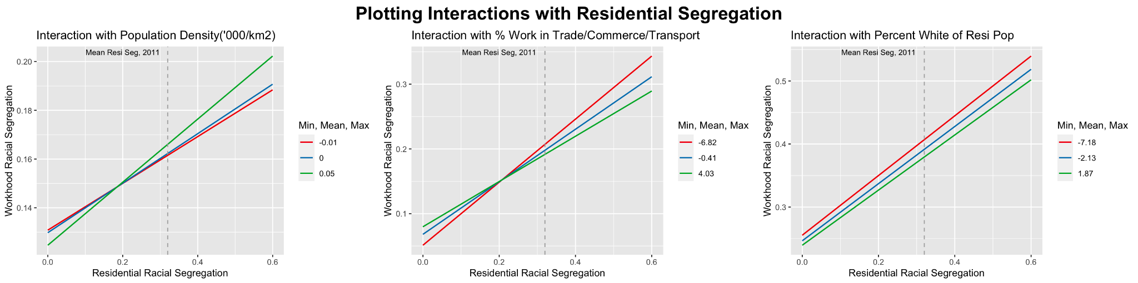
Figure 3.2: Interaction Effects for Significant Moderators of the relationship between workhood and neighborhood racial segregation.

As before, to aid with the interpretation of the interaction effects, we plotted predicted relationships between residential and workplace class segregation assuming the maximum, mean and minimum differences of each significant moderator variable from 2011 to 2018. For instance, between the years 2011 to 2018, the largest increase in MSA-level commuting time was 4.8 minutes, the mean change was about 1 minute increase, whereas the largest decrease was 3.5 minutes (Figure 3.3) 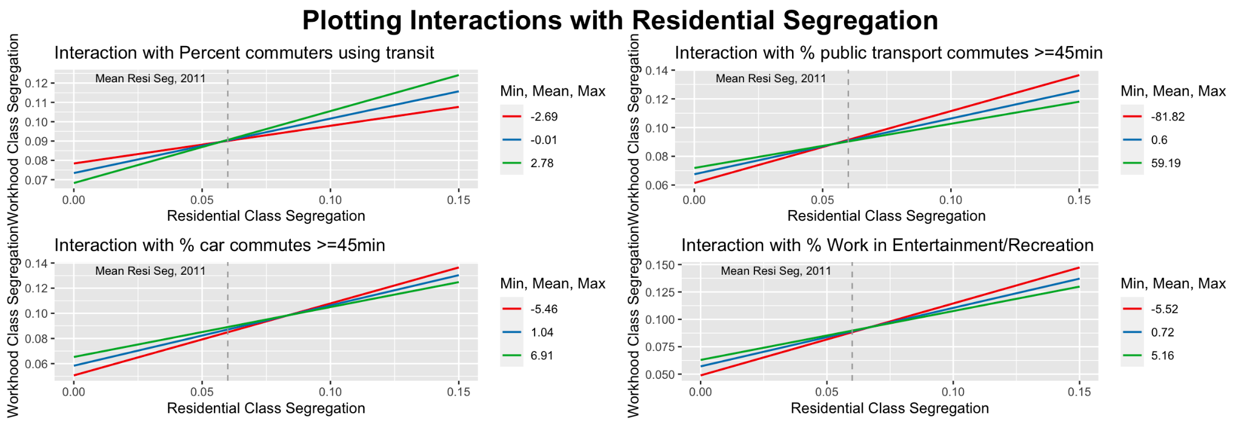

Figure 3.3: Interaction Effects for Significant Moderators of the relationship between workhood and neighborhood class segregation

Supplementary Annex 4: Additional Analyses with Alternative Variables

Regression Models With Alternative Measure of Urban Density
As population density might not fully capture changes in built urban form, in terms of greater compactness and density, we tested an alternative measure of MSA level urban density that more directly captures changes in built form developed by ⁷¹, using a dataset of historical built-up areas for the U.S. from 1810 to 2015 based on Zillow Transaction and Assessment Dataset ⁷². As there was no 2011 data, we joined the 2010 measures of built up areas to year 2011 of our full MSA dataset. Table 4.1 reports

In the main models, we find MSAs that experienced a larger increase in population density over time had a larger positive relationship between residential and workhood segregation compared to counterparts that had relatively less change in population density. Here our alternative measure of built area density yielded similar findings in terms of the directionality of the moderating effect whereby MSAs with a larger increase in built area also had a larger positive relationship between residential and workhood segregation.

Table 4.1: Two-way fixed effects regression results from models using alternative measure of density

 | Workhood Racial Segregation Score
 | Model 2 | Model 3 | Model 4
Residential Racial Seg | 0.658* (0.292) | 0.654* (0.293) | 0.589* (0.290)
Residential Class Seg |  | 0.051 (0.249)
Workhood Class Seg Score |  |  | 0.414** (0.143)
Built Up Area | -0.00000 (0.00000) | -0.00000 (0.00000) | -0.00000 (0.00000)
Residential Racial Seg: Built Up Area | 0.00001* (0.00000) | 0.00001* (0.00000) | 0.00001* (0.00000)
% Work in Agriculture/Mining etc | -0.002 (0.001) | -0.002 (0.001) | -0.002 (0.001)
% Work in Trade/Commerce/Transport | 0.006* (0.003) | 0.006* (0.003) | 0.005 (0.003)
Residential Racial Seg:% Work in Trade/Commerce/Transport | -0.026** (0.009) | -0.026** (0.009) | -0.025** (0.009)
Percent White of Resi Pop | -0.003 (0.002) | -0.003 (0.002) | -0.003 (0.002)
Residential Racial Seg: %White | -0.002 (0.003) | -0.002 (0.003) | -0.001 (0.003)
% 55+years | -0.0004 (0.002) | -0.0004 (0.002) | -0.001 (0.002)
% Income<1250 | 0.004*** (0.001) | 0.004*** (0.001) | 0.004*** (0.001)
% College Educated | 0.003 (0.002) | 0.003 (0.002) | 0.002 (0.002)
% Female | -0.001 (0.001) | -0.001 (0.001) | -0.001 (0.001)
% Population Suburban | -0.001 (0.003) | -0.001 (0.003) | -0.0005 (0.003)
GDP ('000) per capita, chained 2017 | -0.0001 (0.0003) | -0.0001 (0.0003) | -0.0001 (0.0003)
Observations | 746 | 746 | 746
R2 | 0.131 | 0.131 | 0.15
F Statistic | 3.840*** (df = 14; 358) | 3.577*** (df = 15; 357) | 4.216*** (df = 15; 357)
Note: | *p<0.05; **p<0.01; ***p<0.001

Regression Models With Alternative Measure of Road Transportation Infrastructure
For our analyses, we prioritised having measures of transportation connectivity that were available for every year of our study period, in order to have a more comprehensive data set for analysis. Thus our measure were largely based on commuting behavior measured through the ACS 5 year surveys, and are thus arguably indirect proxies of actual changes in transportation infrastructure and spatial accessibility. As an alternative measure of road transportation, we tested two alternative measures of MSA-level road provision and connectivity: the total length of roads built, and the total number of intersection nodes within an MSA, developed by ⁷¹, which were available for years 2010 and 2015. As there was no 2011 data, we joined the 2010 measures of road infrastructure to year 2011 of our full MSA dataset.

Our main models suggested that MSAs with improvements in transportation infrastructure, which would be captured by our proxy measures as a decrease in proportion of long commutes by transit or car, also saw a steeper relationship between residential and workhood segregation. Interestingly, using the alternative measures of increases in road infrastructure described above suggested a different relationship–the larger the increase in road length or number of intersections within an MSA, the smaller the coefficient of the relationship between residential and workhood class segregation (For brevity Table 4.2 report the model results of the measure of total road length only); which contradicts our main models and supports instead our initial hypotheses that more extensive transport infrastructure could help mitigate the link between residential and workplace segregation.

Table 4.2:Two-way fixed effects regression results from models using alternative measure of transportation infrastructure provision
 | Workhood Class Segregation Score
 | Model 2 | Model 3 | Model 4
Residential Class Seg | 0.691*** (0.200) | 0.693*** (0.200) | 0.661*** (0.198)
Residential Racial Seg |  | 0.004 (0.021)
Workhood Racial Seg Score |  |  | 0.052** (0.018)
Percent commuters using transit | -0.011*** (0.003) | -0.011*** (0.003) | -0.011*** (0.003)
Built Up Area | -0.00000* (0.00000) | -0.00000* (0.00000) | -0.00000* (0.00000)
Road length ('000 km) | 0.003 (0.005) | 0.002 (0.005) | 0.003 (0.005)
Residential Class Seg:%commuters using transit | 0.137*** (0.035) | 0.136*** (0.036) | 0.135*** (0.035)
Residential Class Seg: Road length ('000 km) | -0.022* (0.009) | -0.022* (0.009) | -0.021* (0.009)
% Work in Entertainment/Recreation | 0.003** (0.001) | 0.003** (0.001) | 0.003** (0.001)
Residential Class Seg:% Work in Entertainment/Recreation | -0.036* (0.016) | -0.036* (0.016) | -0.034* (0.016)
Difference in NonWhite-White Unemployment Rates | -0.0003 (0.0002) | -0.0003 (0.0002) | -0.0003 (0.0002)
% 55+years | 0.001 (0.001) | 0.001 (0.001) | 0.001 (0.001)
% Income<1250 | -0.0003 (0.0004) | -0.0003 (0.0004) | -0.0005 (0.0004)
% College Educated | 0.002** (0.001) | 0.002** (0.001) | 0.002* (0.001)
% Female | 0.0002 (0.0005) | 0.0002 (0.0005) | 0.0002 (0.0005)
% Population Suburban | -0.001 (0.001) | -0.001 (0.001) | -0.001 (0.001)
GDP ('000) per capita, chained 2017 | -0.00002 (0.0001) | -0.00002 (0.0001) | -0.00001 (0.0001)
Observations | 746 | 746 | 746
R2 | 0.179 | 0.179 | 0.199
F Statistic | 5.172*** (df = 15; 357) | 4.838*** (df = 16; 356) | 5.514*** (df = 16; 356)
Note: | *p<0.05; **p<0.01; ***p<0.001

Regression Models With Alternative Measure of Residential Segregation

Using the LODES data to estimate residential segregation means our estimates of residential segregation is based on worker populations instead of total residential population. To test whether there are substantial differences in our model results if we considered the full residential population instead of a worker-only subset, we created estimates of class and racial residential segregation based on the American Community Survey (ACS) 5 year data which includes both working and non-working populations, and using the same categories of race (Asian, Black, White, Others) and educational attainment as a measure of social class (less than High School, High School, Some College or Associate Degree, Bachelor’s Degree or advanced degree) as our primary analysis. As the ACS 5 year data is collected over the span of five years rather than a single year, to generate yearly estimates, we assigned estimated segregation values to the middle year of the 5 year period. Correlation between the LODES based estimates and ACS-based estimates were fairly high, at 0.9 for racial segregation, and 0.8 for educational segregation.

Re-running models 2 to 4 using estimates of racial segregation from ACS 5 year survey data (Table 4.3), we find similar estimated coefficients of the interactions between residential racial segregation and population density compared to our main models using LODES data. Estimated coefficients of ‘control’ variables of % low income workers, and GDP per capita were also similar to the LODES-based models. However there were also clear differences in other parameters. The interaction between residential racial segregation and percentage of population who were White is positive in the ACS-based models, suggesting a stronger link between workhood and residential segregation when MSAs become more ‘White’--which is contrary to the findings from the LODES-based models. Furthermore, the moderating effect of the proportion of workers in trade,commerce or transport related industries was no longer significant in the ACS model.

Table 4.3 Regression Models using ACS 5 year survey derived estimates of residential racial segregation
 | Workplace Racial Segregation Score
 | Model 2 | Model 3 | Model 4
Home Racial Seg(centered), ACS estimates | 0.026 (0.015) | 0.029 (0.015) | 0.025 (0.015)
Home Educational Seg (centered) |  | 0.276*** (0.079)
Work Educational Seg Score(centered) |  |  | 0.406*** (0.051)
Difference in %commutes >=45min | -0.0001* (0.00003) | -0.0001* (0.00003) | -0.0001* (0.00003)
Population Density('000/km2) | 0.019 (0.089) | 0.052 (0.089) | 0.082 (0.088)
Home Racial Seg:Pop Density | 0.620*** (0.137) | 0.675*** (0.138) | 0.623*** (0.136)
% Work in Trade/Commerce/Transport | -0.0003 (0.0004) | -0.0003 (0.0004) | -0.0002 (0.0004)
% Work in Public/Social Services | 0.001** (0.0003) | 0.001** (0.0003) | 0.001** (0.0003)
Home Racial Seg:% Work in Trade/Commerce/Transport | -0.006* (0.003) | -0.006 (0.003) | -0.006* (0.003)
Percent White of Resi Pop | -0.001* (0.001) | -0.001* (0.001) | -0.001* (0.001)
Gini Income Inequality Score | -0.001 (0.011) | 0.0005 (0.011) | 0.001 (0.011)
Home Racial Seg: %White | 0.002*** (0.001) | 0.002*** (0.001) | 0.002*** (0.001)
Home Racial Seg:Gini | 0.021 (0.016) | 0.019 (0.016) | 0.015 (0.016)
% 55+years | -0.001 (0.001) | -0.001 (0.001) | -0.001 (0.001)
% Income<1250 | 0.003*** (0.0004) | 0.003*** (0.0004) | 0.003*** (0.0003)
% College Educated | 0.001* (0.001) | 0.001 (0.001) | 0.0003 (0.001)
% Female | -0.0003 (0.001) | -0.0002 (0.001) | -0.0003 (0.001)
% workers suburban | -0.090* (0.043) | -0.087* (0.043) | -0.091* (0.042)
Observations | 2,992 | 2,992 | 2,992
R2 | 0.05 | 0.054 | 0.073
F Statistic | 8.538*** (df = 16; 2595) | 8.793*** (df = 17; 2594) | 11.958*** (df = 17; 2594)
Note: | *p<0.05; **p<0.01; ***p<0.00

Re-running models 2 to 4 using estimates of educational class-based segregation calculated from ACS 5 year survey data (Table 4.4), we find that the estimated coefficients of variables such as population density; racial differences in unemployment rates; and percent college educated were similar as the original LODES models, as was the estimated moderation effect of the proportion of workers in entertainment and recreation industries. However, while the estimated relationship between ACS-based residential class segregation scores and workhood segregation was positively significant, the magnitude was much lower than in the original models using LODES-based residential segregation scores. Furthermore, we saw no other significant moderator effects in the ACS-based models, save the proportion of entertainment and recreation workers.

Table 4.4 Regression Models ACS-5 year survey based estimates of residential class segregation
 | Workhood Class Class Segregation Score
 | Model 2 | Model 3 | Model 4
Residential Class Seg, ACS estimates | 0.084** (0.033) | 0.085** (0.033) | 0.074* (0.032)
Residential Racial Seg |  | -0.005 (0.008)
Workhood Racial Seg Score |  |  | 0.066*** (0.007)
Percent commuters using transit | -0.001 (0.001) | -0.001 (0.001) | -0.001 (0.001)
% public transport commutes >=45min | 0.0001 (0.00005) | 0.0001 (0.00005) | 0.0001 (0.00005)
% car commutes >=45min | 0.0003 (0.0004) | 0.0003 (0.0004) | 0.0003 (0.0004)
Population Density('000/km2) | -0.213*** (0.038) | -0.214*** (0.038) | -0.210*** (0.038)
Residential Education Seg:%commuters using transit | 0.007 (0.004) | 0.007 (0.004) | 0.007 (0.004)
Residential Education Seg:% PT commutes >=45min | -0.0004 (0.0003) | -0.0004 (0.0003) | -0.0003 (0.0003)
Residential Education Seg:% car commutes >=45min | 0.0002 (0.002) | 0.0002 (0.002) | 0.0001 (0.002)
% Work in Entertainment/Recreation | 0.001* (0.0004) | 0.001* (0.0004) | 0.001* (0.0004)
Residential Education Seg:% Work in Entertainment/Recreation | -0.005* (0.002) | -0.005* (0.002) | -0.005* (0.002)
Difference in NonWhite-White Unemployment Rates | -0.0003*** (0.0001) | -0.0003*** (0.0001) | -0.0003*** (0.0001)
% 55+years | -0.0002 (0.0002) | -0.0002 (0.0002) | -0.0001 (0.0002)
% Income<1250 | 0.0001 (0.0001) | 0.0001 (0.0001) | -0.00002 (0.0001)
% College Educated | 0.003*** (0.0002) | 0.003*** (0.0002) | 0.003*** (0.0002)
% Female | -0.0001 (0.0002) | -0.0001 (0.0002) | -0.0001 (0.0002)
% Population Suburban | 0.0002 (0.0004) | 0.0002 (0.0004) | 0.0003 (0.0004)
GDP ('000) per capita, chained 2017 | 0.00002 (0.00003) | 0.00002 (0.00003) | 0.00005 (0.00003)
Observations | 3,040 | 3,040 | 3,040
R2 | 0.084 | 0.084 | 0.112
F Statistic | 14.223*** (df = 17; 2636) | 13.450*** (df = 18; 2635) | 18.405*** (df = 18; 2635)
Note: | *p<0.05; **p<0.01; ***p<0.001

Supplementary Annex 5

Table 5.1: Distribution of MSA-level characteristics, year 2011 and 2018
MSA Characteristic | 2011 Mean(SD) | 2011 Range | 2018 Mean(SD) | 2018 Range
Residential Racial Seg | 0.32 (0.11) | 0.09, 0.59 | 0.3 (0.1) | 0.08, 0.55
Workhood Racial Seg Score | 0.17 (0.05) | 0.07, 0.4 | 0.17 (0.04) | 0.06, 0.33
Residential Class Seg | 0.06 (0.02) | 0.03, 0.14 | 0.06 (0.02) | 0.03, 0.12
Workhood Class Seg Score | 0.1 (0.02) | 0.05, 0.18 | 0.09 (0.02) | 0.04, 0.16
Percent commuters using transit | 1.68 (2.56) | 0.04, 32.29 | 1.66 (2.69) | 0.03, 33.36
% public transport commutes >=45min | 36.93 (16.76) | 0, 86.34 | 37.52 (18.33) | 0.99, 100
% car commutes >=45min | 10.71 (4.36) | 3.67, 30.31 | 11.74 (4.99) | 3.33, 30.96
Population Density('000/km2) | 0.11 (0.12) | 0, 1.1 | 0.11 (0.13) | 0, 1.11
Percent White of Resi Pop | 71.76 (17.19) | 3.57, 95.85 | 69.63 (17.53) | 3.53, 95.4
Difference in NonWhite-White Unemployment Rates | 5.56 (2.91) | -2.05, 16.73 | 3.33 (2.14) | -1.96, 10.75
Gini Income Inequality Score | 1.35 (1.47) | 0.39, 12.38 | 1.37 (1.5) | 0.39, 12.62
Percent Labor Force Unemployed | 9.62 (2.66) | 2.66, 18.51 | 5.43 (1.58) | 2.14, 14.18
% Work in Agriculture/Mining/ Utilities/ Construction | 7.28 (4.24) | 2.14, 28.3 | 8.02 (4.57) | 2.46, 36.94
% Work in Manufacturing | 10.9 (6.32) | 1.1, 46.46 | 10.91 (6.69) | 0.71, 53.07
% Work in Trade/Commerce/Transport | 19.02 (3.05) | 10.25, 31.48 | 18.62 (3.03) | 10.75, 31.14
% Work in Professional Services | 17.69 (5.17) | 6.65, 39.16 | 17.79 (5.5) | 6.05, 39.53
% Work in Public/Social Services | 31.73 (6.19) | 17.58, 57.74 | 30.81 (6.27) | 13.7, 54.09
% Work in Entertainment/Recreation | 10.27 (3.24) | 4.85, 32.77 | 10.99 (3.22) | 4.76, 28.92
% 55+years | 20.52 (2.19) | 14.43, 28.95 | 24.06 (2.38) | 15.8, 33.73
% Income<1250 | 23.56 (3.53) | 13.72, 37.49 | 19.73 (2.96) | 9.96, 28.89
% College Educated | 20.07 (4.24) | 11.07, 38.87 | 19.41 (3.95) | 9.7, 37.07
% Female | 50.46 (2.52) | 39.12, 56.67 | 49.96 (2.58) | 35.81, 57.69
% Population Suburban | 7.94 (11.06) | 0, 56.63 | 7.78 (10.89) | 0, 56.7
GDP ('000) per capita, chained 2017 | 47.6 (11.81) | 22.65, 100.27 | 51.61 (15.1) | 24.19, 160.74

Figure 5.1: Bivariate correlations of MSA-level characteristics, year 2018

