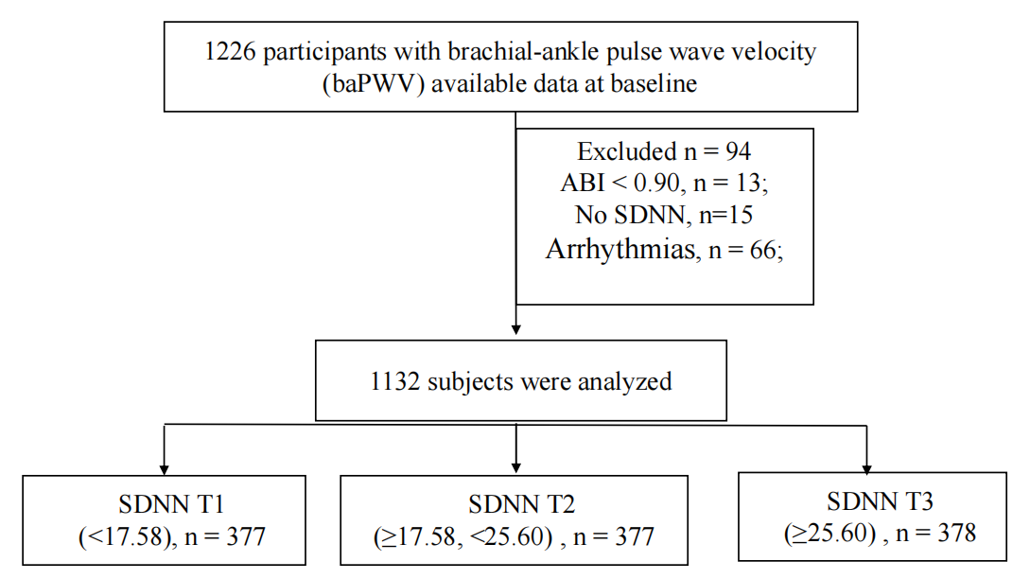

Figure S1 Flow chart of the study participants
*baPWV brachial to ankle pulse wave velocity, ABI ankle-brachial index, SDNN Standard Deviation of Normal-to-Normal Intervals,

Variable | β (95%CI) | P value
gender | -13.51 (-46.23,19.21) | 0.418
age | 11.09 (10.27,11.92) | < 0.001
BMI | -8.17 (-12.49,-3.84) | < 0.001
SBP | -0.39 (-1.27,0.48) | 0.376
DBP | -0.34 (-1.62,0.93) | 0.596
Current smoking | -52.36 (-87.06,-17.67) | 0.003
Current drinking | -13.26 (-47.13,20.61) | 0.443
Antihypertensive drugs | 7.55 (-28.49,43.59) | 0.681
Self-reported diabetes | 62.84 (-2.52,128.2) | 0.059
Antidiabetes drugs | 55.49 (-10.85,121.83) | 0.101
Total cholesterol | -12.17 (-27.28,2.95) | 0.115
Triglyceride | -2.9 (-14.09,8.29) | 0.611
HDL-C | -3.81 (-61.54,53.92) | 0.897
LDL-C | -21.65 (-41.86,-1.44) | 0.036
FPG | 39.34 (29.77,48.91) | < 0.001
HbA1c | 79.25 (64.26,94.23) | < 0.001
SDNN | -5.61 (-7.01,-4.21) | < 0.001
rHR | 0.09 (-1.18,1.35) | 0.891
cSDNN | -369.39 (-500.89,-237.88) | < 0.001
pNN50 | -41.6 (-52.55,-30.64) | < 0.001

Table S1. Univariate linear regression analysis between baPWV and baseline characteristics.
* BMI body mass index, SBP systolic blood pressure, DBP diastolic blood pressure, HDL-C high-density lipoprotein cholesterol, LDL-C low-density lipoprotein cholesterol, FPG Fasting plasma glucose, HbA1c hemoglobin A1c, SDNN Standard Deviation of Normal-to-Normal Intervals, rHR resting heart rate, bpm beats per minute, cSDNN corrected SDNN, PNN50 the percentage of normal-to-normal intervals that differ by more than 50 ms.

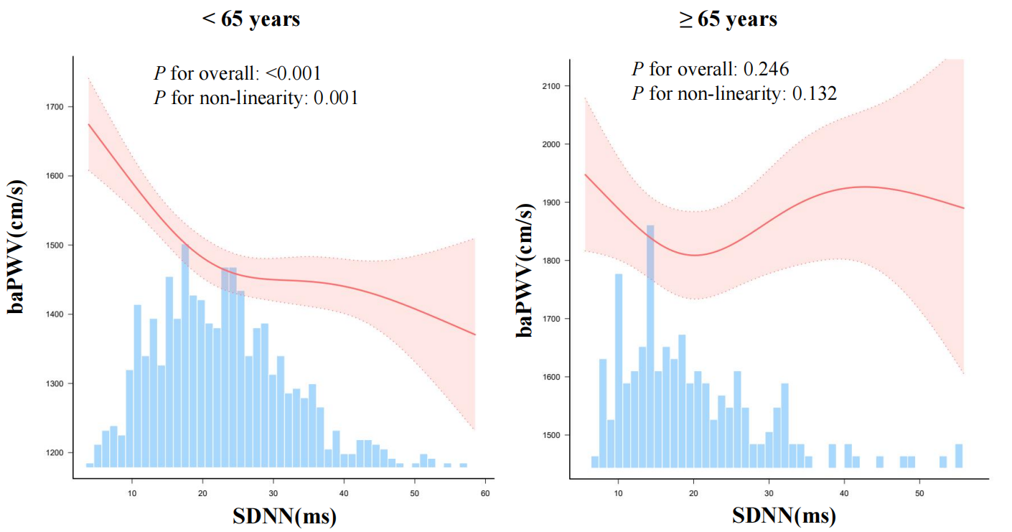

Figure S2 the relationship between SDNN and baPWV in different age

*Adjusted for age，gender，BMI, current smoking，current drinking，SBP, DBP，Total cholesterol,，Triglyceride，HDL-C, LDL-C, FPG，HbA1c，self-reported diabetes，antihypertension drugs，antidiabetes drugs SDNN Standard Deviation of Normal-to-Normal Intervals, baPWV brachial to ankle pulse wave velocity, Only 99% of the data is displayed.

Variables | Total (n = 1132) | <65 years (n = 907) | ≥65 years (n = 225) | p
gender, n (%) |  |  |  | < 0.001
female | 369 (32.6) | 265 (29.2) | 104 (46.2)
male | 763 (67.4) | 642 (70.8) | 121 (53.8)
Age, (years) | 51.4 ± 14.6 | 46.1 ± 10.9 | 72.6 ± 6.0 | < 0.001
BMI, (kg/m²) | 26.2 ± 3.5 | 26.5 ± 3.6 | 24.9 ± 3.0 | < 0.001
SBP, (mmHg) | 147.1 ± 17.6 | 147.5 ± 17.9 | 145.5 ± 16.4 | 0.127
DBP, (mmHg) | 91.9 ± 12.0 | 92.0 ± 11.9 | 91.4 ± 12.5 | 0.509
Current smoking, n (%) |  |  |  | < 0.001
no | 834 (73.7) | 647 (71.3) | 187 (83.1)
yes | 298 (26.3) | 260 (28.7) | 38 (16.9)
Current drinking, n (%) |  |  |  | 0.264
no | 806 (71.2) | 639 (70.5) | 167 (74.2)
yes | 326 (28.8) | 268 (29.5) | 58 (25.8)
Antihypertensive drugs, n (%) |  |  |  | 0.339
no | 269 (23.8) | 221 (24.4) | 48 (21.3)
yes | 863 (76.2) | 686 (75.6) | 177 (78.7)
Self-reported diabetes, n (%) |  |  |  | 0.012
no | 1066 (94.2) | 862 (95) | 204 (90.7)
yes | 66 ( 5.8) | 45 (5) | 21 (9.3)
Antidiabetes drugs, n (%) |  |  |  | 0.019
no | 1068 (94.3) | 863 (95.1) | 205 (91.1)
yes | 64 ( 5.7) | 44 (4.9) | 20 (8.9)
Total cholesterol, (mmol/L) | 4.7 ± 1.0 | 4.8 ± 1.0 | 4.3 ± 1.0 | < 0.001
Triglyceride, (mmol/L) | 1.6 (1.2, 2.3) | 1.7 (1.2, 2.4) | 1.4 (1.0, 1.9) | < 0.001
HDL-C, (mmol/L) | 1.1 ± 0.3 | 1.1 ± 0.3 | 1.1 ± 0.2 | 0.845
LDL-C, (mmol/L) | 2.6 ± 0.8 | 2.7 ± 0.7 | 2.3 ± 0.8 | < 0.001
FPG, (mmol/L) | 5.6 ± 1.6 | 5.6 ± 1.4 | 6.0 ± 2.0 | < 0.001
HbA1c, (%) | 5.8 ± 1.0 | 5.7 ± 0.9 | 6.2 ± 1.2 | < 0.001
SDNN, (ms) | 23.0 ± 10.7 | 23.6 ± 10.5 | 20.8 ± 11.2 | < 0.001
rHR, (bpm) | 73.2 ± 12.1 | 74.6 ± 12.0 | 67.5 ± 10.8 | < 0.001
pNN50, (%) | 0.1 (0.0, 0.2) | 0.1 (0.0, 0.2) | 0.0 (0.0, 0.1) | < 0.001
cSDNN, (%) | 2.8 ± 1.4 | 2.9 ± 1.3 | 2.4 ± 1.5 | < 0.001
ABI | 1.1 ± 0.1 | 1.1 ± 0.1 | 1.1 ± 0.1 | 0.024
baPWV, (cm/s) | 1533.1 ± 262.9 | 1466.5 ± 220.7 | 1801.8 ± 248.1 | < 0.001

Table S2 Baseline characteristics of total and groups by different age.
* BMI body mass index, SBP systolic blood pressure, DBP diastolic blood pressure, HDL-C high-density lipoprotein cholesterol, LDL-C low-density lipoprotein cholesterol, FPG Fasting plasma glucose, HbA1c hemoglobin A1c, SDNN Standard Deviation of Normal-to-Normal Intervals, rHR resting heart rate, bpm beats per minute, cSDNN corrected SDNN, PNN50 the percentage of normal-to-normal intervals that differ by more than 50 ms.

cSDNN | BaPWV, cm/s，β (95%CI) | Elevated baPWV，OR (95%CI)
Per 1 unit increase | -2.48 (-3.18~-1.79) | 0.98 (0.97~0.99)
Tertiles
T1 (<23.39) | 0.00 | 1.00
T2 (23.39~37.41) | -88.36 (-118.84~-57.88) | 0.42 (0.27~0.66)
T3 (≥37.41) | -104.81 (-135.39~-74.24) | 0.42 (0.27~0.65)
P for trend | <0.001 | <0.001

Table S3 The relationships between cSDNN and baPWV, elevated baPWV.
*adjusted for age，gender，BMI, current smoking，current drinking，SBP, DBP，Total cholesterol,，Triglyceride，HDL-C, LDL-C, FPG，HbA1c，self-reported diabetes，antihypertension drugs，antidiabetes drugs
SDNN Standard Deviation of Normal-to-Normal Intervals, baPWV brachial to ankle pulse wave velocity, CI confidence interval.

