Supplementary Information
Supplementary Figure 1
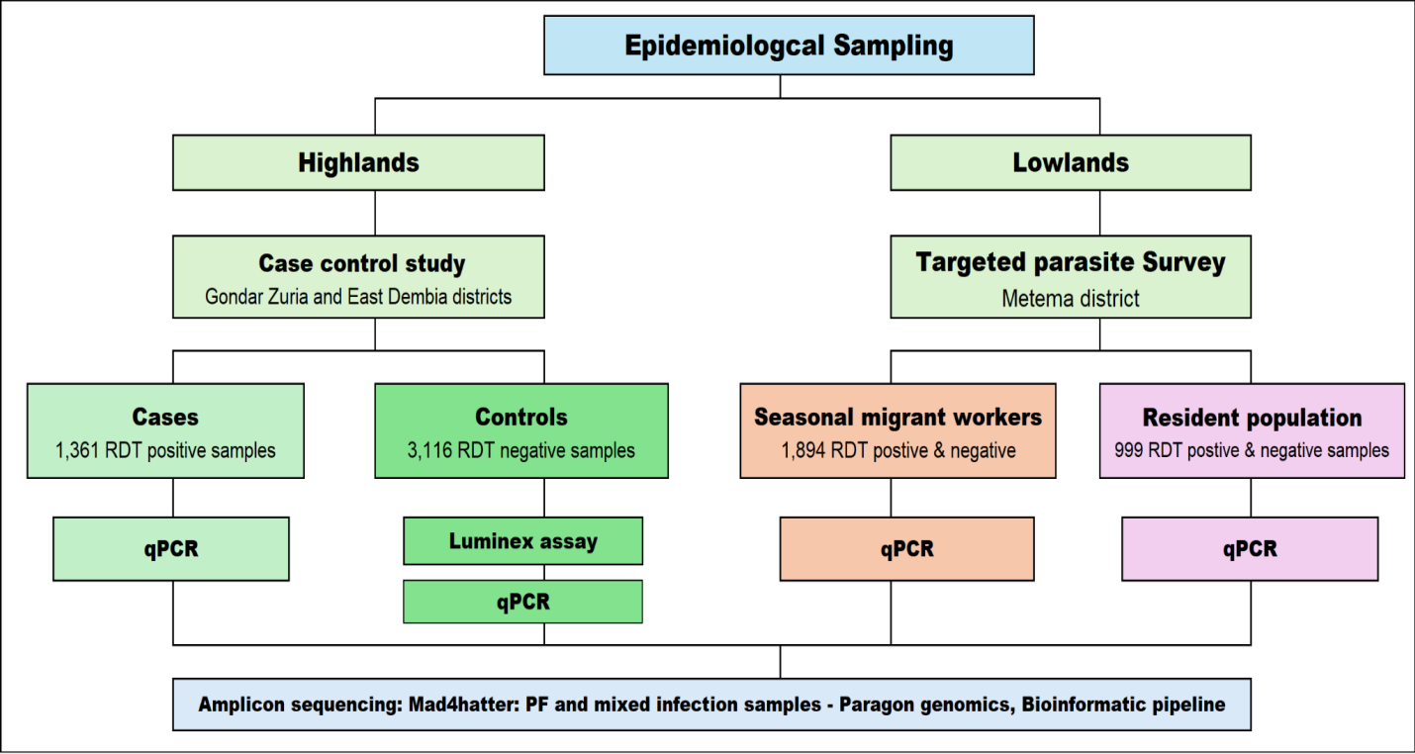
Supplementary Figure 1: Schematic diagram depicting the study design and laboratory method used for the highland population, seasonal migrant workers and lowland resident populations, northwestern Ethiopia. MAD⁴HatTeR: Multiplex Amplicons for Drug, Diagnostic, Diversity, and Differentiation Haplotypes using Targeted Resequencing; qPCR: quantitative polymerase chain reaction; RDT: Rapid diagnostic test.

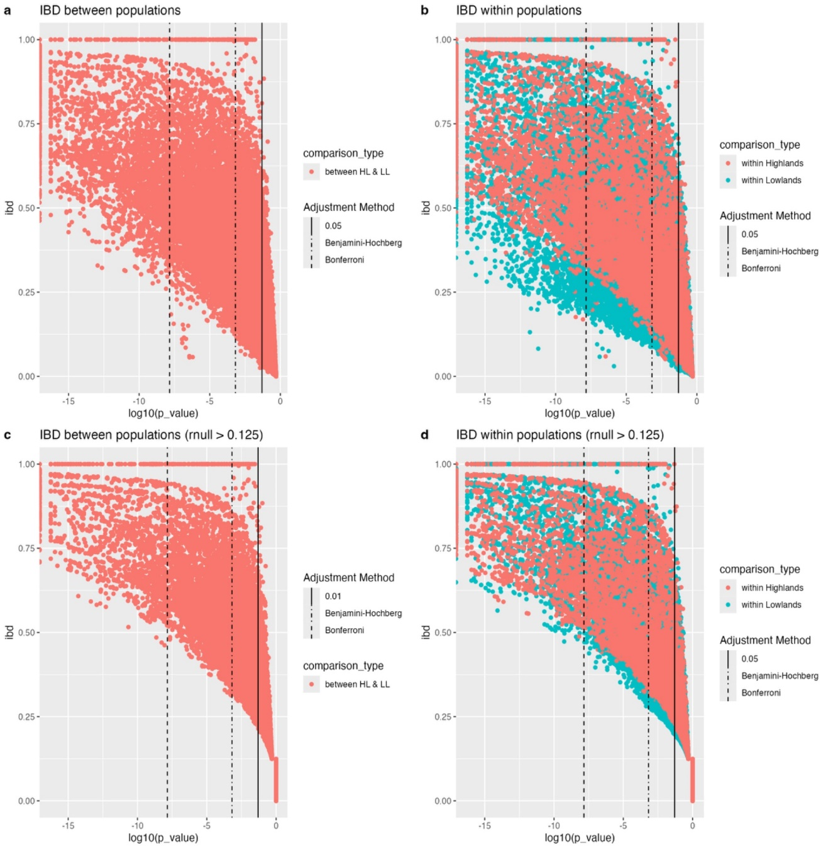
Supplementary Figure 2. P-value adjustments and r threshold determination. P-values were adjusted by either Bonferroni or Benjamini-Hochberg methods (FDR = 0.01) to decide which correction to use and at which r cut-offs. Vertical lines mark the p-value cut-off and depict how many pairs would be filtered out using the respective correction. a) Relatedness between populations (Highland vs. Lowland), using r_{null} = 0. b) Relatedness within populations (Highland and Lowland separately), using r_{null} = 0. c) Relatedness between populations (Highland vs. Lowland), using r_{null} = 0.125. d) r within populations (Highland and Lowland separately), using r_{null} = 0.125.

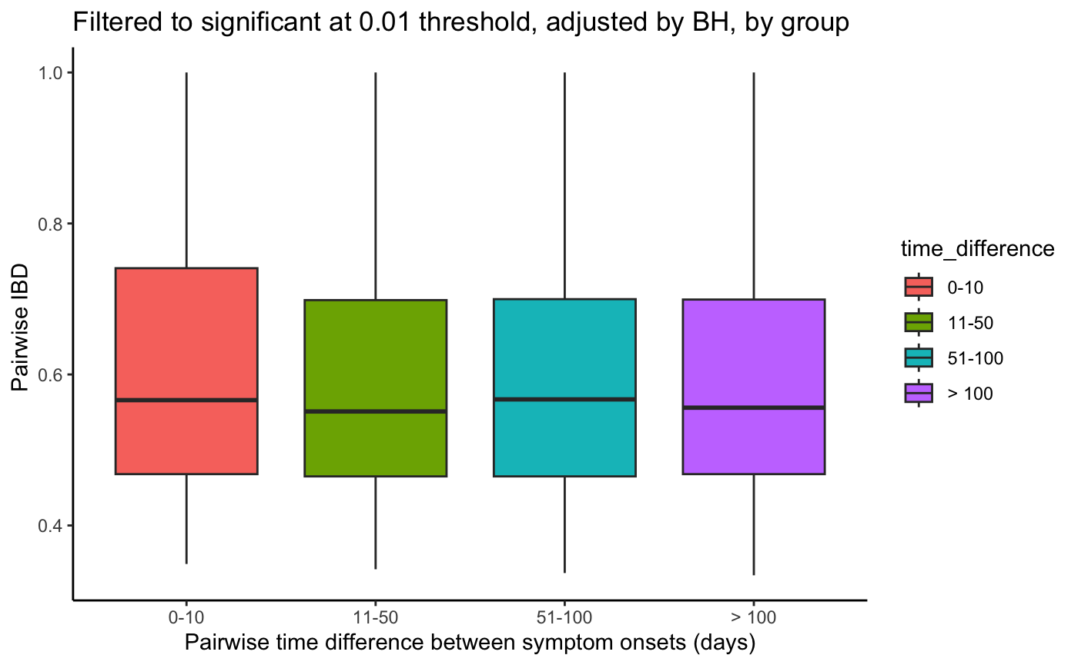
Supplementary Figure 3. Temporal patterns of r by date of symptom onset showing the distribution of r of sample pairs collected 0–10 days apart, 11–50 days apart, 51–100 days apart or >100 days apart.

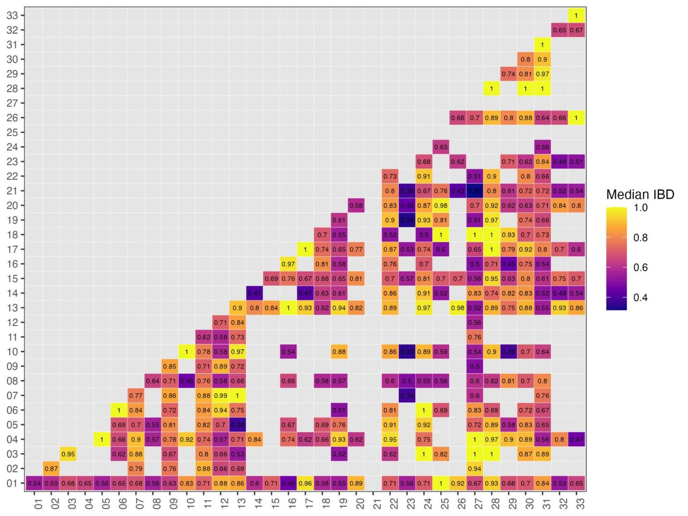
Supplementary Figure S4. Median r across infections in seasonal workers, by farm. Median r values ranged from 0.43 to 1.0, indicating a spectrum of relatedness from moderate to near-identical parasite genotypes within and across different farms. High r values (≥ 0.8) were commonly observed within specific farms, suggesting localized transmission clusters or frequent movement of workers among these locations. In contrast, lower median r values (≤ 0.6) were observed in cross-farm comparisons, implying reduced parasite sharing or more diverse parasite populations across geographically or epidemiologically distinct farms. Several farm pairings showed particularly strong relatedness. The data points are ordered and asymmetrical, indicating relationships that exist in some farms but not in others. The highest values (r = 1.0) were common along the diagonal, indicating that the highest relatedness occurred within, not across farms (Supplementary Figure S4).

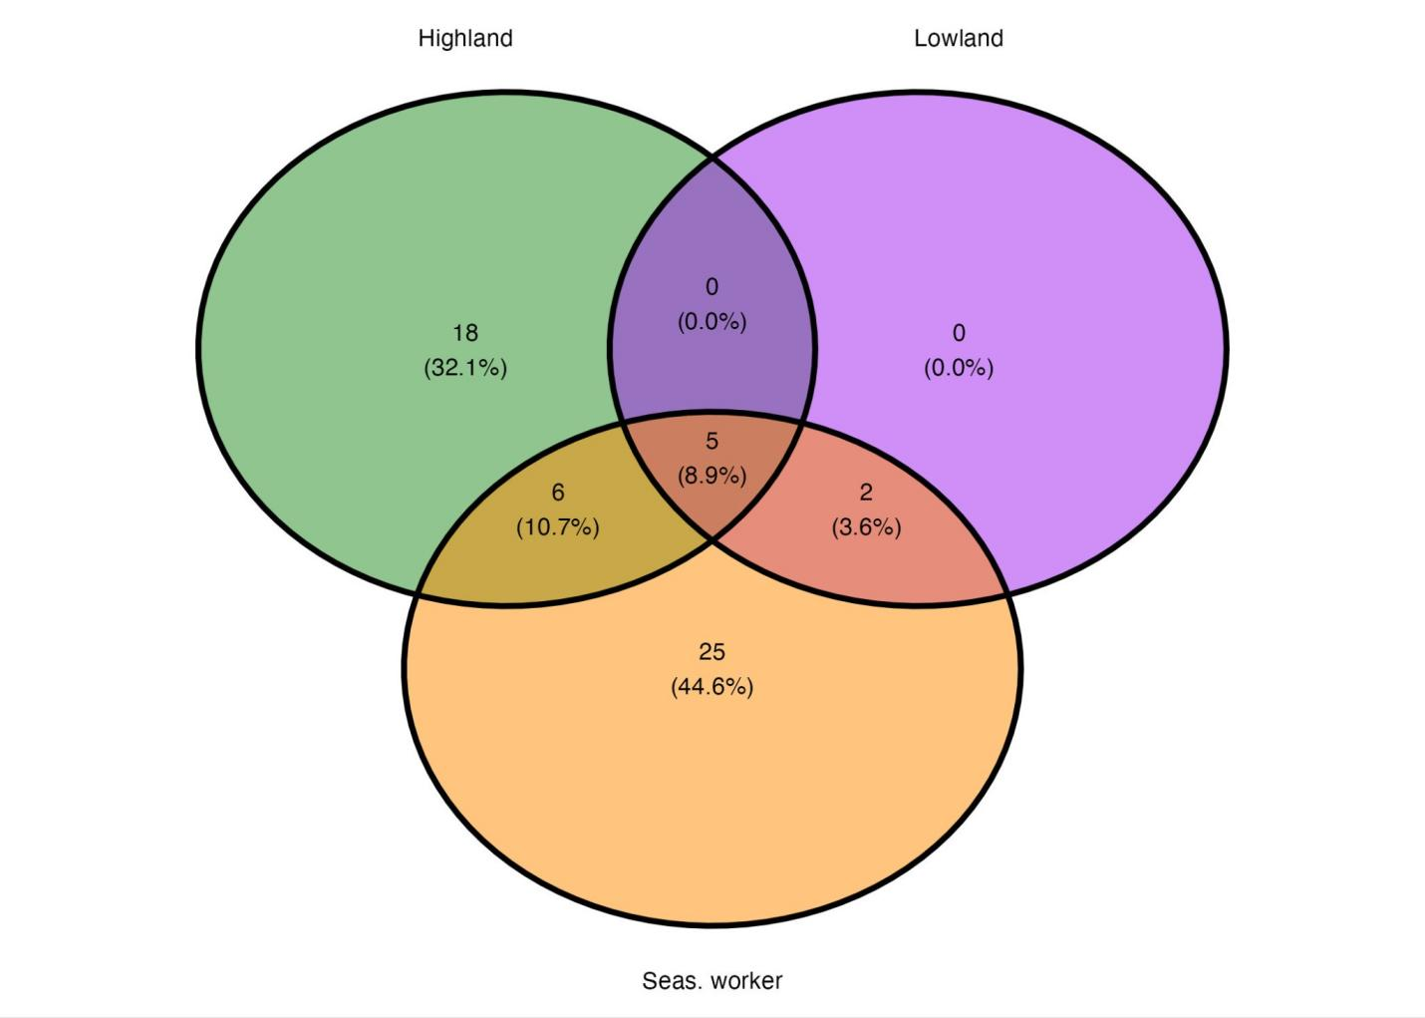
Supplementary Figure S5. Cluster membership with r threshold of 1.
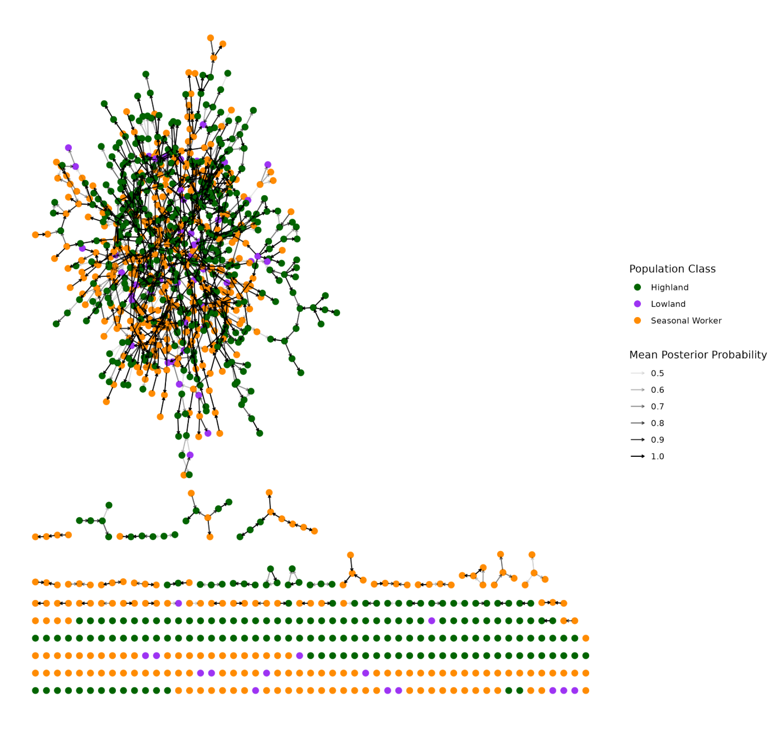
Supplementary Figure S6. Estimated transmission network.

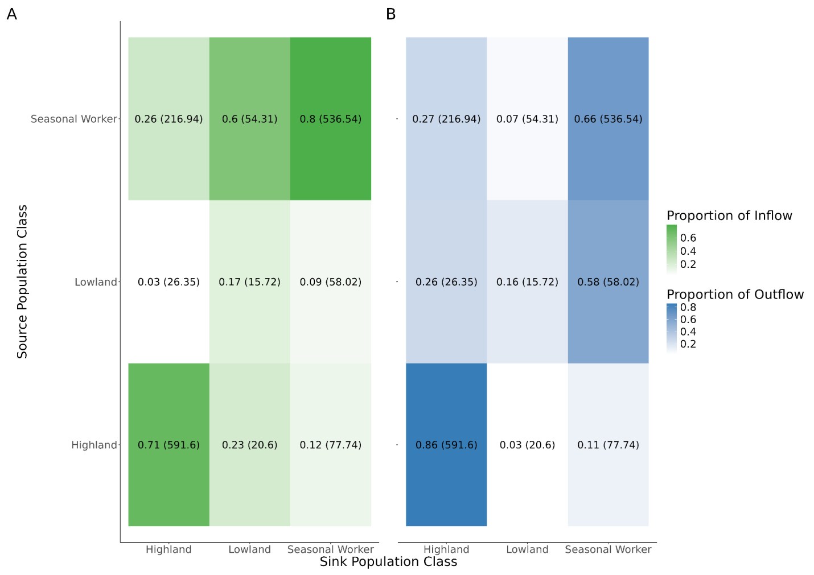
Supplementary Figure S7. Estimated transmission flow between populations. Proportions are calculated with respect to the total incoming (A) or outgoing (B) edges of each population. The total number of edges between populations are indicated in parentheses.

Supplementary Table 1: Characteristics of sequenced samples from highland residents, seasonal workers, and lowland residents in Northwestern Ethiopia.
Variables | Category | Highland residents  n (%) | Seasonal workers  n (%) | Lowland residents  n (%) | Total n (%)
qPCR results | P. falciparum | 904 (49.26) | 746 (81.89) | 129 (79.14) | 1,779 (61.16)
qPCR results | P. vivax | 575 (31.34) | 67 (7.35) | 27 (16.56) | 669 (22.99)
qPCR results | Mixed infections | 356 (19.40) | 98 (10.76) | 7 (4.30) | 461 (15.85)
qPCR results | Total positive | 1,835 (63.08) | 911 (31.32) | 163 (5.60) | 2,909
Amplicon sequencing | P. falciparum | 431 (71.95) | 359 (72.09) | 77 (92.77) | 867 (73.47)
Amplicon sequencing | Mixed infections | 168 (28.05) | 139 (27.91) | 6 (7.23) | 313 (26.53)
Amplicon sequencing | Sample total | 599 (50.76) | 498 (42.20) | 83 (7.04) | 1,180
Sex | Male | 351 (60.2) | 521 (97.6) | 35 (55.6) | 907 (76.9)
Sex | Female | 232 (39.8) | 13 (2.4) | 28 (44.4) | 273(23.1)
Age  (years) | >5 | 41 (7.0) | 0 (0.0) | 9 (14.3) | 50 (4.2)
Age  (years) | 5-14 | 191 (32.8) | 3 (0.6) | 24 (38.1) | 218 (18.5)
Age  (years) | 15-24 | 172 (29.5) | 259 (48.5) | 21 (33.3) | 452 (38.3)
Age  (years) | 25-49 | 135 (23.2) | 259 (48.5) | 9 (14.3) | 403 (34.2)
Age  (years) | ≥50 | 44 (7.5) | 13 (2.4) | 0 (0.0) | 57 (4.8)
Travel history* | Yes | 16 (2.7) | 432 (80.9) | 7 (11.1) | 455 (38.6)
Travel history* | No | 567 (97.3) | 102 (19.1) | 56 (88.9) | 725 (61.4)
n = number of individuals in each category; % = proportion of individuals in each category relative to the total population; qPCR = Quantitative polymerase chain reaction; *Reported engagement in agricultural work in the lowlands within the past 3 months, or overnight travel to the lowlands for agricultural work.

Supplementary file
Supplementary Table 2: Supplementary_table_median_alleles_in_loci_012425.csv
Supplementary Table 3: Supplementary_table_species_composition_012425.csv

