Apendix 1
Figure A1. Topics in February 2022
UK PL

Figure A2. Topics in March 2022

Figure A3. Topics in April 2022
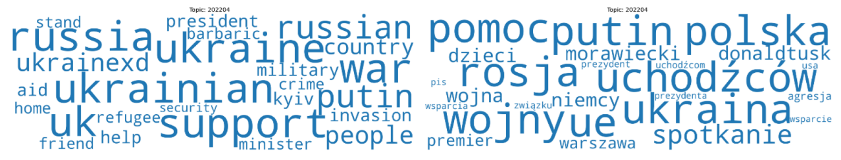
Figure A4. Topics in May 2022

Figure A5. Topics in June 2022

Figure A6. Topics in July 2022
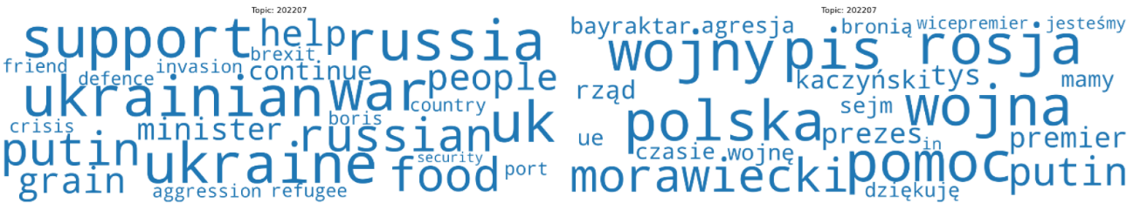
Figure A7. Topics in August 2022

Figure A8. Topics in September 2022
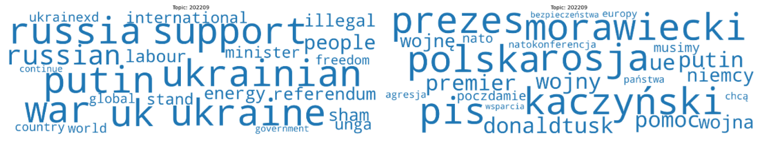
Figure A9. Topics in October 2022
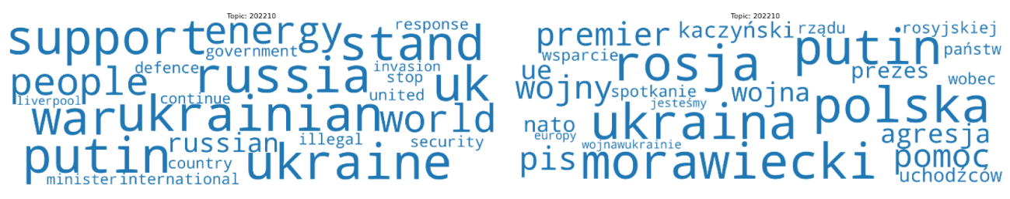
Figure A10. Topics in November 2022

Figure A11. Topics in December 2022

Figure A12. Topics in January 2023
