Supplementary Table 1a. Questions asked in the 2022 Drinkaware Monitor survey conducted by YouGov.

Question 1 | Do you understand the term ‘drink spiking’?  - Yes  - No  - Not sure
Question 2 | Drink spiking is the act of deliberately adding alcohol or other substances, such as drugs of abuse or pharmaceutical compounds, to a drink without knowledge of the individual who is drinking it. Do you understand the term ‘needling’ in relation to drink spiking?  - Yes  - No  - Not sure
Question 3 | Do you think you have ever been a victim of drink spiking?  - Yes  - No  - Not sure  - Prefer not to say
Question 4 | ‘Needling’ is a new issue which has been reported recently. It is the act of covertly injecting someone with a substance, such as drugs of abuse or pharmaceutical compounds, without the person’s prior knowledge or consent. Do you think you have ever been a victim of ‘needling’?  - Yes  - No  - Not sure  - Prefer not to say
Question 5 | You said that you think you have been a victim of drink spiking. Where did the incident take place? Please select all that apply.  - Club  - Bar  - Private home  - Social event  - University/college  - Family event  - Work  - Other (specify)  - Prefer not to say
Question 6 | You said that you think you have been a victim of needling. Where did the incident take place? Please select all that apply.  - Club  - Bar  - Private home  - Social event  - University/college  - Family event  - Work  - Other (specify)  - Prefer not to say
Question 7 | Still thinking about the most recent time you were drugged (either via drink spiking or needling), do you know the identity of the perpetrator?  - Yes  - No  - Prefer not to say
Question 8 | What was your ‘relationship’ with the perpetrator (how well did you know them)? Please select the option that best applies. If you cannot identify them, please select that option.  - Relative  - Co-worker/workmate  - Acquaintance  - Stranger  - Partner/Ex-partner  - Friend  - Classmate  - Other (specify)  - Cannot identify them  - Prefer not to say
Question 9 | After you were drugged, what happened next? Please tick all that apply.  - Rape  - Sexual assault  - Theft/robbery  - Blackmail  - Harassment  - Intimidation  - Prank  - Other  - Nothing happened  - Prefer not to say
Question 10 | Did you report this incident to the police?  - Yes  - No  - Prefer not to say
Question 11 | Did you tell anyone else about this incident?  - Yes  - No  - Prefer not to say
Question 12 | Who did you tell about this incident? Please select all that apply.  - Security at the venue  - Staff at the venue  - Medical professional  - Counsellor  - School/college/university staff  - Friend  - Family member  - Colleague or employer  - Someone else (specify)  - Prefer not to say
Question 13 | What were your reasons for not reporting the incident to the police?  - Too much time had passed since the incident  - I didn’t think there was much point  - I didn’t know it was illegal  - I was scared I’d get into trouble  - I was embarrassed  - I couldn’t remember exactly what happened  - Other (specify)  - Prefer not to say
Question 14 | Please describe your overall experience in reporting this incident to the police.
Question 15 | Did being drugged result in any physical or mental health problems?  - Yes  - No  - Not sure  - Prefer not to say
Question 16 | What physical or mental health problems did you experience as a result of being drugged?
Question 17 | Have you sought any medical assistance (either physical and/or psychological) for these problems?  - Yes  - No  - Not sure  - Prefer not to say
Question 18 | What, if anything, do you think makes people vulnerable to being drugged?
Question 19 | Would you know what to do in case of a drink spiking or ‘needling’ incident?  - Yes  - No  - Not sure  - Prefer not to say
Question 19.1 | If you answered yes (to question 19), What would you do?
Question 20 | Would you be careful of a possible drink spiking or needling during a night out in a club or bar?  - Very careful  - Somewhat careful  - I don’t think it will happen to me  - Not applicable-this is not relevant to me  - Prefer not to say
Question 21 | If you were drugged (i.e. via drink spiking or ‘needling’ and it led to the following consequences, how likely is it that you would report it to the police? (1- very likely to 4- very unlikely)  - Rape  - Sexual assault  - Theft/robbery  - Blackmail  - Harassment  - Intimidation  - A prank  - No particular consequence

Supplementary Table 1b: Questions asked in the 2023 Drinkaware Monitor survey.
Question 1 | Do you think you have been a victim of drink spiking in the last year?  - Yes  - No  - Not sure  - Prefer not to say
Question 2 | ‘Needling’ is a new issue which has been reported recently. It is the act of covertly injecting someone with a substance, such as drugs of abuse or pharmaceutical compounds, without the person’s prior knowledge or consent. Do you think you have been a victim of ‘needling’ in the past year?  - Yes  - No  - Not sure  - Prefer not to say
Question 3 | In which, if any, of the following did the incident(s) of drink spiking take place? Please select all the answers that apply.  - Club  - Bar  - Private home  - Social event  - University/college  - Family event  - Work  - Other (specify)  - Prefer not to say
Question 4 | Do you know what to do in case you or someone you know has experienced drink spiking?  - Yes  - No  - Prefer not to say
Question 5 | What would you do if you or someone you know has experienced drink spiking?
Question 6 | In which, if any, of the following settings did the incident(s) of drink needling take place? Please select all that apply.  - Club  - Bar  - Private home  - Social event  - University/college  - Family event  - Work  - Other (specify)  - Prefer not to say
Question 7 | Do you think that you know what to do if you or someone you know has experienced needling?  - Yes  - No  - I am not sure  - Prefer not to say
Question 8 | What would you do if you or someone you know has experienced drink needling?

Supplementary Table 2. Sample breakdown by age, gender and ethnicity (all data is weighted).

Sample | 2022 | 2023 | Weighting for both datasets
Sample | Number  (N = 6318) | Number  (N = 10473) | Weighting for both datasets
Gender  Male  Female | 3103  3215 | 5144  5329 | 49.1%  50.9%
Age  18 to 24  25 to 34  35 to 44  45 to 54  55 to 64  65 to 75  76+ | 742  1113  1057  1161  940  859  446 | 1227  1848  1753  1924  1559  1423  739 | 11.7%  17.6%  16.7%  18.4%  14.9%  13.6%  7.1%
Ethnicity  White  Mixed/multiple ethnic group  Asian  Black  Other | 5591  103  258  79 (1.3%)  287 (4.5%) | 9302  241  397  170 (1.6%)  363 (3.5%) | 88.5%  1.6%  4.1%  NA
Sexuality  Bisexual  Heterosexual  Queer  Pansexual  Lesbian  Asexual  Gay | 305 (4.8%)  5371 (85.0%)  35 (0.6%)  44 (0.7%)  53 (0.8%)  64 (1.0%)  213 (3.4%) | 552 (5.3%)  8767 (83.7%)  65 (0.6%)  86 (0.8%)  102 (1.0%)  87 (0.8%)  363 (3.5%) | NA

Supplementary Table 3. Breakdown of responses by sexuality and ethnicity to the question on having been a victim of drink spiking or needling?’ From the 2022 Drinkaware Monitor survey.
 | Do you think you have ever been a victim of DRINK SPIKING? |  |  |  | Do you think you have ever been a victim of NEEDLING?
 | Yes (%) | No (%) | Not sure (%) | Prefer not to say (%) | Yes (%) | No (%) | Not sure (%) | Prefer not to say (%)
GENDER
Men (n = 3103) | 278 (9.0) | 2511 (80.9) | 243 (7.8) | 72 (2.3) | 49 (1.6) | 2872 (92.6) | 115 (3.7) | 67 (2.2)
Women (n = 3215) | 432(13.4) | 2474 (77.0) | 270 (8.4) | 38 (1.2) | 40 (1.2) | 3052 (94.9) | 95 (3.0) | 28 (0.9)
SEXUALITY
Bisexual (n = 305) | 50 (16.4) | 218 (71.5) | 34 (11.1) | 4 (1.3) | 5 (1.6) | 288 (94.4) | 9 (3.0) | 3 (1.0)
Heterosexual (n = 5371) | 569 (10.6) | 4340 (80.8) | 404 (7.5) | 58 (1.1) | 70 (1.3) | 5095 (94.9) | 158 (2.9) | 48 0.9)
Queer (n = 35) | 7 (20.0) | 20 (57.1) | 8 (22.9) | 1 (2.9) | 0 (0.0) | 34 (97.1) | 1 (2.9) | 1 (2.9)
Pansexual (n = 44) | 11(25.0) | 25 (56.8) | 7 (15.9) | 0 (0.0) | 3 (6.8) | 34 (77.3) | 7 (15.9) | 0 (0.0)
Lesbian (n = 53) | 15 (23.8) | 35 (66.0) | 3 (5.7) | 0 (0.0) | 2 (3.8) | 48 (90.6) | 4 (7.5) | 0 (0.0)
Asexual (n = 64) | 10 (15.6) | 43 (67.2) | 6 (9.4) | 5 (7.8) | 1 (1.6) | 55 (85.9) | 3 (4.7) | 4 (6.3)
Gay (n = 213) | 29 (13.6) | 157 (73.7) | 24 (11.3) | 4 (1.9) | 4 (1.9) | 192 (90.1) | 13 (6.1) | 4 (1.9)
GENDER IDENTITY
Cis (n = 6219) | 700 (11.3) | 4929 (79.3) | 495 (8.0) | 95 (1.5) | 87 (1.4) | 5846 (94.0) | 203 (3.3) | 83 (1.3)
Trans (n = 99) | 10 (10.1) | 56 (56.5) | 18 (18.2) | 15 (15.2) | 2 (2.0) | 78 (78.8) | 7 (7.1) | 12 (12.1)
ETHNICITY
White (n = 5591) | 653 (11.7) | 4464 (79.8) | 422 (7.5) | 53 (0.9) | 56 1.0) | 5327 (95.3) | 161 (2.9) | 46 (0.8)
Mixed / multi (n = 103) | 6 (5.8) | 80 (77.7) | 15 (14.6) | 3 (2.9) | 7 (6.8) | 88 (85.4) | 4 (3.9) | 4 (3.9)
Asian (n = 258) | 13 (5.0) | 206 (79.8) | 23 (8.9) | 16 (6.2) | 12 (4.7) | 218 (84.5) | 14 (5.4) | 14 (5.4)
Black (n = 79) | 11 (13.9) | 47 (59.5) | 17 (21.5) | 3 (3.8) | 7 (8.9) | 58 (73.4) | 9 (11.4) | 5 (6.3)

Supplementary Table 4. Breakdown of responses to the reporting to police or anyone else by alleged offence type with the three most selected options. Based on 2022 Drinkaware Monitor survey, n = 748.
Offence type | Told nobody | Reported to police | Reported to someone else | 3 most selected options
Rape | 50.0% | 26.7% | 50.0% | Friend (100%)  Family member (60.0%)  Medical professional (20.0%)
Sexual assault | 39.3% | 11.1% | 57.1% | Friend (84.4%)  Family member (43.8%)  Counsellor (15.6%)
Theft/ robbery | 46.7% | 34.6% | 53.3% | Friend (75.0%)  Staff at venue (37.5%)  Family member or colleague (12.5% both)
Blackmail | 50.0% | 55.6% | 50.0% | Friend or family member (100% both)
Harassment | 18.2% | 18.5% | 81.8% | Friend (72.2%)  Family member (44.4%)  Colleague (22.2%)
Intimidation | 50.0% | 40.0% | 50.0% | Friend (100%)  Family member (50.0%)  Staff at venue (16.7%)
Prank | 37.7% | 15.9% | 62.3% | Friend (75.8%)  Family member (33.3%)  Colleague (15.2%)
Nothing happened | 27.7% | 2.4% | 71.1% | Friend (77.9%)  Family member (37.9%)  Staff at venue (5.3%)

Supplementary Figure 1. Experience of drink spiking (1a)/ needling (1b) in the last year by age, from the respondents of the 2023 Drinkaware Monitor survey (N = 10473). Response “no” not included to enhance figure clarity.

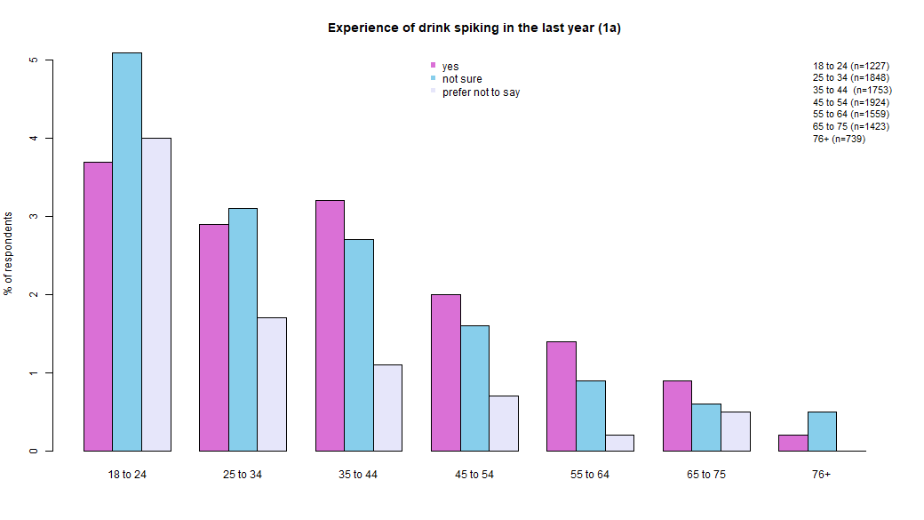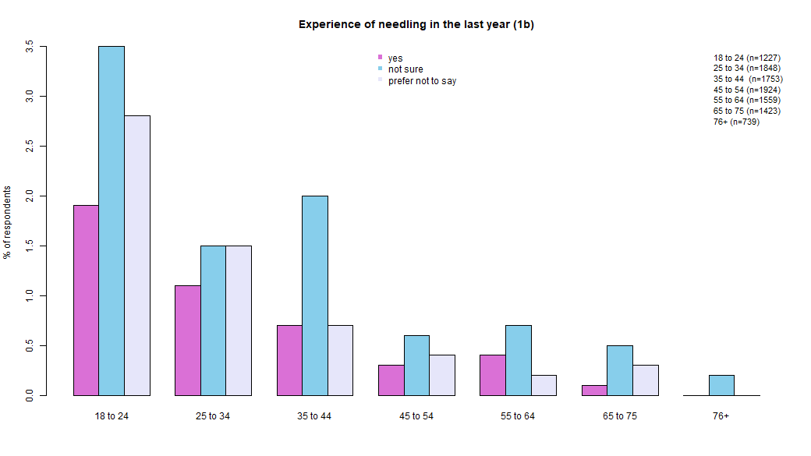

Supplementary Figure 2. Location of alleged drink spiking incidents by ethnicity (A) and sexuality (B), as well as needling incidents by ethnicity (C) and sexuality (D). Data from the 2023 survey.

A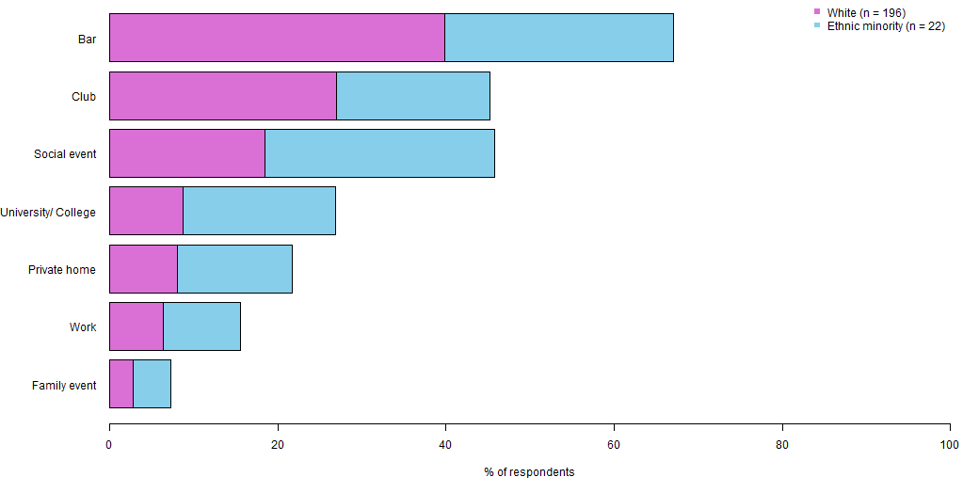
B
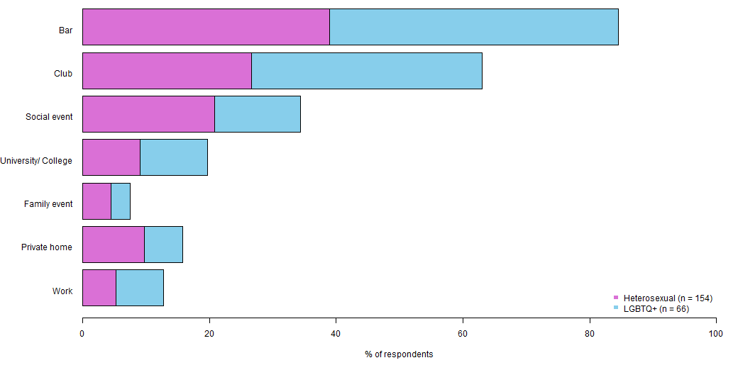

C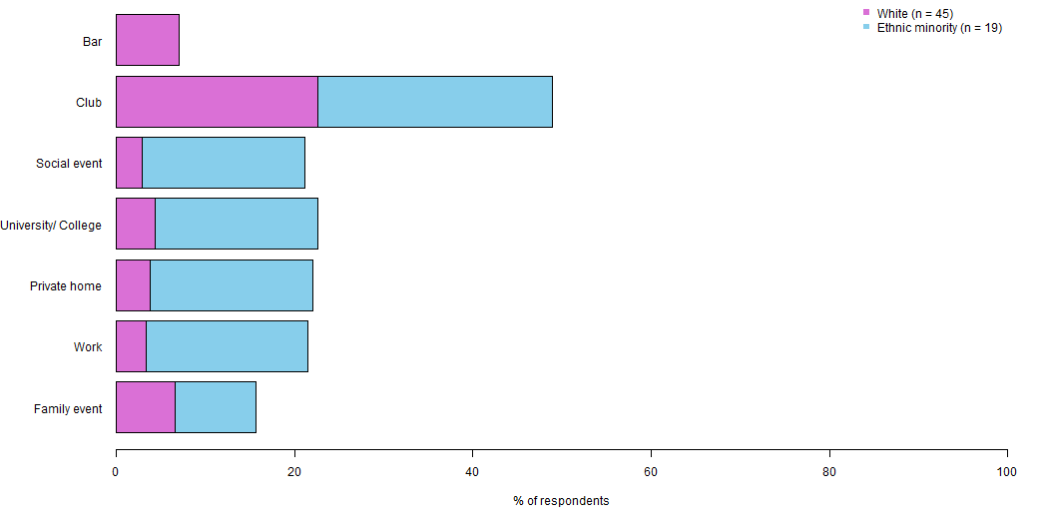
D