Supplementary Information

Nitrate Modulates Microbial Interaction and Biocorrosion Activities of Acid Producing Bacteria
Submitted to: Environmental Science and Pollution Research
Tekle Tafese Fida^{1*}, Taylor Rambo¹, Marie Hall¹, Rebekah Wilson², Scott Leleika¹, Karen Crippen¹
¹ Environmental and Chemical Research group, GTI Energy, Des Plaines, Illinois, USA
² US Army Corps of Engineers, Champaign, Illinois, USA.

*Corresponding author:
Tekle T. Fida
GTI Energy
1700 S Mt Prospect Rd
Des Plaines, IL 60018
E-mail address: tfida@gti.energy
telephone: +1-847-768-0633

Supplementary Figures and Tables

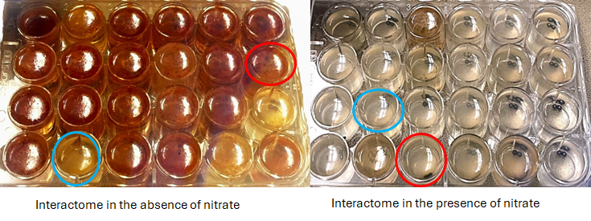
Online resource 1 Corrosion deposits observed in the presence or absence of nitrate during growth of the selected APB interactomes in culture media containing pairs of carbon steel beads. The circled wells indicate interactomes showing the lowest (blue) or the highest (red) beads weight loss for each culture in the presence or absence of nitrate

Online resource 2 Microbial community composition (16S rRNA) of APB consortia in the absence and presence of nitrate
