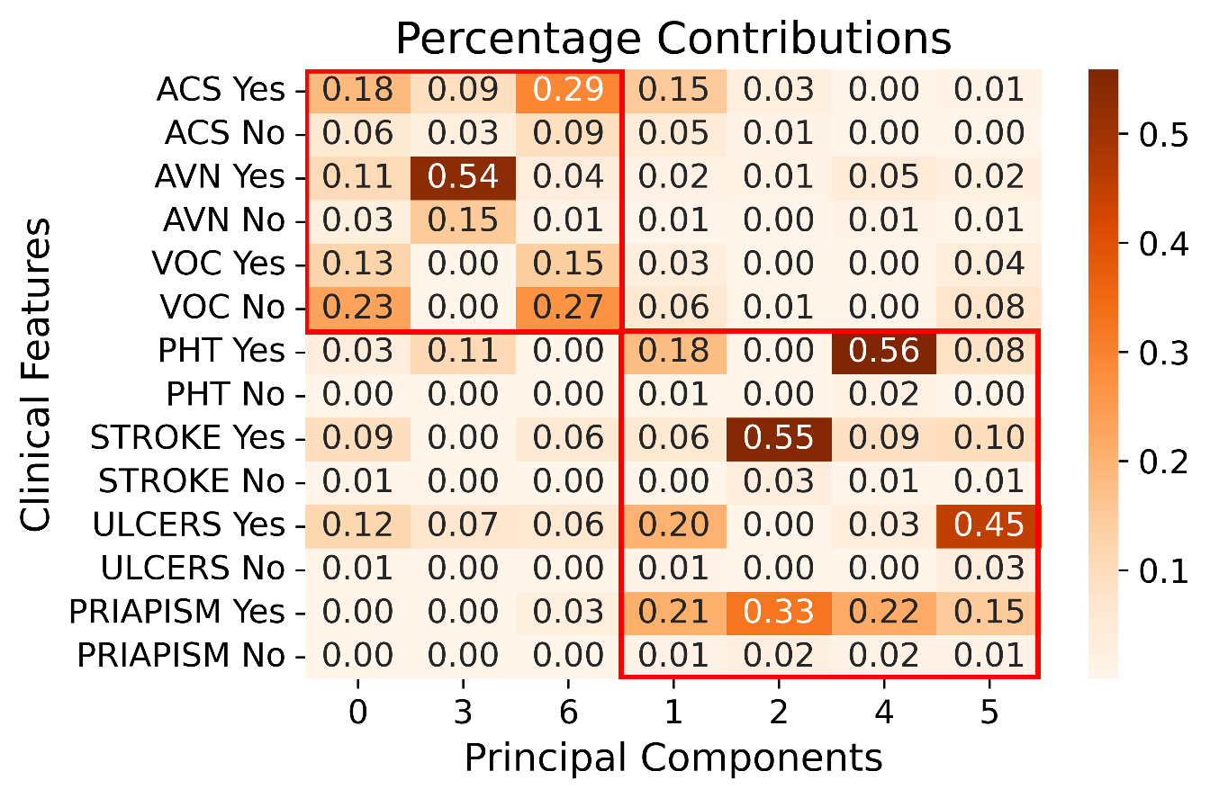
Supplementary Figure 1. The percentage contribution of each category (“Yes” or “No”) within each clinical feature to each principal component.

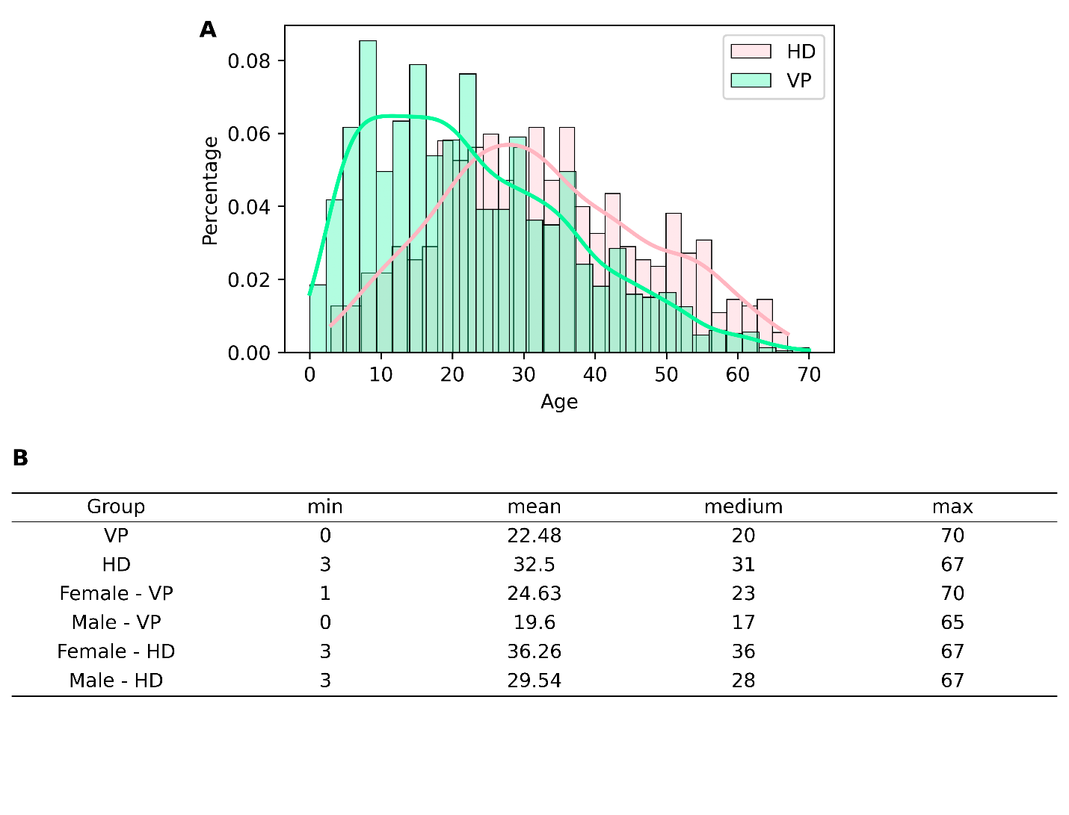
Supplementary Figure 2. Age distributions across gender and subphenotype subsets. (A) Percentage histograms of age distributions for the two subphenotypes, with density curves overlaid. (B) The summary statistics table for each subset shown in Panels A and Figure 2D. VP: Vasoocclusive Primary subphenotype; HD: Hemolysis-Dominant subphenotype.

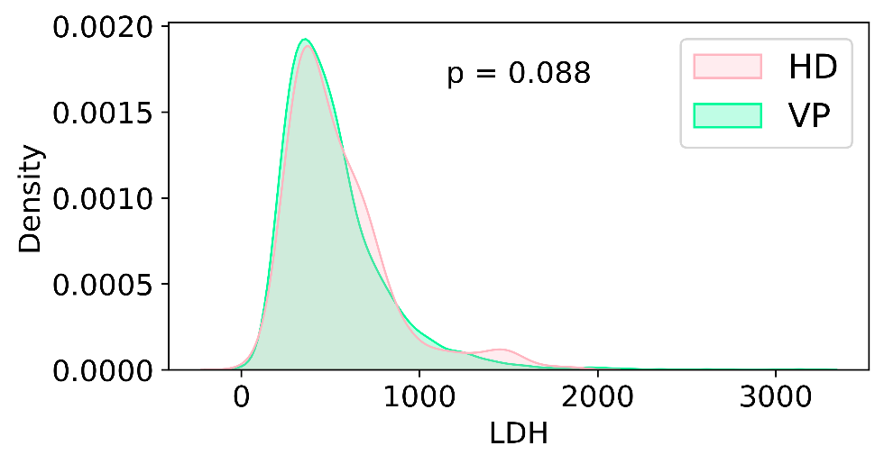
Supplementary Figure 3. Density distribution of LDH by subphenotype (VP and HD) (U/L, N_{total}=1,623, N_{VP}=1,295, N_{HD}=328). A bimodal distribution in HD is clearly visualized. Mann-Whitney U test p value is displayed. VP: Vasoocclusive Primary subphenotype; HD: Hemolysis-Dominant subphenotype.

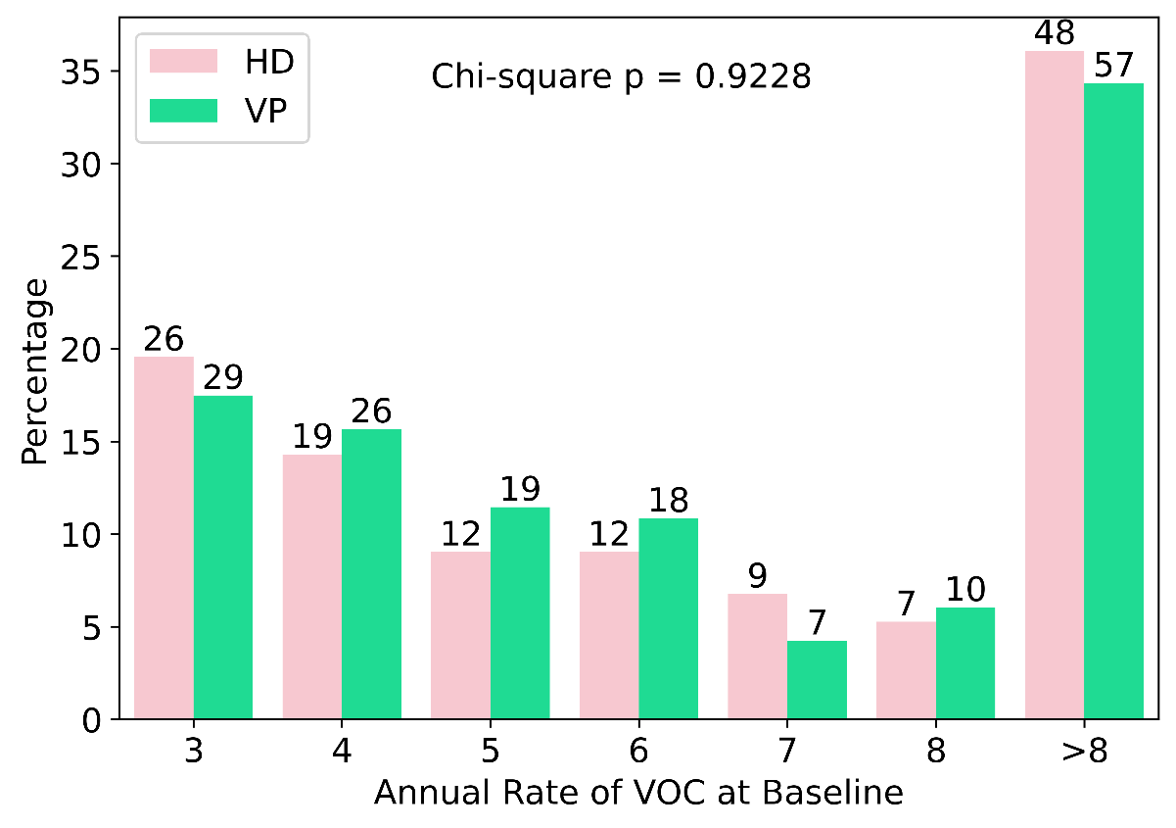
Supplementary Figure 4. The figure shows the percentage of patients in each number of annual rate of VOC events at baseline, stratified by subphenotype. The patient counts in each group are labelled at the top of the bar. N_{Total} = 299, N_{VP}=166, N_{HD}=133. VP: Vasoocclusive Primary subphenotype; HD: Hemolysis-Dominant subphenotype.

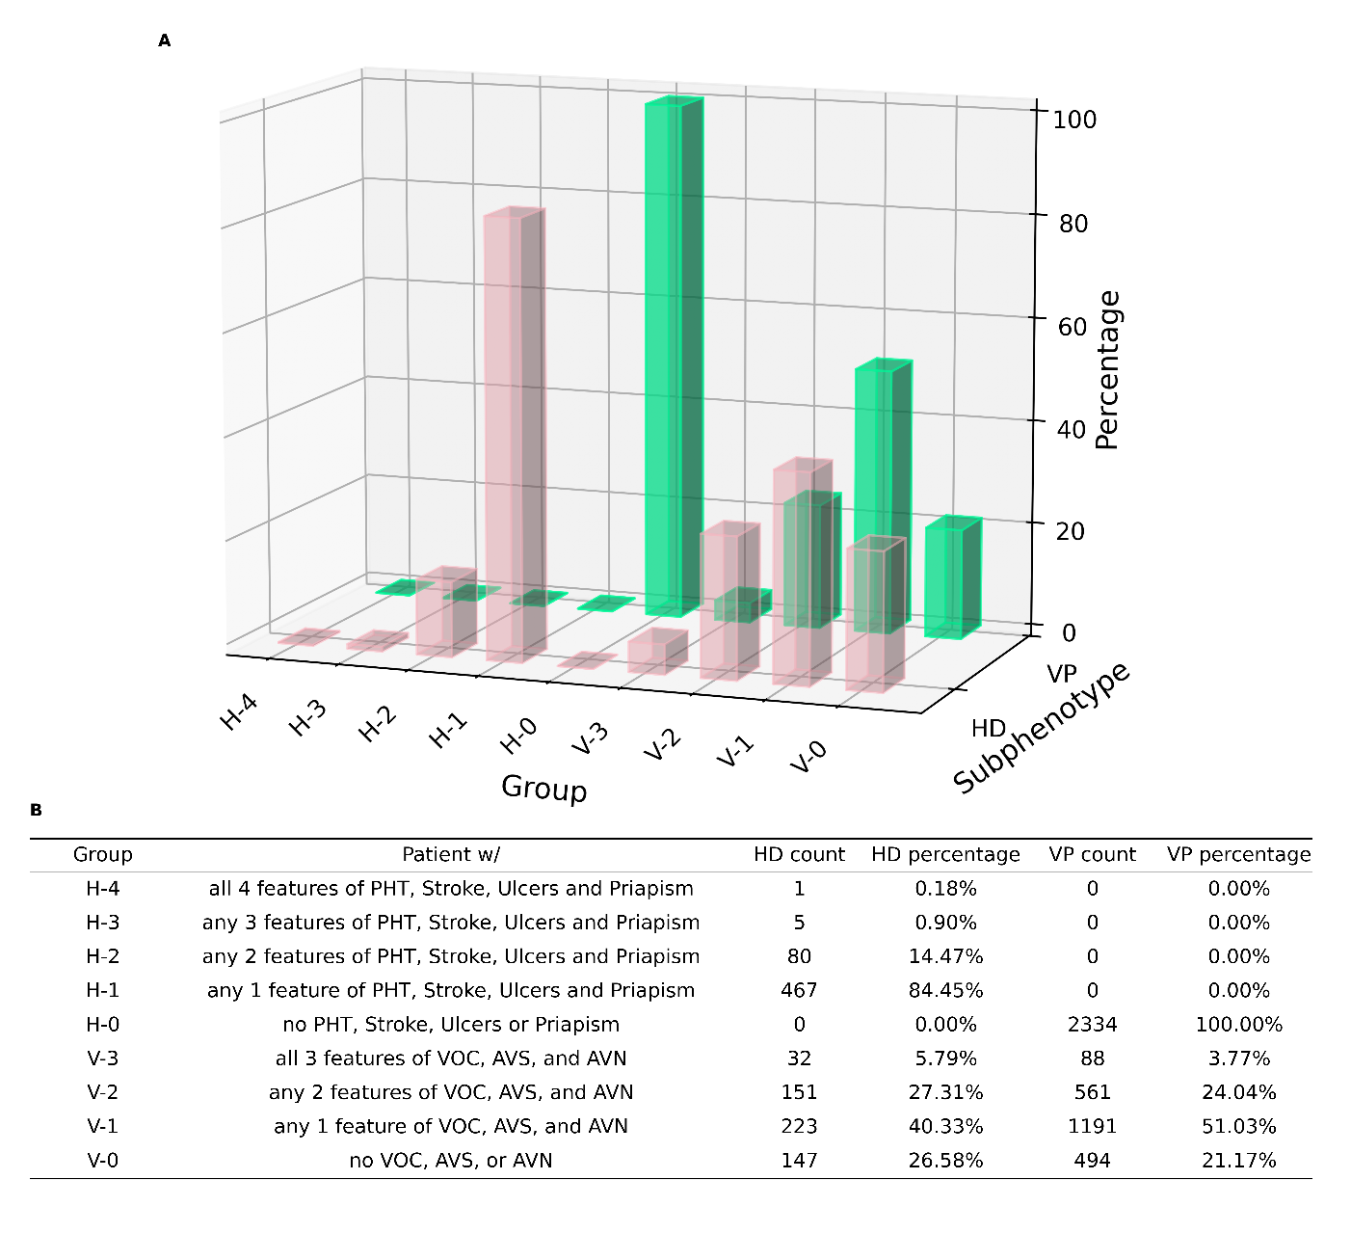
Supplementary Figure 5. Clinical feature distribution across patients within subphenotypes. (A) A 3D bar plot illustrating the proportion of patients in each clinical feature combination group within the subphenotype. (B) A table detailing the group name, an explanation of the group’s clinical feature combination characteristics, and the patient count and percentage of groups within each subphenotype. VP: Vasoocclusive Primary subphenotype; HD: Hemolysis-Dominant subphenotype.

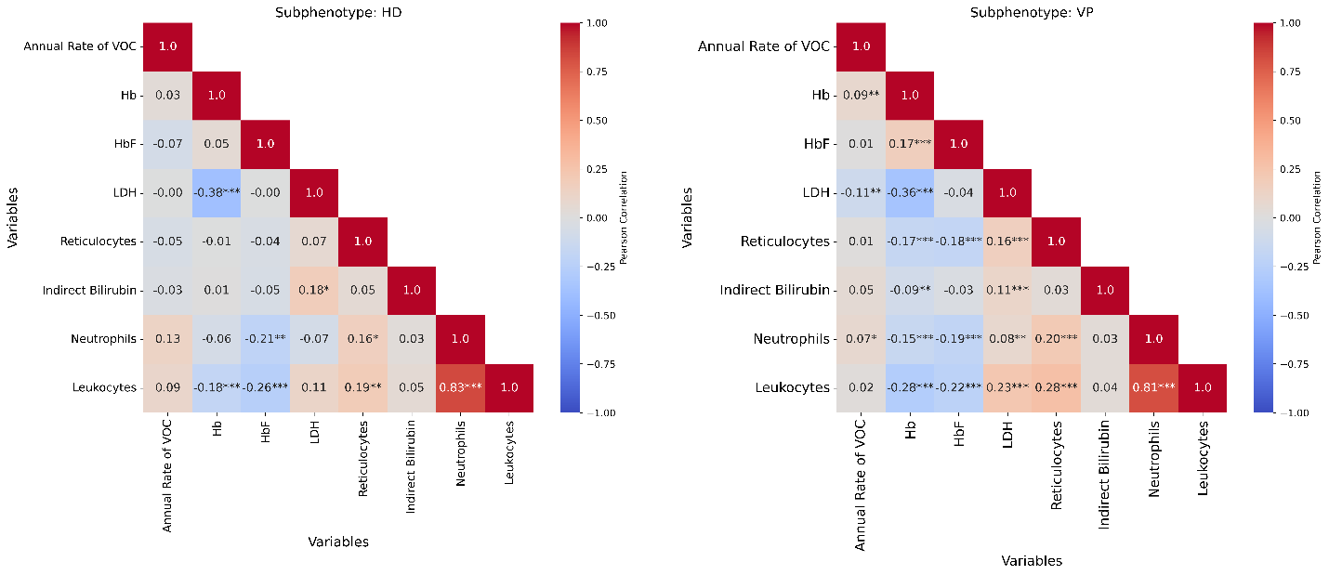Supplementary Figure 6. Correlation matrices of the clinical feature and laboratory biomarkers for HD and VP Subphenotypes. (A) and (B) display the Pearson correlation coefficients between the clinical feature, annual rate of VOC, and all available laboratory biomarkers for the HD and VP subphenotypes, respectively. The lower triangular heatmaps show the correlation matrix, with correlation coefficients colored and labeled in plot, and significant p-values indicated by asterisks (p < 0.001: ***, p < 0.01: **, p < 0.05: *). VP: Vasoocclusive Primary subphenotype; HD: Hemolysis-Dominant subphenotype.

Population | Counts | Percentage
Number of Patients | 2887 | 100.00%
Sex
Female | 1576 | 54.59%
Male | 1300 | 45.03%
Unknown | 11 | 0.38%
Race
African American or Black | 725 | 25.11%
Other | 242 | 8.38%
Unknown | 1920 | 66.51%
Age (year)
0-9 | 506 | 17.53%
10-19 | 727 | 25.18%
20-29 | 655 | 22.69%
30-39 | 511 | 17.70%
40-49 | 279 | 9.66%
50-59 | 153 | 5.30%
60+ | 42 | 1.45%
Unknown | 14 | 0.48%
Mean | 24.41 | 0.85%
Median | 22 | 0.76%
Continent
Europe | 2041 | 70.70%
North America | 412 | 14.27%
Africa | 102 | 3.53%
Asia | 68 | 2.36%
South America | 67 | 2.32%
Other | 59 | 2.04%
Unknown | 138 | 4.78%
Pre-Hydroxyurea Treatment
Yes | 1479 | 51.23%
No | 1270 | 43.99%
Unknown | 138 | 4.78%

Supplementary Table 1. Summary of SCD population from clinical trial database.

Feature Name | Proportion of Subjects with Vasooclusive Features in Each Subphenotype |  | p value
Feature Name | VP (%) | HD (%) | p value
VOC | 65.94 | 60.4 | 0.0162
ACS | 23.52 | 24.59 | 0.6335
AVN | 20.95 | 27.31 | 0.0015

Supplementary Table 2. The Proportion of Subjects with Vasooclusive Features. This table presents the proportion of patients who have the listed clinical features (VOC, ACS, AVN) at baseline in the VP and HD subphenotypes. P-values from Chi-square tests are shown to assess the statistical significance of differences between subphenotypes. NVP = 2,334, NHD = 553. VP: Vasoocclusive Primary subphenotype; HD: Hemolysis-Dominant subphenotype.

 | Age group | Value range
Hb | 0-1 | 0-17
 | 1-17 | 0-15
 | >=18 | 0-18
HbF | 0-1 | 0-20
 | 1-10 | 0-15
 | 10-17 | 0-10
 | >=18 | 0-5
LDH | 0-1 | 0-450
 | 1-17 | 0-370
 | >=18 | 0-225
Indirect bilirubin | - | 0-0.8
Reticulocytes | - | 0-100
Neutrophils | 0-1 | 0-15
 | 1-17 | 0-10
 | >=18 | 0-7
Leukocytes | 0-1 | 0-19
 | >1 | 0-11

Supplementary Table 3. Age-specific value ranges used for the normalization of laboratory biomarkers. These ranges were based on the literature reported for both normal individual and patient’s with SCD.

Biomarker/Clinical Feature | Missing data in VP | Missing data in HD
Hb | 250/10.71% | 51/9.22%
HbF | 1004/43.02% | 212/38.34%
Indirect Bilirubin | 793/33.98% | 153/27.67%
LDH | 1039/44.52% | 225/40.69%
Reticulocytes | 806/34.53% | 167/30.20%
Neutrophils | 433/18.55% | 89/16.09%
Leukocytes | 284/12.17% | 58/10.49%
Annual Rate of VOC | 855/36.63% | 217/39.24%

Supplementary Table 4. Summary of missing data. Patient counts and percentages of missing data counts for biomarkers in the VP and HD subphenotypes. VP: Vasoocclusive Primary subphenotype; HD: Hemolysis-Dominant subphenotype.

Population | Counts | Percentage
Number of Patients | 299 | 100.00%
Sex
Female | 153 | 51.17%
Male | 146 | 48.83%
Race
Black | 292 | 97.66%
Other | 7 | 2.34%
Age (year)
0-9 | 0 | 0.00%
10-19 | 21 | 7.02%
20-29 | 132 | 44.15%
30-39 | 115 | 38.46%
40-49 | 26 | 8.70%
50-59 | 5 | 1.67%
60+ | 0 | 0.00%
Mean | 29.79 | 9.96%
Median | 29 | 9.70%

Supplementary Table 5. Summary of SCD population from MSH study.

Biomarker | Subphenotype |  | Age
Biomarker | Coefficient | p value | Coefficient | p value
Hb | 0.43 | < 0.001 | 0.01 | < 0.001
HbF | 1.1 | 0.059 | 0.03 | 0.058
LDH | -60.11 | 0.001 | -3.78 | < 0.001
Indirect Bilirubin | -0.83 | 0.083 | -0.04 | 0.004
Reticulocytes | -29.29 | 0.012 | -2.32 | < 0.001
Leukocytes | -0.42 | 0.032 | -0.08 | < 0.001
Neutrophils | -0.04 | 0.804 | -0.02 | < 0.001

Supplementary Table 6. Coefficients and p-values from Generalized Linear Models (GLM) assessing the association between biomarkers and subphenotype and age. The table presents the estimated coefficients for the effect of subphenotype and age on each biomarker, along with the corresponding p-values indicating statistical significance. A positive coefficient for subphenotype indicates higher biomarker levels in VP patients compared to HD patients, adjusted for age. VP: Vasoocclusive Primary subphenotype; HD: Hemolysis-Dominant subphenotype.

Multiple Comparison of Means - Tukey HSD, FWER=0.05
Group 1 | Group 2 | p-adj | meandiff
HD HbSBeta | HD HbSS | 0.0168 | -5.0255
VP HbSBeta | VP HbSS | <0.001 | -3.1683
HD HbSBeta | VP HbSBeta | 0.8884 | -1.2428
HD HbSS | VP HbSS | 0.7629 | 0.6144

Supplementary Table 7. Multiple Comparison of Means using Tukey HSD for the comparison of HbF between different genotypes (HbSBeta and HbSS) and subphenotypes (HD and VP) combinations. The p-values represent the adjusted significance levels (FWER = 0.05) for pairwise comparisons, with meandiff indicating the difference in means between the groups (Higher mean group is marked in bold, meandiff = mean(group2) - mean(group1)). A p-value less than 0.05 suggests a statistically significant difference. N_{HD HbSBeta}= 33, N_{HD HbSS}= 281, N_{VP HbSBeta}= 230, N_{VP HbSS}= 934. VP: Vasoocclusive Primary subphenotype; HD: Hemolysis-Dominant subphenotype.

