Electronic Supplemenatry Material

Thymosin β4 is an endogenous iron chelator and molecular switcher of ferroptosis
Joanna I. Lachowicz¹, Giusi Pichiri,^{1,*} Marco Piludu^{2,*}, Sara Fais³, Germano Orrù³, Terenzio Congiu¹, Monica Piras¹, Gavino Faa¹, Daniela Fanni¹, Gabriele dalla Torre⁴, Xabier Lopez⁴, Kousik Chandra, ⁵ Kacper Szczepski, ⁵ Lukasz Jaremko, ⁵ Mitra Ghosh, ⁵ Abdul-Hamid Emwas,⁶ Castagnola Massimo^{7,8}, Mariusz Jaremko^{5,*} Ewald Hannappel⁹ and Pierpaolo Coni¹.
¹Department of Medical Sciences and Public Health, University of Cagliari, Cittadella Universitaria, 09042 Monserrato, Italy
²Department of Biomedical Sciences, University of Cagliari, Cittadella Universitaria, 09042 Monserrato, Italy
³Department of Surgical Science, OBL Oral Biotechnology Laboratory, University of Cagliari, Cagliari Italy
⁴Kimika Fakultatea, Euskal Herriko Unibertsitatea UPV/EHU, Donostia International Physics Center (DIPC), P.K. 1072 Donostia Euskadi, San Sebastian, 20080, Spain
⁵Division of Biological and Environmental Sciences and Engineering (BESE), King Abdullah University of Science and Technology (KAUST), 23955-6900 Thuwal, Saudi Arabia.
⁶Core Labs, King Abdullah University of Science and Technology (KAUST), 23955-6900 Thuwal, Saudi Arabia.
⁷Institute of Chemistry of Molecular Recognition, National Research Council (Consiglio Nazionale delle Ricerche), Rome, Italy
⁸Laboratory of Proteomics and Metabolomics, IRCCS, Santa Lucia Foundation, Rome, Italy
⁹Friedrich-Alexander-University Erlangen-Nuremberg, Institute of Biochemistry, Erlangen, Germany

*Corresponding Authors: Marco Piludu (piludu@unica.it); Mariusz Jaremko (Mariusz.jaremko@kaust.edu.sa); Giuseppina Pichiri (pichiri@unica.it);

TABLE OF CONTEST

Figure S1. The assigned ¹³C-¹H HSQC of free thymosin (Tβ4) in D₂O. 2048 and 512 data points were collected in proton and carbon dimensions, respectively, which correspond to 125 ms and 18 ms acquisition time in the respective dimension. The data were apodized with sine function and zero filled with 4096 and 1024 points in proton and carbon dimensions, respectively. The recycle delay was kept for 1 second. The total measurement time was 300 minutes.
Figure S2. The overlay of the two-dimensional ¹³C-¹H HSQC spectra in free Tβ4 form (red) and with Fe²⁺/Thymosin molar ratio 0.2:1 (yellow). Peptide concentration 1.48 mM. The upfield shifted carbon region are shown here. The highlighted residues in the blue dotted circles shows intensity change. No change in chemical shifts were observed.
Figure S3. The overlay of the two-dimensional ¹³C-¹H HSQC spectra in free Tβ4 form (red) and with Fe²⁺/Thymosin molar ratio 0.2:1 (yellow). The downfield shifted carbon region is shown here. The highlighted residues in the blue dotted circles show intensity change. No change in chemical shifts were observed.
Figure S4. The percentage change in intensities from apo to molar ratio 0.2:1 Fe(II)/Thymosine are plotted for the distinct residues from the two-dimensional ¹³C-¹H HSQC spectra. The red line represents the mean + standard deviation value. Beyond this, the existing residues are considered as major changes.
Figure S5. The overlay of the two-dimensional ¹³C-¹H HSQC spectra in free Tβ4 form (red) and with Fe³⁺/Thymosin molar ratio 0.2:1 (yellow). The upfield shifted carbon region are shown here. The highlighted residues in the blue dotted circles show intensity changes. No changes in chemical shifts are observed.
Figure S6. The overlay of the two-dimensional ¹³C-¹H HSQC spectra in free Tβ4 form (red) and with Fe³⁺/Thymosin molar ratio 0.2:1 (yellow). The downfield shifted carbon region are shown here. The highlighted residues in the blue dotted circles show intensity change. No change in chemical shifts were observed.
Figure S7. The percentage change in intensities from apo to molar ratio 0.2:1 Fe(III):Thymosine are plotted for the distinct residues from the two-dimensional ¹³C-¹H HSQC spectra. The red line represents the mean + standard deviation value. Beyond this, the existing residues are considered as a major change.
Figure S8. EPR spectra of free Tb4 (0.3 mM) and A) iron (II) and B) iron (III) in water; pH=7.4 (fixed by the addition of NaOH); metal to peptide molar ratio 1:1.

Figure S9. CD spectra of free Tβ4 and its iron (II) and iron (III) adducts in Tris buffer (pH 7.5).
Figure S10. The assigned ¹³C-¹H HSQC of free thymosin Tβ4 in D₂O. 2048 and 360 data points were collected in proton and carbon dimensions respectively, which correspond to 125 ms and 12.7ms acquisition time in the respective dimension. The data were apodized with sine function and zero filled with 4096 and 1024 points in proton and carbon dimensions, respectively. The recycle delay was kept for 1 second. The total measurement time was 110 minutes.
Figure S11. The assigned ¹³C-¹H TOCSY-HSQC of free thymosin Tβ4 in D₂O. Mixing time was kept at 16ms. 2048 and 360 data points were collected in proton and carbon dimensions, respectively, which correspond to 125 ms and 16.2ms acquisition time in the respective dimension. The data were apodized with sine function and zero filled with 4096 and 1024 points in proton and carbon dimensions, respectively. The recycle delay was kept for 1.5 seconds. The total measurement time was 240 minutes.
Figure S12. The overlay of the one dimension proton spectra with different Thymosin:Al ratios.
Figure S13. The intensities are plotted for the 48 distinct residues from the two-dimensional ¹³C-¹H HSQC spectra as a function of the Thymosin:Al ratio.
Figure S14. The chemical shift perturbation (CSP) plot for the distinct C^{α}-H^{α} residues from the overlay of the two-dimensional ¹³C-¹H HSQC spectra in free form and with Thymosin:Al ratio 1:5.
Figure S15. The chemical shift perturbation (CSP) plot for the distinct C-H and other side chainsfrom the overlay of the two-dimensional ¹³C-¹H HSQC spectra in free form and with Thymosin:Al ratio 1:5.
Table S1. Average structural parameters for the three MD simulations.
Table S2. Occupancies and average number of residues involved in eight different secondary structure motifs.
Table S3. Multistep equilibration scheme with decreasing force constants employed in the molecular dynamics study. FC: Force constants. The subscript bb refers to backbone force constants.

Figure S16. Secondary structure analysis according to the DSSP definitions of Tβ4^{N-C}.
Figure S17. Secondary structure analysis according to the DSSP definitions of Tβ4^{N-mid}.
Figure S18. Secondary structure analysis according to the DSSP definitions of Tβ4^{N-N}.
Figure S19. Electron micrographs of a mitotic J774 cell. Arrows indicate the condensed packed chromatin of the chromosomes.

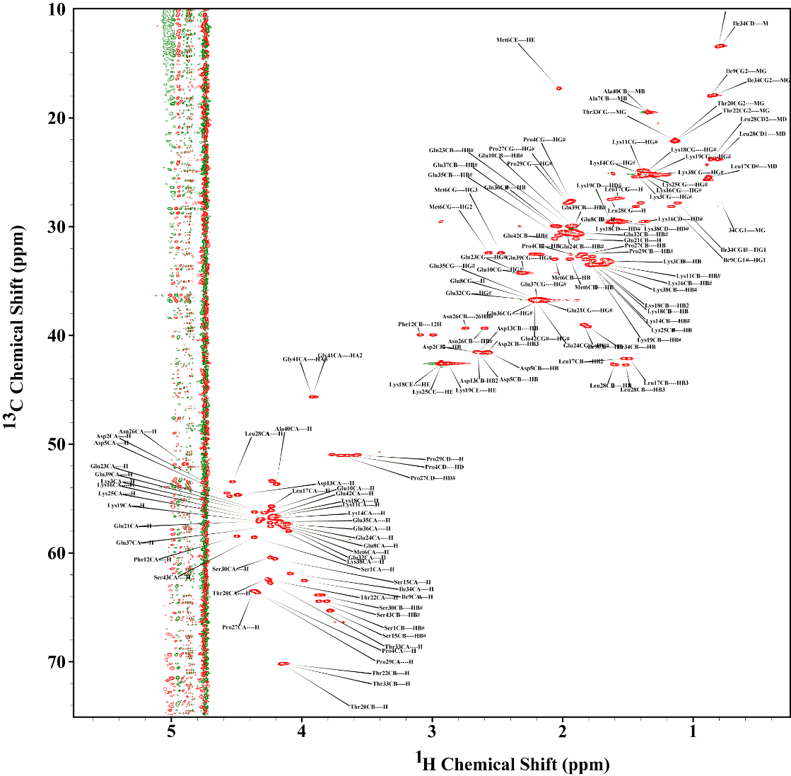
Figure S1. The assigned ¹³C-¹H HSQC of free thymosin (Tβ4) in D₂O. 2048 and 512 data points were collected in proton and carbon dimensions, respectively, which correspond to 125 ms and 18 ms acquisition time in the respective dimension. The data were apodized with sine function and zero filled with 4096 and 1024 points in proton and carbon dimensions, respectively. The recycle delay was kept for 1 second. The total measurement time was 300 minutes.

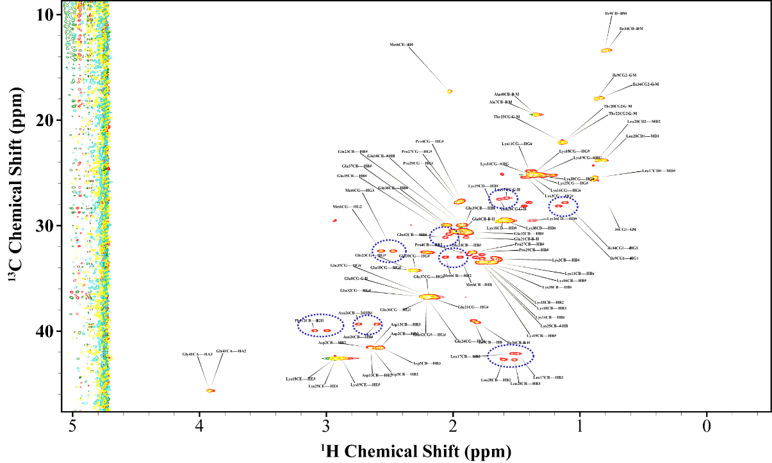
Figure S2. The overlay of the two-dimensional ¹³C-¹H HSQC spectra in free Tβ4 form (red) and with Fe²⁺/Thymosin molar ratio 0.2:1 (yellow). Peptide concentration 1.48 mM. The upfield shifted carbon region are shown here. The highlighted residues in the blue dotted circles shows intensity change. No change in chemical shifts were observed.

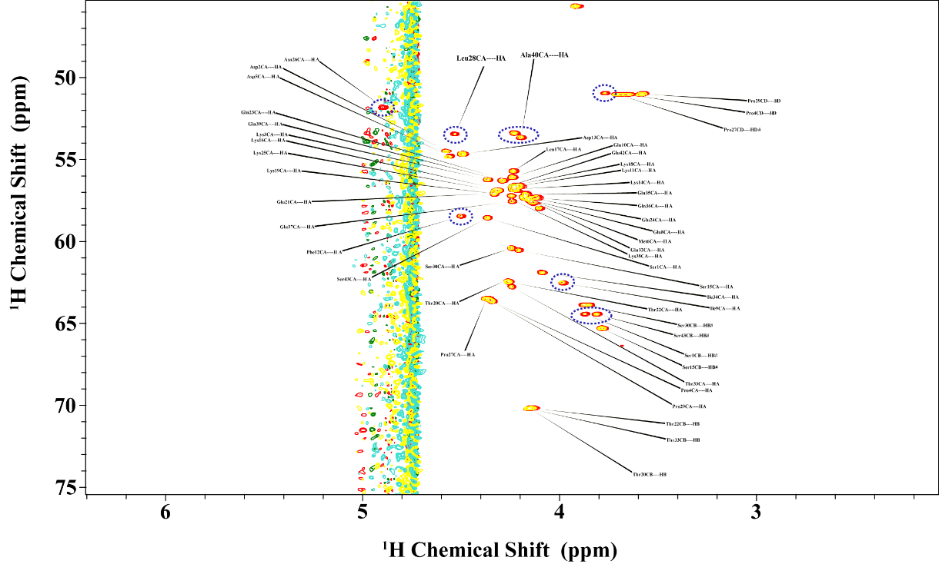

Figure S3. The overlay of the two-dimensional ¹³C-¹H HSQC spectra in free Tβ4 form (red) and with Fe²⁺/Thymosin molar ratio 0.2:1 (yellow). The downfield shifted carbon region is shown here. The highlighted residues in the blue dotted circles show intensity change. No change in chemical shifts were observed.
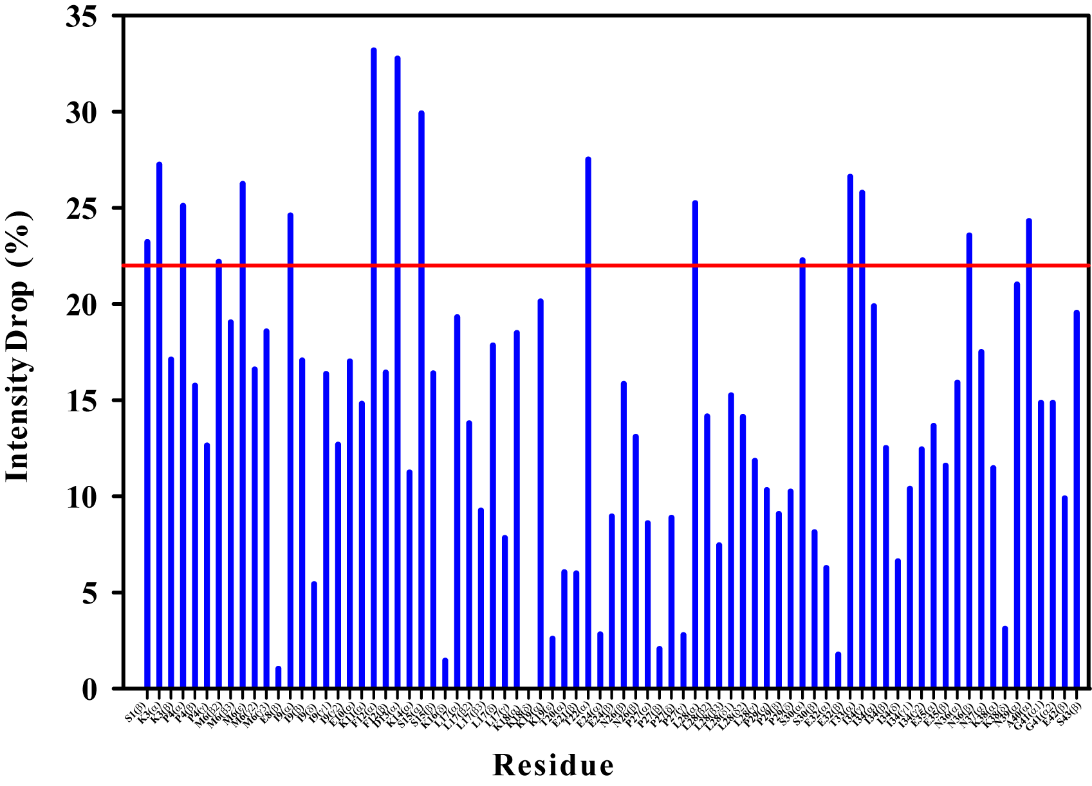
Figure S4. The percentage change in intensities from apo to molar ratio 0.2:1 Fe(II)/Thymosine are plotted for the distinct residues from the two-dimensional ¹³C-¹H HSQC spectra. The red line represents the mean + standard deviation value. Beyond this, the existing residues are considered as major changes.

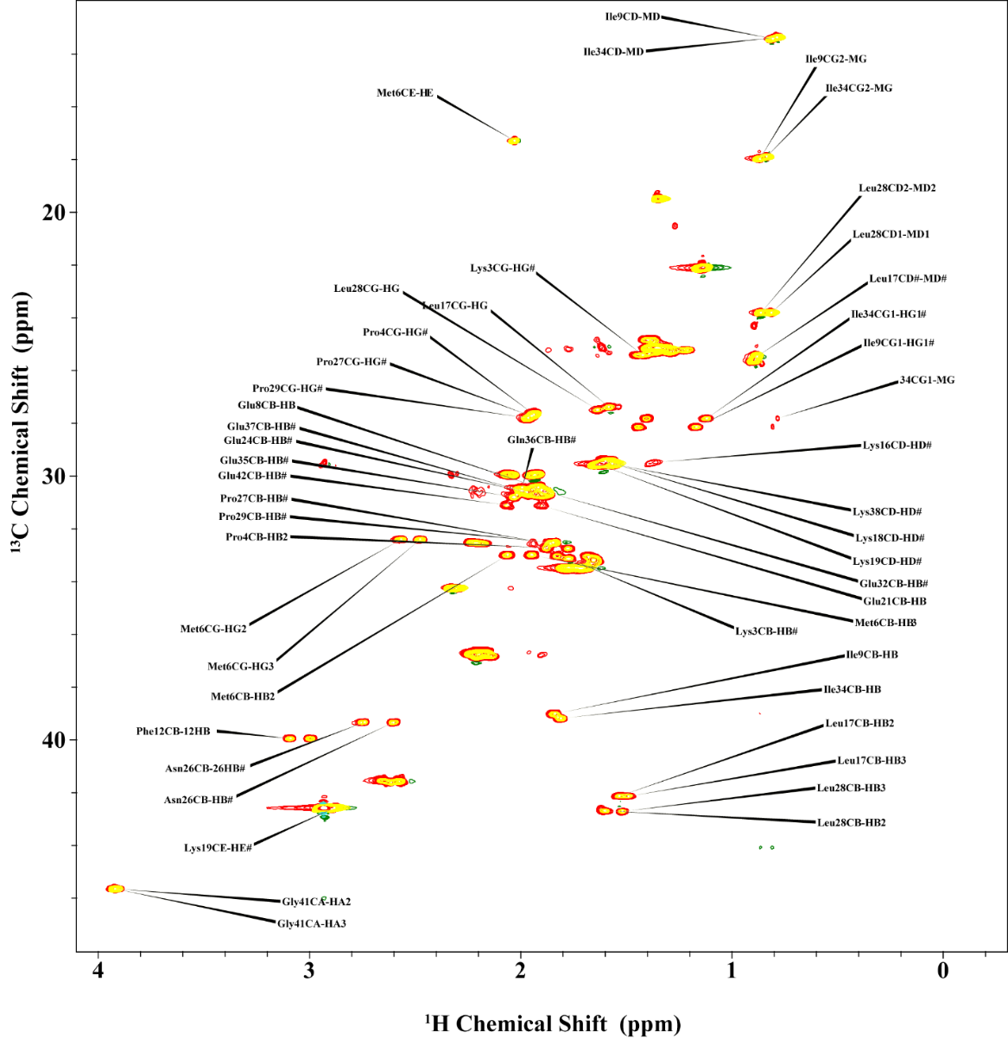

Figure S5. The overlay of the two-dimensional ¹³C-¹H HSQC spectra in free Tβ4 form (red) and with Fe³⁺/Thymosin molar ratio 0.2:1 (yellow). The upfield shifted carbon region are shown here. The highlighted residues in the blue dotted circles show intensity changes. No changes in chemical shifts are observed.
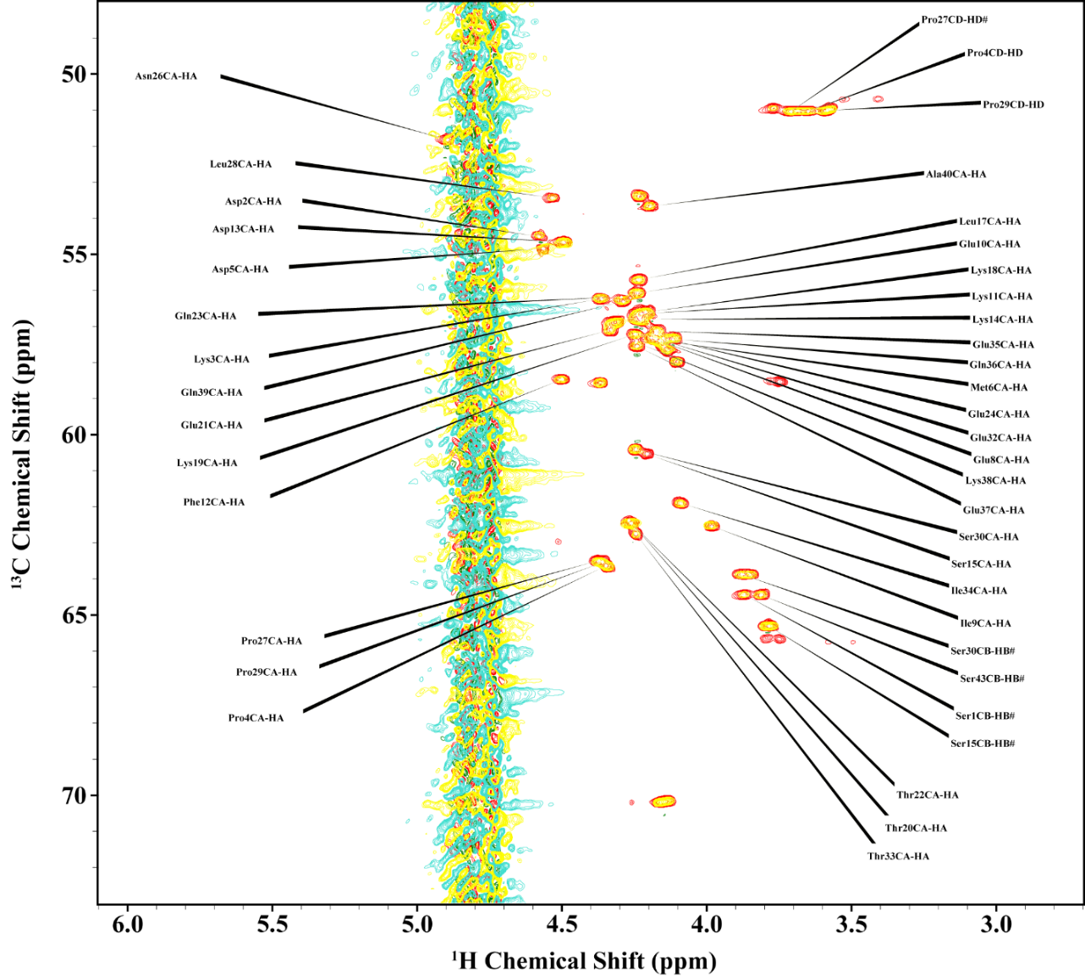

Figure S6. The overlay of the two-dimensional ¹³C-¹H HSQC spectra in free Tβ4 form (red) and with Fe³⁺/Thymosin molar ratio 0.2:1 (yellow). The downfield shifted carbon region are shown here. The highlighted residues in the blue dotted circles show intensity change. No change in chemical shifts were observed.

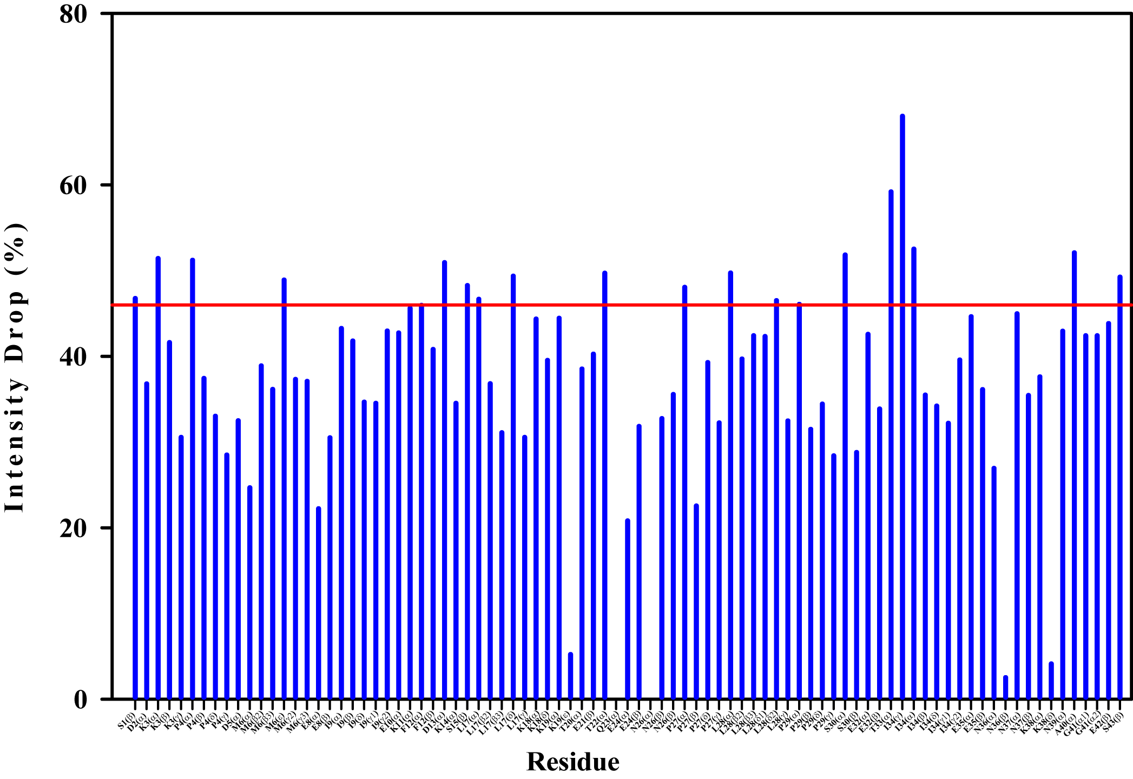
Figure S7. The percentage change in intensities from apo to molar ratio 0.2:1 Fe(III):Thymosine are plotted for the distinct residues from the two-dimensional ¹³C-¹H HSQC spectra. The red line represents the mean + standard deviation value. Beyond this, the existing residues are considered as a major change.

Figure S8. EPR spectra of free Tb4 (0.3 mM) and A) iron (II) and B) iron (III) in water; pH=7.4 (fixed by the addition of NaOH); metal to peptide molar ratio 1:1.

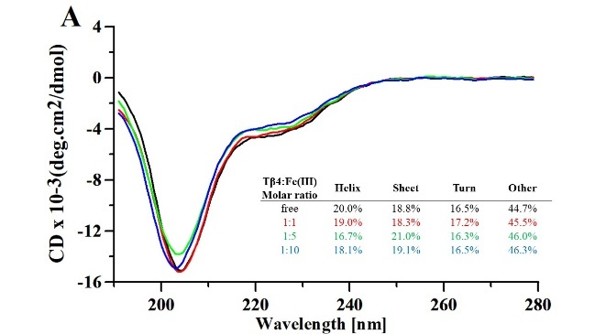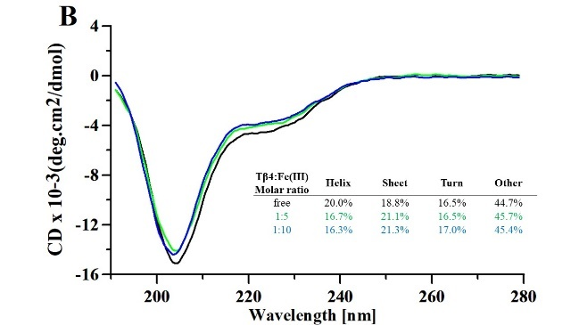

Figure S9. CD spectra of free Tβ4 and its iron (II) and iron (III) adducts in Tris buffer (pH 7.5).

Figure S10. The assigned ¹³C-¹H HSQC of free thymosin Tβ4 in D₂O. 2048 and 360 data points were collected in proton and carbon dimensions respectively, which correspond to 125 ms and 12.7ms acquisition time in the respective dimension. The data were apodized with sine function and zero filled with 4096 and 1024 points in proton and carbon dimensions, respectively. The recycle delay was kept for 1 second. The total measurement time was 110 minutes.
Figure S11. The assigned ¹³C-¹H TOCSY-HSQC of free thymosin Tβ4 in D₂O. Mixing time was kept at 16ms. 2048 and 360 data points were collected in proton and carbon dimensions, respectively, which correspond to 125 ms and 16.2ms acquisition time in the respective dimension. The data were apodized with sine function and zero filled with 4096 and 1024 points in proton and carbon dimensions, respectively. The recycle delay was kept for 1.5 seconds. The total measurement time was 240 minutes.

Figure S12. The overlay of the one dimension proton spectra with different Thymosin:Al ratios.

Figure S13. The intensities are plotted for the 48 distinct residues from the two-dimensional ¹³C-¹H HSQC spectra as a function of the Thymosin:Al ratio.
Figure S14. The chemical shift perturbation (CSP) plot for the distinct C^{α}-H^{α} residues from the overlay of the two-dimensional ¹³C-¹H HSQC spectra in free form and with Thymosin:Al ratio 1:5.

Figure S15. The chemical shift perturbation (CSP) plot for the distinct C-H and other side chainsfrom the overlay of the two-dimensional ¹³C-¹H HSQC spectra in free form and with Thymosin:Al ratio 1:5.

Table S1. Average structural parameters for the three MD simulations.
Al-thymosin complex | RMSD (Å) | Rg (Å) | End to end distance (Å) | H-bonds
TB4^{N-C} | 0.92 | 1.15 | 22.27 | 12.06
TB4^{N-mid} | 0,89 | 1.11 | 24.37 | 15.28
TB4^{N-N} | 1.07 | 1.29 | 28.03 | 12.62
Table S2. Occupancies and average number of residues involved in eight different secondary structure motifs.
 | TB4^{N-C} |  | TB4^{N-mid} |  | TB4^{N-N}
Motif | (%) | n. res. | (%) | n. res. | (%) | n. res.
Random Coil | 100 | 22.5 | 100 |  | 100
β-sheet | 16.8 | 4.4 | 17.6 | 4.4 | 2.5
β-bridge | 62.6 | 2.7 | 52.0 |  | 26.1
Bend | 100 | 11.8 | 100 |  | 99.9
Turn | 89.3 | 4.8 | 92.7 |  | 87.4
α-helix | 18.3 | 4.7 | 26.4 | 5.0 | 26.5 | 4.8
π-helix | 0.07 | 5.0 | 0.9 | 5.0 | 0 | 0
3₁₀-helix | 31.5 | 3.63 | 38.7 | 3.5 | 94.1 | 4.8

Table S3. Multistep equilibration scheme with decreasing force constants employed in the molecular dynamics study. FC: Force constants. The subscript bb refers to backbone force constants.

Equilibration  Step | FC_{bb}  (kJ/mol nm²) | NPT/NVT | Time  (ns)
Step 1 | 4000.0 | NVT | 0.6
Step 2 | 2000.0 | NVT | 0.6
Step 3 | 1000.0 | NPT | 0.6
Step 4 | 500.0 | NPT | 0.6
Step 5 | 200.0 | NPT | 0.6
Step 6 | 50.0 | NPT | 0.5
Step 7 | 0.0 | NPT | 0.5

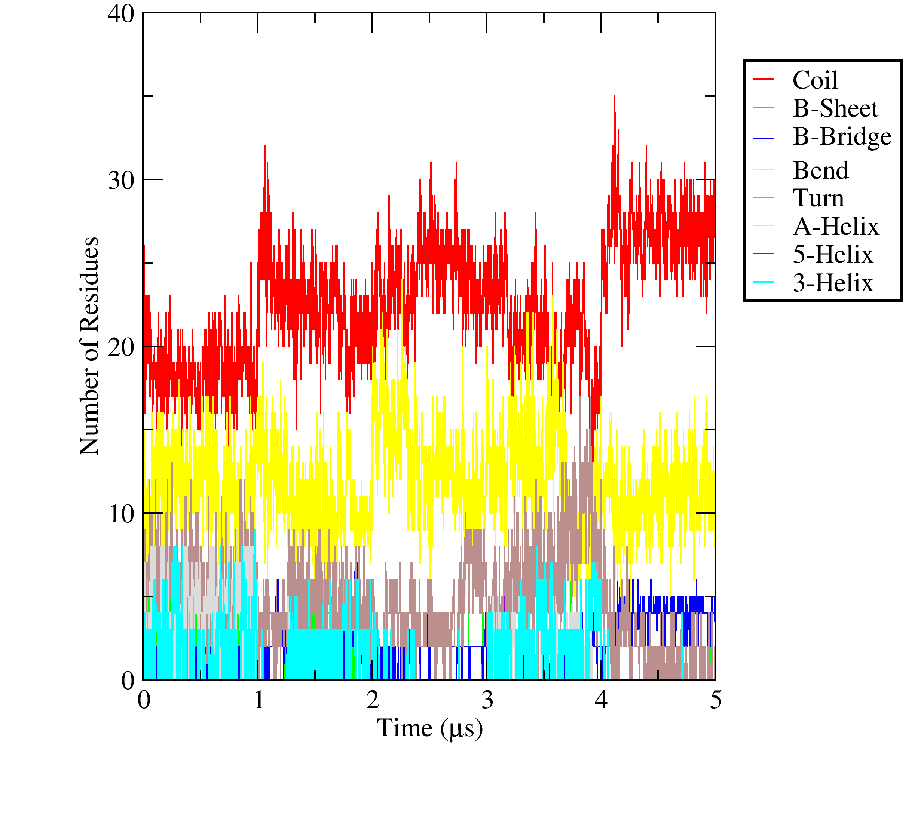
Figure S16. Secondary structure analysis according to the DSSP definitions of Tβ4^{N-C}.

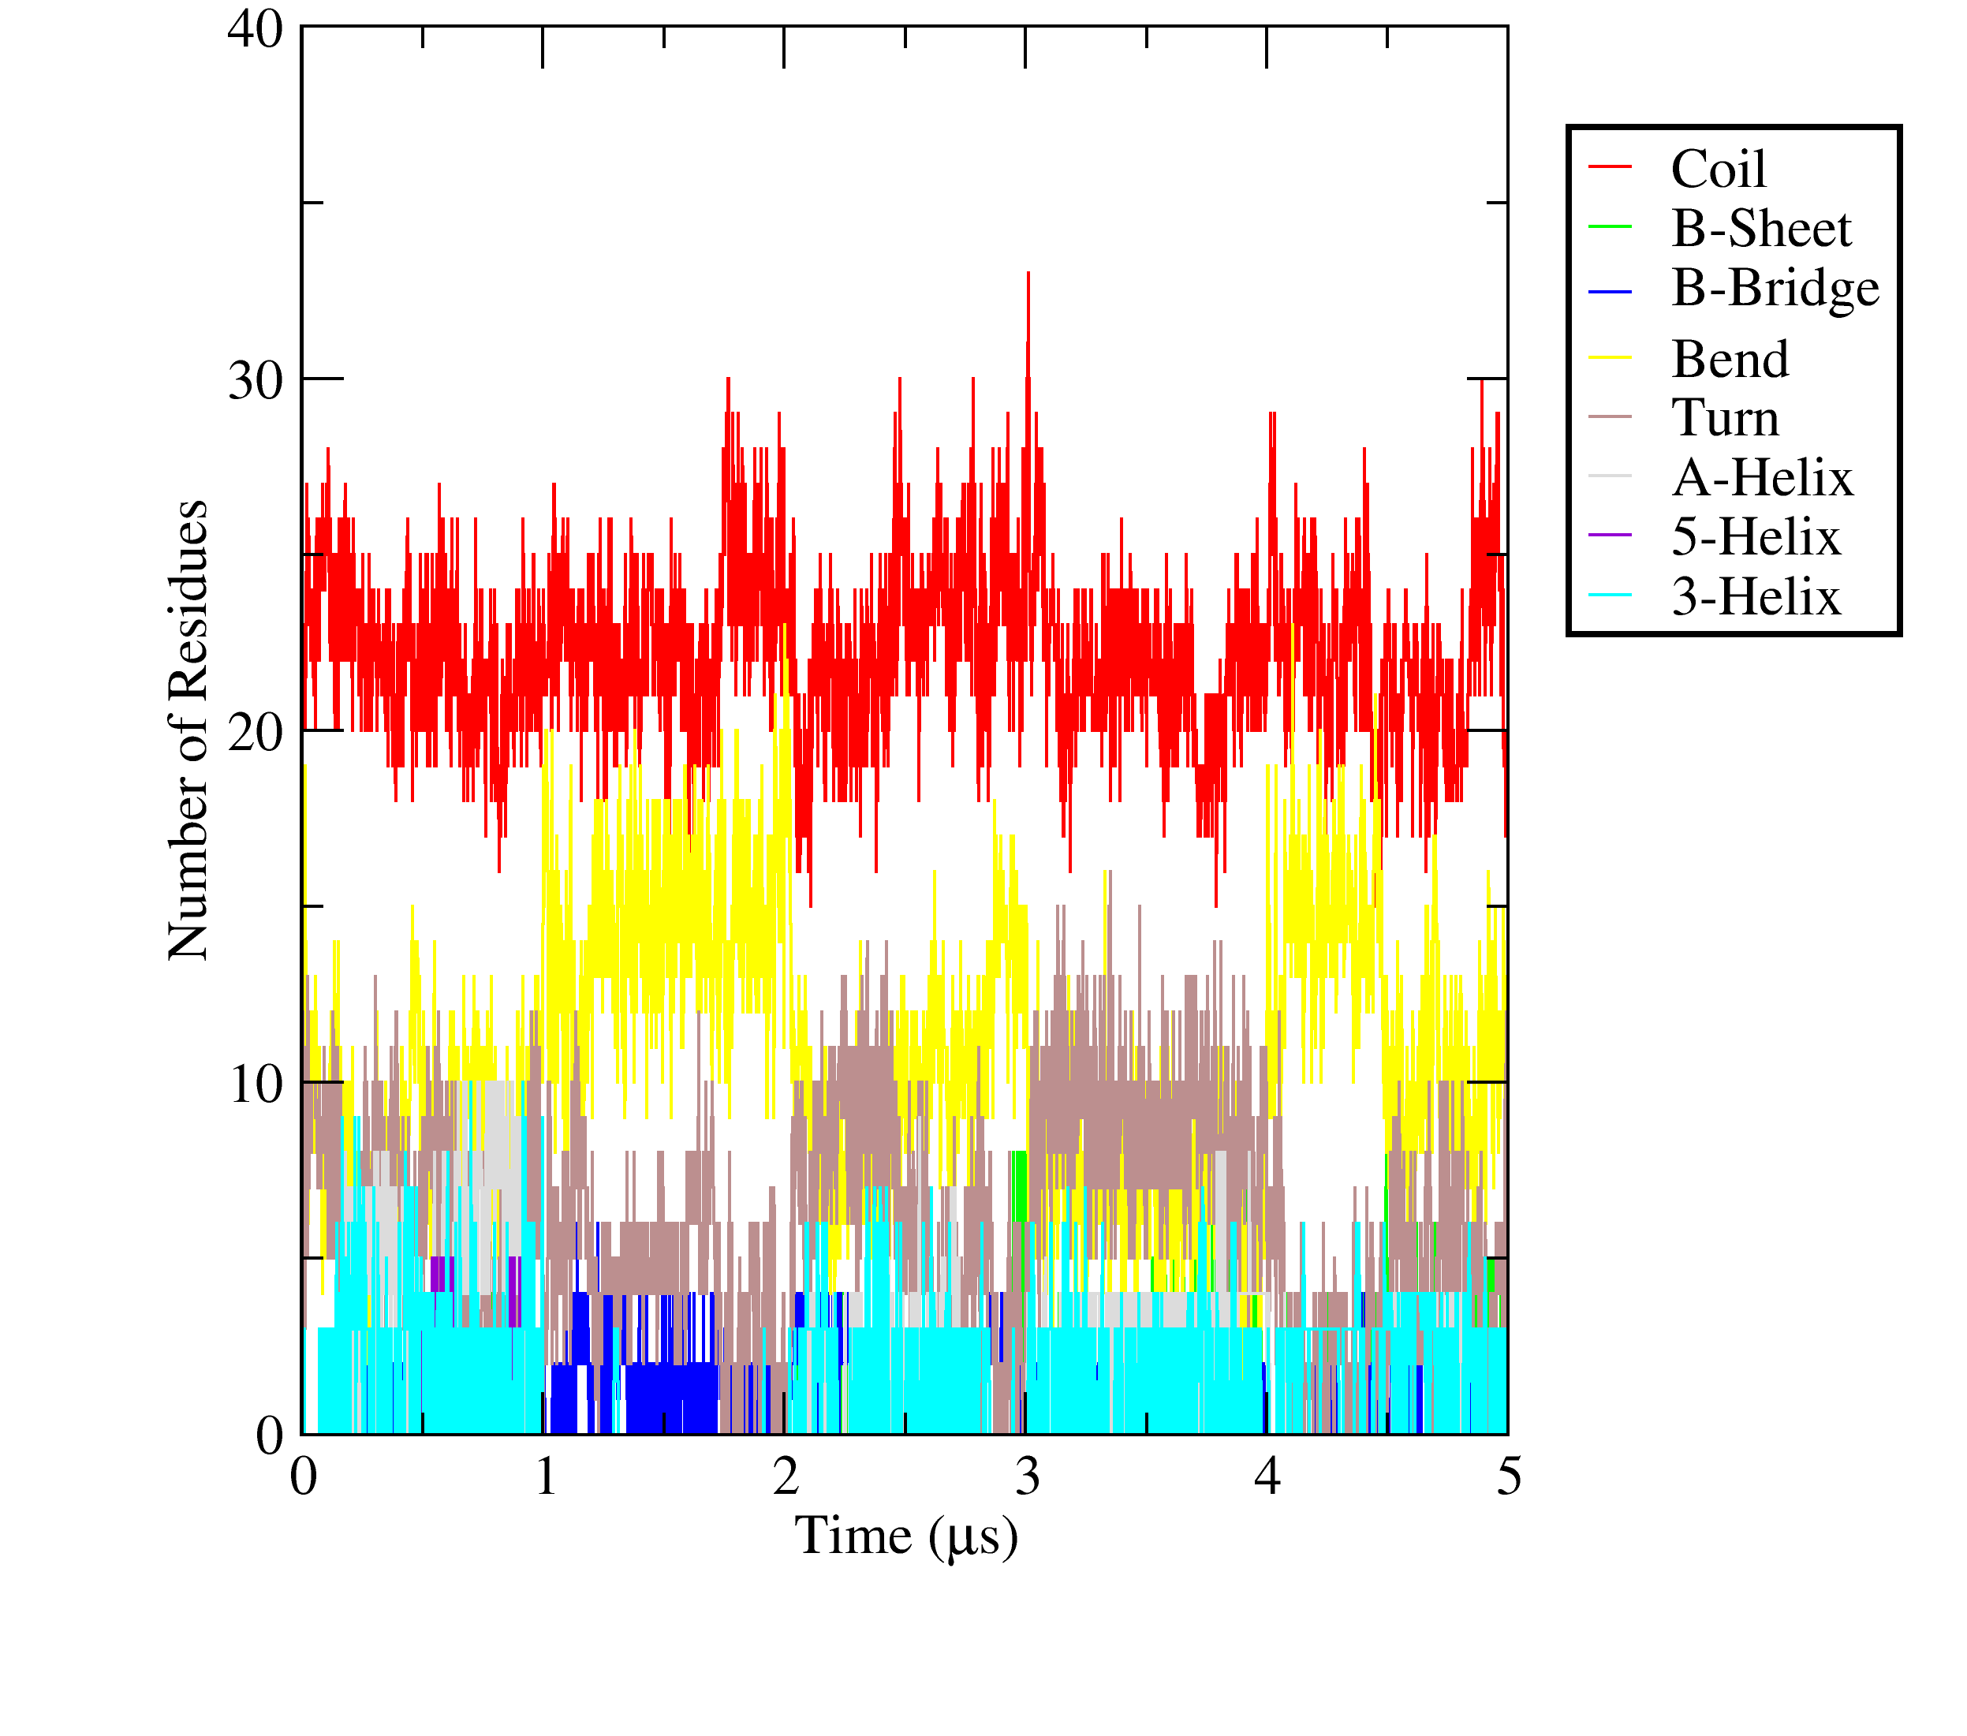
Figure S17. Secondary structure analysis according to the DSSP definitions of Tβ4^{N-mid}.
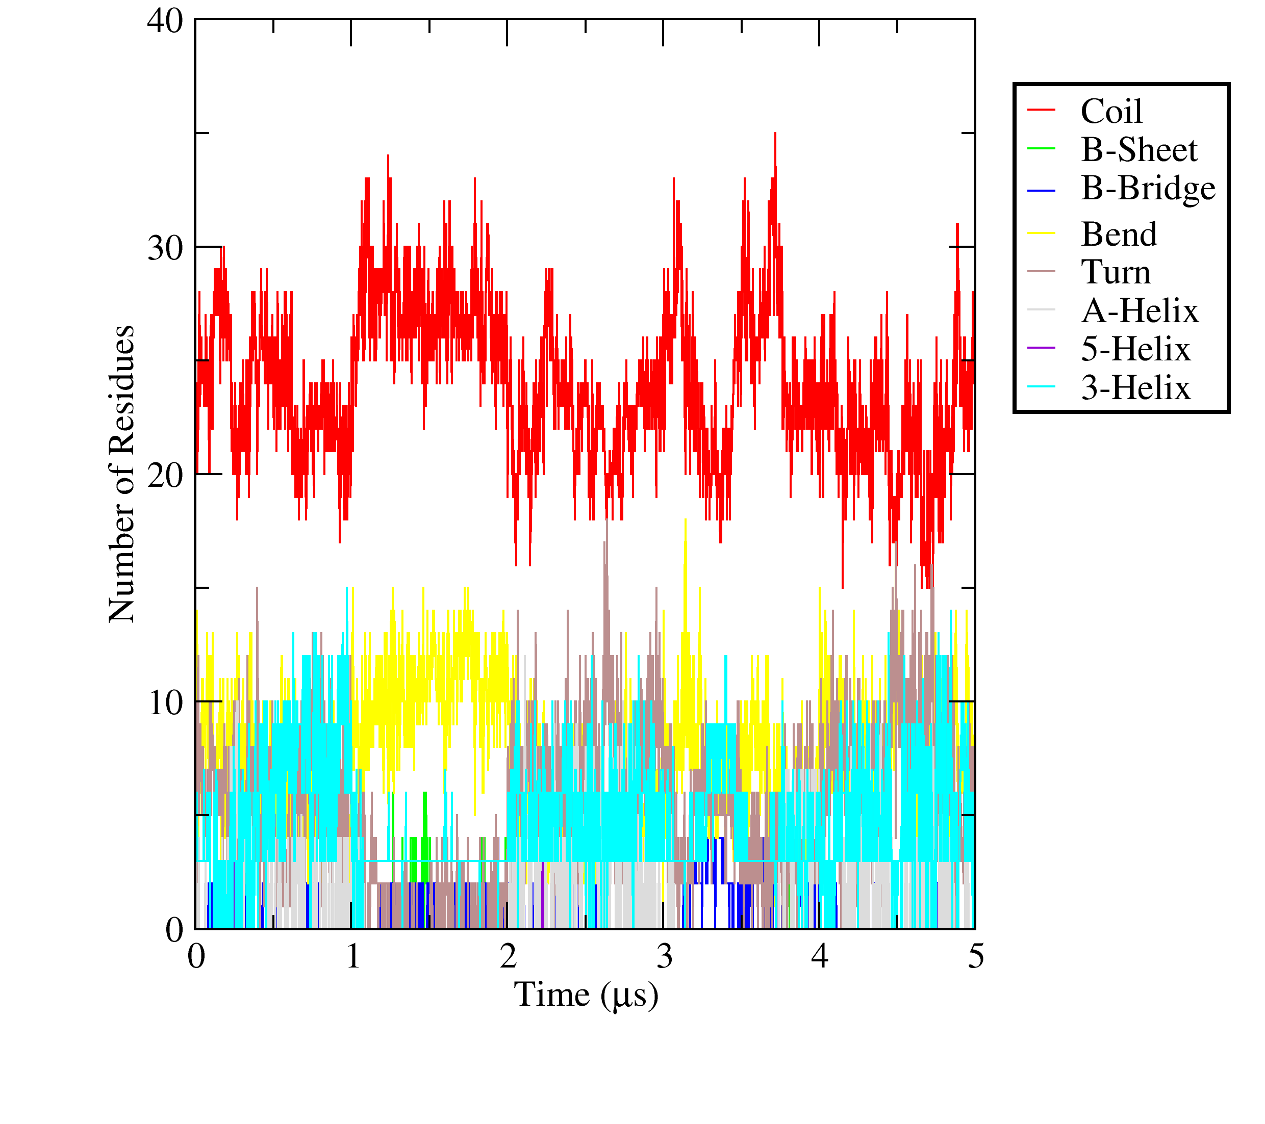
Figure S18. Secondary structure analysis according to the DSSP definitions of Tβ4^{N-N}.

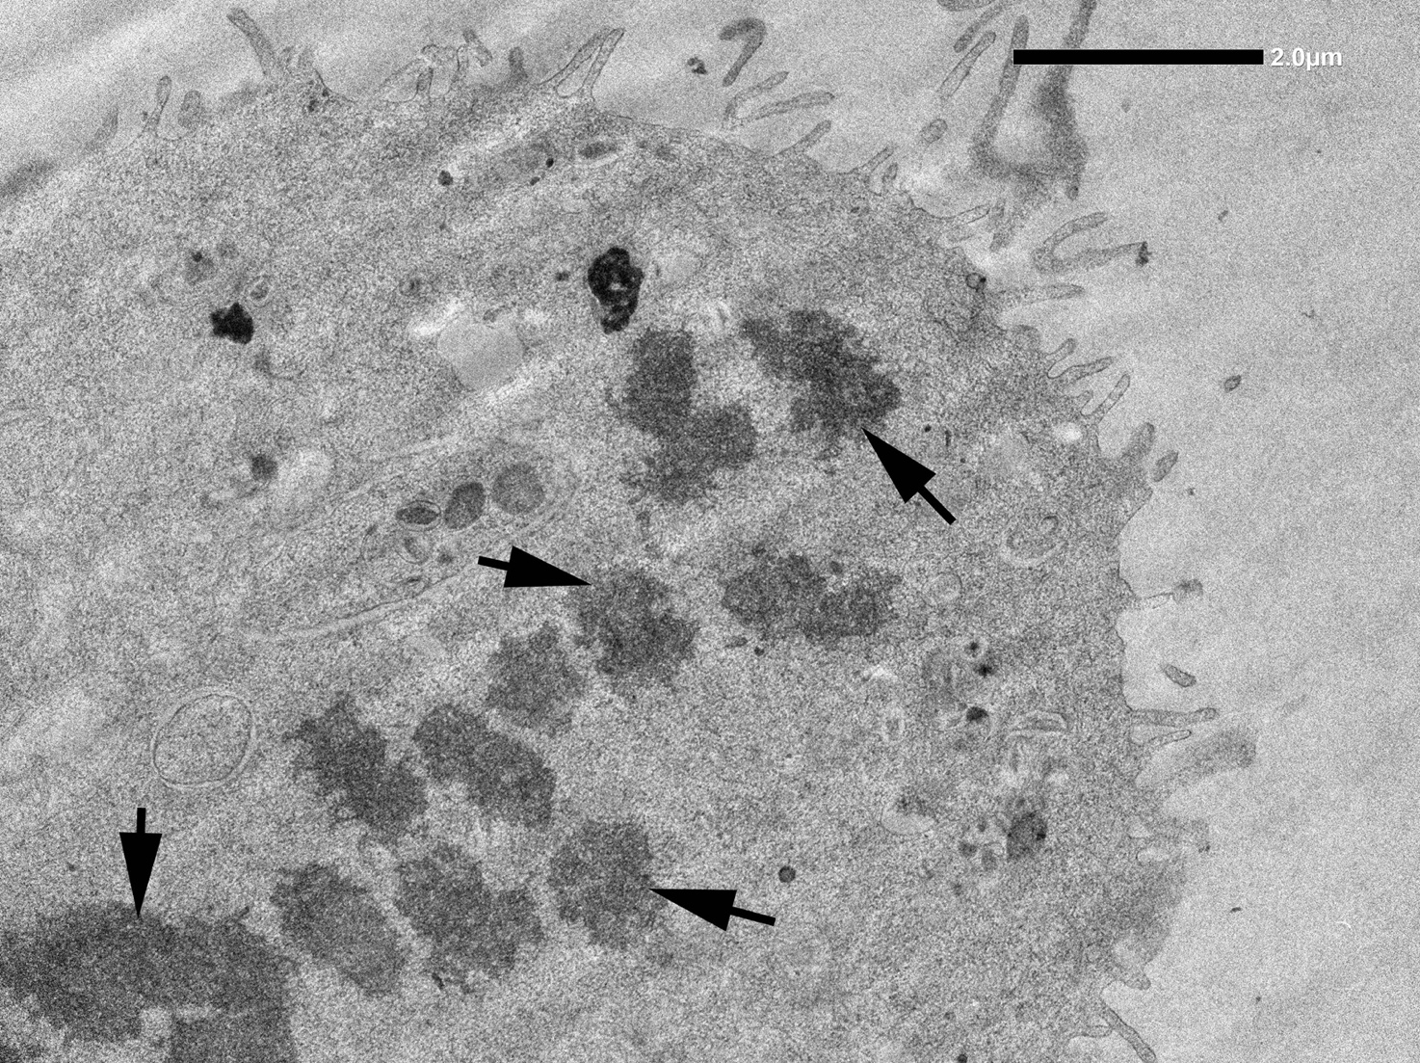
Figure S19. Electron micrographs of a mitotic J774 cell. Arrows indicate the condensed packed chromatin of the chromosomes.

