Supplementary materials
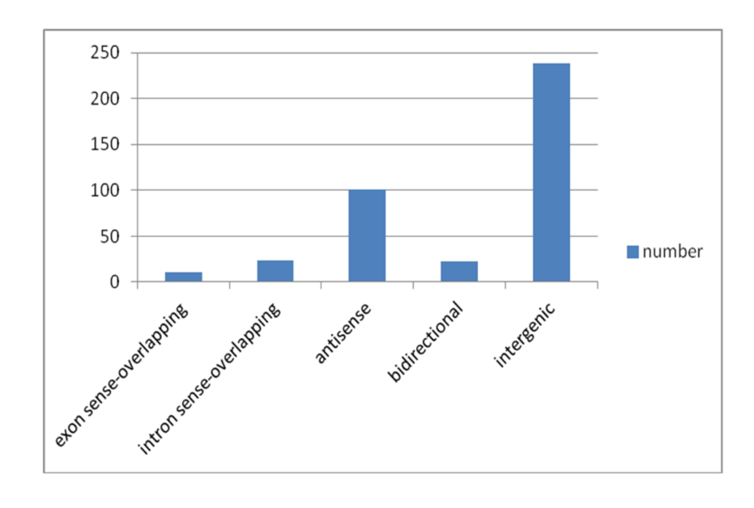
Supplementary Figure 1 Specific classification of DE lncRNAs in lncRNA/mRNA microarray.
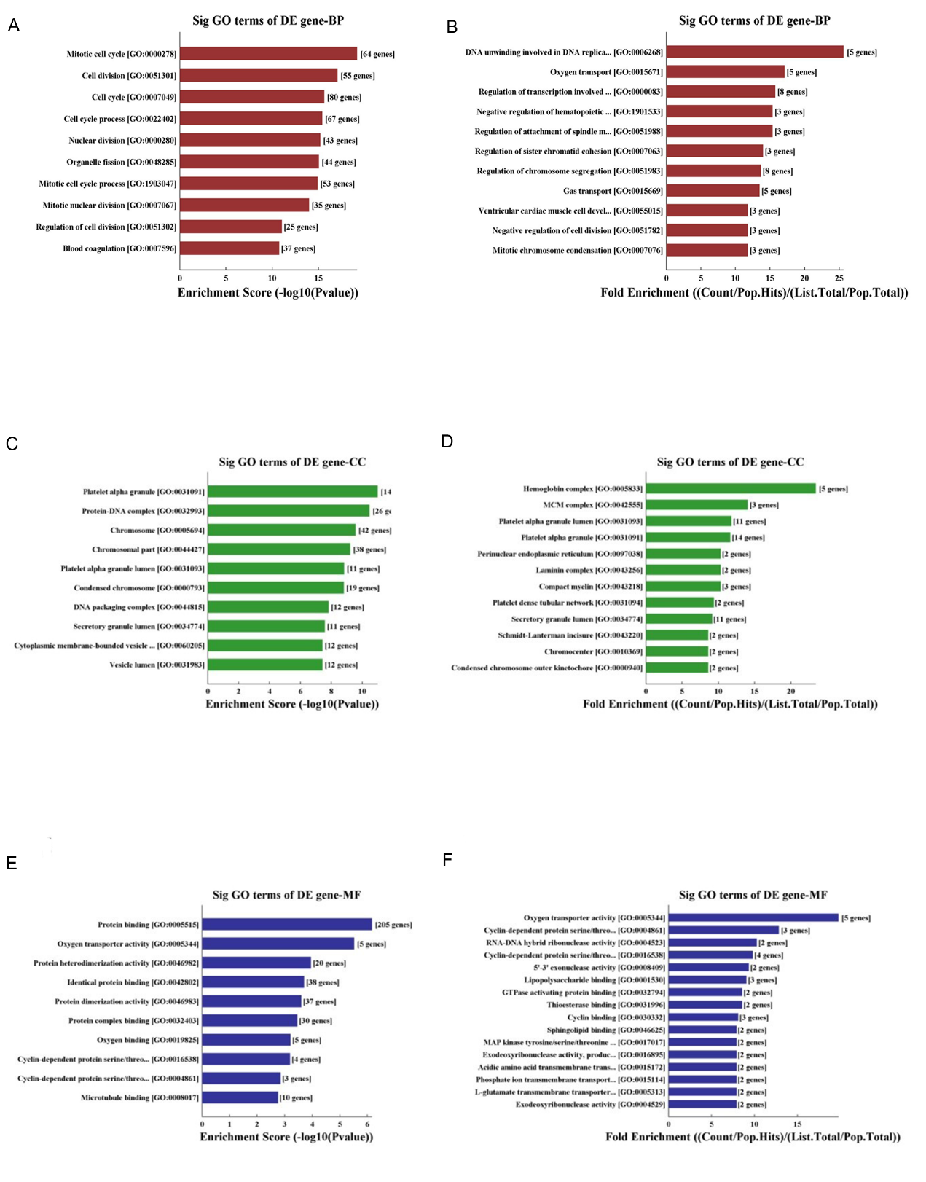
Supplementary Figure 2 GO analysis of upregulated mRNAs. Cluster analysis (A, C, E) and enrichment analysis (B, D, F); biological processes (A, B), cellular components (C, D), and molecular functions (E, F).
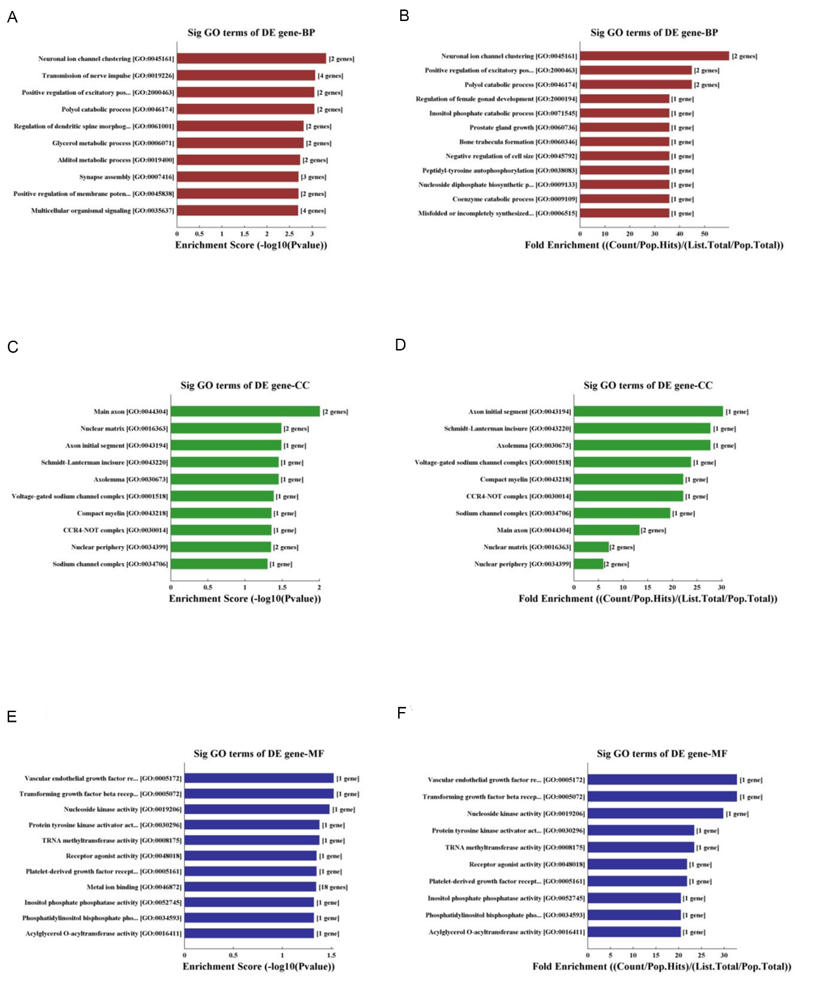
Supplementary Figure 3 GO analysis of downregulated mRNAs. Cluster analysis (A, C, E) and enrichment analysis (B, D, F); biological processes (A, B), cellular components (C, D), and molecular functions (E, F).
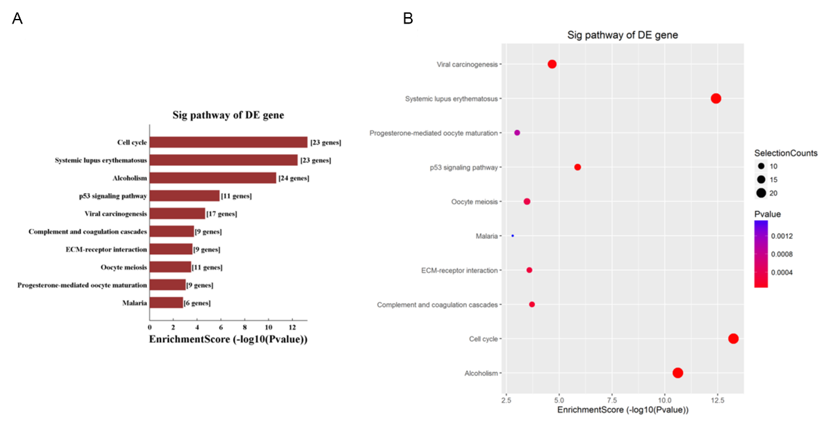
Supplementary Figure 4 KEGG analysis of upregulated mRNAs.
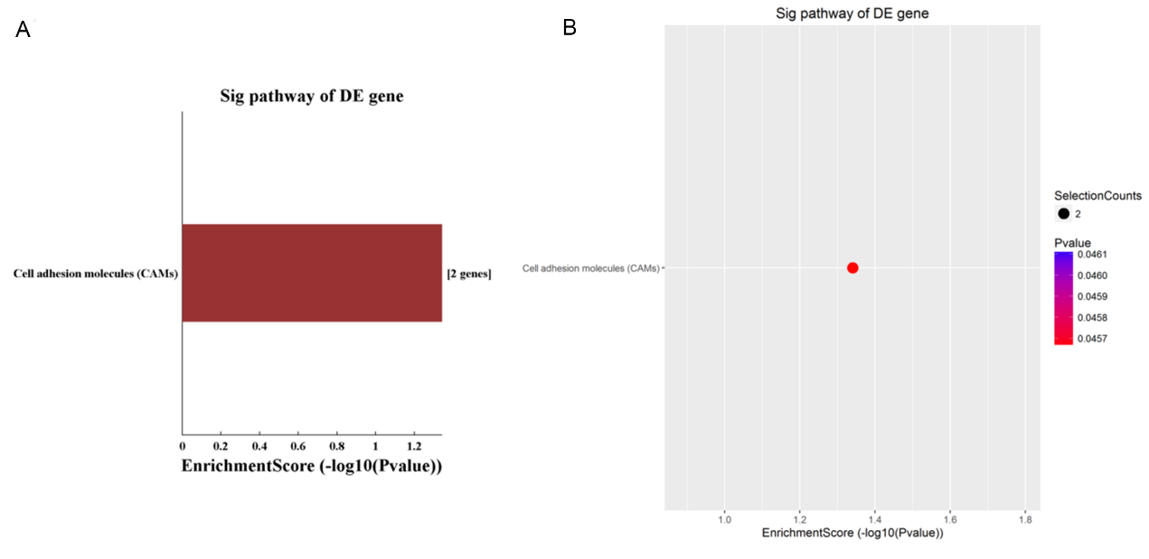
Supplementary Figure 5 KEGG analysis of downregulated mRNAs.
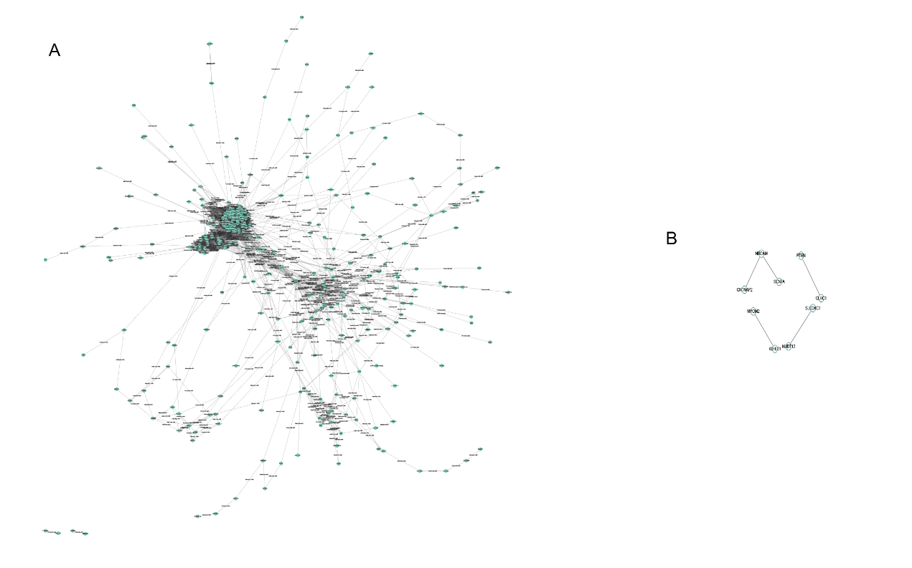
Supplementary Figure 6 PPI network of DE mRNAs. (A) Upregulated mRNAs (B) downregulated mRNAs.
Supplementary Table 1: The correlation between lncRNA-hub mRNA pairs.
GENE1 | GENE2 | P | R
RP11-54O7.17 | CCNA2 | 2.53E-06 | 0.998701
RP11-885N19.6 | CCNA2 | 2.86E-05 | 0.995632
PTTG3P | CCNA2 | 4.56E-05 | 0.99448
RP11-598F7.3 | CCNA2 | 1.05E-04 | 0.991624
G044892 | CCNB1 | 6.90E-06 | 0.997854
LINC01358 | CCNB1 | 8.71E-06 | 0.997589
RP11-65J21.3 | CCNB1 | 1.83E-05 | 0.996504
XLOC_003410 | CCNB1 | 2.12E-05 | 0.996237
XLOC_010724 | CCNB1 | 2.26E-05 | 0.996112
IGH | CCNB1 | 2.50E-05 | 0.995913
CTD-2227E11.1 | CCNB1 | 2.80E-05 | 0.995675
IGHV3-07 | CCNB1 | 4.18E-05 | 0.994714
FAM212B-AS1 | CCNB1 | 5.78E-05 | 0.993789
LOC440895 | CCNB1 | 9.10E-05 | 0.992201
G026517 | CCNB1 | 1.16E-04 | 0.991185
IGKV | CCNB1 | 1.29E-04 | 0.990718
AP000769.7 | CCNB1 | 1.36E-04 | 0.99046
PTTG3P | CCNB1 | 0.001921 | 0.964002
LINC00403 | CDC6 | 5.47E-06 | 0.99809
RP11-598F7.3 | CDC6 | 2.10E-05 | 0.996255
PTTG3P | CDC6 | 2.71E-05 | 0.995748
RP11-872J21.3 | CDC6 | 3.25E-05 | 0.995342
LOC101927100 | CDC6 | 6.53E-05 | 0.993394
G026517 | CDC6 | 6.77E-05 | 0.993272
IGHV3-07 | CDC6 | 7.83E-05 | 0.992764
AC104024.1 | CDC6 | 8.02E-05 | 0.992677
RP11-885N19.6 | CDC6 | 8.56E-05 | 0.992436
BC005081 | CDC6 | 1.04E-04 | 0.991679
CTD-2227E11.1 | CDC6 | 1.16E-04 | 0.991201
AC093627.8 | CDC6 | 1.45E-04 | 0.990157
RP11-556E13.1 | CDC6 | 1.47E-04 | 0.990068
PTTG3P | CDK1 | 1.26E-05 | 0.997102
LINC00403 | CDK1 | 1.30E-05 | 0.99705
RP11-598F7.3 | CDK1 | 2.08E-05 | 0.996276
RP11-872J21.3 | CDK1 | 3.03E-05 | 0.9955
LOC101927100 | CDK1 | 3.40E-05 | 0.995236
BC005081 | CDK1 | 5.12E-05 | 0.994151
AC104024.1 | CDK1 | 5.18E-05 | 0.994119
RP11-885N19.6 | CDK1 | 8.34E-05 | 0.992532
RP11-556E13.1 | CDK1 | 8.46E-05 | 0.99248
G026517 | CDK1 | 1.10E-04 | 0.991442
RP4-736L20.3 | CDK1 | 1.18E-04 | 0.991101
IGHV3-07 | CDK1 | 1.26E-04 | 0.990825
RP11-254F7.4 | CDK1 | 1.31E-04 | 0.990634
RP11-598F7.3 | CHEK1 | 3.18E-05 | 0.99539
RP11-54O7.17 | CHEK1 | 4.25E-05 | 0.994669
PTTG3P | CHEK1 | 5.65E-05 | 0.993857
G026517 | CHEK1 | 9.71E-05 | 0.991945
RP11-885N19.6 | CHEK1 | 1.26E-04 | 0.990838

Supplementary Table 2: Details of the Rp11-598F7.3 and PTTG3P.
seqname | GeneSymbol | Fold change | Regulation-  LncRNAs | source | RNAlength | Nearby  GeneSymbol
ENST00000540226 | RP11-598F7.3 | 3.4892251 | up | GENCODE | 586 | IQSEC3
NR_002734 | PTTG3P | 8.1023594 | up | RefSeq | 609 | SGK3

