Supplementary Information

PET Imaging of Synaptic Density Loss in Patients with Multiple Sclerosis

Pou Hong Justin Chia^{1,3, #}, Takuya Toyonaga^{5, #}, Junchao Tong¹, Hannah Le^{1,3}, Mark Dias⁵, Amanda J. Boyle¹⁻³, Roger Raymond¹, Erin E Longbrake⁷, Yiyun Huang⁵, Richard E. Carson⁵, Laura Airas⁶, Neil Vasdev^{1,2}, Ming-Kai Chen^{5*}, and Chao Zheng^{1,2,3,4*}

¹ Azrieli Centre for Neuro-Radiochemistry, Brain Health Imaging Centre, Campbell Family Mental Health Research Institute, Centre for Addiction and Mental Health, Toronto, Ontario, Canada
² Department of Psychiatry, Temerty Faculty of Medicine, University of Toronto, Toronto, Ontario, Canada
³ Department of Pharmacology and Toxicology, Temerty Faculty of Medicine, University of Toronto, Toronto, Ontario, Canada
⁴ Department of Chemistry, University of Toronto, Toronto, Ontario, Canada
⁵ Department of Radiology and Biomedical Imaging, PET Center, Yale School of Medicine, New Haven, CT, United States
⁶ University of Turku and Turku University Hospital, Turku, Finland
⁷ Department of Neurology, Yale School of Medicine, New Haven, CT, United States

# These authors contributed equally to this work.
* Correspondence: ming-kai.chen@yale.edu (M.-K. C.), chao.zheng@camh.ca (C.Z.)

Supplementary Figures with Legends:

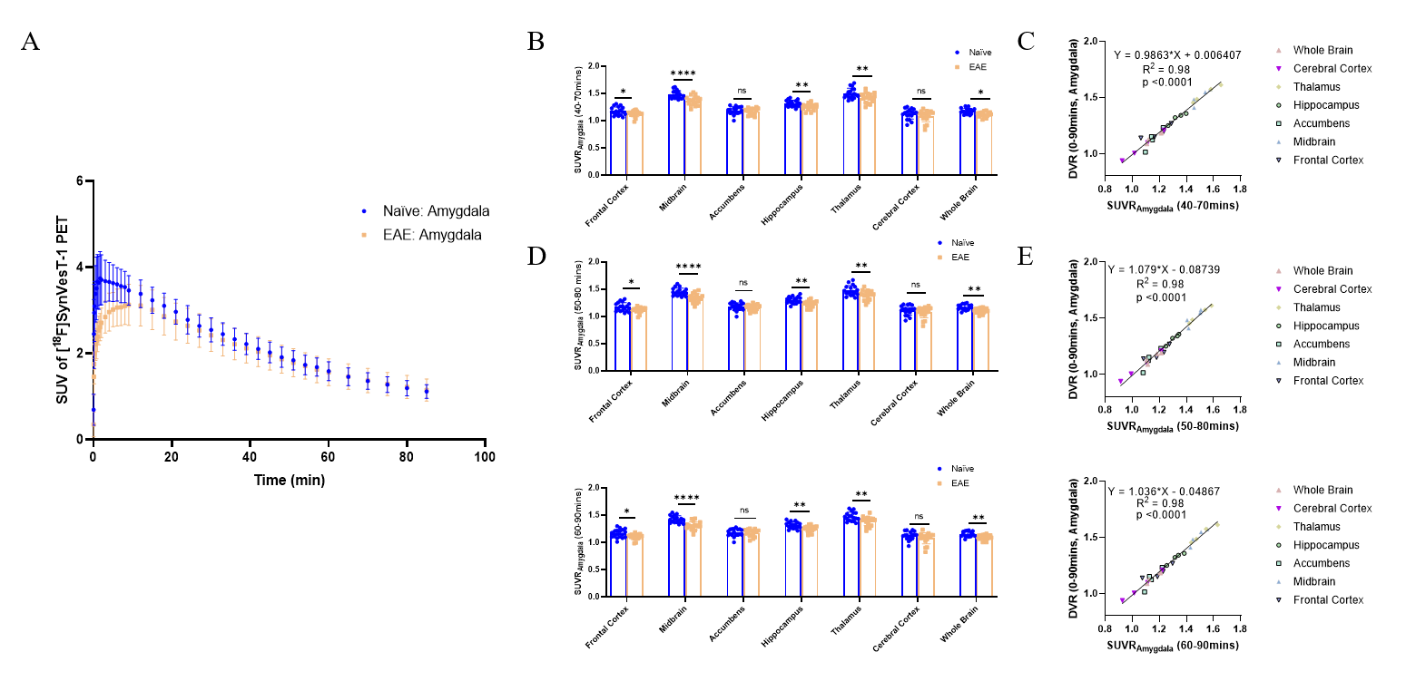
Supplementary Figure 1. SV2A PET quantification in naïve and EAE mice using Reference Regions. (A) TACs of [¹⁸F]SynVesT-1 SUV in the amygdala regions over 90 min (n = 18/group) (B, D, F) SUVR_{Amygdala} ​ values calculated using the mean SUV obtained from 40–70 min, 50–80 min, and 60–90 min post-injection across different brain regions, showing a significant reduction in EAE mice compared to naïve controls (n = 18/group). (C, E, G) Correlation between SRTM2 derived DVR ​ (0–90 min) and SUVR_{Amygdala} at different time windows, demonstrating strong linear relationships across brain regions (n = 4). Data are presented as mean ± SD. ****p < 0.0001.

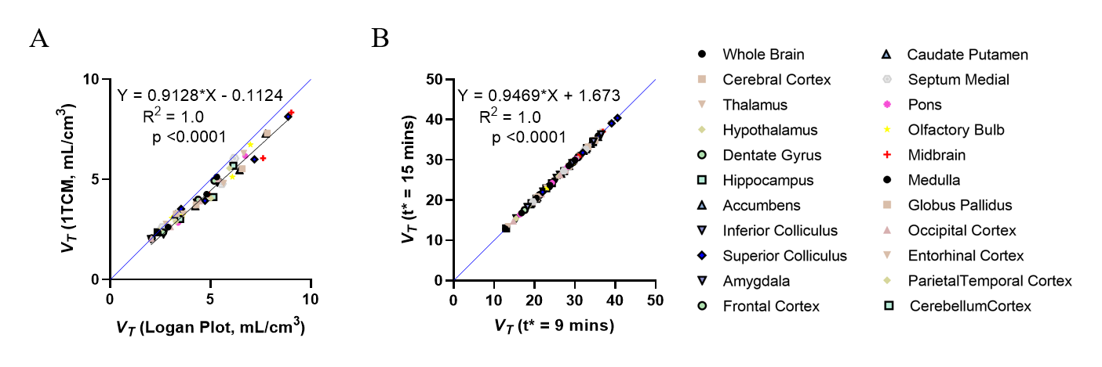
Supplementary Figure 2. Correlation analyses of [¹⁸F]SynVesT-1 binding parameters. (A) Linear regression analysis of uncorrected V_{T}, (B) Linear regression analysis of radiometabolite- and plasma-to-whole-blood ratio-corrected V_{T} estimated using the Logan plot with t* set at 9 and 15 mins. Blue line represents the line of identity (n = 4).

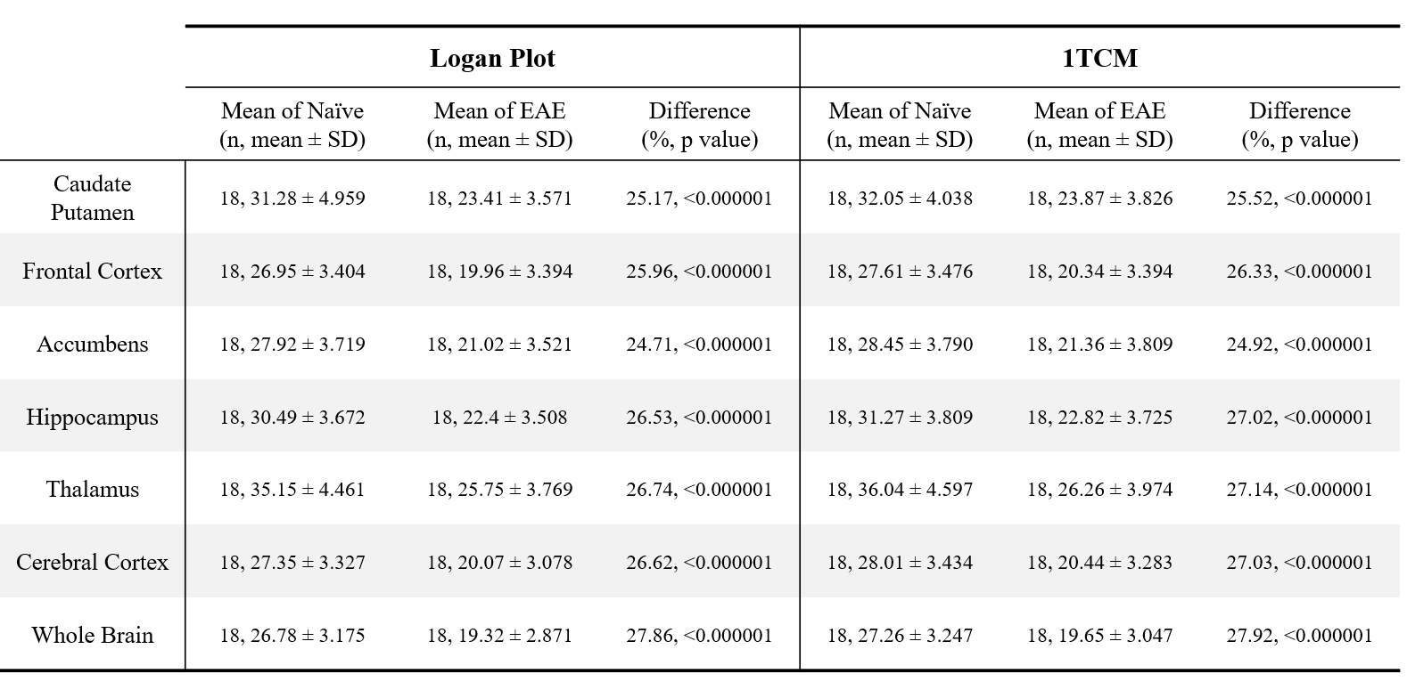
Supplementary Table 1. Regional V_{T} values in naïve and EAE mice.

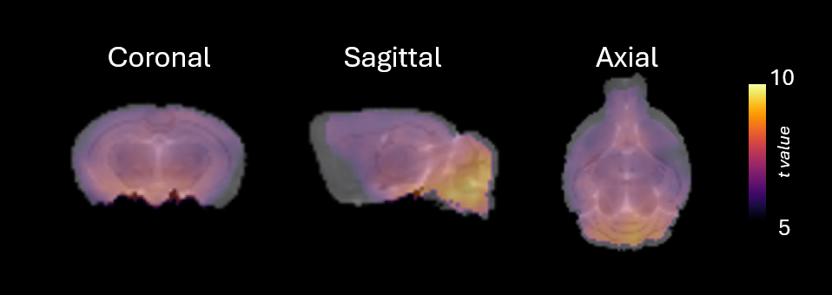
Supplementary Figure 3. Voxel-wise analysis t value map comparing naïve and EAE mice (n = 18/group). Colour Scale represents decrease tracer uptake in EAE compared to naïve mice. Statistical significance per voxel was established at p < 0.001 with family-wise error (FWE) correction.

Supplementary Figure 4. Altered K₁ ​ in EAE mice. K₁ values estimated using an IDIF in naïve and EAE mice across multiple brain regions. Significant reductions in K₁ are observed in the caudate putamen, frontal cortex, accumbens, hippocampus, thalamus, cerebral cortex, and whole brain of EAE mice. Data are presented as mean ± SD (n = 18/group). *p < 0.05, **p < 0.01.

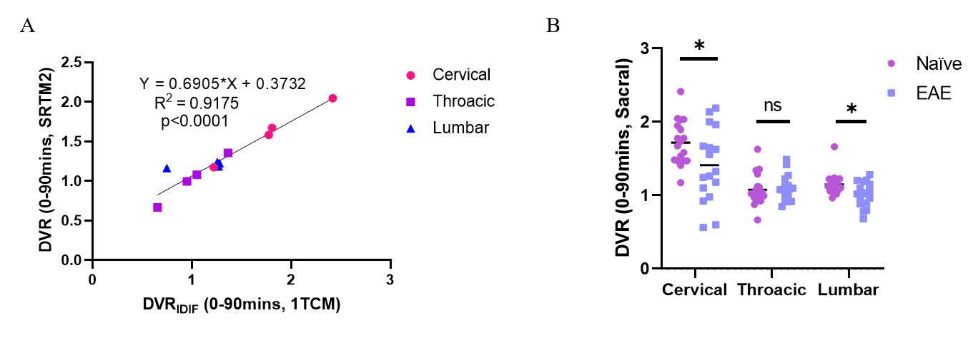
Supplementary Figure 5. Correlation analyses of [¹⁸F]SynVesT-1 binding parameters in the Spinal Cord. (A) Linear regression analysis of SRTM2-derived DVR and IDIF-derived DVR using 1TCM (n = 4). (B) Regional DVR values in the spinal cord. DVR was estimated by SRTM2, using sacral as the reference region. Data are presented as mean ± SD (n = 18/group; one EAE mouse was excluded from SUVR and DVR calculations due to being a significant outlier); *p < 0.05, ***p < 0.001, ns = not significant.

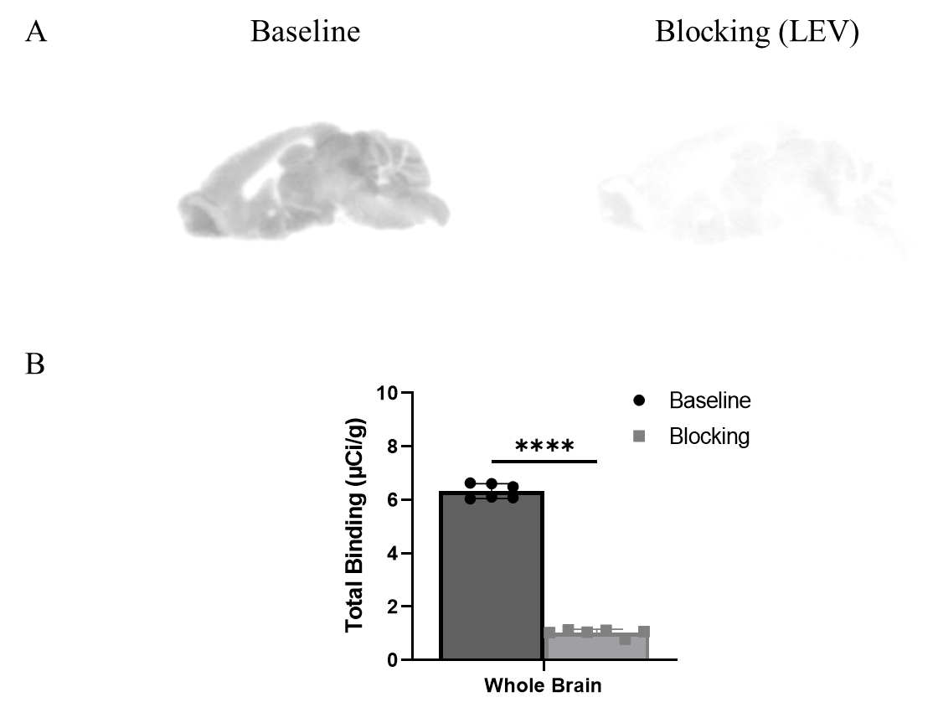

Supplementary Figure 6. Specific binding of [¹⁸F]SynVesT-1 in EAE mice. (A) Representative autoradiography images of [¹⁸F]SynVesT-1 binding in sagittal brain sections at baseline and blocking with LEV in the same mouse brain. (B) Quantification of total binding in the whole brain shows a significant reduction in baseline treatment compared to blocking. Data are presented as mean ± SD (n = 6/group). ****p < 0.0001.

Supplementary Figure 7. Regional Brain Volume in Healthy Control and MS Patents. Regional brain volumes were derived from the automated anatomic labeling (AAL) template in healthy controls and MS patients. Volumes (mL) for selected regions of interest, including the amygdala, caudate nucleus, cerebellar cortex, anterior cingulate cortex, posterior cingulate cortex, entorhinal cortex, frontal lobe, hippocampus, occipital lobe, pallidum, parietal lobe, precuneus, putamen, temporal lobe, and thalamus. Data are represented as mean ± SD. No significance differences were observed.

