Supplementary data

Supplementary Figure 1. Scalable production process of extracellular vesicles and animal study design.
Three-dimensional (3D)-MSC spheroids were generated in serum-free medium using a micropatterned well system. EVs were isolated from the culture medium using a combination of filter and tangential flow filtration systems, and their concentration and size were measured using nanoparticle tracking (NTA). Quality control was performed using enzyme-linked immunosorbent assay (ELISA) and quantitative polymerase chain reaction (qPCR).
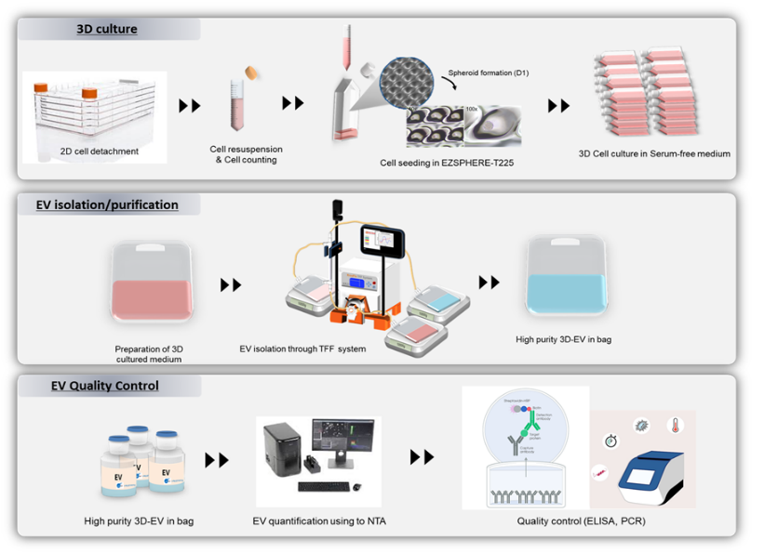

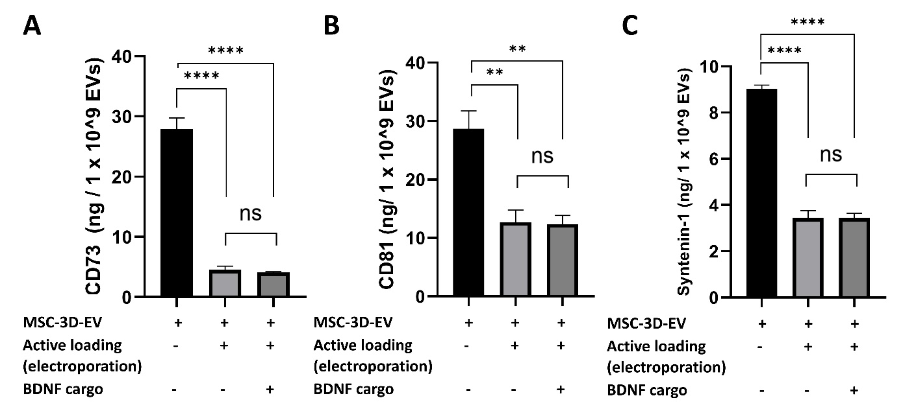
Supplementary Figure 2. Quantification of total integrity of EV surface marker proteins in ELISA. Analysis of mean protein expression levels of CD73 (A), CD81 (B), and Syntenin (C) in EVs after active loading, measured using ELISA. Data are expressed as the mean ± SD (n = 5). One-way analysis of variance followed by Tukey’s multiple comparisons test was performed (**p < 0.01, ****p < 0.0001).

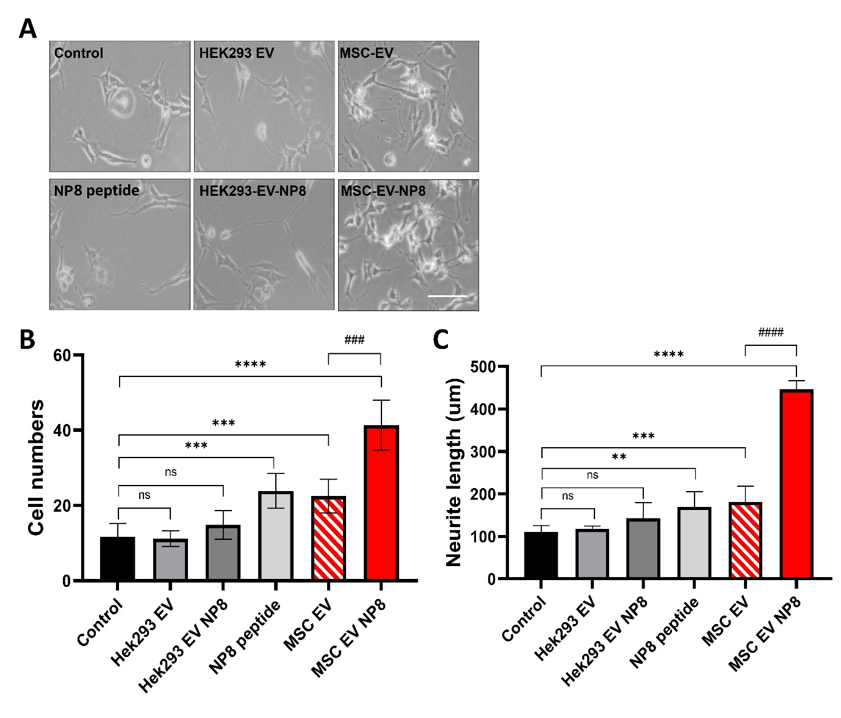
Supplementary Figure 3. Neuropeptide-loaded MSC-EVs demonstrated superior effects on neuroregeneration and differentiation compared to HEK-EVs. The cells were treated once per day for 3 d, Scale bar 100 µm. Neurite length was measured at 0–3 d. The cells with only solvent were used as controls. Compared with the cells of day 1. The values were averaged for 200 neurites. Data are expressed as the mean ± SD (n = 5). One-way analysis of variance followed by Tukey’s multiple comparisons test was performed (**p < 0.01, ***p < 0.001, ****p < 0.0001 vs. control; ###p < 0.001, ####p < 0.0001 for comparisons between MSC-EV and MSC-EV-NP8).
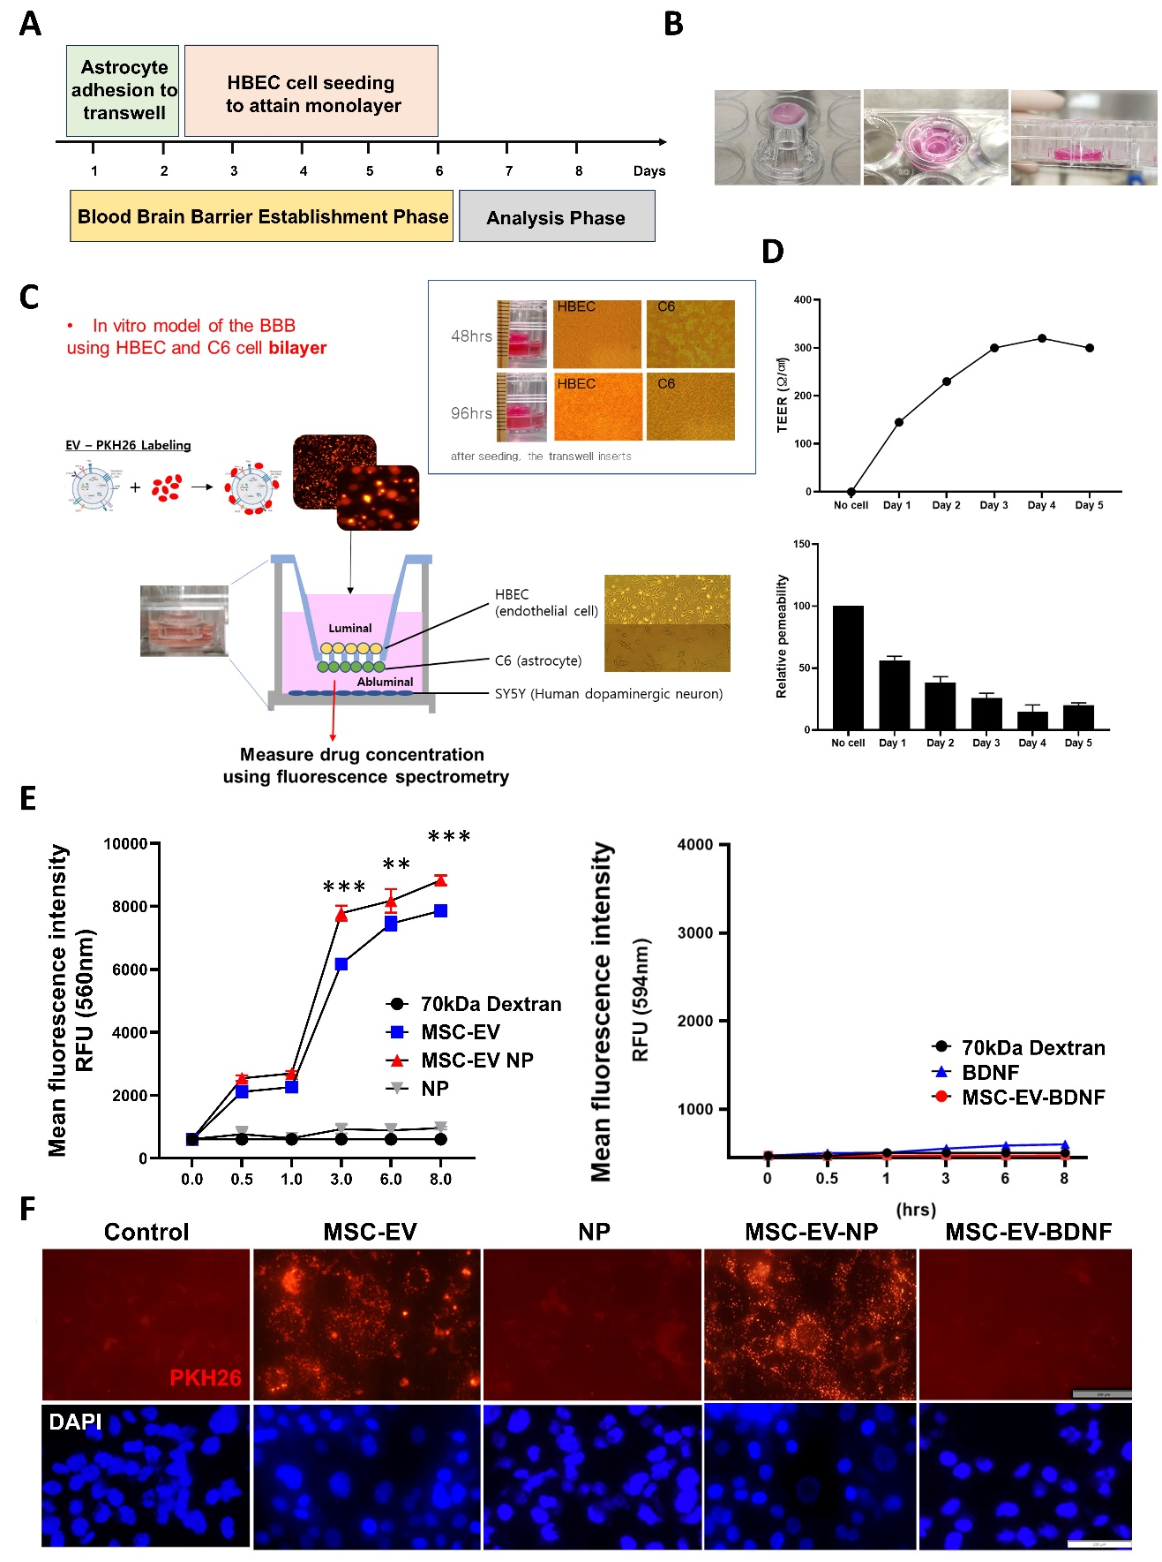
Supplementary Figure 4. In vitro models to study mesenchymal stem cell (MSC)-extracellular vesicle (EV) containing neuropeptides (NPs) crossing the blood–brain barrier (BBB). (A) Schematic diagram showing the preparation of an in vitro BBB model using an HBEC and C6 cell transwell system. (B) Images of the transwell setup. (C) Diagram of the in vitro BBB model, where HBEC and C6 cells form a co-culture BBB model, with SY5Y neurons present on the abluminal side to simulate neuronal exposure. (D) Trans-Endothelial Electrical Resistance (TEER) values and relative permeability measurements. The top graph shows TEER (Ω·cm²) values indicating the integrity of the BBB model, whereas the bottom graph shows relative permeability as the barrier is established. (E) Trans-Endothelial permeability assays were conducted using an in vitro BBB model. A significant fluorescence increase was observed in the MSC-EV and MSC-EV-NP groups (***p < 0.001), whereas minimal fluorescence was detected in the BDNF and MSC-EV-BDNF groups. (F) EV uptake by SH-SY5Y cells located on the abluminal side of the transwell in the in vitro BBB model.

Supplementary data5. STORM video clip
Super-resolution dSTORM images of MSC derived EVs. EVs were stained with Cellbright and TAMRA-peptides.

Materials and Methods
Preparation and isolation of clinical scale MSC-EVs:
These methods have been described in detail elsewhere (Son et al., 2023). Briefly, MSCs derived from human Wharton’s Jelly of the umbilical cord were cultured and expanded in growth medium in a 5% CO₂ incubator at 37°C. P6 WJ-MSCs were seeded into a micropatterned well system, washed with phosphate-buffered saline (PBS), and trypsinized using TrypLE Express (Gibco, Grand Island, NY, USA). The cell suspension (60 mL) was placed in a microarray containing approximately 69,000 microwells, each with a diameter and depth of 500 × 200 μm, coated with 2-methacryloyloxyethyl phosphorylcholine polymer at a density of 400 cells/well. For 3D spheroid culture of WJ-MSCs, serum-free medium (α-minimal essential medium) was used without antibiotic. A 3D spheroidal cell aggregate was prepared by inducing spontaneous spheroidal cell aggregate formation while maintaining a static state by dispensing uniformly and culturing in a CO₂ incubator at 37°C for 4 d.

Isolation of EVs:
EVs were isolated in a biological safety cabinet. The culture medium was collected by gentle pipetting from the top of each well. To remove cell debris and apoptotic bodies, 1.8 liters of culture medium was centrifuged at 2500 ×g for 10 min, followed by filtration through a 0.22-μm membrane. The filtered medium was separated using a 300-kDa MWCO mPES hollow fiber MiniKros filter module (Spectrum Laboratories, Rancho Dominguez, CA, USA) on a commercially available KrosFlo KR2I tangential flow filtration system (Spectrum Laboratories). EV-containing samples were recirculated in a filtration bottle. Small molecules, including free proteins, that passed through the membrane pores were eluted as the permeate and collected. The collected solution was used as the secretome. The EVs were maintained in circulation as a retentate and concentrated in the bag. We conducted five volume exchanges of EVs with PBS, and the EVs were concentrated to a final volume of 300 mL in recovery solution (PBS). The recovered solution was filtered through a 0.22-μm membrane. After harvesting the conditioned media, EV isolation was immediately initiated using the tangential flow filtration procedure. All processes were performed according to the guidelines on quality, non-clinical, and clinical assessment of EV therapy products of the Korean Food and Drug Administration (released December 2018), using good manufacturing practice-compliant methods.
References
[1] J. Chung, et al., Super-resolution imaging of platelet-activation process and its quantitative analysis, Sci. Rep. 11 (2021) 10511. https://doi.org/10.1038/s41598-021-89799-9
[2] S. Go, et al., Super-resolution imaging reveals cytoskeleton-dependent organelle rearrangement within platelets at intermediate stages of maturation, Structure 29 (2021) 810–822.e3. https://doi.org/10.1016/j.str.2021.06.001
[3] M.J. Rust, M. Bates, X. Zhuang, Sub-diffraction-limit imaging by stochastic optical reconstruction microscopy (STORM), Nat. Methods 3 (2006) 793–796. https://doi.org/10.1038/nmeth929
[4] J.P. Son, et al., Mesenchymal stem cell–extracellular vesicle therapy for stroke: scalable production and imaging biomarker studies, Stem Cells Transl. Med. 12 (2023) 459–473. https://doi.org/10.1093/stcltm/szad034

