Detection of Avian Influenza Virus in Surface Waters Using Passive Samplers

Madison T. Gouthro¹, Emalie K. Hayes¹, Taylor Prest¹, and Graham A. Gagnon¹

¹Centre for Water Resources Studies, Department of Civil & Resource Engineering, Dalhousie University, 1360 Barrington Street, Halifax, Nova Scotia B3H 4R2, Canada

Table S1. Minimum and maximum gene copies per sampler across all sites and gene targets. Sites without PMMoV concentrations listed were measured but not detected.
Site | Target | Min GC | Max GC
1 | H5 | 1.88 × 10⁴ | 3.10 × 10⁸
1 | Pan-FluA | 2.74 × 10⁴ | 9.06 × 10⁸
2 | H5 | 3.14 × 10⁷ | 3.14 × 10⁷
2 | Pan-FluA | 5.11 × 10⁴ | 2.13 × 10⁵
3 | H5 | 2.18 × 10⁸ | 1.47 × 10¹⁰
3 | Pan-FluA | 5.08 × 10⁴ | 5.61 × 10¹²
3 | PMMoV | 4.89 × 10³ | 4.89 × 10³
4A | H5 | 3.60 × 10⁷ | 3.60 × 10⁷
4A | Pan-FluA | 1.80 × 10⁵ | 6.72 × 10⁸
4B | H5 | 2.17 × 10⁴ | 5.80 × 10⁹
4B | Pan-FluA | 5.97 × 10⁴ | 3.60 × 10¹²
4B | PMMoV | 2.59 × 10³ | 1.74 × 10⁵
4C | H5 | 1.19 × 10⁷ | 1.19 × 10⁷
4C | Pan-FluA | 1.73 × 10⁴ | 1.90 × 10⁸
5 | H5 | 3.94 × 10⁴ | 1.77 × 10¹¹
5 | Pan-FluA | 1.03 × 10⁵ | 3.31 × 10¹²

Table S2. Median values and standard deviations for select water chemistry parameters were measured between May and October 2024 at Sites 4A, 4B, and 4C.
Site 4A | Parameter | Median | Standard Deviation | Units
Site 4A | Temperature | 17.9 | 4.9 | °C
Site 4A | Dissolved Oxygen | 8.9 | 0.7 | mg L⁻¹
Site 4A | Conductivity | 113.8 | 28.7 | μs cm⁻¹
Site 4A | Total Dissolved Solids | 82.1 | 24.9 | mg L⁻¹
Site 4A | pH | 6.7 | 0.08 | -
Site 4A | Turbidity | 1.0 | 1.2 | NTU
Site 4A | UV 254 | 0.2 | 0.09 | cm⁻¹
Site 4A | Color | 35.0 | 16.7 | Pt-Co
Site 4A | Alkalinity | 14.5 | 3.1 | mg L⁻¹
Site 4A | Total Coliforms | 1433.8 | 797.3 | CFU 100 mL⁻¹
Site 4A | E. coli | 60.2 | 85.7 | CFU 100 mL⁻¹
Site 4A | Dissolved Organic Carbon | 4.6 | 1.5 | mg L⁻¹
Site 4A | Dissolved Nitrogen | 0.3 | 0.6 | mg L⁻¹
Site 4A | Total Organic Carbon | 4.8 | 1.6 | mg L⁻¹
Site 4A | Total Nitrogen | 0.3 | 0.05 | mg L⁻¹
Site 4A | Ducks | 0 | 0 | Count
Site 4B | Temperature | 17.2 | 3.2 | °C
Site 4B | Dissolved Oxygen | 6.8 | 1.5 | mg L⁻¹
Site 4B | Conductivity | 300.1 | 184.6 | μs cm⁻¹
Site 4B | Total Dissolved Solids | 219.7 | 135.3 | mg L⁻¹
Site 4B | pH | 6.9 | 0.4 | -
Site 4B | Turbidity | 5.5 | 6.3 | NTU
Site 4B | UV 254 | 0.2 | 0.07 | cm⁻¹
Site 4B | Color | 51.0 | 16.5 | Pt-Co
Site 4B | Alkalinity | 72.9 | 55.4 | mg L⁻¹
Site 4B | Total Coliforms | 6884.5 | 4540.4 | CFU 100 mL⁻¹
Site 4B | E. coli | 173.3 | 616.3 | CFU 100 mL⁻¹
Site 4B | Dissolved Organic Carbon | 7.4 | 2.3 | mg L⁻¹
Site 4B | Dissolved Nitrogen | 5.4 | 5.1 | mg L⁻¹
Site 4B | Total Organic Carbon | 7.2 | 3.3 | mg L⁻¹
Site 4B | Total Nitrogen | 5.5 | 5.2 | mg L⁻¹
Site 4B | Ducks | 0 | 0 | Count
Site 4C | Temperature | 16.8 | 4.1 | °C
Site 4C | Dissolved Oxygen | 9.1 | 0.9 | mg L⁻¹
Site 4C | Conductivity | 120.6 | 27.9 | μs cm⁻¹
Site 4C | Total Dissolved Solids | 92.6 | 21.4 | mg L⁻¹
Site 4C | pH | 6.7 | 0.09 | -
Site 4C | Turbidity | 1.8 | 20.7 | NTU
Site 4C | UV 254 | 0.2 | 0.01 | cm⁻¹
Site 4C | Color | 28.0 | 17.8 | Pt-Co
Site 4C | Alkalinity | 16.9 | 4.5 | mg L⁻¹
Site 4C | Total Coliforms | 773.4 | 427.4 | CFU 100 mL⁻¹
Site 4C | E. coli | 83.3 | 700.8 | CFU 100 mL⁻¹
Site 4C | Dissolved Organic Carbon | 4.5 | 1.7 | mg L⁻¹
Site 4C | Dissolved Nitrogen | 0.2 | 0.08 | mg L⁻¹
Site 4C | Total Organic Carbon | 4.4 | 1.7 | mg L⁻¹
Site 4C | Total Nitrogen | 0.2 | 0.08 | mg L⁻¹
Site 4C | Ducks | 0 | 0 | Count

Table S3. Monthly mean surface water temperatures (°C ± standard deviations) recorded from May to October at Sites 1, 2, 3,4, and 5.
Site | May | June | July | August | September | October
1 | 15.2 + 1.88 | 19.3 + 1.30 | 23.2 + 1.59 | 23.8 + 0.67 | 20.0 + 1.30 | 15.8 + 1.20
2 | 15.9 +2.34 | 19.8 +1.52 | 24.7 +0.88 | 24.4 +0.40 | 20.4 +0.98 | 16.2 +1.43
3 | 14.1 +1.79 | 17.3 +1.23 | 22.6 +0.99 | 22.4 +0.99 | 17.9 +1.31 | 14.9 +1.49
4 | 15.0 +2.18 | 16.1 +4.86 | 19.4 +1.81 | 21.6 +1.57 | 16.6 +1.41 | 13.2 +3.29
5 | 14.0 +2.42 | 18.2 +1.35 | 23.3 +1.09 | 23.3 +0.50 | 19.4 + 1.25 | 16.2 +1.48

Table S4. Integrated DNA Technologies (IDT) gBlock® gene fragments and Twist Bioscience RNA standards.
Assay Name | Manufact. | NCBI | Length (bp) | Concentration | Control Type | Storage
H5N1 (M1 Gene) | IDT | NC_007363.1 | 759 | 1.28×10¹² copies/uL | cDNA | -20ºC
H5N1 (HA Gene) | IDT | AF144305.1 | 1760 | 1.28×10¹² copies/uL | cDNA | -20ºC
H5N1 (HA & NA Genes) | Twist Bioscience (109012) | OR051630.1, OR051629.1 | HÁ =1,695  NA = 1,410 | ~1×10⁶ copies/µL | ssRNA (- sense) | -90 ºC to -70ºC

Table S5. Quantification curve results for the H5 Hemagglutinin (HA) and Pan-FluA matrix (M) RT-qPCR assay, including slope, amplification efficiency, and coefficient of determination (R²) values derived from serial dilutions prepared of the cDNA reference material.
Target Gene | Slope | Efficiency (%) | R² Value
H5 (HA) | -3.46 | 95% | 0.999
Pan-FluA (M) | -3.60 | 90% | 0.998

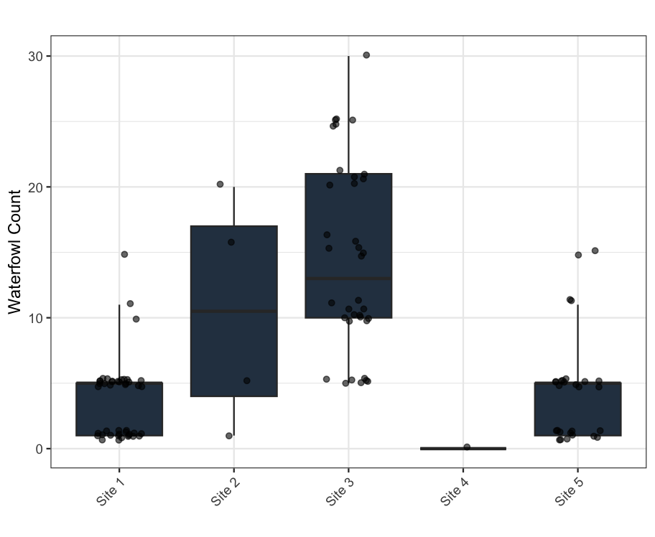
Figure S1. Weekly waterfowl counts at Sites 1 through 5 for each sampling event where at least one waterfowl was present. Points represent individual sampling event counts, and boxplots indicate the median and interquartile range of counts observed.

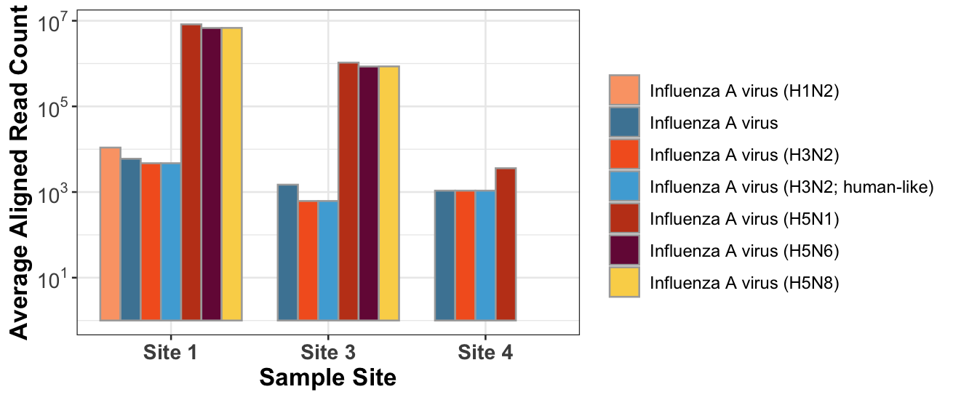
Figure S2. Average read counts aligned to Influenza A virus reference genomes across all samples analyzed at Sites 1, 3 and 4. Targeted enrichment sequencing was performed using the Illumina viral surveillance protocol version 2.
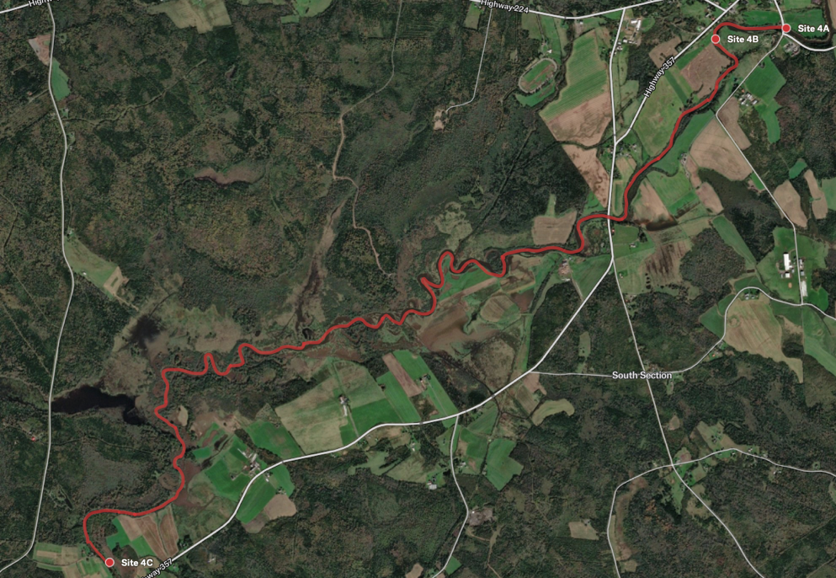
Figure S4. Map of the Site 4 study area showing the approximate locations of Sites 4A, 4B, and 4C. Land use and site functions are described. Site 4A is located at the intake of the municipal drinking water treatment facility and is a direct point for source water quality monitoring. Site 4B is situated downstream of Site 4A (~1 km) at the discharge point of the municipal wastewater treatment facility and captures treated wastewater effluent as it enters the receiving surface water. Site 4C is positioned downstream of Site 4B (~11 km) and is used for recreational purposes.
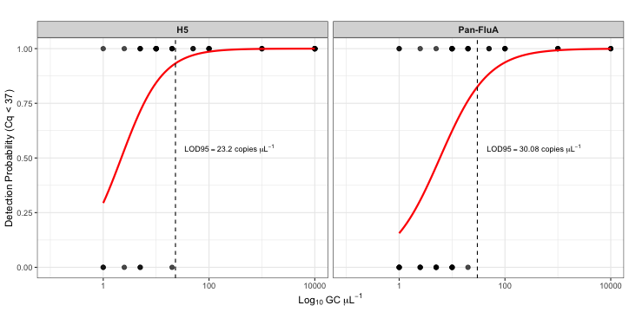
Figure S4. Limit of detection at 95% confidence intervals for the duplex RT-qPCR assay. The LOD_{95%} for the H5 and the Pan-FluA targets were estimated by logistic regression modeling and were determined to be ~23 and ~30 copies μL⁻¹, respectively.

Table S6. The Environmental Microbiology Minimum Information (EMMI) Guidelines: qPCR and dPCR Quality and Reporting for Environmental Microbiology. Table outline taken from a template provided by Borchardt et al. (2021).
