Ligand-mediated conformation diversity of Hsp90 revealed by GaMD simulations and Markov model
Huayin Bao · Jian Wang² · Lu Zhao² · Jianzhong Chen²

File S1. The details for GaMD simulations
GaMD simulation is an efficient technology to enhance conformation sampling of target. In this method, if the potential energy $V(\overset{⃑}{r})$ of the system is lower than a threshold energy $E$, the $V(\overset{⃑}{r})$ is revised as $V^{*}(\overset{⃑}{r})$ according to two equations (1) and (2)
$V^{*}\left(\overset{⃑}{r}\right)=V\left(\overset{⃑}{r}\right)+∆V(\overset{⃑}{r})$ (1)
$∆V\left(\overset{⃑}{r}\right)=\left\{\begin{aligned}0, &V(\overset{⃑}{r})≥E \\ \\ \frac{1}{2}k{\left(E-V\left(\overset{⃑}{r}\right)\right)}^{2}, & V\left(\overset{⃑}{r}\right)<E\end{aligned}\right.$ (2)
where the parameter $k$ represents the harmonic force constant. Through two enhanced sampling principles described in the equations (3) and (4), the parameters $E$ and $k$ can be tuned
$V_{max}≤E≤V_{min}+\frac{1}{k}$ (3)
$k=k_{0}\frac{1}{V_{max-}V_{min}}$ (4)
in which if $E$ is set as the lower bound $E=V_{max}$, then $k_{0}$ is obtained by using the equation (5)
$k_{0}=min⁡(1.0, \frac{σ_{0}}{σ_{V}}∙\frac{V_{max}-V_{min}}{V_{max}-V_{avg}})$ (5)
on the contrary, if $E$ is set as the upper bound $E=V_{min}+\frac{1}{k}$, then $k_{0}$ is got according to the equation (6)
$k_{0}=(1.0-\frac{σ_{0}}{σ_{V}})∙(\frac{V_{max}-V_{min}}{V_{avg}-V_{min}})$ (6)
in the aforementioned equations, three energy parameters $V_{max}$, $V_{min}$ and $V_{avg}$ respectively indicate the maximum, minimum and averaged potential energies of the systems extracted from three independent cMD simulations. The parameter $σ_{V}$ corresponds to the standard deviation of the system potential energies and the $σ_{0}$ is a user-determined upper limit for rationally reweighting.

Table S1. Hydrogen bonds formed between inhibitors and Hsp90
Complexes | Hydrogen bonds | ªDistance(Å) | ªAngle(°) | ^{b}Occupacy(%)
D57-Hsp90 | D57-OAD…T184-OG1-HG1 | 2.81 | 160.51 | 96
D57-Hsp90 | D57-OAM…N51-ND2-HD22 | 2.92 | 159.54 | 96
D57-Hsp90 | D93-OD1…D57-OAG-H17 | 2.69 | 163.42 | 91
D57-Hsp90 | L48-O…D57-OAJ-H18 | 2.95 | 239.39 | 75
9QY-Hsp90 | D93-OD2…9QY-OAD-H19 | 2.58 | 167.44 | 100
9QY-Hsp90 | L48-O…9QY-OAD-H19 | 2.93 | 144.34 | 53
9QY-Hsp90 | 9QY-OAB…T184-OG1-HG1 | 2.81 | 162.97 | 35
2GJ-Hsp90 | 2GJ-O33…T184-OG1-HG1 | 3.04 | 160.86 | 80
2GJ-Hsp90 | D93-OD2…2GJ-O33-H31 | 2.66 | 165.31 | 100
2GJ-Hsp90 | G97-O…2GJ-N10-H15 | 2.97 | 159.91 | 99
2GJ-Hsp90 | 2GJ-N1…G97-N-H | 3.31 | 127.06 | 26
ªHydrogen bonds are analyzed by an acceptor···donor distance of < 3.5 Å and acceptor···H-donor angle of > 120°.
^{b}Occupancy (%) is defined as the percentage of simulation time that a specific hydrogen bond exists.

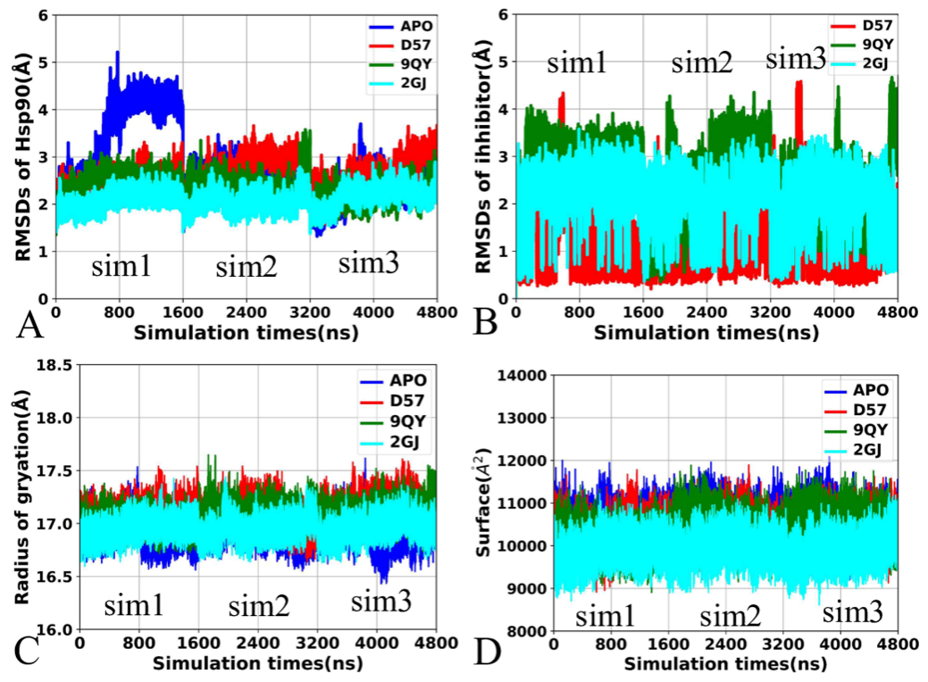
Figure S1. The time evolution of RMSDs, radius of gyration and molecular surface areas as simulation time: (A) RMSDs of heavy atoms from Hsp90, (B) RMSDs of heavy atoms from inhibitors, (C) Radius of gyration from Hsp90 and (D) molecular surfaces of Hsp90.

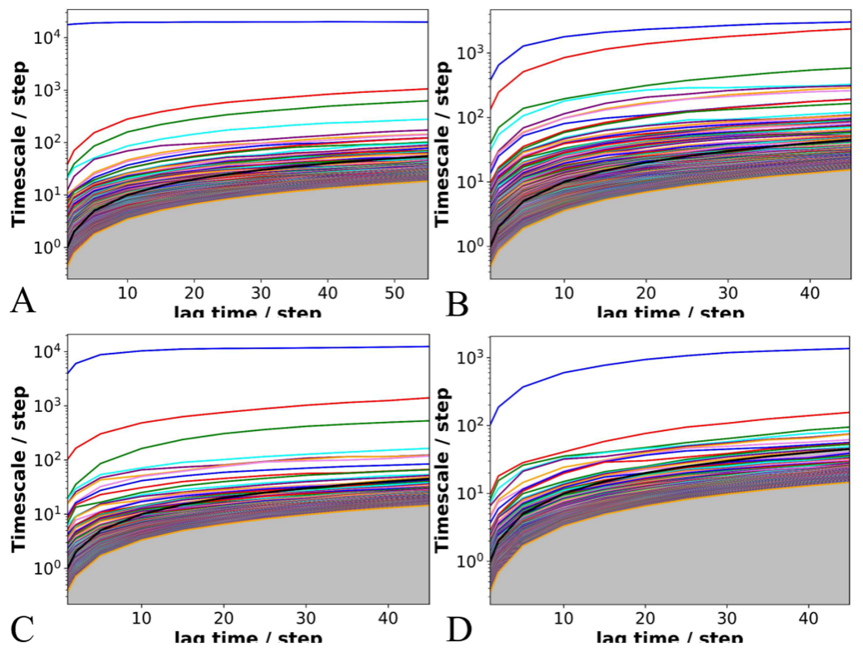
Figure S2. Lag time determination of four systems: (A) apo Hsp90, (B) D57-bound Hsp90, (C) 9QY-bound Hsp90 and (D) 2GJ-bound Hsp90.

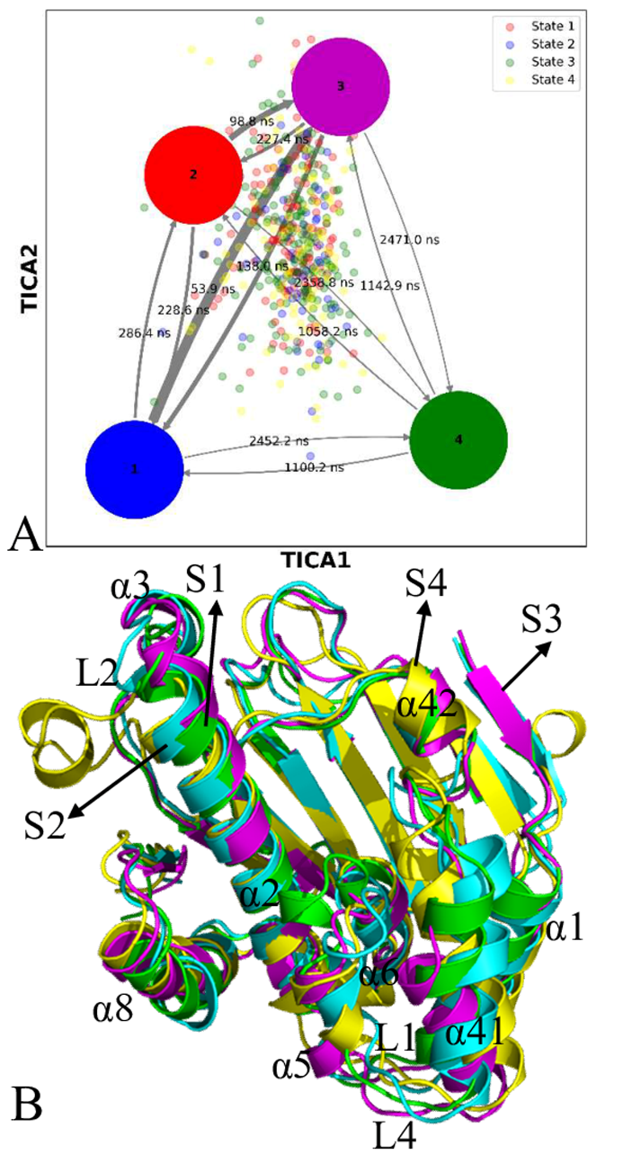
Figure S3. Macrostates of Hsp90 and corresponding representative structures: (A) macrostates of Hsp90 captured by Markov model with 500 microstates and (B) superimposition of representative structures located at four macrostates of Hsp90.

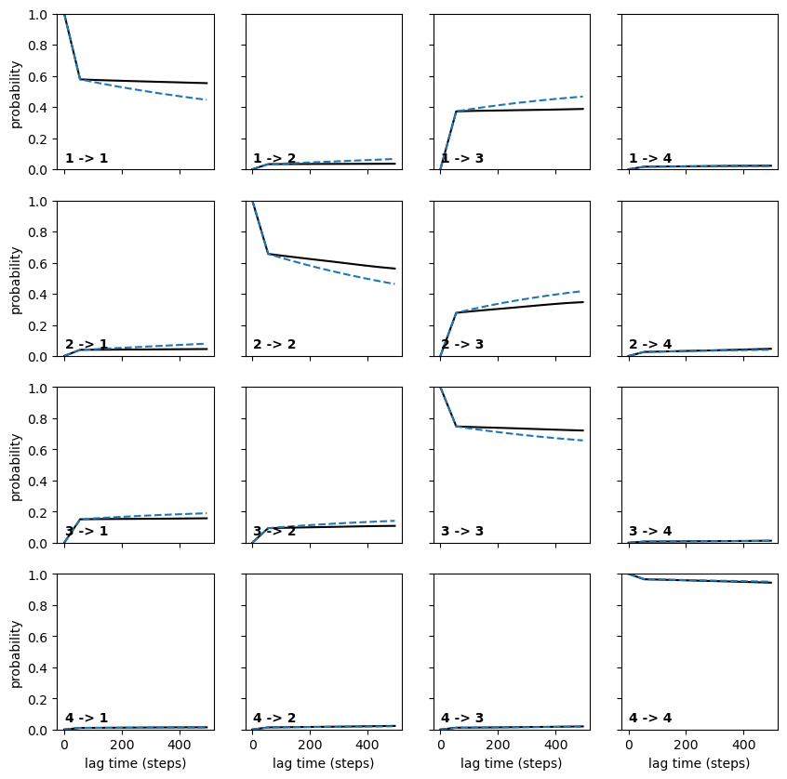
Figure S4. Chapman-Kolmogorov (C-K) test applied to the 4-macrostate model of apo Hsp90 derived from our Markov model analysis

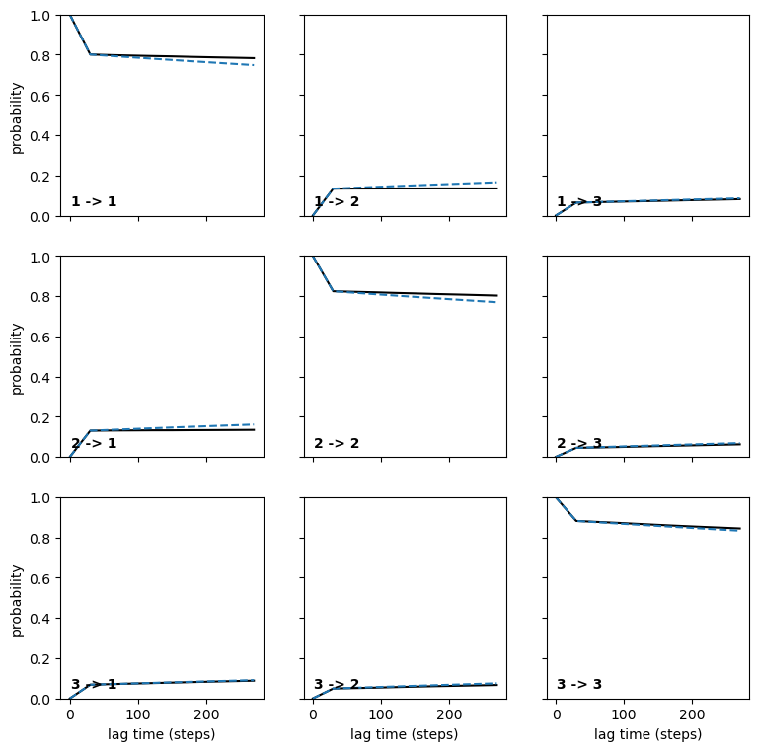
Figure S5. Chapman-Kolmogorov (C-K) test applied to the 3-macrostate model of D57-bound Hsp90 derived from our Markov model analysis

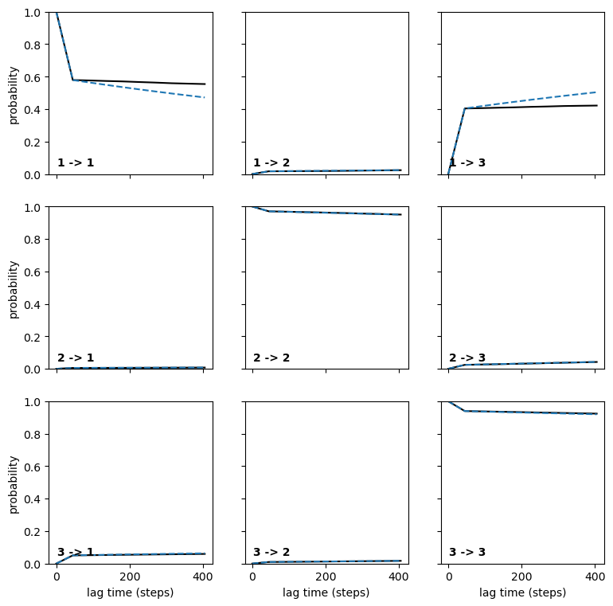
Figure S6. Chapman-Kolmogorov (C-K) test applied to the 3-macrostate model of 9QY-bound Hsp90 derived from our Markov model analysis

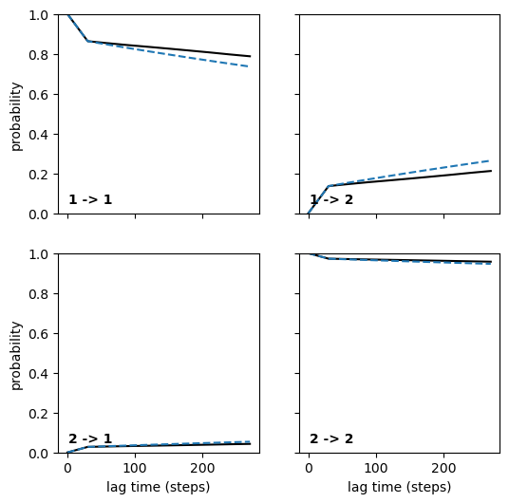
Figure S7. Chapman-Kolmogorov (C-K) test applied to the 2-macrostate model of 2GJ-bound Hsp90 derived from our Markov model analysis

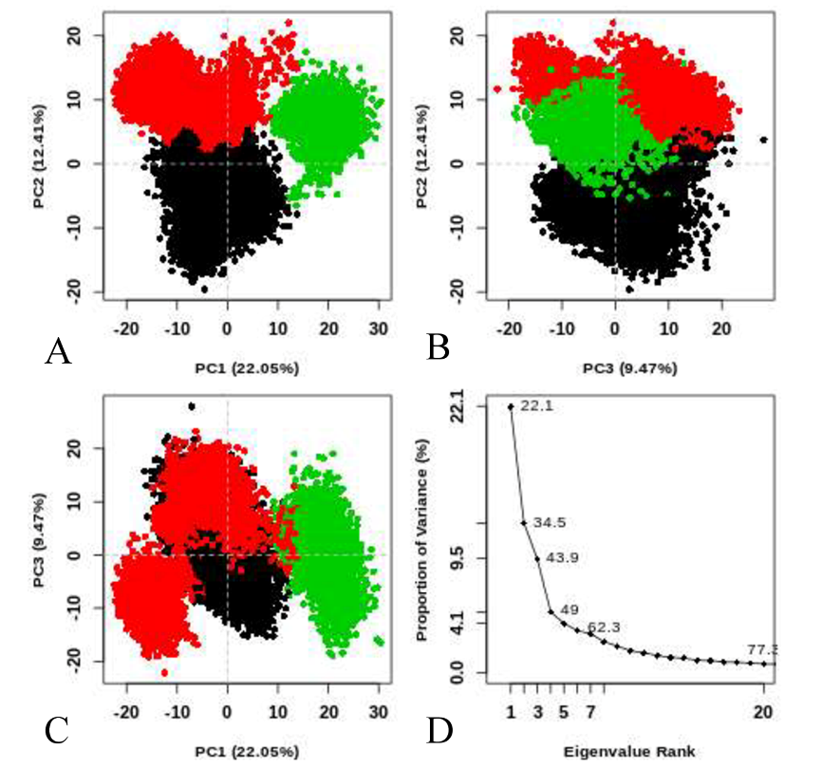
Figure S8. Cluster analyses and eigenvalues based on principal component analysis of D57-bound Hsp90: (A) cluster analyses using PC1 and PC2, (B) cluster analyses through PC2 and PC3, (C) cluster analyses with PC1 and PC3 and (D) separate eigenvalues.

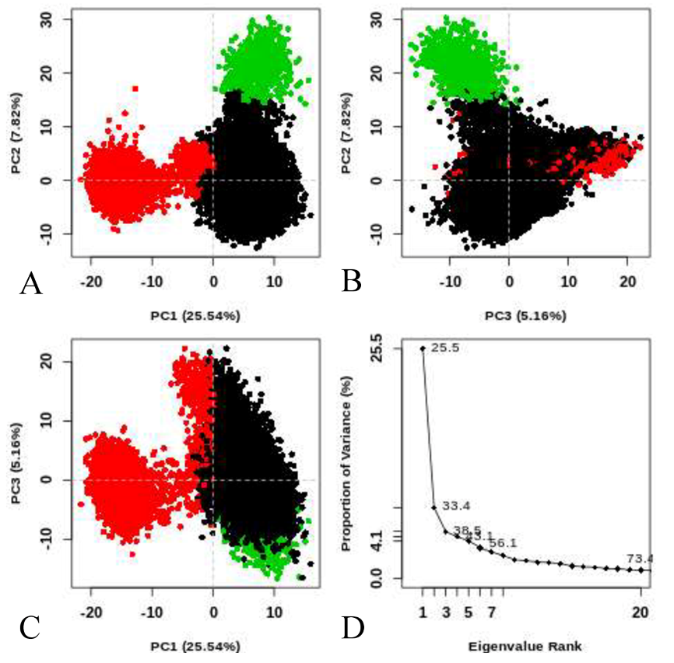
Figure S9. Cluster analyses and eigenvalues based on principal component analysis of 9QY-bound Hsp90: (A) cluster analyses using PC1 and PC2, (B) cluster analyses through PC2 and PC3, (C) cluster analyses with PC1 and PC3 and (D) separate eigenvalues.

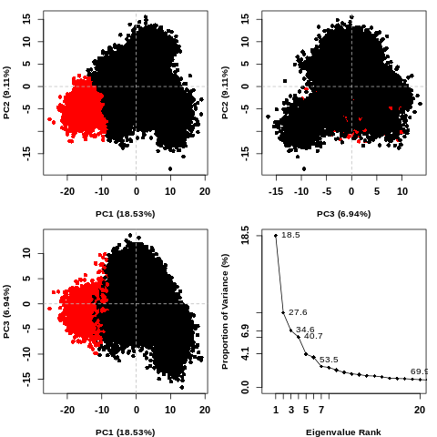
Figure S10. Cluster analyses and eigenvalues based on principal component analysis of 2GJ-bound Hsp90: (A) cluster analyses using PC1 and PC2, (B) cluster analyses through PC2 and PC3, (C) cluster analyses with PC1 and PC3 and (D) separate eigenvalues.

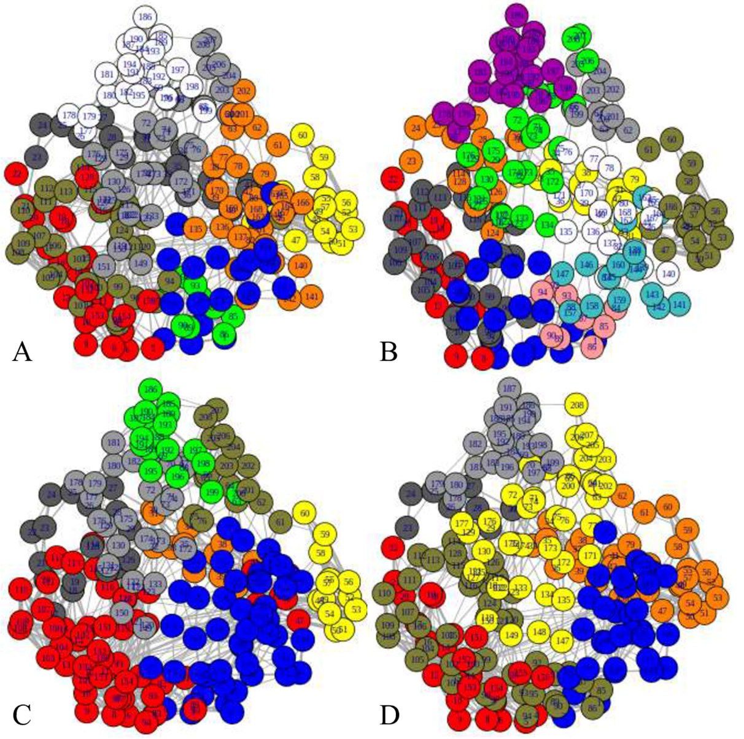
Figure S11. Residue network communications between key structural domains of Hsp90: (A) APO Hsp90, (B) D57-bound Hsp90, (C) 9QY-bound Hsp90 and (D) 2GJ-bound Hsp90.

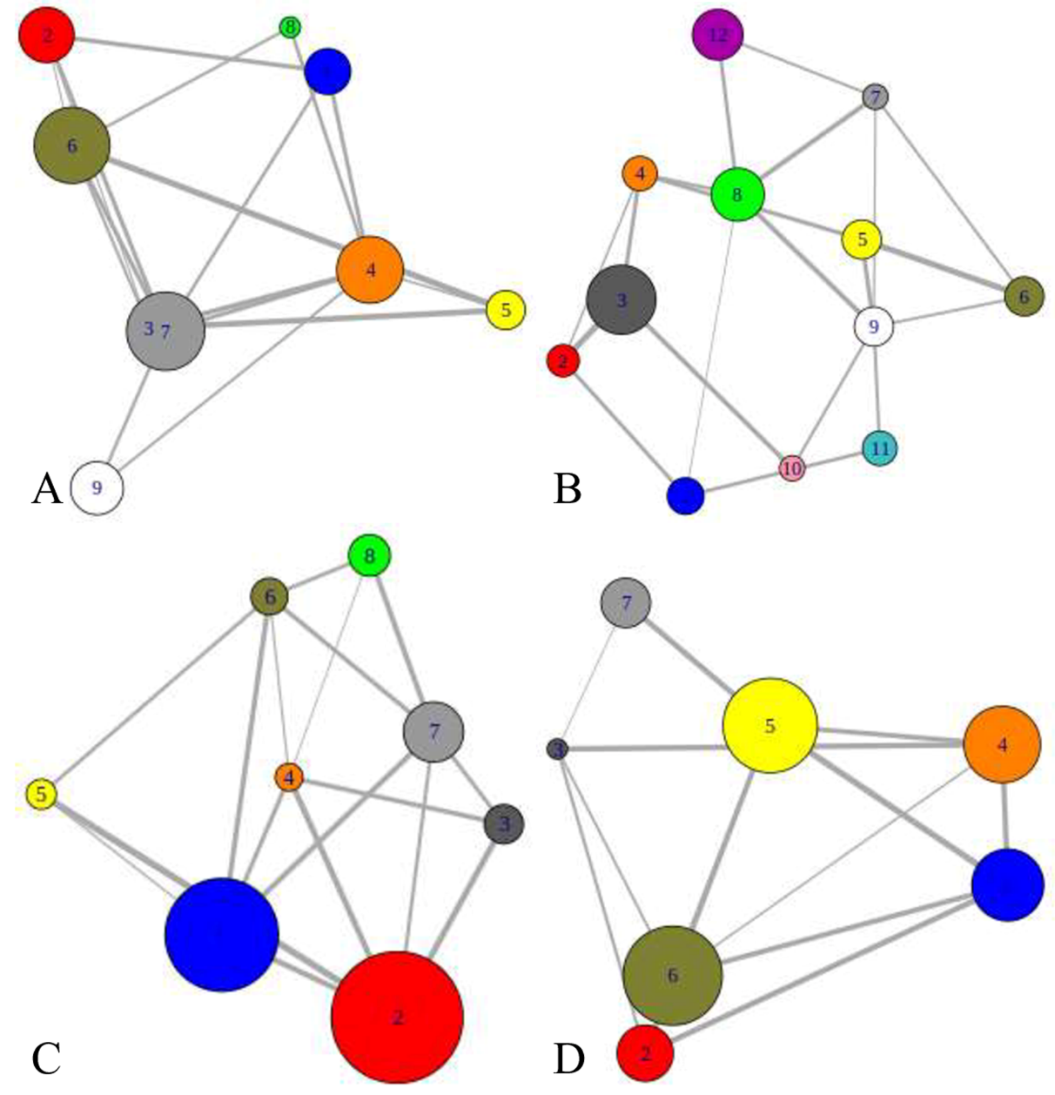
Figure S12. Network communications between different clusters: (A) APO Hsp90, (B) D57-bound Hsp90, (C) 9QY-bound Hsp90 and (D) 2GJ-bound Hsp90. In this figure, color circles indicate nodes and the gray lines represent edges describing communications between nodes.

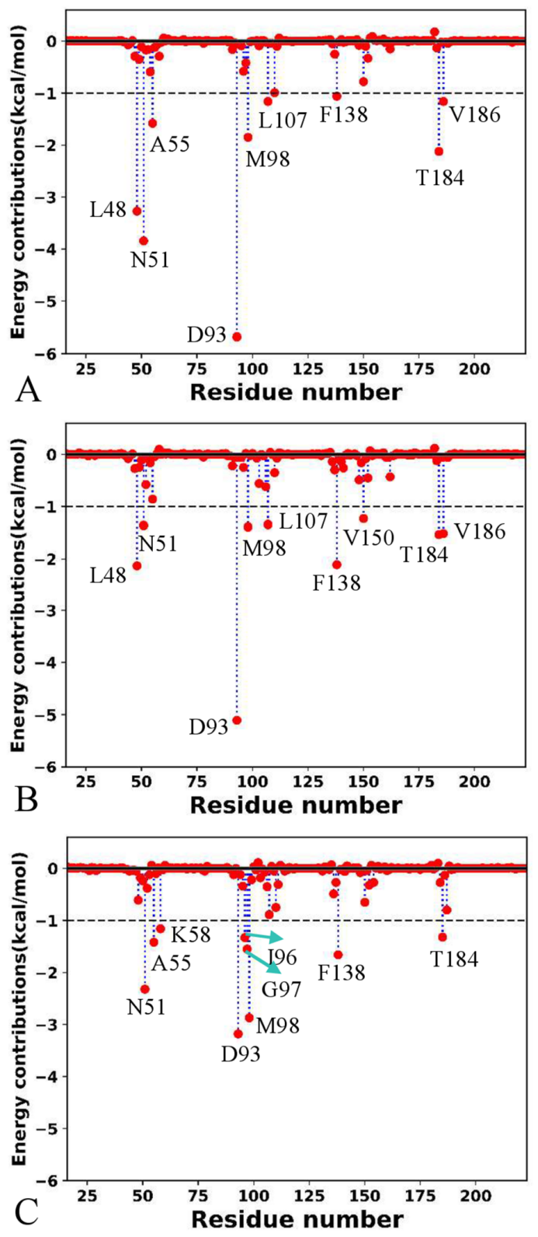
Figure S13. Interactions of D57, 9QY and 2GJ with separate residues: (A) D57, (B) 9QY and (C) 2GJ. The residues of interactions stronger than -1.0 kcal/mol were labeled.

Corresponding author: Huayin Bao E-mail: huayinbao@126.com Jianzhong Chen E-mail: chenjianzhong1970@163.com, jzchen@sdjtu.edu.cn ¹School of Pharmacy, Shandong University of Traditional Chinese Medicine, Jinan, China ²School of Science, Shandong Jiaotong University, Jinan, China

