Supporting information
Table S1 Experimental parameters and levels for bioethanol production.
Parameter | Symbol | Coded factor level
Parameter | Symbol | -1 | 0 | 1
L-trp （g/L） | A | 0 | 0.4 | 0.8
Inoculation amount (%) | B | 1 | 1.5 | 2
Glucose (g/L) | C | 20 | 25 | 30

Table S2 Design matrix for violacein.
Run | A | B | C | Yield of violacein
1 | 1 | 0.4 | 2 | 30
2 | 2 | 0.4 | 1.5 | 25
3 | 3 | 0.4 | 1 | 20
4 | 4 | 0 | 1 | 25
5 | 5 | 0.4 | 2 | 20
6 | 6 | 0.8 | 2 | 25
7 | 7 | 0.4 | 1.5 | 25
8 | 8 | 0 | 2 | 25
9 | 9 | 0.8 | 1.5 | 30
10 | 10 | 0.8 | 1.5 | 20
11 | 11 | 0.8 | 1 | 25
12 | 12 | 0.4 | 1.5 | 25
13 | 13 | 0.4 | 1 | 30
14 | 14 | 0.4 | 1.5 | 25
15 | 15 | 0 | 1.5 | 30
16 | 16 | 0 | 1.5 | 20
17 | 17 | 0.4 | 1.5 | 25

Table S3 Significance test and variance results for quadratic model
Source | Sum of Squares | df | Mean Square | F-value | p-value
Model | 1572.24 | 9 | 174.69 | 10.52 | 0.0026 | **
A | 49.66 | 1 | 49.66 | 2.99 | 0.1273
B | 211.24 | 1 | 211.24 | 12.73 | 0.0091 | **
C | 195.37 | 1 | 195.37 | 11.77 | 0.011 | **
AB | 0.845 | 1 | 0.845 | 0.0509 | 0.8279
AC | 90.08 | 1 | 90.08 | 5.43 | 0.0426 | **
BC | 33.97 | 1 | 33.97 | 2.05 | 0.1957
A² | 291.79 | 1 | 291.79 | 17.58 | 0.0041 | **
B² | 60.96 | 1 | 60.96 | 3.67 | 0.0968
C² | 552.69 | 1 | 552.69 | 33.3 | 0.0007 | **
Residual | 116.2 | 7 | 16.6
Lack of Fit | 116.2 | 3 | 38.73
Pure Error | 0 | 4 | 0
Cor Total | 1688.44 | 16
Note: A is the L-trp concentration, B is the Inoculation amount, C is the Glucose concentration, and df is the degree of

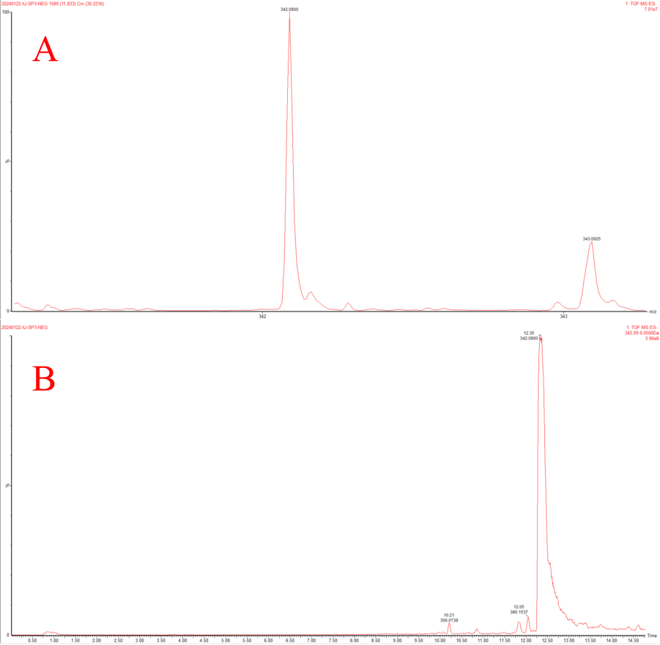
Figure S1 Liquid Chromatography-Mass Spectrometry result of violacein in ES-. A: Violacein in HPLC. B: Violacein in MS

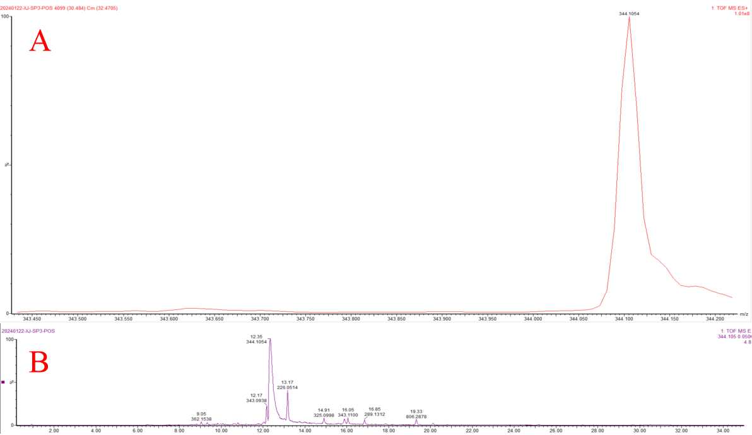
Figure S2 Liquid Chromatography-Mass Spectrometry result of violacein in ES+. A: Violacein in HPLC. B: Violacein in MS.

