Supplementary figure 1 –

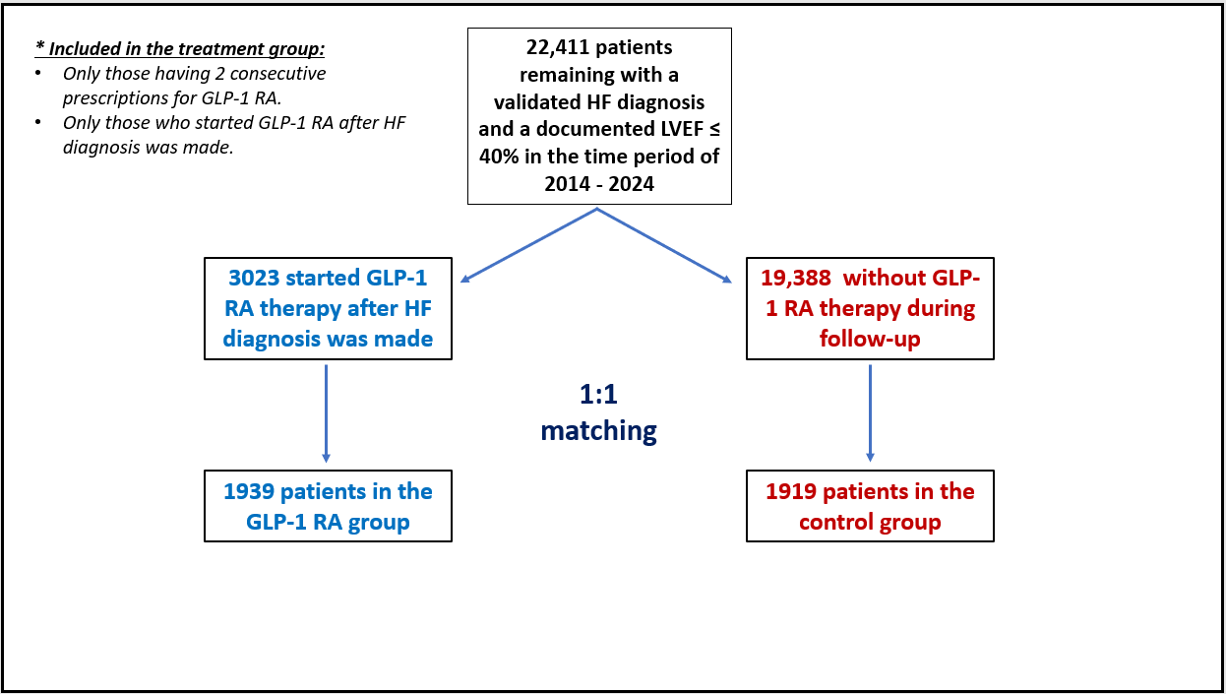
A CONSORT diagram representing the inclusion process of the study. HF: heart failure; LVEF: left ventricular ejection fraction; GLP-1 RA: glucagon-like peptide-1 receptor agonists.

Socioeconomic score –
Explanation on the Socio-Economic Status (SES) Measure SES was based on the small statistical areas (SSA) used in the 2008 Israeli census. SSAs contain 3000–4000 people and are created to maintain homogeneity in terms of the sociodemographic composition of the population. The Israeli Central Bureau of Statistics (CBS) utilized demography, education, employment, housing conditions, and income to define the SSAs, and these were grouped into 20 categories. This data was updated by the POINTS Location Intelligence Company to improve the accuracy of the SES measure, using up-to-date sociodemographic, commercial, and housing data. The entire population was grouped into ten categories, ranging from 1 (lowest) to 10 (highest)

