Supplementary Materials for

Concurrent Detection of Cognitive Impairment and Amyloid Positivity with a Next-Generation Digital Cognitive Assessment

Ali Jannati^{1,2}, Karl Thompson², Claudio Toro-Serey²,
Joyce Gomes-Osman³, Russell E. Banks⁴, Connor Higgins²,
John Showalter², David Bates², Sean Tobyne², and Alvaro Pascual-Leone^{1,2,5}

¹ Department of Neurology, Harvard Medical School, 25 Shattuck Street, Boston, MA, 02115 USA
² Linus Health, Inc., 280 Summer Street, 10th Floor, Boston, MA, 02210 USA
³ Department of Neurology, University of Miami Miller School of Medicine, 1600 NW 10th Avenue, Miami, FL 33136 USA
⁴ Department of Communicative Sciences & Disorders, Michigan State University, 404 Wilson Rd, East Lansing, MI 48824 USA
⁵ Hinda and Arthur Marcus Institute for Aging Research and Deanna and Sidney Wolk Center for Memory Health, Hebrew SeniorLife, 1200 Centre St, Boston, MA 02131 USA

Please address all correspondence to:

Alvaro Pascual-Leone, MD, PhD.
Deanna and Sidney Wolk Center for Memory Health
Hebrew SeniorLife – Harvard Medical School
1200 Centre St,
Boston, MA 02131
USA
Email: apleone@hsl.harvard.edu

Bio-Hermes Eligibility Criteria
Enrollment inclusion and exclusion criteria are listed below for reference. Criteria are also available for review at https://clinicaltrials.gov/study/NCT04733989. See Mohs et al. (2024) for additional information.

Inclusion Criteria:
- Participants must meet all the following criteria for entry into the study:
  - Participants must provide written consent in the IRB-approved informed consent form or have a Legally Authorized Representative (LAR) provide written consent in the IRB-approved consent form on the participant's behalf;
  - Male or female 60 to 85 years of age (inclusive) at the time of consent;
  - Participants must be willing to undergo an amyloid PET scan within 60 days of signing informed consent; or for sites that do not have access to PET imaging, the participant must be willing to undergo a lumbar puncture for cerebrospinal fluid (CSF) collection within 30 days of the coagulation panel;
  - Participants must have a study partner who, in the investigator's judgement, has sufficient and frequent contact (defined as at least 8 hours of contact a week) with the participant and is able to provide accurate information regarding the participant's cognitive and functional abilities;
  - Participants must be willing to comply with all study procedures as outlined in the informed consent, including blood sampling;
  - Fluency in the language of the tests used at the study site;
  - Participants must be willing to be contacted for possible participation in clinical research trials once their participation in this study ends; and
  - Participants must have a Mini-Mental State Exam (MMSE) score of 17 to 30 inclusive at screening; those with a score of 17-19 must have a diagnosis of Probable AD.

Exclusion Criteria:
- Participants who meet any of the following criteria will not be eligible for entry into the study:
  - Participants who, in the opinion of the Site Principal Investigator, have serious or unstable medical conditions that would prohibit their completion of all study procedures and data collection;
  - Participants who have serious or unstable medical conditions that would likely preclude their participation in an interventional research trial;
  - Participants who are unable to undergo amyloid PET due to self-reported pregnancy, sensitivity of ligands being used, poor venous access, contraindication to PET, or planned or recent exposure to ionizing radiation that in combination with the planned administration of amyloid radioligand would result in a cumulative exposure that exceeds recommended local guidelines;
  - Participants who have reported or have a known negative amyloid PET scan in past 12 months;
  - Participants with self-reported, untreated conditions such as vitamin B12 or folate deficiency or bladder infections that in the opinion of the Site Principal Investigator could contribute to cognitive impairment;
  - Participants with history of stroke or seizures within 1 year of the Visit 1 (Screening);
  - Participants with history of cancer within the past 5 years with the exception of non-melanoma skin cancer or prostate cancer in situ;
  - Participants with known or suspected alcohol or drug abuse or dependence within 1 year of the Visit 1 (Screening);
  - Participants who report any current unstable psychiatric symptoms that could interfere with study procedures or impact study data (e.g., uncontrolled depression);
  - Participants who have participated in a clinical trial of any potential disease modifying AD treatment and received active drug within 6 months prior to Visit 1 (Screening);
  - Participants who have completed clinical or observational study procedures (e.g., imaging, cognitive testing) within 3 months of Visit 1 (Screening);
  - Participants who have any neurological disorder affecting the central nervous system, other than AD, that may be contributing to cognitive impairment (e.g., Parkinson's disease, other dementias, multiple concussions or seizures) as deemed significant by the Site Principal Investigator;
  - Participants with a Geriatric Depression Scale (GDS) score greater than or equal to 8 at Visit 1 (Screening);
  - Participants with a RAVLT-Delayed Recall Score of 1.5 standard deviation above the age-adjusted mean;
  - Participants with known history or self-report to be Human Immunodeficiency Virus (HIV) Positive;
  - Participants weighing less than 110 pounds;
  - Participants that have previously been consented to this study unless prior approval was granted by the Sponsor on a case-by-case basis;
  - Participants who are direct employees or family members of direct employees of the participating investigators' sites;
  - Participants who are direct employees of the Sponsor;
  - Participants who, in the opinion of the investigator, are unable to complete cognitive testing due to inadequate visual or auditory acuity;
  - For participants of the RetiSpec retinal substudy only: Those with a known history of ocular diseases (such as retinopathy, age-related macular degeneration, and glaucoma), with the exception of mild to moderate cataracts, and/or vision correction with glasses/contact lenses;
  - For participants undergoing LP: contraindication to lumbar puncture, including coagulopathy, concomitant anticoagulation (except for a platelet inhibitor such as aspirin or clopidogrel), thrombocytopenia, prior lumbar spinal surgery, significant deformity of the lumbosacral region, INR results > 1.3, or other factor that precludes safe LP in the opinion of the Site Principal Investigator.

Bio-Hermes Visit Schedule and Protocol

All participants completed one screening visit (Visit 1) to collect demographic, clinical, and cognitive information; one imaging visit (Visit 2) to complete amyloid PET scan; and one follow-up visit (Visit 3) to receive results of amyloid PET scan. All screening and follow-up visits and procedures were conducted at the clinic whenever possible except some that were completed remotely, when necessary, with written Sponsor approval.

Visit 1 (Screening)
The following procedures were completed during Visit 1:

1. Obtain informed consent
2. Collection of contact and demographic information including, but not limited to, gender, date of birth, race, and ethnicity
3. Collection of recruitment source
4. Collection of vital signs (includes blood pressure, heart rate, respiration rate)
5. Collection of height and weight
6. Review of Inclusion and Exclusion Criteria
7. Medical History including known family history
8. Concomitant Medications
9. Psychometric Assessment (MMSE, RAVLT, FAQ, GDS)
10. Cognivue® Clarity for Cognitive Assessment
11. Linus Platform Tests
12. Biospecimen Collection

Visit 2 (Imaging)
At Visit 2, participants underwent an amyloid PET brain scan at a designated imaging center. The results of this scan were reviewed at Visit 3 (Follow-up).

Visit 3 (Follow-Up)
Participants completed a follow-up visit at the site to allow the Site Principal Investigator or other appropriate study staff to disclose and review the results of PET imaging. PET imaging results were disclosed to all study participants unless the participant declined this disclosure after a meaningful discussion with the Site Principal Investigator or designee. The following procedures were completed during this visit:

1. Review of Medical History or other relevant Health Information
2. Review of Concomitant Medications
3. Speech Vitals
4. Biospecimen Collection
5. Disclosure of amyloid PET brain scan results
6. Adverse Event Collection

Schedule of Events

Activity | Visit 1 | Visit 2 | Visit 3
Visit Window | Day 1 | Day 30  (+ 30 days) | Day 60  (+ 30 days)
Informed Consent | X
Contact and Demographic Information | X
Collection of Recruitment Source | X
Vital Signs | X
Height and Weight | X
Review of Inclusion and Exclusion Criteria | X
Medical History | X |  | X
Concomitant Medications | X |  | X
MMSE | X
RAVLT | X
FAQ | X
Geriatric Depression Scale (GDS) | X
Cognivue® Clarity for Cognitive Assessment | X
Linus Health Digital Clock and Recall (DCR) | X |  | X
Biospecimen Collection | X |  | X
Amyloid PET Scan |  | X
Amyloid PET Imaging Results Review* |  |  | X
Adverse Event Collection |  |  | X
*Participants who received positive PET results were contacted within 72 hours following Visit 3, to evaluate their overall well-being.

Cognitive Assessments
The MMSE is a 30-point test commonly used to screen for cognitive impairment in elderly adults and assesses orientation, memory, attention, naming, comprehension, verbal, and written commands. The MMSE can detect mild to moderate stages of dementia with acceptable sensitivity and specificity but can take 7–12 minutes to complete, especially in individuals with dementia.

The RAVLT is a verbal list-learning test widely used in clinical and research settings to assess verbal memory including encoding, learning, storage, consolidation, and subsequent free recall or recognition. Delayed recall is completed after approximately 25 minutes.

Cognivue® Clarity for Cognitive Assessment is an FDA-listed computerized testing tool designed to assess early signs of cognitive impairment, consisting of 3 sub-batteries (visuomotor and visual salience, perceptual processing, and memory processing) presented in a 10-minute sequence.

The Linus Health DCR™ is an FDA-listed Class II 510k exempt software as a medical device, and a digital and AI-enabled adaptation of the well-known, paper-based Mini-Cog. The DCR detects signs of cognitive impairment by analyzing the individual’s performance using a combination of a digital clock drawing test (DCTclock™) and 3-word immediate and delayed verbal recall tests. This multimodal digital assessment captures drawing and voice process metrics and employs automated scoring and AI algorithms to provide objective insights into various cognitive domains including verbal memory, executive function, visuospatial reasoning, and motor function.

It is important to note that both MMSE and RAVLT were used for cohort definition, which also considered FAQ information and clinical impression by the investigator at baseline. All analyses that consider the classification performance of MMSE and RAVLT for cognitive impairment are biased due to this circularity.

Sample-Size Considerations
The organizers of the Bio-Hermes study aimed to recruit 1000 participants in total, with target enrollments of 400, 300, and 300 participants in the cognitively unimpaired (CU), mild cognitive impairment (MCI), and probable Alzheimer’s dementia (pAD) cohorts, respectively, as defined below.

Cognitive Cohort Definition
The 930 participants were defined by the Bio-Hermes study team into three cohorts: CU (n=398), MCI (n=291), or pAD (n=241) based on the following a priori criteria:

- Cohort 1, Cognitively Unimpaired:
  - No reported memory loss or concerns (as reported by participant and study partner)
  - Mini-Mental Status Exam (MMSE) score of 25 to 30 inclusive
  - Rey Auditory Verbal Learning Test (RAVLT)- Delayed Recall Score within normal range based on age-adjusted mean
  - In the investigator’s judgment, no evidence of functional decline based on the Functional Activities Questionnaire (FAQ) score/study partner report

- Cohort 2, MCI:
  - A diagnosis of Mild Cognitive Impairment (MCI) given within 3 months of Visit 1 and verified through medical records
OR
  - All the following criteria:
    - Memory loss may or may not be reported by participant or study partners
    - MMSE score of 24-30 inclusive
    - RAVLT- Delayed Recall Score of 1 standard deviation below the age-adjusted mean
    - In the investigator’s judgment, no evidence of functional decline based on the FAQ score/study partner report

- Cohort 3, pAD:
  - A diagnosis of probable Alzheimer’s disease based on the National Institute of Aging (NIA) criteria¹¹ given within 3 months of Visit 1 and verified through medical records
OR
  - All the following criteria:
    - Reported memory loss by participant or study partner
    - MMSE score of 20-26
    - RAVLT- Delayed Recall Score of 1 standard deviation below the age-adjusted mean
    - In the investigator’s judgment, evidence of functional decline based on FAQ score/study partner report

Table S1. Cognitive-impairment classification performance of blood-based biomarkers and cognitive tests.

 | Age-only | pTau217 | pTau181 | Aβ42/40 | APS | MMSE | RAVLT | Cognivue | DCR
AUC | 0.627 | 0.716 | 0.663 | 0.630 | 0.639 | 0.816 | 0.890 | 0.738 | 0.865
95% CI | 0.616,  0.638 | 0.706, 0.726 | 0.651, 0.673 | 0.620, 0.639 | 0.629, 0.649 | 0.808, 0.824 | 0.885, 0.896 | 0.730, 0.746 | 0.857, 0.873
Accuracy | 0.607 | 0.650 | 0.633 | 0.601 | 0.597 | 0.729 | 0.812 | 0.679 | 0.792
Specificity | 0.585 | 0.759 | 0.679 | 0.590 | 0.599 | 0.790 | 0.787 | 0.713 | 0.777
Sensitivity | 0.623 | 0.573 | 0.597 | 0.610 | 0.595 | 0.684 | 0.831 | 0.652 | 0.802
NPV | 0.533 | 0.558 | 0.563 | 0.531 | 0.526 | 0.649 | 0.774 | 0.614 | 0.743
PPV | 0.672 | 0.771 | 0.710 | 0.666 | 0.666 | 0.816 | 0.841 | 0.747 | 0.830
Machine-learning classification performance of blood-based biomarkers and cognitive tests in predicting cognitive impairment (CU vs. MCI+pAD). The CU cohort constitutes the negative cohort while the MCI and pAD cohorts are combined to create the positive class for the classification task. The DCR model is a random forest classifier trained on features extracted from DCTclock drawing data, recall audio recordings, and participant age. All other models are based on logistic regression classifiers trained with the corresponding biomarker/test primary metric as well as participant age. APS, C2N amyloid probability score; AUC, area under the receiver operating characteristic curve; CI, confidence interval; CU, cognitively unimpaired; DCR, Digital Clock and Recall; MCI, mild cognitive impairment; MMSE, Mini-Mental State Examination; NPV, negative predictive value; pAD, probable Alzheimer’s dementia; PPV, positive predictive value; RAVLT, Rey Auditory Verbal Learning Test.

Table S2. Aβ status classification performance of cognitive tests per cohort.

Criteria | Cognitively Unimpaired |  |  |  | Cognitively Impaired
Model | MMSE | RAVLT | Cognivue | DCR | MMSE | RAVLT | Cognivue | DCR
AUC | 0.601 | 0.642 | 0.650 | 0.797 | 0.685 | 0.695 | 0.667 | 0.818
95% CI | 0.586, 0.615 | 0.629, 0.656 | 0.635, 0.664 | 0.785, 0.809 | 0.677, 0.694 | 0.686, 0.703 | 0.658, 0.675 | 0.809, 0.827
Accuracy | 0.713 | 0.762 | 0.703 | 0.803 | 0.618 | 0.607 | 0.602 | 0.744
Specificity | 0.834 | 0.904 | 0.779 | 0.870 | 0.500 | 0.469 | 0.510 | 0.730
Sensitivity | 0.259 | 0.230 | 0.402 | 0.550 | 0.760 | 0.771 | 0.714 | 0.760
NPV | 0.808 | 0.814 | 0.838 | 0.880 | 0.715 | 0.712 | 0.683 | 0.785
PPV | 0.295 | 0.390 | 0.317 | 0.532 | 0.560 | 0.549 | 0.547 | 0.704

Machine learning classification performance for different cognitive tests on predicting binary Aβ positivity status, per cognitive-impairment status. The cognitively unimpaired group constitutes the native CU cohort while the cognitively impaired group comprises MCI and pAD cohorts. The cognitively unimpaired group comprises 398 participants with an Aβ positivity rate of 21.1%, while the cognitively impaired group is made up of 532 participants with an Aβ positivity rate of 45.5%. AUC, area under the receiver operating characteristic curve; CI, confidence interval; CU, cognitively unimpaired; DCR, Digital Clock and Recall; MCI, mild cognitive impairment; MMSE, Mini-Mental State Examination; NPV, negative predictive value; pAD, probable Alzheimer’s dementia; PPV, positive predictive value; RAVLT, Rey Auditory Verbal Learning Test.

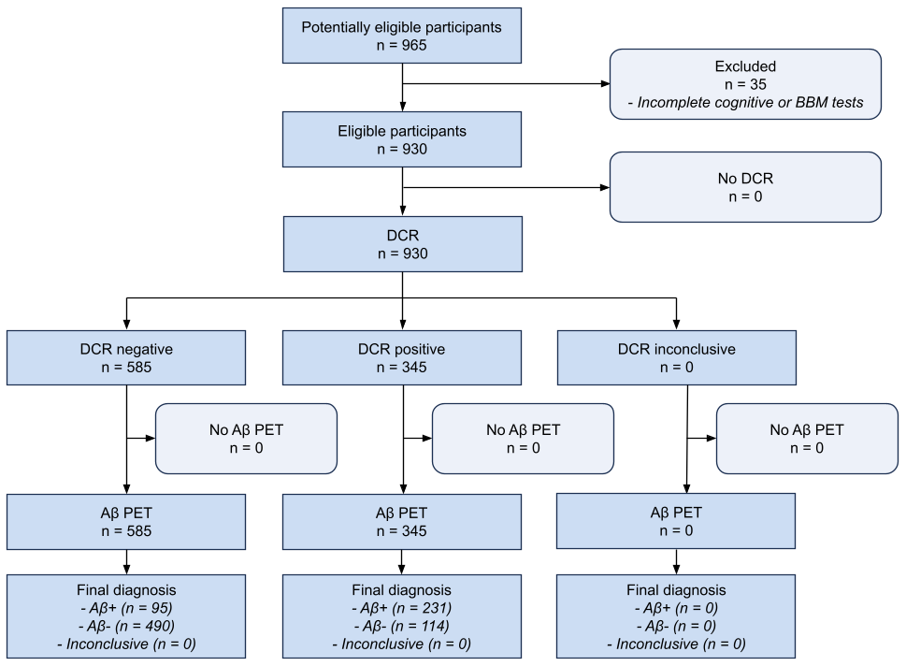

Figure S1. STARD diagram of PET Aβ status classification by the DCR.
Aβ, amyloid-beta; BBM, blood-based biomarker; DCR, Digital Clock and Recall; PET, positron emission tomography; STARD, standards for reporting diagnostic accuracy studies.

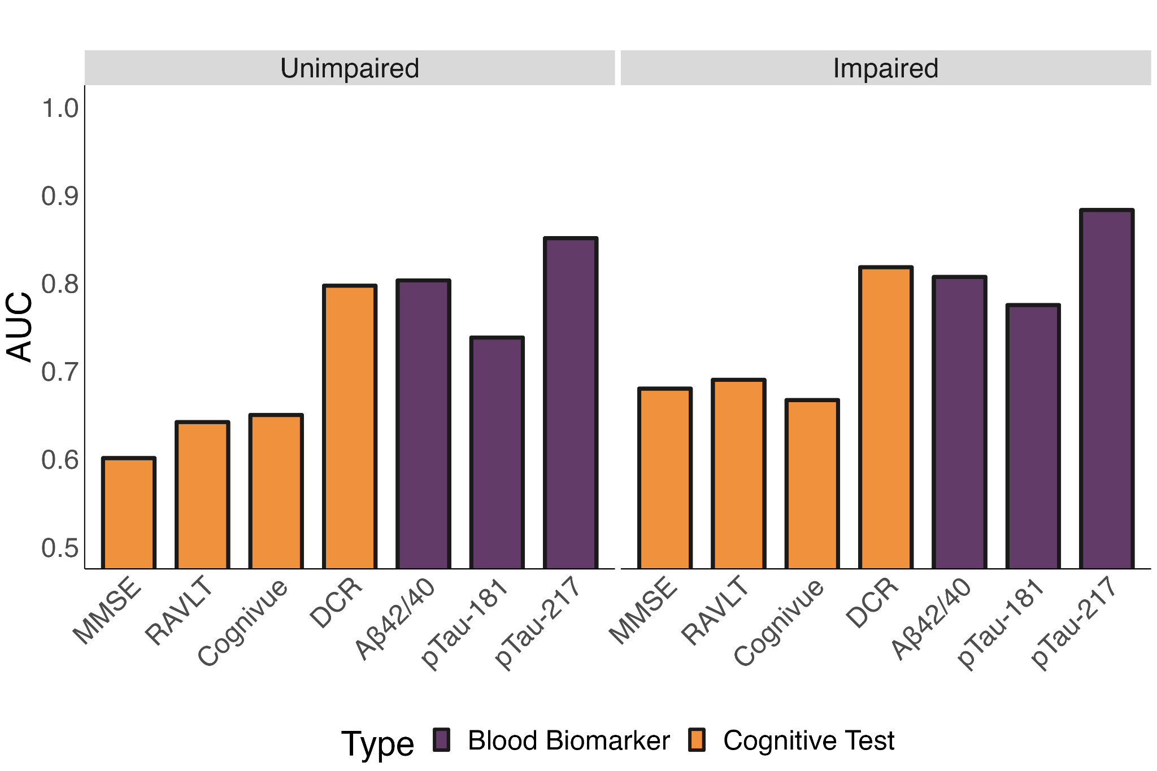

Figure S2. Aβ+ classification per cohort.
Left: AUC for the prediction of PET Aβ status in CU participants for each cognitive assessment and BBM. Note the AUCs for MMSE and RAVLT were inflated by circularity bias as they were part of the criteria for cohort determination. Right: AUC for the prediction of PET Aβ status in cognitively impaired participants (MCI or pAD cohorts) for each cognitive assessment and BBM. Note the AUCs for MMSE and RAVLT were affected by circularity bias as they were part of the criteria for cohort determination (shaded area). These results resemble those based on the overall classification of Aβ+, which showed that the DCR was superior to cognitive tests and Aβ42/40/pTau-181, and non-inferior to pTau-217.

Table S3. Aβ status classification performance of blood-based biomarkers per cognitive-impairment status.

Criteria | Cognitively Unimpaired |  |  |  | Cognitively Impaired
Model | pTau217 | Aβ42/40 | pTau181 | APS | pTau217 | Aβ42/40 | pTau181 | APS
AUC | 0.851 | 0.803 | 0.738 | 0.835 | 0.883 | 0.807 | 0.775 | 0.853
95% CI | 0.839, 0.863 | 0.790, 0.816 | 0.727, 0.748 | 0.823, 0.848 | 0.876, 0.890 | 0.799, 0.815 | 0.766, 0.784 | 0.846, 0.860
Accuracy | 0.837 | 0.807 | 0.716 | 0.819 | 0.838 | 0.727 | 0.719 | 0.771
Specificity | 0.898 | 0.856 | 0.776 | 0.855 | 0.831 | 0.805 | 0.717 | 0.814
Sensitivity | 0.655 | 0.630 | 0.515 | 0.687 | 0.845 | 0.634 | 0.721 | 0.720
NPV | 0.886 | 0.895 | 0.842 | 0.911 | 0.825 | 0.722 | 0.732 | 0.774
PPV | 0.688 | 0.543 | 0.412 | 0.561 | 0.851 | 0.735 | 0.708 | 0.767

Machine-learning classification performance of different blood biomarkers for predicting binary Aβ positivity status, per cognitive-impairment status. The cognitively unimpaired group constitutes the native CU cohort while the cognitively impaired group comprises MCI and pAD cohorts. The cognitively unimpaired cohort comprises 398 participants with an Aβ positivity rate of 21.1%, while the cognitively impaired group is made up of 532 participants with an Aβ positivity rate of 45.5%. APS, C2N amyloid probability score; AUC, area under the receiver operating characteristic curve; CI, confidence interval; CU, cognitively unimpaired; MCI, mild cognitive impairment; NPV, negative predictive value; pAD, probable Alzheimer’s dementia; PPV, positive predictive value.

Table S4. Aβ status classification performance of ensemble models.
Ensemble Model | AUC
DCR + All BBMs + APOE | 0.94
DCR + pTau181 + pTau217 + APOE | 0.93
DCR + pTau217 + Aβ42/40 + APOE | 0.93
DCR + pTau217 + APOE | 0.92
DCR + pTau181 + Aβ42/40 + APOE | 0.92
DCR + pTau217 | 0.91
DCR + Aβ42/40 + APOE | 0.91
DCR + APS | 0.90
DCR + pTau181 + APOE | 0.90
DCR + APOE | 0.88
DCR + Aβ42/40 | 0.87
DCR + pTau181 | 0.85
The ensemble models combined the DCR with most combinations of biomarkers. This ensemble provided improvements in the classification performance of each of the individual predictor models.

Table S5. Comparing Aβ status classification performance of DCR and BBM(s) ensemble models.
 | Models to compare against
Ensembles  (all 3 class + age) | DCR | pTau181 + pTau217 + AB42/40
DCR + pTau181 | -0.01 - 0.04✝✝ | -0.08 - -0.03✝
DCR + pTau217 | 0.05 - 0.1✝✝* | 0 - 0.04✝✝
DCR + AB42/40 | 0.02 - 0.05✝✝* | -0.05 - 0✝✝
DCR + APS | 0.04 - 0.09✝✝* | -0.02 - 0.02✝✝
Results from bootstrapped analyses evaluating the non-inferiority, equivalence, or superiority of ensemble models that contain DCR and individual BBM models. Each entry is the 95% CI of the difference in AUC between model configurations, with positive ranges denoting better performance from the ensemble model. The margin M is set to 0.05. ✝ = non-inferiority; ✝✝ = equivalence; ✝✝✝ = superiority; * = statistically greater significance at an alpha of 0.05. Adding DCR to other biomarkers provides significantly greater results and superiority in some cases.

Table S6. Comparing Aβ status classification performance of DCR, BBM(s), and APOE ensemble models.

 | Models to compare against
Ensembles  (all 3 class + age) | DCR | pTau181 + pTau217 + AB42/40
DCR + APOE | 0.03 - 0.07✝✝* | -0.05 - 0.01✝✝
DCR + pTau181 + APOE | 0.05 - 0.09✝✝* | -0.02 - 0.02✝✝
DCR + pTau217 + APOE | 0.06 - 0.11✝✝✝* | 0.01 - 0.04✝✝*
DCR + AB42/40 + APOE | 0.05 - 0.09✝✝* | -0.01 - 0.03✝✝
DCR + pTau181 + AB42/40 + APOE | 0.06 - 0.11✝✝✝* | 0 - 0.03✝✝
DCR + pTau181 + pTau217 + APOE | 0.07 - 0.12✝✝✝* | 0.01 - 0.05✝✝*
DCR + pTau217 + AB42/40 + APOE | 0.07 - 0.12✝✝✝* | 0.01 - 0.05✝✝*
DCR + pTau181 + pTau217 + AB42/40 + APOE | 0.08 - 0.12✝✝✝* | 0.02 - 0.05✝✝*
Results from bootstrapped analyses evaluating the non-inferiority, equivalence, or superiority of ensemble models that contain DCR, individual BBM models, and APOE. Each entry is the 95% CI of the difference in AUC between model configurations, with positive ranges denoting better performance from the ensemble model. The margin M is set to 0.05. ✝ = non-inferiority; ✝✝ = equivalence; ✝✝✝ = superiority; * = statistically greater significance at an alpha of 0.05. Adding DCR to other biomarkers provides significantly greater results and superiority in some cases.

Table S7. Model threshold values.

DCR Model Type | Lower Threshold | Upper Threshold
Binary AB PET Status Classification | 0.39 | N/A
3-class AB PET Status Classification | 0.39 | 0.42
Binary Cognitive Impairment Status Classification | 0.56 | N/A
3-class Cognitive Impairment Status Classification | 0.55 | 0.58

