SUPPLEMENTAL DATA

CONTENTS
1.0 Supplementary Figures
Supplementary Figure 1. Effect of BCV in NKTCL cell lines
Supplementary Figure 2. Activity of selected antivirals in NKTCL cell lines
Supplementary Figure 3. Downstream mechanisms of BCV in NKTCL cell lines
Supplementary Figure 4. Single cell transcriptomic sequencing reveals distinct cell states evoked by BCV treatment
Supplementary Figure 5. Effect of BCV in T-cell lymphoma cell lines
Supplementary Figure 6. In vivo efficacy of BCV in PTCL-S2 xenograft model
Supplementary Figure 7. NanoString pathway scores in EL4-C57BL/6 treatment groups
Supplementary Figure 8. NanoString cell-type scores in EL4-C57BL/6 treatment groups
Supplementary Figure 9. Expression of selected genes in EL4-C57BL/6 treatment groups
Supplementary Figure 10. Effect of BCV in B-cell lymphoma cell lines
Supplementary Figure 11. Expanded Western blot images used in the manuscript
Supplementary Figure 12. FACS gating strategies
2.0 Supplementary Tables (see excel file)
Supplementary Table 1. Differentially regulated genes in sensitive versus resistant NKTCL cell lines
Supplementary Table 2. Differentially regulated pathways in sensitive versus resistant NKTCL cell lines
Supplementary Table 3. Clinicopathological features of patient cohort with NKTCL
Supplementary Table 4. Differentially regulated genes in TLE1-low and TLE1-high NKTCL tumor samples
Supplementary Table 5. Differentially regulated pathways in TLE1-low and TLE1-high NKTCL tumor samples
Supplementary Table 6. Differentially regulated genes in NK-S1 cell line following BCV treatment
Supplementary Table 7. Differentially regulated genes in KAI-3 cell line following BCV treatment
Supplementary Table 8. Differentially regulated pathways in NK-S1 cell line following BCV treatment
Supplementary Table 9. Differentially regulated pathways in KAI-3 cell line following BCV treatment
Supplementary Table 10. Differentially regulated pathways from scRNAseq clusters in KAI-3 and NK-S1 cell-lines following BCV treatment
Supplementary Table 11. Differentially regulated genes in PTCL-S1 cell line following BCV treatment
Supplementary Table 12. Differentially regulated pathways in PTCL-S1 cell line following BCV treatment
Supplementary Table 13. NanoString pathway scores in EL4-C57BL/6 treatment groups
Supplementary Table 14. NanoString cell-type scores in EL4-C57BL/6 treatment groups
Supplementary Table 15. Differentially regulated genes in sensitive versus resistant B-cell lymphoma cell lines
Supplementary Table 16. List of cell-line models used in the study
Supplementary Table 17. List of antibodies and primers used in the study
3.0 Supplementary Methods

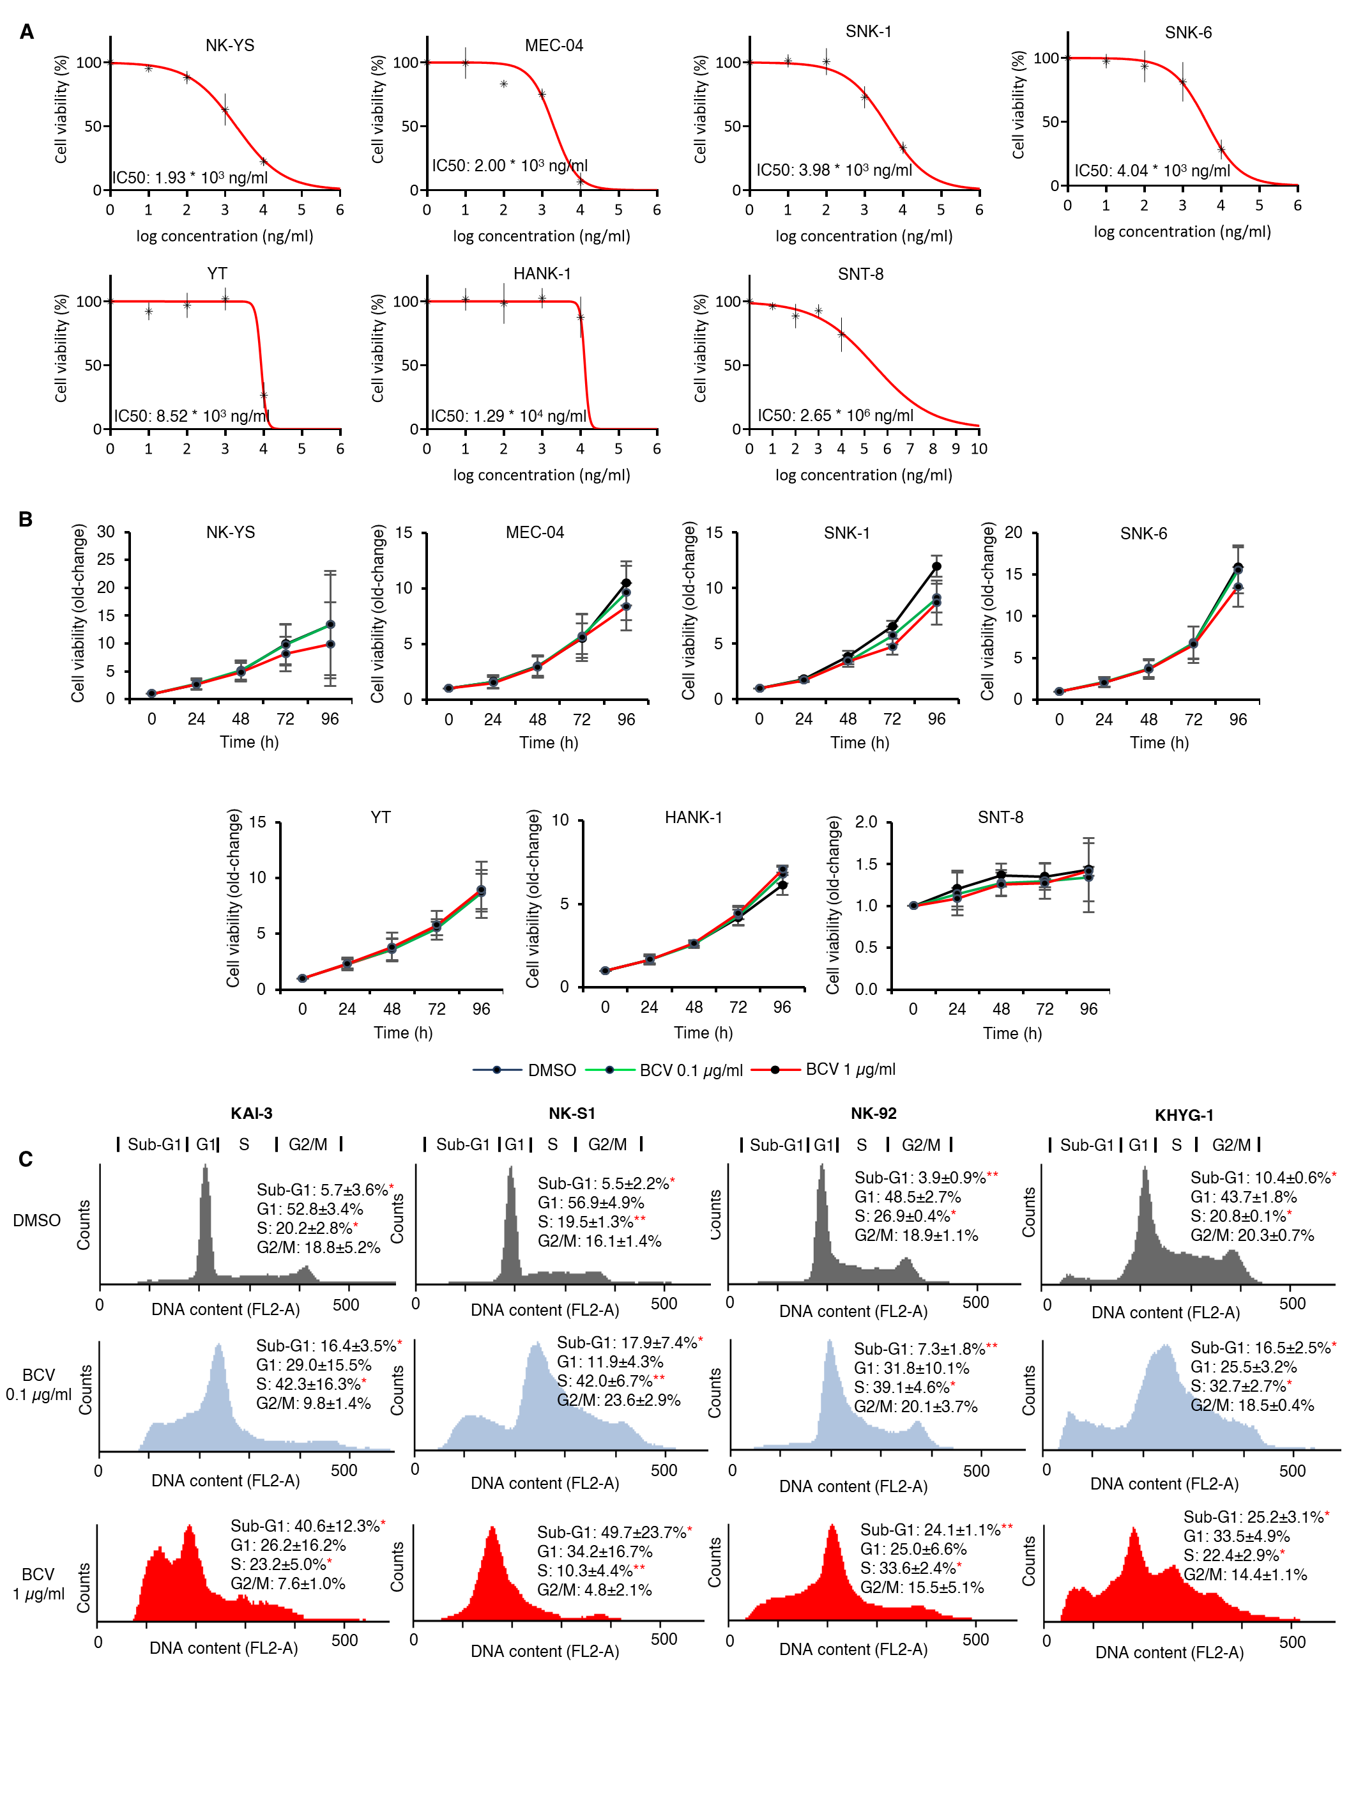
Supplementary Figure 1. Effect of BCV in NKTCL cell lines
(A) Dose response curves of NKTCL cell lines following BCV treatment.
(B) Time response curves of cell viability following BCV treatment in NKTCL cell lines.
(C) BCV evoked a dose-dependent increase in the sub-G1 cell fraction and induced S-phase arrest in the 4 most sensitive cell lines tested. *p < 0.05 **p < 0.001
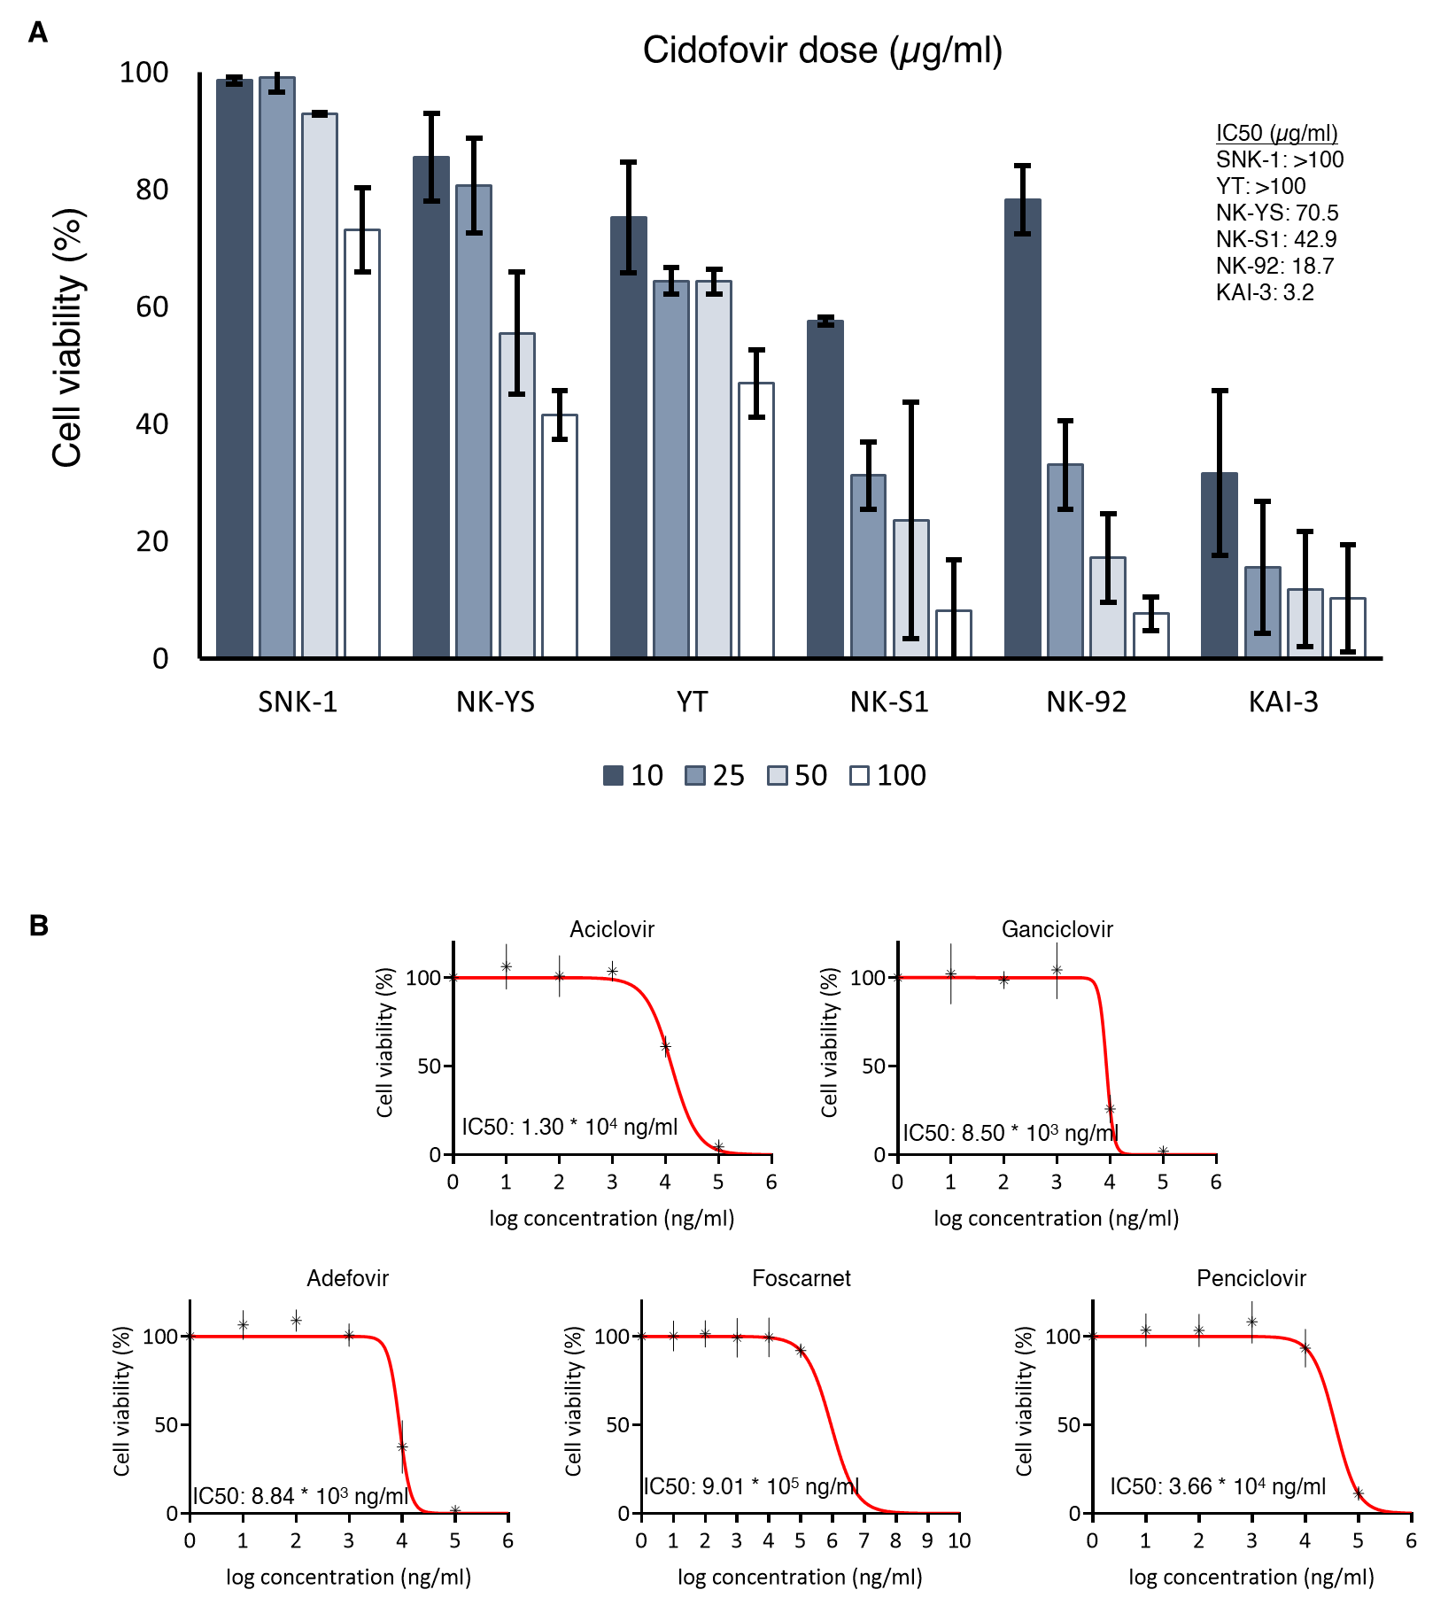
Supplementary Figure 2. Activity of selected antivirals in NKTCL cell lines
(A) Effect of cidofovir on cell viability in NKTCL cell lines.
(B) Effect of selected antiviral drugs in the NK-S1 cell line.

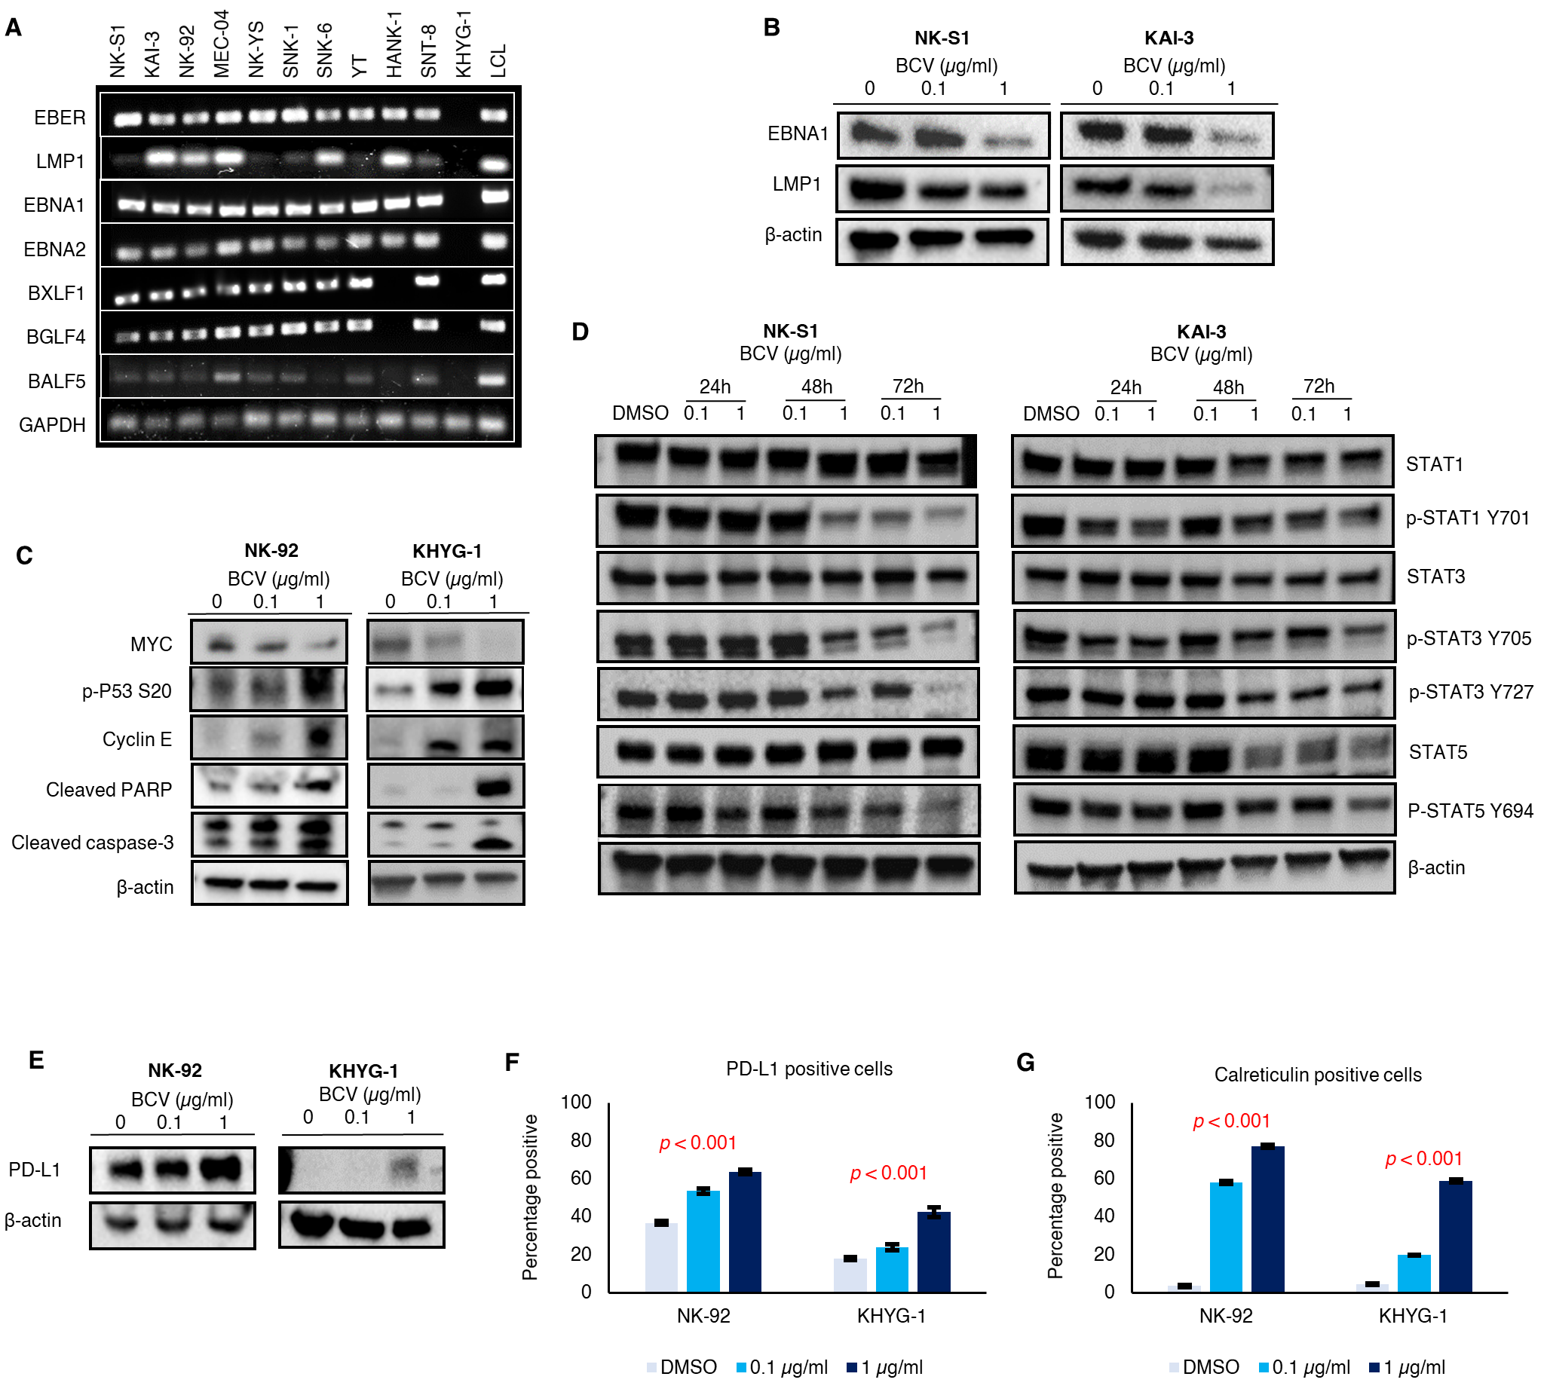
Supplementary Figure 3. Downstream mechanisms of BCV in NKTCL cell lines
(A) Variable expression of EBV transcripts across NKTCL cell lines, including both latent genes LMP1, EBNA1, EBNA2, as well as lytic genes BXLF1, BGLF4 and BALF5. Included controls are EBV-negative NKTCL cell line KHYG-1 and EBV-immortalized lymphoblastoid cell line (LCL).
(B) BCV downregulates EBNA1 and LMP1 protein expression in NK-S1 and KAI-3 cell lines.
(C) Decreased protein expression of MYC, and increased phopho-p53, cyclin E, cleaved PARP and cleaved caspase-3 protein expression in NK-92 and KHYG-1 cell lines.
(D) BCV treatment led to a dose and time-dependent decrease in total and phospho-STAT1, STAT3, and STAT5 protein expression in NK-S1 and KAI-3 cell lines.
(E) Upregulation of PD-L1 protein expression on Western blot and (F) PD-L1-expressing cells on flow cytometry in NK-92 and KHYG-1 cell lines.
(F) Increase in proportion of calreticulin-expressing cells upon BCV treatment.

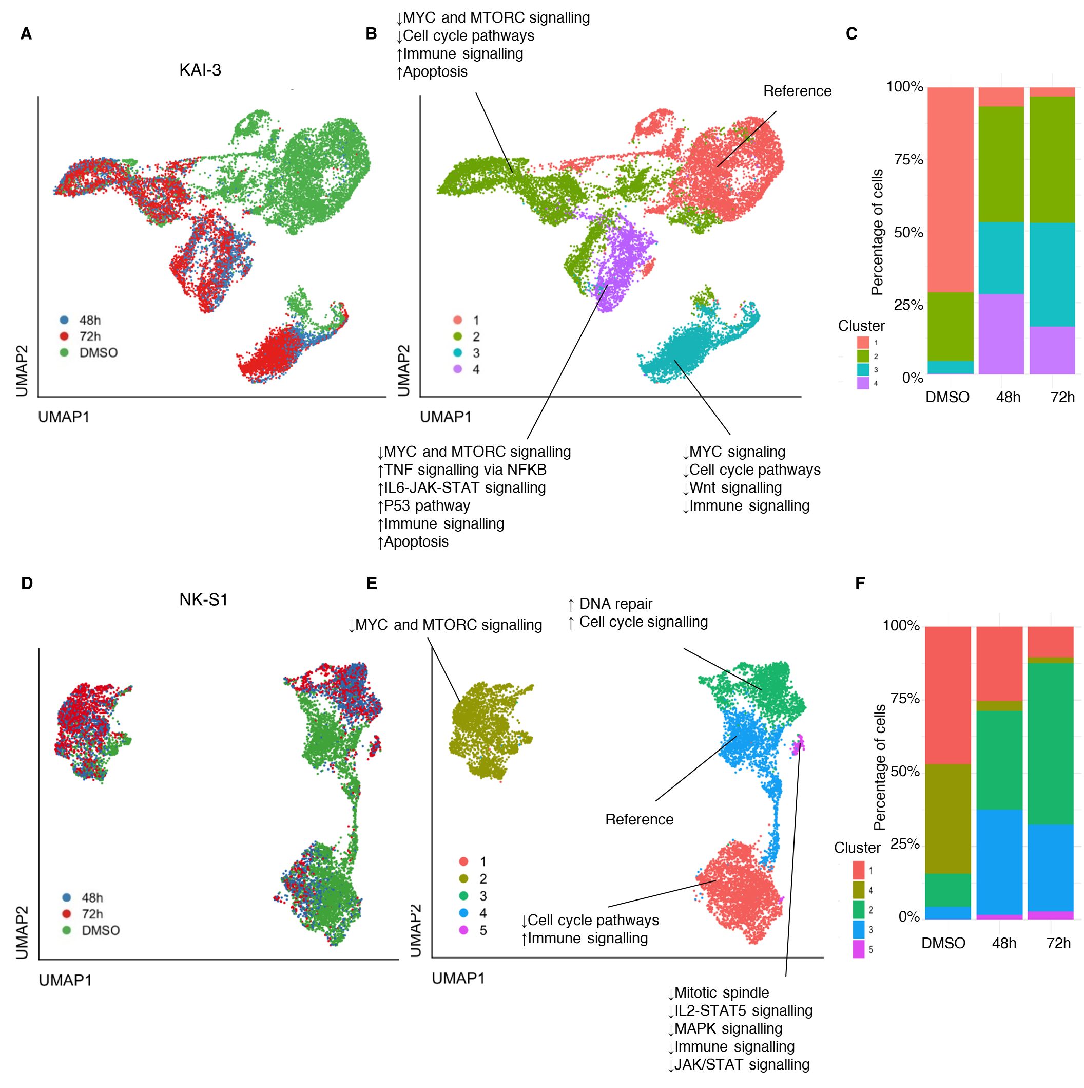
Supplementary Figure 4. Single cell transcriptomic sequencing reveals distinct cell states evoked by BCV treatment.
(A) UMAP plots demonstrating distinct clusters of mock (DMSO)-treated cells and BCV-treated cells at 48h and 72h for KAI-3 cell line.
(B) UMAP plots demonstrated distinct clusters of cells in various states, expressing genes involved in various signaling pathways.
(C) Changes in proportion of each cell cluster over time for KAI-3 cell line after BCV treatment.
(D-F) Corresponding data shown for NK-S1 cell line.

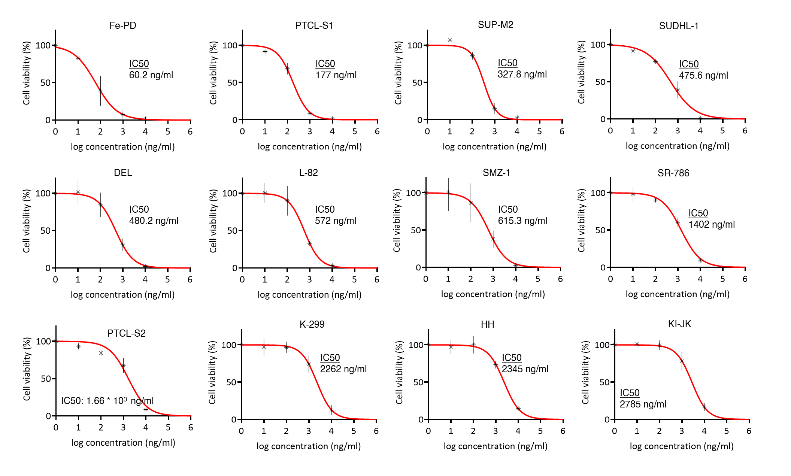
Supplementary Figure 5. Effect of BCV in T-cell lymphoma cell lines.

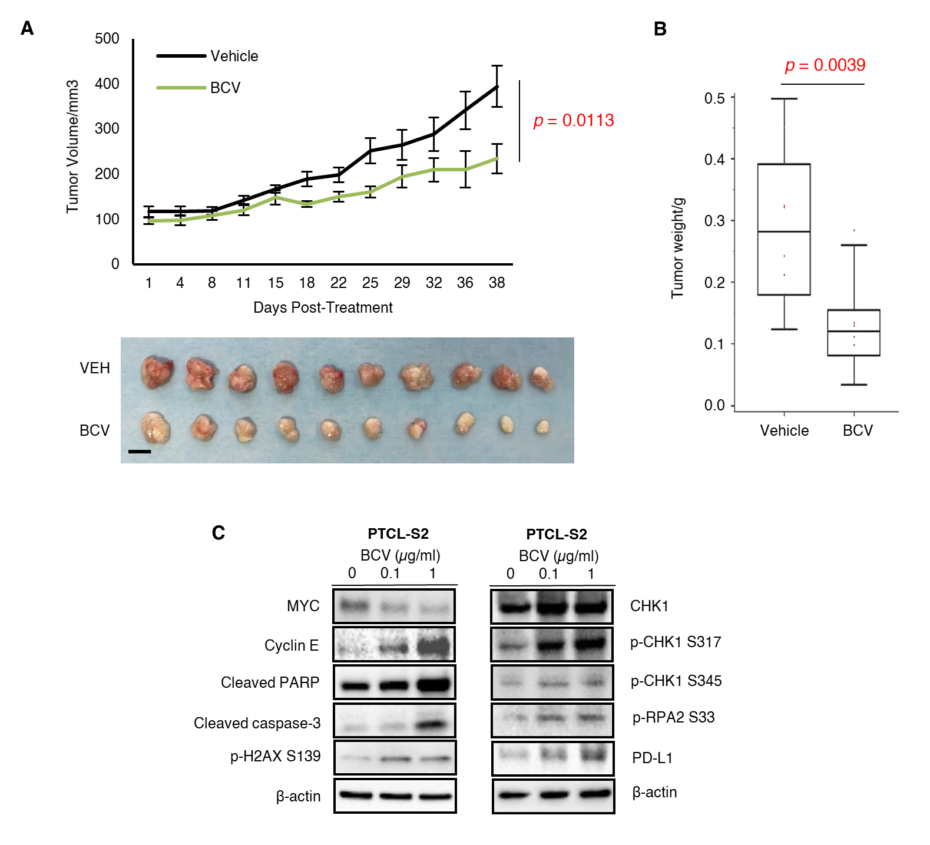
Supplementary Figure 6. In vivo efficacy of BCV in PTCL-S2 xenograft model
(A) BCV inhibited tumor growth in the PTCL-S2 xenograft model (tumor volume: p = 0.0113, two-tailed t-test; (B) tumor weight: p = 0.0039, Mann-Whitney U test). NSG mice were treated twice per week IP with either vehicle or BCV (40 mg/kg) after subcutaneous flank inoculation with PTCL-S2 cells (n = 10 per group) (scale bar: 10 mm).
(C) Western blot demonstrated decrease protein expression of MYC, while cyclin E, cleaved PARP, cleaved caspase-3 were increased. p-H2AX, p-CHK1, p-RPA2, and PD-L1 were similarly increased.

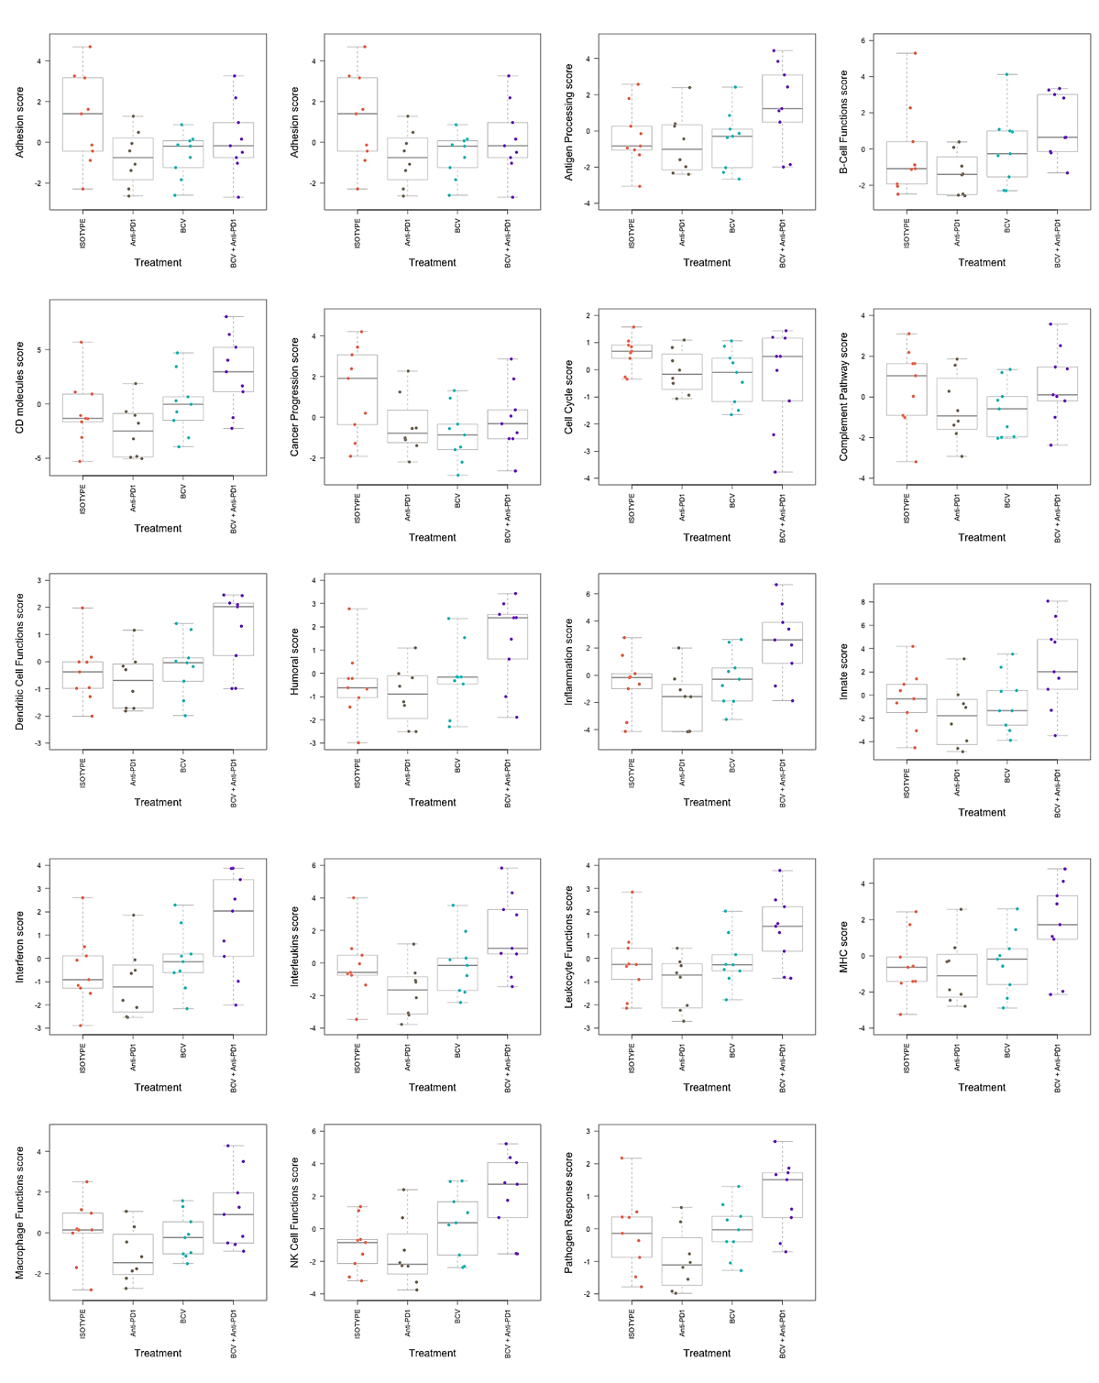
Supplementary Figure 7. NanoString pathway scores in EL4-C57BL/6 treatment groups

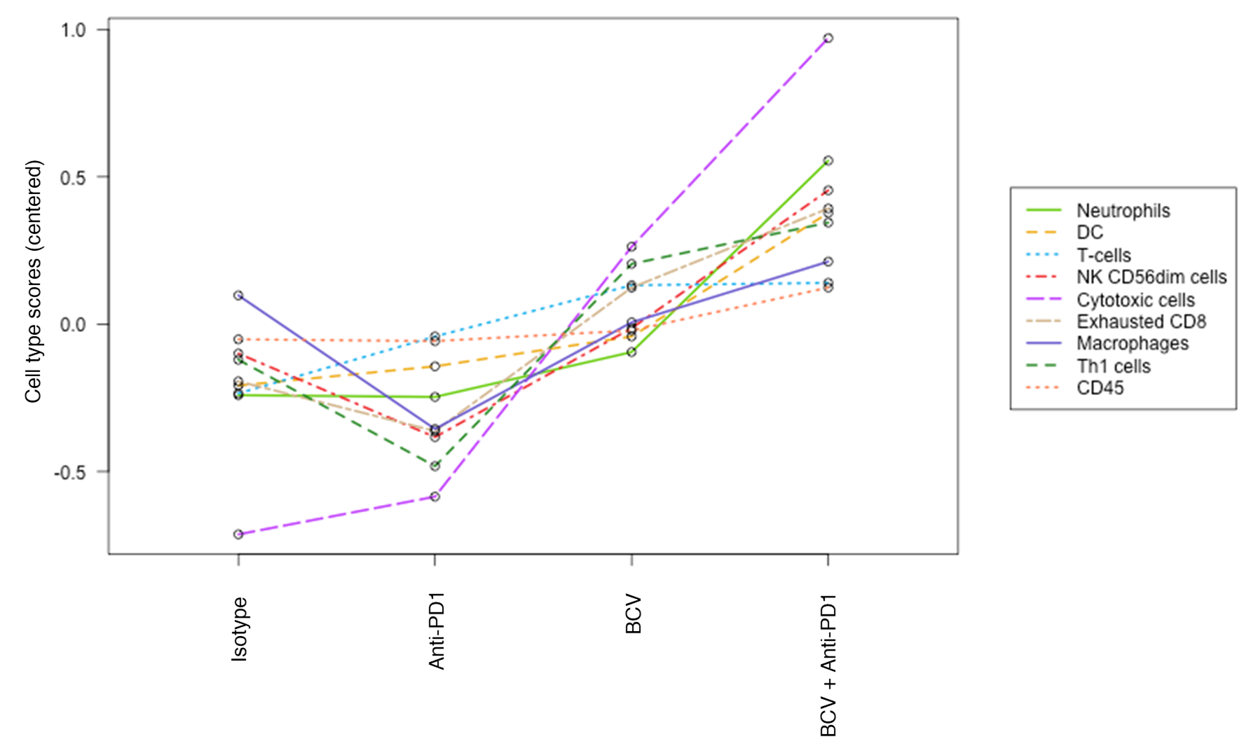
Supplementary Figure 8. NanoString cell-type scores in EL4-C57BL/6 treatment groups

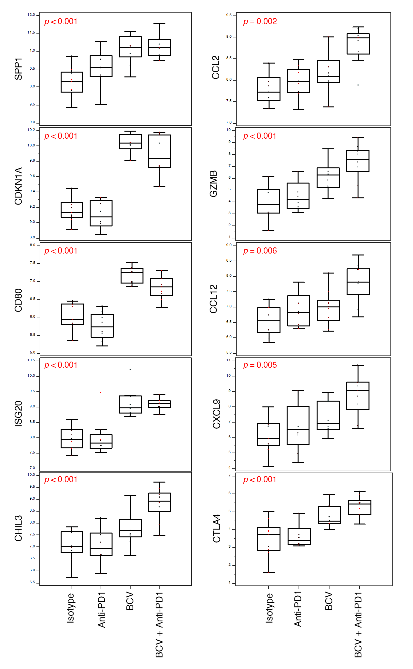
Supplementary Figure 9. Expression of selected genes in EL4-C57BL/6 treatment groups

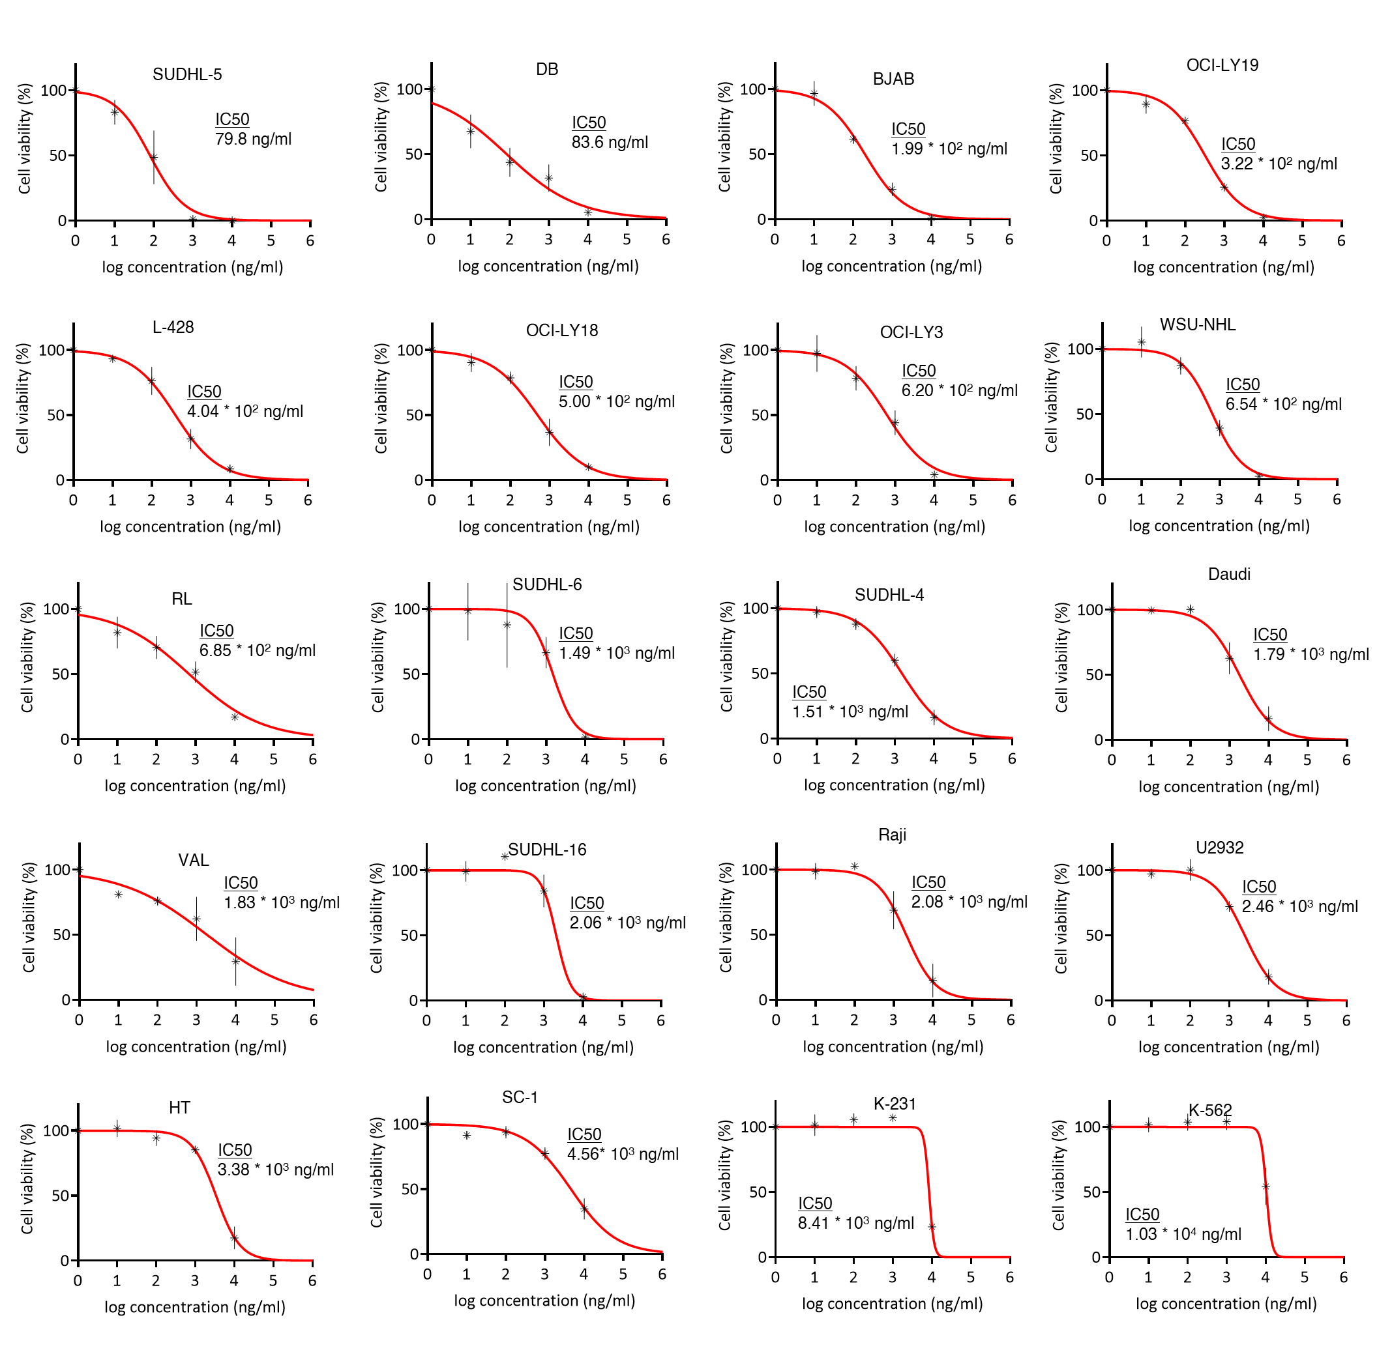
Supplementary Figure 10. Effect of BCV in B-cell lymphoma cell lines

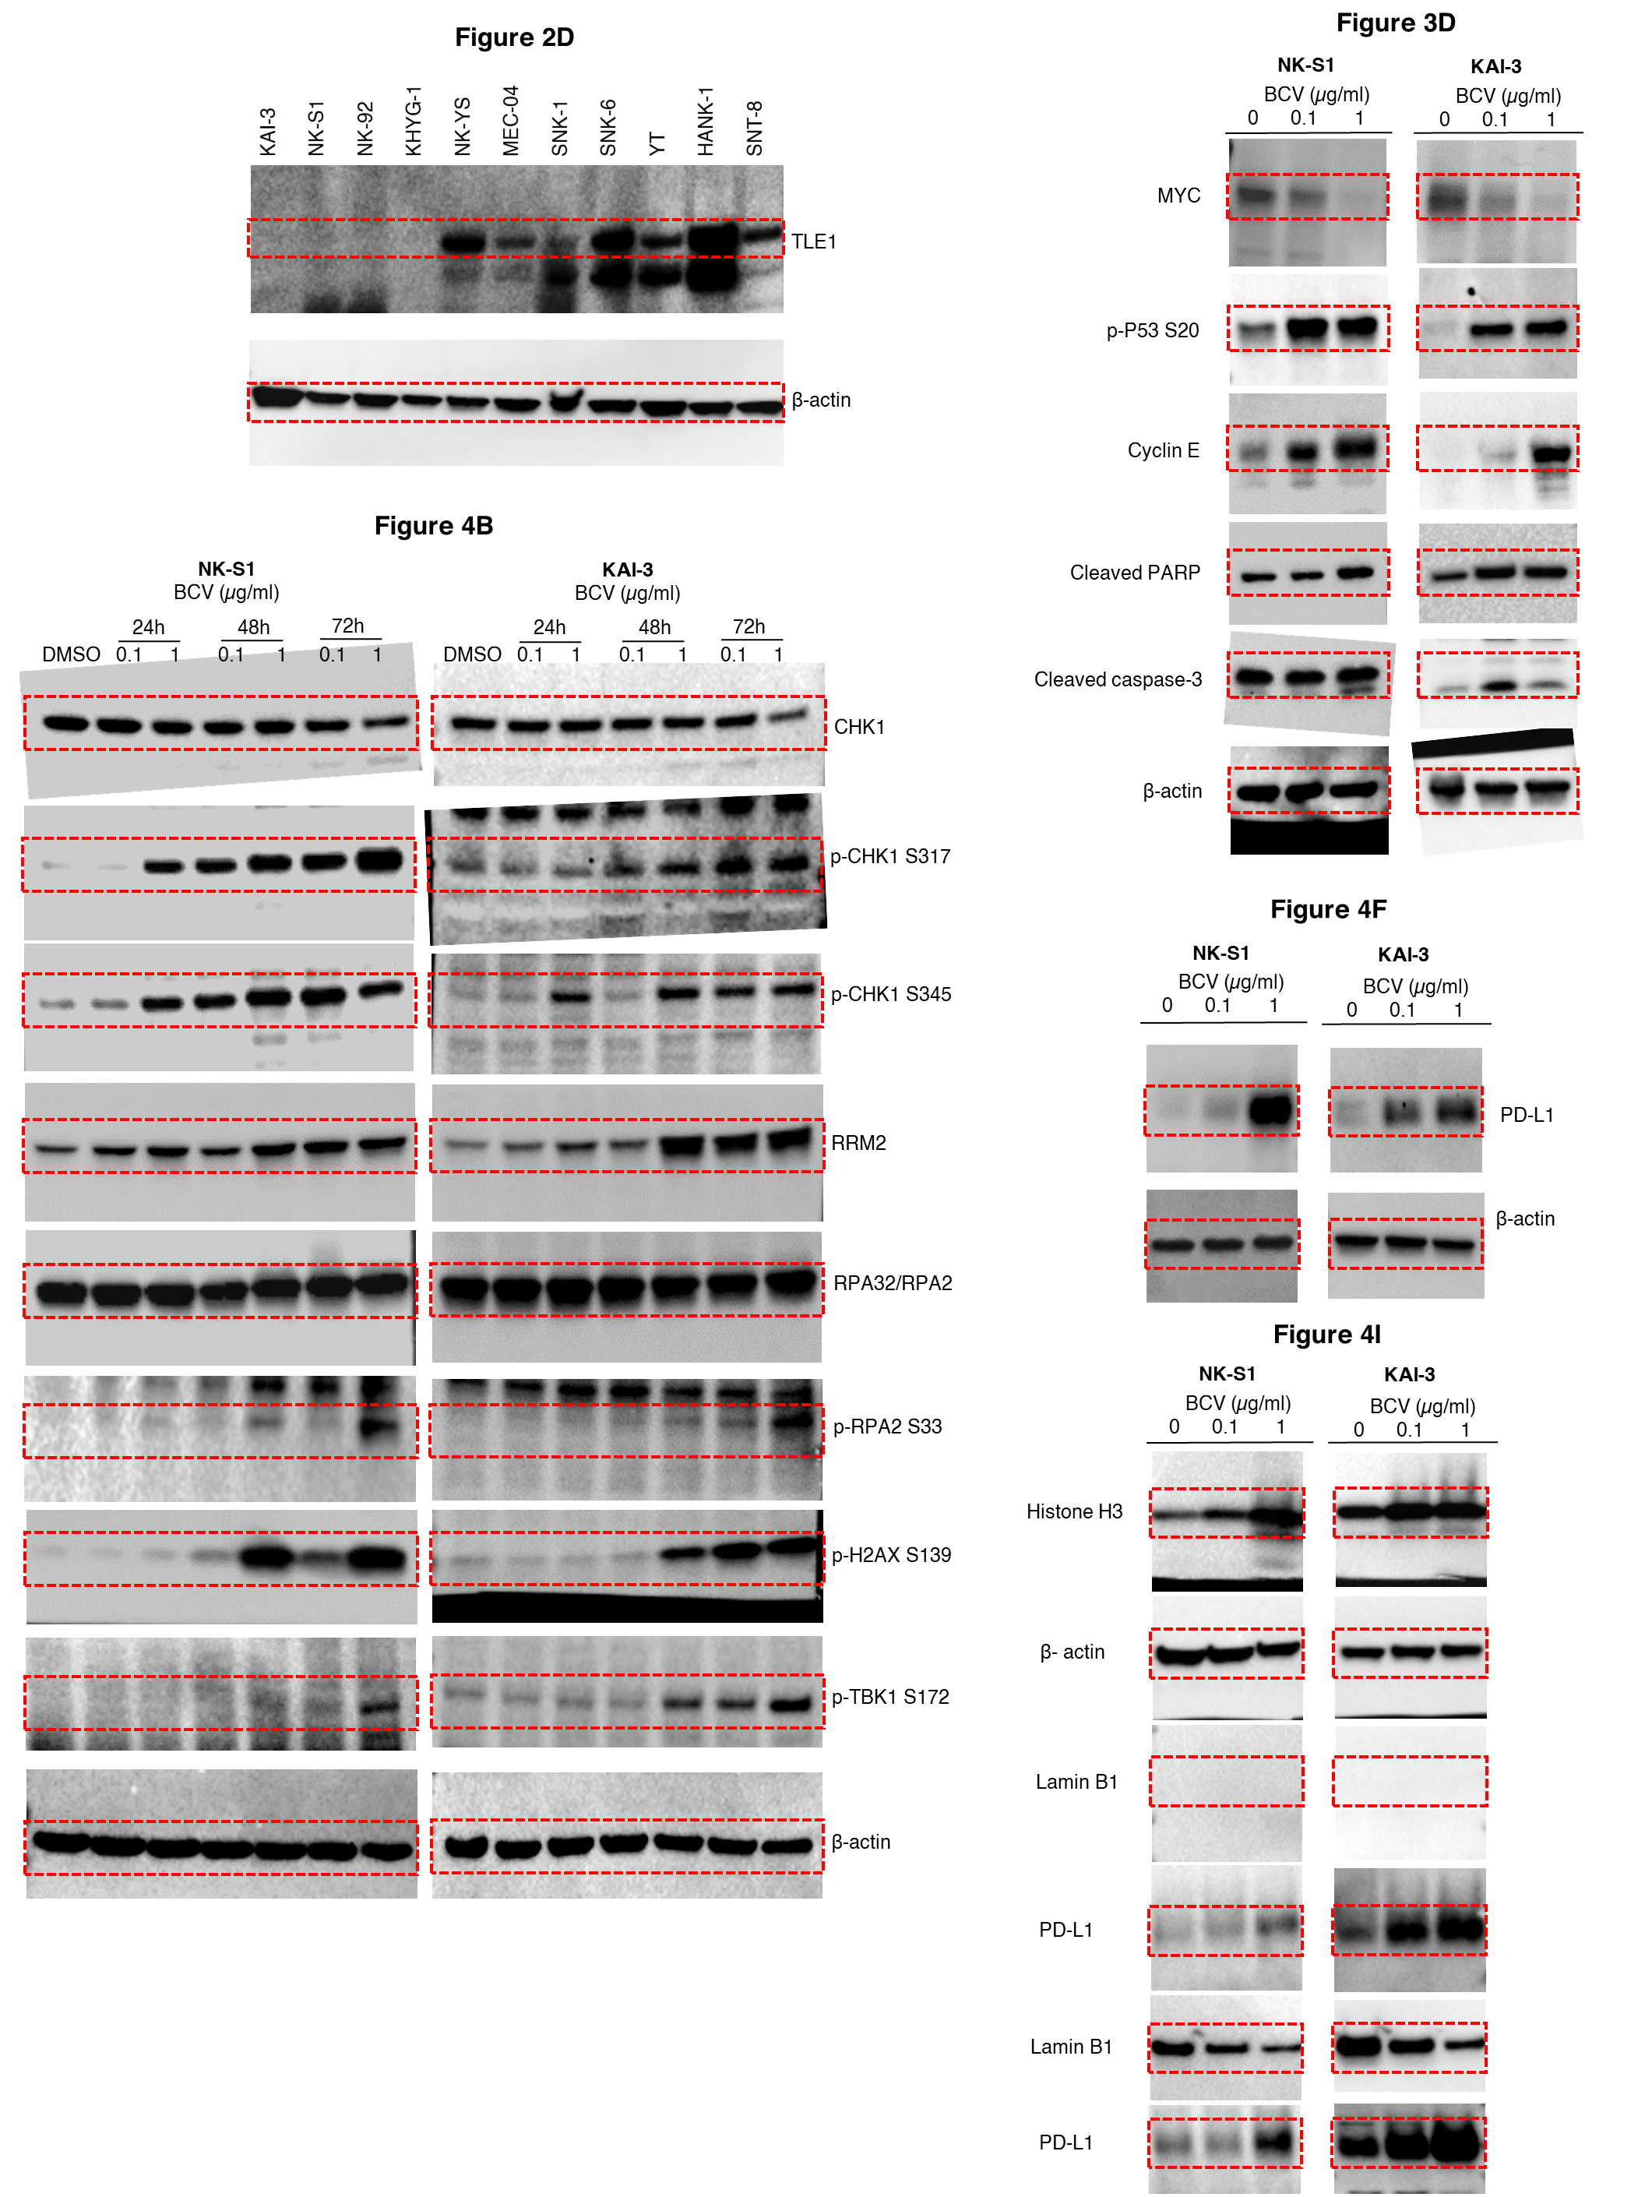
Supplementary Figure 11. Full gels for all Western blot images used in the manuscript.

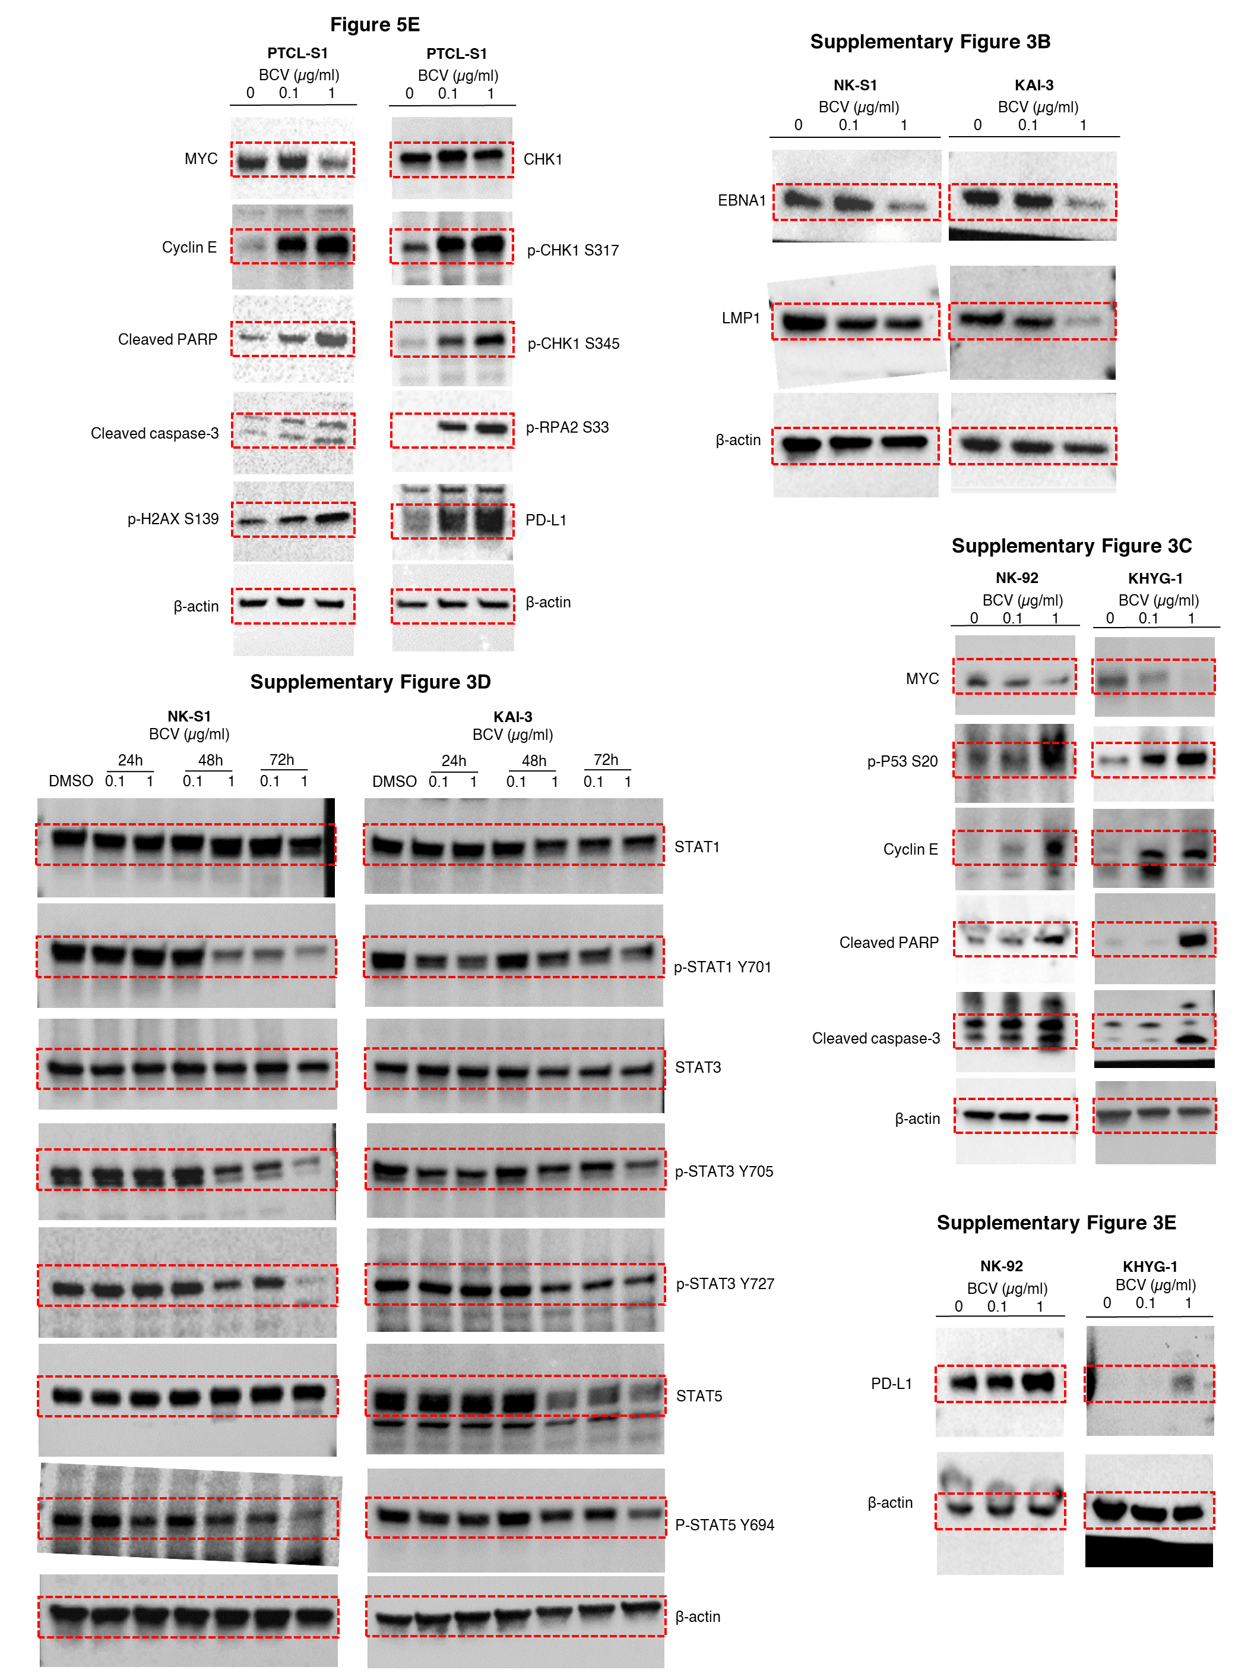
Supplementary Figure 11. Full gels for all Western blot images used in the manuscript (continued).

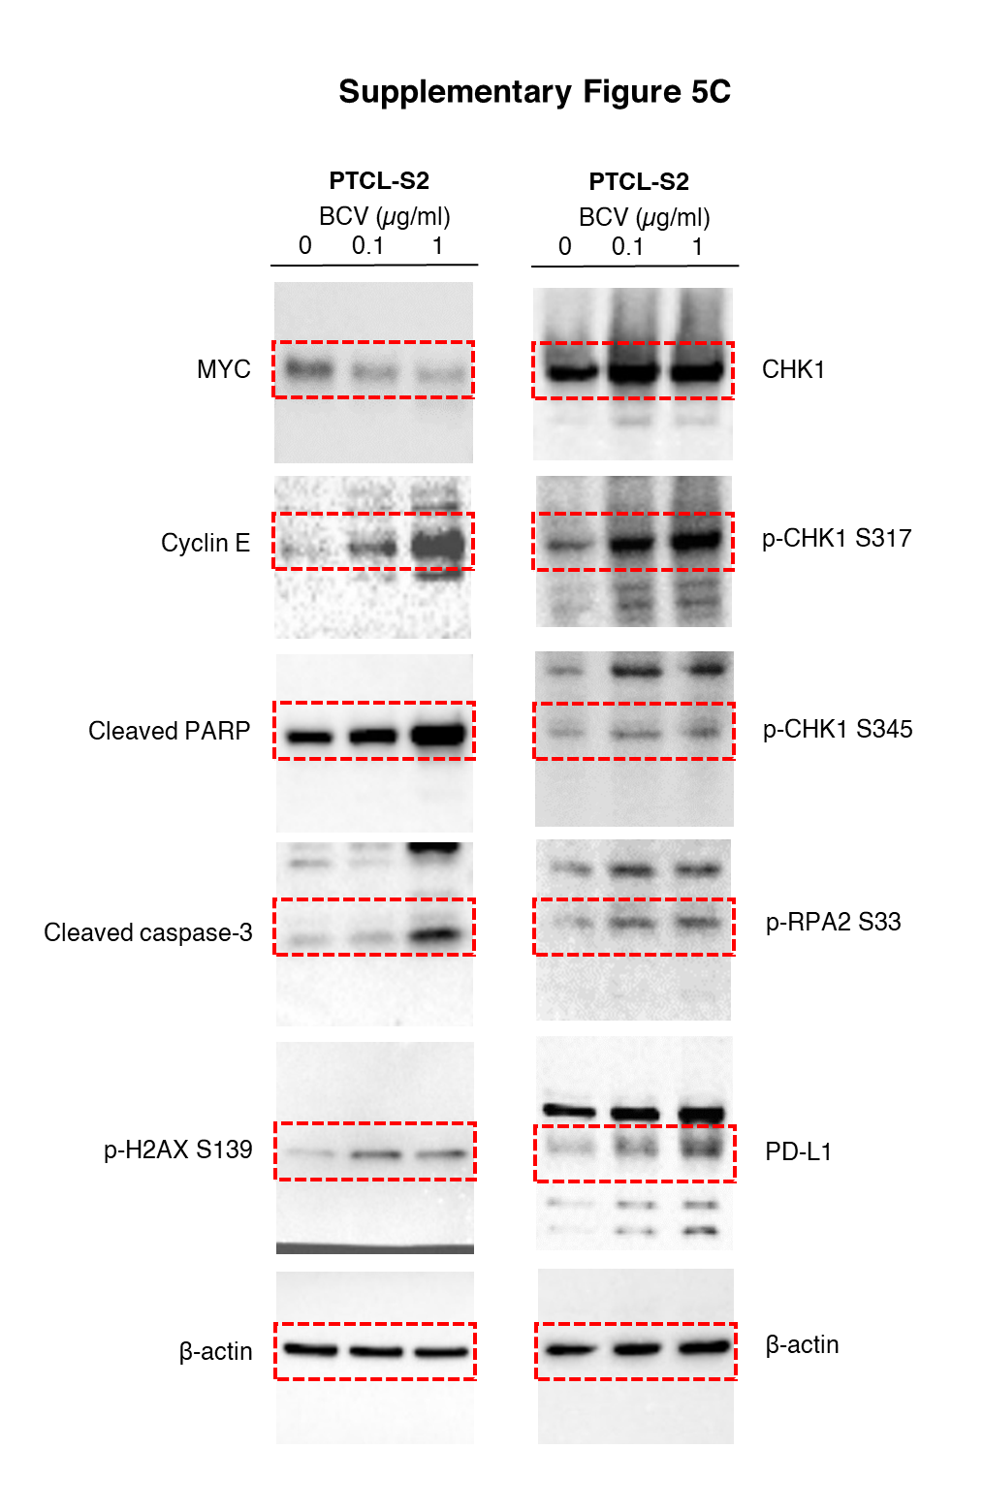
Supplementary Figure 11. Full gels for all Western blot images used in the manuscript (continued).

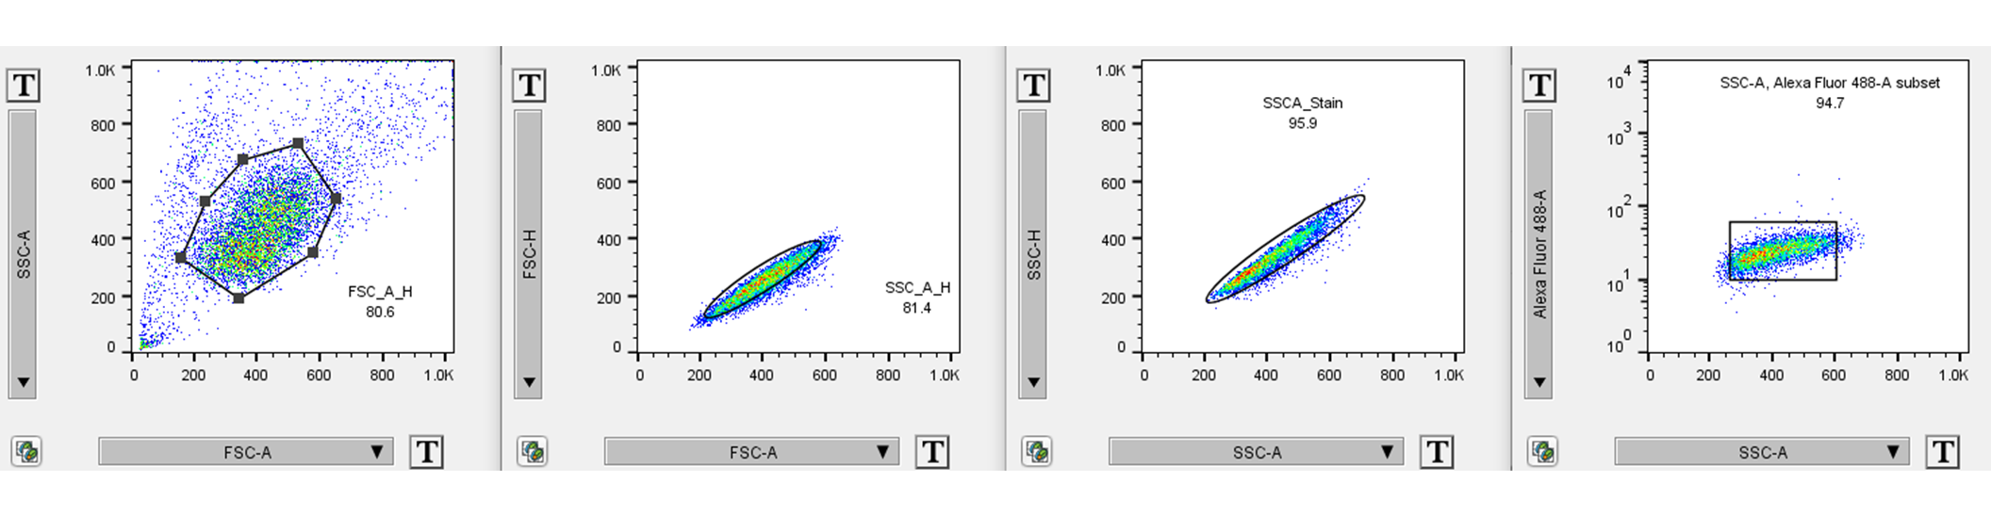
Supplementary Figure 12. FACS gating strategies. Shown are representative representative FACS plots for calreticulin in figure 4D for NK-S1 as an example.

SUPPLEMENTARY METHODS
SDS-PAGE and Western blot
Whole cell or cellular fraction lysates were obtained using Cell Fractionation Kit (#9038, Cell Signalling Technology, Danvers, MA, USA) following the manufacturers’ protocols. Cell lysates were subjected to separation using SDS-PAGE with 4 - 15% Mini-PROTEAN™ TGX Stain-Free™ Protein Gels (Bio-Rad Laboratories, Hercules, CA, USA) and then transferred onto 0.2 μm PVDF membranes (Bio-Rad Laboratories, Hercules, CA, USA). After blocking for 1 h with either 5% non-fat dry milk (Bio-Rad Laboratories, Hercules, CA, USA) or 5% bovine serum albumin (Sigma-Aldrich, Darmstadt, Germany) in TBST solution (50 mM Tris/HCl pH 7.4, 150 mM NaCl, 0.1% Tween-20), the membranes were exposed to primary antibodies (Supplementary Table S16) overnight at 4°C with gentle shaking. Exposure to the appropriate HRP-conjugated anti-rabbit or anti-mouse antibodies (Cytiva, Washington, DC, USA) were performed for 1 h and eventually subjected to chemiluminescence detection using the SuperSignal Substrate Western Blotting Kit (Thermo Fisher Scientific, MA, USA) and imaged with ChemiDoc™ XRS+ System with Image Lab™ Software (Bio-Rad Laboratories, Hercules, CA, USA). Expanded Western blot images used in the manuscript are shown in Supplementary Figure S11.

Quantification of gene expression via quantitative polymerase chain reaction (qPCR)
Total RNA isolated as described above were subjected to cDNA synthesis using the iScript cDNA Synthesis kit, (Bio-Rad Laboratories, USA), according to the manufacturer’s protocol. Primer sequences are shown in Supplementary Table S16. qPCR was performed using Maxima SYBR Green/ROX qPCR Master Mix (Thermo Scientific, USA). ΔCt for mRNA expression of genes was calculated in relation to Ct value of GAPDH, which was used as an internal control. ΔΔCt was calculated by subtracting treated group ΔCt values from that of untreated control group. The normalised expression ratio was calculated with the formula 2^{-ΔΔCt}.

PD-L1 Immunohistochemistry
Sections (4 μm) were cut from FFPE tissue blocks and mounted onto positively charged Bond Plus Slides (Leica Biosystems, Inc., Richmond, IL, USA) glass slides, and dried on a heating bench for at least 20 minutes. After deparaffinization and rehydration, tissue samples were subjected to antigen retrieval before incubation with PD-L1 (28-8) primary antibodies (#ab205921, Abcam, Cambridge, UK) (Supplementary Table S17). Slides were counter-stained with Mayer’s Haematoxylin (Dako, Glostrup, Denmark). Intensity of PD-L1 staining was quantified based on H-score.

Confocal microscopy and identification of micronuclei
Micronuclei identification was performed as previously described.¹⁴ Briefly, cells were fixed using 4% paraformaldehyde in PBS for 15 minutes, permeabilized with 0.1% Triton X-100 in PBS for 15 minutes and stained with NucBlue® Live ReadyProbes® Reagent (Hoechst 33342) (Thermo Fisher Scientific, USA) for 20 minutes and imaged with Leica TCS SP8 STED 3X (Leica Biosystems, Richmond, IL, USA). Confocal micrographs at 40X magnification of Hoechst 33342-stained cells were assessed for the occurrence of micronuclei by manual inspection. The criteria used for identifying micronuclei are: 1) round in shape; 2) less than a third of the size of a nucleus; 3) boundary of micronuclei is distinguishable from nuclear boundary; and 4) micronuclei are adjacent to a nucleus.

Cell cycle analysis
Fluorescence-activated cell sorting (FACS) analyses of sub-G₁ fractions by using propidium iodide (PI) staining for DNA fragmentation. Briefly, the cells were harvested in 15-mL tubes, fixed with 70% ethanol, washed twice with PBS and stained with PI (50 μg/ml) and RNase A (100 μg/ml) for 30 minutes at 37°C. At least 10,000 events were analyzed by flow cytometry (Coulter EPICS Elite ESP; Beckman Coulter, Fullerton, CA, USA) with the excitation set at 488 nm and emission at 610 nm. Data were analyzed using Flowing Software version 2.5.1 (Turku Bioscience, Turku, Finland).

Flow cytometry for calreticulin and PD-L1 expression
For PD-L1 and calreticulin staining, cells were incubated with respective antibody (1:100, 30 minutes at room temperature) (Supplementary Table S16), washed and resuspended in PBS. For PD-L1, this was marked with PE-conjugated secondary antibody (#31864, Thermo Fisher Scientific, MA, USA) before analysis (BD LSR Fortessa, BD Biosciences, San Jose, CA, USA). Data were analyzed using FlowJo version 10.8.0 (BD Biosciences, San Jose, CA, USA). FACS gating strategies are available in Supplementary Figure S12.

HMGB1 release assay
The release of High Mobility Group Box 1 (HMGB1) protein from cells was quantified using the Lumit HMGB1 (Human/Mouse) Immunoassay (Promega, Madison, WI, USA), as per manufacturer’s protocol. Briefly, 20 µl of 5X antibody mixture was added to 80 µl of treated cells and incubated for 60 minutes at room temperature. Following incubation, 25 µl of Lumit Detection Reagent B was added and luminescence recorded using Tecan M200 Infinite 96-well plate reader with IControl Software 1.6 (Tecan, Männedorf, Switzerland).

NanoString gene expression profiling
Gene expression profiling on murine EL4 cell line-derived tumors (from flank implants on C57BL6N mice) treated with BCV (n = 9), isotype alone (n = 9), anti-PD-1 (n = 8) and BCV plus anti-PD1 (n = 9), was performed using the NanoString Mouse Immunology Panel on the nCounter platform (NanoString Technologies, Seattle, WA, USA) following manufacturer’s protocol. RNA was extracted from all samples and analyzed using the 2100 Bioanalyzer (Agilent Technologies, Palo Alto, CA, USA). The data was analyzed on the nSolver 4.0 Advanced Analysis module using default settings to derive differentially-expressed genes, pathway scores, and cell-type scores.

