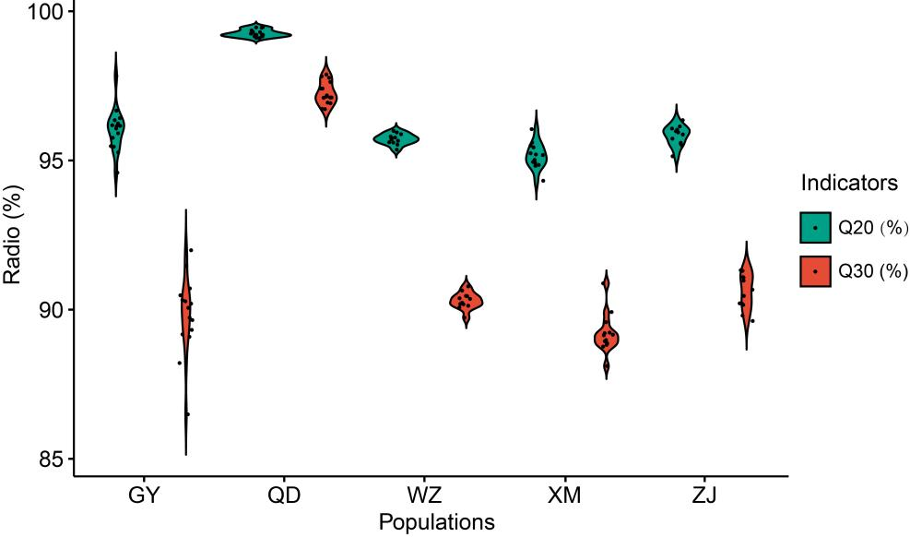
Fig. S1 Q20 and Q30 of the clean reads

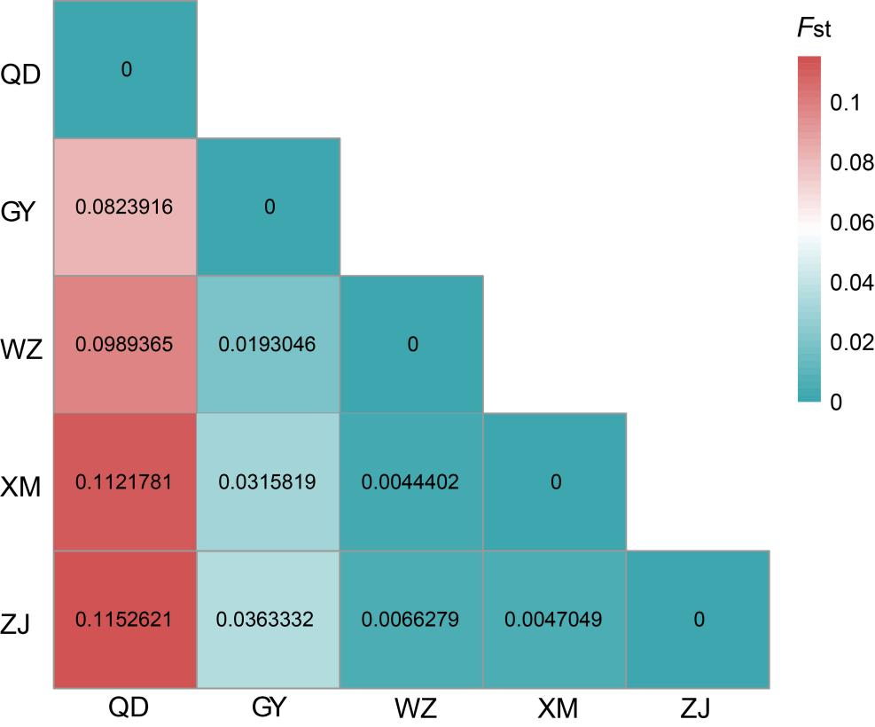
Fig. S2 Fst values between five B. pectinirostris populations

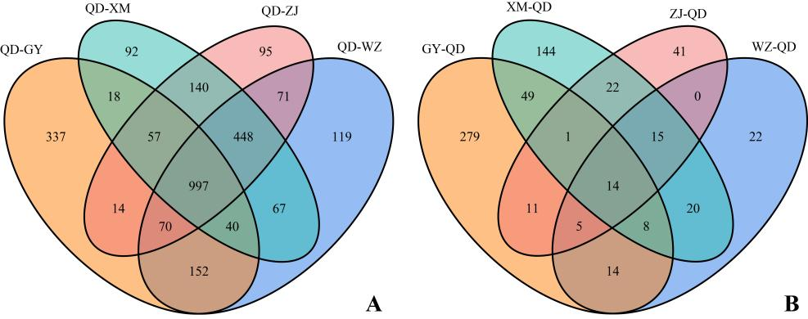
Fig. S3 (A) Overlapping northern populations adaptation genes in QD/GY, QD/WZ, QD/XM and QD/ZJ pairs based on the Venn diagram; (B) Overlapping southern populations adaptation genes in GY/QD, WZ/QD, XM/QD and ZJ/QD pairs based on the Venn diagram

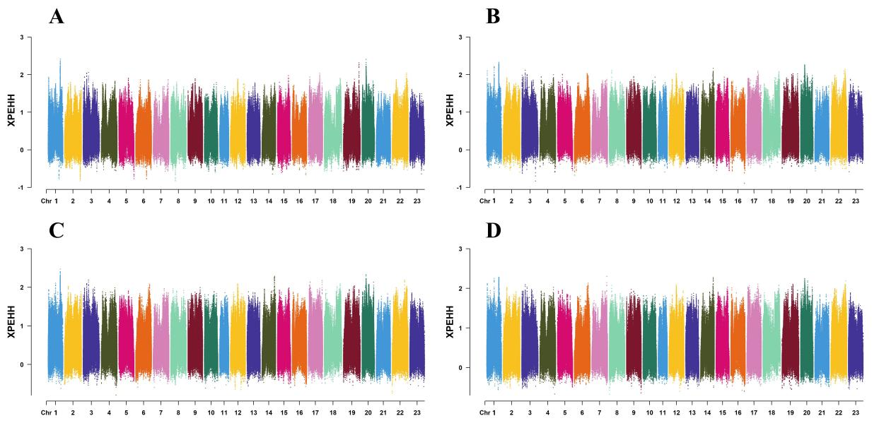
Fig. S4 (A) XP-EHH analysis between the QD and GY populations; (B). XP-EHH analysis between the QD and WZ populations; (C) XP-EHH analysis between the QD and XM populations; (D). XP-EHH analysis between the QD and ZJ populations

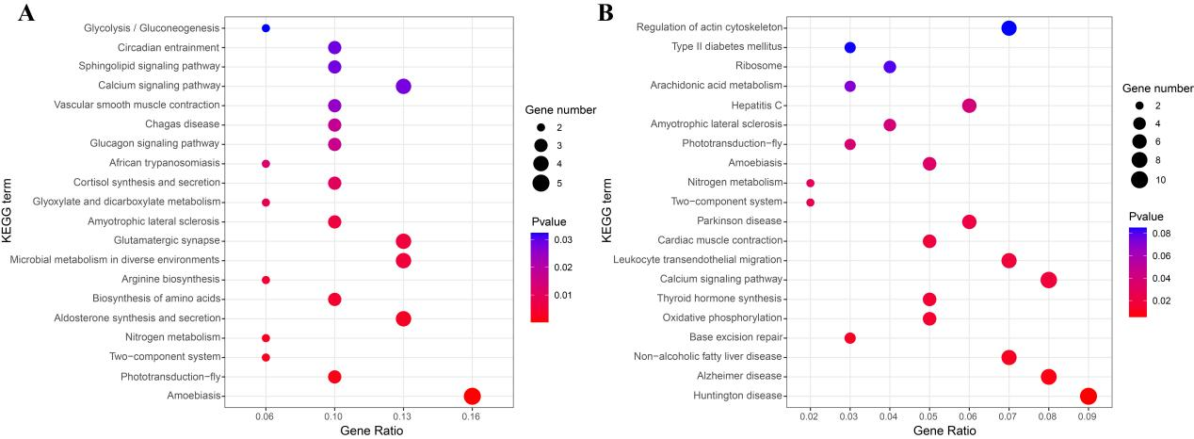
Fig. S5 (A) KEGG enrichment for the selected genes based on XP-EHH values between the QD and GY populations; (B) KEGG enrichment for the selected genes based on XP-EHH values between the QD and XM populations

