Supporting Information

Dipolar interaction-mediated molecular anchoring electrolyte enables wide-temperature sodium-ion batteries with enhanced safety and durability

Yong-Li Heng¹, Zhen-Yi Gu^{1*}, Han-Hao Liu², Xiao-Tong Wang¹, Jie Wang², Shu-Yu Li², Xing-Long Wu^{1*}
1 Y.-L. Heng, Z.-Y. Gu, X.-T. Wang, X.-L. Wu
State Key Laboratory of Integrated Optoelectronics, and MOE Key Laboratory for UV Light-Emitting Materials and Technology, Department of Physics, Northeast Normal University, Changchun, Jilin 130024, P. R. China
E-mail: xinglong@nenu.edu.cn
2 H.-H. Liu, J. Wang, S.-Y. Li
Department of Chemistry, Northeast Normal University, Changchun, Jilin 130024, P. R. China

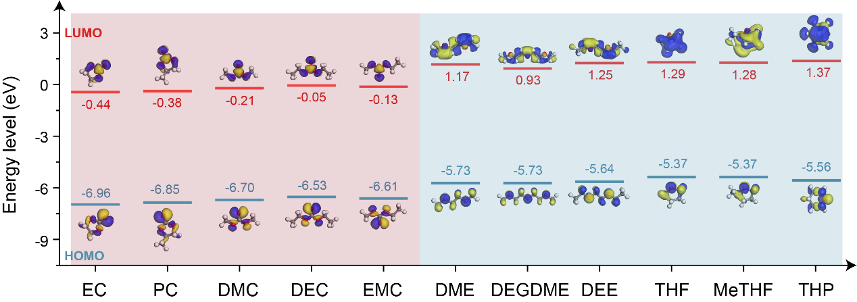
Supplementary Figure 1. The calculated HOMO/LUMO energy levels of a series of carbonate ester and ether based solvents.

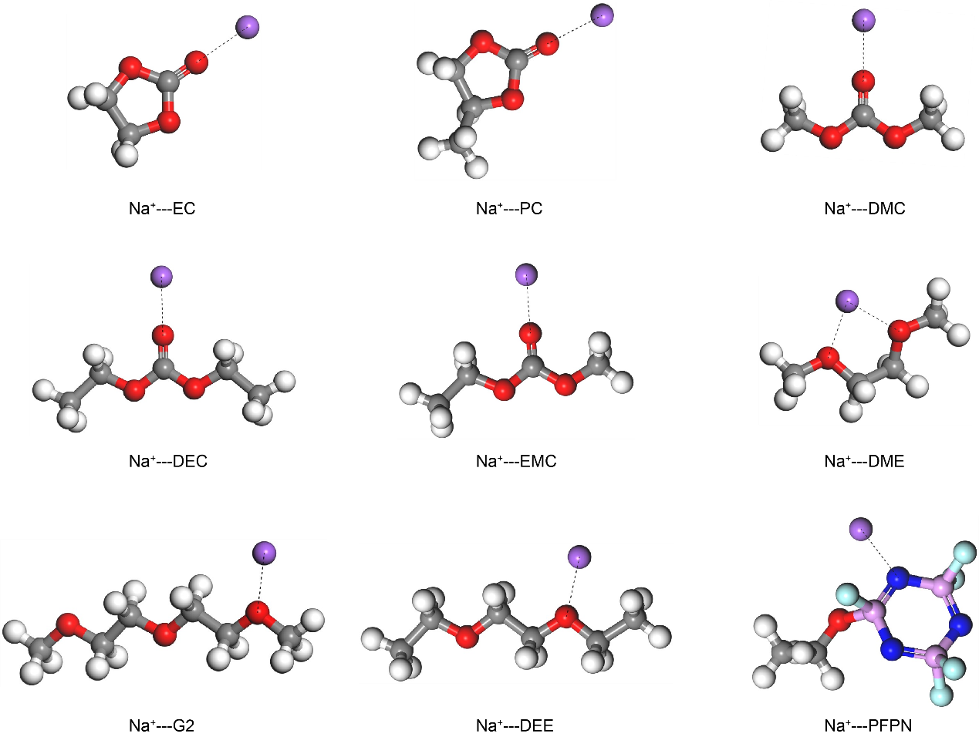
Supplementary Figure 2. The binding energy calculations with optimized structures for various Na⁺-solvent complexes.

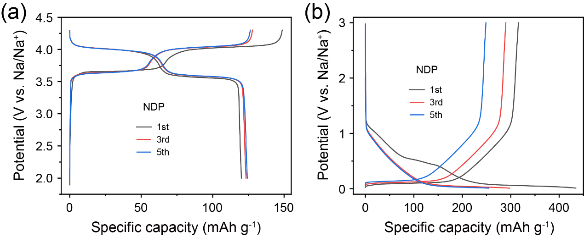
Supplementary Figure 3. Initial GCD curves of the sodium-ion half cells with (a) NVPOF cathode at 0.1 C and (b) HC anode at 25 mA g⁻¹ in the NDP electrolyte.

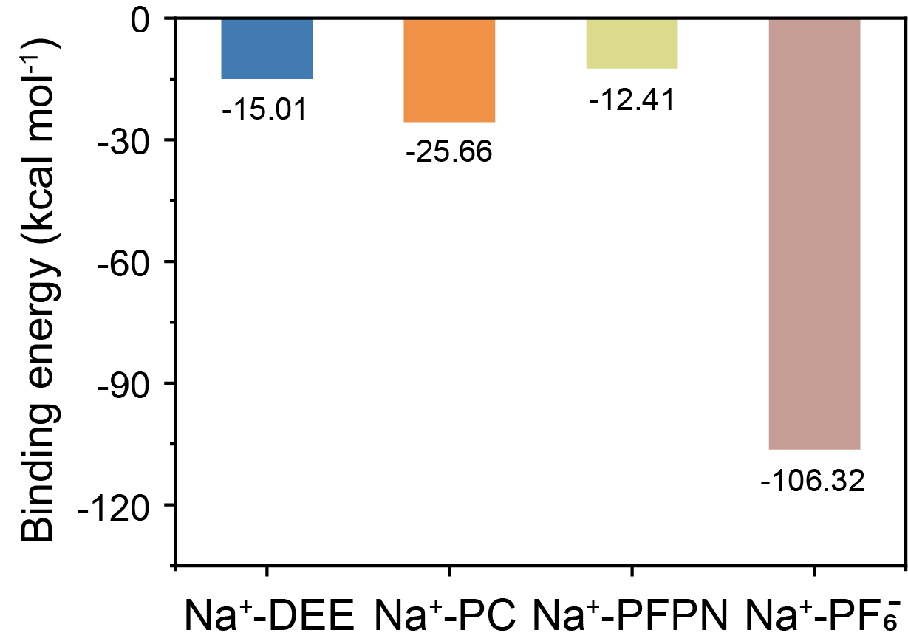
Supplementary Figure 4. Binding energies between various species and Na⁺.

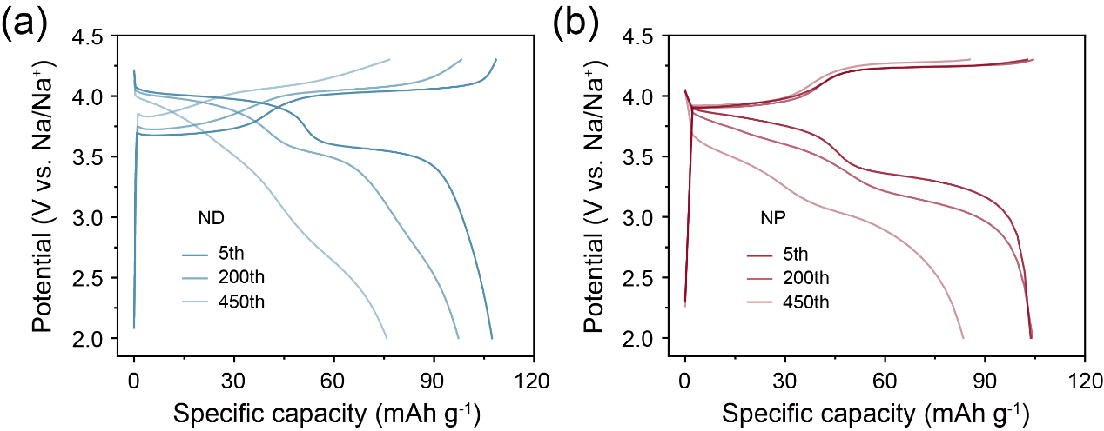
Supplementary Figure 5. Charge/discharge curves of the NVPOF cathode after different cycles in (a) ND and (b) NP electrolytes, respectively.

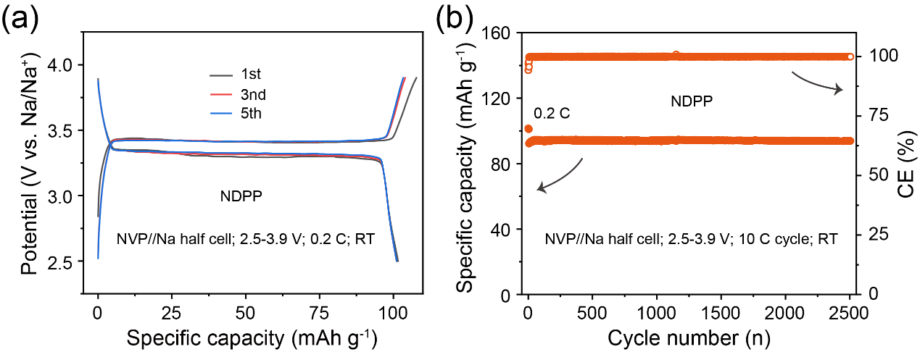
Supplementary Figure 6. Electrochemical properties of the NVP cathode in NDPP electrolyte at RT. (a) Typical GCD curves. (b) Cycling stability.

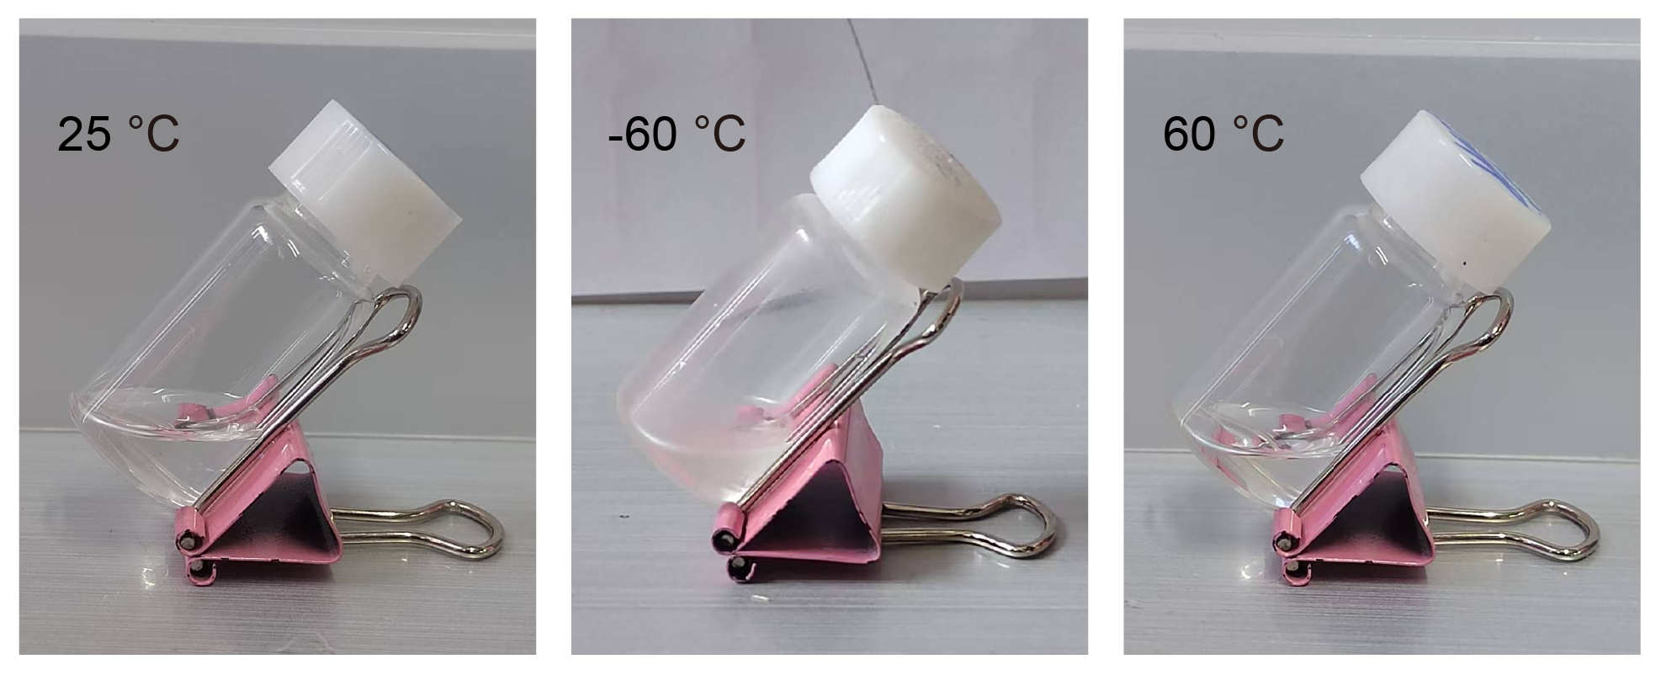
Supplementary Figure 7. Optical photographs of the formulated NDPP electrolyte after storage at 25, -60 and 60 ℃.

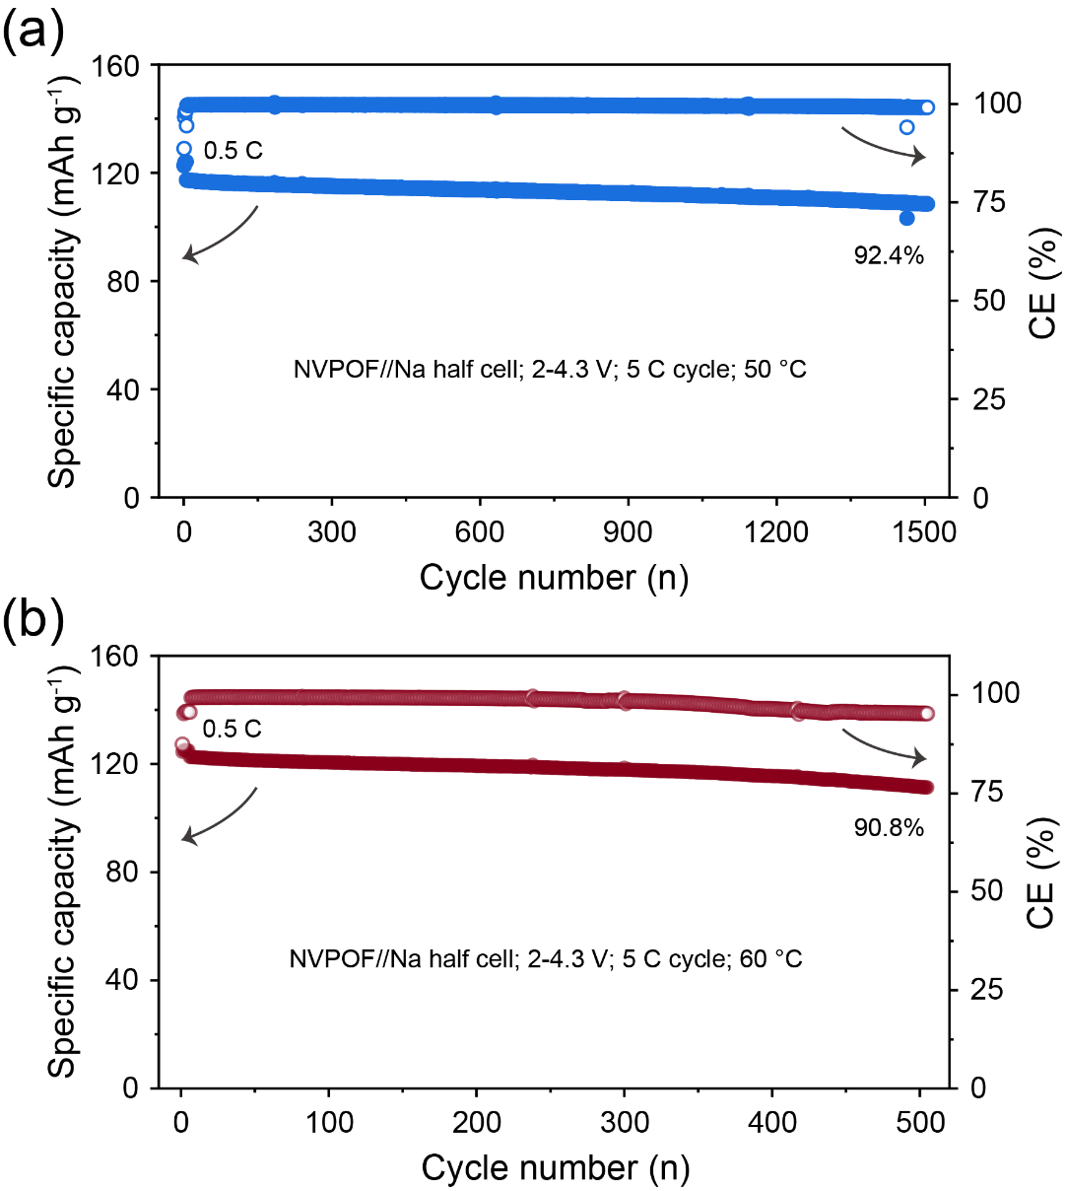

Supplementary Figure 8. Cycling stability of the NVPOF cathode in NDPP electrolyte at high temperatures. (a) 50 ℃. (b) 60 ℃.

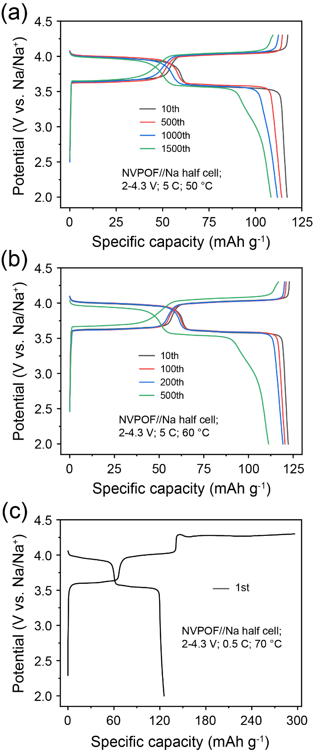
Supplementary Figure 9. GCD curves of the NVPOF cathode in NDPP electrolyte at high temperatures. (a) 50 ℃. (b) 60 ℃. (c) 70 ℃.

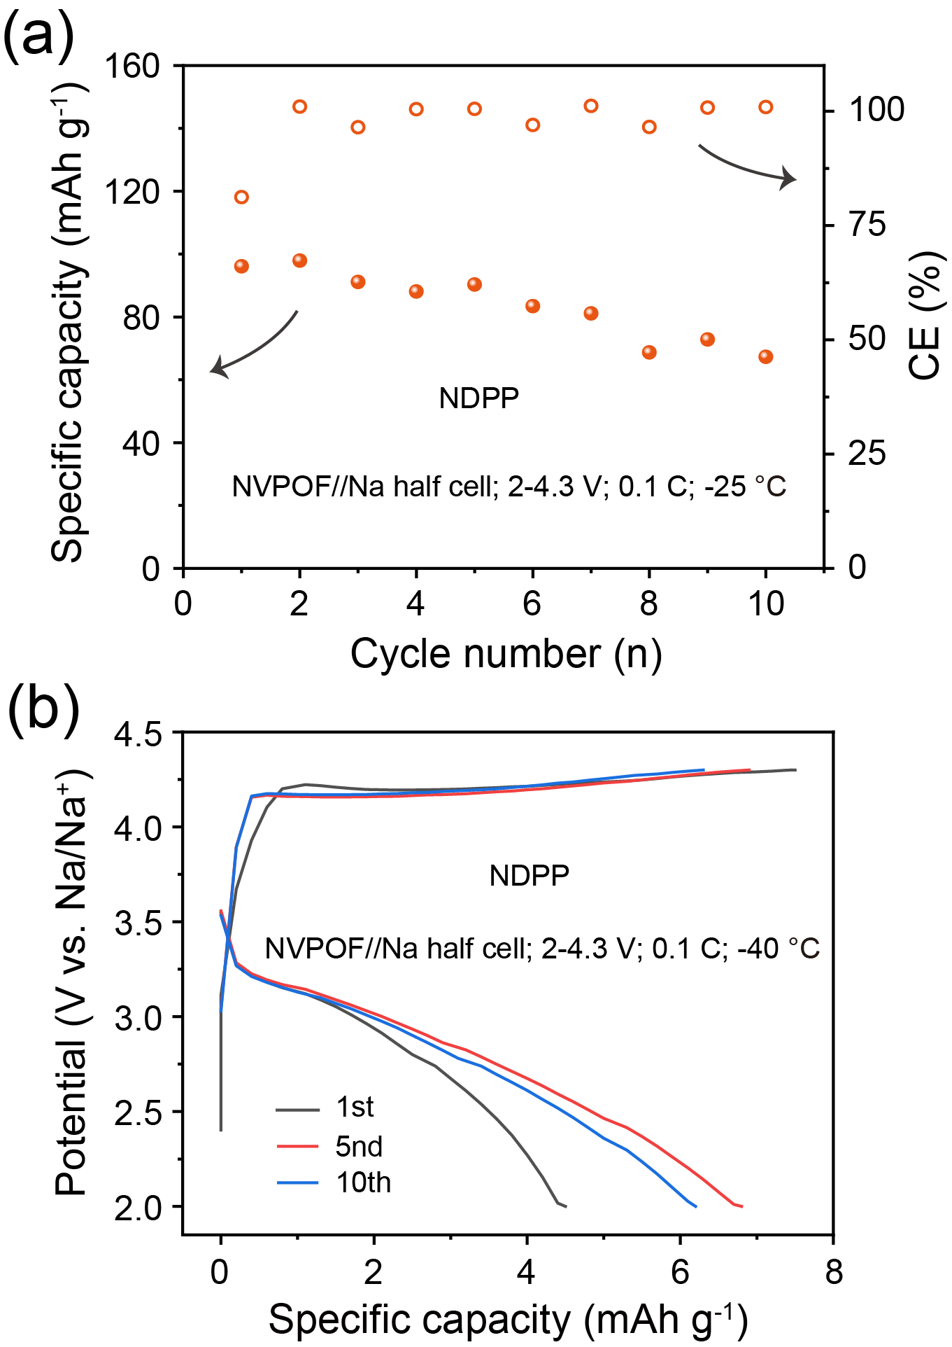
Supplementary Figure 10. Electrochemical properties of the NVPOF cathode in NDPP electrolyte at low temperatures. (a) Cycling stability at -25 ℃. (b) Typical GCD curves at -40 ℃.

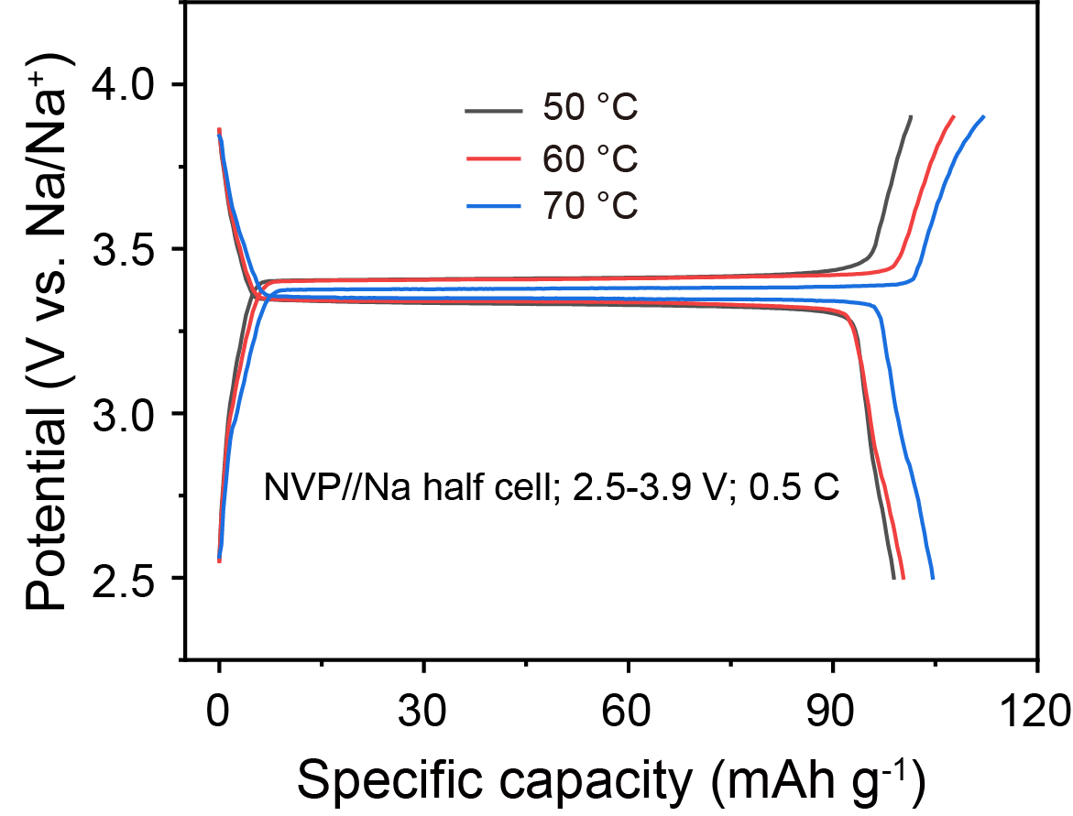
Supplementary Figure 11. Typical GCD curves of the NVP cathode in NDPP electrolyte at high temperatures.

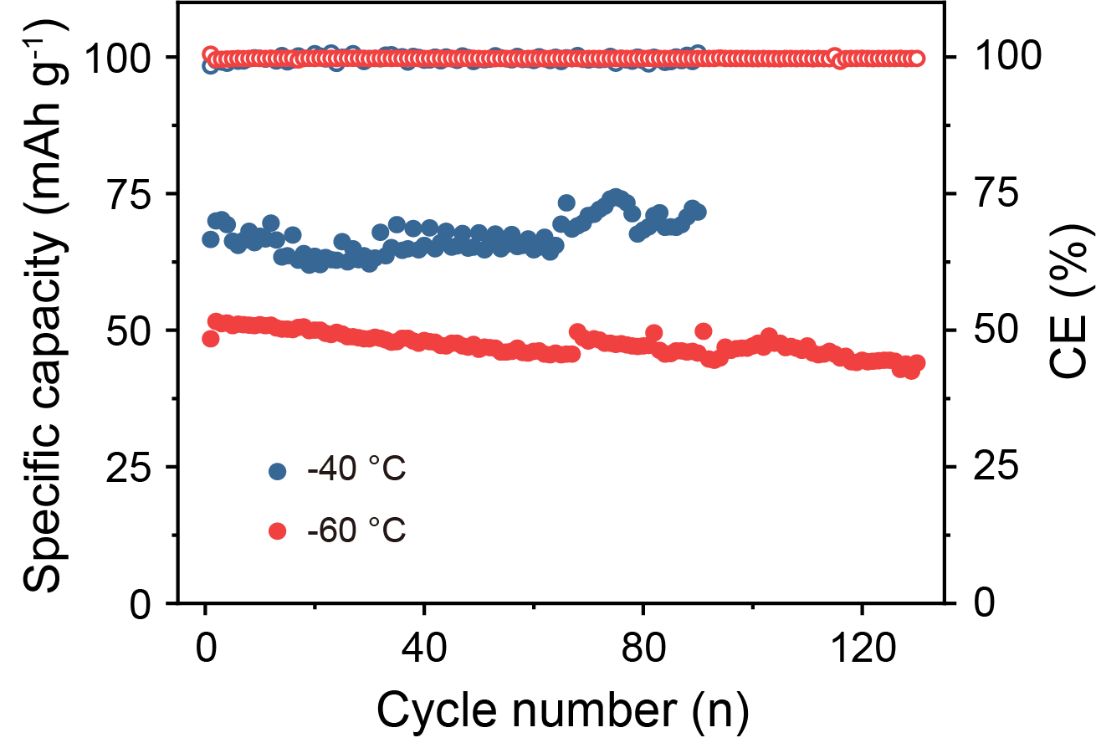
Supplementary Figure 12. Cycling stability of the NVP cathode in NDPP electrolyte at 0.1 C and low temperatures.

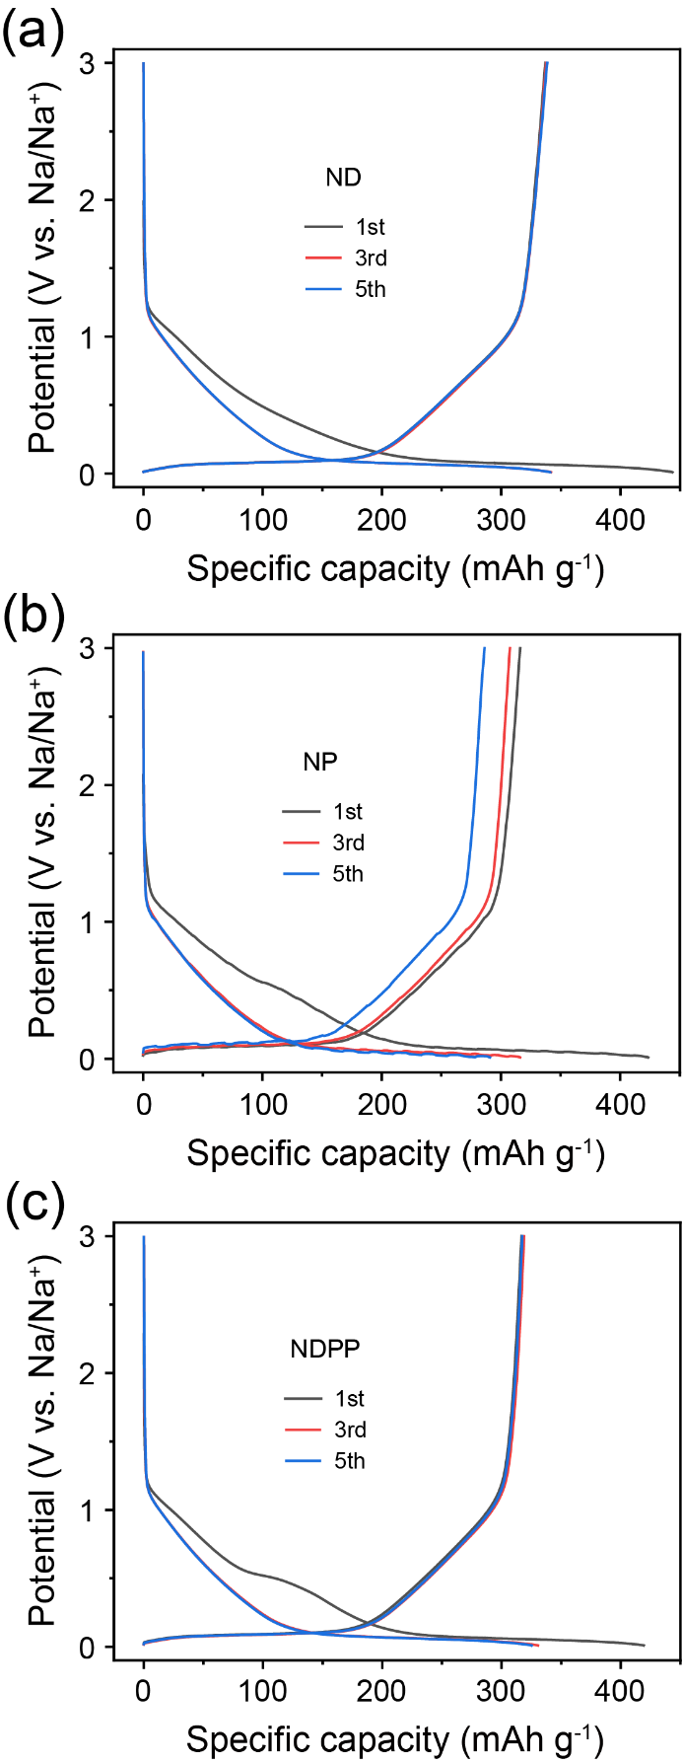
Supplementary Figure 13. GCD curves of the HC//Na half cells at 25 mA g⁻¹ with different electrolytes. (a) ND, (b) NP and (c) NDPP.

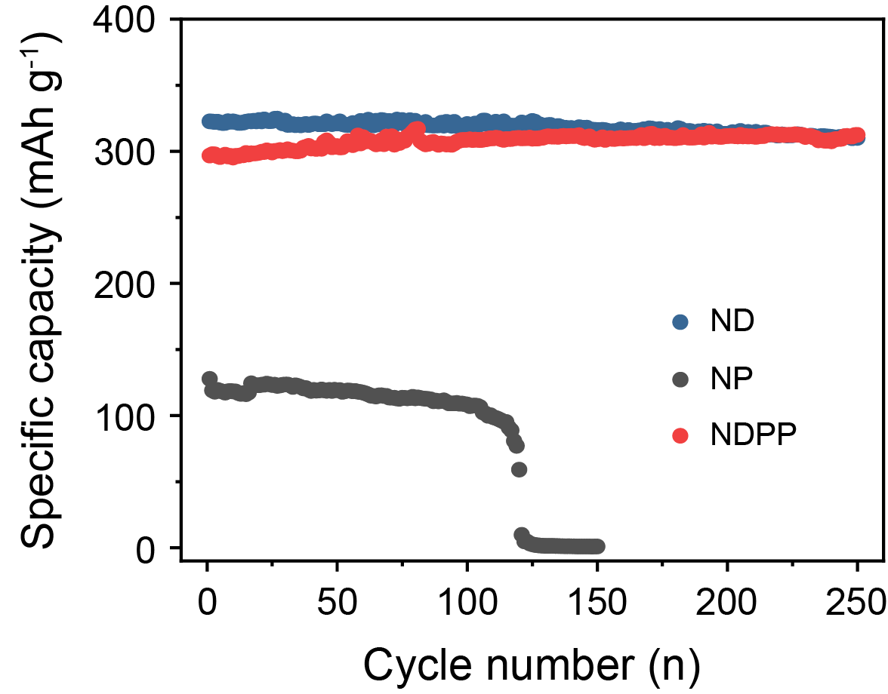
Supplementary Figure 14. Electrochemical stability of the HC//Na half cells with different electrolytes at 100 mA g⁻¹.

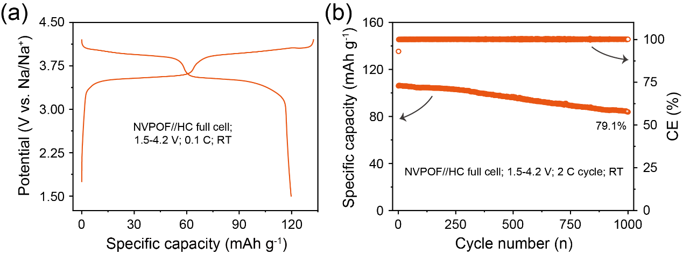
Supplementary Figure 15. Electrochemical evaluation of NVPOF//HC full cells with the NDPP electrolyte. (a) The initial GCD profile. (b) Cycling performance.

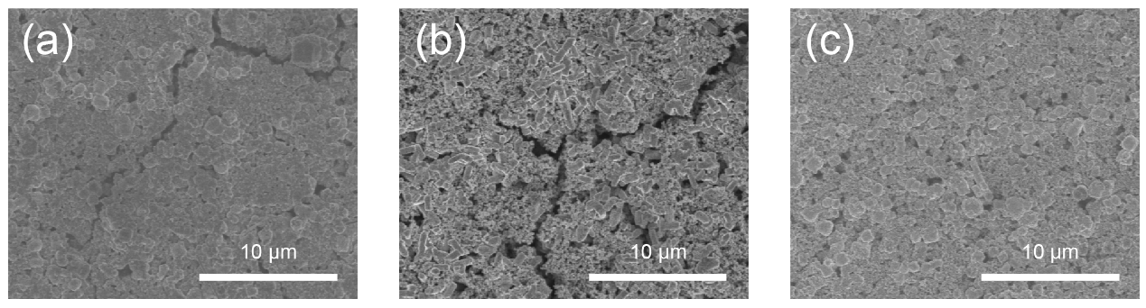
Supplementary Figure 16. SEM images for the cycled NVPOF cathodes at RT in (a) ND, (b) NP and (c) NDPP electrolytes, respectively.

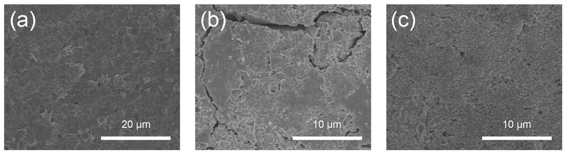
Supplementary Figure 17. SEM images of the cycled HC anodes at RT in (a) ND, (b) NP and (c) NDPP electrolytes, respectively.

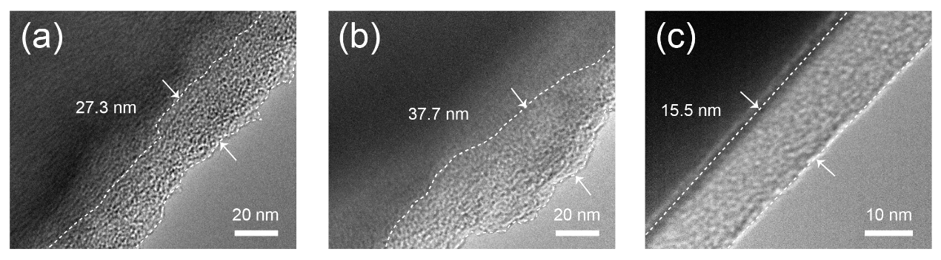
Supplementary Figure 18. TEM images for the cycled HC anodes at RT in (a) NDPP, (b) NP and (c) ND electrolytes, respectively.

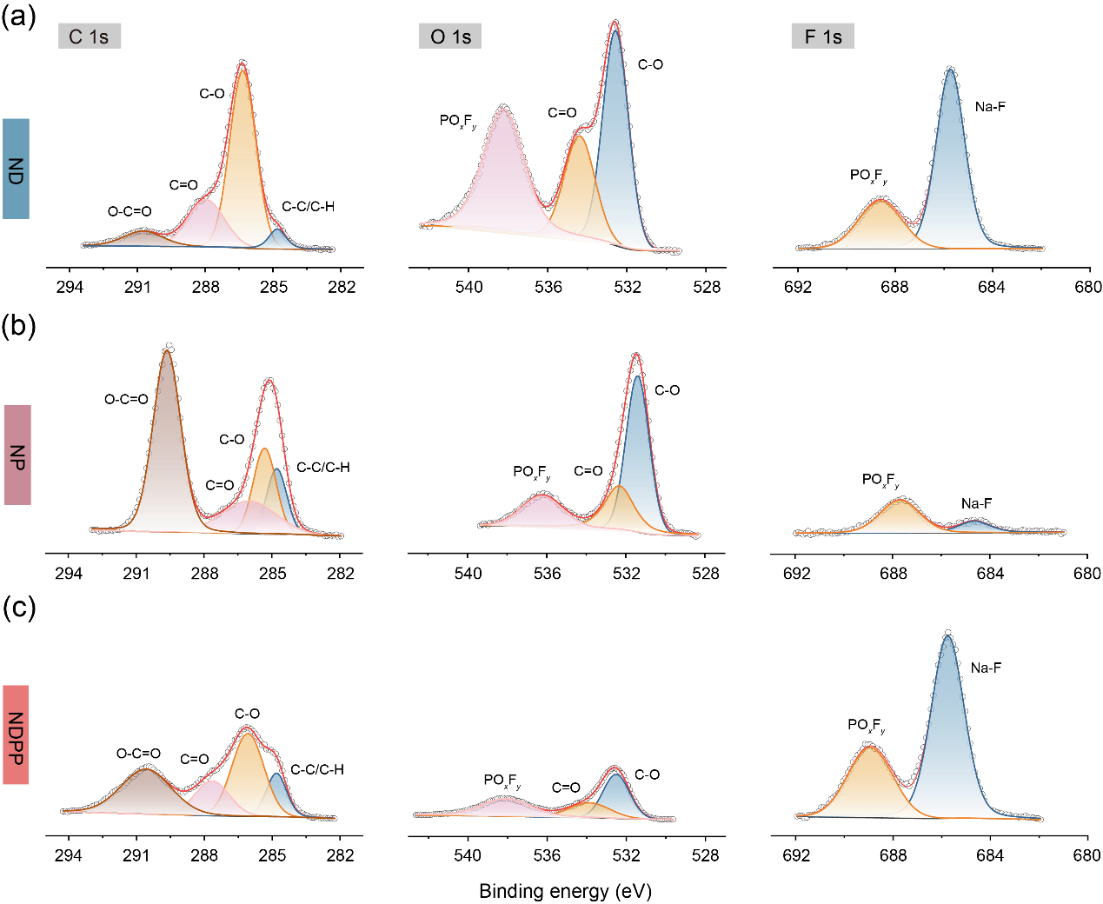
Supplementary Figure 19. XPS spectra for C1s, O1s and F1s for the cycled HC anodes in (a) ND, (b) NP and (c) NDPP electrolytes, respectively.

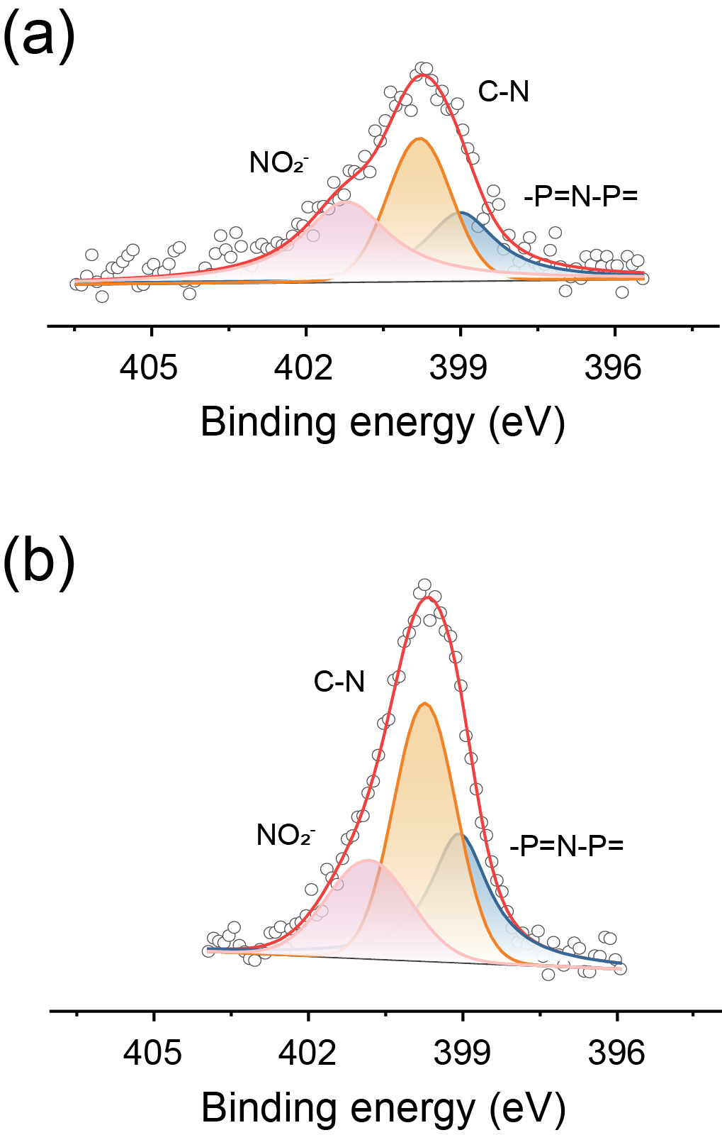
Supplementary Figure 20. XPS spectra for N1s for the cycled (a) NVPOF cathode and (b) HC anode in NDPP, respectively.

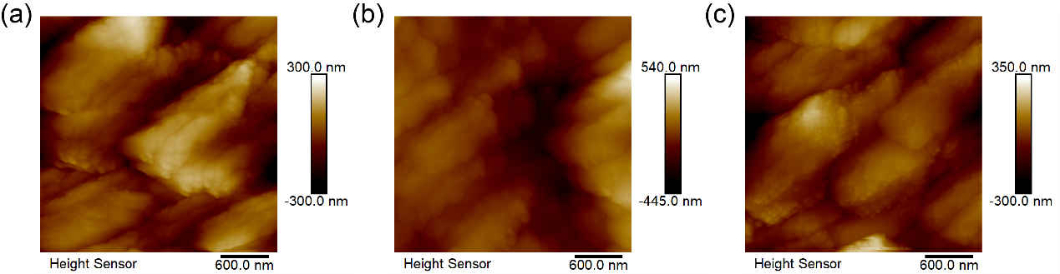
Supplementary Figure 21. 2 D AFM images for the cycled NVPOF cathodes in (a) ND, (b) NP and (c) NDPP electrolytes, respectively.

Supplementary Table 1: Abbreviations of different solvents.
Name | Abbreviations
Ethylene carbonate | EC
Propylene carbonate | PC
Dimethyl carbonate | DMC
Diethyl carbonate | DEC
Ethyl methyl carbonate | EMC
1,2-Dimethoxyethane | DME
Diethylene glycol dimethyl ether | G2
Ethylene glycol diethyl ether | DEE
Tetrahydrofuran | THF
2-Methyltetrahydrofuran | MeTHF
Tetrahydropyran | THP
Ethoxy (pentafluoro)cyclotriphosphazene | PFPN

Supplementary Table 2: A series of basic physicochemical properties of various solvents.
Solvent | Melting point (T_{m}) [℃] | Boiling point (T_{b}) [℃] | Flash point (T_{f}) [℃] | Viscosity (η) at 25 ℃ [cP] | Dielectric constant (ε) at 25 ℃ | DN value
EC | 36.4 | 248 | 160 | 1.9 | 89.78 | 16.4
PC | -48.8 | 242 | 132 | 2.53 | 64.9 | 15.1
DMC | 4.6 | 91 | 18 | 0.59 | 3.11 | 16
DEC | -74.3 | 126 | 31 | 0.75 | 2.81 | 16
EMC | -53 | 110 | 23 | 0.65 | 2.4 | 17.2
DME | -58 | 82.5 | 0 | 0.45 | 7.18 | 20
G2 | -64 | 162 | 57 | 1.88 | 7.23 | 19.5
DEE | -74 | 121 | 27 | - | 3.9 | -
THF | -108.5 | 66 | -14 | 0.46 | 7.58 | 20
MeTHF | -137.2 | 78 | -11 | 0.47 | 6.97 | 18
THP | -45.2 | 87.9 | -15.6 | 0.764 | 5.61 | 22

Supplementary Table 3: Names and formulae of the studied electrolyte systems.
Name | Composition
ND | 0.8 M NaPF₆ in DEE
NP | 0.8 M NaPF₆ in PC
NDP | 0.8 M NaPF₆ in DEE-PC (1: 1 by volume ratio)
NDPP | 0.8 M NaPF₆ in DEE-PC-PFPN (5: 5: 2 by volume ratio)

Video S1. Flame test of the ND electrolyte.

Video S2. Flame test of the NP electrolyte.

Video S3. Flame test of the NDPP electrolyte.

