Supporting Information for:
Electronic Energy Levels and Optical Spectra of Trivalent Lanthanide Ions in Water – Ce(III), Pr(III), Nd(III), Sm(III), Eu(III), Gd(III), Tb(III), Dy(III), Ho(III), Er(III), Tm(III), and Yb(III)
Villads R. M. Nielsen and Thomas Just Sørensen*
¹ Department of Chemistry and NanoScience Centre, University of Copenhagen, Universitetsparken 5, 2100 Copenhagen, Denmark, TJS@chem.ku.dk

Contents
Contents S2
Details regarding the absorbance spectra S3
As-measured absorbance spectra S3
Corrections of absorbance spectra S5
Additional details regarding the emission spectra S6
Comments on the Difficulties of measurements in the NIR range S7
Additional details regarding the excitation spectra S8
Additional details regarding the determination of speciation S9
Concentration Series S9
Emission Spectra Recorded at Various Wavelengths of Excitation S10
Additional spectroscopic details and details regarding the analysis S20
Fits of spectra S36
Ce Fits S36
Pr Fits S38
Nd Fits S42
Sm Fits S49
Eu Fits S56
Gd Fits S60
Tb Fits S63
Dy Fits S68
Ho Fits S73
Er Fits S78
Tm Fits S83
Yb fits S88

Details regarding the absorbance spectra

As-measured absorbance spectra
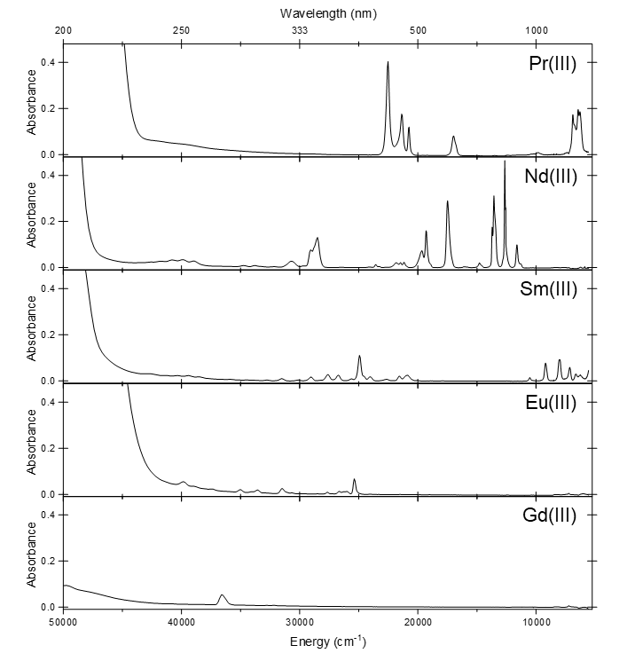
Figure S1. Absorbance of 50mM Ln(OTf)₃ (Ln = Pr, Nd, Sm, Eu, Gd) in D₂O with 100 mM DClO₄ at room temperature.

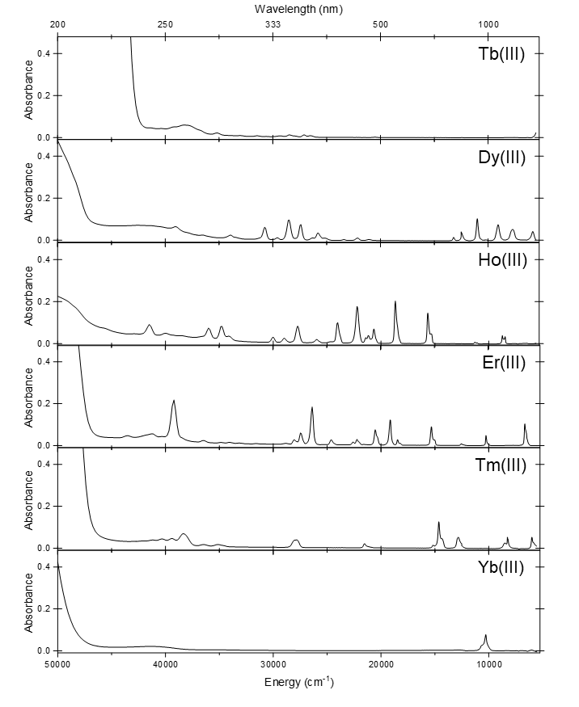
Figure S2. Absorbance of 50mM Ln(OTf)₃ (Ln = Tb, Dy, Ho, Er, Tm, Yb) in D₂O with 100 mM DClO₄ at room temperature.

Corrections of absorbance spectra
Figure S1-S2 shows the raw absorbance data of the lanthanide series in deuterated water. The raw absorbance data is the as-measured data. The absorbance data is measured against D₂O in the cuvette in an absolute measurement. The absolute D₂O measurement was collected on an absolute scale from 0 % to 100 % transmission. The data is corrected with two additional correction procedures displayed in Figure S3.
Water has significant absorption bands above 1200 nm, due to excitation of vibrational overtones, as shown in the transmission reference in Figure S3a. The samples used are prepared in deuterated water and a minor contribution of non-deuterated water will therefore inevitably enter from the atmosphere as the preparation is performed in air. This contribution is slightly different for all samples and the background must therefore be corrected with a representative background that is linearly scaled individually for each sample. The Gd(III) absorption spectrum from 1200 to 1800 nm is chosen for this and is scaled manually to correct for this error in all samples. Gd(III) was chosen as no f-f transitions are present in this range, but still have triflate and Ln(III) ions. Figure S3a shows the effect of this manual scaling performed for the Sm(III) data and how the corrected data looks.
All samples show a drastic increase in absorbance data below 240 nm. The rise is likely a combination of absorption from water, triflate, and transitions involving the d configurations in the lanthanides(III). The data is manually corrected to account for this edge for each Ln(III) as shown in Figure S3b for Sm(III). Therefore, all absorbance data above 35000 cm⁻¹ is slightly distorted, but the correction is necessary to fit peak positions of the narrow f-f transitions properly.

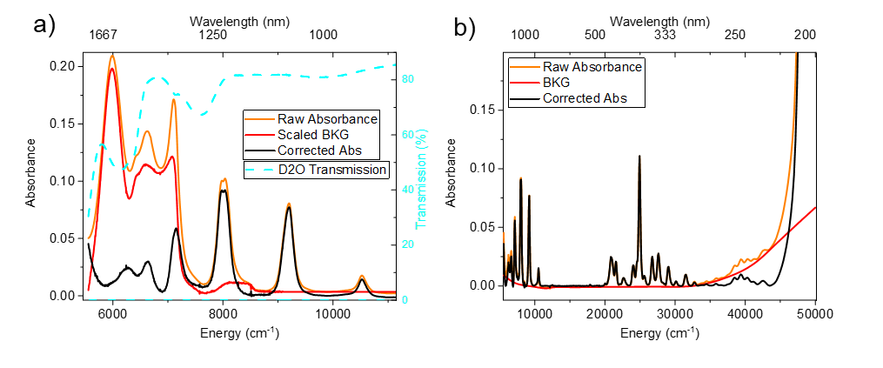
Figure S3. Examples of the two corrections of the absorbance spectra illustrated for Sm(III). a) Absorbance of raw Sm(III), a scaled background (for this the Gd sample was used), background corrected Sm(III), and the absolute measurement of the transmission from 0 to 100 %. b) Raw absorbance, the background constructed from interpolation of selected background points, and the final corrected absorbance for Sm(III).

Additional details regarding the emission spectra
For the emission spectra, three different detector setups are used to capture the entire emission range from 300 to 1700 nm. This results in three different correction profiles and the stitching of spectra between different settings in non-trivial ways. The three detectors are named: Horiba, PyLoN, and NIRvana. The Irina detector is from a Horiba instrument and the PyLoN and NIRvana are two different detectors of the custom instrument SuCo.⁹ The relative quantum efficiencies are shown for the three detectors in Figure S4a. Irina is effective from 320 to 700 nm, PyLoN from 500 to 950m and NIRvana from 850 to 1700 nm. Figure S4b shows Sm(III) emission collected with the three different detectors. Sm(III) does not emit in a range suitable for detection with Irina and the PyLoN data is perfectly adequate from 550 to 900 nm. Resultantly, the data from PyLoN is in significantly better quality and above 800 the Irina is found unreliable. Above 950 nm the Pylon detector does not provide adequate data and NIRvana must be used. The peaks in this range are incredibly weak and the spectral data resolution must be decreased in order to collect useable data. This is achieved with a spectral resolution of 4 nm, which results in two orders of magnitude of increased intensity (see Figure S4b). The PyLoN and NIRvana data is stitched together with normalization to the area between 830 and 980 nm. The final spectrum used for Sm(III) is thus covered with PyLoN emission from 550 to 830nm and NIRvana emission from 830 to 1660 nm. The Spectrum is normalized to a band which both detectors are able to record, where possible. In Figure S4c this is shown for Sm(III). A similar procedure is performed for most elements in the series and will be detailed in the section for each element.
Figure S4. a) Relative quantum efficiency of the three detectors: Irina, PyLoN, and NIRvana. b) As measured Sm(III) emission collected on the three different detectors. Data for the NIRvana detector is shown with both low and high spectral resolution. c) The final alignment of the corrected emission spectra, which are stitched together. The entire Sm(III) emission range is covered with PyLoN emission from 550 to 830nm and NIRvana emission from 830 to 1660 nm. The two spectra a stitched by normalization to the area between 830 – 980 nm.

Comments on the Difficulties of measurements in the NIR range
Figure S5 shows all NIR emissive Ln(III) measured with the NIRvana detector with the same resolution of 4 nm. The line broadness for Nd(III) in D₂O at 13400 was found in Paper 7 to be 1.7 nm, and 4 nm is therefore realized to be of insufficient resolution. By far only Nd(III) and Yb(III) are readily measured in high resolution, likely to higher absorbance coefficients of the excitation bands and higher quantum yields of the bands in this spectral region. These two elements are therefore the only elements where the entire NIR range could be recorded in high spectral resolution (0.4 nm). A particular effort was made with the 1600 nm band for Er(III) due to the importance of this specific band and this was therefore also collected at high resolution. However, this singly band took 10 h of exposure time for each of the the RT and 77 K measurements. For comparison the Eu(III) luminescence spectrum is measured within a second. For all other elements, this range was only recorded at a resolution of 4 nm and only at RT, and although the resolution may still be high at long wavelengths, the resolution was not deemed to warrant cold spectra. PyLoN spectra are all recorded with 0.4 nm for all elements and Irina spectra are all recorded with 1 nm for elements (except for Gd(III) which is recorded with 0.25 nm resolution).
Figure S5. Spectra of all NIR emissive lanthanides(III) in D₂O at 50 mM. Each data set is background subtracted and recorded following different excitation wavelength (units in nm) chosen based on the most intense available excitation band. All other instrumental settings are identical and the spectral resolution is 4 nm.

Additional details regarding the excitation spectra
For the excitation spectra, two different light sources are used. Similar to the emission spectra, this results in some stitching of the excitation spectrum collected with different instruments and non-trivial choices of how to best perform the stitching. Figure S6a, shows the normalized relative lamp power of the light sources on the Irina and the relative laser power of SuCo (For the PyLoN and NIRvana detector) instruments. Irina excitation is reliable in all ranges above 250 nm and while excitation can be collected down to 220 nm, the lamp efficiency is approaching zero in this region. The SuCo excitation source works from 450 nm, but is only reliable above 500 nm.
Despite the efficiency of the Irina excitation source in the entire range the higher efficiency of the PyLoN detector makes this instrument superior for excitation spectra above 500 nm. Figure S6b shows the excitation spectra of Sm(III) as collected on the Irina and SuCo instruments. Figure S6c) shows the two ranges stitched together with normalization to the area between 455 and 510 nm. While the Irina instruments can capture the entire excitation range for Sm(III) the PyLoN detector deliver a significantly higher data quality (See Figure S6c) and will be used wherever possible.
Figure S6. a) Relative lamp power of the two light sources: Irina and SuCo. b) As-measured excitation of Sm(III) collected from the two different light sources. c) The final alignment of the corrected excitation spectra, which are stitched together. The entire Sm(III) excitation range is covered with Irina excitation from 250 to 510 nm and with the PyLoN excitation from 510 to 625 nm. The two spectra are stitched together by normalization to the area between 455 – 510 nm. Insert shows the range from 490 to 600 nm zoomed in to see the low intensity peaks.

Additional details regarding the determination of speciation

Concentration Series
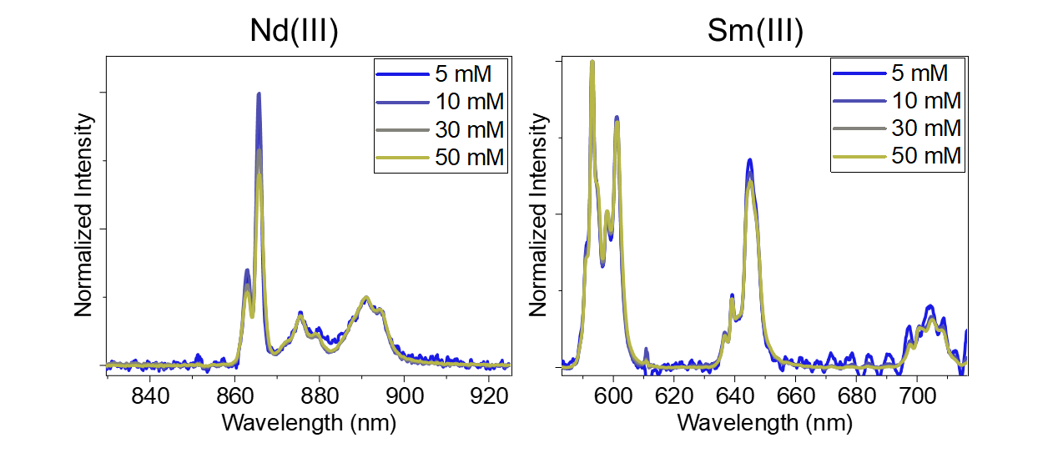
Figure S7. Luminescence measured at 77 K for varying concentrations of Ln(OTf)₃ (Nd left and Sm right) in D₂O with 100 mM DClO₄.
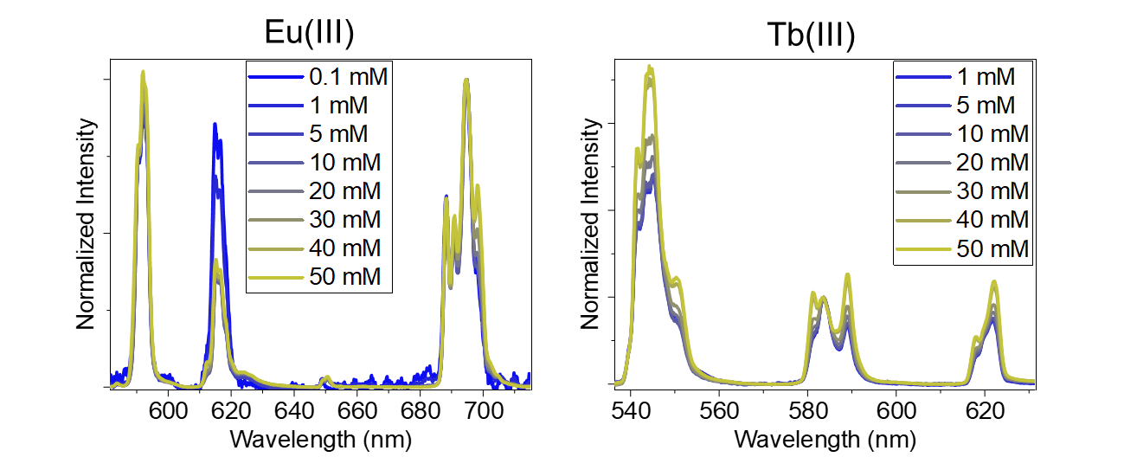
Figure S8. Luminescence measured at 77 K for varying concentrations of Ln(OTf)₃ (Eu left and Tb right) in D₂O with 100 mM DClO₄.
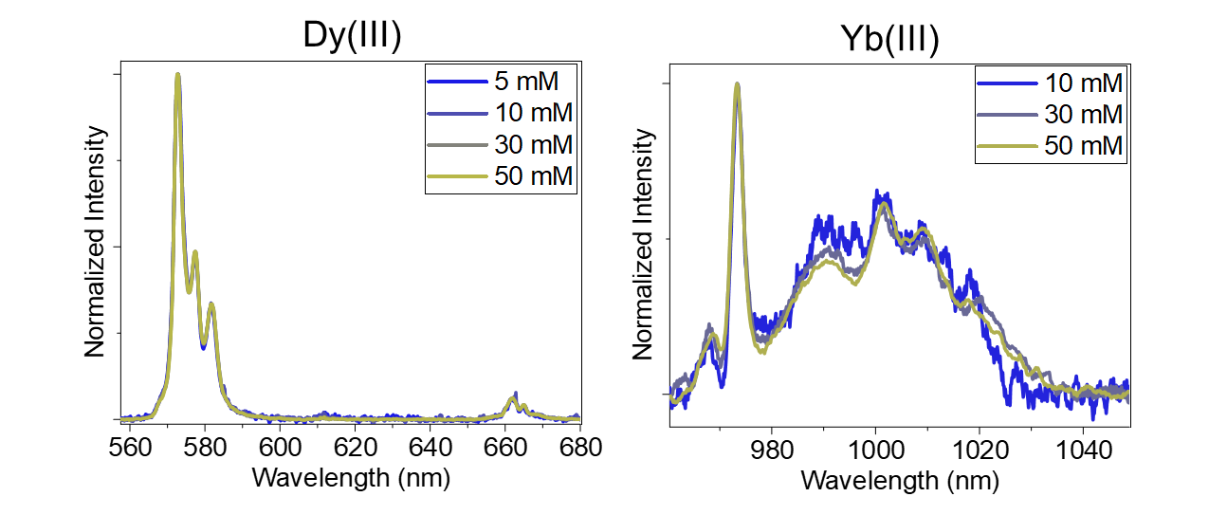
Figure S9. Luminescence measured at 77 K for varying concentrations of Ln(OTf)₃ (Dy left and Yb right) in D₂O with 100 mM DClO₄.

Emission Spectra Recorded at Various Wavelengths of Excitation

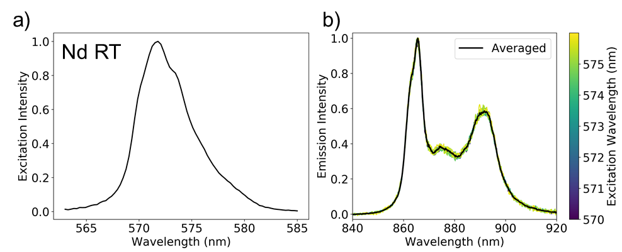
Figure 10. Spectra of 50 mM Nd(OTf)₃ in D₂O with 100 mM DClO₄ at RT. a) Excitation spectrum constructed from emission integrated from 860 to 900 nm. b) Normalized emission spectra following excitation from 570 to 576 nm.

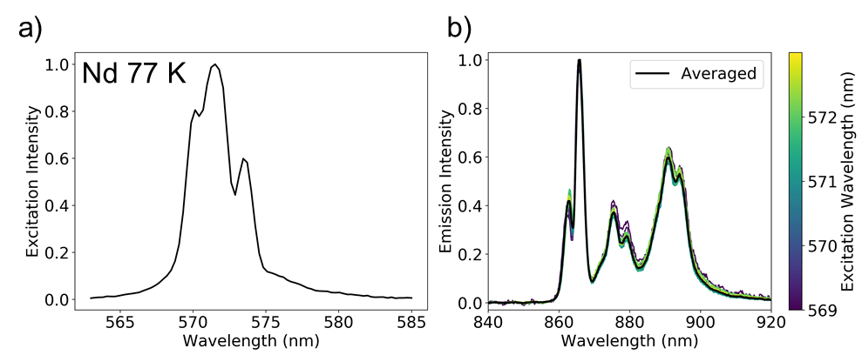
Figure 11. Spectra of 50 mM Nd(OTf)₃ in D₂O with 100 mM DClO₄ at 77 K. a) Excitation spectrum constructed from emission integrated from 860 to 900 nm. b) Normalized emission spectra following excitation from 570 to 576 nm.
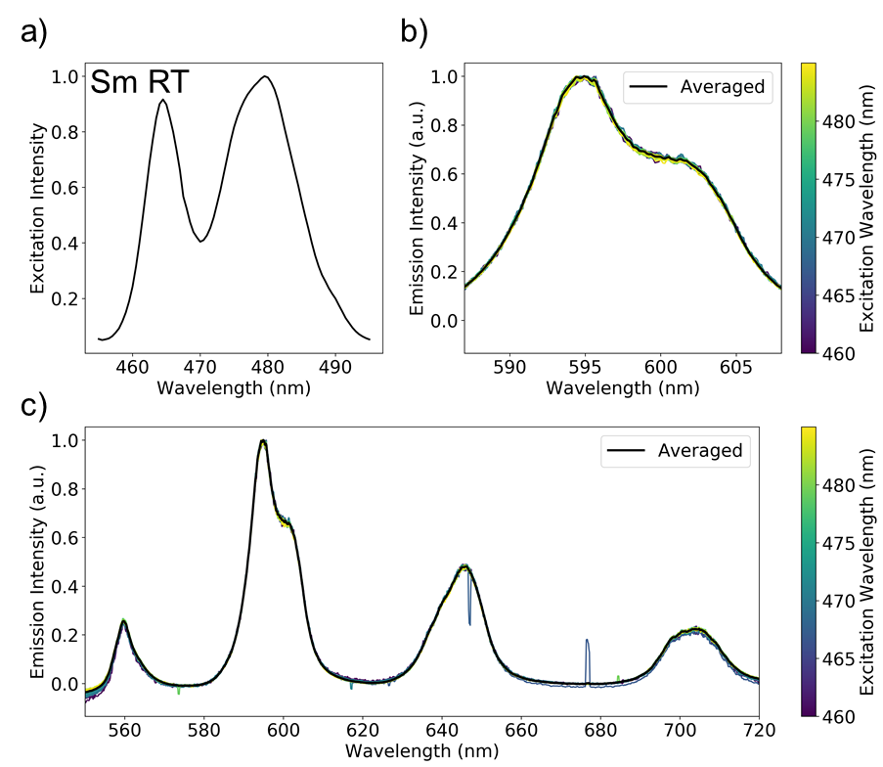
Figure 12. Spectra of 50 mM Sm(OTf)₃ in D₂O with 100 mM DClO₄ at RT. a) Excitation spectrum constructed from emission integrated from 550 to 725 nm. b-c) Normalized emission spectra following excitation from 460 to 486 nm.

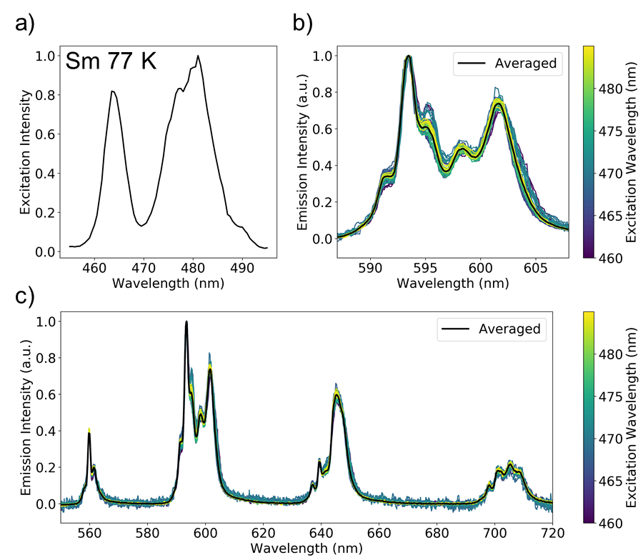
Figure 13. Spectra of 50 mM Sm(OTf)₃ in D₂O with 100 mM DClO₄ at 77K. a) Excitation spectrum constructed from emission integrated from 550 to 725 nm. b-c) Normalized emission spectra following excitation from 460 to 486 nm.

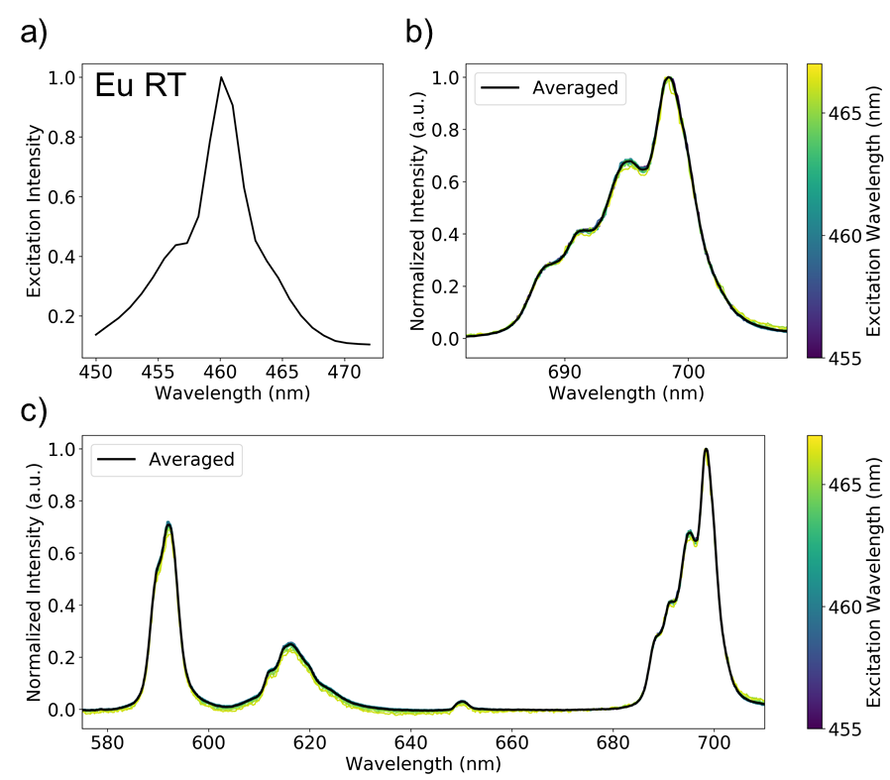
Figure 14. Spectra of 50 mM Eu(OTf)₃ in D₂O with 100 mM DClO₄ at RT. a) Excitation spectrum constructed from emission integrated from 570 to 710 nm. b-c) Normalized emission spectra following excitation from 455 to 468 nm.

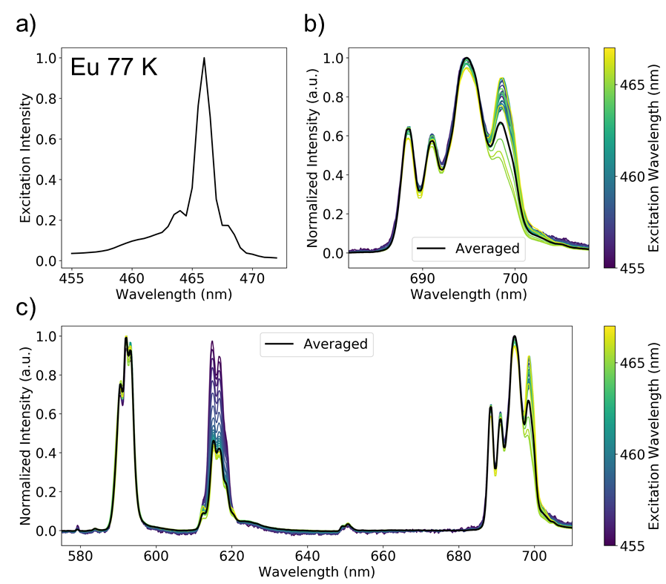
Figure 15. Spectra of 50 mM Eu(OTf)₃ in D₂O with 100 mM DClO₄ at 77 K. a) Excitation spectrum constructed from emission integrated from 570 to 710 nm. b-c) Normalized emission spectra following excitation from 455 to 468 nm.

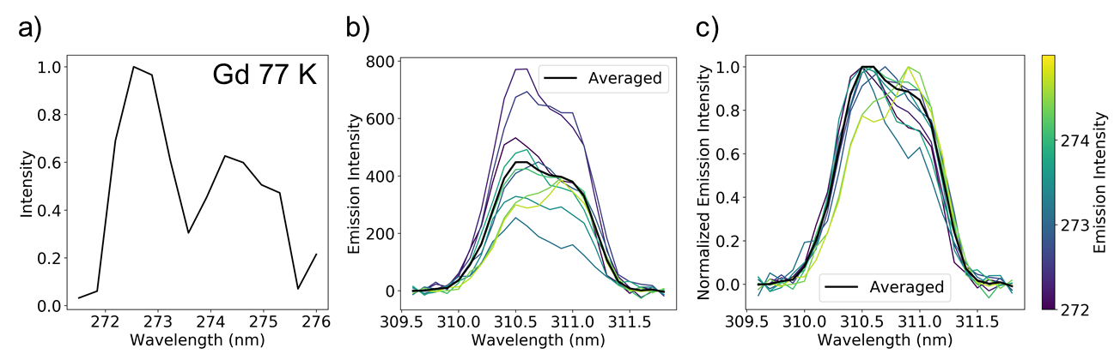
Figure 16. Spectra of 50 mM Gd(OTf)₃ in D₂O with 100 mM DClO₄ at 77 K. a) Excitation spectrum constructed from emission integrated from 310 to 311.5 nm. b) Emission spectra following excitation from 455 to 468 nm. c) Normalized emission spectra following excitation from 455 to 468 nm.

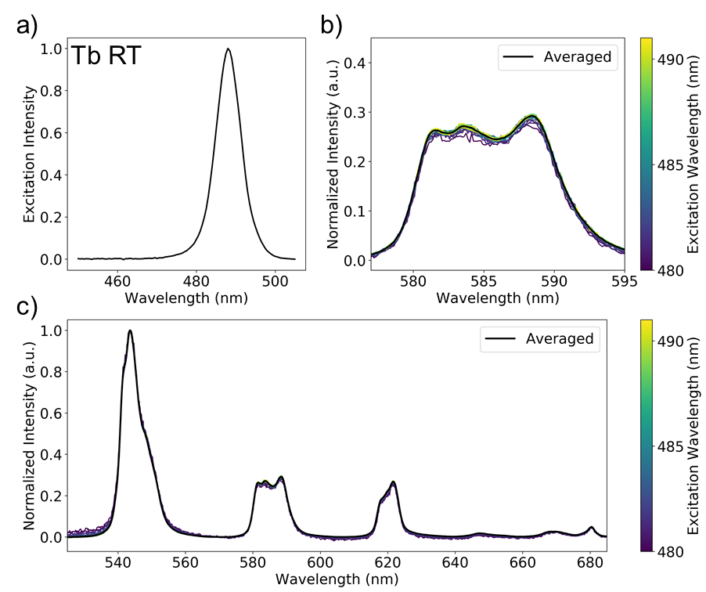
Figure 17. Spectra of 50 mM Tb(OTf)₃ in D₂O with 100 mM DClO₄ at RT. a) Excitation spectrum constructed from emission integrated from 535 to 685 nm. b-c) Normalized emission spectra following excitation from 480 to 492 nm.

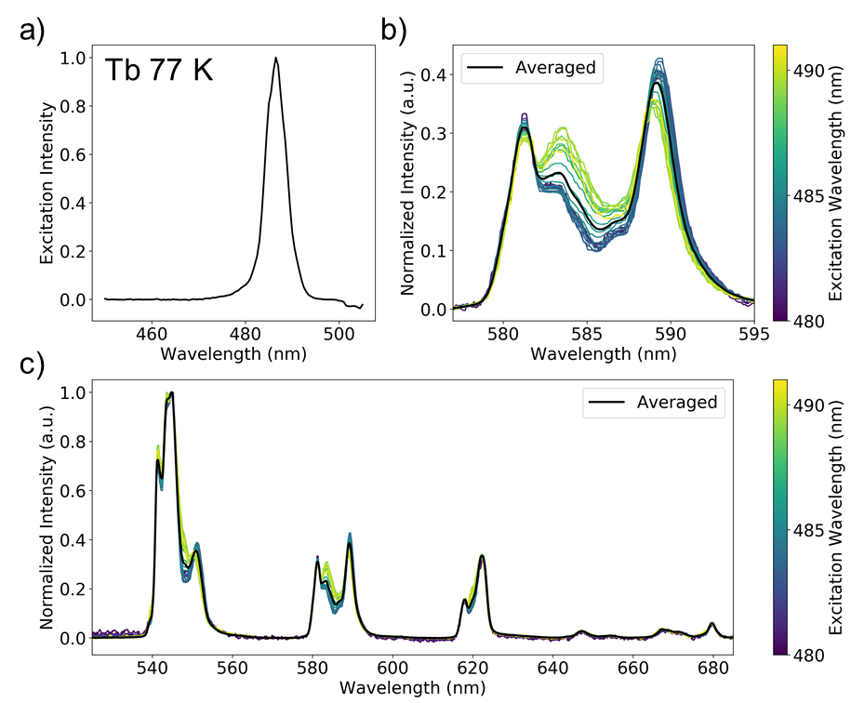
Figure 18. Spectra of 50 mM Tb(OTf)₃ in D₂O with 100 mM DClO₄ at 77 K. a) Excitation spectrum constructed from emission integrated from 535 to 685 nm. b-c) Normalized emission spectra following excitation from 480 to 492 nm.

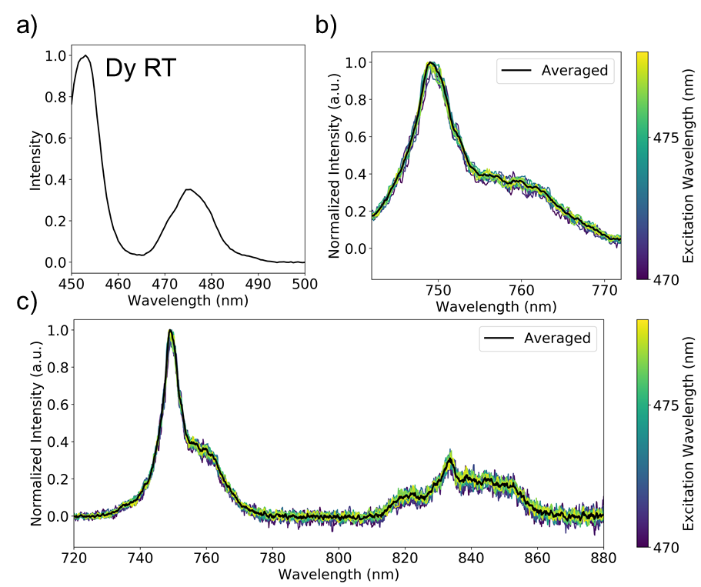
Figure 19. Spectra of 50 mM Dy(OTf)₃ in D₂O with 100 mM DClO₄ at RT. a) Excitation spectrum constructed from emission integrated from 747 to 767 nm. b-c) Normalized emission spectra following excitation from 470 to 767 nm.

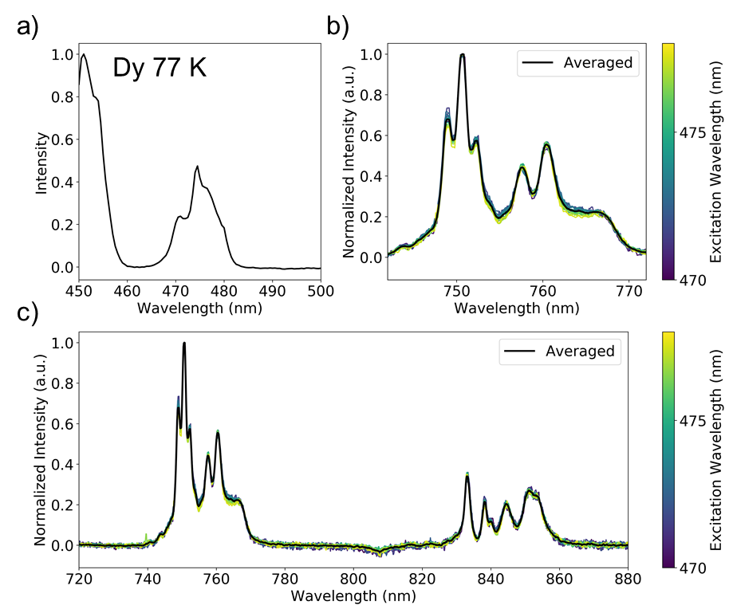
Figure 20. Spectra of 50 mM Dy(OTf)₃ in D₂O with 100 mM DClO₄ at 77 K. a) Excitation spectrum constructed from emission integrated from 747 to 767 nm. b-c) Normalized emission spectra following excitation from 470 to 767 nm.

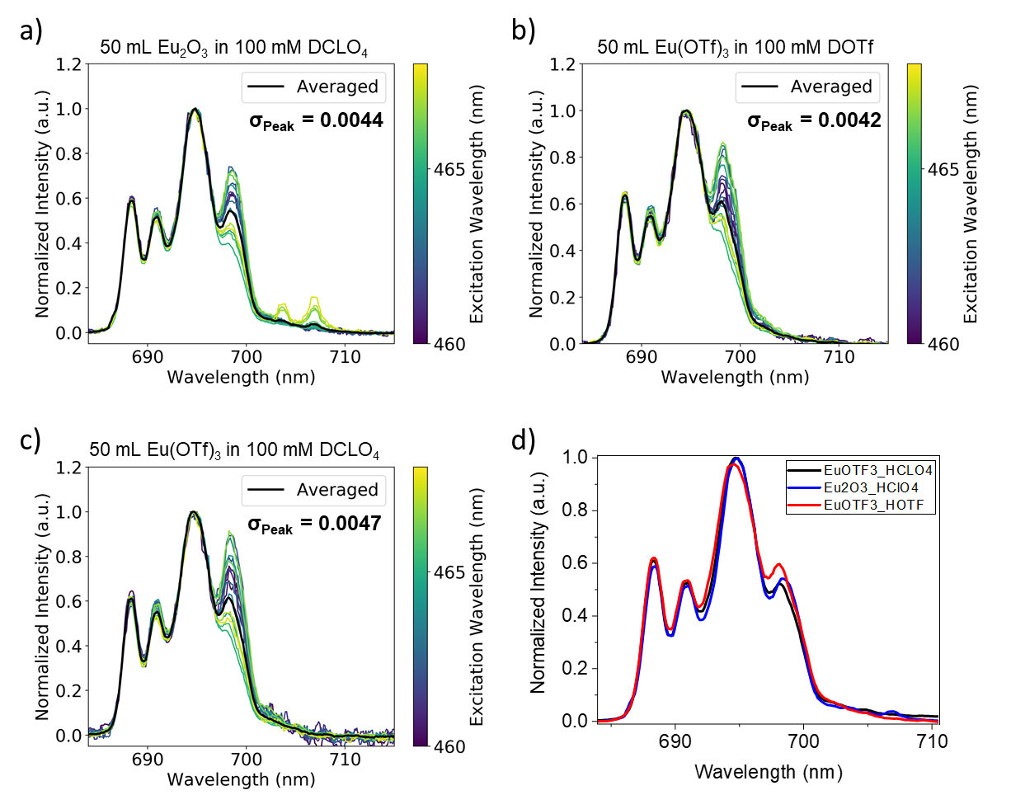
Figure S21. Three different 50 mM Eu(III) samples prepared and measured in D₂O at 77 K. a: Normalized emission spectra following excitation from 455 to 468 nm of 50 mM Eu₂O₃ in D₂O with 100 mM DClO₄. b: Normalized emission spectra following excitation from 455 to 468 nm of 50 mM Eu(OTf)₃ in D₂O with 100 mM DOTf. c: Normalized emission spectra following excitation from 455 to 468 nm of 50 mM Eu(OTf)₃ in D₂O with 100 mM DCLO₄. d: Normalized averaged spectra of the emission spectra showed in a-c. The σ_{peak} value is calculated according to Eq. 1 of the main text.

Additional spectroscopic details and details regarding the analysis

Cerium(III)
Emission spectra. Emission spectra are collected on the Horiba detector following excitation at 250 nm.
Excitation spectra. Excitation spectra are on the Horiba detector following emission at 340 nm.
Additional Measurement Details. Measurements on Ce(III) was performed at 0.25 mM to acquire an absorbance maximum at 0.1, see Figure S22.
Figure S22. Absorbance of 50, 2.5 and 0.25 mM Ce(OTf)₃ in D₂O with 100 mM DClO₄ at room temperature.
Figure S23 shows an analysis of the emissive level to the lowest energy levels that need consideration prior to the extraction of photophysical parameters. A two-peak model describes the emission spectrum, which is assumed to be transitions from the lowest state in the 5d¹ configuration to the two ²F_{J} terms. Fitting these peaks with Gaussian peak functions the positions and widths are obtained. These transitions are not f-f therefore the Lorentzian contribution in the Voigt functions was found to be unnecessary, it is hypothesized that the Lorentzian contribution become insignificant to the broadening as the sensitivity to the chemical environment is larger for the d-orbitals. The extracted energies, relative transition probabilities and peak ranges are provided in the main text where the information is given for the data collected at 77 K. The energy ranges of each of the transitions are calculated from the fitted width as seen in Figure S23. The boxes of each transitions goes from the peak center to plus/minus the full-width-half-max (FWHM) and the total width of the boxes are therefore two times the FWHM. The Excitation spectra are less trivial to analyze. The absorption data displays five peaks, the RT excitation spectrum has three peaks, while the 77 K spectrum only has two peaks. The nature of these transitions is not considered. Instead, only the two peaks at 77 K is reported.

Figure S23. Left: Bands involved between emissive states and lowest energy multiplets of Ce(III). Middle: Initial model for the composition of the emissive and low energy states. Right: Fit of the emission spectra. The boxes indicate the full range of each transition.

Praseodymium(III)
Emission spectra. Emission spectra are collected on the Horiba detector and the PyLoN detector. Below 500 nm the Horiba detector is used following excitation at 434 nm. Above 500 nm the PyLoN detector is used following excitation at 468 nm. These two emission spectra are stitched together upon normalization to area of the convoluted ³P₀ → ³H₄ and ¹D₂ → ³H₄ emission bands at 600 nm.
Excitation spectra. Excitation spectra are also collected on both the Horiba detector and the PyLoN detector. Below 550 nm the Horiba detector is used following emission at 600 nm. Above 550 nm the PyLoN detector is used following emission at 690 nm. These two emission spectra are stitched together upon normalization to area of the ³H₄ → ³P₀ excitation band at 482 nm. These two excitation spectra are stitched together upon normalization to area of the ³H₄ → ³P₀ excitation band at 482 nm
Assigning Transitions. Pr(III) display emission from both the ³P₀ and the ¹D₂ multiplets. In order to resolve which emission transitions arise from which, emission spectra are collected following excitation into both the 468 (³H₄ → ³P₀) and 600 nm (³H₄ → ¹D₂) bands. The spectra are shown in Figure S24. Transitions from ³P₀ following 600 nm excitation do not occur. Excitation following emission at 720 and 800 nm is used to see which excitation bands give rise to emission from ³P₀ and ¹D₂ respectively. Accordingly each transition can be assigned as shown in the figure.
Figure S24. Left: Excitation spectra of Pr(III) measured at different emission wavelengths: 800 and 720 nm, corresponding to emission from ¹D₂ and ³P₀ respectively. Right: Emission spectra of Pr(III) following excitation at different wavelengths: 468 and 590 nm, corresponding to excitation into ³P₀ and ¹D₂ respectively.
Devonvolution of Transitions. Figure S25 shows the emission and excitation bands involving the lowest energy term, ⁵H₆, and the two emissive terms, ¹D₂ and ³P₀. Starting with the emission from ¹D₂ to ⁵H₆ it is observed that emission from a ³P₀ is overlapping with the band of interest. With considerations to the energies of the transitions, this band is assigned to be ³P₀ to ⁵H₄. This assignment is supported by the fact that no intensity at this wavelength can be observed at the same wavelength in the excitation spectrum.
A model to explain the transitions can thus be constructed. The model that best describes the differences between the 77 K and RT spectra contain two ensembles of states in the ¹D₂ multiplet and one ensemble of states in the ⁵H₆ multiplet. A total of 5 x 13 = 65 transitions should be present in this band and a full resolution is therefore not possible. This assignment is furthermore supported by the excitation and emission spectra involving the ³P₀ term—only a single peak is observed in all spectra at both RT and 77 K, albeit the resolution is poor. With these considerations, all transitions are fitted with Voigt functions. The results are reported in the main text. We find that all levels reported by Carnall are also reported here, but slight variations in the energies have been determined.

Figure S25. Left: Bands involved between the emissive terms and lowest energy term of Pr(III). Middle: Initial models for the composition of the emissive and low energy levels. Right: Boltzmann population analysis of the assigned levels.

Neodymium(III)
Emission spectra. Emission spectra are collected on the PyLoN detector and the NIRvana detector. Below 980 nm the PyLoN detector is used following excitation at 580 nm. Above 980 nm the NIRvana detector is used following excitation at 980 nm. These two emission spectra are stitched together upon normalization to area of the ⁴F_{3/2} → ⁴I_{11/2} emission band at 1060 nm. In both ranges the spectral resolution is 0.4 nm.
Excitation spectra. Excitation spectra are also collected on the NIRvana detector following emission at 1060 nm.
Devonvolution of Transitions. Before fitting the spectra, the states in the emissive (⁴F_{3/2}) and lowest energy (⁴I_{9/2}) terms must be qualitatively assigned. Figure S26 shows an analysis of these terms. ⁴F_{3/2} has two and ⁴I_{9/2} has five levels, all of which can be assigned in the emission spectrum. The excitation spectrum contains two peaks separated by 42 cm⁻¹ at 77 K, which is assigned to go from the lowest level of ⁴I_{9/2} into the two ⁴F_{3/2} levels. As shown in Figure S26, the contribution from the first thermally populated level in ⁴I_{9/2} given the proposed model is only 9 %, and the two lines are resultantly assigned to be purely from the lowest level. The relative populations between these two levels in ⁴F_{3/2} are calculated to 31 and 69 % based on the Boltzmann distribution. The relative intensity of the high-energy shoulders follows a similar relative transition intensity. Following these arguments, all levels in these terms have been fully assigned and fitted.
Figure S26. Left: Bands involved between the emissive term and lowest energy term of Nd(III). Middle: Initial model for the composition of the emissive and low energy levels. Right: Boltzmann population analysis of the assigned levels.

Samarium(III)
Emission spectra. Emission spectra are collected on the PyLoN detector and the NIRvana detector. Below 980 nm the PyLoN detector is used following excitation at 476 nm. Above 980 nm the NIRvana detector is used following excitation at 476 nm. These two emission spectra are stitched together upon normalization to area of the ⁴G_{5/2} → ⁶F_{3/2} and ⁴G_{5/2} → ⁶F_{5/2,} emission bands at 880 to 950 nm.
Excitation spectra. Excitation spectra are collected on the Horiba detector and the PyLoN detector. Below 510 nm the Horiba detector is used following emission at 595 nm. Above 510 nm the PyLoN detector is used following emission at 595 nm. These two emission spectra are stitched together upon normalization to area of the excitation band at 450 to 500 nm.
Devonvolution of Transitions. To extract the crystal field levels, the two bands involving the emissive term (⁴G_{5/2}) and the lowest energy term (⁶H_{5/2}) are studied. These two multiplets maximally give rise to nine lines, but only three are observed. Figure S27 shows the excitation band and emission band between these two terms including a thermal analysis of the levels. Three transitions can be assigned in both bands: 1) The 0—0’ transition, which is the transitions between the lowest energy levels in each multiplet, highest in intensity in both bands. 2) The 1—0’ transition, which is thermally excited in the excitation spectra. 3) The 0—1’ transition, which is thermally excited in the emission spectra. The 1—1’ is also in there, but as it is thermally excited in both bands it is not observable, but convoluted with other transitions. To quantify, a fit with two sets of two Voigt functions is shown in Figure S27. Each set of two Voigt functions shares a split-parameter, which corresponds to the splitting of ⁴G_{5/2} and ⁶H_{5/2} in the emission and excitation spectra respectively.

Figure S27. Left: Bands involved between the emissive term and lowest energy term of Sm(III). Middle: Initial model for the composition of the emissive and low energy levels. Right: Boltzmann population analysis of the assigned levels assuming one state in each level.

Based on the Boltzmann population analysis methodology discussed in Chapter II, the lowest energy term can be fully deconvoluted. The populations of the two observed levels in ⁶H_{5/2} are calculated to be 73 and 27 % at 77 K. By following only the emission and excitation involved in the lowest energy level in ⁴G_{5/2} the intensities can be used to find which of the two transitions involve two levels. The ‘observed populations’, see Chapter II, based on the transition probabilities are found to be 87 and 13 %. The boltzmann distribution gives a population of 85 and 15 % if the ground level is doubly degenerate and 61 and 39 if the second level is doubly degenerate. Therefore it is concluded that the crystal field splits the ⁶H_{5/2} into a (0,0,1) grouping. The ⁴G_{5/2} is similarely found to group in a (0,0,1) pattern. The results are provided in Figure S28.
Using this analysis, all other emission and excitation spectra are fitted. The emission spectra are fitted with double Voigt functions where thermal contributions are assigned for with a global split-parameter of ⁴G_{5/2} found to be ~60 cm⁻¹. The spectral resolution of the excitation spectra and the absorbance spectra do not allow for a similar approach. Here the spectra are fitted with Voigt functions with no splitting parameter.

Figure S28. Fits of the emission and excitation bands involving ⁴G_{5/2} and ⁶H_{5/2}. The model of each fit is provided to the right of the each plot. The accepted model of the final crystal field splitting in each term is provided to the right.

Europium(III)
Emission spectra. Emission spectra are collected on the PyLoN detector following 465 nm excitation
Excitation spectra. Excitation spectra are collected on the Horiba detector and the PyLoN detector. Below 500 nm the Horiba detector is used following emission at 695 nm. Above 500 nm the PyLoN detector is used following emission at 695 nm. These two excitation spectra are stitched together upon normalization to area of the excitation band at 465 nm.
Devonvolution of Transitions. In the emission spectrum, the ⁵D₀ to ⁷F₀ transition is found to be vanishing small. Only at 77 K in the excitation spectrum where the ⁷F₀ state is populated with 99.6 % of the population is it found to be of comparative intensity to the ⁷F₁ band. As only the ⁵D₀ – ⁷F₀ transition is forbidden and the 99.6 % thermal population ensures all excitation arises from this single state, however, at RT this is not the case and multiple significant shoulders are found in Figure S29. Notably, shoulder to ⁵G₆ and ⁵H₆ are of significant contribution.

Figure S29. Left: Bands involved between the emissive term and lowest energy term of Eu(III). Middle: Initial model for the composition of the emissive and low energy levels. Right: Boltzmann population analysis of the assigned levels.

Gadolinium(III)
Emission spectra. Emission spectra are collected on the Horiba detector following excitation at 273 nm.
Excitation spectra. Excitation spectra are collected on the Horiba detector following emission at 310 nm.

Terbium(III)
Emission spectra. Emission spectra are collected on the Horiba detector following excitation at 368 nm.
Excitation spectra. Excitation spectra are collected on the Horiba detector following emission at 545 nm.
Devonvolution of Transitions. The bands involving the emissive state and lowest energy states are analyzed in Figure S30. The ⁵D₄ term has 9 states and ⁷F₆ has 13 states and a maximum of 9 x 13 = 117 lines can therefore be observed. This is practically impossible to resolve for the aqua ion with optical spectroscopy. Therefore only ensembles of lines can be reported. In Figure S30, four peaks can be observed in the emission spectrum and three peaks are found in the excitation spectrum. These peaks are assigned to levels representing ensembles of states in the multiplets. To validate how well this assignment holds up, the ⁵D₄ to ⁷F₀ transitions are are shown in Figure S30 at RT and 77 K. The peak changes slightly as the temperature is changed and even at 77 K the band is not found to be symmetric, which it should, if only one line were observed. The fit results obtained for Tb(III) must therefore be taken lightly as the thermal contributions into the manifold of closely lying energy levels in ⁵D₄ in the spectra is impossible to correct for at even 77 K. Still, all observable peaks are fitted with Voigt functions and the results reported in the main text. The peak positions are compared to the work of Carnall,⁴ and furthermore a similar analysis with data for Tb(III) aqua ion has been performed by Kofod et al.⁶ It is found that all levels are very similar to the work of Carnall.

Figure S30. Left: Bands involved between the emissive term and lowest energy term of Tb(III) along with an initial model for the composition of the emissive and low energy levels. Right: The ⁵D₄ to ⁷F₀ band along with an initial model for the composition of the two terms.

Dysprosium(III)
Emission spectra. Emission spectra are collected on the Horiba detector and the PyLoN detector. Below 530 nm the Horiba detector is used following excitation at 350 nm. Above 530 nm the PyLoN detector is used following excitation at 475 nm. These two emission spectra are stitched together upon normalization to area of the emission band at 575 nm.
Excitation spectra. Excitation spectra are collected on the Horiba detector following emission at 575 nm.
Devonvolution of Transitions.The differences between RT and 77 K emission spectra reveal some information on the nature of the emissive term. A high-energy shoulder at ~200 cm⁻¹ higher energy is found for each emissive band at RT, which is frozen out at 77 K. This indicates that the emissive term contain levels split in an order of hundreds of cm⁻¹. The bands involving the emissive states and lowest energy states is analyzed in Figure S31. The ⁴F₉ term has 19 states and ⁶H₁₅ has 31 states. A maximum of 19 x 31 = 589 lines can therefore be observed. This is effectively impossible to resolve for the aqua ion with optical spectroscopy. Therefore, only ensembles of lines can be reported. Furthermore, no meaningful 0-0’ transition can be identified. Meaning that in neither the emission nor the excitation band is it possible to assign an equivalent transition between the lowest level in the emissive and the lowest energy multiplet. However, it seems meaningful to group the states in ⁶H₁₅ in two ensembles and ⁴F₉ in three. Based on these observations all transitions are fitted with Voigt functions.

Figure S31. Left: Bands involved between the emissive ⁴F_{9/2} and lowest energy ⁶H_{15/2} multiplets of of Dy(III). Right: An initial model for the composition of the emissive and low energy levels.

Holmium(III)
Emission spectra. Emission spectra are collected on the PyLoN detector and the NIRvana detector. Below 890 nm the PyLoN detector is used following excitation at 485 nm. Above 890 nm the NIRvana detector is used following excitation at 485 nm. No emission band within the region of both detectors are available and the absolute ranges between the two regions are therefore not comparable. Each region has been normalized to peak maxima individually.
Excitation spectra. Excitation spectra are collected on the PyLoN detector following emission at 650nm.
Devonvolution of Transitions. The emission of Ho(III) in water, even when deuterated, is incredibly weak and emission could only be obtained after long exposures. The excitation spectra can only be measured from 450 to 500 nm with present instrumentation, due to the following issues: 1) Only the 650 nm emission band is of significant intensity for excitation spectra to be collected in a reasonable time frame ( < 4 h). 2) The Raman spectrum of deuterated water (excitation energy + 2500 cm⁻¹) was orders of magnitude more intense than the Ho(III) transitions resulting in the 540 nm band being inaccessible to obtain confidently. Excitation wavelengths higher than 500 results in the Raman spectrum overlapping with the 630 nm emission. Excitation could therefore only be collected in a meaningful way below the 500 nm range. In this range, the excitation source is unreliable. Therefore, analysis of the Ho(III) spectra is mostly performed on the absorbance data and the emission spectra and any full analysis of crystal field levels is uncertain. To properly study Ho(III) in solution it is most likely fruitful to move to solvents with less efficient quenching pathways than water.
Luminescence spectra of the Ho(III) aqua ion is therefore a challenging task that we could not fully overcome, but despite the difficulties mentioned above, it is still possible to refine the positions of all bands. For select bands, the crystal field levels can also be commented on. For Ho(III), three emissive terms are assigned based on the observation of three individual bands into the lowest energy multiplet These are shown in Figure S32, where the available emission and absorption is plotted on top, along with a fit model of the levels below each set of bands. The ⁴I₈ term has 17 states and full deconvolution is not achievable, likely not even with high resolution data. The shape of the absorption spectra is, however, useful to comment on the splitting in the multiplets. All levels in ⁵F₅ and ⁵I₆ are described by a single broad ensemble each. Two models for ⁵I₈ can be constructed, both of which are incomplete. They are different, but not necessarily contradictory. The ⁵F₅ ⁵I₈ emission band is used for Voigt function fitting to extract the levels in ⁵I₈ as the data quality was best in this band. Following this, all peaks in the spectra were fitted with single Voigt function and the results are provided in the main text. Here the fitted energy levels were are compared to the data from Carnall.¹ The results deviate quite significantly from Carnall. In general it is found that Carnall report significantly more transitions than we are able to resolve above 20000 cm⁻¹. Notably we do not observe any transitions involving ⁵G₂ or ³D₃ at 31000 and 33000 cm⁻¹. Perhaps Carnall measured these with higher resolution absorbance spectroscopy than 1 nm which we used, allowing for more resolved data or perhaps they tended to over-assigned transitions.

Figure S32. Bands involved between emissive terms and the lowest energy term of Ho(III) along with fits and models for the levels involved in these bands. Left: ⁵S₂, ⁵F₄ to ⁵I₈. Middle: ⁵F₅ to ⁵I₈ Right: ⁵I₆ to ⁵I₈

Erbium(III)
Emission spectra. Emission spectra are collected on the PyLoN detector and the NIRvana detector. Below 890 nm the PyLoN detector is used following excitation at 522 nm. Above 890 nm the NIRvana detector is used following excitation at 522nm. These two emission spectra are stitched together upon normalization to area of the emission band at 850 nm. Furthermore, the 1530 nm emission band has been measured for an extended period of 20 h at both temperatures due to the importance of this band.
Excitation spectra. Excitation spectra are collected on the PyLoN detector and the NIRvana detector. Below 890 nm the PyLoN detector is used following emission at 522 nm. Above 890 nm the NIRvana detector is used following emission at 522 nm. These two excitation spectra are stitched together upon normalization to area of the XXX → XXX excitation band at XXX nm
Devonvolution of Transitions. To investigate the multiple different emissive multiplets, multiple different excitation wavelengths where explored, see Figure S33. Emission at 850 nm is not found to occur at 653 nm excitation and this transition is therefore assigned to be from the higher energy term ⁴S_{3/2}, which aligns in terms of energy to emission into the ⁴I_{13/2} state. Similar to Ho(III), the emission of Er(III) is incredibly weak in water and emission could only be obtained on the SuCo instrument with very long exposures. Similar restrictions on both the emission and excitation spectra therefore limits the data quality.
Similar to Ho(III) more than one emission band into the lowest energy term is observed. The emission spectra and absorbance spectra of ⁴I_{15/2} to ⁴I_{13/2} and ⁴I_{15/2} to ⁴I_{11/2} are shown in Figure S34. Because of the importance of the ⁴I_{13/2} to ⁴I_{15/2} emission band in e.g. optical fibers,¹¹ an extraordinary effort was put into measuring this band. Both the RT and 77 K spectra has been measured for 20 h with a spectral resolution of 0.4 nm. This transition contain a maximum of 8 x 7 = 56 lines, which cannot be resolved here. However, comparing the emission at 77 K to the RT spectrum and the Absorption spectrum 6 ensembles of levels can be assigned. The peak at highest energy is after comparison with the absorption band assigned as thermal contributions. Comparing this assignment of levels to the ⁴I_{11/2} to ⁴I_{15/2} emission band three ensembles of levels can similarly be assigned, admittedly a bit forcefully, which is in support of the energy groupings of the six levels. Following this, all peaks in the absorption spectra was fitted with single Voigt functions

Figure S33. Emission at RT following excitation from 521 and 653 nm laser excitation for 50 mM Er(OTf)₃ in D₂O with 100 mM DClO₄.
Figure S34. Left: Bands involved between the emissive terms ⁴I_{13/2} (top) and term ⁴I_{11/2} (Bottom) and lowest energy term of Er(III). Right models describing the observed transitions.

Thulium(III)
Emission spectra. Emission spectra are collected on the Horiba detector, the PyLoN detector, and the Nirvana detector. The Horiba detector is used below 590 nm following excitation at 358 nm. The PyLoN detector is used between 590 and 900 nm following excitation at 465 nm. The NIRvana detector is used above 900 nm following excitation at 465 nm. These three emission spectra are stitched together upon normalization to area of the emission band at 650 nm and 780 nm respectively.
Excitation spectra. Excitation spectra are collected on the Horiba detector and the PyLoN detector. The Horiba detector is used below 450 nm following emission at 650 nm. The PyLoN detector is used above 450 nm following emission at 780 nm. These two excitation spectra are stitched together upon normalization to area of the excitation band at 465 nm
Devonvolution of Transitions. Figure S35 shows an emission band involving the ground state, ⁵H₄ to ⁵H₆, superimposed with the corresponding absorption. ⁵H₆ has 13 states and both ⁵H₄ has 9 states. Therefore, 13 x 9 = 117 lines is possible within this band, which is not possible to resolve. The 77 K spectra has three ensembles of transitions that do not change significantly in relative intensity between 77 K and RT. They are therefore assigned to three ensemble of levels in ⁵H₆. Furthermore, the absorption can be described by a single broad ensemble at RT, as 77 K is not available. This interpretation fits the excitation band at 465 nm, where only a single peak is observed at 77 K, while a broad shoulder at lower energy arises from the thermally excited ensembles in ⁵H₆ can be observed.

Figure S35. Left: Band involved between the emissive term ⁵H₄ and the lowest energy term ⁵H₆ of Ho(III) with a model for involved levels.

Ytterbium(III)
Emission spectra. Emission spectra are collected on the NIRvana detector following 920 nm excitation.
Excitation spectra. Excitation spectra are collected on the NIRvana detector following 1020 nm emission.
Devonvolution of Transitions. Figure S36 shows an analysis of the transitions between the two states. At 77 K, the excitation has one broad peak and two narrow peaks. These are assigned to be from the ground state into the three Kramers doublets in ²F_{5/2}. The energy difference between the two narrow peaks is 61 cm⁻¹ and the resulting Boltzmann population of these two states are therefore 75 and 24 % at 77 K. Therefore, significant contribution from both levels are expected in the emission spectrum. Interrogating the emission spectrum 7 peaks can be seen. These peaks are fitted with four double Voigt functions with a shared splitting parameter initialized to 61 cm⁻¹ as the split-parameter of the two lowest emissive levels. With this, the spectrum is found to fit adequately to the four levels in the lowest energy multiplet.

Figure S36. Left: Band involved between the emissive term ²F_{5/2} and the lowest energy term ²F_{7/2} of Yb(III). Middle: A model for involved levels. Right: Boltzmann populations of the different levels at RT and 77 K.

Fits of spectra

Ce Fits
Figure S37. Fits with a sum of Voigt functions of the 77 K emission spectrum of Ce(III) measured on Horiba detector.
Table S1. Fitted parameters of the fits with a sum of Voigt functions of the 77 K emission spectrum of Ce(III) measured on Horiba detector.

Line center (cm⁻¹) |  | Area (a.u.) |  | Gaussian width (cm⁻¹) |  | Lorentzian width (cm⁻¹) |  | Full width half maxima (cm⁻¹)
xc | error | A | error | wG | error | wL | error | FWHM | error
39719.9 | 7.53 | 3328.55 | 99.53 | 687.33 | 155.06 | 1938.64 | 104.75 | 2170.62 | 31.19
32714.28 | 15.93 | 1399.37 | 97.82 | 1777.56 | 204.29 | 1336.34 | 282.34 | 2597.62 | 63.08

Figure S38. Fits with a sum of Voigt functions of the 77 K excitation spectrum of Ce(III) measured on Horiba detector.
Table S2. Fitted parameters of the fits with a sum of Voigt functions of the 77 K emission spectrum of Ce(III) measured on Horiba detector.
Line center (cm⁻¹) |  | Area (a.u.) |  | Gaussian width (cm⁻¹) |  | Lorentzian width (cm⁻¹) |  | Full width half maxima (cm⁻¹)
xc | error | A | error | wG | error | wL | error | FWHM | error
29786.37 | 23.49 | 2518.09 | 102.37 | 2340.99 | 93.56 | 391.86 | 165.42 | 2557.57 | 28.88
27634.14 | 44.3 | 1392.88 | 47.2 | 2615.99 | 82.52 | 29.85 | 84.09 | 2631.99 | 50.66

Pr Fits
Figure S39. Fits with a sum of Voigt functions of the 77 K excitation spectrum of Pr(III) measured on Horiba detector.
Table S3. Fitted parameters of the fits with a sum of Voigt functions of the 77 K excitation spectrum of Pr(III) measured on Horiba detector.
Line center (cm⁻¹) |  | Area (a.u.) |  | Gaussian width (cm⁻¹) |  | Lorentzian width (cm⁻¹) |  | Full width half maxima (cm⁻¹)
xc | error | A | error | wG | error | wL | error | FWHM | error
22535.41 | 2.98 | 300.01 | 18.93 | 184.28 | 26.62 | 89.07 | 33.14 | 236.5 | 9.23
21544.35 | 104.96 | 89.74 | 64.74 | 374.04 | 246.82 | 0 | 271.68 | 374.04 | 163.51
21351.08 | 3.49 | 113.55 | 67.23 | 133.4 | 34.22 | 2.01E-7 | 84.83 | 133.4 | 69.87
20756.73 | 2.76 | 79.63 | 10.17 | 84.93 | 22.96 | 28.83 | 29.86 | 101.4 | 8.14
Figure S40. Fits with a sum of Voigt functions of the 77 K emission spectrum of Pr(III) measured on the PyLoN detector of SuCo.
Figure S41. Fits with a sum of Voigt functions of the 77 K emission spectrum of Pr(III) measured on the PyLoN detector of SuCo.
Table S4. Fitted parameters of the fits with a sum of Voigt functions of the 77 K emission spectrum of Pr(III) measured on the PyLoN detector of SuCo. These fits are for the luminescent transitions assigned to be from the ¹D₂ term.
Line center (cm⁻¹) |  | Area (a.u.) |  | Gaussian width (cm⁻¹) |  | Full width half maxima (cm⁻¹)
xc | error | A | error | w | error | FWHM | error
16726.53 | 0 | 86.27 | 2.56 | 74.84 | 0 | 176.25 | 0
14560.8 | 1.4 | 0.86 | 0.05 | 98.54 | 2.9 | 232.06 | 6.83
14431.68 | 1.46 | 3.18 | 0.06 | 175.97 | 2.92 | 414.41 | 6.88
12518.07 | 0.34 | 3.88 | 0.03 | 90.17 | 0.82 | 212.35 | 1.93
11664.67 | 0.69 | 2.21 | 0.03 | 103.47 | 1.66 | 243.67 | 3.91
Table S5. Fitted parameters of the fits with a sum of Voigt functions of the 77 K emission spectrum of Pr(III) measured on the PyLoN detector of SuCo. These fits are for the luminescent transitions assigned to be from the ³P₀ term.
Line center (cm⁻¹) |  | Area (a.u.) |  | Gaussian width (cm⁻¹) |  | Full width half maxima (cm⁻¹)
xc | error | A | error | w | error | FWHM | error
19119.36 | 2.47 | 116.97 | 9.12 | 127.4 | 7.54 | 300.03 | 17.76
20718.19 | 3.07 | 36.48 | 6.52 | 70.95 | 8.42 | 167.09 | 19.83
16478.56 | 2.84 | 46.94 | 3.37 | 122.95 | 5.04 | 289.55 | 11.87
16308.01 | 11.71 | 30.33 | 2.13 | 350.67 | 19.62 | 825.83 | 46.21
15660.65 | 0.46 | 4.27 | 0.06 | 82.02 | 1.18 | 193.16 | 2.78
14849.09 | 0.52 | 1.88 | 0.03 | 136.97 | 1.64 | 322.56 | 3.86
13878.05 | 0.18 | 3.64 | 0.09 | 42.99 | 0.61 | 101.24 | 1.44
13833.87 | 2.05 | 3.01 | 0.13 | 115.35 | 3.04 | 271.65 | 7.16
Figure S42. Fits with a sum of Voigt functions of the RT absorption spectrum of Pr(III).
Table S6. Fitted parameters of the fits with a sum of Voigt functions of the RT absorption spectrum of Pr(III).
Line center (cm⁻¹) |  | Area (a.u.) |  | Gaussian width (cm⁻¹) |  | Lorentzian width (cm⁻¹) |  | Full width half maxima (cm⁻¹)
xc | error | A | error | wG | error | wL | error | FWHM | error
6895.35 | 0.39 | 7.8 | 1.01 | 98.26 | 7.81 | 6.22 | 17.49 | 101.63 | 2.26
6782.43 | 4.49 | 50.02 | 0.81 | 408.21 | 10.5 | 4.4 | 17.55 | 410.57 | 4.31
6450.27 | 0.51 | 29.65 | 1.97 | 42.42 | 14.33 | 146.27 | 11.79 | 158.4 | 3.9
6263.17 | 1.06 | 62.43 | 1.16 | 153.76 | 3.78 | 186.01 | 3.51 | 275.9 | 2.19
9735.37 | 42.86 | 2.76 | 0.71 | 0 | 0 | 0 | 0 | 432.04 | 43.16
9823.62 | 3.05 | 0.55 | 0.27 | 0 | 0 | 0 | 0 | 141.72 | 14.23
9950.49 | 34.49 | 0.69 | 1.19 | 0 | 0 | 0 | 0 | 253.06 | 181.77
10239.06 | 18.19 | 0.98 | 0.53 | 0 | 0 | 0 | 0 | 301.86 | 137.04
10438.94 | 6.46 | 0.37 | 0.2 | 0 | 0 | 0 | 0 | 164.65 | 21.01

Nd Fits
Figure S43. Fits with a sum of five sets of two Voigt functions of the 77 K emission spectrum of Nd(III) measured on the PyLoN detector of SuCo. Each set of two Voigt function is separated in position with a globally shared fit parameter “Delta” to account for the thermal population in the emissive state.
Figure S44. Fits with a sum sets of two Voigt functions of the 77 K emission spectrum of Nd(III) measured on the NIRvana detector of SuCo. Each set of two Voigt function is separated in position with a globally shared fit parameter “Delta” to account for the thermal population in the emissive state.
Figure S45. Fits with a sum of sets of two Voigt functions of the 77 K emission spectrum of Nd(III) measured on the NIRvana detector of SuCo. Each set of two Voigt function is separated in position with a globally shared fit parameter “Delta” to account for the thermal population in the emissive state.
Table S7. Fitted parameters of the fits with a sum of Voigt functions of the 77 K emission spectrum of Nd(III) measured on the NIRvana detector of SuCo.
Global splitting parameter  (cm⁻¹) |  | Global Gaussian width (cm⁻¹) |  | Line 1 center (cm⁻¹) |  | Area 1 (a.u.) |  | Lorentzian width 1 (cm⁻¹) |  | Area 2 (a.u.) |  | Lorentzian width 2 (cm⁻¹)
Delta | error | wG | error | xc1 | error | A1 | error | wL1 | error | A2 | error | wL2 | error
44.38 | 0.39 | 25.66 | 0.86 | 11567.45 | 0.59 | 42.76 | 1.18 | 15.39 | 1.55 | 9.37 | 0.43 | 1.14E-13 | 1.34
44.38 | 0.39 | 25.66 | 0.86 | 11446.6 | 4.15 | 14.99 | 8.69 | 47.33 | 7.46 | 0.84 | 1.29 | 5.38E-15 | --
44.38 | 0.39 | 25.66 | 0.86 | 11386.32 | 45.32 | 7.71 | 6.91 | 33.45 | 12.4 | 2.83 | 3.25 | 11.16 | 14.67
44.38 | 0.39 | 25.66 | 0.86 | 11249.94 | 8.22 | 37.96 | 10.07 | 84.52 | 21.98 | 1.87 | 3.79 | 22.4 | 49.22
44.38 | 0.39 | 25.66 | 0.86 | 11197.9 | 18.69 | 23.78 | 7.23 | 60.35 | 6.08 | 2.74 | 2.29 | 3.19 | 11.54
39.21 | 0.93 | 15.78 | 1.55 | 9536.15 | 0.33 | 13.94 | 6.4 | 2.04 | 5.89 | 1.97 | 0.36 | 13.75 | 3.25
39.21 | 0.93 | 8.98 | 7.51 | 9479.55 | 2.84 | 38.61 | 67.81 | 33.26 | 19.26 | 5.02 | 17.26 | 20.51 | 29.18
39.21 | 0.93 | 24.37 | 17.96 | 9453.21 | 31.46 | 10.75 | 9.46 | 15.37 | 40.34 | 4.04 | 12.48 | 0.13 | 70.97
39.21 | 0.93 | 19.58 | 3.84 | 9429.11 | 131.56 | 30.55 | 82.77 | 43.88 | 2.87 | 4.61 | 4.91 | 17.25 | 28.44
41.5 | 0 | 15.14 | 1.37 | 7583.67 | 0.75 | 9.32 | 1.94 | 2.43E-9 | 3.65 | 4.32 | 0.86 | 14.33 | 2.16
41.5 | 0 | 15.14 | 1.37 | 7549.32 | 3.35 | 23.2 | 30.52 | 18.13 | 5.26 | 7.11 | 0.85 | 12.4 | 1.13
41.5 | 0 | 15.14 | 1.37 | 7509.76 | 106.58 | 19.17 | 148.7 | 29.62 | 74.74 | 0 | 14.1 | 76.08 | 1.72E8
41.5 | 0 | 15.14 | 1.37 | 7488.14 | 26.94 | 18.3 | 18.13 | 23.96 | 11.82 | 3.9 | 34.59 | 19.35 | 101
41.5 | 0 | 15.14 | 1.37 | 7456.99 | 156.31 | 20.66 | 102.35 | 42.24 | 22.07 | 0 | 0 | 100 | 0
41.5 | 0 | 15.14 | 1.37 | 7422.17 | 41.88 | 12.94 | 59.27 | 27.88 | 97.25 | 4.21 | 37.3 | 30.37 | 109.93
41.5 | 0 | 15.14 | 1.37 | 7380.33 | 32.16 | 17.09 | 14.92 | 35.93 | 1.33 | 2.03 | 56.81 | 26.63 | 479.27

Figure S46. Fits with a sum Voigt functions of the 77 K excitation spectrum of Nd(III) measured on the NIRvana detector of SuCo.
Figure S47. Fits with a sum Voigt functions of the 77 K excitation spectrum of Nd(III) measured on the NIRvana detector of SuCo.
Figure S48. Fits with a sum Voigt functions of the 77 K excitation spectrum of Nd(III) measured on the NIRvana detector of SuCo.
Table S8. Fitted parameters of the fits with a sum of Voigt functions of the 77 K excitation spectrum of Nd(III) measured on the NIRvana detector of SuCo.
Line center (cm⁻¹) |  | Area (a.u.) |  | Gaussian width (cm⁻¹)
xc | error | A | error | w | error
11597.44 | 0.81 | 45.93 | 2.14 | 52.04 | 2.02
11555.56 | 0.53 | 27.78 | 1.99 | 34.33 | 1.45
12769.8 | 5.13 | 35.92 | 5.11 | 121.24 | 13.27
12610.47 | 0.39 | 132.16 | 8.58 | 75.01 | 0.98
12496.42 | 3.32 | 36.92 | 4.44 | 97.92 | 6.97
13686.14 | 0.36 | 35.45 | 1.43 | 35.22 | 0.91
13634.56 | 0.64 | 21.6 | 1.57 | 36.5 | 1.63
13545.74 | 0.48 | 66.67 | 2.26 | 56.79 | 1.57
13439.03 | 5.39 | 17.98 | 2.66 | 102.13 | 15.27
14886.63 | 1.27 | 2.77 | 0.1 | 103.01 | 3.27
14751.64 | 1.6 | 2.45 | 0.15 | 104 | 2.79
16087.67 | 1.15 | 0.86 | 0.05 | 45.16 | 2.46
16026.43 | 2.38 | 0.48 | 0.11 | 48.82 | 5.79
17512.29 | 0.92 | 37.9 | 2.75 | 65.83 | 2.26
17425.57 | 0.69 | 123.98 | 4.28 | 95.7 | 2.44
17313.53 | 0.69 | 20.95 | 1.34 | 55.05 | 1.86
19814.69 | 85.38 | 46.18 | 43.69 | 340.4 | 74.46
19691.29 | 16.62 | 56.43 | 39.56 | 214.04 | 54.67
19249.36 | 0.76 | 63.36 | 3.51 | 55.06 | 2.18
19193.67 | 1 | 67.07 | 3.47 | 64.56 | 2.55
Figure S49. Fits with a sum Gaussian functions of the RT absorption spectrum of Nd(III).
Figure S50. Fits with a sum Gaussian functions of the RT absorption spectrum of Nd(III).

Figure S51. Fits with a sum Gaussian functions of the RT absorption spectrum of Nd(III).
Figure S52. Fits with a sum of Gaussian functions of the RT absorption spectrum of Nd(III).

Table S9. Fitted parameters of the fits with a sum of Gaussian functions of the RT absorption spectrum of Nd(III).
Line center (cm⁻¹) |  | Gaussian width  (cm⁻¹) |  | Gaussian area (cm⁻¹) |  | Full width half maxima (cm⁻¹)
xc | error | w | error | A | error | FWHM | error
24181.37 | 26.22 | 251.91 | 52.98 | 2.97 | 0.54 | 296.6 | 62.38
23678.45 | 4.74 | 159.26 | 9.59 | 10.82 | 0.6 | 187.52 | 11.29
23392.54 | 15.66 | 196.07 | 33.21 | 4.42 | 0.64 | 230.86 | 39.1
21917.13 | 5.19 | 413.62 | 11.03 | 44.65 | 1 | 487 | 12.98
21556.94 | 3.21 | 139.88 | 7.32 | 12.09 | 0.85 | 164.7 | 8.61
21259.29 | 3.03 | 238.29 | 6.61 | 27.05 | 0.62 | 280.56 | 7.78
30887.56 | 22.62 | 624.62 | 53.1 | 85.83 | 7.94 | 735.43 | 62.52
29212.19 | 11.75 | 355.2 | 20.21 | 137.29 | 8.9 | 418.21 | 23.8
28694.05 | 7.1 | 392.7 | 12.75 | 266.31 | 9.25 | 462.37 | 15.01
6241.27 | 0.61 | 153.63 | 2 | 3.98 | 0.08 | 180.89 | 2.35
5979.16 | 2.75 | 97.85 | 6.43 | 0.68 | 0.05 | 115.21 | 7.57
5885.99 | 0.27 | 41.66 | 0.59 | 1.54 | 0.03 | 49.05 | 0.69

Sm Fits
Figure S53. Fits with a sum of five sets of two Voigt functions of the 77 K emission spectrum of Sm(III) measured on the PyLoN detector of SuCo. Each set of two Voigt function is separated in position with a globally shared fit parameter “Delta” to account for the thermal population in the emissive state.

Figure S54. Fits with a sum of five sets of two Voigt functions of the 77 K emission spectrum of Sm(III) measured on the PyLoN detector of SuCo. Each set of two Voigt function is separated in position with a globally shared fit parameter “Delta” to account for the thermal population in the emissive state.

Figure S55. Fits with a sum of five sets of two Voigt functions of the 77 K emission spectrum of Sm(III) measured on the PyLoN detector of SuCo. Each set of two Voigt function is separated in position with a globally shared fit parameter “Delta” to account for the thermal population in the emissive state.

Figure S56. Fits with a sum of five sets of two Voigt functions of the 77 K emission spectrum of Sm(III) measured on the NIRvana detector of SuCo. Each set of two Voigt function is separated in position with a globally shared fit parameter “Delta” to account for the thermal population in the emissive state.
Table S10. Fitted parameters of the fits with a sum of five sets of two Voigt functions of the 77 K emission spectrum of Sm(III) measured on the PyLoN detector of SuCo.
Global splitting parameter  (cm⁻¹) |  | Global Gaussian width (cm⁻¹) |  | Line 1 center (cm⁻¹) |  |  | Area 1 (a.u.) |  |  | Lorentzian width 1 (cm⁻¹) |  |  |  | Area 2 (a.u.) |  | Lorentzian width 2 (cm⁻¹)
Delta | error | wG | error | xc1 | error |  | A1 | error |  | wL1 |  | error |  | A2 | error | wL2 |  | error
50.74 | 3.29 | 24.13 | 3.45 | 17863.35 | 2.21 | 36.55 |  |  | 5.82 |  | 15.79 | 5.15 | 10.1 |  | 8.57 | 35.38 | 21.78
50.74 | 3.29 | 24.13 | 3.45 | 17809.07 | 18.18 | 68.73 |  |  | 12.4 |  | 91.36 | 3.81 | 0 |  | 2.03 | 6.54 | 0
57.26 | 2.53 | 38.6 | 3.08 | 16849.89 | 2.33 | 79.68 |  |  | 20.87 |  | 5.98 | 8.87 | 54.6 |  | 13.09 | 38.41 | 8.38
57.26 | 2.53 | 38.6 | 3.08 | 16802.06 | 7.59 | 62.06 |  |  | 26.81 |  | 21.83 | 9.77 | 9.66 |  | 6.78 | 9.49E-32 | 3.64E8
57.26 | 2.53 | 38.6 | 3.08 | 16714.2 | 31.59 | 50 |  |  | 77.7 |  | 29.51 | 33.71 | 29.37 |  | 23.55 | 42.61 | 46.67
57.26 | 2.53 | 38.6 | 3.08 | 16621.21 | 43.05 | 220.19 |  |  | 111.92 |  | 82.47 | 2.63 | 0 |  | 45.82 | 100 | 0
60.44 | 1.27 | 41.36 | 2.71 | 15641.61 | 3.23 | 13.76 |  |  | 4.92 |  | 3.13 | 10.74 | 5.74 |  | 1.37 | 0.02 | 8.6
60.44 | 1.27 | 41.36 | 2.71 | 15589.64 | 10.29 | 6.61 |  |  | 7.77 |  | 3.63 | 24.17 | 0 |  | 8.27 | 93.02 | 5.57E8
60.44 | 1.27 | 41.36 | 2.71 | 15449.24 | 9.16 | 93.64 |  |  | 11.47 |  | 81.51 | 1.79 | 67.94 |  | 4 | 48.74 | 5.7
48.81 | 5.66 | 24.18 | 7.4 | 14330.99 | 9.45 | 5.08 |  |  | 5.56 |  | 30.89 | 17.08 | 0.85 |  | 1.31 | 29.63 | 51.65
48.81 | 5.66 | 24.18 | 7.4 | 14273.08 | 23.37 | 9.2 |  |  | 4.63 |  | 32.22 | 13.47 | 0 |  | 0.93 | 11.81 | --
48.81 | 5.66 | 24.18 | 7.4 | 14182.23 | 33.18 | 10.52 |  |  | 9.42 |  | 43.94 | 23.73 | 12.74 |  | 11.68 | 68.66 | 40.97
48.81 | 5.66 | 24.18 | 7.4 | 14121.42 | 48.93 | 28.81 |  |  | 19.25 |  | 100 | 3.53 | 0 |  | 8.66 | 100 | 0
-118.44 | 3.93 | 93.97 | 25.34 | 12885.43 | 26.17 | 1.77 |  |  | 1.02 |  | 100 | 77.78 | 1.3 |  | 0.68 | 57.79 | 40.67
55 | 0 | 48.13 | 3 | 11221.12 | 3.33 | 4.26 |  |  | 0.45 |  | 16.18 | 4.36 | 4.6 |  | 0.52 | 100 | 6.48
64.32 | 0.76 | 17.18 | 5.26 | 10716 | 0 | 6.15 |  |  | 0.24 |  | 41.32 | 3.73 | 1.15 |  | 0.1 | 19.82 | 5.29

Figure S57. Fits with a sum Voigt functions of the 77 K excitation spectrum of Sm(III) measured on the PyLoN detector of SuCo.

Figure S58. Fits with a sum Voigt functions of the 77 K excitation spectrum of Sm(III) measured on the PyLoN detector of SuCo.

Table S11. Fitted parameters of the fits with a sum Voigt functions of the 77 K excitation spectrum of Sm(III) measured on the PyLoN detector of SuCo.
Global splitting parameter  (cm⁻¹) |  | Global Gaussian width (cm⁻¹) |  | Line 1 center (cm⁻¹) |  | Area 1 (a.u.) |  | Lorentzian width 1 (cm⁻¹) |  | Area 2 (a.u.) |  | Lorentzian width 2 (cm⁻¹)
Delta | error | wG | error | xc1 | error | A1 | error | wL1 | error | A2 | error | wL2 |  | error
-47.07 | 212.95 | 47.81 | 464.81 | 17961.35 | 55.24 | 74.48 | 353.3 | 59.34 | 535.03 | 0 | 1569.91 |  | 99.78 | --
-47.07 | 212.95 | 47.81 | 464.81 | 17901.98 | 172.15 | 47.4 | 1420.76 | 8.76 | 1423.52 | 13.7 | 114.14 |  | 26.24 | 644.02
-72.62 | 52.04 | 74.09 | 79.69 | 19047.7 | 86.06 | 9.14 | 23.37 | 21.57 | 261.44 | 4.23 | 20.48 |  | 5.47E-39 | --
-72.62 | 52.04 | 74.09 | 79.69 | 18941.55 | 120.15 | 16.36 | 31.96 | 4.02E-54 | -- | 11.24 | 32.54 |  | 9.89 | 218.28
-43.34 | 1729.02 | 78.42 | 3613.45 | 20169.41 | 5699.5 | 170.39 | 5878.26 | 74.46 | 23431.64 | 9.55 | 5239.28 |  | 5.79E-9 | 25502.89
-43.34 | 1729.02 | 78.42 | 3613.45 | 20070.53 | 13369.5 | 126.99 | 13556.64 | 5.85 | 13028.86 | 51.83 | 14060.15 |  | 35.27 | 3783.02
-59.97 | 147.33 | 162.26 | 127.08 | 20866.8 | 196.33 | 4.45 | 20.56 | 3.84E-13 | -- | 36.61 | 72.94 |  | 147.26 | 121.47
-59.97 | 147.33 | 162.26 | 127.08 | 21071.6 | 218.05 | 32.5 | 154.66 | 108.99 | 955 | 0 | 119.64 |  | 400 | --
-59.97 | 147.33 | 162.26 | 127.08 | 21606.97 | 44.1 | 29.33 | 76.02 | 30.28 | 427.27 | 13.46 | 87.5 |  | 258.38 | 509.32
-59.97 | 147.33 | 162.26 | 127.08 | 22655.4 | 53.13 | 12.39 | 6.02 | 128.39 | 150.52 | 0 | 4.02 |  | 0 | 0
-54 | 0 | 74.27 | 102.68 | 24111.8 | 19.84 | 18.2 | 21.15 | 67.69 | 179.53 | 26.31 | 18.35 |  | 164.91 | 43.75
-54 | 0 | 95.73 | 23 | 24580.78 | 9.2 | 28.35 | 4.4 | 34.45 | 34.3 | 0 | 1.42 |  | 4.89 | --
-54 | 0 | 140.77 | 15.1 | 24954.46 | 21.88 | 160.85 | 27.1 | 18.57 | 22.02 | 17.07 | 10.52 |  | 2.52E-24 | --
-54 | 0 | 163.65 | 295.7 | 25223.01 | 153.08 | 12.11 | 74.78 | 121.26 | 666.26 | 11.62 | 68.32 |  | 7.44E-16 | --
-54 | 0 | 75.63 | 164.73 | 25658 | 52.22 | 25.58 | 18.15 | 194.72 | 135.04 | 1.9 | 8.86 |  | 0.36 | 389.69
-54 | 0 | 161.59 | 54.7 | 26748.38 | 48 | 38.77 | 46.75 | 64.04 | 137.05 | 9.02 | 42.36 |  | 0 | 384.54
-54 | 0 | 161.59 | 54.7 | 27685.62 | 38.06 | 49.86 | 44.91 | 140.69 | 77.4 | 15.3 | 40.15 |  | 15.65 | 247.83
-54 | 0 | 161.59 | 54.7 | 29057 | 16.88 | 35.68 | 17.75 | 43.13 | 123.12 | 0 | 22.46 |  | 484.04 | 3.02E9
-54 | 0 | 161.59 | 54.7 | 30188.59 | 171.59 | 6.55 | 30.28 | 200 | 427.9 | 4.45 | 25.82 |  | 0.55 | 413.47
-54 | 0 | 161.59 | 54.7 | 31561.53 | 101.07 | 17.52 | 46.78 | 86.6 | 418.52 | 4.66 | 47.24 |  | 200 | 862.87

Figure S59. Fits with a sum Voigt functions of the RT absorption spectrum of Sm(III).

Figure S60. Fits with a sum Voigt functions of the RT absorption spectrum of Sm(III).

Table S12. Fitted parameters of the fits with a sum Voigt functions of the RT absorption spectrum of Sm(III).
Line center (cm⁻¹) |  | Area (a.u.) |  | Gaussian width (cm⁻¹) |  | Lorentzian width (cm⁻¹) |  | Full width half maxima (cm⁻¹)
xc | error | A | error | wG | error | wL | error | FWHM | error
8026.45 | 2.57 | 282.91 | 5.1 | 295.47 | 5.31 | 3.53E-13 | 4.09 | 295.47 | 5.31
8440.66 | 66.11 | 12.46 | 4.25 | 295.47 | 5.31 | 4.63E-13 | 5.19E8 | 295.47 | 5.31
9170.7 | 3.86 | 201.1 | 4.78 | 295.47 | 5.31 | 1.3E-12 | 17.39 | 295.47 | 5.31
10520.33 | 25.17 | 35.35 | 5.03 | 295.47 | 5.31 | 1.73E-15 | 0 | 295.47 | 5.31
32756.37 | 4.97 | 11.91 | 0.45 | 370.4 | 13.46 | 7.6E-13 | 18.63 | 370.4 | 13.46
33781.01 | 41.72 | 3.01 | 1.68 | 505.59 | 365.12 | 1.01 | 604.5 | 506.13 | 101.44
34460.35 | 14.92 | 6.77 | 2 | 344.18 | 157.47 | 125.32 | 240.52 | 416.08 | 40.73
35837.28 | 11.99 | 8.72 | 2.86 | 446.21 | 142.45 | 52.69 | 254.48 | 475.05 | 40.57
36529.64 | 43.3 | 2.04 | 1.13 | 385.9 | 127.02 | 1.5E-12 | -- | 385.9 | 127.02
37551.13 | 113.95 | 7.85 | 24.24 | 468.65 | 419.42 | 170.61 | 1243.66 | 566.54 | 430.93
38467.63 | 62.44 | 54.96 | 48 | 766.24 | 670.74 | 12.34 | 1382.58 | 772.86 | 121.73
39391.78 | 45.92 | 82.71 | 72.72 | 650.09 | 466.05 | 139.74 | 1040.84 | 728.04 | 160.31
40299.07 | 55.83 | 62.23 | 91.55 | 699.96 | 703 | 107.8 | 1673.32 | 759.38 | 273.28
41194.96 | 100 | 49.54 | 44.18 | 657.86 | 361.39 | 316.73 | 688.58 | 843.5 | 188.53
42544.96 | 25.14 | 84.79 | 8.31 | 1172.54 | 69.11 | 5.01E-71 | -- | 1172.54 | 69.11
43734.41 | 40.27 | 9.42 | 1.73 | 705.86 | 86.45 | 9.99E-15 | 0 | 705.86 | 86.45

Eu Fits
Figure S61. Fits with a sum Voigt functions of the 77 K emission spectrum of Eu(III) measured on the PyLoN detector of SuCo.

Figure S62. Fits with a sum Voigt functions of the 77 K emission spectrum of Eu(III) measured on the PyLoN detector of SuCo.

Figure S63. Fits with a sum Voigt functions of the 77 K emission spectrum of Eu(III) measured on the PyLoN detector of SuCo.
Table S13. Fitted parameters of the fits with a sum Voigt functions of the 77 K emission spectrum of Eu(III) measured on the PyLoN detector of SuCo.
Line center (cm⁻¹) |  | Area (a.u.) |  | Gaussian width (cm⁻¹) |  | Lorentzian width (cm⁻¹) |  | Full width half maxima (cm⁻¹)
xc | error | A | error | wG | error | wL | error | FWHM | error
17266.09 | 0.42 | 0.18 | 0.01 | 25.07 | 1 | 8.02E-15 | 0 | 25.07 | 1
16942.02 | 0.67 | 58.01 | 1.76 | 40.24 | 1.06 | 35.49 | 2.13 | 62.47 | 1.25
16891.9 | 0.72 | 24.52 | 1.16 | 40.24 | 1.06 | 3E-30 | -- | 40.24 | 1.06
16851.73 | 0.71 | 64.97 | 2.13 | 40.24 | 1.06 | 28.93 | 1.81 | 57.9 | 1.01
16331.18 | 0.54 | 4 | 0.3 | 40.76 | 1.76 | 2.75 | 2.92 | 42.25 | 1.71
16257.53 | 0.74 | 25.88 | 1.22 | 40.76 | 1.76 | 23.68 | 2.42 | 54.88 | 1.33
16209.29 | 0.45 | 11.54 | 2.35 | 40.76 | 1.76 | 2.32 | 8.64 | 42.01 | 3.23
16168.52 | 1.61 | 5.43 | 0.78 | 40.76 | 1.76 | 1.67E-12 | 0.21 | 40.76 | 1.76
16125.76 | 4.61 | 12.56 | 1.55 | 40.76 | 1.76 | 96.03 | 11.41 | 111.83 | 10.1
15403.15 | 0.54 | 0.34 | 0.03 | 24.75 | 1.46 | 1.61E-29 | 1.46E8 | 24.75 | 1.46
15366.42 | 0.54 | 1.86 | 0.06 | 24.75 | 1.46 | 32.32 | 2.32 | 46.25 | 1.07
14534.5 | 0.44 | 11.68 | 0.47 | 33.8 | 1.17 | 1.65E-39 | 3.72E7 | 33.8 | 1.17
14478.94 | 0.72 | 14.04 | 1.32 | 33.8 | 1.17 | 18.08 | 5 | 44.5 | 2.54
14400.62 | 0.52 | 53.7 | 2.22 | 33.8 | 1.17 | 51.91 | 2.87 | 69.3 | 2.3
14321.28 | 0.71 | 32.98 | 1.44 | 33.8 | 1.17 | 44.17 | 2.53 | 63.17 | 1.84
13352.3 | 0.84 | 0.51 | 0.02 | 55.17 | 2.88 | 46.8 | 4.04 | 84.33 | 2.16
13252.65 | 0.82 | 0.32 | 0.01 | 55.17 | 2.88 | 24.23 | 4.49 | 69.26 | 2.02
12403.9 | 2.17 | 0.07 | 0.01 | 55.17 | 2.88 | 6.58E-38 | -- | 55.17 | 2.88

Figure S64. Fits with a sum Gaussian functions of the 77 K excitation spectrum of Eu(III) measured on Horiba detector.
Figure S65. Fits with a sum Gaussian functions of the 77 K excitation spectrum of Eu(III) measured on Horiba detector.

Figure S66. Fits with a sum Gaussian functions of the 77 K excitation spectrum of Eu(III) measured on Horiba detector.
Table S14. Fitted parameters of the fits with a sum Gaussian functions of the 77 K excitation spectrum of Eu(III) measured on Horiba detector.
Line center (cm⁻¹) |  | Area (a.u.) |  | Gaussian width (cm⁻¹) |  | Full width half maxima (cm⁻¹)
xc | error | A | error | w | error | FWHM | error
21520.03 | 0.77 | 1.19 | 0.03 | 58.22 | 1.82 | 137.11 | 4.29
19031.27 | 0.52 | 0.8 | 0.02 | 37.08 | 1.17 | 87.32 | 2.76
39852.47 | 310.97 | 0.78 | 2.07 | 239.72 | 732.24 | 564.54 | 1724.43
37430.9 | 76.18 | 1.72 | 1.62 | 165.08 | 179.98 | 388.76 | 423.85
35064.65 | 12.02 | 12.34 | 1.61 | 187.4 | 28.29 | 441.33 | 66.62
33597.38 | 4.08 | 23.03 | 1.35 | 142.32 | 9.61 | 335.16 | 22.63
31546.08 | 2.05 | 62.31 | 1.43 | 181.97 | 4.82 | 428.54 | 11.35
27677.96 | 2.31 | 15.71 | 0.87 | 85.95 | 5.52 | 202.41 | 13
26689.18 | 3.28 | 34.71 | 1.23 | 188.44 | 7.72 | 443.78 | 18.18
25355.17 | 0.5 | 169.42 | 1.08 | 159.24 | 1.17 | 375.01 | 2.76

Gd Fits
Figure S67. Fits with a sum Gaussian functions of the 77 K emission spectrum of Gd(III) measured on Horiba detector.
Table S15. Fitted parameters of the fits with a sum Gaussian functions of the 77 K emission spectrum of Gd(III) measured on Horiba detector.
Line center (cm⁻¹) |  | Area (a.u.) |  | Gaussian width (cm⁻¹) |  | Lorentzian width (cm⁻¹) |  | Full width half maxima (cm⁻¹)
xc | error | A | error | wG | error | wL | error | FWHM | error
32189.72 | 0.4 | 110.43 | 0.98 | 97.01 | 1.02 | 3.34E-12 | 0.48 | 97.01 | 1.02

Figure S68. Fits with a sum Gaussian functions of the 77 K excitation spectrum of Gd(III) measured on Horiba detector.
Figure S69. Fits with a sum Gaussian functions of the 77 K excitation spectrum of Gd(III) measured on Horiba detector.
Table S16. Fitted parameters of the fits with a sum Gaussian functions of the 77 K excitation spectrum of Gd(III) measured on Horiba detector.
Line center (cm⁻¹) |  | Area (a.u.) |  | Gaussian width (cm⁻¹) |  | Full width half maxima (cm⁻¹)
xc | error | A | error | w | error | FWHM | error
36718.87 | 0.4 | 100.15 | 0.94 | 92.13 | 0.98 | 216.97 | 2.31
36576.54 | 0.96 | 51.76 | 0.99 | 106.93 | 2.44 | 251.82 | 5.75
36347.43 | 1.06 | 75.97 | 2.18 | 81.08 | 1.92 | 190.94 | 4.52
36266.06 | 2.81 | 23.46 | 2.12 | 72.72 | 4.5 | 171.26 | 10.6
35948.69 | 1.76 | 16.54 | 0.68 | 86.93 | 4.14 | 204.72 | 9.75
32799.04 | 3.02 | 10.52 | 0.66 | 97.99 | 7.1 | 230.77 | 16.72
33383.98 | 76.94 | 0.32 | 0.62 | 82.26 | 181.17 | 193.72 | 426.66
Figure S70. Fits with a sum Voigt functions of the RT absorbance spectrum of Gd(III).
Table S17. Fitted parameters of the fits with a sum Voigt functions of the RT absorbance spectrum of Gd(III).
Line center (cm⁻¹) |  | Area (a.u.) |  | Gaussian width (cm⁻¹) |  | Lorentzian width (cm⁻¹) |  | Full width half maxima (cm⁻¹)
xc | error | A | error | wG | error | wL | error | FWHM | error
39638.47 | 24.82 | 0.27 | 0.04 | 432.58 | 66.23 | 6.77E-12 | 108.94 | 432.58 | 66.23
40812.58 | 22.33 | 0.36 | 0.05 | 473.39 | 59.82 | 1.08E-15 | 0 | 473.39 | 59.82

Tb Fits
Figure S71. Fits with a sum Voigt functions of the 77 K emission spectrum of Tb(III) measured on the Horiba detector
Figure S72. Fits with a sum Voigt functions of the 77 K emission spectrum of Tb(III) measured on the PyLoN detector of SuCo.
Figure S73. Fits with a sum Voigt functions of the 77 K emission spectrum of Tb(III) measured on the PyLoN detector of SuCo.
Table S18. Fitted parameters of the fits with a sum Voigt functions of the 77 K emission spectrum of Tb(III) measured on the PyLoN detector of SuCo.
Line center (cm⁻¹) |  | Area (a.u.) |  | Gaussian width (cm⁻¹) |  | Lorentzian width (cm⁻¹) |  | Full width half maxima (cm⁻¹)
xc | error | A | error | wG | error | wL | error | FWHM | error
20234.4 | 4.11 | 51.16 | 3.73 | 85.8 | 2.85 | 141.53 | 7.05 | 183.83 | 6.84
20380.91 | 0.54 | 77.79 | 5.2 | 85.8 | 2.85 | 44.49 | 8.86 | 112.05 | 3.35
20497.34 | 1.27 | 29.85 | 1.8 | 85.8 | 2.85 | 6.66E-13 | 19.16 | 85.8 | 2.85
20583.45 | 2.79 | 13.66 | 1.21 | 85.8 | 2.85 | 5.7 | 7.93 | 88.89 | 3.76
18470.8 | 0.68 | 33.11 | 1.93 | 52.05 | 1.42 | 1.13E-26 | 4.19E7 | 52.05 | 1.42
18405.36 | 1.88 | 45.51 | 14.01 | 52.05 | 1.42 | 20.53 | 13.09 | 63.89 | 7.03
18346.66 | 2.77 | 106.2 | 21.79 | 52.05 | 1.42 | 58.91 | 10.65 | 90.32 | 8.3
18237.29 | 6.79 | 29.17 | 21.77 | 52.05 | 1.42 | 109.99 | 65.56 | 131.81 | 56.44
18143.82 | 3.21 | 41.15 | 9.84 | 52.05 | 1.42 | 74.32 | 11.1 | 102.22 | 8.72
17207.56 | 1.41 | 20.82 | 1.89 | 45.82 | 1.99 | 21.09 | 2.13 | 58.14 | 2.14
17148.92 | 6.63 | 10.21 | 9.87 | 45.82 | 1.99 | 11.77 | 30.51 | 52.44 | 16.56
17105.73 | 8.81 | 7.96 | 11.43 | 45.82 | 1.99 | 16.18 | 49.41 | 55.08 | 31.37
17054.27 | 6.14 | 3.36 | 3.06 | 45.82 | 1.99 | 1.52E-8 | 23.65 | 45.82 | 11.26
16973.12 | 0.39 | 41.72 | 0.55 | 45.82 | 1.99 | 52.75 | 1.73 | 80.18 | 1.01
16185.57 | 0.66 | 7.76 | 0.49 | 53.38 | 1.32 | 6.96E-20 | 1.74E7 | 53.38 | 1.32
16123.82 | 1.64 | 8.42 | 1.8 | 53.38 | 1.32 | 14.11 | 11.59 | 61.32 | 5.84
16067.31 | 0.76 | 24.99 | 1.16 | 53.38 | 1.32 | 18.1 | 1.45 | 63.71 | 1.21
15449.48 | 0.27 | 3.85 | 0.11 | 22.17 | 6.98 | 82.5 | 3.93 | 88.44 | 1.14
15282.49 | 1.04 | 1.31 | 0.07 | 22.17 | 6.98 | 93.35 | 5.29 | 98.67 | 3.59
14990.22 | 1.25 | 2.74 | 0.29 | 0 | 23313.65 | 61.93 | 3.26 | 61.93 | 2.77
14951.7 | 1.98 | 1.38 | 0.42 | 0 | 23313.65 | 59.59 | 10.2 | 59.59 | 10.3
14891.98 | 1.63 | 3 | 0.22 | 0 | 23313.65 | 91.26 | 3.67 | 91.26 | 4.59
14712.2 | 0.11 | 4.78 | 0.09 | 0 | 23313.65 | 49.05 | 1.67 | 49.05 | 0.5

Figure S74. Fits with a sum Voigt functions of the 77 K excitation spectrum of Tb(III) measured on the Horiba detector.
Figure S75. Fits with a sum Voigt functions of the 77 K excitation spectrum of Tb(III) measured on the Horiba detector.

Table S19. Fitted parameters of the fits with a sum Voigt functions of the 77 K excitation spectrum of Tb(III) measured on the Horiba detector.
Line center (cm⁻¹) |  | Area (a.u.) |  | Gaussian width (cm⁻¹) |  | Lorentzian width (cm⁻¹) |  | Full width half maxima (cm⁻¹)
xc | error | A | error | wG | error | wL | error | FWHM | error
20678.12 | 8.92 | 8.28 | 2.65 | 54.31 | 15.54 | 75.26 | 6.15 | 104.86 | 13.57
20603.56 | 2.42 | 5.31 | 5.7 | 54.31 | 15.54 | 39.1 | 66.85 | 78.18 | 31.73
20533.12 | 13.76 | 5.82 | 3.02 | 54.31 | 15.54 | 76.79 | 9.49 | 106.06 | 17.35
26409.99 | 63.62 | 48.04 | 30.41 | 240.24 | 110.49 | 5.04E-21 | -- | 240.24 | 110.49
26626.03 | 13.94 | 139.9 | 39.68 | 195.66 | 57.4 | 1.56E-7 | 93.96 | 195.66 | 55.77
27112.14 | 4.26 | 263.59 | 36.48 | 205.77 | 46.28 | 76.87 | 68.8 | 249.96 | 12.38
27940.33 | 8.63 | 80.09 | 110.77 | 136.66 | 114.74 | 28.79 | 252.3 | 152.71 | 43.39
28318.41 | 404.54 | 105.87 | 511.3 | 467.76 | 668.33 | 10.27 | 1491.3 | 473.27 | 1110.86
28570.47 | 12.43 | 152.45 | 392.69 | 162.97 | 167.94 | 80.1 | 446.25 | 210 | 133.77
29275.63 | 39.74 | 63.16 | 117.61 | 131.69 | 193.56 | 108.14 | 304.21 | 198.79 | 107.03
29527.69 | 25.25 | 64.74 | 264.18 | 163.23 | 853.01 | 100.23 | 1527.86 | 223.34 | 213.66
29833.75 | 272.08 | 17.25 | 112.55 | 187.77 | 733.12 | 96.91 | 1192.39 | 244.91 | 611.47
30697.95 | 205.83 | 3.99 | 9.63 | 226.4 | 533.62 | 3.9E-21 | -- | 226.4 | 533.62
31544.14 | 20.7 | 71.35 | 36.37 | 314.37 | 201.19 | 18.21 | 328.51 | 324.22 | 57.6
33095.49 | 26.26 | 52.54 | 36.36 | 238.39 | 242.31 | 60.83 | 362.72 | 272.58 | 75.82
33959.68 | 372.73 | 15.4 | 81.88 | 417.89 | 5447.47 | 314.35 | 6889.4 | 610.81 | 1176.2
35345.99 | 90.07 | 55.63 | 64.38 | 169.76 | 418.97 | 134.46 | 423.6 | 252.8 | 193.67
35129.94 | 304.91 | 20.61 | 73.04 | 97.16 | 1996.16 | 217.68 | 1333.6 | 256.74 | 600.36
36716.71 | 8.34 | 350.83 | 76.86 | 404.69 | 78.07 | 0 | 146.65 | 404.69 | 21.08
37612.78 | 167.54 | 282.53 | 219.76 | 741.4 | 1471.11 | 904.04 | 1725.92 | 1335.76 | 456.35
Figure S76. Fits with a sum Voigt functions of the RT absorption spectrum of Tb(III).

Table S20. Fitted parameters of the fits with a sum Voigt functions of the RT absorption spectrum of Tb(III).
Line center (cm⁻¹) |  | Area (a.u.) |  | Gaussian width (cm⁻¹) |  | Lorentzian width (cm⁻¹) |  | Full width half maxima (cm⁻¹)
xc | error | A | error | wG | error | wL | error | FWHM | error
36864.3 | 512.08 | 8.78 | 56.29 | 948.81 | 1314.52 | 1.27E-10 | 99.57 | 948.81 | 1323.7
37908.18 | 948.92 | 56.5 | 363.4 | 1263.79 | 3256.93 | 363.05 | 8733.15 | 1469.12 | 3461.75
39116.35 | 823.07 | 27.14 | 935.31 | 1081.56 | 16119.18 | 542.83 | 44672.78 | 1400.87 | 14493.35
40201.93 | 141.59 | 0.91 | 27.01 | 405.02 | 4441.84 | 1.45 | 12532.17 | 405.8 | 2402.4

Dy Fits
Figure S77. Fits with a sum Voigt functions of the 77 K emission spectrum of Dy(III) measured on the Horiba detector.
Figure S78. Fits with a sum Voigt functions of the 77 K emission spectrum of Dy(III) measured on the PyLoN detector of SuCo.

Table S21. Fitted parameters of the fits with a sum Voigt functions of the 77 K emission spectrum of Dy(III) measured on the PyLoN detector of SuCo.
Line center (cm⁻¹) |  | Area (a.u.) |  | Gaussian width (cm⁻¹) |  | Lorentzian width (cm⁻¹) |  | Full width half maxima (cm⁻¹)
xc | error | A | error | wG | error | wL | error | FWHM | error
20854.64 | 1.2 | 252.86 | 6.1 | 29.49 | 30.04 | 160 | 9.4 | 165.62 | 4.55
20482.13 | 1.31 | 139.11 | 5.4 | 110.98 | 11.36 | 60.36 | 13.45 | 146.75 | 4.06
17449.6 | 0.51 | 80.77 | 2.77 | 56.41 | 3.95 | 40.41 | 4.92 | 81.06 | --
17324.35 | 1.62 | 63.36 | 4.22 | 0 | 150636.82 | 114.84 | 7.69 | 114.84 | --
17180.77 | 2.06 | 30.26 | 2.85 | 24.71 | 31.18 | 86.65 | 15.74 | 93.62 | --
13350.62 | 0.33 | 1.58 | 0.07 | 15.03 | 2.62 | 16.99 | 2.18 | 26.07 | 1.1
13319.47 | 0.14 | 2.02 | 0.18 | 15.03 | 2.62 | 11.55 | 4 | 22.14 | 0.59
13290.59 | 0.42 | 0.7 | 0.05 | 15.03 | 2.62 | 8.22 | 3.26 | 19.9 | 1.07
13264.3 | 0 | 1.22 | 0.18 | 15.03 | 2.62 | 61.46 | 8.48 | 65.17 | 7.97
13198.57 | 0.43 | 1.15 | 0.09 | 15.03 | 2.62 | 25.79 | 3.16 | 33.02 | 1.79
13146.57 | 0.39 | 2.24 | 0.08 | 15.03 | 2.62 | 39.85 | 2.3 | 45.17 | 1.45
13055.7 | 1.22 | 1.81 | 0.08 | 15.03 | 2.62 | 81.13 | 3.73 | 84.01 | 3.76
12000.65 | 0.18 | 0.89 | 0.01 | 9.44 | 1.69 | 24.37 | 0.93 | 27.78 | 0.64
11928.14 | 0.42 | 0.31 | 0.02 | 9.44 | 1.69 | 15.13 | 1.77 | 19.86 | 1.24
11905.14 | 1.1 | 0.11 | 0.02 | 9.44 | 1.69 | 14.84 | 4.12 | 19.63 | 3.13
11840.78 | 0.45 | 0.77 | 0.03 | 9.44 | 1.69 | 41.75 | 1.71 | 43.92 | 1.65
11751.38 | 2.01 | 0.65 | 0.15 | 9.44 | 1.69 | 47.37 | 5.69 | 49.31 | 5.43
11718.19 | 3.87 | 0.73 | 0.16 | 9.44 | 1.69 | 64.35 | 5.07 | 65.8 | 4.99
15114.6 | 0.17 | 3.99 | 0.03 | 29.88 | 0.56 | 60.06 | 0.82 | 73.02 | 0.56
15042.11 | 0.2 | 0.53 | 0.01 | 29.88 | 0.56 | 2.72E-30 | 9.68E8 | 29.88 | 0.56
14975.38 | 1.77 | 1.67 | 0.05 | 29.88 | 0.56 | 133.05 | 4.7 | 139.89 | 4.41

Figure S79. Fits with a sum Voigt functions of the 77 K excitation spectrum of Dy(III) measured on the Horiba detector.

Figure S81. Fits with a sum Voigt functions of the 77 K excitation spectrum of Dy(III) measured on the Horiba detector.
Table S22. Fitted parameters of the fits with a sum Voigt functions of the 77 K excitation spectrum of Dy(III) measured on the Horiba detector.
Line center (cm⁻¹) |  | Area (a.u.) |  | Gaussian width (cm⁻¹) |  | Lorentzian width (cm⁻¹) |  | Full width half maxima (cm⁻¹)
xc | error | A | error | wG | error | wL | error | FWHM | error
31217.26 | 49.91 | 22.85 | 12.48 | 329.01 | 341.52 | 129.79 | 462.86 | 403.9 | 132.58
30789.65 | 1.73 | 145.24 | 8.58 | 164.64 | 13.71 | 22.55 | 20.94 | 177.03 | 4.53
29618.58 | 8.33 | 24.21 | 4.49 | 175.82 | 57.94 | 0 | 82.08 | 175.82 | 22.42
28565.51 | 1.21 | 275.82 | 4.97 | 89.88 | 12.59 | 146.77 | 9.05 | 191.35 | 4.38
27944.17 | 37.65 | 2.2 | 1.59 | 50 | 0 | 50 | 0 | 81.88 | 0
27452.76 | 1.3 | 168.01 | 4.34 | 145.09 | 9.79 | 52.59 | 11.7 | 175.26 | 3.91
26355.02 | 28.18 | 28.34 | 7.58 | 342.52 | 85.14 | 9.34E-11 | 90.44 | 342.52 | 85.14
25850.95 | 6.57 | 72.89 | 18.01 | 225.97 | 66.86 | 0 | 119.84 | 225.97 | 20.24
25604.16 | 12.49 | 14.47 | 15.69 | 124.92 | 150.73 | 24.04 | 267.02 | 138.27 | 33.01
25215.95 | 33.32 | 36.92 | 8.23 | 406.88 | 76.54 | 1.12E-16 | 0 | 406.88 | 76.54
33177.77 | 22.17 | 4.21 | 2.12 | 140.36 | 225.05 | 96.75 | 258.79 | 199.13 | 70.14
33554.54 | 10.77 | 9.47 | 1.15 | 236.38 | 27.87 | 4.03E-29 | 2.06E9 | 236.38 | 27.87
33961.79 | 3.27 | 15.02 | 2 | 148.04 | 11.97 | 8.11E-40 | -- | 148.04 | 11.97
34437.67 | 266.47 | 23.31 | 25.99 | 555.31 | 435.51 | 1.25E-12 | 0 | 555.31 | 435.51
23445.07 | 4.44 | 5.77 | 0.5 | 160.47 | 34.18 | 45.6 | 42.48 | 186.25 | 13.23
22234.85 | 1.81 | 18.33 | 0.82 | 102.59 | 11.72 | 76.2 | 12.56 | 149.28 | 5.09
22076.82 | 2.48 | 6.17 | 0.71 | 111.34 | 15.14 | 1.71 | 23.94 | 112.26 | 5.85
21313.08 | 4.02 | 3.43 | 0.63 | 76.65 | 36.49 | 56.8 | 42.79 | 111.45 | 12.35
21114.18 | 4.83 | 7.36 | 1.03 | 2.88E-8 | 6927.91 | 126.99 | 19.37 | 126.99 | 19.37
20987.13 | 12.35 | 0.87 | 0.72 | 50.36 | 100.5 | 50.4 | 112.72 | 82.5 | 38.1

Figure S82. Fits with a sum Gaussian functions of the RT absorbance spectrum of Dy(III).
Figure S83. Fits with a sum Gaussian functions of the RT absorbance spectrum of Dy(III).

Table S23. Fitted parameters of the fits with a sum Gaussian functions of the RT absorbance spectrum of Dy(III).
Line center (cm⁻¹) |  | Area (a.u.) |  | Gaussian width (cm⁻¹) |  | Full width half maxima (cm⁻¹)
xc | error | A | error | w | error | FWHM | error
5858.92 | 1.61 | 145.88 | 1.4 | 294.85 | 3.35 | 347.15 | 3.94
7731.92 | 1.88 | 270.48 | 2.14 | 411.95 | 3.76 | 485.03 | 4.42
9077.32 | 1.41 | 271.31 | 2.16 | 306.1 | 2.82 | 360.41 | 3.32
11001.44 | 1.02 | 240.41 | 2.12 | 200.28 | 2.04 | 235.81 | 2.4
12426.85 | 3.32 | 85.6 | 2.42 | 203.82 | 6.65 | 239.98 | 7.83
13198.44 | 6.7 | 27.83 | 2.19 | 147.7 | 13.4 | 173.9 | 15.77
36407.34 | 21.4 | 570.34 | 69.94 | 26.18 | 3.14 | 570.34 | 69.94
38987.78 | 6.84 | 320.54 | 109.23 | 162.72 | 16.49 | 652.99 | 25.18
41219.87 | 597.07 | 4645.5 | 970.04 | 5574.46 | 1563.57 | 7104.65 | 183.24
10266.11 | 6.69 | 603.99 | 74.07 | 25.32 | 6.38 | 603.99 | 74.07

Ho Fits
Figure S84. Fits with a sum Voigt functions of the 77 K emission spectrum of Ho(III) measured on the PyLoN detector of SuCo.
Figure S85. Fits with a sum Voigt functions of the 77 K emission spectrum of Ho(III) measured on the PyLoN detector of SuCo below 900 nm and on the NIRvana detector of SuCo above 900.

Table S24. Fitted parameters of the fits with a sum Voigt functions of the 77 K emission spectrum of Ho(III) measured on the PyLoN detector of SuCo below 900 nm and on the NIRvana detector of SuCo above 900.
Line center (cm⁻¹) |  | Area (a.u.) |  | Gaussian width (cm⁻¹) |  | Lorentzian width (cm⁻¹) |  | Full width half maxima (cm⁻¹)
xc | error | A | error | wG | error | wL | error | FWHM | error
18631.11 | 1.83 | 18.49 | 1.12 | 67.65 | 2.07 | 50.74 | 6.9 | 98.78 | 4.84
18488.86 | 2.66 | 8.18 | 1.97 | 67.65 | 2.07 | 14.85 | 14.62 | 75.95 | 8.81
18361.98 | 4.39 | 46.65 | 3.83 | 67.65 | 2.07 | 163.93 | 16.97 | 189.6 | 14.19
18192.92 | 0.7 | 18.76 | 0.69 | 67.65 | 2.07 | 7.19E-19 | 0 | 67.65 | 2.07
15609.71 | 11.19 | 5.35 | 5.18 | 67.12 | 28.48 | 3.13E-14 | 1.64E8 | 67.12 | 28.48
15535.13 | 3.8 | 10.67 | 19.9 | 35.97 | 88.76 | 44.08 | 155.37 | 64.97 | 45.35
15469.93 | 14.54 | 14.5 | 14.33 | 0.02 | 99712.73 | 93.45 | 67.62 | 93.45 | 30.57
15330.31 | 1.32 | 47.45 | 4.16 | 2.72E-7 | 18472.24 | 99.73 | 7.04 | 99.73 | 7.04
15219.68 | 0.31 | 95.5 | 1.81 | 79.04 | 1.8 | 13.84 | 2.72 | 86.7 | 0.81
13314.51 | 0.44 | 19.82 | 0.71 | 5.82 | 11.23 | 43.23 | 2.77 | 44.06 | 1.44
13257.95 | 0.97 | 3.45 | 0.89 | 33.6 | 11.5 | 3.85 | 19.24 | 35.71 | 2.58
13180.45 | 0.86 | 3.96 | 0.53 | 23.37 | 7.46 | 15.39 | 9.07 | 32.67 | 2.58
10407.94 | 5.14 | 50 | 5.04 | 119.53 | 8.86 | 3.06E-70 | 3E8 | 119.53 | 8.86
10267.95 | 3.21 | 114.8 | 6.21 | 131.71 | 12.91 | 19.87 | 15.35 | 142.65 | 6.57
8431.96 | 3.78 | 43.75 | 3.44 | 0.01 | 313973.78 | 125.42 | 27.97 | 125.42 | 10.92

Figure S86. Fits with a sum Voigt functions of the 77 K excitation spectrum of Ho(III) measured on the PyLoN detector of SuCo.

Table S25. Fitted parameters of the fits with a sum Voigt functions of the 77 K excitation spectrum of Ho(III) measured on the PyLoN detector of SuCo.
Line center (cm⁻¹) |  | Area (a.u.) |  | Gaussian width (cm⁻¹) |  | Lorentzian width (cm⁻¹) |  | Full width half maxima (cm⁻¹)
xc | error | A | error | wG | error | wL | error | FWHM | error
20622.02 | 1.61 | 83.45 | 5.29 | 48.72 | 11.75 | 68.13 | 10.05 | 94.55 | 4.57
20716.65 | 2.25 | 36.8 | 5.92 | 50.42 | 18.35 | 41.92 | 22.09 | 76.47 | 6.22
21101 | 151.24 | 34.71 | 82.57 | 139.65 | 179.5 | 14.58 | 94.81 | 147.61 | 135.83
21168.48 | 69.01 | 9.61 | 85.6 | 101.93 | 158.55 | 3.66E-8 | 208.61 | 101.93 | 339.72
21368.08 | 2.85 | 54.67 | 4.75 | 0 | 4521282.3 | 109.84 | 39.96 | 109.84 | 39.97

Figure S87. Fits with a sum Voigt functions of the RT absorption spectrum of Ho(III).

Figure S88. Fits with a sum Voigt functions of the RT absorption spectrum of Ho(III).
Figure S89. Fits with a sum Voigt functions of the RT absorption spectrum of Ho(III).

Table S26. Fitted parameters of the fits with a sum Voigt functions of the RT absorption spectrum of Ho(III).
Line center (cm⁻¹) |  | Area (a.u.) |  | Gaussian width (cm⁻¹) |  | Lorentzian width (cm⁻¹) |  | Full width half maxima (cm⁻¹)
xc | error | A | error | wG | error | wL | error | FWHM | error
11226.75 | 3.54 | 1.43 | 0.14 | 138.81 | 24.52 | 32.91 | 34.73 | 157.25 | 9.36
11008.36 | 6.1 | 0.74 | 0.07 | 161.19 | 15.13 | 2.37E-29 | -- | 161.19 | 15.13
8680.72 | 0.63 | 4.53 | 0.3 | 0 | 125741.06 | 93.71 | 3.53 | 93.71 | 3.53
8543.63 | 9.78 | 4.53 | 0.54 | 252.87 | 18.36 | 1.39E-12 | 3.75 | 252.87 | 18.36
8423.57 | 0.65 | 2.66 | 0.51 | 56.99 | 8.6 | 43.82 | 16.41 | 83.96 | 4.35
18633.64 | 1.71 | 18.66 | 4.86 | 141.76 | 16.21 | 1.78E-10 | 40.3 | 141.76 | 7.51
18518.78 | 11.93 | 40.5 | 4.96 | 315.29 | 15.87 | 50.19 | 20.3 | 342.99 | 10.31
15593.05 | 1.21 | 28.77 | 0.76 | 153.81 | 6.48 | 37.98 | 8.94 | 175.13 | 2.74
15324.76 | 4.58 | 13.57 | 0.56 | 270.9 | 10.78 | 4.19E-16 | 0 | 270.9 | 10.78
22158.93 | 1.45 | 71.97 | 1.14 | 257.19 | 12.44 | 135.1 | 14.14 | 336.99 | 4.62
29990.98 | 3.15 | 8.96 | 0.41 | 346.59 | 28.14 | 5.66E-10 | 40.07 | 346.59 | 28.14
28933.13 | 4.11 | 10.21 | 0.48 | 271.05 | 40.07 | 189.51 | 44.63 | 386.35 | 13.29
27695.57 | 0.98 | 35.42 | 0.38 | 350.46 | 7.81 | 75.27 | 10.44 | 392.45 | 2.82
25915.11 | 4.84 | 7.06 | 0.33 | 423.95 | 36.98 | 14.27 | 52.23 | 431.63 | 13.47
24548.35 | 35.85 | 3.64 | 0.62 | 590.86 | 75.64 | 1.66E-12 | 42.78 | 590.86 | 75.64
24005.47 | 3.44 | 26.29 | 1.5 | 234.58 | 11.08 | 27.83 | 19.35 | 249.81 | 5.26
23783.44 | 10.75 | 8.18 | 0.96 | 249.29 | 13.92 | 1.43E-15 | 0 | 249.29 | 13.92
42588.91 | 116.38 | 6.01 | 1.97 | 1197.2 | 287.73 | 5.5E-10 | 250.44 | 1197.2 | 287.73
41468.61 | 4.34 | 42.84 | 5.08 | 409.38 | 69.03 | 303.02 | 108.61 | 594.99 | 15.72
39987.81 | 25.75 | 12.94 | 19.5 | 846.65 | 537.09 | 12.04 | 1433.21 | 853.1 | 253.01
38618.85 | 220.17 | 27.9 | 40.84 | 2123.73 | 905.97 | 18.31 | 3360.88 | 2133.53 | 1257.87
36605.02 | 66.42 | 16.26 | 26.16 | 660.44 | 948.99 | 688.46 | 1849.67 | 1102.11 | 570.17
35949.11 | 4.04 | 32.34 | 6.49 | 313.84 | 57.03 | 248.77 | 103.15 | 467.51 | 23.36
34771.36 | 1.86 | 37.61 | 2.35 | 347.7 | 29.76 | 166.56 | 48.64 | 445.28 | 6.13
34060.69 | 9.47 | 16.37 | 1.26 | 387.59 | 73.53 | 326.93 | 85.43 | 591.16 | 23.79
13244.63 | 11.93 | 0.57 | 0.12 | 383.62 | 149.23 | 236 | 209.47 | 525.2 | 39.87

Er Fits
Figure S90. Fits with a sum Voigt functions of the 77 K emission spectrum of Er(III) measured on the PyLoN detector of SuCo below 920 nm and of the RT emission of Er(III) measured on the NIRvana detector of SuCo above 920.
Figure S91. Fits with a sum Voigt functions of the 77 K emission spectrum of Er(III) measured on the NIRvana detector of SuCo.
Table S27. Fitted parameters of the fits with a sum Voigt functions of the 77 K emission spectrum of Er(III) measured on the NIRvana detector of SuCo.
Line center (cm⁻¹) |  | Area (a.u.) |  | Gaussian width (cm⁻¹) |  | Lorentzian width (cm⁻¹) |  | Full width half maxima (cm⁻¹)
xc | error | A | error | wG | error | wL | error | FWHM | error
6624.2 | 2.92 | 20.56 | 2.21 | 13.93 | 1.1 | 72.01 | 5.57 | 74.79 | 5.41
6579.64 | 0.92 | 13.92 | 2.56 | 13.93 | 1.1 | 21.23 | 4.64 | 28.43 | 3.4
6561.96 | 1.06 | 3.41 | 0.84 | 13.93 | 1.1 | 1.94E-12 | 0.75 | 13.93 | 1.1
6548.11 | 0.88 | 8.43 | 2.23 | 13.93 | 1.1 | 7.63 | 4.38 | 18.45 | 2.23
6510.95 | 0.57 | 28.28 | 3.24 | 13.93 | 1.1 | 36.14 | 3.99 | 41.15 | 3.86
6480.37 | 0.16 | 17.37 | 1.42 | 13.93 | 1.1 | 6.81 | 1.89 | 17.92 | 0.48
6419.08 | 0.51 | 20.56 | 0.66 | 13.93 | 1.1 | 40.93 | 1.64 | 45.48 | 1.6
10215.44 | 5.03 | 133.99 | 10.77 | 17.16 | 1.34 | 66.99 | 5.39 | 157.76 | 12.69
11818.72 | 0.47 | 31.87 | 2.03 | 9.75 | 5.92 | 20.49 | 3.83 | 24.6 | 1.75
11729.24 | 0.84 | 67.61 | 2.46 | 0 | 768482.23 | 55.17 | 6.42 | 55.17 | 6.42

Figure S92. Fits with a sum Gaussian functions of the 77 K excitation spectrum of Er(III) measured on the PyLoN detector of SuCo.
Table S28. Fitted parameters of the fits with a sum Gaussian functions of the 77 K excitation spectrum of Er(III) measured on the PyLoN detector of SuCo.
Line center (cm⁻¹) |  | Area (a.u.) |  | Gaussian width (cm⁻¹) |  | Full width half maxima (cm⁻¹)
xc | error | A | error | w | error | FWHM | error
20616.44 | 3.43 | 174.91 | 5.94 | 205.53 | 8.05 | 484.02 | 18.96
19213.92 | 3.06 | 144.71 | 5.11 | 176.52 | 7.18 | 415.7 | 16.91
18527.57 | 3.62 | 48.77 | 3.66 | 98.5 | 8.56 | 231.97 | 20.16

Figure S93. Fits with a sum Gaussian functions of the RT absorption spectrum of Er(III).

Figure S94. Fits with a sum Gaussian functions of the RT absorption spectrum of Er(III).

Figure S95. Fits with a sum Gaussian functions of the RT absorption spectrum of Er(III).

Table S29. Fitted parameters of the fits with a sum Gaussian functions of the RT absorption spectrum of Er(III).
Line center (cm⁻¹) |  | Area (a.u.) |  | Gaussian width (cm⁻¹) |  | Full width half maxima (cm⁻¹)
xc | error | A | error | w | error | FWHM | error
6655.93 | 0.98 | 79.64 | 4.31 | 111.03 | 3.03 | 261.48 | 7.14
6569.01 | 4.89 | 10.82 | 3.82 | 56.52 | 8.23 | 133.1 | 19.38
6514.33 | 6.73 | 15.39 | 4.18 | 70.53 | 10.2 | 166.1 | 24.02
6514.33 | 8.86 | 84.31 | 6.65 | 298.55 | 10.76 | 703.09 | 25.34
10253.42 | 0.78 | 42.93 | 0.79 | 110.93 | 1.87 | 261.24 | 4.4
10094.13 | 0 | 17.91 | 1.12 | 221.66 | 7.61 | 522.01 | 17.92
15331.58 | 1.19 | 151.04 | 1.94 | 203.94 | 2.67 | 480.28 | 6.29
15053.95 | 3.74 | 57.26 | 1.99 | 230.23 | 8.7 | 542.19 | 20.49
12554.26 | 11.48 | 5.18 | 2 | 135.77 | 34.84 | 319.74 | 82.05
12453.48 | 28.32 | 16.51 | 2.42 | 426.02 | 46.79 | 1003.28 | 110.19
28053.8 | 33.25 | 73.25 | 14.46 | 350.15 | 74.76 | 824.6 | 176.06
27808.04 | 39.52 | 8.87 | 12.56 | 139.53 | 139.06 | 328.59 | 327.49
27433.23 | 7.38 | 170.23 | 7.48 | 354.6 | 19.14 | 835.08 | 45.07
26404.32 | 1.93 | 472.26 | 5.97 | 311.85 | 4.55 | 734.41 | 10.72
24632.3 | 79.55 | 53.72 | 47.86 | 268.44 | 90.5 | 632.18 | 213.13
24388.22 | 394.04 | 16.57 | 48.14 | 312.81 | 481.15 | 736.67 | 1133.11
22586.98 | 22.6 | 28.61 | 5.57 | 247.36 | 58.26 | 582.53 | 137.2
22236.77 | 38.23 | 43.11 | 22.09 | 202.96 | 66.67 | 477.97 | 157.01
22027.7 | 93.42 | 22.33 | 21.09 | 221.81 | 138.69 | 522.36 | 326.61
39242.74 | 3.96 | 1003.79 | 0 | 612.33 | 0 | 1442.04 | 0
45023.2 | 0 | 4525.8 | 0 | 11072.97 | 0 | 26076.84 | 0
36452.75 | 65.35 | 41.51 | 11.1 | 498.59 | 153.88 | 1174.18 | 362.39
34826.86 | 198.55 | 21.84 | 15.69 | 591.64 | 502.3 | 1393.31 | 1182.92
34053.14 | 140.26 | 26.65 | 21.92 | 505.19 | 387.98 | 1189.72 | 913.69
33144.24 | 286.66 | 30.83 | 21.07 | 915.46 | 753.48 | 2155.91 | 1774.45
31584.77 | 272.43 | 15.73 | 12.03 | 734.36 | 657.6 | 1729.42 | 1548.65
28863.83 | 811.01 | 17.48 | 61.44 | 469.92 | 1139.26 | 1106.66 | 2682.96

Tm Fits
Figure S96. Fits with a sum Voigt functions of the 77 K emission spectrum of Tm(III) measured on the Horiba detector.

Figure S97. Fits with a sum Voigt functions of the 77 K emission spectrum of Tm(III) measured on the PyLoN detector of the SuCo instrument.

Figure S98. Fits with a sum Voigt functions of the 77 K emission spectrum of Tm(III) measured on the NIRvana detector of the SuCo instrument.
Table S30. Fitted parameters of the fits with a sum Voigt functions of the 77 K emission spectrum of Tm(III) measured on the NIRvana detector of the SuCo instrument.
Line center (cm⁻¹) |  | Area (a.u.) |  | Gaussian width (cm⁻¹) |  | Lorentzian width (cm⁻¹) |  | Full width half maxima (cm⁻¹)
xc | error | A | error | wG | error | wL | error | FWHM | error
20905.4 | 9.34 | 48.49 | 6.51 | 355.5 | 71.68 | 3.73 | 108.63 | 357.5
22145.18 | 1.22 | 426.05 | 3.14 | 385.94 | 3.01 | 7.37E-13 | 9.57 | 385.94 | 25.29
15407.55 | 0.18 | 40.67 | 0.36 | 11.46 | 3.72 | 53.22 | 1.26 | 55.74 | 3.01
15187.37 | 0.49 | 14.78 | 0.36 | 25.31 | 5.64 | 48.04 | 3.77 | 59.46 | 0.69
12902.88 | 0.11 | 94.88 | 0.68 | 66.91 | 0.93 | 27.07 | 1.24 | 82.56 | 1.82
12668.58 | 0.26 | 119.87 | 1.13 | 81.25 | 3.64 | 106.71 | 3.46 | 152.27 | 0.32
12316.34 | 2.55 | 10.48 | 0.4 | 178.69 | 6.76 | 1.34E-16 | 0 | 178.69 | 0.89
8483.91 | 3.62 | 2.79 | 0.29 | 73.31 | 137.66 | 360.51 | 61.41 | 375.83 | 6.76
6847.63 | 1.86 | 3.81 | 0.21 | 0 | 2143333.11 | 187.34 | 31.34 | 187.34 | 16.77
6667.73 | 3.85 | 0.82 | 0.06 | 170.94 | 9.02 | 1.55E-16 | 0 | 170.94 | -
Figure S99. Fits with a sum Voigt functions of the 77 K excitation spectrum of Tm(III) measured on the Horiba detector.

Figure S100. Fits with a sum Voigt functions of the 77 K excitation spectrum of Tm(III) measured on the PyLoN detector on the SuCo instrument.
Table S31. Fitted parameters of the fits with a sum Voigt functions of the 77 K excitation spectrum of Tm(III) measured on the PyLoN detector on the SuCo instrument.
Line center (cm⁻¹) |  | Area (a.u.) |  | Gaussian width (cm⁻¹) |  | Lorentzian width (cm⁻¹) |  | Full width half maxima (cm⁻¹)
xc | error | A | error | wG | error | wL | error | FWHM | error
27972.75 | 6.23 | 574.06 | 13.43 | 1510.55 | 34.59 | 287.03 | 6.72 | 675.91 | 15.81
21523.05 | 0.59 | 214.9 | 2.34 | 90.15 | 5.3 | 103.02 | 4.51 | 157.18 | 2.06
Figure S101. Fits with a sum Voigt functions of the RT absorbance spectrum.

Figure S102. Fits with a sum Voigt functions of the 77 K excitation spectrum of Tm(III) measured on the PyLoN detector on the SuCo instrument.
Table S32. Fitted parameters of the fits with a sum Voigt functions of the 77 K excitation spectrum of Tm(III) measured on the PyLoN detector on the SuCo instrument.
Line center (cm⁻¹) |  | Area (a.u.) |  | Gaussian width (cm⁻¹) |  | Lorentzian width (cm⁻¹)
xc | error | A | error | wG | error | wL | error
5992.22 | 13.1 | 416.59 | 213.19 | 121.71 | 73.98 | 40.88 | 114.7
5839.51 | 95.3 | 83.86 | 146.59 | 121.71 | 73.98 | 6.26E-16 | 1.63E11
8510.42 | 73.46 | 379.23 | 215.9 | 224.55 | 399.73 | 100 | 413.37
8245.27 | 21.22 | 443.56 | 983.55 | 81 | 118.49 | 100 | 175.31
12870.12 | 4.27 | 659.82 | 51.36 | 261.76 | 14.63 | 22.91 | 26.3
14481.8 | 90.5 | 6.37 | 321.07 | 178.82 | 90.71 | 3.62E-20 | 3.9E9
14632.11 | 14.18 | 1456.32 | 1398.76 | 106.85 | 153.64 | 120.17 | 243.53
15171.31 | 166.12 | 81.42 | 788.53 | 169.22 | 665.3 | 3.43E-9 | 1945.1

Yb fits

Figure S103. Fits with a sum of sets of two Voigt functions of the 77 K emission spectrum of Yb(III) measured on the NIRvana detector of SuCo. Each set of two Voigt function is separated in position with a globally shared fit parameter “Delta” to account for the thermal population in the emissive state.
Table S33. Fitted parameters of the fits with a sum of sets of two Voigt functions of the 77 K emission spectrum of Yb(III) measured on the NIRvana detector of SuCo. Each set of two Voigt function is separated in position with a globally shared fit parameter “Delta” to account for the thermal population in the emissive state.
Global splitting parameter  (cm⁻¹) |  | Global Gaussian width (cm⁻¹) |  | Line 1 center (cm⁻¹) |  | Area 1 (a.u.) |  | Lorentzian width 1 (cm⁻¹) |  | Area 2 (a.u.) |  | Lorentzian width 2 (cm⁻¹)
Delta | error | wG | error | xc1 | error | A1 | error | wL1 | error | A2 | error | wL2 | error
63.69 | 2.76 | 18.04 | 2.63 | 10276.69 | 1.92 | 34.45 | 3.46 | 14.85 | 3.59 | 5.22 | 1.85 | 21.46 | 8.51
63.69 | 2.76 | 100 | 92.95 | 10092.85 | 130.84 | 44.83 | 192.79 | 67.47 | 231.97 | 21.39 | 170.91 | 89.76 | 131.85
63.69 | 2.76 | 36.18 | 76.7 | 9920.92 | 17.3 | 26.97 | 29.7 | 41.17 | 125.42 | 32.42 | 29.97 | 38.7 | 118.39
63.69 | 2.76 | 43.95 | 7.3 | 9817.77 | 43.33 | 43 | 34.86 | 132.41 | 18.04 | 4.92 | 5.92 | 3.79E-15 | 0

Figure S104. Fits with a sum of Voigt functions of the 77 K excitation spectrum of Yb(III) measured on the NIRvana detector of SuCo.
Table S34. Fitted parameters of the fits with a sum of Voigt functions of the 77 K excitation spectrum of Yb(III) measured on the NIRvana detector of SuCo.
Line center (cm⁻¹) |  | Area (a.u.) |  | Gaussian width (cm⁻¹) |  | Lorentzian width (cm⁻¹) |  | Full width half maxima (cm⁻¹)
xc | error | A | error | wG | error | wL | error | FWHM | error
10695.96 | 4.78 | 51.19 | 2.89 | 2.45E-11 | 6.12 | 187.28 | 14.7 | 187.28 | 14.7
10345.13 | 1.58 | 70.92 | 3.98 | 0 | 337506.7 | 78.03 | 5.52 | 78.03 | 5.52
10284.43 | 0.41 | 33.64 | 3.03 | 22.52 | 3.76 | 14.48 | 4.97 | 31.25 | 1.25

