Supporting Information

Synergistic Energetic Composites: 3D-Printed Al/Ti/CuO-HMX Architectures with Programmable Multiscale Energy Release

Yongjin Chen, Hui Ren*, Haoyue, Xin, Xinzhou Wu, Qingjie, Jiao
State Key Laboratory of Explosion Science and Safety Protection, Beijing Institute of Technology, Beijing 100081, PR China
chenyongjin1226@163.com (Y.-L. Chen); renhui@bit.edu.cn (H.Ren.*)

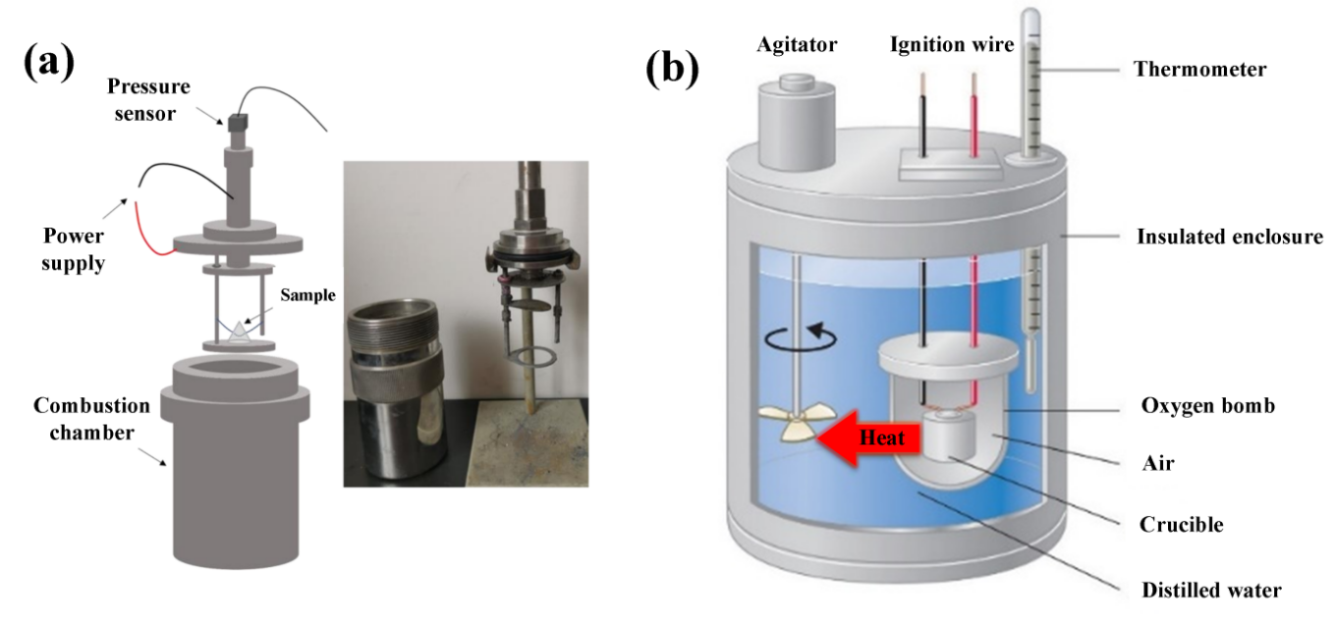
Fig. S1 | a Schematic diagram and physical diagram of the constant volume combustion chamber. b Schematic diagram of oxygen bomb calorimeter.

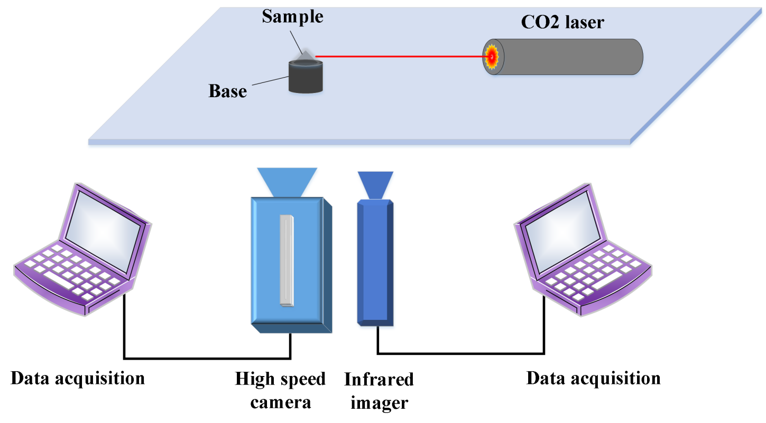
Fig. S2 | Schematic diagram of laser ignition test experimental device.

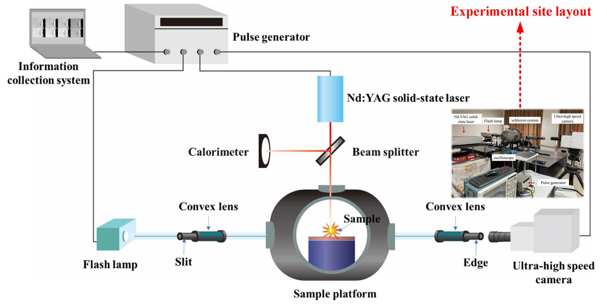
Fig. S3 | Schematic diagram of self-built micro-explosion laser schlieren test system.

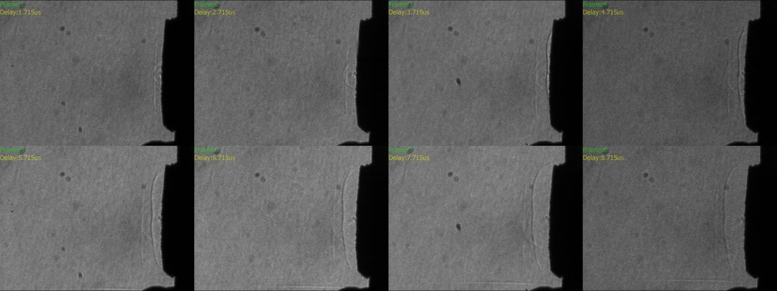
Fig. S4 | Ultrahigh-speed schlieren images showing plasma and shock wave evolution during ultrafast reactions of HMX.
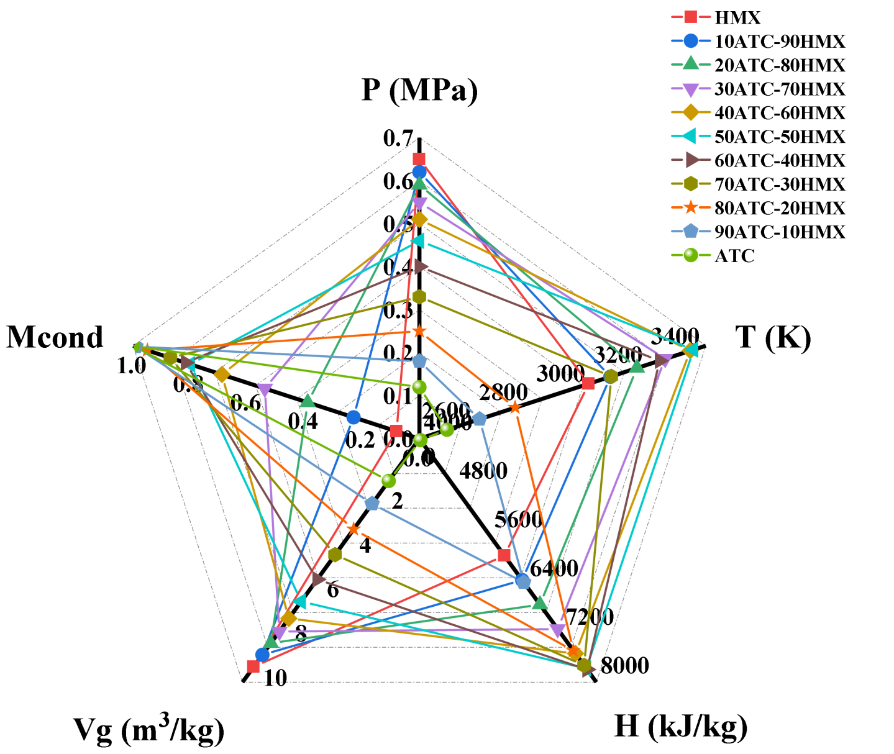
Fig. S5 | Thermodynamic parameters of the ATC-HMX composite system calculated by the REAL program.

