Supplementary Information

Leveraging earth observation data to monitor boat-based recreational fishing
Javier Menéndez-Blázquez *, Mara Segovia, David March

*Corresponding author: Javier Menéndez-Blázquez. Email: javier.menendez@uv.es. Present address: Cavanilles Institute of Biodiversity and Evolutionary Biology, University of Valencia, 46980, Paterna (Valencia, Spain).

Contents

Supplementary Methods
Supplementary Figures (Supplementary Figures 1-5)

Supplementary Methods

Digitalization validates
The digitalization process was carried out by two different digitizers. To validate the reliability of the results obtained from the processed satellite imagery, we explored the differences between them. Five PlanetScope scenes were processed by both digitizers, and the differences in the digitalization process were analyzed in terms of: (i) the total number of ships per scene. Additionally, for each scene, the nearest pair of digitizer measurements was identified, representing the minimum distance between the centroid of the first digitizer's polygon and the second digitizer's interpolated position. These digitizer pairs, assumed to represent the same vessel, allowed for a comparison of the size measurements obtained from both digitizers in terms of (ii) boat length (the long side of the polygon). Furthermore, we examined (iii) the percentage of digitized ship matches (the number of ships intersected between the two digitizers per scene) and (iv) the distance between the centroids of the nearest digitized polygons, which serves as a measure of potential spatial discrepancies between the same vessel.

Supplementary Figures
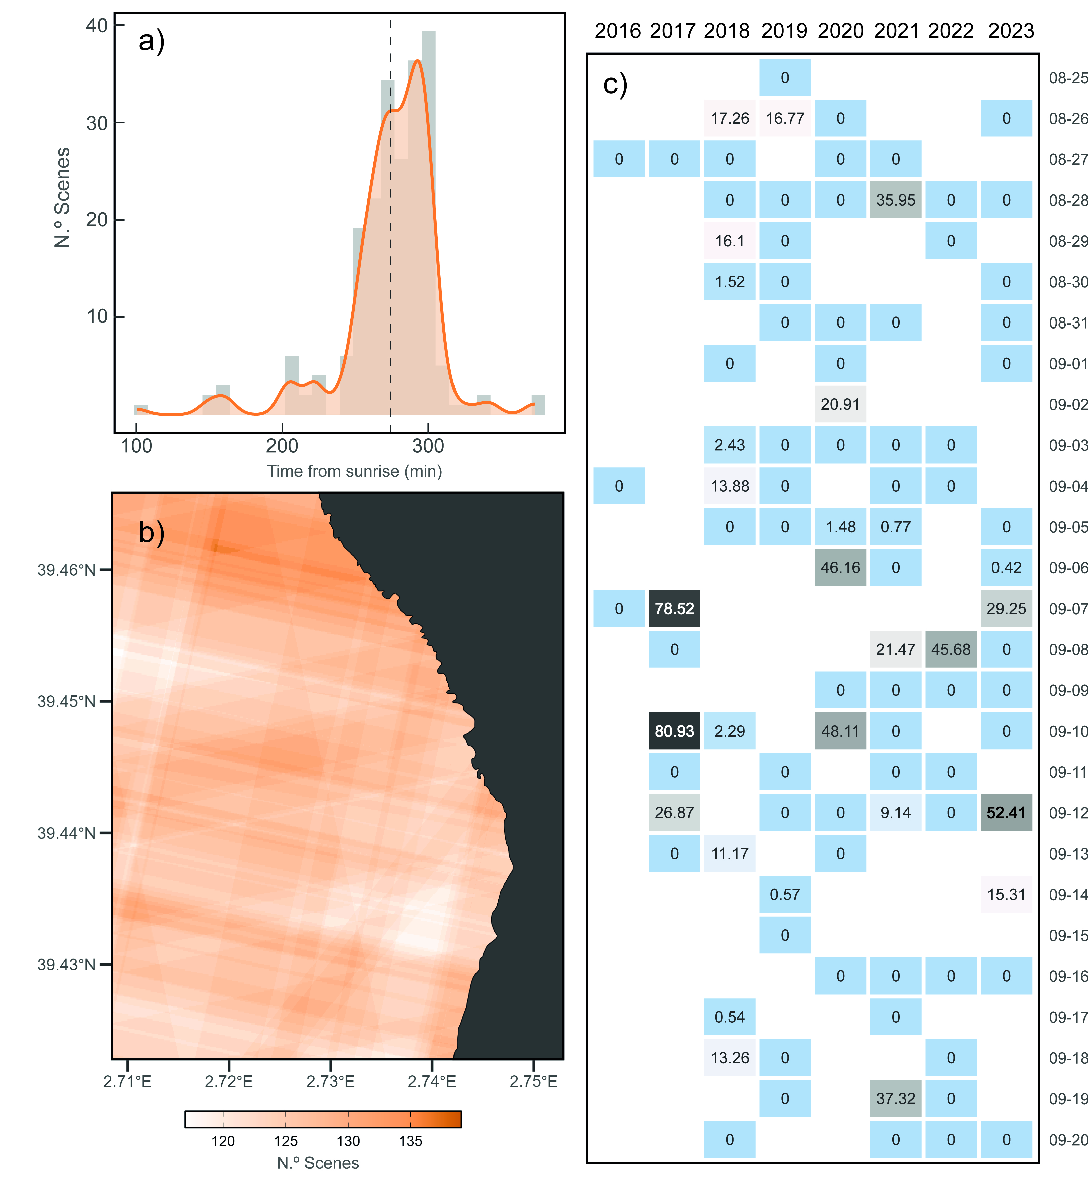
Supplementary Figure 1. a) Distribution of the acquired time (minutes from sunrise) of the different PlanetScope scenes processed. Mean minutes value area represented by the dashed black line. b) Satellite scenes coverage over the study area, darker areas represent higher number of scenes overlapping. c) Heatmap of percentage of cloud coverage digitalized over the total scene extension processed per unique day analyzed (n = 96).

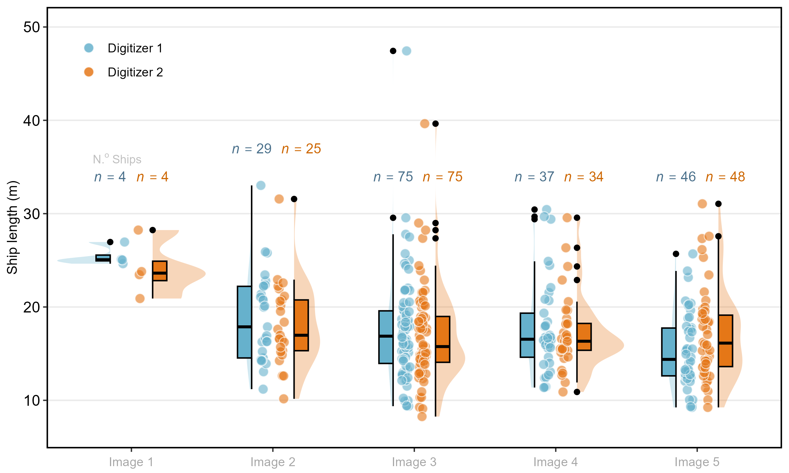
Supplementary Figure 2: Comparison of ship lengths and boat detections by two observers across five PlanetScope images. The annotations (n) indicate the number of ships digitized in each scene, with varying counts across the five scenes, highlighting similarities in the results from the two digitizers.

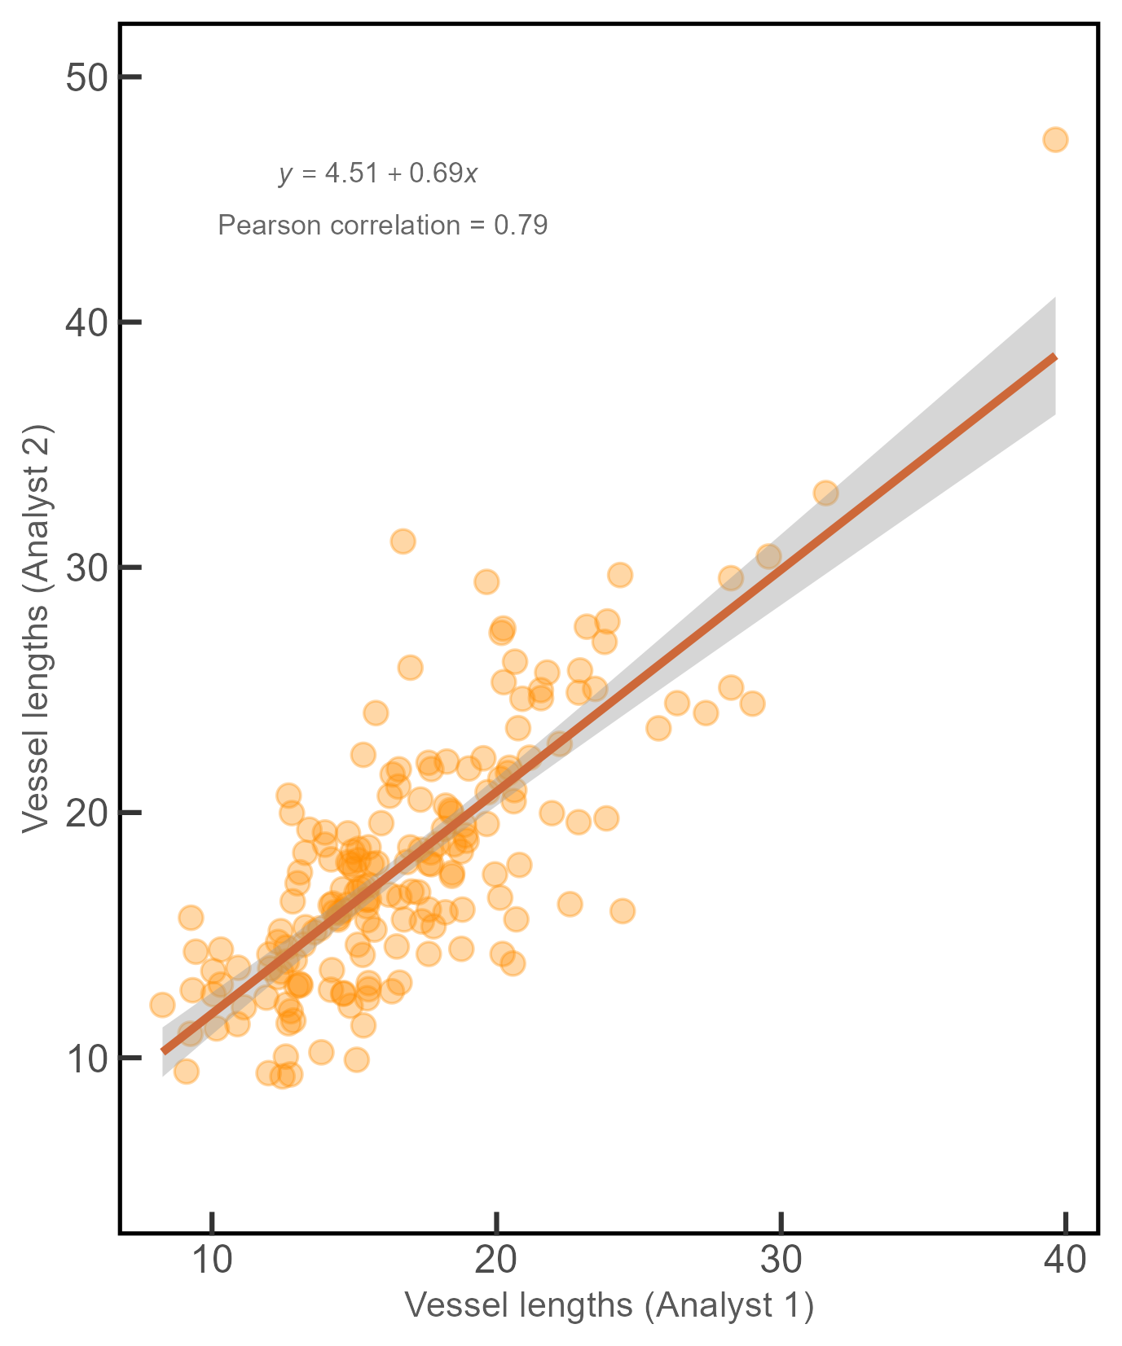

Supplementary Figure 3: Linear regression between lengths measurements for paired vessels digitized by the two different analyst. Dark orange line represents the best-fit regression, with the shaded area indicating the confidence interval.

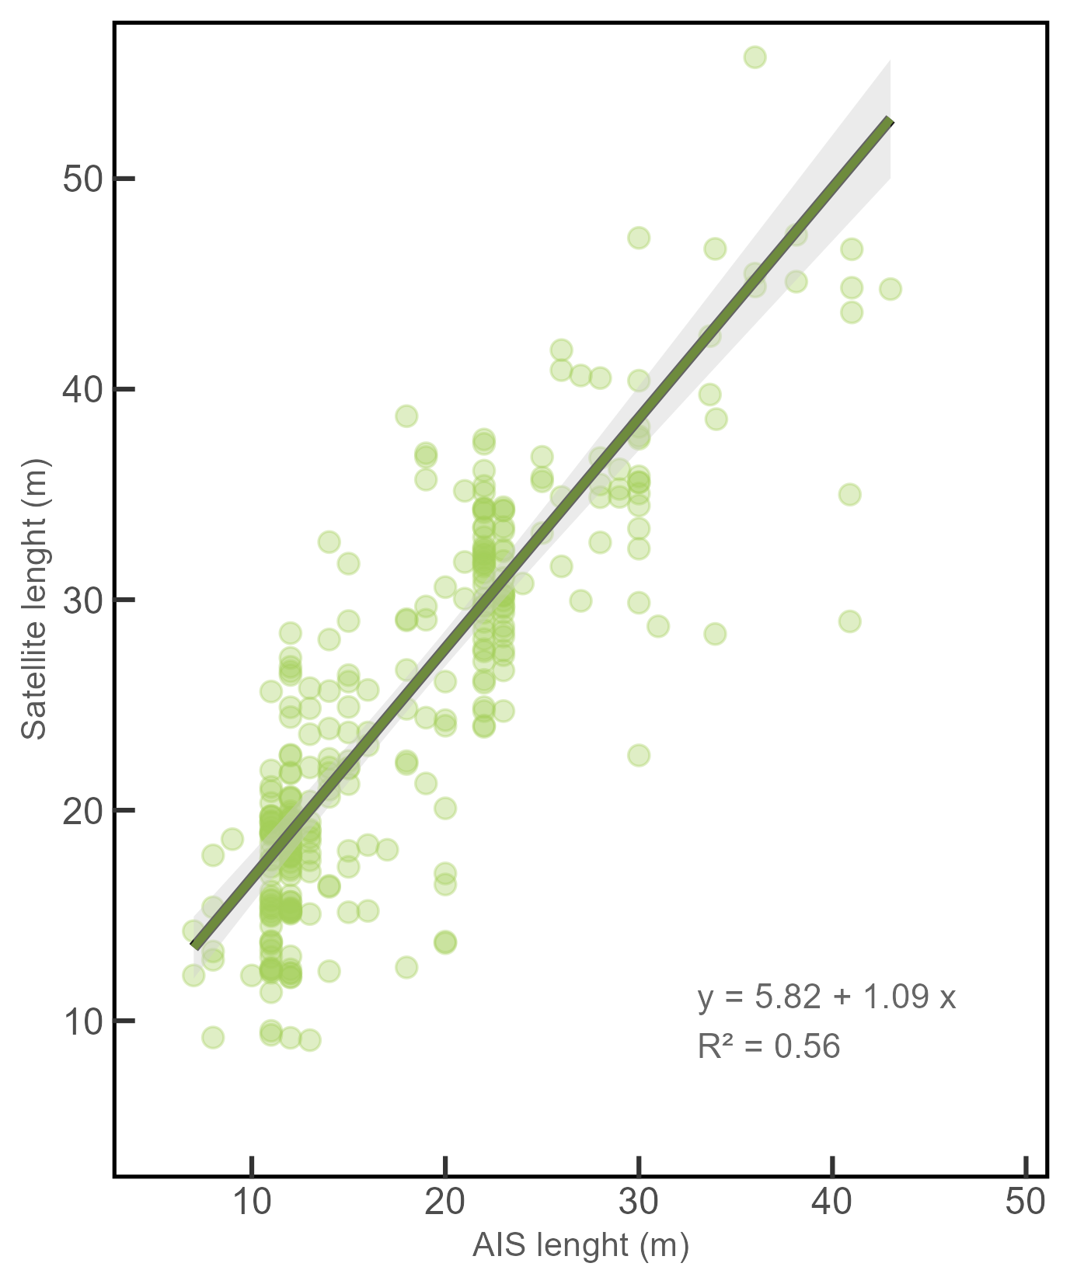
Supplementary Figure 4: Linear regression between satellite and AIS length measurements for paired vessels. The dark green line represents the best-fit regression, with the shaded area indicating the 95% confidence interval (y-axis limited to 50).

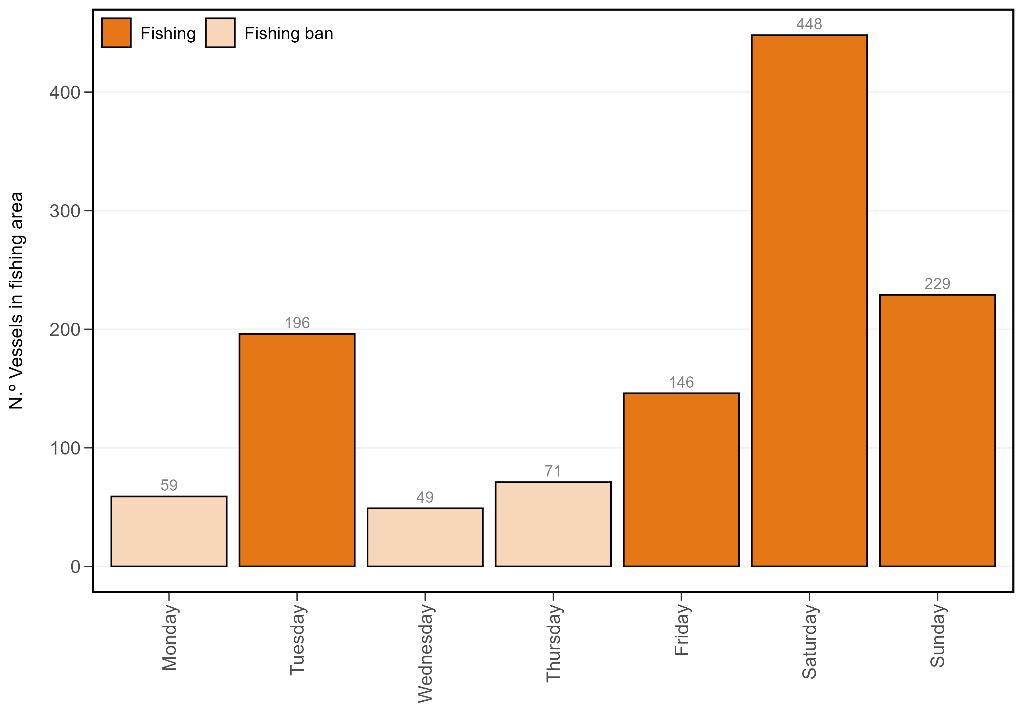

Supplementary Figure 5: Daily number of total vessel detected in the potential fishing area across the different years of the study (2016-2023) for PlanetScope scenes. Weekdays without fishing restrictions (Tuesday, Friday, Saturday, and Sunday) are highlighted in dark orange, while pale orange represent days with fishing limitations after the general fishing ban lifting September 1st.

