Supplementary Tables and Figures
Station | 51 | 130
Sampling time span | 18/04/2023 11:00 - 19/04/2023 07:00 | 20/04/2023 08:00 - 21/04/2023 08:00
Station coordinates | N 51.5317° E 3.1828° | N 51.2164° E 2.8513°
High tide | 11:52 18/04/2023, 00:06 19/04/2023 | 06:33 20/04/2023, 18:50 20/04/2023, 07:14 21/04/2023
Low tide | 18:12 18/04/2023, 06:40 19/04/2023 | 12:12 20/04/2023, 00:26 21/04/2023
Temperature (°C) | 9.9 ± 0.50 | 10.47 ± 0.10
Salinity (PSU) | 32.48 ± 0.21 | 31.36 ± 0.63
Turbidity (NTU) | 5.69 ± 2.22 | 17.51 ± 11.07
Nitrite/Nitrate  (µmol/L) | 7.49 ± 1.49  max. 11.58 (19:11)  min. 5.60 (00:07) | 14.74 ± 7.97  max. 32.71 (22:58)  min. 1.78 (15:58)
Phosphate  (µmol/L) | 0.14 ± 0.03  max. 0.20 (19:11)  min. 0.07 (00:07) | 0.07 ± 0.04  max. 0.19 (22:58)  min. 0.03 (13:58)
Silicate  (µmol/L) | 7.11 ± 0.34  max. 7.61 (16:00)  min. 6.23 (01:59) | 13.06 ± 1.80  max. 14.59 (22:58)  min. 8.76 (04:00)

Table S1. Summary of environmental conditions at the Stations 51 (post-bloom) and Station 130 (colonial P. globosa bloom) during the sampling campaign in April 2023. The table provides the sampling dates and coordinates, tidal cycles, and measured environmental parameters, including temperature (°C), salinity (PSU), turbidity (NTU), and nutrient concentrations (nitrite + nitrate, phosphate, and silicate in µmol/L). Values represent mean ± standard deviation (SD) over the sampling period. Times are in UTC.
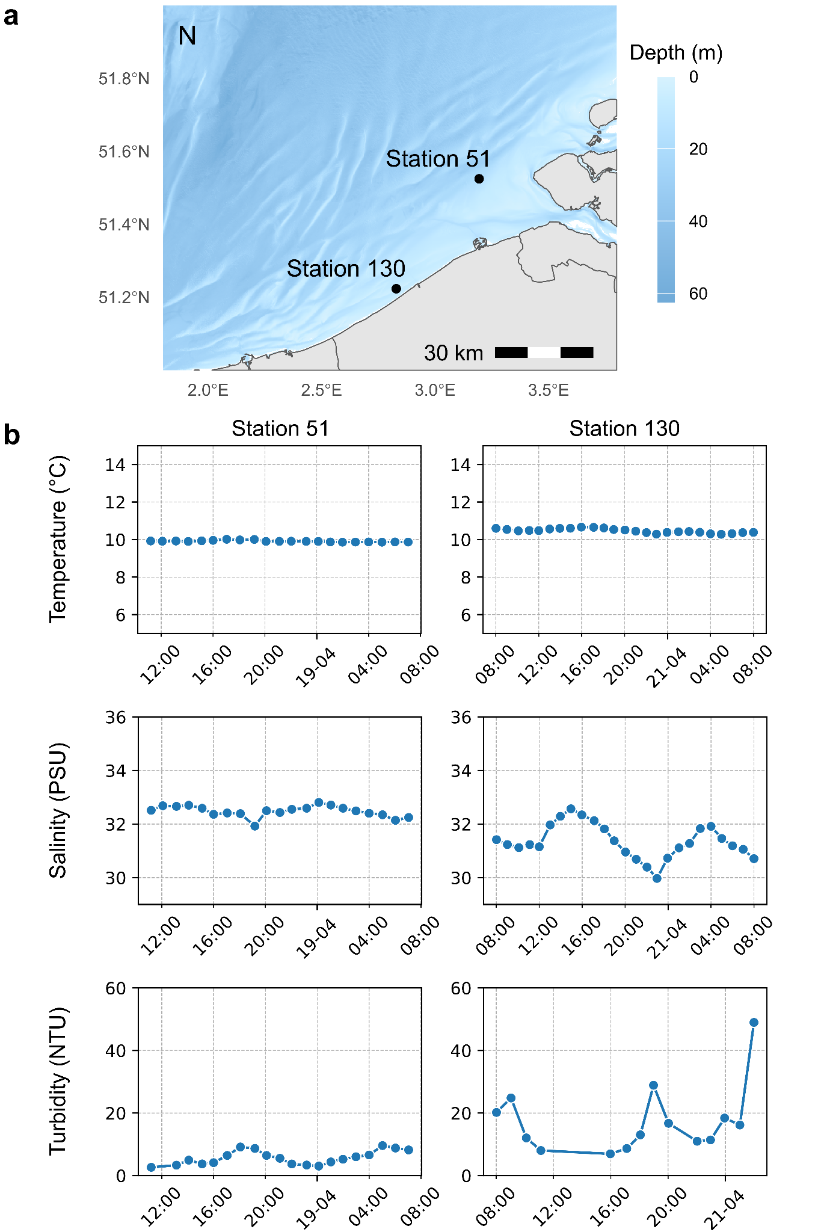
Figure S1. Oceanographic context of Station 130 and 51. (a) Location of the diel sampling sites, labelled Station 52 and Station 130, in the Southern Bight of the North Sea. (b) Temperature (°C), salinity (Practical Salinity Units, PSU), and turbidity (nephelometric turbidity units, NTU) levels for Station 51 and Station 130.
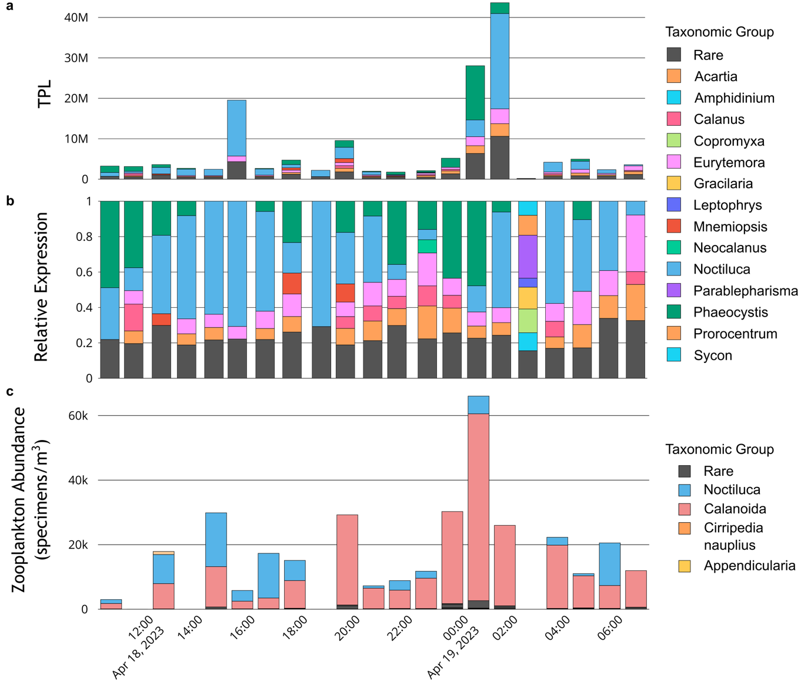
Figure S2. Taxonomic identity of metabolically active microeukaryotic and zooplankton community at Station 51. (a) Estimates for the number of transcripts per L (TPL) per sample. TPL are calculated by relating transcript per million (TPM) values to ERCC92 spike-in recovery values and accounting for the volumes processed. Transcripts were annotated to the genus level using EukProt (>95% sequence identity with reference). If the relative abundance fraction of a group in a sample was <2%, it was labeled as ‘rare’. (b) Relative transcript abundance (TPM) of genus-level annotations, annotated using EukProt as a reference and retaining transcripts >= 95% of sequence identity with reference. If the relative abundance fraction of a group in a sample was <2%, it was labeled as ‘rare’. (c ) Zooplankton abundances estimated by ZooScan analysis. If a classified group had a relative abundance <5%, it was labeled as ‘rare’.
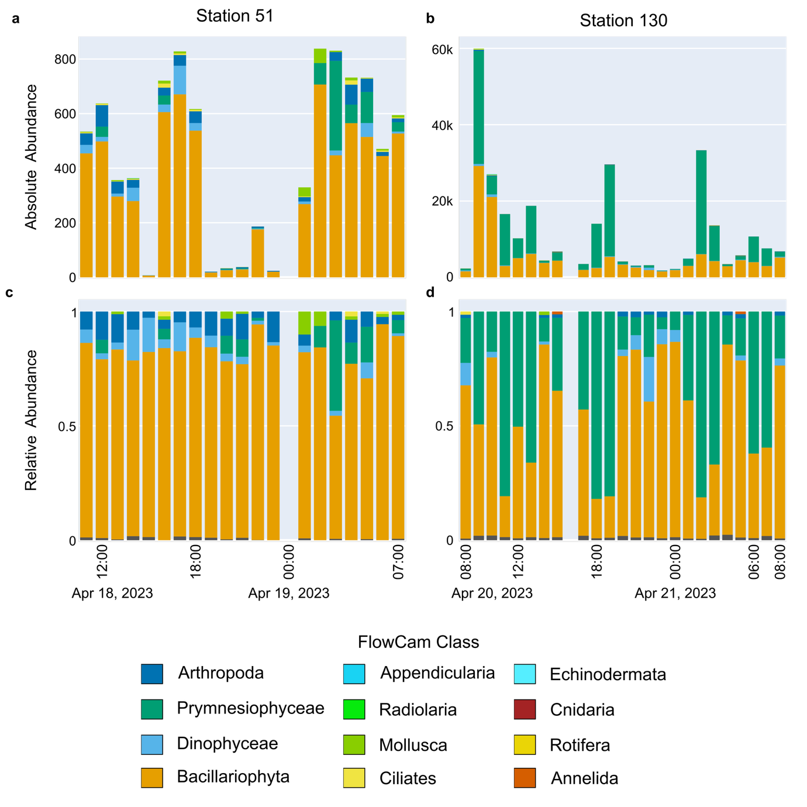
Figure S3. FlowCam counts for surface plankton (>50µm) at Stations 51 and 130. Number of annotated particles per L of seawater, calculated using FLowCam automated imaging analysis (excluding unannotated particles) for Station 51 (a) and 130 (b). Relative particle densities of taxonomic groups per sample for Station 51 (c) and 130 (d), as observed through FlowCam automated image classification. When the relative density of a group was <2%, it was labeled as ‘rare’ and marked in dark grey.
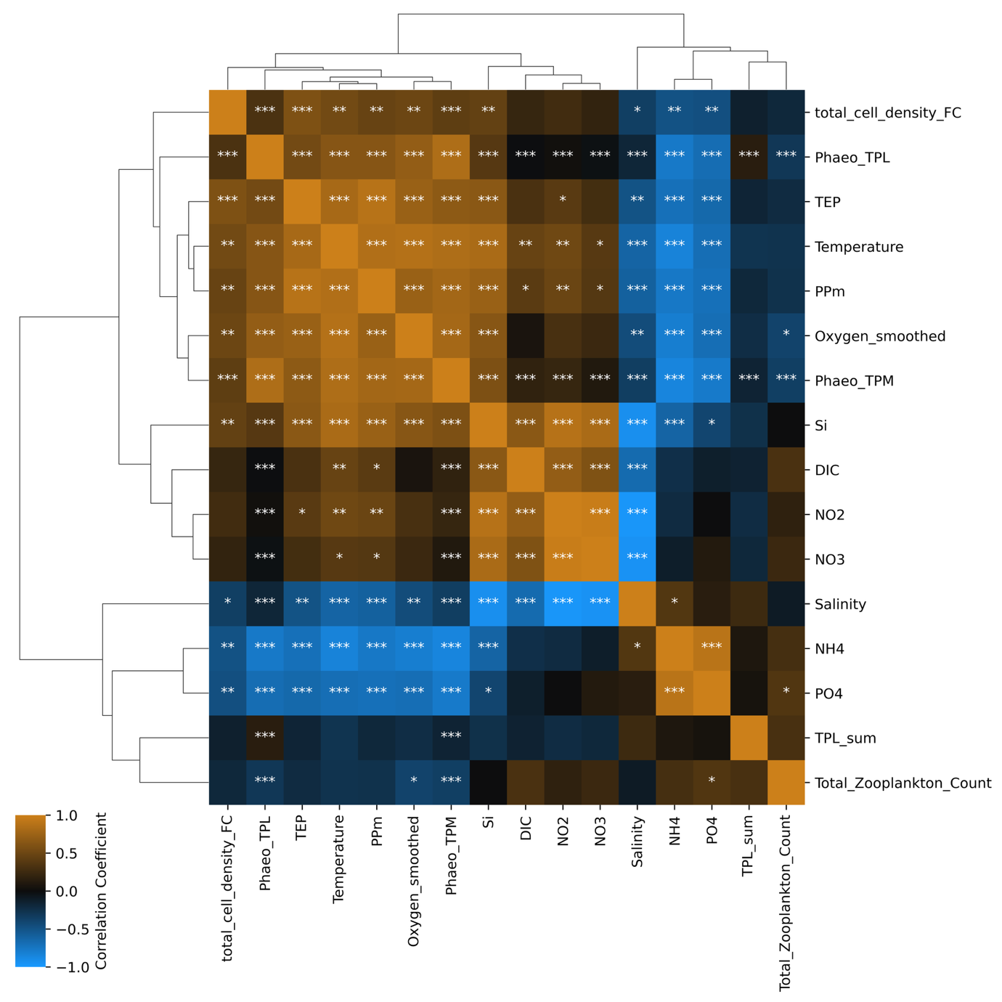
Figure S4. Pearson correlation heatmap of environmental parameters, primary production, cell density, and Phaeocystis expression metrics across Stations 130 and 51. The heatmap displays pairwise correlation coefficients for selected parameters, including temperature, salinity, fluorescence, nutrient concentrations (NH₄, NO₂⁻, NO₃⁻, PO₄³⁻, SiO₄⁴⁻), TEP (transparent exopolymer particles), dissolved inorganic carbon (DIC), oxygen (Oxygen_smoothed), total cell density (FlowCam), maximum primary production estimated from STAF (PPm), relative (Phaeo_TPM) and total Phaeocystis transcript estimates (Phaeo_TPL), overall transcriptional activity and abundance (TPL_sum) and zooplankton abundance (Total_Zooplankton_Count). Each cell is annotated with the correlation significance level (Benjamini-Hochberg corrected): *** (p < 0.001), ** (p < 0.01), * (p < 0.05).

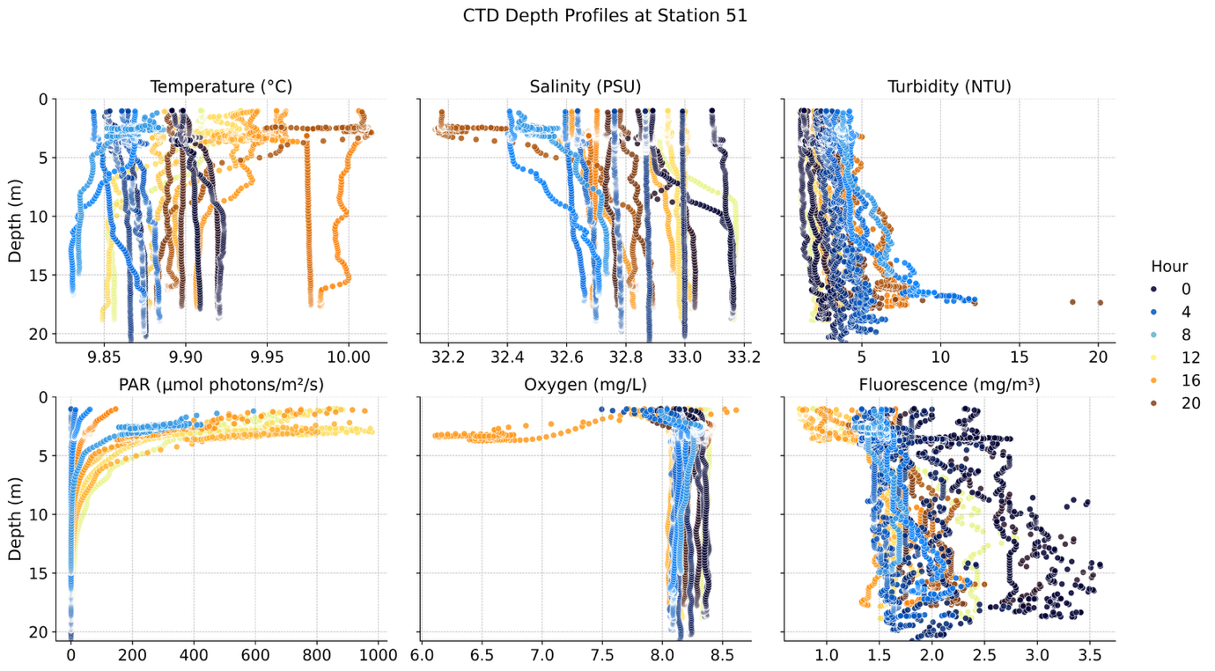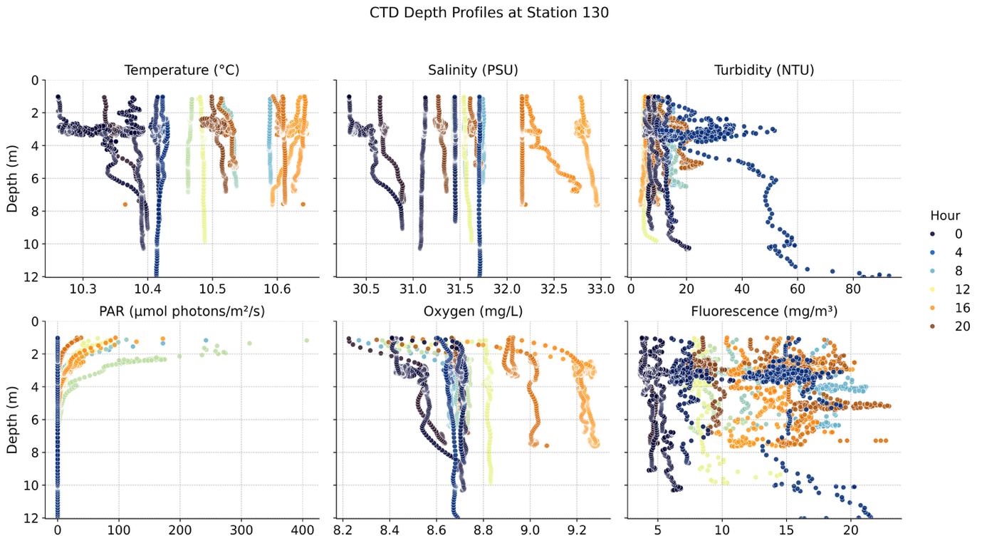
Figure S5. CTD vertical profiles for a selection of environmental parameters for Station 51 and 130. Selected environmental parameters are shown, with hourly vertical CTD profiles coloured according to time of sampling.

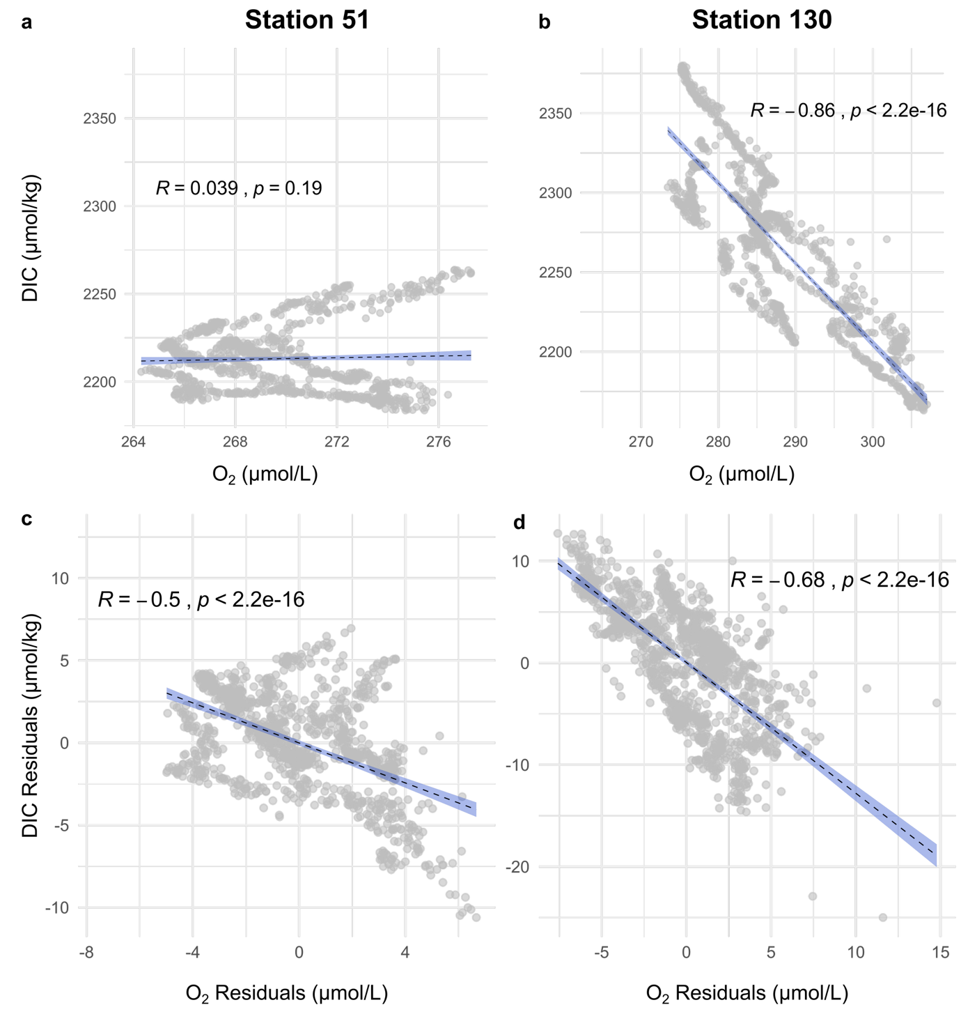

Figure S6. Relationship between dissolved inorganic carbon (DIC) and oxygen (O₂) and their GAMM residuals in the surface waters of Stations 51 and 130. (a–b) Relationship between DIC and O₂ at each station, with fitted regression lines showing the linear relationships. At Station 51, the linear relationship was not significant (r = 0.039, p = 0.19), while at Station 130, we found the linear relationship DIC = -5.049 × O₂ + 3719.694 (r = -0.86, p < 2.2 * 10⁻¹⁶). (c-d) Relationship between DIC and O₂ residuals after accounting for salinity, temperature, and wind speed variations using GAMMs (see Methods) at each station, with fitted regression lines showing the linear relationships.
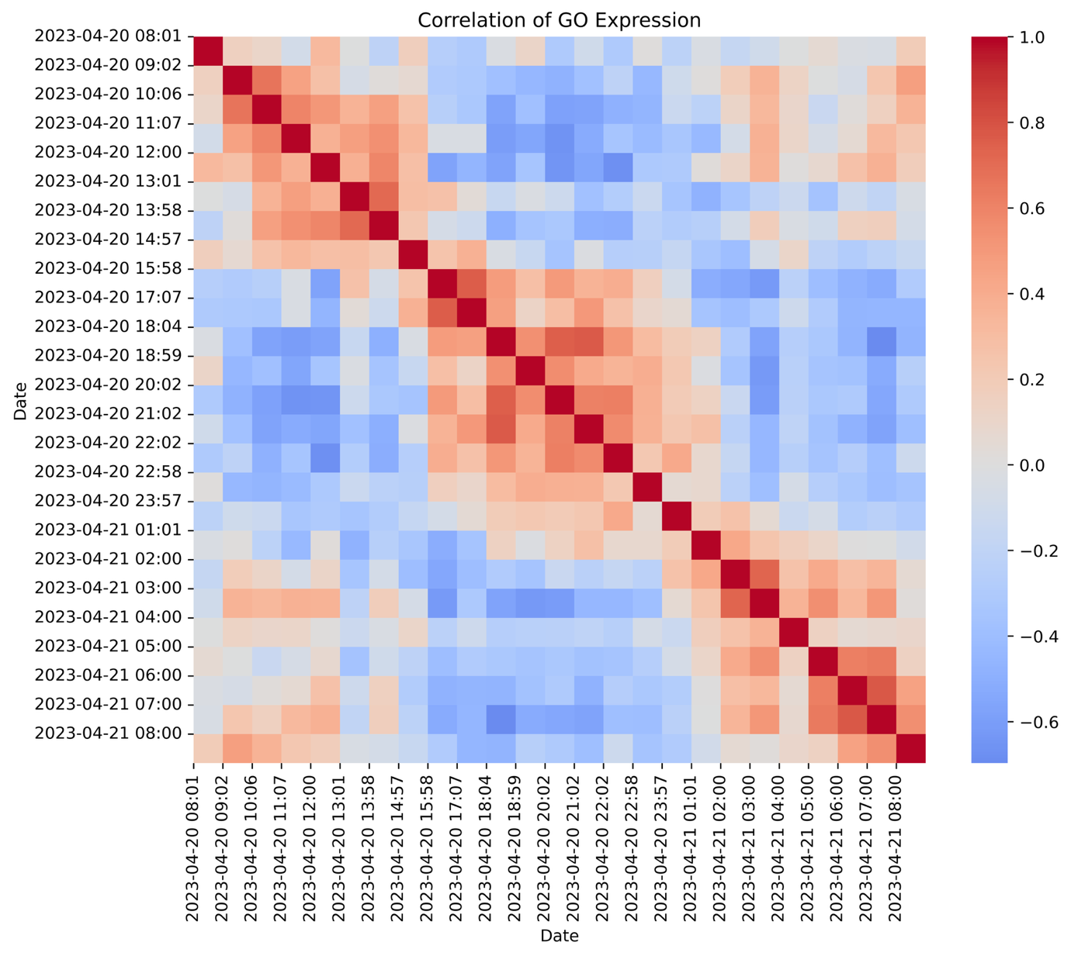
Figure S7. Heatmap showing the correlation of GO slim category expression across metatranscriptomic samples at Station 130 for P. globosa. Each cell represents the Pearson correlation coefficient between samples’ TPL expression profiles, with transcript TPL values summed per GO slim category from a curated list of 120 GO Slim categories of interest, z-scored across sampling dates and times.

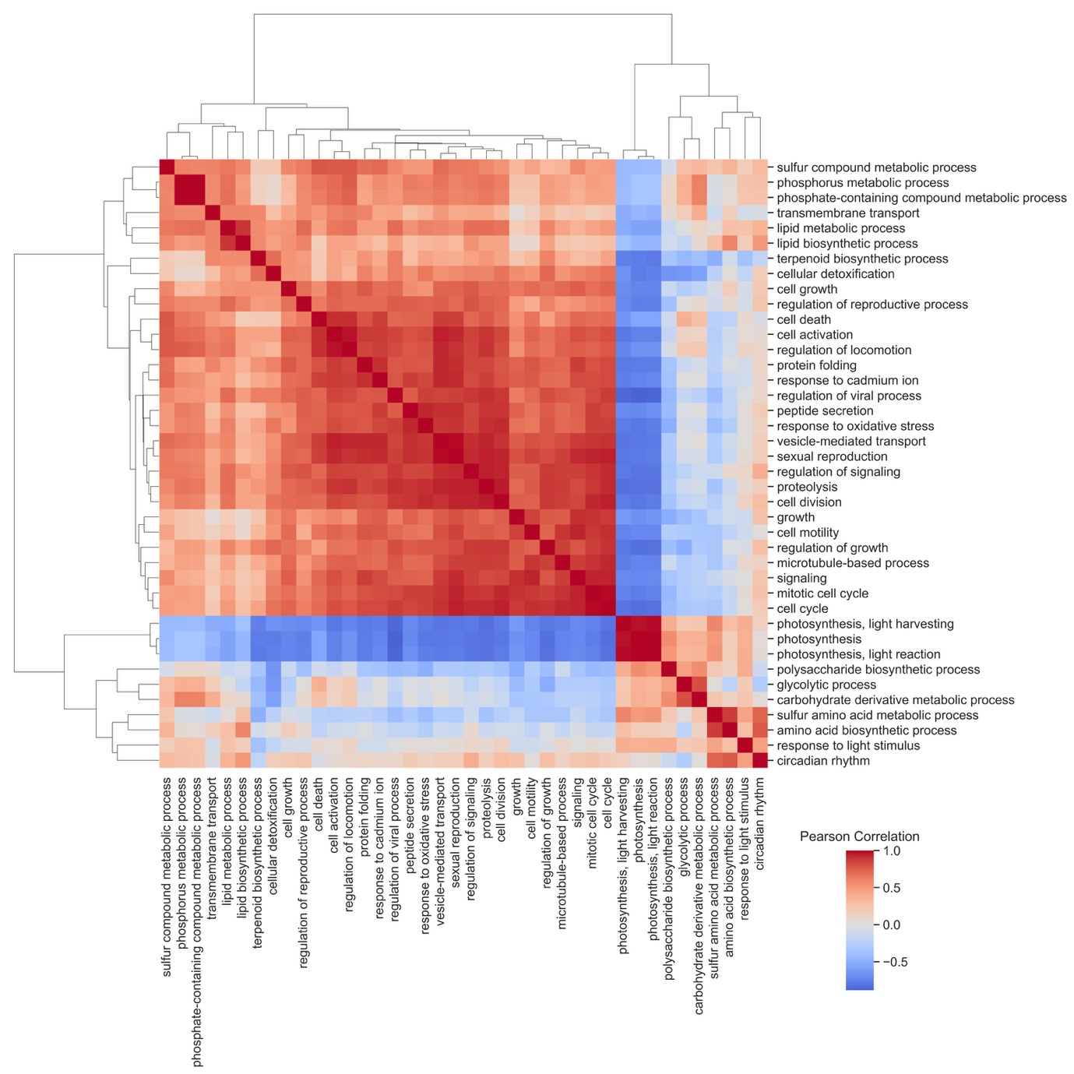
Figure S8. Clustermap of GO slim category expression at Station 130 by P. globosa. Rows and columns represent GO slim categories, clustered by similarity in z-scored TPL expression profiles across sampling events. The color bar indicates Pearson correlation coefficients, with warm colors representing positive correlations and cool colors indicating negative correlations. Only the 40 most variable GO Slim categories from a curated list of 120 terms of interest are displayed to ensure the readability of the plot.
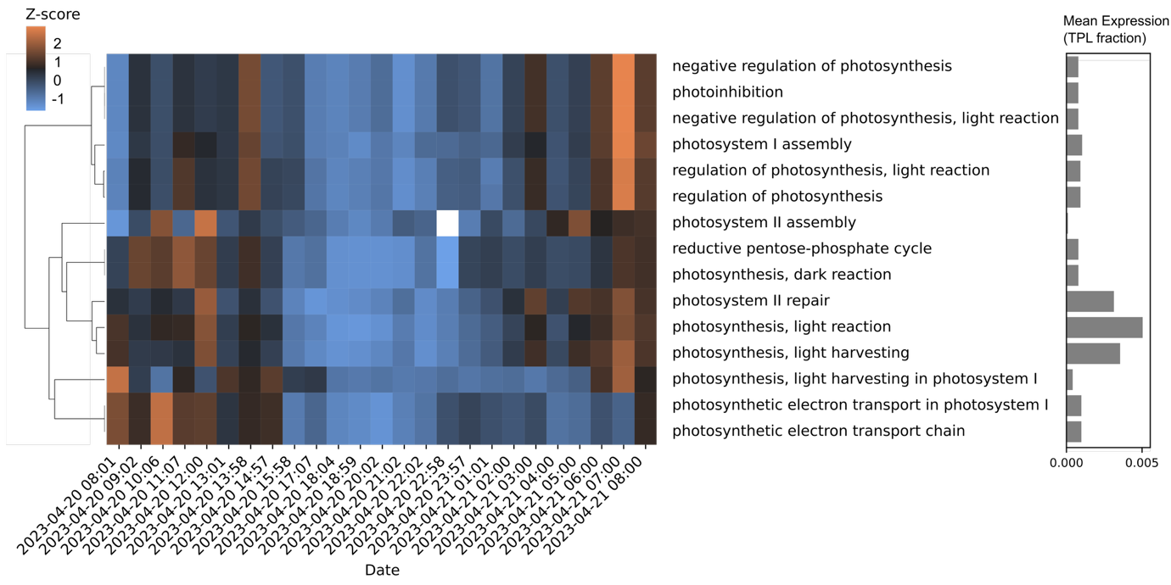
Figure S9. Clustered heatmap of z-scored expression data at Station 130 for Gene Ontology (GO) terms related to photosynthesis, with mean expression overview. The heatmap displays the z-scored TPL expression profiles of the GO terms from a curated list of terms related to photosynthesis. Only GO terms with an average expression > 0.1 % of the Phaeocystis globosa transcriptome across samples were retained. Heatmap rows, representing individual GO terms, were grouped using hierarchical clustering (Ward's method), as shown by the dendrogram on the left. Columns represent sampling points. Color intensity indicates relative expression levels (Z-scores calculated across samples), with orange representing higher relative expression and blue representing lower relative expression. GO term labels are shown to the right of the heatmap, while the bar plot adjacent to the labels shows the mean expression for each included GO term across all samples, calculated by averaging the normalized transcripts per liter (TPL) sums per GO term across timepoints. The TPL sum for a given GO term at a given time point is normalized against the total TPL attributed to Phaeocystis globosa at that time point.
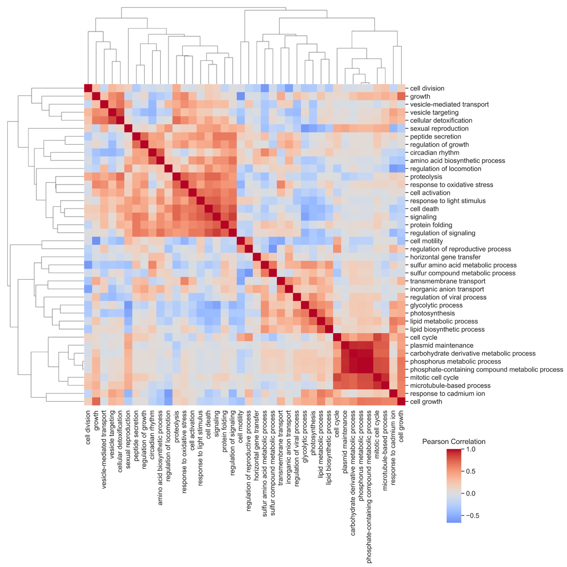
Figure S10. Clustermap of GO slim category expression at Station 51 by P. globosa. Rows and columns represent GO slim categories, clustered by similarity in z-scored TPL expression profiles across sampling events. The color bar indicates Pearson correlation coefficients, with warm colors representing positive correlations and cool colors indicating negative correlations. Only the 40 most variable GO Slim categories from a curated list of 120 terms of interest are displayed to ensure the readability of the plot.
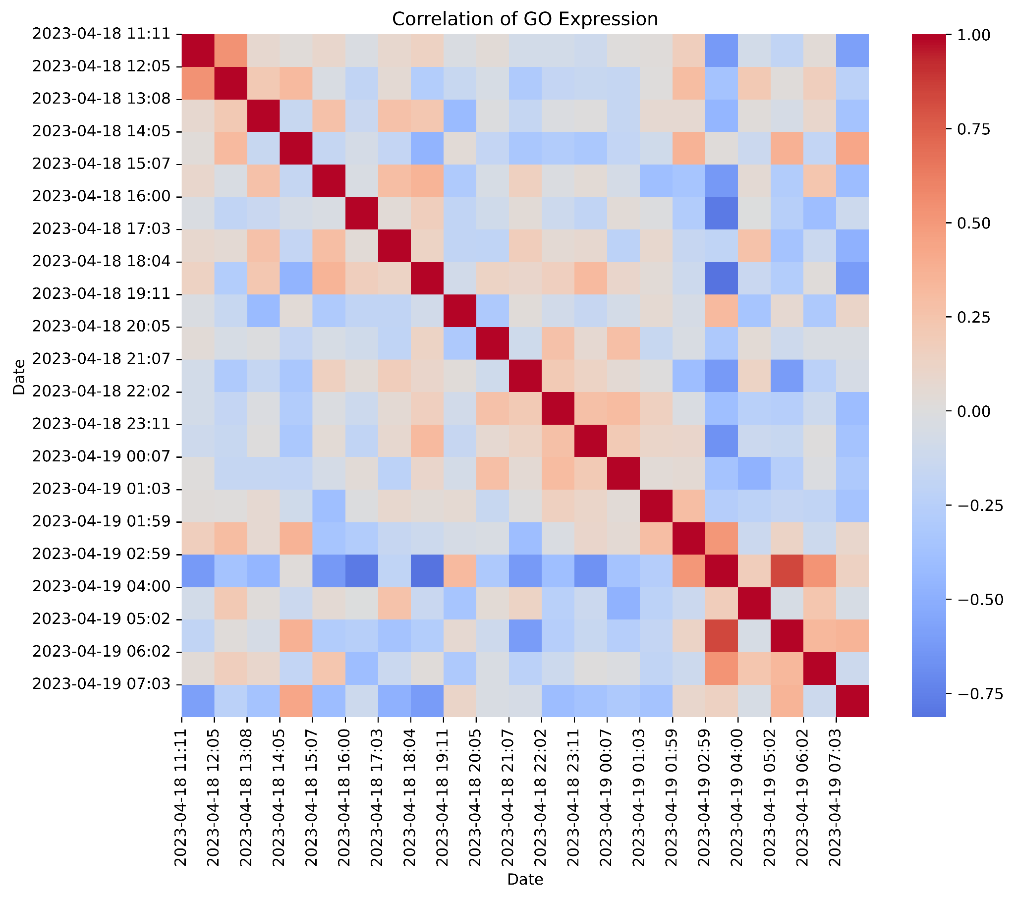
Figure S11. Heatmap showing the correlation of GO slim category expression across metatranscriptomic samples at Station 51 for P. globosa. Each cell represents the Pearson correlation coefficient between samples’ TPL expression profiles, with transcript TPL values summed per GO slim category from a curated list of 120 GO Slim categories of interest, z-scored across sampling dates and times.

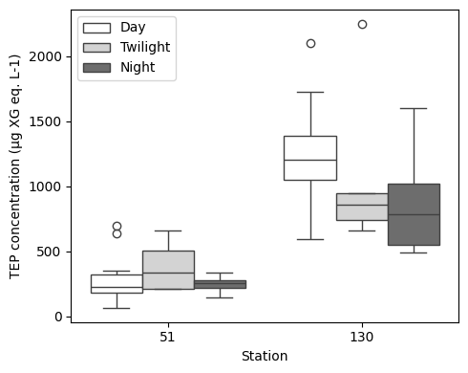
Figure S12. Boxplot summarizing concentrations of Transparent Exopolymer Particles (TEP) in µg Xanthan Gum equivalents per L during day, twilight, and nighttime. Boxes encompass the interquartile range, with the central line showing the median. Whiskers extend to the furthest data points within 1.5 times the interquartile range below the first or above the third quartile.

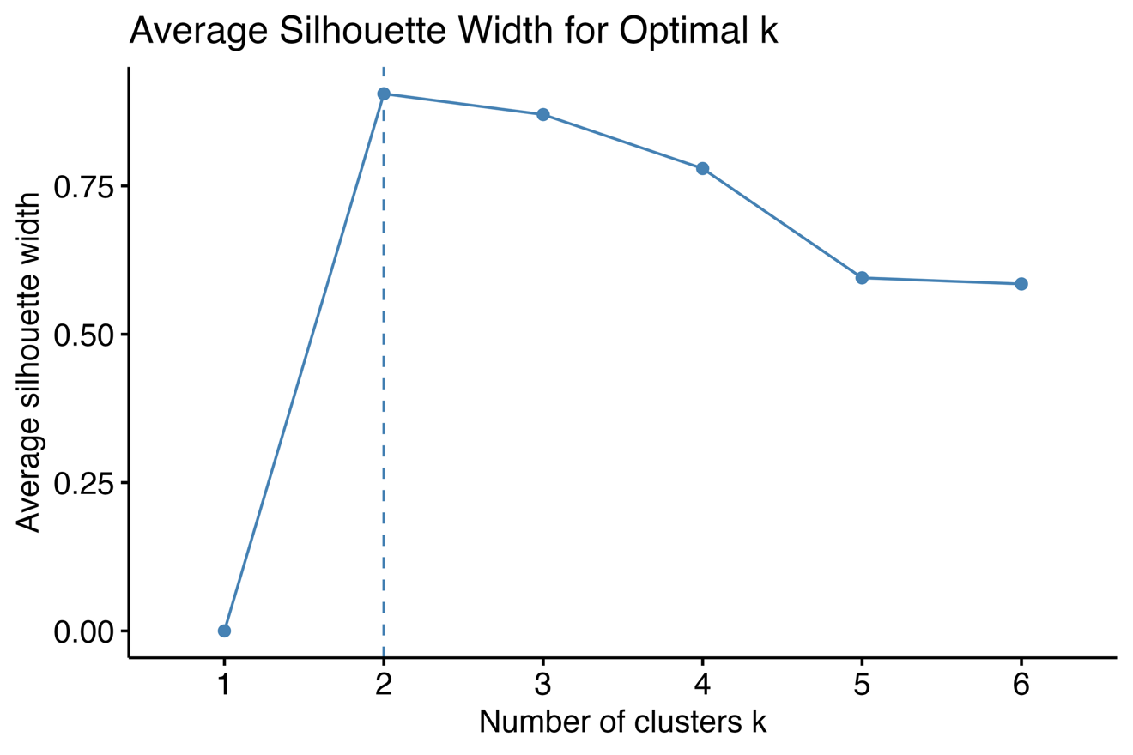
Figure S13. Silhouette analysis for determining the optimal number of clusters in the Phaeocystis globosa transcript expression dataset at Station 130. Average silhouette width is shown for k = 2 to 6, based on k-means clustering of the 5,000 most variable transcripts standardized by total Phaeocystis expression per sample (TPL). The silhouette width quantifies how well each transcript fits within its assigned cluster compared to other clusters, with higher values indicating better-defined clusters. A maximum silhouette width was observed at k = 2, supporting the choice of k = 2 clusters for MBCluster.Seq.

