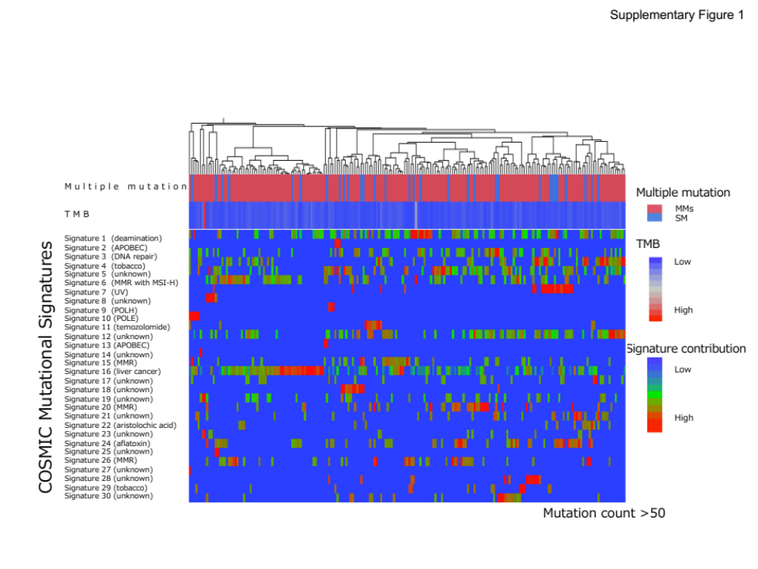
Supplementary Fig. 1 Mutation signature in the sample with multiple mutations. Multiple mutation, tumor mutation burden (TMB) and signature contributions are shown in the top, middle and bottom panels, respectively. Each row represents a sample. Signatures in a sample with mutation count of >50 are shown. Proposed etiologies described in COSMIC are shown in parentheses. Signatures with no information regarding etiology are labeled as unknown

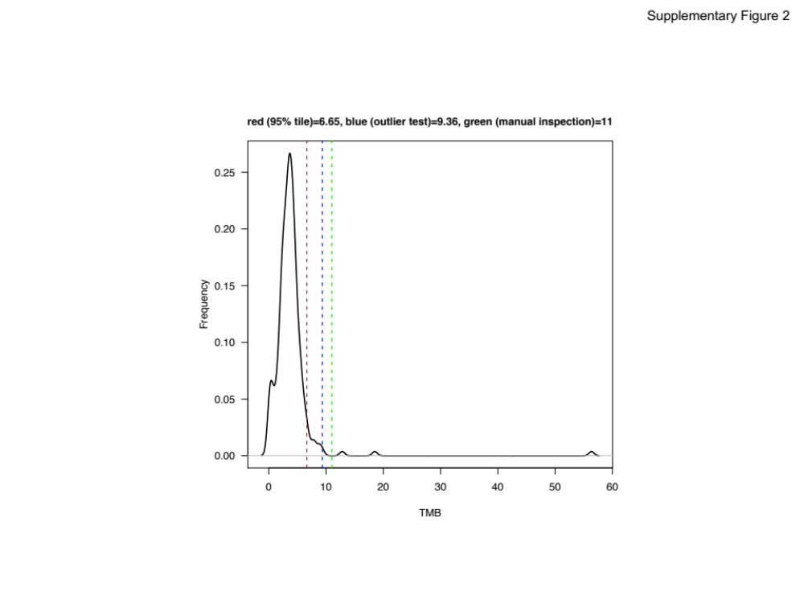
Supplementary Fig. 2 The distribution of TMB in HCCs.
The cutoff value was set to 6.65 as 95% tile.

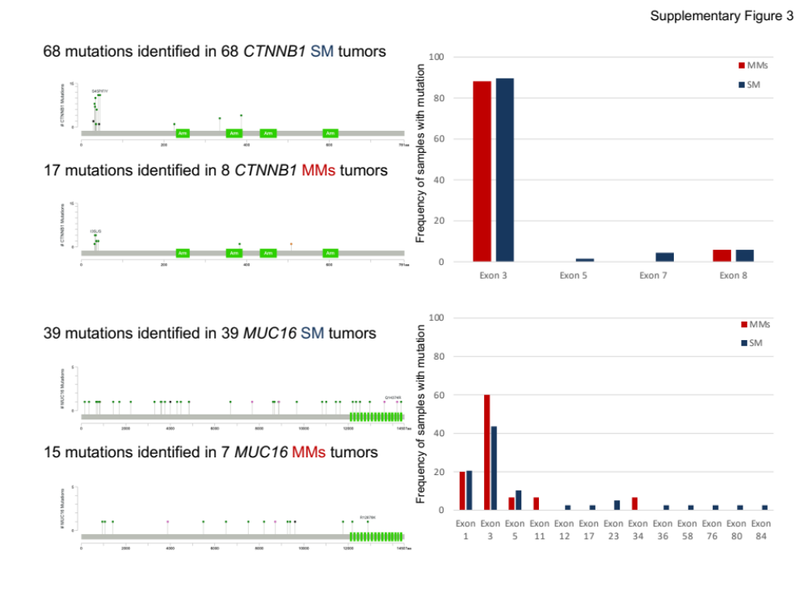
Supplementary Fig. 3 The mutational mapping of MMs in CTNNB1 and MUC16.
In CTNNB1, most mutations were located in major hotspots of exon 3. No significant difference of the frequency was observed between CTNNB1 SM tumors and CTNNB1 MMs tumors. In MUC16, mutations frequently located at exon 3 and there was no significant difference in the frequency between MUC16 SM and MUC16 MMs tumors.
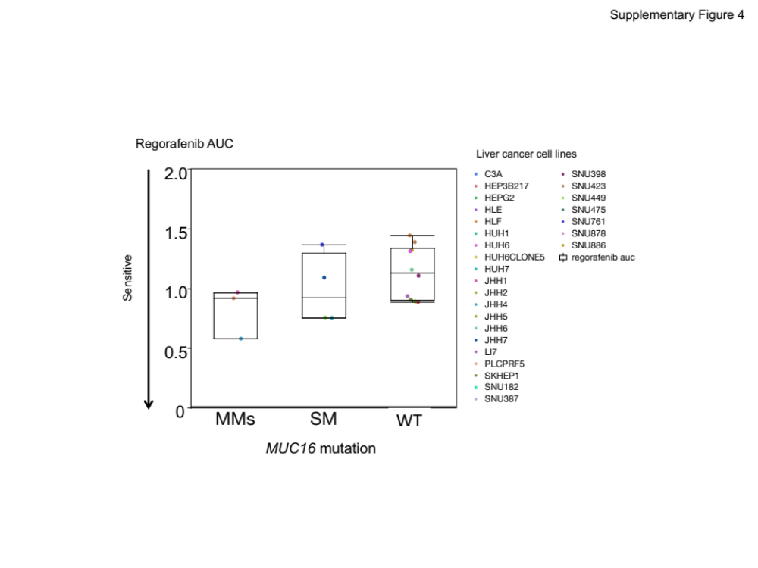
Supplementary Fig. 4 Drug sensitivity screens in Cancer Cell Line Encyclopedia
To assess the impact of MMs on phenotypes in cancer cell lines, an analysis of drug sensitivity screens in Cancer Cell Line Encyclopedia (CCLE) cell lines ¹⁰ was performed. Box plots show sensitivity to regorafenib for 27 CCLE liver cancer cell lines, according to mutational status. Cells harboring MUC16 MMs exhibited higher sensitivity to regorafenib than those with no or single MUC16 mutations, pointing to the potential value of MMs as a predictive marker for targeted therapies.

