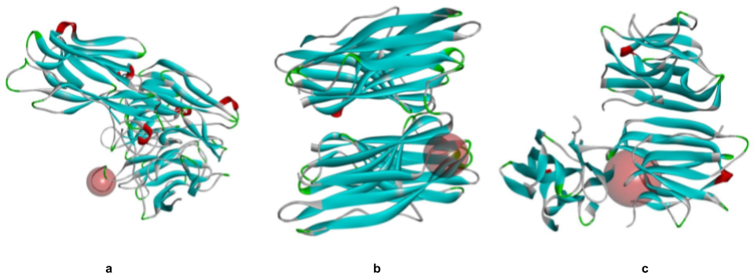
Online Resource 1 Active site of the receptors depicted as red spheres: (a) Bap1, (b) RbmA, (c) RbmC

Online Resource 2 Docking scores of the ligands with the receptors
LIGANDS | COMPOUND CID | BINDING AFFINITY (kcal/mol)
LIGANDS | COMPOUND CID | Bap1 | RbmA | RbmC
Resveratrol (control) | 445154 | -7.1 | -7.6 | -7.4
1-Caffeoylquinic acid | 10155076 | -7.1 | -8.1 | -8.3
4-O-Caffeoylquinic acid | 9798666 | -6.9 | -8.0 | -8.5
1,3-Di-O-caffeoylquinic acid | 6474640 | -6.6 | -9.3 | -9.1
3,4-Di-O-caffeoylquinic acid | 5281780 | -7.9 | -9.8 | -10.4
3,5-Di-O-caffeoylquinic acid | 6474310 | -7.2 | -9.1 | -9.0
4,5-Di-O-caffeoylquinic acid | 6474309 | -7.8 | -9.8 | -10.4
3,5,6,4'-Tetrahydroxy-7-methoxyflavone | 14258996 | -7.5 | -8.5 | -8.1
3-O-caffeoyl-gamma-quinide | 102210472 | -7.6 | -8.4 | -8.2
5,7-Dihydroxychromone | 5281343 | -5.5 | -6.0 | -6.4
Apigenin | 5280443 | -7.6 | -8.3 | -8.2
Betulabuside A | 14484636 | -6.6 | -6.3 | -7.0
Caffeic acid | 689043 | -5.4 | -6.2 | -6.7
Chlorogenic acid | 1794427 | -7.0 | -8.5 | -8.8
Erigeroside | 162876 | -5.8 | -7.0 | -6.9
Erigeside A | 101666177 | -7.3 | -7.2 | -8.0
Erigeside B | 5318046 | -5.3 | -5.5 | -6.3
Erigeside C | 14132346 | -6.3 | -7.1 | -7.8
Eriodictyol | 440735 | -7.5 | -8.7 | -8.2
Scopoletin | 5280460 | -5.6 | -6.4 | -6.6
Isoscopoletin | 69894 | -5.7 | -6.3 | -7.1
Kaempferol-3-O-glucoside | 5282102 | -7.1 | -9.9 | -8.5
Kaempferol-3-O-rutinoside | 5318767 | -7.6 | -9.5 | -10.1
Luteolin | 5280445 | -7.5 | -8.6 | -8.6
Methyl caffeate | 689075 | -5.3 | -5.8 | -6.2
Naringenin | 932 | -7.6 | -8.4 | -8.0
Naringenin-7-O-glucuronide | 51136360 | -8.2 | -9.9 | -9.8
Pyromeconic acid | 68129 | -3.9 | -4.0 | -4.9
Quercetin-3-O-beta-D-glucoside | 25203368 | -7.5 | -9.8 | -9.0
Quercetin-3-O-glucuronide | 5274585 | -7.6 | -9.7 | -9.2
Scutellarin | 185617 | -8.1 | -9.8 | -9.9

Online Resource 3 Additional ADME properties of resveratrol and the selected ligands
PROPERTY | PARAMETERS | LIGANDS
PROPERTY | PARAMETERS | Resveratrol | Apigenin | Eriodictyol | Naringenin
Physicochemical | Formula | C₁₄H₁₂O₃ | C₁₅H₁₀O₅ | C₁₅H₁₂O₆ | C₁₅H₁₂O₅
Physicochemical | Molecular weight (g/mol) | 228.24 | 270.24 | 288.25 | 272.25
Physicochemical | Fraction Csp3 | 0.00 | 0.00 | 0.13 | 0.13
Physicochemical | Num. rotatable bonds | 2 | 1 | 1 | 1
Lipophilicity | XLOGP3 | 3.13 | 3.02 | 2.02 | 2.52
Pharmacokinetics | Log K_{p} (skin permeability; cm/s) | -5.47 | -5.80 | -6.62 | -6.17
Pharmacokinetics | CYP1A2 inhibitor | Yes | Yes | No | Yes
Pharmacokinetics | CYP2C19 inhibitor | Yes | Yes | No | No
Pharmacokinetics | CYP2C9 inhibitor | No | No | No | No
Pharmacokinetics | CYP2D6 inhibitor | No | No | No | No
Pharmacokinetics | CYP3A4 inhibitor | No | No | No | No
Druglikeness | Ghose | Yes | Yes | Yes | Yes
Druglikeness | Veber | Yes | Yes | Yes | Yes
Druglikeness | Egan | Yes | Yes | Yes | Yes
Druglikeness | Muegge | Yes | Yes | Yes | Yes
Medicinal Chemistry | PAINS | 0 | 0 | 1 | 0
Medicinal Chemistry | Brenk | 1 | 0 | 1 | 0
Medicinal Chemistry | Lead likeness | No | Yes | Yes | Yes
Medicinal Chemistry | Synthetic accessibility | 2.02 | 2.96 | 3.11 | 3.01

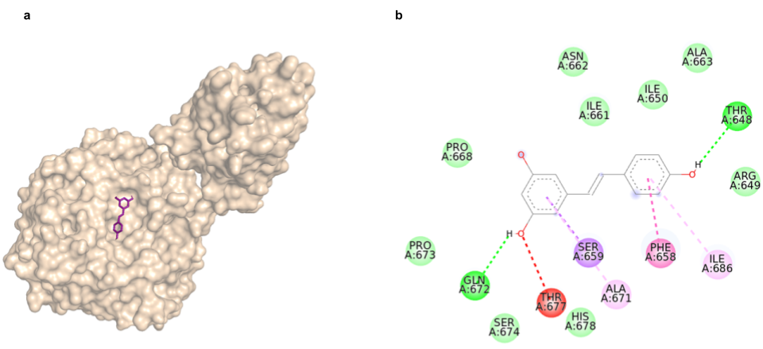
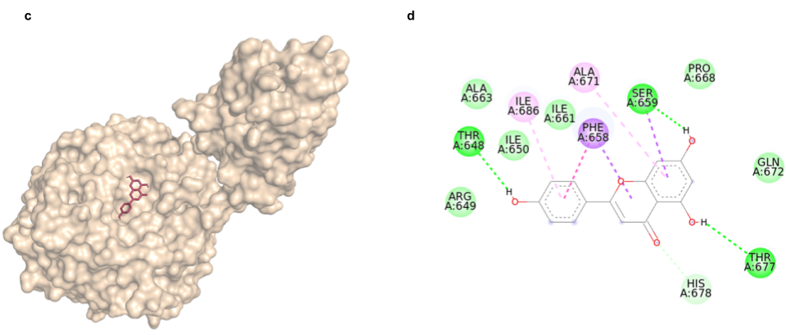
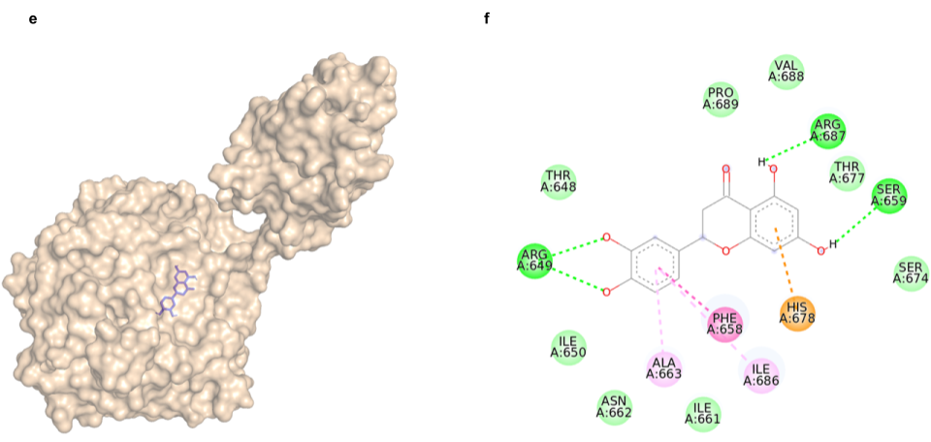
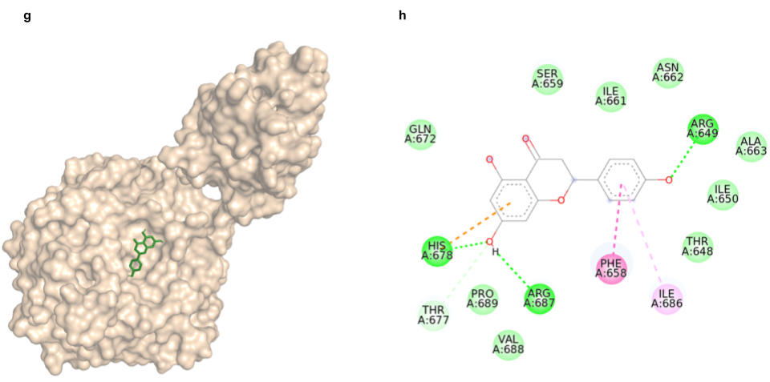
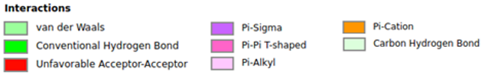
Online Resource 4 Binding of the ligands with Bap1: (a) 3D illustration of resveratrol in the binding site of Bap1, (b) 2D illustration of the interactions between resveratrol and Bap1, (c-d) Apigenin, (e-f) Eriodictyol and (g-h) Naringenin

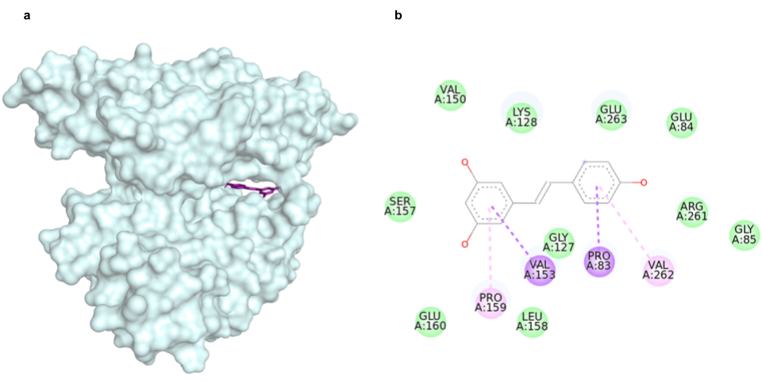
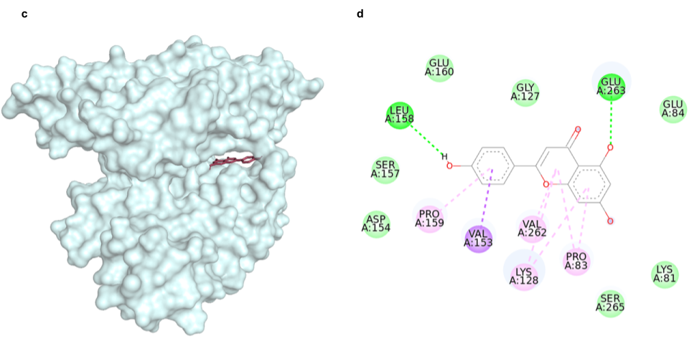
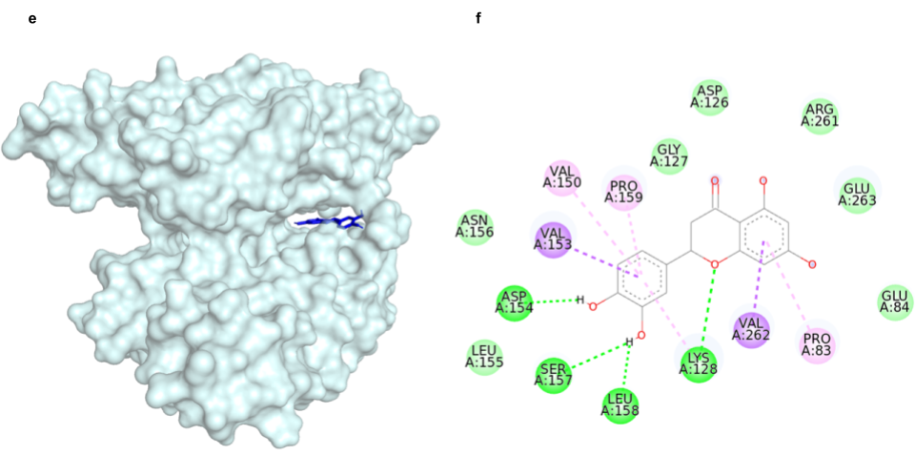
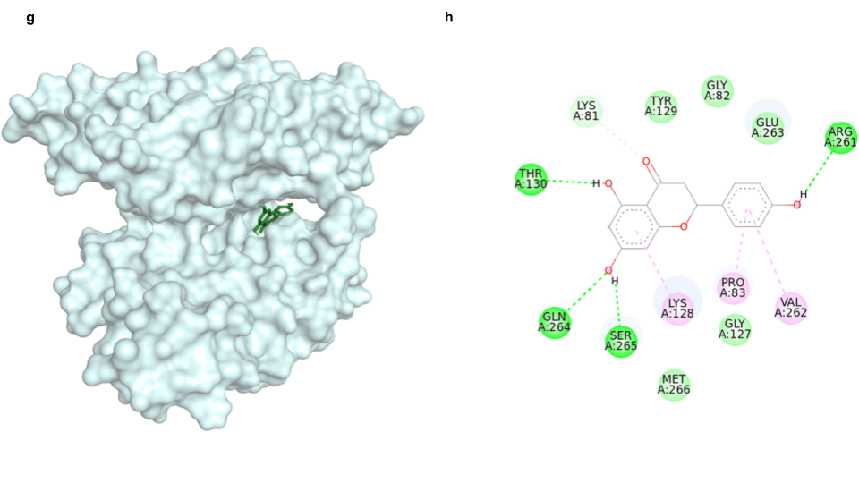
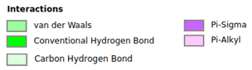
Online Resource 5 Binding of the ligands with RbmA: (a) 3D illustration of resveratrol in the binding site of RbmA, (b) 2D illustration of the interactions between resveratrol and RbmA, (c-d) Apigenin, (e-f) Eriodictyol and (g-h) Naringenin

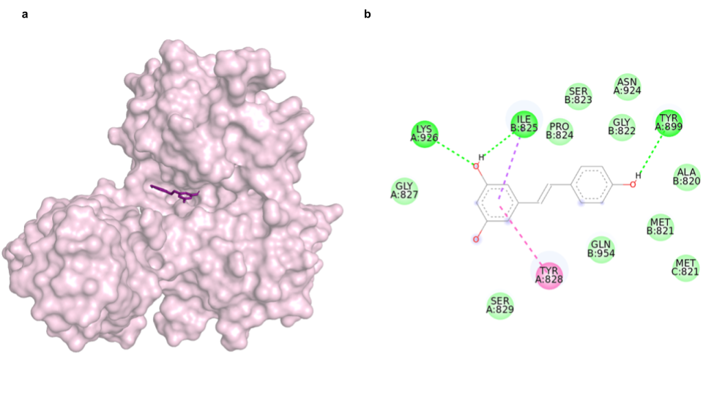
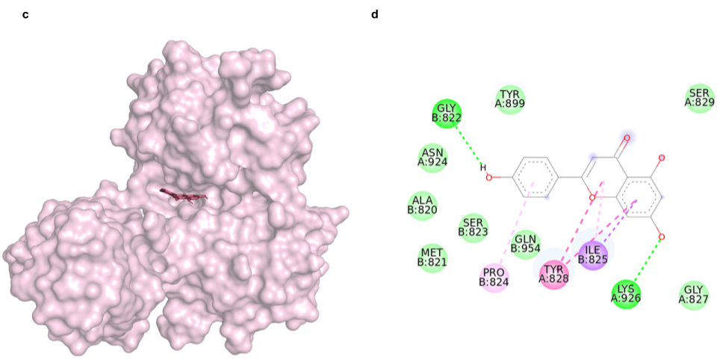
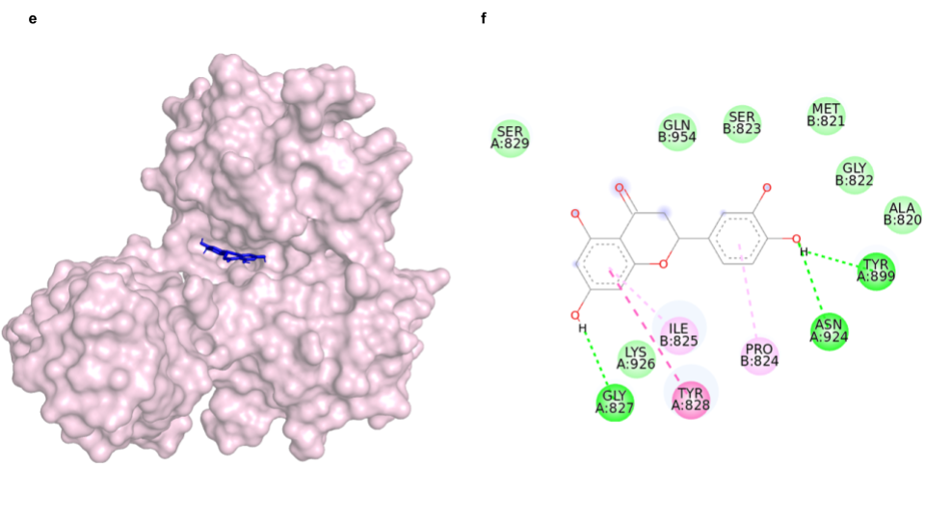
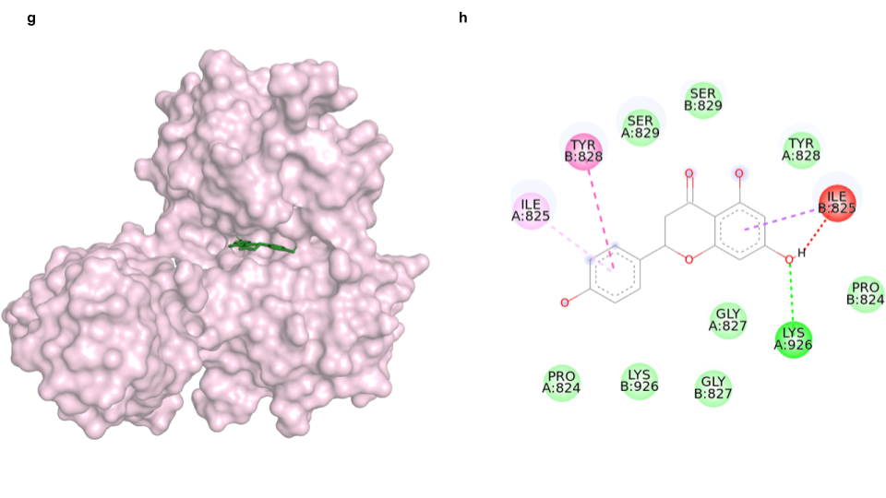
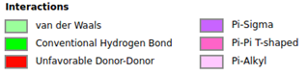
Online Resource 6 Binding of the ligands with RbmC: (a) 3D illustration of resveratrol in the binding site of RbmC, (b) 2D illustration of the interactions between resveratrol and RbmC, (c-d) Apigenin, (e-f) Eriodictyol and (g-h) Naringenin

