Supplementary Material to Impact of Cable Structure on Distributed Fiber Optic Sensing
Giuseppe Cappelli^{1,2}, Shane Murphy², Mael Arhant³, Pascal Casari⁴, Lionel Quetel¹, Peter Davies³, Marco Terzariol², Stephan Ker², Maiwenn Groleau², Giorgio Riccobene⁵, Salvatore Aurnia⁵, Salvatore Viola⁵, Sara Pulvirenti⁵, Marc-André Gutscher²

¹ Idil Fibres Optiques, Lannion, France
² Geo-Ocean, Université de Brest, CNRS, IFREMER, Plouzané, France
³ Marine Structures Laboratory, IFREMER Centre Bretagne, Plouzané, France
⁴ Nantes Université, Ecole Centrale Nantes, CNRS, GeM, UMR 6183, F-44600 Saint-Nazaire, France
⁵ Istituto Nazionale Fisica Nucleare – Laboratori Nazionali del Sud, Catania, Italy

Contents
Supplementary Images 2
Supplementary Tables 7
Supplementary Notes 8
Analytical elastic modeling 8
Zero Strain Boundary Conditions 12
Fourier Decomposition of the external strain field 14
Multilayered case 15
Filtering effect of FOCUS sensing fibers 16
References for the Supplementary Material 18

Supplementary Images
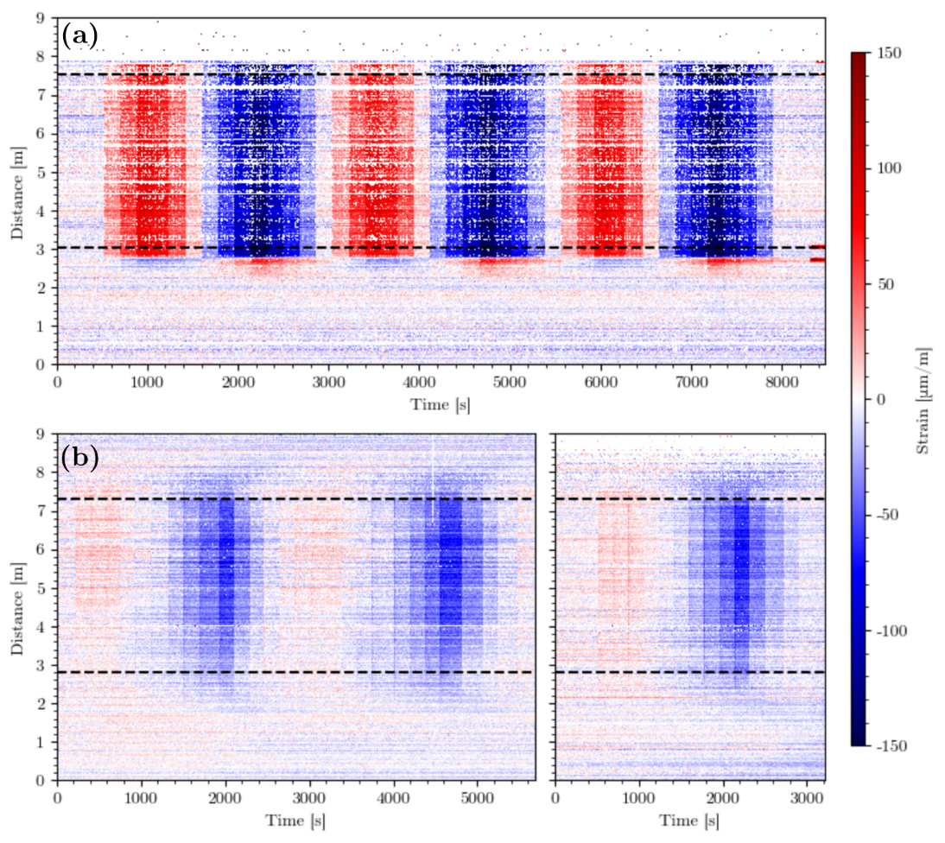
Supplementary Figure S 1: Strain measured with SWI along the fibers throughout the laboratory experiments. Dashed lines represent the position of the attachment points. (a) SWI obtained during testing on the tight fiber. (b) SWI obtained during testing on the loose fiber.
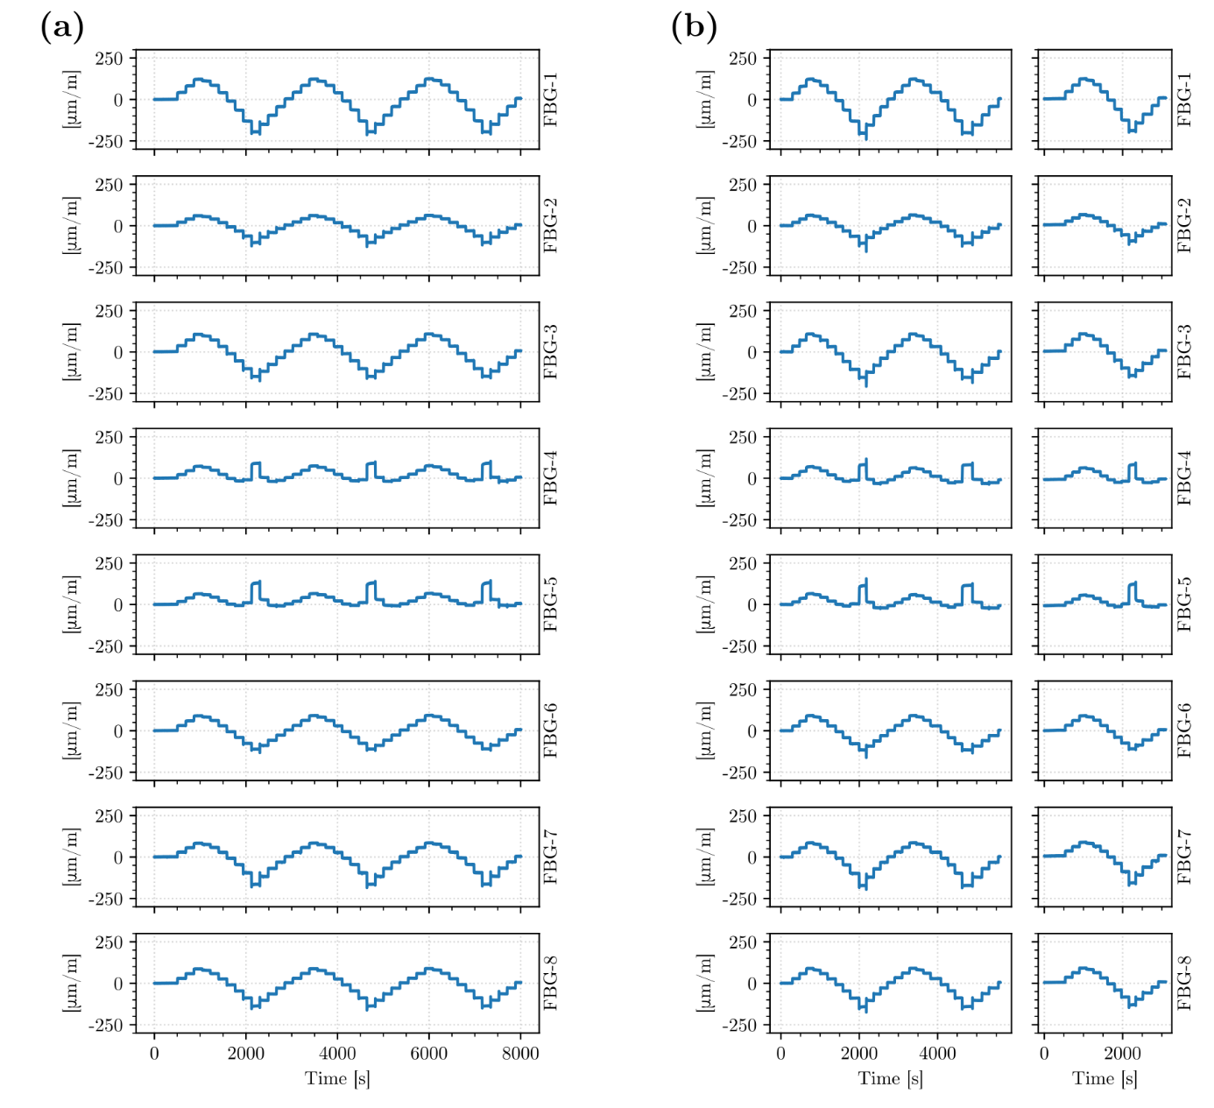
Supplementary Figure S 2: Strain measured with FBGs bonded to the surface of the cable throughout the laboratory experiment. (a) FBG readings during the tight fiber testing. (b) FBG readings during the loose fiber testing. FBG-5 and FBG-6 show a different strain trend compared to other FBGs because of their proximity to the pulley. As such, they have been removed from the analysis.
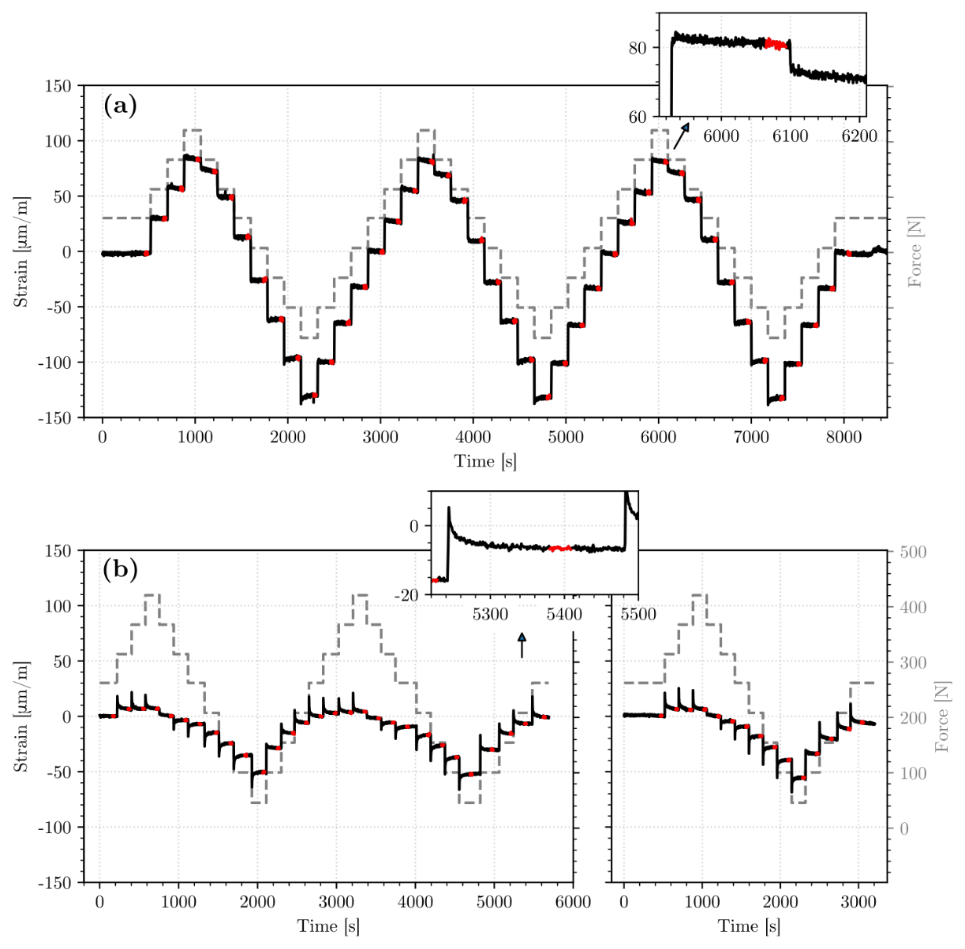
Supplementary Figure S 3: Average fiber strain during loading cycles. Dashed line represents the load applied to the prototype cable specimen. Data highlighted in red has been used to estimate final cable strain values. (a) Data from the tight fiber. (b) Data from the loose fiber.
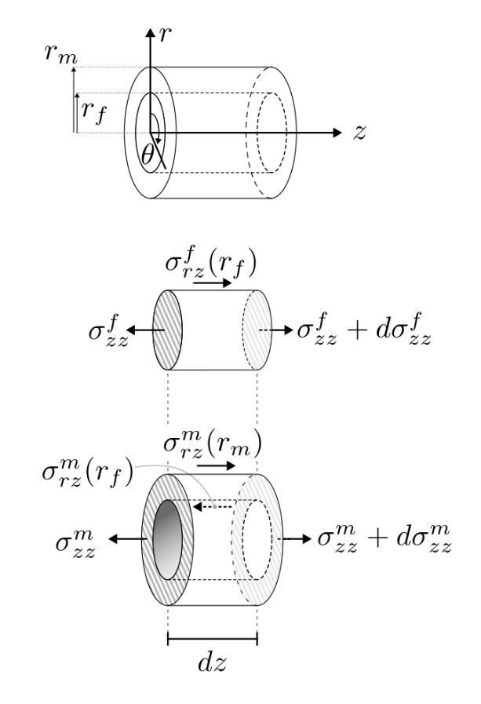
Supplementary Figure S4: Diagram of the cylindrical element and applied forces for the simplest analytical strain transfer model, with only the fiber in the middle and a coating material surrounding it.
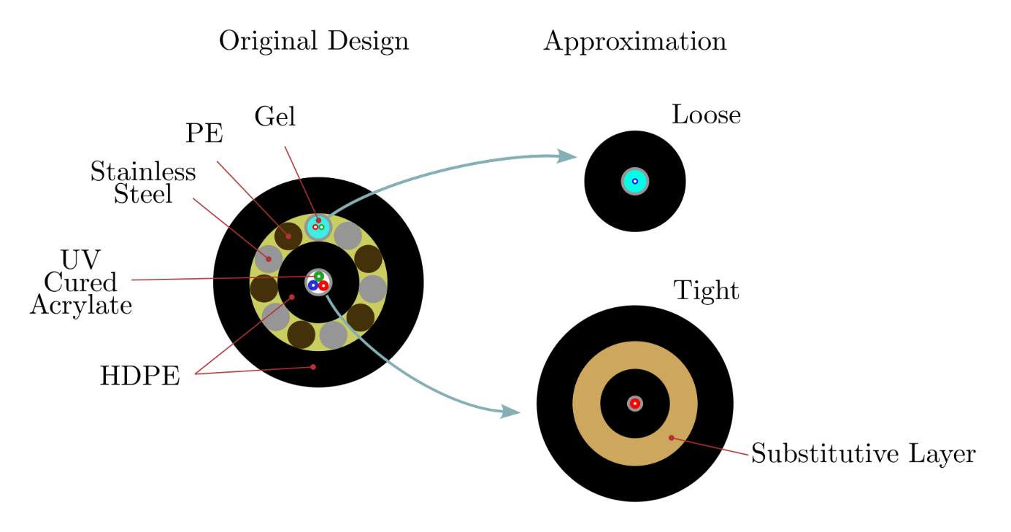
Supplementary Figure S5: Configurations used for the analytical elastic modeling of the FOCUS fiber strain transfer. The models for the loose and tight fiber are constructed by considering the materials present on the shortest path between the fiber and the cable surface. In the tight fiber model, the multi-component armoring layer has been replaced with a substitutive homogeneous layer.
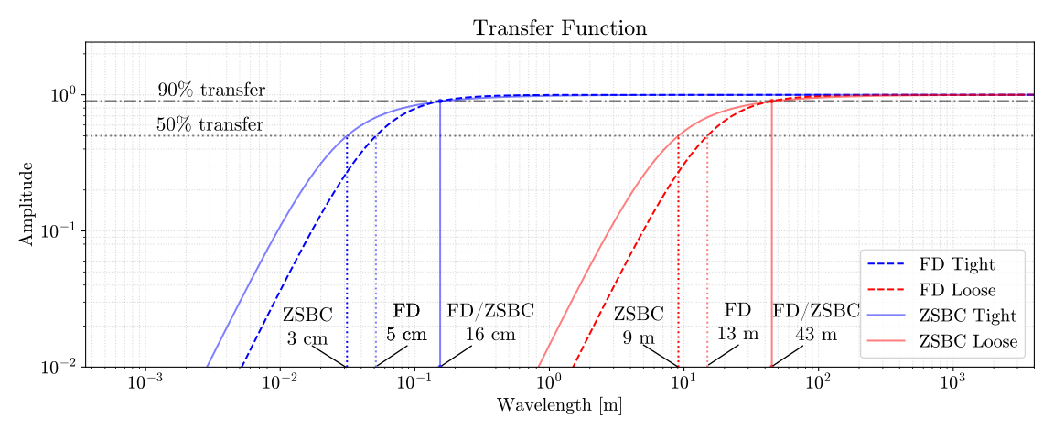
Supplementary Figure S6: Strain transfer function prediction for loose and tight FOCUS fibers. Dashed curves represent the transfer function of the FD approach, solid curves represent the ASTR according to the ZSBC approach. Dotted vertical lines represent the 50% transfer cut-off wavelength for the FD and ZSBC approach, while solid vertical lines represent the 90% transfer cut-off wavelength, for the tight and loose fiber respectively.
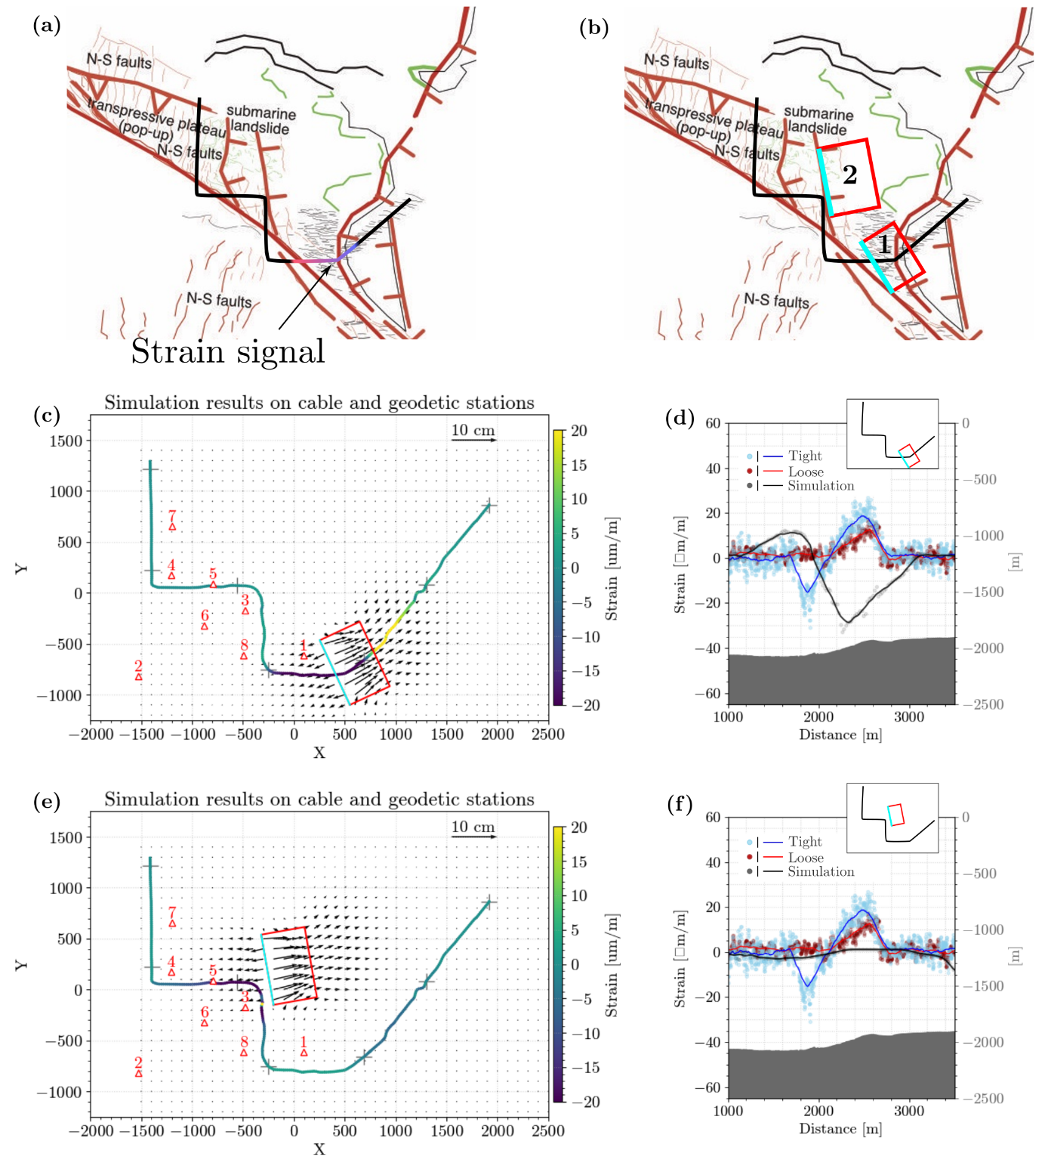
Supplementary Figure S7: Modeling constrains from geological context and preliminary numerical modeling. (a) Geological context surrounding the FOCUS cable, with highlight of the position of the strain signal (red shade: positive strain, blue shade: negative strain). (b) Preliminary choice of slipping patches, given the surface expression of normal faults. Patch 1: landslide (normal fault) directly under the FOCUS cable. Patch 2: landslide (normal fault) with updip edge aligned to a surface expression normal fault east of the plateau. (c-d) Results for Patch 1 at the surface with 30° dip, 700 m long, 500 m wide, 250 m downdip edge depth. Slip distribution is uniform 5 cm dip-slip, tapering linearly within 25 m of the edges. Modelled strain has the opposite polarity from what expected, so a normal fault directly under the FOCUS cable is excluded as a possible source for the Nov. 2020 event. (e-f) Results for Patch 2 at the surface with 30° dip, 700 m long, 500 m wide, 250 m downdip edge depth. Slip distribution is uniform 10 cm dip-slip, tapering linearly within 25 m of the edges. Modelled strain has the correct polarity (positive to negative along the FOCUS cable) but is too low compared to the signal (not even breaking 1 µm/m max) because the fault is too far away. Moreover, such a fault causes a strong negative strain at the third cable bend which is not observed. From this and previous simulation, the conclusion is that a plausible source would maintain this orientation, but should be located closer to the inside of the first bend, as shown in the main text.

Supplementary Tables
Component | Material | Young’s Modulus [GPa] | Thickness [m]
Optical Fiber | Silica Glass | 72 | 62.5·10⁻⁶
Loose Coating | UV-cured acrylate | 8·10⁻³ | 62.5·10⁻⁶
Thick Coating | UV-cured acrylate | 8·10⁻³ | 162.5·10⁻⁶
Gel | Hydrophobic gel | 10⁻⁷ | 412.5·10⁻⁶
Stainless-steel tube | Stainless steel | 221 | 125·10⁻⁶
Protective Sheath | High Density Polyethylene (HDPE) | 0.471 | 1.15·10⁻³
Stainless-steel wire | Stainless Steel | 211 | 1.2·10⁻³
Polyethylene wire | Polyethylene (PE) | 0.221 | 1.2·10⁻³
Substitutive layer | / | 70.7 | 1.2·10⁻³
Supplementary Table 1: Mechanical and geometric characteristics of the components used for the elastic analytical modeling of strain transfer in the FOCUS cable. The Young’s Modulus of silica glass, hydrophobic gel and stainless steel are reported as in Reinsch et al, 2017¹; UV-cured acrylate is the “single coat buffer” value from Lawson et al, 1980². The Young’s Modulus for the PE and HDPE used in the FOCUS cable have been obtained with laboratory pullout tests. The substitutive layer was used in the analytical modeling of the tight fiber: its Young’s modulus was obtained by volume averaging the Young’s moduli of the armoring layer components in the FOCUS cable.

Supplementary Notes

Analytical elastic modeling
We implement a class of purely elastic models to predict the strain transfer between in-cable sensing fibers and the external world. The models approximate the sensor cable as a series of cylindrical layers, with the fiber at the core. The ideas presented here about these models were originally discussed in Duck & LeBlanc, 2000³ and Li et al., 2006⁴, and we propose a unified framework for them. In particular, we show how the generalization for multiple layers shown in Li et al., 2006 can be extended to the previous work of Duck & LeBlanc, 2000.
The modeling starts by considering the simplest possible configuration, that is a fiber surrounded by an outside material, or coating, as schematized in Supplementary Figure S5. The shear lag effect can be predicted by taking a small element of length $dz$ and studying its free body diagram with the following assumptions:
- All the materials in model remain elastic, and only the outer material is subjected to stresses in the axial direction. The bare fiber does not directly bear any external loadings.
- When it comes to the optical fiber, the mechanical properties of the core (where light propagation happens) and cladding (silica surrounding the core necessary for the total internal reflection phenomenon to take place) are the same.
- There are no strain discontinuities across the interfaces i.e., all the interfaces are perfectly coupled with no debonding.
The working condition expected for the sensor is that it will be used to measure axial strains. Therefore, radial and azimuthal stresses are assumed to be negligible. From the equilibrium of stresses on the fiber we obtain (Supplementary Figure S5) :
$$\begin{aligned}\frac{dσ_{zz}^{f}(z)}{dz}=-2\frac{σ_{rz}^{f}\left(r_{f},z\right)}{r_{f}}\#\left(1\right)\end{aligned}$$
Here $r_{f}$ is the external the radius of the fiber, while the tensors $σ_{zz}^{f}$ and $σ_{rz}^{f}$ are, respectively, the axial stress applied at the faces of the cylinder and the shear stress applied at the sides of the fiber. In Equation 1 and in the following, tensors components in the axial direction $z$ are averaged over the corresponding surface area of application, be it $A$. In other words, we imply that³:
$$\begin{aligned}σ_{zz}(z)=\frac{1}{A}\int_{A}{σ_{zz}\left(r, θ,z\right)dA}\#\left(2\right)\end{aligned}$$
From the equilibrium of stresses in the coating material we obtain:
$$\begin{aligned}σ_{rz}^{m}\left(r\right)= -\frac{r_{f}^{2}}{2r}\frac{dσ_{zz}^{f}(z)}{dz}-\frac{\left(r^{2}-r_{f}^{2}\right)}{2r}\frac{dσ_{zz}^{m}(z)}{dz}\#\left(3\right)\end{aligned}$$
where superscript $m$ refers to stress components in the coating material. Shear stress is not averaged over the material cross-section, but computed inside the material at the radial position $r$: we expect variable shearing as a consequence of the fact that only the surface is bearing the external load. Since Hooke’s Law states that $σ_{zz}=Eε_{zz}$, where $E$ is the material’s Young’s Modulus and $ε_{zz}$ is the axial component of strain (averaged for the fiber, remember Equation 2), Equation 3 becomes:
$$\begin{aligned}σ_{rz}^{m}\left(r,z\right)= -\frac{{E_{f}r}_{f}^{2}}{2r}\left\{\frac{dε_{zz}^{f}(z)}{dz}-\frac{\left(r^{2}-r_{f}^{2}\right)}{r_{f}^{2}}\frac{E_{m}}{E_{f}}\frac{dε_{zz}^{m}(z)}{dz}\right\}\#\left(4\right)\end{aligned}$$
where we factored out $E_{f}r_{f}^{2}/2r$. At this point, two simplifying assumptions are made. First, we consider the spatial derivatives to be of the same order:
$$\begin{aligned}\left|\frac{dε_{zz}^{f}}{dz}\right|≈\left|\frac{dε_{zz}^{m}}{dz}\right|\#\left(5\right)\end{aligned}$$
and we take the coating material’s Young’s Modulus, $E_{m}$, is much smaller than the fiber’s Young’s Modulus, $E_{f}$:
$$\begin{aligned}E_{m}≪E_{f}\#\left(6\right)\end{aligned}$$
This can be considered true, as glass’ typical Young’s Modulus is 72 GPa⁵ while UV acrylate coatings’ is 10 MPa^{2,6}.
With these two simplifying assumptions, Equation 4 is reduced to:
$$\begin{aligned}σ_{rz}^{m}\left(r,z\right)= -\frac{{E_{f}r}_{f}^{2}}{2r}\frac{dε_{zz}^{f}(z)}{dz}\#\left(7\right)\end{aligned}$$
and displacements can be introduced by considering Hooke’s Law for shear stresses, which states:
$$\begin{aligned}σ_{rz}^{m}\left(r,z\right)=G_{m}\left(\frac{∂u_{m}}{∂r}+\frac{∂w_{m}}{∂z}\right)=G_{m}\frac{∂u_{m}(r,z)}{∂r}\#\left(8\right)\end{aligned}$$
Here, $u_{m}$ is an axial displacement in the material element, and $w_{m}$ is a radial displacement in the material element. The simplification of Equation 8 comes from the fact that radial displacements are negligible. $G_{m}$ is the Shear Modulus of the material i.e., $G_{m}=E_{m}/2(1+ν_{m})$ with $ν_{m}$ the Poisson’s ratio of the material. Substituting Equation 7 in Equation 8 yields:
$$\begin{aligned}G_{m}\frac{∂u_{m}(r,z)}{∂r}= -\frac{{E_{f}r}_{f}^{2}}{2r}\frac{dε_{zz}^{f}(z)}{dz}\#\left(9\right)\end{aligned}$$
Equation 9 contains the derivative of axial displacements in the material along the radial direction. We can obtain the displacements along the axial directions by integration:
$$\begin{aligned}\int_{r_{f}}^{r_{m}}{G_{m}\frac{∂u_{m}}{∂r}}dr= G_{m}\left[u_{m}\left(r_{m},z\right)- u_{m}\left(r_{f},z\right)\right]= \\ =-\frac{E_{f}r_{f}^{2}}{2}\frac{dε_{zz}^{f}(z)}{dz}\int_{r_{f}}^{r_{m}}{\frac{dr}{r}}=-\frac{E_{f}r_{f}^{2}}{2}\frac{dε_{zz}^{f}(z)}{dz}\ln\left(\frac{r_{m}}{r_{f}}\right)\#\left(10\right)\end{aligned}$$
Yielding:
$$\begin{aligned}u_{m}\left(r_{m},z\right)- u_{m}\left(r_{f},z\right)= -\frac{r_{f}^{2}}{2}\frac{E_{f}}{G_{m}}\ln\left(\frac{r_{m}}{r_{f}}\right)\frac{dε_{zz}^{f}\left(z\right)}{dz}=-\frac{1}{h^{2}} \frac{dε_{zz}^{f}(z)}{dz}\#\left(11\right)\end{aligned}$$
In the last passage in Equation 11, all coefficients are factored in the constant $h$, called strain lag parameter:
$$\begin{aligned}h^{2}=\frac{2G_{m}}{r_{f}^{2}E_{f}\ln\left(\frac{r_{m}}{r_{f}}\right) } \#\left(12\right)\end{aligned}$$
According to Equation 11, the displacement at the outside of the material $u_{m}\left(r_{m}\right)$, and the displacement at the material-fiber boundary $u_{m}(r_{f})$, are connected to the axial variation of fiber strain $\frac{dε_{zz}^{f}(z)}{dz}$through the coefficient $h$. This coefficient contains the effect of the geometry of the system via the ratio between fiber and coating radii, and the effect of the stiffness of the system via the ratio between their respective Young’s and shear moduli. Equation 11 is therefore the shear lag equation written for displacements, describing a displacement transfer mechanism. We differentiate with respect to the axial direction to obtain a relationship for axial strains:
$$\begin{aligned}ε_{zz}^{f}(z)-\frac{1}{h^{2}} \frac{d^{2}ε_{zz}^{f}(z)}{dz^{2}}=ε_{zz}^{m}\left(r_{m},z\right)\#\left(13\right)\end{aligned}$$

Where the substitution $ε_{zz}^{m}\left(r_{f}\right)=ε_{zz}^{f}$ is justified by assumption 3.
Written like this, Equation 13 represents a partial derivative equation for the axial strain in the fiber, which is forced by the axial strain at the external boundary of the coating material i.e., $ε_{zz}^{m}\left(r_{m}\right)$. With it, we have now obtained an equation describing the strain transfer mechanism caused by shear lag, for the simplest geometry of a fiber optic sensor cable i.e., a fiber surrounded by a coating material. The ideal case for fiber optic sensing is when fiber strain is equal to the strain of the sensor cable. This means that sensor cable design should be aimed at a choice of radii and moduli maximizing the strain lag $h$, so that Equation 13 is reduced to $ε_{zz}^{f}\left(z\right)=ε_{zz}^{m}\left(r_{m},z\right)$. Two different approaches are proposed to predict the effect of shear lag by solving Equation 13 analytically.

Zero Strain Boundary Conditions
Equation 13 is a second-order non homogeneous partial derivative equation, and analytical solutions can be proposed by setting up appropriate boundary conditions. The general solution to Equation 13 takes on the form:
$$\begin{aligned}ε_{zz}^{f}(z)=c_{1}e^{hz}+c_{2}e^{-hz}+ε_{zz}^{m}\left(r_{m},z\right)\#\left(14\right)\end{aligned}$$
Let us assume that our sensor cable is solicited exclusively over a certain distance $L$, which is the strain gauge length. If we center the origin of the reference system in the middle of the gauge length, this assumption means that the strain transferred to the fiber is zero at its extrema, leading to the system:
$$\begin{aligned}\left\{\begin{aligned}ε_{zz}^{f}\left(-\frac{L}{2}\right)=c_{1}e^{-\frac{hL}{2}}+c_{2}e^{\frac{hL}{2}}+ε_{zz}^{m}\left(r_{m}\right)=0 \\ ε_{zz}^{f}\left(\frac{L}{2}\right)=c_{1}e^{\frac{hL}{2}}+c_{2}e^{-\frac{hL}{2}}+ε_{zz}^{m}\left(r_{m}\right)=0\end{aligned}\right.\#\left(15\right)\end{aligned}$$
This system only allows a choice of constants where $c_{1}=c_{2}$. Substituting this in any of the two leads to:
$$\begin{aligned}c_{1}=c_{2}=-\frac{ε_{zz}^{m}\left(r_{m}\right)}{2\cosh\left(\frac{hL}{2}\right)}\#\left(16\right)\end{aligned}$$
And, by substitution of Equation 16 in Equation 14, we obtain the general solution for fiber strain with zero-strain boundary conditions (ZSBC), hence why we refer to this solution as the ZSBC solution:
$$\begin{aligned}ε_{zz}^{f}\left(z\right)=ε_{zz}^{m}\left(r_{m}\right)\left[1-\frac{\cosh\left(hz\right)}{\cosh\left(\frac{hL}{2}\right)}\right]\#\left(17\right)\end{aligned}$$
The strain transfer STR along the axial direction, $α(z)$, is defined as:
$$\begin{aligned}STR= α\left(z\right)=\frac{ε_{zz}^{f}\left(z\right)}{ε_{zz}^{m}\left(r_{m}\right)}=1-\frac{\cosh\left(hz\right)}{\cosh\left(\frac{hL}{2}\right)}\#\left(18\right)\end{aligned}$$
Distributed Fiber Optic Sensing (DFOS) interrogators work by sending laser pulses of a certain length, say $L$ without loss of generality, and analyzing the backscattered light to obtain information about the strain state. Returning pulses of the same length $L$ are analyzed, which means that the information recovered by the DFOS interrogator is averaged over the gauge length $L$. We are therefore interested in the average strain transfer (ASTR) of the sensor cable, $\overline{α}$, computed as:
$$\begin{aligned}ASTR= \overline{α}=\frac{2}{L}\int_{0}^{\frac{L}{2}}{α\left(z\right)}dz=\frac{ε_{zz}^{f}\left(z\right)}{ε_{zz}^{m}\left(r_{m}\right)}=1-\frac{\sinh\left(\frac{hL}{2}\right)}{\frac{hL}{2}cosh\left(\frac{hL}{2}\right)}\#\left(19\right)\end{aligned}$$
In the ideal fiber optic sensor cable, fiber strain is equal to the outside material’s strain, which we saw from Equation 13 happens when the strain lag parameter $h$ is maximized. The ZSBC approach confirms this, as large values of $h$ drive the $ASTR$ close to 1 in Equation 18. Moreover, $L$ is a factor in the denominator to the right of Equation 18, meaning the ASTR gets closer to 1 also if $L$ increases. In other words, the $ASTR$ depends not only on cable design, but also on the length of the sensor cable affected by the solicitation. For any given cable design, bonding length has to be adequate to ensure proper strain transfer to the sensing fiber.

Fourier Decomposition of the external strain field
Imposing zero strain at the boundaries of the fiber under test is a strong assumption that might be unjustified. For example, it would impose a discontinuity in the strain field that is unlikely to happen⁴. A different approach was proposed by Duck & LeBlanc prior to the work of Li et al, 2006, in which the boundaries are put far away from the sensing area and a periodic boundary condition is enforced. This way, Equation 13 can be solved by Fourier decomposition (FD in the following). The axial strain function, be it $ε(z)$, is represented in wavenumber space as:
$$\begin{aligned}ε\left(z\right)=\int_{-∞}^{∞}{\hat{ε}(k) e^{2πikz}dk}\#\left(20\right)\end{aligned}$$
Where wavenumber $k=1/λ$ with $λ$ the wavelength of the strain field. According to Fourier theory, the $\hat{ε}(k)$ coefficients are computed as:
$$\begin{aligned}\hat{ε}\left(k\right)=\int_{-∞}^{∞}{ε\left(z\right)e^{-2πikz}dz}\#\left(21\right)\end{aligned}$$
Therefore, taking the Fourier transform of Equation 13 yields:
$$\begin{aligned}{\hat{ε}}_{zz}^{f}\left(k\right)+{\left(\frac{2πk}{h}\right)}^{2}{\hat{ε}}_{zz}^{f}\left(k\right)={\hat{ε}}_{zz}^{m}\left(k, r_{m}\right)\#\left(22\right)\end{aligned}$$
In this approach, the strain transfer function is still obtained by dividing outside strain by fiber strain, only this time in wavenumber space (or $k$-space):
$$\begin{aligned}H\left(k\right)=\frac{{\hat{ε}}_{zz}^{f}\left(k\right)}{{\hat{ε}}_{zz}^{m}\left(k, r_{m}\right)}=\frac{1}{1+{\left(\frac{2πk}{h}\right)}^{2}}\#\left(23\right)\end{aligned}$$
The strain transfer function $H(k)$ depends on both cable design, contained in the strain lag parameter $h$, and wavenumber content $k.$ As with the ZSBC approach, increasing $h$ optimizes the strain transfer in the sensor: for $h→∞$ the righthand term of Equation 23 tends to 1 for any $k$. Within the ZSBC, Equation 19 stated that the bonding length should be maximized to ensure a favorable ASTR. Since wavenumber is the inverse of wavelength, the expression for transfer function $H(k)$ leads to a similar conclusion. For small wavelengths, that is large wavenumbers, $H\left(k→∞\right)→0$and the transfer is unfavorable. On the opposite side, for large wavelengths $H\left(k→0\right)→1$i.e., favorable transfer to the fiber.
If we write Equation 20 for the fiber strain we obtain
$$\begin{aligned}ε_{zz}^{f}\left(z\right)=\int_{-∞}^{+∞}{{\hat{ε}}_{zz}^{f}\left(k\right)e^{2πikz}dk}= \int_{-∞}^{+∞}{{H\left(k\right)\hat{ε}}_{zz}^{m}\left(k,r_{m}\right)e^{2πikz}dk}\#\left(24\right)\end{aligned}$$
Where the last term follows from Equation 23. This form illustrates the filtering effect that the cable design has on fiber strain. The Fourier representation of outside strain is:
$$\begin{aligned}ε_{zz}^{m}\left(z\right)= \int_{-∞}^{+∞}{{\hat{ε}}_{zz}^{m}\left(k,r_{m}\right)e^{2πikz}dk}\#\left(25\right)\end{aligned}$$
Therefore, Equation 24 states that fiber’s axial strain field is the convolution between the cable’s transfer function and the external axial strain field.

Multilayered case
The ZSBC and FD approaches can be easily generalized to the case of a sensor cable with multiple elastic layers. Here, instead of a single coating material of radius $r_{m}$ we consider a multilayered system with radii $r_{1},…, r_{n}$. Let us also call, for simplicity’s sake, $r_{0}=r_{f}$. This means that the integration in Equation 10 can be rewritten as⁷:
$$\begin{aligned}\int_{r_{f} }^{r_{m}}{dr }=\left[\int_{r_{0} }^{r_{1}}{+}\int_{r_{1} }^{r_{2}}{+}⋅⋅⋅+\int_{r_{n-1} }^{r_{n}}{ }\right]dr\#\left(26\right)\end{aligned}$$
Effectively splitting the procedure on the different layers, with their respective Young’s moduli $E_{i}$ and shear moduli $G_{i}$, $i=1,…,n$. Equation 12 then becomes:
$$\begin{aligned}u_{m}\left(r_{m}\right)- u_{m}\left(r_{f}\right)= \frac{1}{h_{m}^{2}} \frac{dε_{zz}^{f}}{dz}\#\left(27\right)\end{aligned}$$
With a multilayered strain lag parameter taking on the form:
$$\begin{aligned}h_{m}^{2}=\frac{2}{r_{0}^{2}E_{0}\left[\sum_{i=1}^{n}{\left(1/G_{i}\right)ln\left(r_{i}/r_{i-1}\right)}\right]}\#\left(28\right)\end{aligned}$$
From here, the effects of shear lag in a multilayered system can be computed by substituting $h$ with the appropriate $h_{m}$ in both the ZSBC and the FD approach. This way, both can be used to approximate strain transfer in a multilayered sensor cable.

Filtering effect of FOCUS sensing fibers
We use the ZSBC and FD approach to compute the strain transfer mechanism expected to affect the strain sensing of the FOCUS cable loose and tight fibers. Therefore, the two types of buffering have been modelled considering only the layers separating each fiber from the external world. The stratified models shown in Supplementary Figure S 5 are considered, with the layer dimensions and Young’s moduli in Table S 1. In the following discussion of the filtering effect, we will conflate the gauge length from the ZSBC approach with the wavelength of the external strain field, as proposed by Reinsch et al., 2017¹. The filtering effect of the loose and tight fiber in the ZSBC is obtained by computing the ASTR for different gauge lengths, while for the FD approach we simply plot the transfer function $H(k)$.
The results from the analysis are shown in Supplementary Figure S 6, where the transfer functions have a typical filter function shape, passing all wavelength above a certain cut-off. According to the ZSBC approach, the tight fiber has a 50% ASTR for 3 cm wavelengths, while the 50% cut-off wavelength for the FD transfer function is 5 cm. For the loose fiber, instead, the low-stiffness buffering gel strongly undercuts passed wavelengths: the 50% cut-off is now 2 orders of magnitude higher than the tight fiber, at 9 m for the ZSBC approach and 13 m for the FD approach. This means that the tight fiber is expected to recover much 100 times the fine-scale detail of the external strain compared to loose fibers. Supplementary Figure S 6 also shows the 90% transfer line, above which the transfer from cable to fiber strain can be considered near 1:1. As shown by the vertical solid line, the ZSBC and FD approaches agree in the prediction of 90% cut-off wavelengths, with 16 cm for the tight fiber and 43 m on the loose fiber. This is a further indication that the tight fiber is about 100 times more showcases the wavelength filtering effect caused by the low-stiffness gel surrounding loose fibers. that the low-stiffness gel layer effectively suppresses the wavelengths in the reduces the reaching above 90% for wavelengths larger than 16 cm. For the loose fiber, the 50% cutoff wavelength is 9 m, and reaches above 90% for gauge lengths above 60 m. In the FD approach, the 50% cutoff wavelength for the tight fiber is a similar 5 cm, while the 90% cutoff wavelength is 20 cm. For the loose fiber configurations, the 50 % cutoff wavelength is 15 meters, and the 90% cutoff is 60 m. In other words, both approaches agree on the strain transfer of the tight fiber, while they slightly disagree for on the average strain transfer of the loose fiber 10-20 m wavelengths. In either case, for wavelengths above 60 m both strain is expected to transfer correctly to both loose and tight fibers.

References for the Supplementary Material
1. Reinsch, T., Thurley, T. & Jousset, P. On the mechanical coupling of a fiber optic cable used for distributed acoustic/vibration sensing applications—A theoretical consideration. Measurement Science and Technology 28, 127003 (2017).
2. Lawson, K., Ansel, R. & Stanton, J. Optical Fiber Buffer Coatings Cured With Ultraviolet Light. in Third International Fiber Optics and Communications Exposition 3–6 (1980).
3. Duck, G. & LeBlanc, M. Arbitrary strain transfer from a host to an embedded fiber-optic sensor. Smart materials and structures 9, 492 (2000).
4. Falcetelli, F., Rossi, L., Di Sante, R. & Bolognini, G. Strain transfer in surface-bonded optical fiber sensors. Sensors 20, 3100 (2020).
5. Hartog, A. H. An Introduction to Distributed Optical Fibre Sensors. (CRC press, 2017).
6. Janani, R. et al. From acrylates to silicones: A review of common optical fibre coatings used for normal to harsh environments. Progress in Organic Coatings 180, 107557 (2023).
7. Li, D., Li, H., Ren, L. & Song, G. Strain transferring analysis of fiber Bragg grating sensors. Optical engineering 45, 024402–024402 (2006).

