Figure2---A (RAW+BMDM)
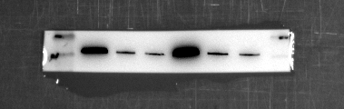
NSUN2
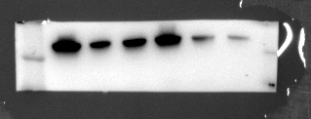
ARG-1
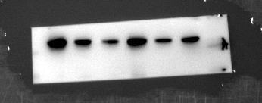
IL-10
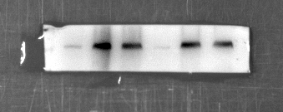
TNF-α
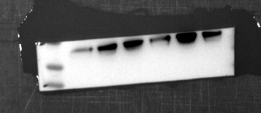
iNOS
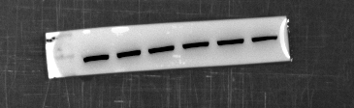
GAP

Figure2---A (THP-1+PBMC)
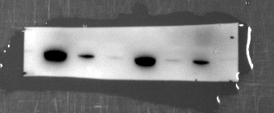
NSUN2
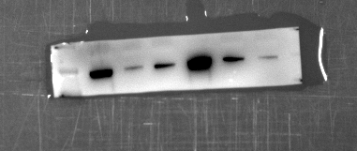
ARG-1
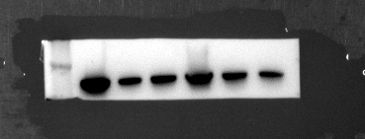
IL-10
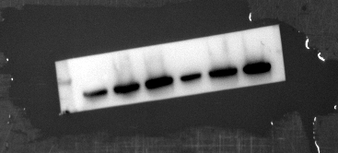
TNF-α
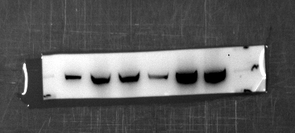
Inos
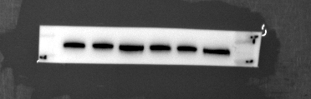GAPDH
Figure2---D(RAW+BMDM)
NSUN2
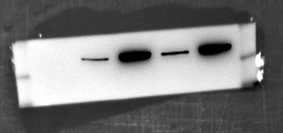
ARG-1
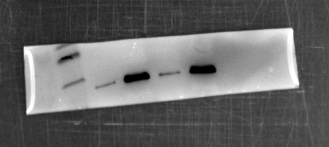
IL-10
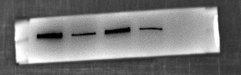
TNF-α
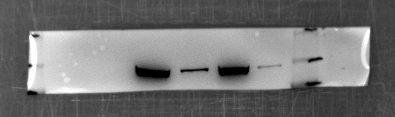
iNOS

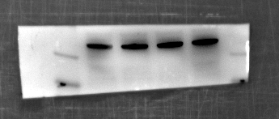
GAPDH

Figure2---D (THP-1+PBMC)
NSUN2
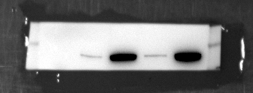
ARG-1
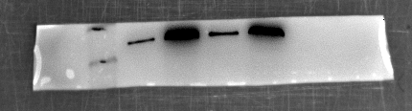
IL-10
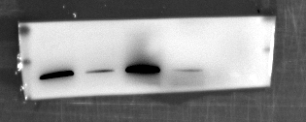
TNF-α
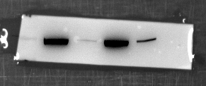
iNOS

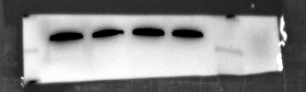
GAPDH

Figure3---D (RAW+BMDM)
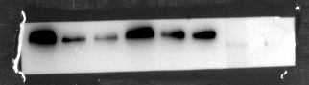
NSUN2
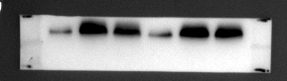
SOCS3
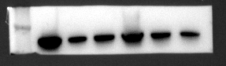
JAK2
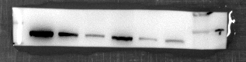
STAT3
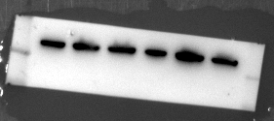
GAPDH

Figure3---D (THP-1+PBMC)
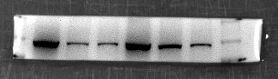
NSUN2
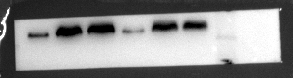
SOCS3
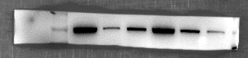
JAK2
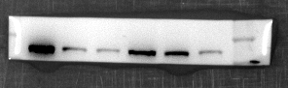
STAT3
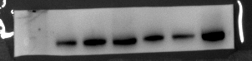
GAPDH

Figure4---A(RAW+BMDM)
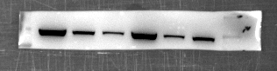
NSUN2
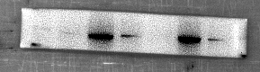
SOCS3
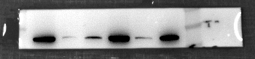
JAK2
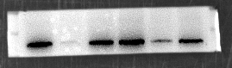
STAT3
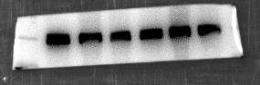
GAPDH

Figure4---A (THP-1+PBMC)
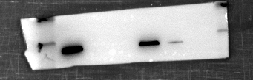
NSUN2
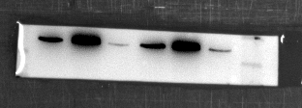
SOCS3
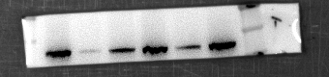
JAK2
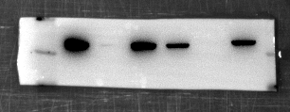
STAT3
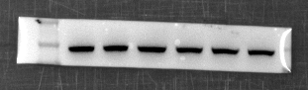
GAPDH

Figure4---C(RAW+BMDM)
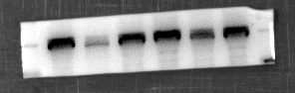
ARG-1
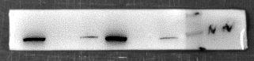
IL-10
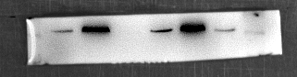
TNF-α
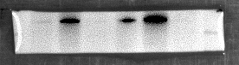
iNOS
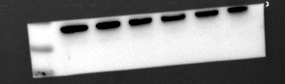
GAPDH

Figure4---C (THP-1+PBMC)
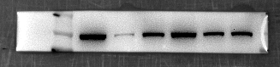
ARG-1
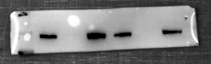
IL-10
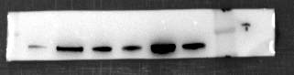
TNF-α
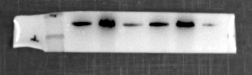
Inos
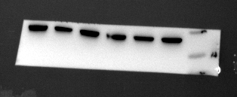
GAPDH

Figure5---A
NSUN2
SOCS3
ARG-1
TNF-α
GAP

Figure7---D
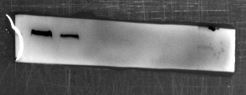
THP-1
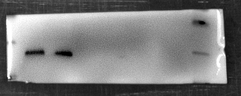
PBMC

Figure8---A
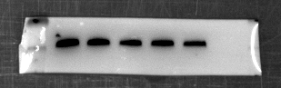
site1-input
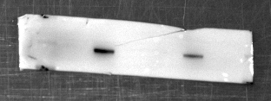
site1-output

Figure8---D-- siYBX1 group (RAW+BMDM)
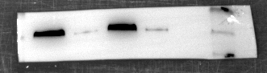
YBX1
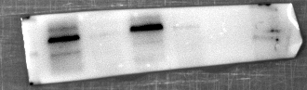
ARG-1
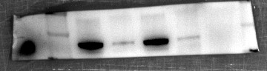
IL-10
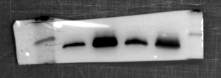
TNF-α
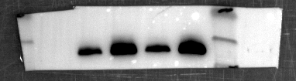
Inos
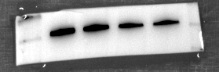
GAPDH

Figure8---D-- siYBX1 group (THP-1+PBMC)
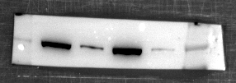
YBX1
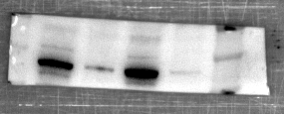
ARG-1
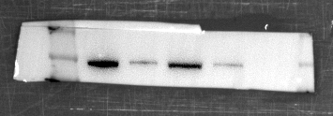
IL-10
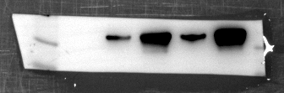
TNF-α

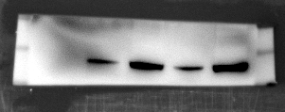
iNOS
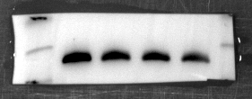
GAPDH

Figure8---D-- siTET2 group (RAW+BMDM)
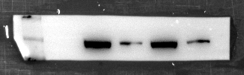
TET2
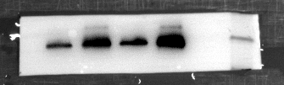
ARG-1
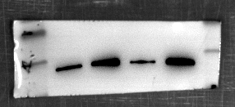
IL-10
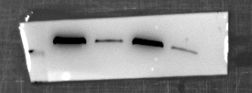
TNF-α
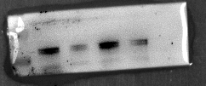
INOS
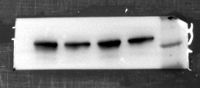
GAPDH

Figure8---D-- siTET2 group (THP-1+PBMC)
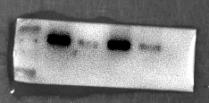
TET2
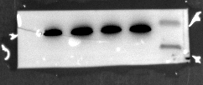
ARG-1
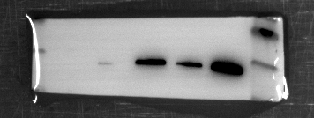
IL-10
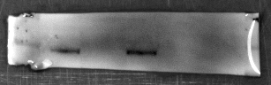
TNF-α
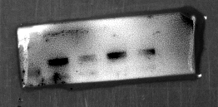
INOS
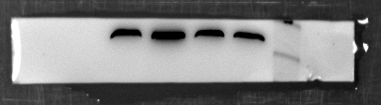
GAPDH

