🔍 Extracted Visual References and Candidates for Regeneration
1. CDM Hubble Curve Visualization
Reference: Simulated entropy divergence curve showing luminosity distance vs. redshift
Function: Replaces standard ΛCDM acceleration curve by interpreting curvature as entropy divergence
Caption: Figure X. CDM-predicted luminosity distance as a function of redshift, derived from a simulated entropy divergence field E(t).
📌 This graph was explicitly mentioned and described with a full proposed caption.

2. ΛCDM vs CDxM Structural Comparison Table
Reference: Comparative table between scale factor a(t), Hubble parameter H(t), redshift z, etc.
Function: Clarifies structural/operational differences between mainstream and divergence models
Type: Table, not figure
Status: Fully drafted; already available for Appendix A integration.

3. 3D Divergence Field Diagram
Axes:
- X-axis = Gravitational Coherence (G): the structural “now”
- Y-axis = Temporal Curvature (T′): the light-based timeline
- Z-axis = Entropic Divergence (E): the space between
Interpretation:
- Dark matter = bulge in E-space
- Dark energy = widening along E-axis over scale
Purpose: Ontological interpretation of entropy field
Caption Suggestion: Figure X. Divergence Field in Measurement Space: Time vs Gravity vs Entropy.
📌 This is one of the most central conceptual diagrams and was described in detail across multiple segments.

4. Curvature Gradient Formula Visualization
Formula:
E(t,x)=∥∇T(t)−∇G(x)∥E(t,x) = \| \nabla T(t) - \nabla G(x) \|E(t,x)=∥∇T(t)−∇G(x)∥
Purpose: Visualizing divergence gradient across spacetime; potential for surface or heatmap plot
Function: Core diagnostic tool to interpret where and why standard cosmological inferences fail
Caption Suggestion: Figure X. Entropy Gradient between Observational Time and Gravitational Coherence.

5. Galaxy Rotation Curve Comparison
Curves:
- Newtonian (expected from visible mass)
- Observed (flat tail — dark matter anomaly)
- CDxM corrected (entropy-based adjustment)
Function: Demonstrates CDxM alignment without invoking unseen mass
Caption Suggestion: Figure X. Galactic rotation curves under Newtonian, observed, and divergence-corrected (CDxM) regimes.

6. Entropy Divergence Over Time (Optional)
Proposed in discussion but not yet visualized
Function: Entropy increase over cosmological time mapped independently of spatial expansion
Potential Style: 2D curve, or overlaid curves showing divergence under different initial coherence conditions

✅ Summary of Needed Visual Assets for Appendix A
# | Visual | Type | Status | Priority
1 | CDxM Luminosity Distance Curve | Figure | Described | High
2 | ΛCDM vs CDxM Comparison Table | Table | Drafted | High
3 | Divergence Field (G, T′, E) | Diagram | Conceptualized | High
4 | Divergence Gradient Surface | Formula Diagram | Conceptualized | Medium
5 | Galaxy Rotation Curve (CDxM correction) | Figure | Simulated (requires export) | High
6 | Entropy Divergence Over Time | Optional Figure | Not yet visualized | Low
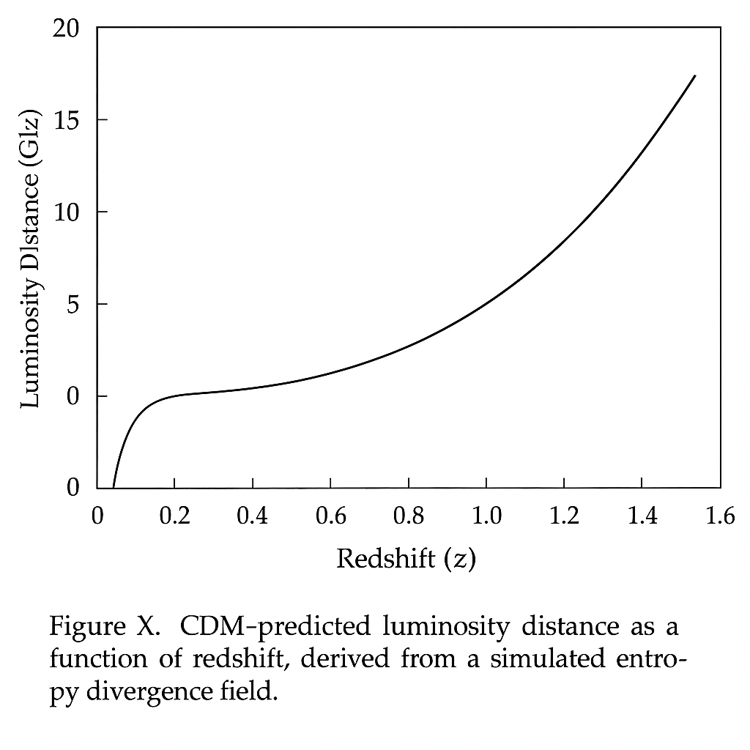
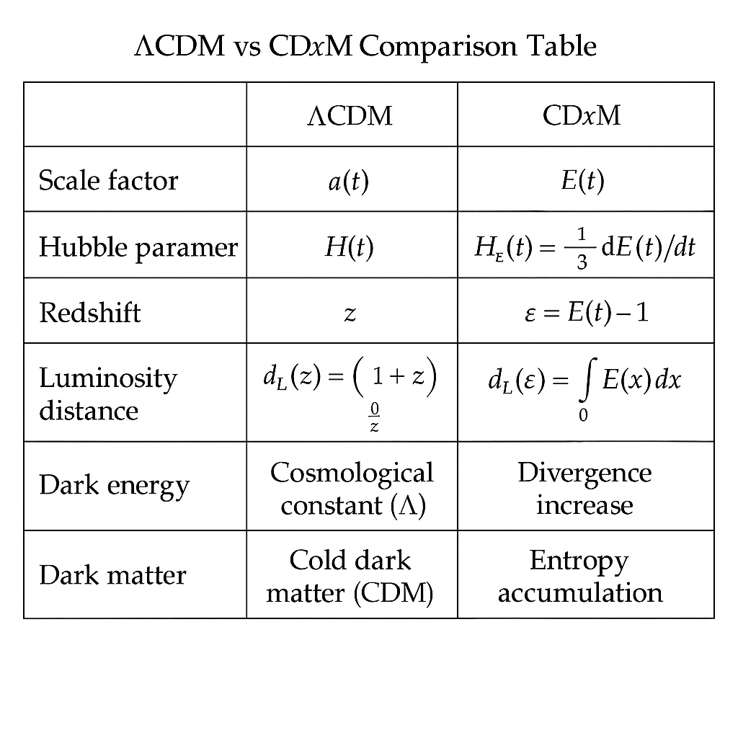
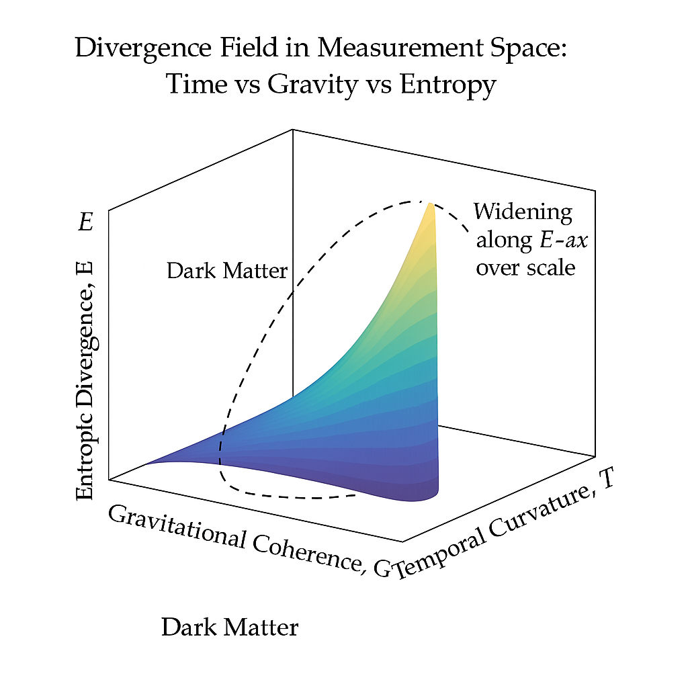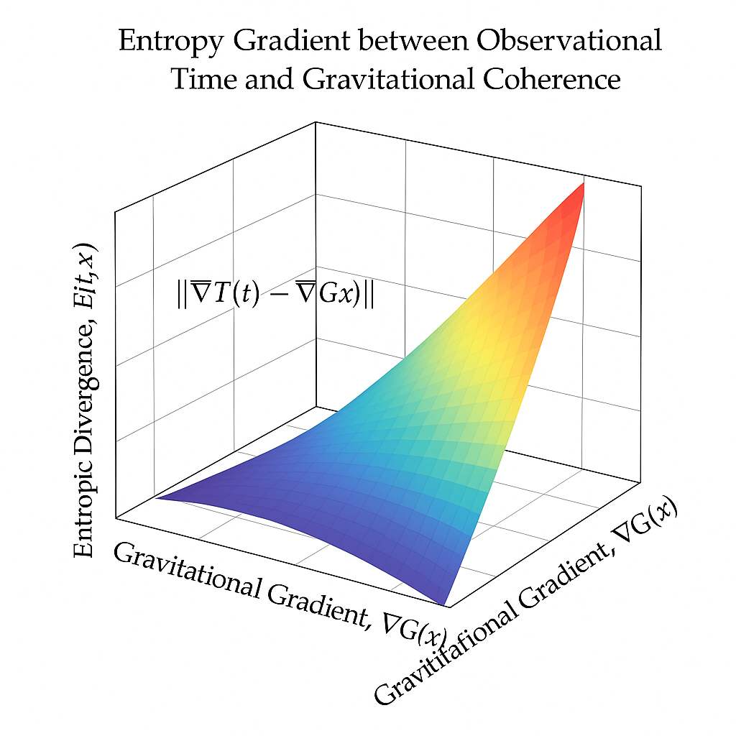
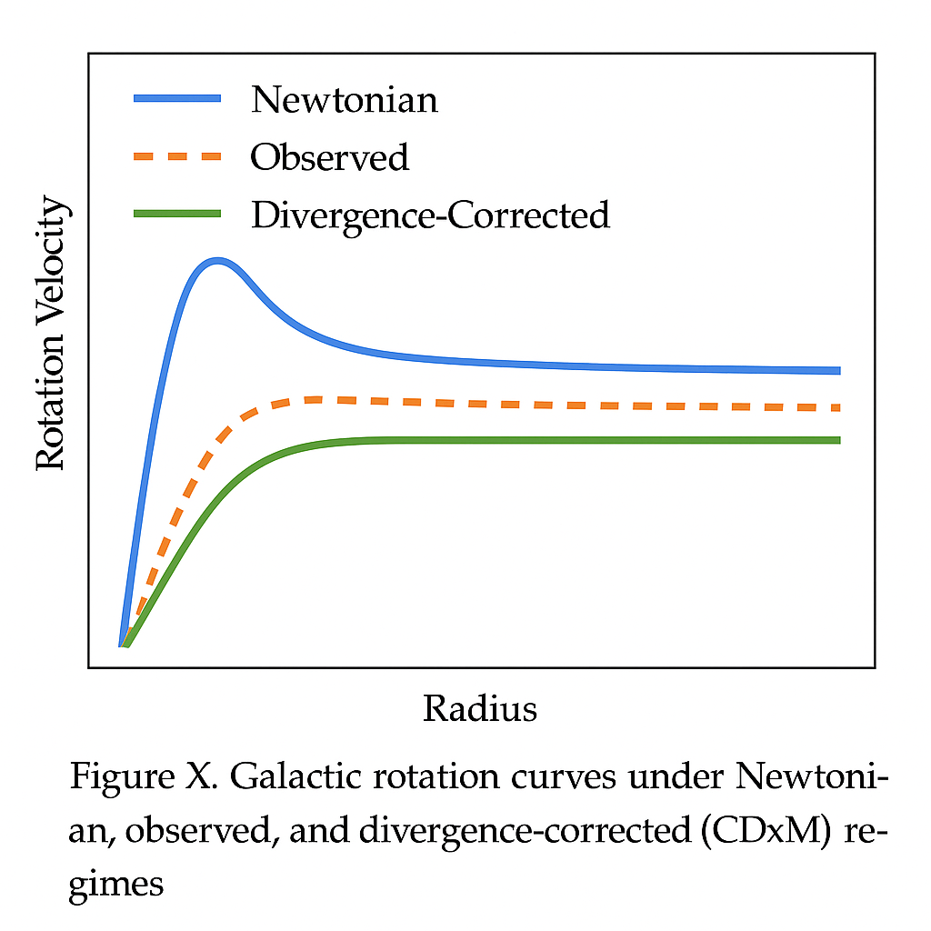

Optional sixth.
