Supplementary Material

Appendix 1
Formula used for sample size calculation
In Botucatu, 1,631 individuals with insulin-dependent diabetes are registered with the Municipal Health Department to receive a glucose meter, corresponding to the base population of our study. A representative sample was selected based on the following parameters:
- Total population: 1,631.
- Estimate of S. aureus carriage (p): 50% (value suggested for unknown proportion).
- Margin of error (d): 5%.
- Design effect (DEFF): 1.
Based on these parameters, application of the formula n = [DEFF*Np(1-p)]/[(d2/Z21-α/2*(N-1)+p*(1-p)] resulted in a suggested sample of 312 subjects.

Table S1. Number of isolates according to the location of sample collection.
Samples collected | n (%)
At home | 204 (65.4)
At Basic Health Units* | 70 (22.4)
In the doctor’s office* | 23 (7.4)
At ABAD* | 15 (4.8)
Total | 312 (100)
* The individuals were contacted by telephone and invited to come to the location of sample collection.
ABAD: Botucatu Association for Diabetes Support

Table S2. Number of excluded patients according to the exclusion criteria.
Exclusion criterion | n (%)
Individuals not found based on personal data* | 388 (82.5)
Individuals who did not use insulin | 70 (14.9)
Deaths | 10 (2.2)
Refusal of sample collection | 2 (0.4)
Total | 470 (100)
*The personal data of the insulin-dependent diabetic individuals were provided by the Municipal Health Department..

Table S3. Antimicrobial susceptibility profile of MSSA and MRSA isolates.
S. aureus (112) | mecA gene | Oxacillin  R S | Cefoxitin  R S | Linezolid  R S | Q/D  R S | S/T  R S | Vancomycin MIC* (μg/mL)
MSSA (97) | 0 | 0 97 | 0 97 | 0 97 | 0 97 | 1 96 | 0.19 – 1.5
MRSA (15)  Total (112) | 15  15 | 7 8  7 105 | 11 4  11 101 | 0 15  0 112 | 0 15  0 112 | 0 15  1 111 | 0.38– 1.5  0.19 – 1.5
Note. Isolates identified as MSSA and MRSA based on the presence of the mecA gene. R= resistant; S= susceptible; Q/D=quinupristin/dalfopristin; S/T= sulfamethoxazole/trimethoprim; MIC = minimum inhibitory concentration. *Range of vancomycin susceptibility obtained for mecA-negative (MSSA) and mecA-positive (MRSA) isolates.

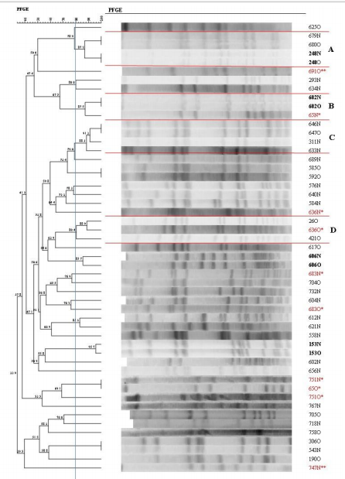
Note. Isolates in bold are from the same subject and have the same profile at both sampling sites (nasal/oropharyngeal). * Isolates obtained from the same subject but showing different profiles. ** The isolates identified as 691N and 747O and obtained from the same subjects as isolates 691O and 747N, respectively, were not typed with SmaI. N = nasal mucosa; O = oropharyngeal mucosa.
Figure S1. Dendrogram of the PFGE-SmaI profiles of MSSA isolated from insulin-dependent diabetic individuals generated by Dice analysis/UPGMA (BioNumerics, Applied Maths).

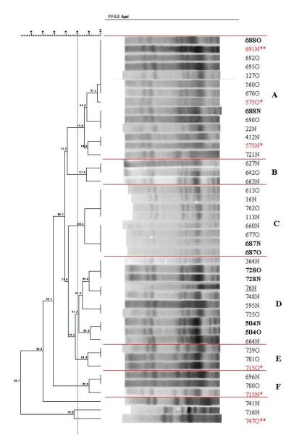

Note. Isolates in bold are from the same subject and have the same profile at both sampling sites (nasal/oropharyngeal)). * Isolates obtained from the same subject but showing different profiles. ** The isolates identified as 691N and 747O and obtained from the same subjects as isolates 691O and 747N, respectively, were typed with SmaI. Strain 76N previously isolated in another study and identified as S. aureus ST398 in a patient from the same city is underlined in the dendrogram. N = nasal mucosa; O = oropharyngeal mucosa.
Figure S2. Dendrogram of the PFGE-ApaI profiles of MSSA isolated from insulin-dependent diabetic individuals generated by Dice analysis/UPGMA (BioNumerics, Applied Maths).

