Supplementary Methods
Patient Enrollment
As the inclusion criteria for patient shown in Fig. S2, we searched the imaging data of all hospitalized patients in the PACS system from Jan 2019 to May 2021, and found a total of 453 institutional patients with pathologically confirmed NSCLC, of which 308 patients were used in this study due to the exclusion criterias. Then we checked the image sequence integrity and the image quality of these patients and resulted in 100 subjects, which were used for the model construction. Similarly as shown in Fig. S2, we found 43 subjects in the TCIA database, and used as individual external test set.

CT imaging
Chest CT images were obtained from the hospital's Picture Archiving and Communication System (PACS). The CT scanners used included Philips IQon-Spectral CT (Philips Healthcare), Philips Ingenuity CT (Philips Healthcare), GE Discovery (GE Healthcare), UIH uCT (United Imaging Healthcare), and Siemens Somatom Force CT (Siemens Healthcare). The tube voltage was 120 kV, and the tube current ranged from 100 to 350 mA. The images were all reconstructed with a slice thickness of 1.25 mm or 1.0 mm, an interslice spacing of 1.25 mm, and a matrix size of 512×512. The lung window images were reconstructed using a sharp algorithm.

Radiomics Features
Radiomics features were extracted based on several different ROIs (Intratumoral and three peritumoral areas) of the CT lung images using pyradiomics codes (https://pyradiomics.readthedocs.io/en/latest/). The category of original features was calculated in this study, which contained the classes of First order statistics, Shape and texture features. The texture features contained Gray level co-occurrence matrix(GLCM), Gray level Run-length matrix(GLRLM), Gray level size zone matrix(GLSZM), Neighboring Gray Tone Difference Matrix (NGTDM) and Gray Level Dependence Matrix(GLDM). These original radiomics features were calculated based on the original images and ROIs. Finally, a total of 107 radiomics features were extracted for each ROI for each patient.
The description and calculation details for all radiomics features could be found in the online pyradiomics docs. (https://pyradiomics.readthedocs.io/en/latest/features.html).

ICC calculation
Twenty samples were randomly selected from all samples for the test of feature reliability and reproducibility. The differences between the features generated by reader 1 and those by reader 2 (inter-observer reliability), as well as the differences between the twice-generated features by reader 1 (intra-observer reproducibility) were all evaluated. Inter- and intra-class correlation coefficients (ICCs) were used to evaluate the agreement of feature extraction. A good agreement was reached when the ICC was greater than 0.8 in this study.

Heterogeneity Model Construction
The heterogeneity modeling process primarily referenced the methodology described in ref [1] and was implemented using the Python code released on their GitHub repository (https://github.com/zhenweishi/QMITH). Specifically, the modeling process included the following steps: (1) subregion segmentation within the ROI using the Simple Linear Iterative Clustering (SLIC) method; (2) unsupervised clustering of all obtained subregions, generating distinct subregions with different cluster labels; and (3) extraction of traditional radiomic features based on the different subregions and their labels, followed by machine learning modeling. The detailed workflow is illustrated in Fig. S1.

Reference
[1] Shi Z, Huang X, Cheng Z, Xu Z, Lin H, Liu C, Chen X, Liu C, Liang C, Lu C, Cui Y, Han C, Qu J, Shen J, Liu Z. MRI-based Quantification of Intratumoral Heterogeneity for Predicting Treatment Response to Neoadjuvant Chemotherapy in Breast Cancer. Radiology. 2023 Jul;308(1): e222830.

Supplementary Figures
Figure. S1 The flowchart of the Heterogeneity Model Construction. Step 1: the original CT images (A) were delineated by radiologists manually, and resulted in the tumoral ROI and peritumoral ROIs (B), then generated the subregions within the ROI using the the SLIC method; Step 2: extracted traditional radiomic features, and then performed unsupervised clustering via a Gaussian mixed model by each feature; step 3: constructed the ecological diversity feature vector based on the cluster results in step 2 for each subjects.
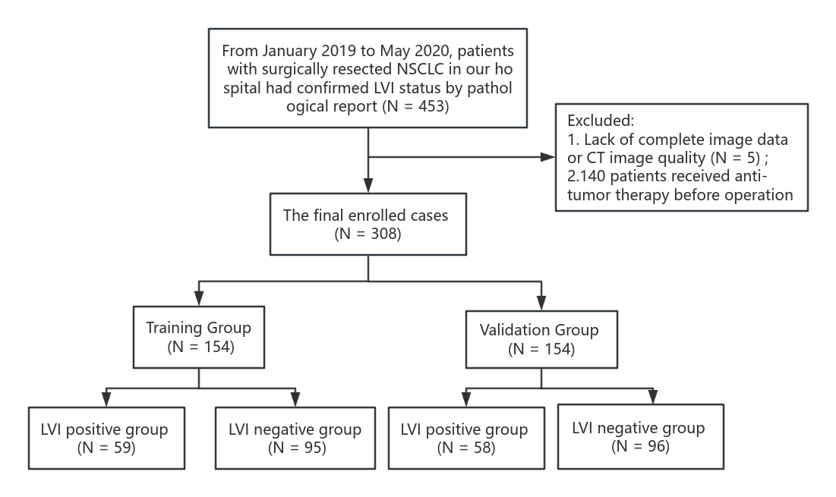
Figure. S2 Flowchart of patient selection of this study.
Figure S3 Delong test results (p-value maps) between different PTR models. Each block in the map showed the p-value of Delong test between corresponding two models in the training set (A) and test set (B). The closer the block color is to light white, the smaller the p-value and the more significant of performance difference between the models.
Figure S4 Delong test results (p-value maps) between different constructed models. Each block in the map showed the p-value of Delong test between corresponding two models in the training set (A) and test set (B). The closer the block color is to light white, the smaller the p-value and the more significant of performance difference between the models.
Figure. S5 The calibration curves drawn for the ITR model. The calibration curves with the Hosmer-Lemeshow test showed the consistency between the actual observed and the model predicted probability in the training set (A) and test set (B), respectively. The closer the curve is to the middle diagonal line, the higher the consistency between the model prediction and the actual observation; if the p-value of the H-L test is greater than 0.05, the model is considered to be well-fitted; otherwise (p <0.05), the model is considered to be poorly fitted.
Figure. S6 The calibration curves drawn for the ITH model. The calibration curves with the Hosmer-Lemeshow test showed the consistency between the actual observed and the model predicted probability in the training set (A) and test set (B), respectively. The closer the curve is to the middle diagonal line, the higher the consistency between the model prediction and the actual observation; if the p-value of the H-L test is greater than 0.05, the model is considered to be well-fitted; otherwise (p <0.05), the model is considered to be poorly fitted.
Figure. S7 The calibration curves drawn for the PTR_0-6 model. The calibration curves with the Hosmer-Lemeshow test showed the consistency between the actual observed and the model predicted probability in the training set (A) and test set (B), respectively. The closer the curve is to the middle diagonal line, the higher the consistency between the model prediction and the actual observation; if the p-value of the H-L test is greater than 0.05, the model is considered to be well-fitted; otherwise (p <0.05), the model is considered to be poorly fitted.
Figure. S8 The calibration curves drawn for the PTH_0-6 model. The calibration curves with the Hosmer-Lemeshow test showed the consistency between the actual observed and the model predicted probability in the training set (A) and test set (B), respectively. The closer the curve is to the middle diagonal line, the higher the consistency between the model prediction and the actual observation; if the p-value of the H-L test is greater than 0.05, the model is considered to be well-fitted; otherwise (p <0.05), the model is considered to be poorly fitted.
Figure. S9 The calibration curves drawn for the Clinical model. The calibration curves with the Hosmer-Lemeshow test showed the consistency between the actual observed and the model predicted probability in the training set (A) and test set (B), respectively. The closer the curve is to the middle diagonal line, the higher the consistency between the model prediction and the actual observation; if the p-value of the H-L test is greater than 0.05, the model is considered to be well-fitted; otherwise (p <0.05), the model is considered to be poorly fitted.
Figure. S10 The calibration curves drawn for the Combined model. The calibration curves with the Hosmer-Lemeshow test showed the consistency between the actual observed and the model predicted probability in the training set (A) and test set (B), respectively. The closer the curve is to the middle diagonal line, the higher the consistency between the model prediction and the actual observation; if the p-value of the H-L test is greater than 0.05, the model is considered to be well-fitted; otherwise (p <0.05), the model is considered to be poorly fitted.

Supplementary Tables
Table. S1 Clinical model construction using GLM method
index | Feature Name | Coef. (95% CI) | p-value
0 | Const | 0.142(0.009-0.275) | 0.037
1 | CEA | -0.002(-0.004-0.001) | 0.186
2 | gender | 0.137(-0.01-0.283) | 0.067
3 | VCS | 0.313(0.144-0.482) | <0.001
4 | TNM_stage | -0.027(-0.158-0.104) | 0.684
5 | N_stage | 0.480(0.266-0.693) | <0.001

Table. S2 The ITR model construction using LASSO method
index | Radiomics Feature Name | Weighted.
0 | intercept | -0.0021915
1 | original_firstorder_Median | 0.01246569
2 | original_firstorder_Skewness | -0.0172667
3 | original_firstorder_InterquartileRange | -0.0127458

Table. S3 PTR_0-6 model construction using LASSO method
index | Radiomics Feature Name | Weighted.
0 | intercept | -1.0309154
1 | original_firstorder_Maximum | -0.7063845
2 | original_glszm_LargeAreaLowGrayLevelEmphasis | -6.0910751
3 | original_ngtdm_Complexity | -0.0968257
4 | original_glszm_GrayLevelVariance | -0.8839995
5 | original_glszm_ZoneVariance | 3.11947701
6 | original_firstorder_Kurtosis | -1.1087898
7 | original_glcm_ClusterShade | -2.8239331
8 | original_glcm_ClusterProminence | 2.6947199
9 | original_glszm_LargeAreaHighGrayLevelEmphasis | -1.3393801
10 | original_firstorder_Range | -0.690996

Table. S4 The ITH model construction using LASSO method
index | Radiomics Feature Name | Weighted.
0 | intercept | 0.12971795
1 | original_glrlm_LongRunHighGrayLevelEmphasis | 0.07242301
2 | original_glcm_Autocorrelation | 0.11400824
3 | original_glszm_LargeAreaHighGrayLevelEmphasis | -0.0791118
4 | original_glszm_SmallAreaLowGrayLevelEmphasis | -0.071352
5 | original_glszm_GrayLevelNonUniformity | -0.0717795

Table. S5 PTH_0-6 model construction using LASSO method
index | Radiomics Feature Name | Weighted.
0 | intercept | -0.0186168
1 | original_glszm_GrayLevelVariance | -0.0478227
2 | original_glszm_ZoneVariance | 0.07104097
3 | original_glcm_ClusterShade | -0.10849
4 | original_glcm_ClusterProminence | -0.073199
5 | original_firstorder_Range | -0.0537585

Table. S6 Combined model construction using GLM method
index | Feature Name | Coef. (95% CI) | p-value
0 | Const | 0.251(0.134-0.367) | <0.001
1 | VCS | 0.175(0.026-0.324) | 0.021
2 | N_stage | 0.277(0.134-0.419) | <0.001
3 | PTR_0-6 | 0.039(0.023-0.055) | <0.001
4 | PTH_0-6 | 0.437(0.129-0.745) | 0.005
5 | ITH | 0.294(0.078-0.509) | 0.008

