Supplementary materials

Supplementary figure 1 Progression free survival (PFS) – all patients.
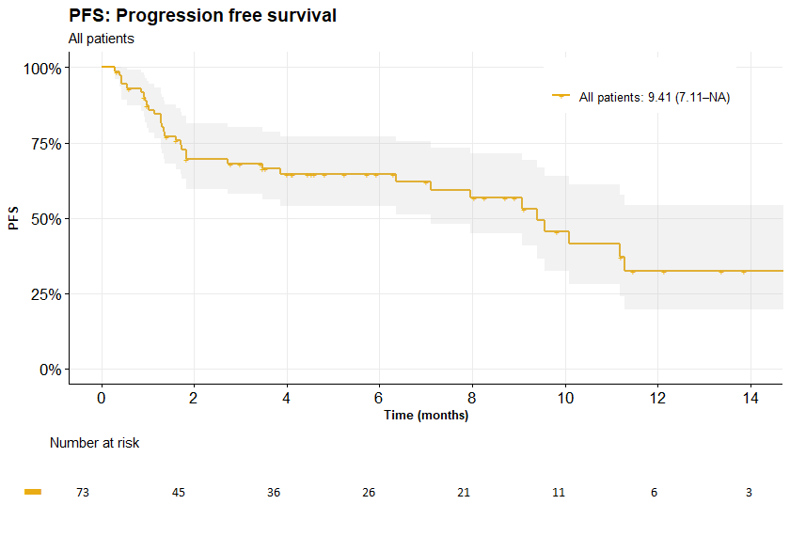
PFS
n valid | 73
n events (%) | 34 (46.6%)
KM median (95% CI) | 9.4 (7.1–NA)
Probability at time, % (95% CI): | ⠀
2 months | 69.7 (59.6–81.4)
4 months | 64.6 (54.1–77.2)
6 months | 64.6 (54.1–77.2)
8 months | 56.6 (44.9–71.4)
10 months | 45.5 (32.4–63.9)
12 months | 32.6 (19.5–54.3)

Supplementary figure 2 Overall survival (OS) – all patients.

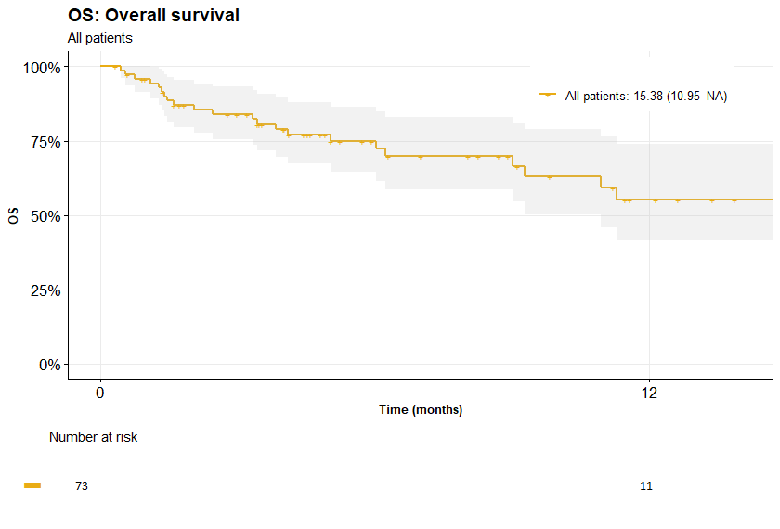
OS
n valid | 73
n events (%) | 23 (31.5%)
KM median (95% CI) | 15.4 (11.0–NA)
Probability at time, % (95% CI): | ⠀
2 months | 87.0 (79.5–95.3)
4 months | 78.8 (69.5–89.4)
6 months | 74.8 (64.6–86.5)
8 months | 69.8 (58.6–83.1)
10 months | 63.0 (50.3–78.9)
12 months | 55.3 (41.4–73.8)

Supplementary figure 3 Progression free survival (PFS) – best response.
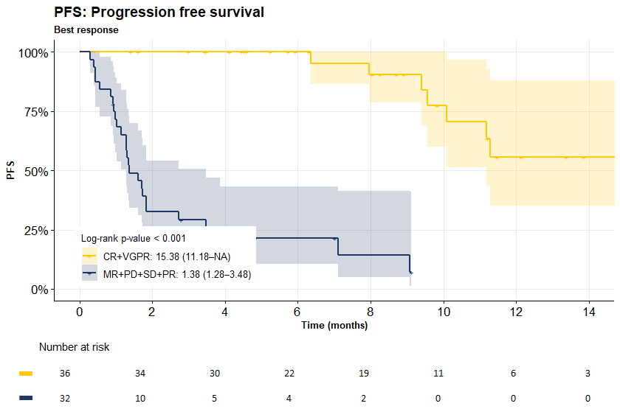

PFS | CR+VGPR | MR+PD+SD+PR | p-value of
PFS | CR+VGPR | MR+PD+SD+PR | log-rank test
n valid | 36 | 32 | <0.001
n events (%) | 8 (22.2%) | 26 (81.2%) | <0.001
KM median (95% CI) | 15.4 (11.2–NA) | 1.4 (1.3–3.5) | <0.001
Probability at time, % (95% CI): | ⠀ | ⠀ | <0.001
2 months | 100.0 (100.0–100.0) | 32.6 (19.6–54.1) | <0.001
4 months | 100.0 (100.0–100.0) | 21.4 (10.6–43.2) | <0.001
6 months | 100.0 (100.0–100.0) | 21.4 (10.6–43.2) | <0.001
8 months | 90.5 (78.8–100.0) | 14.2 (4.9–41.4) | <0.001
10 months | 77.6 (60.1–100.0) | – | <0.001
12 months | 55.5 (35.1–87.9) | – | <0.001

Supplementary figure 4 Overall survival (OS) – best response.

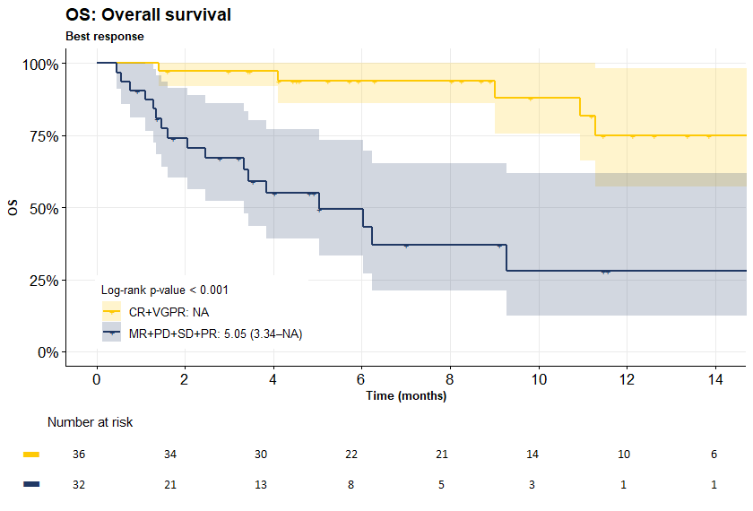

OS | CR+VGPR | MR+PD+SD+PR | p-value of
OS | CR+VGPR | MR+PD+SD+PR | log-rank test
n valid | 36 | 32 | <0.001
n events (%) | 6 (16.7%) | 17 (53.1%) | <0.001
KM median (95% CI) | – | 5.0 (3.3–NA) | <0.001
Probability at time, % (95% CI): | ⠀ | ⠀ | <0.001
2 months | 97.2 (92.0–100.0) | 74.2 (60.2–91.4) | <0.001
4 months | 97.2 (92.0–100.0) | 55.0 (39.2–77.1) | <0.001
6 months | 94.0 (86.2–100.0) | 49.5 (33.3–73.5) | <0.001
8 months | 94.0 (86.2–100.0) | 37.1 (21.1–65.2) | <0.001
10 months | 88.1 (75.6–100.0) | 27.8 (12.5–61.8) | <0.001
12 months | 75.0 (57.2–98.4) | 27.8 (12.5–61.8) | <0.001

Supplementary Figure 5 Progression free survival (PFS) – Extraosseous plasmacytomas in multiple myeloma (EMM) – Extramedullary (EMD) plasmacytomas vs. Para-skeletal (PS) plasmacytoma vs. No plasmacytomas
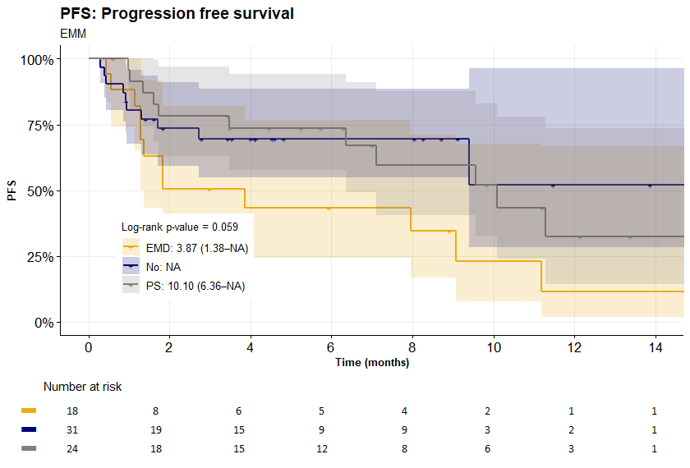

PFS | EMD | No | PS | p-value of
 |  |  |  | log-rank test
n valid | 18 | 31 | 24 | 0.059
n events (%) | 13 (72.2%) | 10 (32.3%) | 11 (45.8%) | 0.059
KM median (95% CI) | 3.9 (1.4–NA) | – | 10.1 (6.4–NA) | 0.059
Probability at time, % (95% CI): | ⠀ | ⠀ | ⠀ | 0.059
2 months | 50.4 (31.0–81.9) | 73.5 (59.3–91.1) | 78.3 (63.1–97.1) | 0.059
4 months | 43.2 (24.4–76.6) | 69.6 (54.8–88.5) | 73.7 (57.6–94.2) | 0.059
6 months | 43.2 (24.4–76.6) | 69.6 (54.8–88.5) | 73.7 (57.6–94.2) | 0.059
8 months | 34.6 (16.8–71.1) | 69.6 (54.8–88.5) | 59.5 (40.5–87.5) | 0.059
10 months | 23.0 (7.9–67.7) | 52.2 (28.2–96.5) | 52.1 (32.7–83.0) | 0.059
12 months | 11.5 (2.0–66.7) | 52.2 (28.2–96.5) | 32.6 (14.4–73.6) | 0.059

Supplementary Figure 6 Overall survival (OS) – Extraosseous plasmacytomas in multiple myeloma (EMM) – Extramedullary (EMD) plasmacytomas vs. Para-skeletal (PS) plasmacytoma vs. No plasmacytomas
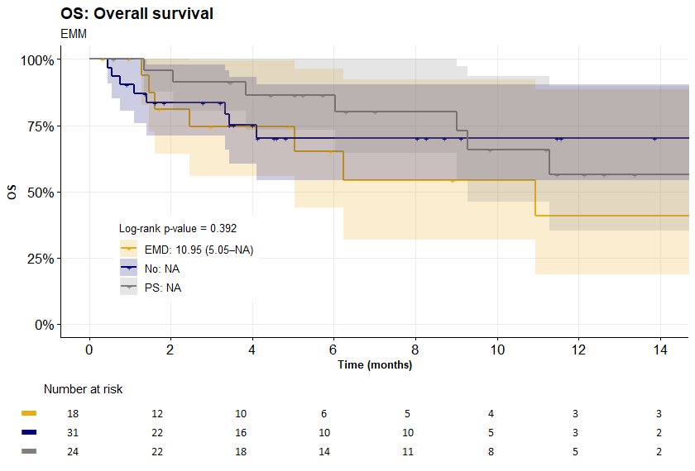

OS | EMD | No | PS | p-value of
 |  |  |  | log-rank test
n valid | 18 | 31 | 24 | 0.392
n events (%) | 8 (44.4%) | 8 (25.8%) | 7 (29.2%) | 0.392
KM median (95% CI) | 11.0 (5.0–NA) | – | – | 0.392
Probability at time, % (95% CI): | ⠀ | ⠀ | ⠀ | 0.392
2 months | 81.2 (64.2–100.0) | 83.5 (71.3–97.8) | 95.7 (87.7–100.0) | 0.392
4 months | 74.5 (55.7–99.6) | 75.1 (60.6–93.2) | 86.5 (73.4–100.0) | 0.392
6 months | 65.2 (44.1–96.4) | 70.1 (54.4–90.5) | 86.5 (73.4–100.0) | 0.392
8 months | 54.3 (32.0–92.3) | 70.1 (54.4–90.5) | 80.3 (64.5–100.0) | 0.392
10 months | 54.3 (32.0–92.3) | 70.1 (54.4–90.5) | 65.7 (46.1–93.7) | 0.392
12 months | 40.7 (18.8–88.4) | 70.1 (54.4–90.5) | 56.3 (35.3–89.8) | 0.392

Supplementary Figure 7 Progression free survival (PFS) – Two or more high-risk cytogenetic aberration* (“double hit multiple myeloma”)
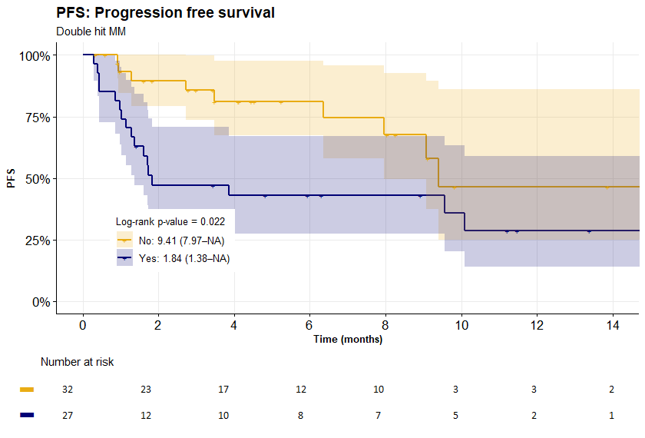
PFS | No | Yes | p-value of
PFS | No | Yes | log-rank test
n valid | 32 | 27 | 0.022
n events (%) | 10 (31.2%) | 17 (63.0%) | 0.022
KM median (95% CI) | 9.4 (8.0–NA) | 1.8 (1.4–NA) | 0.022
Probability at time, % (95% CI): | ⠀ | ⠀ | 0.022
2 months | 89.6 (79.2–100.0) | 47.2 (31.5–70.8) | 0.022
4 months | 81.2 (67.5–97.7) | 42.9 (27.5–67.0) | 0.022
6 months | 81.2 (67.5–97.7) | 42.9 (27.5–67.0) | 0.022
8 months | 67.7 (49.5–92.6) | 42.9 (27.5–67.0) | 0.022
10 months | 46.4 (25.0–86.1) | 35.8 (20.2–63.4) | 0.022
12 months | 46.4 (25.0–86.1) | 28.6 (13.9–58.8) | 0.022

* t(4;14), t(14;16), del(17p), del(1p32) and gain/amp(1q21)

Supplementary Figure 8 Overall survival (OS) – Two or more high-risk cytogenetic aberration* (“double hit multiple myeloma”)
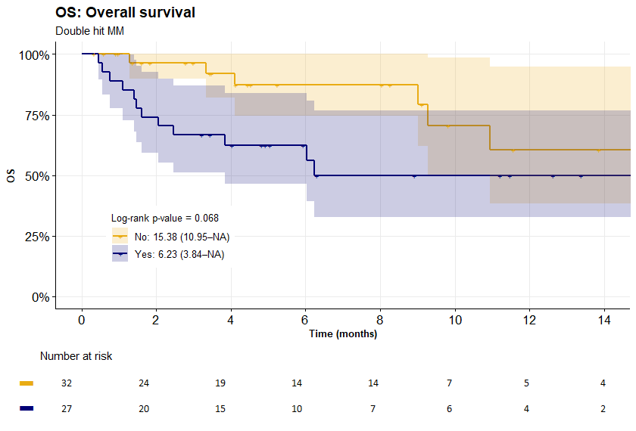
OS | No | Yes | p-value of
OS | No | Yes | log-rank test
n valid | 32 | 27 | 0.068
n events (%) | 7 (21.9%) | 12 (44.4%) | 0.068
KM median (95% CI) | 15.4 (11.0–NA) | 6.2 (3.8–NA) | 0.068
Probability at time, % (95% CI): | ⠀ | ⠀ | 0.068
2 months | 96.4 (89.8–100.0) | 74.1 (59.3–92.6) | 0.068
4 months | 92.0 (82.0–100.0) | 62.5 (46.5–84.0) | 0.068
6 months | 87.2 (74.5–100.0) | 62.5 (46.5–84.0) | 0.068
8 months | 87.2 (74.5–100.0) | 50.0 (32.6–76.7) | 0.068
10 months | 70.5 (50.4–98.6) | 50.0 (32.6–76.7) | 0.068
12 months | 60.4 (38.4–94.9) | 50.0 (32.6–76.7) | 0.068

* t(4;14), t(14;16), del(17p), del(1p32) and gain/amp(1q21)

