Supplementary materials
Visual short-term memory impairments in presymptomatic familial Alzheimer’s disease: A longitudinal observational study
Here we provide supplementary information on methods and results including: details on the participants included in this study; statistical analysis; baseline results for the longitudinal sample and findings on the nearest item control (NIC) metric.

- Methods
  - Participants included
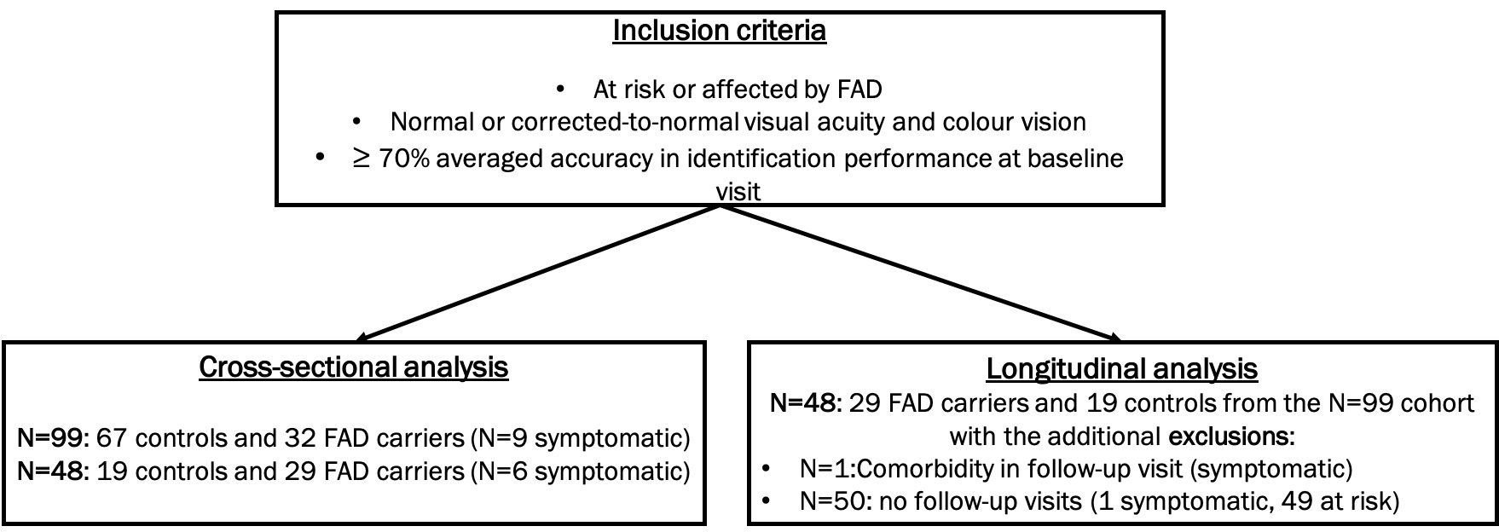
Figure-e1. Participants included in the analyses.

Differences between our N=99 and Liang et al., 2016 study
Additions:
- N=14 - first visit was after the original study (13 at-risk, 1 symptomatic)
- N=4 - mutation carrier status has become available since the original study (all at-risk)
Exclusions:
- N=1 - missing neuropsychology (at-risk)

  - Additional information on statistical methods
Due to a skewed distribution the NIC metric was also log transformed. In the longitudinal analysis of VSTM with groups by symptom status and EYO: for each outcome, rates of change were compared between groups (symptomatic carriers, early PMCs, late PMCs and controls) by including group at the baseline assessment and an interaction between group at the baseline assessment and follow-up length as predictors in each model. The linear mixed effects models also included separate residual error terms for symptomatic mutation carriers, PMCs, and controls to allow for heteroscedasticity. Models included a random slope and intercept to allow clustering by participant. The models for localisation and NIC error additionally included a random effect of visit, nested in participant. In the longitudinal analysis of VSTM using EYO as a continuous measure: for each outcome, performance was compared between gene carriers and controls by including as predictors carrier status, and in the carriers, years to expected onset and years to expected onset squared. To examine whether years to expected onset varied by delay, block and number of items, interactions were added between the condition and carrier status, years to expected onset and years to expected onset squared. In this approach, separate random intercept terms were included for controls and for mutation carriers to allow for clustering by participant. A random slope for time to expected onset (or actual onset) was also included where this significantly improved the model fit. In the longitudinal analysis of neuropsychology with groups by symptom status and EYO: for each outcome, rates of change were compared between group (symptomatic carriers, early PMCs, late PMCs and controls) by including group at the baseline assessment and an interaction between group at the baseline assessment and follow-up length as predictors in each model. Due to skewed data a cubic transform was used for BPVS and inverse for Stroop prior to analysis. To allow for clustering at a participant level random effects were included, with separate random effects by carrier status included where these additional terms improved model fit. The random effects included in the linear regression models were: a random intercept for GNT, NART and Stroop; a random intercept and slope for BPVS; and a random slope and intercept for carriers and a separate random intercept for controls for performance IQ, verbal IQ and arithmetic. All the mixed effects linear regression models had separate residual error terms for symptomatic carriers, PMCs and controls to allow for heteroscedasticity. The regression models for RMT words, RMT faces, VOSP, digit span forwards and digit span backwards included separate random intercepts for carriers and controls.

- Results
  - Baseline results for subgroups of participants included in the longitudinal analysis (N=48)
    - Demographics and traditional neuropsychology
Nineteen controls and 29 carriers with longitudinal data were available for the VSTM binding task. Early PMCs were on average younger than the control group and 12.6 years before EYO. Late PMCs were on average 5.8 years before EYO. Baseline anxiety and depression scores were slightly lower for the late PMCs compared to controls. As expected, symptomatic carriers were older, had lower MMSE and higher global CDR and were on average 2.7 years after expected onset at the baseline visit (Table e1).
There was evidence that the early PMC group had higher scores for backwards digit span compared to controls and late PMCs had lower values for performance IQ compared to the controls. Symptomatic individuals were on average, significantly worse than controls on arithmetic, RMT for words and Stroop and tended to have lower performance IQ scores (Table e1).

    - VSTM performance
Symptomatic carriers had 41% lower odds of correctly identifying the target (OR=0.59, p=0.003), 53% greater localisation error (p=0.002) and made a greater proportion of swap errors (p<0.001) in comparison to controls. There was also a trend for symptomatic participants to have greater error at localising the nearest fractal (p=0.080) (Table e1). Late PMCs were significantly worse than controls (p=0.015) at localising the nearest fractal at baseline but no significant differences were seen from controls for the other measures (Table e1). Early PMCs had similar performance to controls on all measures (Table e1, Fig.e2).
A significant interaction of group with block was observed for the identification measure (p=0.020) with symptomatic carriers showing a much larger difference from controls in block 2 (p<0.001) than in block 1 (p=0.479). A trend towards an interaction of group with increasing memory load was seen for the localisation measure (p=0.067), whereby symptomatic carriers showed greater differences from controls in the 3-item vs the 1-item condition (Table e1). There were no significant interactions with group for the proportion of swap errors (delay: p=0.117; block: p=0.273). However, following Liang and colleagues (Liang et al. 2016) we investigated performance in the 4s delay, block 1 condition. Significant differences from controls were only seem for the symptomatic carriers (Table e1, Fig.e2).

Table e1. Baseline demographics, neuropsychology and VSTM performance by group for participants in the longitudinal analysis (N=48).
 | Controls  (N=19) | Early PMCs (N=12) | Late PMCs (N=11) | Symptomatic  carriers (N=6)
Demographics
Sex: N (%) Male | 9 (47.4) | 3 (25.0) | 7 (63.6) | 4 (66.7)
Age (yrs) | 41.2 (9.4) | 34.8 (6.4)* | 37.0 (5.0) | 50.0 (11.8)*
EYO (yrs) | NA | -12.6 (4.7) | -5.8 (1.8) | 2.7 (4.3)
AYO (yrs) | NA | NA | NA | 2.0 (2.4)
Education (yrs) | 14.2 (2.7) | 14.3 (2.5) | 13.3 (2.5) | 15.0 (3.0)
MMSE | 29.6 (0.7) | 29.3 (0.9) | 29.5 (0.8) | 25.3 (3.7)**
CDR global | 0.0 (0.0) | 0.0 (0.0) | 0.0 (0.0) | 0.6 (0.2)**
Anxiety | 6.9 (3.9) | 7.8 (4.8) | 3.9 (3.9)* | 6.0 (4.7)
Depression | 3.5 (3.4) | 3.1 (4.2) | 1.3 (1.6)* | 1.7 (1.8)
Neuropsychology
Performance IQ | 113.5 (7.5) | 106.5 (15.0) | 101.4 (10.1)** | 104.3 (12.1)
Verbal IQ | 106.7 (15.9) | 96.9 (14.6) | 95.4 (13.5) | 102.7 (20.3)
Arithmetic total/24 | 17.2 (5.4) | 13.9 (5.0) | 14.3 (4.6) | 11.2 (6.3)*
RMT faces | 42.5 (4.2) | 41.1 (4.2) | 43.8 (4.5) | 41.2 (4.3)
RMT words | 47.6 (2.8) | 48.7 (2.2) | 46.5 (2.8) | 38.0 (4.0)**
Digit span forwards/8 | 6.8 (1.2) | 6.8 (1.0) | 7.4 (1.1) | 6.3 (1.5)
Digit span backwards/7 | 4.8 (1.1) | 5.7 (1.3)* | 5.4 (1.1) | 4.8 (1.6)
BPVS | 140.9 (9.5) | 135.0 (14.4) | 139.8 (10.1) | 140.5 (11.1)
GNT/30 | 20.3 (4.3) | 17.8 (5.8) | 19.2 (5.4) | 22.0 (4.6)
NART/50 | 28.6 (9.0) | 24.1 (8.6) | 27.7 (10.7) | 29.7 (12.1)
VOSP OD /20 | 17.9 (2.1) | 17.8 (1.8) | 18.3 (1.3) | 18.2 (1.2)
Stroop (s) | 49.8 (12.8) | 47.6 (8.7) | 52.6 (14.1) | 73.3 (25.8)*
VSTM performance
Identification (% correct)
Overall | 91.3 (4.6) | 89.9 (6.3) | 92.0 (3.9) | 83.7 (5.3)**
Block 1 | 88.9 (6.5) | 89.8 (5.9 | 91.3 (4.3) | 85.0 (5.5)
Block 2 | 93.6 (5.4) | 90.2 (8.8) | 92.7 (5.3) | 82.3 (6.1)**
Localisation error (deg)
Overall | 5.1 (1.1) | 5.8 (2.0) | 5.7 (1.5) | 9.6 (1.6)**
1-item, (all delays) # | 2.3 (0.7) | 2.3 (0.3) | 2.5 (0.8) | 3.1 (1.7)
3-items, (all delays) # | 5.9 (1.4) | 6.8 (2.5) | 6.6 (1.8) | 11.6 (1.8)**
Nearest item control (deg)
Overall: all delays | 3.3 (0.6) | 3.5 (0.8) | 3.7 (0.6)* | 4.0 (0.8)
Swap error proportion (%)
Overall | 9.4 (3.1) | 12.2 (4.6) | 10.2 (5.9) | 25.8 (7.7)**
Block 1, 1s delay | 12.1 (6.3) | 12.9 (9.0) | 9.9 (5.0) | 24.2 (14.9)*
Block 1, 4s delay | 13.9 (5.9) | 18.3 (9.4) | 15.0 (10.8) | 30.1 (18.5)**
Unadjusted mean values are given with SD unless otherwise stated. SD = standard deviation; NA= not applicable; PMC= presymptomatic mutation carrier; EYO=years to/from predicted symptom onset (a negative value indicates a younger age than their estimated age at symptom onset); AYO=actual years to/from onset (positive values indicate years post onset; Anxiety and depression measures scores were taken from the HADS= hospital anxiety and depression scale; IQ=intelligence quotient; Digit spans forwards and backwards are taken from the WMS-R= Wechsler Memory Scale; RMT=recognition memory test; GNT=graded naming test. #localisation measures are separated by item-number to allow for comparison with NIC findings. Neuropsychology data were available at baseline for: 47 participants for performance IQ, verbal IQ and Stroop; for all 48 participants for the remaining tests. Bold = bold; *: significant at p<0.05; **: significant at p<0.01.

A. Identification performance  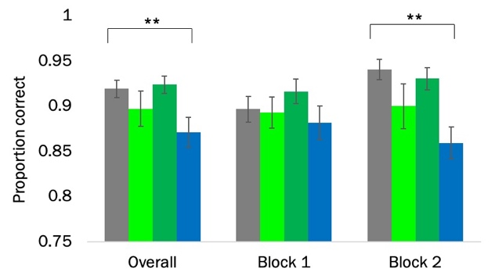 | B. Swap error proportion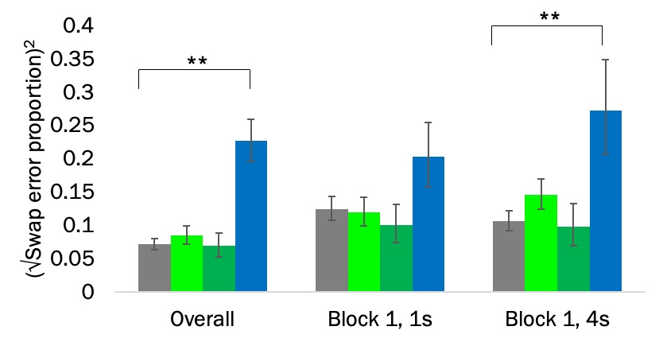
C. Localisation and NIC performance
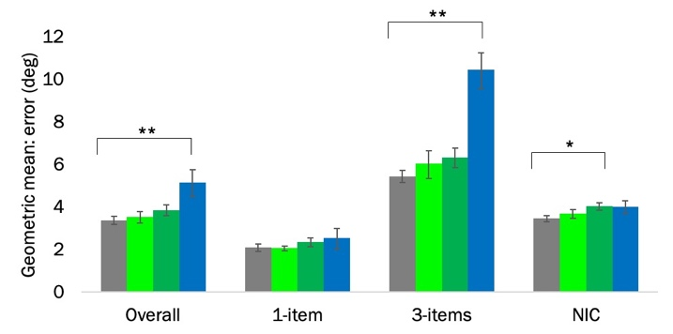
Figure-e2. Cross-sectional adjusted mean performance by group for the longitudinal sample (from model adjusted for age, sex and NART at baseline). A. Identification performance (across all conditions); B. Swap error proportion across all conditions and in the 4s delay, block 1 condition. C. Localisation and nearest item control (NIC) performance by item-number. Note that the NIC is by definition calculated with 3-items only. Error bars show +/- standard error of the mean. PMC=presymptomatic mutation carrier. *= significant at p<0.05; **: significant at p<0.01.

  - Longitudinal rates of change (N=48)
    - Effect of delay, memory load and block on VSTM performance in longitudinal analysis
Delay: performance was significantly worse for long than short delay for gross localisation error (24% greater with 4s vs 1s, p<0.001); NIC (14% greater with 4s vs 1s, p<0.001); identification (OR=0.75 for 4s vs 1s, p<0.001) and swap error rate (coefficient=0.024 for 4s vs 1s, p=0.048).
Memory load (number of items): performance significantly worse for high memory-load than low memory load for localisation error (2.3 times greater with 3 vs 1 item, p<0.001) and identification (OR=0.24 for 3 items vs 1 item, p<0.001). Swap and localisation error with NIC are only assessed in the 3-item condition.
Block: performance was significantly better in block 2 than block1 for localisation error (12% smaller for block 2 vs block 1, p<0.001); NIC (6% smaller for block 2 vs block 1, p<0.001) and swap error (coefficient=-0.068 for block 2 vs block 1, p<0.001) and identification also showed a trend for better performance in block 2 (OR=1.12 for block 2 vs block 1, p=0.055).

    - Effect of demographic variables on VSTM performance in longitudinal analysis
Age: there was weak evidence that older age at baseline tended to be associated with larger localisation error (0.8% larger error per 1 year increase in age, p=0.110); greater NIC error (0.7% greater error per 1 year increase in age, p=0.055); and lower identification performance (OR=0.98 per 1 year increase in age, p=0.070). There was no significant effect of age on swap error rate (coefficient=0.001, p=0.341).
Sex: did not show significant associations with localisation error (3.9% smaller for males vs females, p=0.629); NIC error (4.9% smaller for males vs females, p=0.398); identification performance (OR=0.81 for males vs females, p=0.200); or swap error rate (coefficient=0.026 for males vs females, p=0.279).
NART: there was little evidence of an effect of NART on localisation error (0.4% smaller per point increase, p=0.345); NIC (0.2% smaller per point increase, p=0.439); identification performance (OR=1.01 per point increase, p=0.120); or swap error rate (coefficient=-0.002 per point increase, p=0.127).

    - Motor function in longitudinal analysis
Following the greater localisation error in PMCs, we considered whether these differences might be due to motor function difficulties. In order to evaluate this, we calculated the distance from the participant selected location within the stimulus to its centre every time a correct fractal was selected. This was quantified as the deviation from the centre. For early PMCs, there was no evidence of a difference in rate of change of mean deviation from the centre compared to controls (p=0.429). Late PMCs showed a significantly slower increase in the deviation from the centre compared to controls (p=0.024). Symptomatic carriers also showed a trend towards a slower increase compared to controls (p=0.054). Delay and item number also had significant effects on the deviation whereby longer delay and higher load were associated with smaller deviation from the centre (both p<0.001). While participants were not explicitly asked to select the centre of the stimuli when making a choice, the significant effect of delay and load as well as the smaller deviation for late PMCs compared to controls, suggests that the faster decline in VSTM observed in the localisation metric for late PMC cannot be entirely explained by a motor impairment.

  - Nearest item control (NIC) results
    - Cross-sectional results (N=99)
The adjusted group mean error was 3.6 deg control, 3.6 deg early PMCs, 4.0 deg late PMCs and 4.2 deg symptomatic carriers. Symptomatic carriers had significantly greater error in the NIC metric compared to controls (17.5 [95% CI 1.4, 36.2] % greater localisation error, p=0.032). While there was a trend for higher NIC error in the late PMC group, this did not reach statistical significance (10.5 [-1.4, 23.9] % greater error p=0.085). NIC error was similar between early PMCs and controls (-0.2 [-12.9, 14.5] % difference, p=0.980). There was no significant interaction between group and delay (p=0.236) or block (p=0.454).
For comparison, in the 3-item condition the adjusted mean localisation error (without NIC) was 6.0 deg for controls, 5.9 deg for early PMCs, 6.3 deg for late PMCs, and 10.0 deg for symptomatic carriers. Symptomatic carriers had significantly greater localisation error compared to controls in the 3-item condition (67.2 [95% CI 41.4, 97.5] % greater localisation error, p<0.001). The was little evidence that either PMC group had higher localisation error than controls (late PMCs: 5.1 [-10.4, 23.4] % difference, p=0.534; early PMCs: -0.9 [-21.0, 24.3] % difference p=0.938).
The finding of much smaller difference in localisation between symptomatic carriers and controls after NIC suggests that some of the greater localisation error in this group at baseline may be accounted for by a tendency to mislocalise the fractal to the location of the nearest fractal (regardless of whether it was the target).

    - Longitudinal results (N=48)
      - Rates of change between late PMCs, early PMCs, symptomatic carriers vs controls
NIC performance of controls generally stayed the same throughout the course of the study (0.6 [-1.6, 2.7] %, p=0.607). There was a trend for greater error for early PMCs (2.3 [-0.1, 4.8] %, p=0.057) and a significantly poorer performance for late PMCs (2.7 [0.1, 5.5] %, p=0.045) and symptomatic carriers (7.6 [2.3, 13.1] %, p=0.004).
PMCs did not show a significant difference in the rate of NIC error per year compared to controls (early PMCs=1.8 [-1.4, 5.1] % greater error per year, p=0.281; late PMCs= 2.2 [-1.2, 5.7] % greater error per year, p=0.215). Symptomatic carriers on the other hand, had faster increase in NIC localisation error compared to controls (7.0 [1.3, 12.9] % greater error per year, p=0.015). This suggests that the increase in localisation error observed for the symptomatic group (6.5 [-0.4, 13.9] % greater error per year) was not accounted for by a tendency to mislocalise the fractal to the location of the nearest fractal (regardless of whether it was the target).
While no significant interactions of group rate of change emerged for delay (p=0.364) or block (p=0.986), delay conditions were evaluated separately given the findings for localisation error. Symptomatic carriers showed a significantly faster increase in NIC error compared to controls in the 4s delay condition (9.1 [1.8, 17.0] % greater error per year, p=0.013) and a trend in the same direction in 1s delay condition (5.1 [-1.7, 12.3] % greater error per year, p=0.114). There was a suggestion that late PMC group may have faster increase in NIC error compared to controls specific to the 4s delay condition (3.9 [-0.2, 8.2] % greater error per year, p=0.064) as no difference was seen for the 1s delay condition (0.6 [-3.4, 4.7] % greater error per year, p=0.778). There was a weak trend for the early PMC group to have faster increase in NIC error than controls in the 4s condition (3.1 [-0.7, 7.0] % greater error per year, p=0.112) but not 1s condition (0.5 [-3.2, 4.3] % greater error per year, p=0.804). A comparison between NIC (3.9 [-0.2, 8.2] % greater error per year) and localisation (6.9 [1.8, 12.2] % greater error per year) error differences in late PMCs compared to controls in the 4s condition suggested that some, but not all, of the difference from controls in localisation error could be accounted by a tendency to mislocalise the fractal to the location of the nearest fractal (regardless of whether it was the target). However, as some of the difference from controls remained with NIC, this indicated that part of the increase in localisation error was specific to the target distance rather than solely an effect of mislocalising the fractal.

      - Relationship with proximity to symptom onset
Considering all FAD (presymptomatic and symptomatic) carriers, there was a trend towards greater NIC error with EYO (p=0.068). Although there was no significant interaction with delay (p=0.082), delay conditions were examined separately for comparison to localisation error performance. In the 4s condition, there was a significant association with EYO (p=0.036, Fig.e3A), with a difference in NIC error between FAD carriers and controls observed 6 years prior to EYO (difference=13.0%, p=0.023). There was also a significant association between worsening NIC performance and AYO (p=0.002, Fig.e3B).

EYO: All carriers | AYO: Symptomatic carriers | Individual raw data
A.  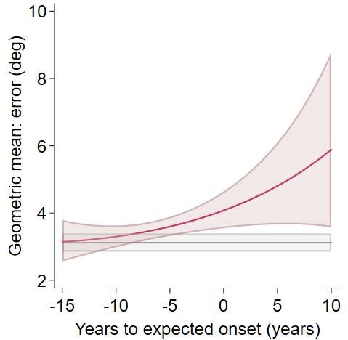 | B.  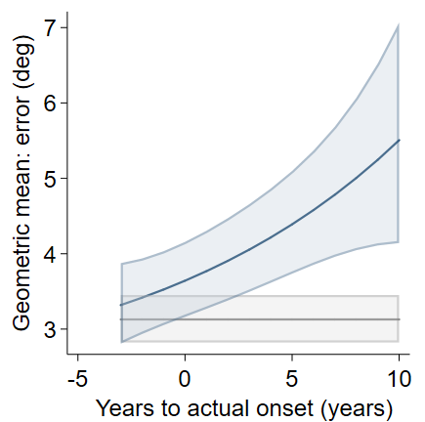 | C.  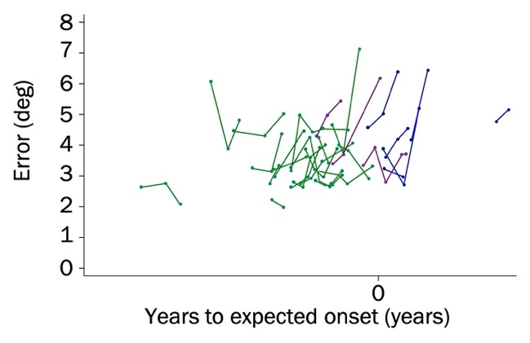
Figure-e3. Relationship between NIC performance and proximity to symptom onset, 4s delay. Panels A and B show the predicted NIC mean (from models adjusted for age, sex and NART). A. Against EYO. B. Against AYO. Shaded area indicates 95% confidence intervals. Panel C shows the unadjusted raw NIC data plotted against EYO with visits marked as dots and connected for each participant; note there is no scale on the x-axes to preserve participant anonymity. Converters are PMCs who transitioned into a symptomatic stage at their last visit. NIC= nearest item control; PMC=presymptomatic mutation carrier; EYO=estimated years to/from symptom onset; AYO=actual years to/from symptom onset.

