Supplementary materials
Visual short-term memory impairments in presymptomatic familial Alzheimer’s disease:
A longitudinal observational study
Ivanna M. Pavisic^{1,2}, Jennifer M. Nicholas^{1,4}, Yoni Pertzov³, Antoinette O’Connor^{1,2}, Yuying Liang¹, Jessica D. Collins¹, Kirsty Lu¹, Philip S. J. Weston¹, Natalie S. Ryan^{1,2}, Masud Husain^{5,6}, Sebastian J. Crutch^{1,2}, Nick C. Fox^{1,2}
- Dementia Research Centre, Department of Neurodegenerative Diseases, UCL Institute of Neurology, London, UK
- UK Dementia Research Institute at University College London, London, UK
- Department of Psychology, The Hebrew University of Jerusalem, Israel
- Department of Medical Statistics, London School of Hygiene and Tropical Medicine, London, UK
- Nuffield Department of Clinical Neuroscience, University of Oxford, UK
- Department of Experimental Psychology, University of Oxford, UK

Here we provide supplementary information on methods and results including: further details on the participants included in this study; statistical analysis; baseline results for the longitudinal sample and findings on the nearest item control (NIC) metric.

- Methods
  - Participants included
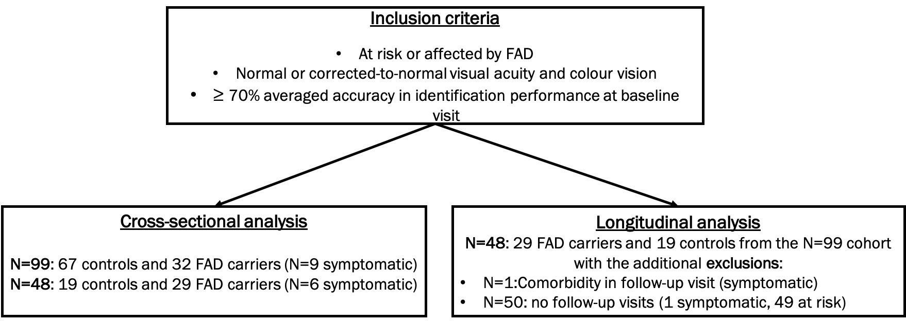
Figure-e1. Participants included in the analyses.
Differences between our N=99 and Liang et al., 2016 study
Additions:
- N=14 - first visit was after the original study (13 at-risk, 1 symptomatic)
- N=4 - mutation carrier status has become available since the original study (all at-risk)
Exclusions:
- N=1 - missing neuropsychology (at-risk)
  - Additional information on statistical methods
Cross-sectional analysis of VSTM: analysis used logistic regression for object identity and linear regression for all other VSTM outcomes. Due to a skewed distribution the localisation error was log transformed and proportion of swap errors was square root transformed before analysis. Group was the main predictor of interest. Each of the mutation carrier groups (symptomatic carriers, early PMC, late PMC) was compared to controls. Wald interaction tests were used to examine whether there was evidence that group differences in performance varied by delay, block and number of items. If significant interactions were found then comparison of the groups was made for each level of the condition (e.g. by number of items).
Longitudinal analysis of VSTM with groups by symptom status and EYO: Longitudinal change in object identity was analysed using a mixed effects logistic regression model and analysis of the other VSTM outcomes used a linear mixed effects model. Due to a skewed distribution the absolute localisation error was log transformed and proportion of swap errors was square root transformed before analysis. For each outcome, rates of change were compared between group (symptomatic carriers, early PMC, late PMC and controls) by including group at the baseline assessment and an interaction between group at the baseline assessment and follow-up length as predictors in each model. Wald tests of the interaction coefficients were used to examine whether group differences in performance or changes in performance over time varied by delay, block and number of items. If significant interactions were found then comparison of the groups rate of change was made for each level of the condition (e.g. by number of items). Models included a random slope and intercept to allow clustering by participant. The linear mixed effects models also included separate residual error terms for symptomatic mutation carriers, presymptomatic mutation carriers, and non-carriers to allow for heteroscedasticity. The models for localisation additionally included a random effect of visit, nested in participant.
Longitudinal analysis of VSTM using EYO as a continuous measure: object identity was analysed using a mixed effects logistic regression model and analysis of the other VSTM outcomes used a linear mixed effects model. For each outcome performance was compared between gene carriers and controls by including as predictors carrier status, and in the carriers years to expected onset and years to expected onset squared. In addition, further analysis was conducted in participants with at least one symptomatic visit (symptomatic at baseline or became symptomatic during the study) to examine the association between performance and years to (or from) onset. To examine allow the relationship with years to expected onset varied by delay, block and number of items interactions were added between the condition and carrier status, years to expected onset and years to expected onset squared. Wald tests of the interaction coefficients were used to examine the evidence for interaction and if these were significant results were presented separately for each level of the condition (e.g. by number of items). To allow for clustering by participant a separate random intercept terms were included for controls and for mutation carriers. A random slope for time to expected onset (or actual onset) was included where this significantly improved the model fit.
Longitudinal analysis of neuropsychology with groups by symptom status and EYO:
For each outcome, rates of change were compared between group (symptomatic carriers, early PMC, late PMC and controls) by including group at the baseline assessment and an interaction between group at the baseline assessment and follow-up length as predictors in each model. Due to skewed data a cubic transform was used for BPVS and inverse for Stroop prior to analysis. To allow for clustering participant level random effects were included, with separate random effects by carrier status included where these additional terms improved model fit. The random effects included in the linear regression models were: a random intercept for GNT, NART and Stroop; a random intercept and slope for BPVS; and a random slope and intercept for carriers and a separate random intercept for controls for performance IQ, verbal IQ and arithmetic. All the mixed effects linear regression models had separate residual error terms for symptomatic mutation carriers, presymptomatic mutation carriers, and non-carriers to allow for heteroscedasticity. The mixed effect logistic regression models for RMT words, RMT faces, VOSP, digit span forwards and digit span backwards included separate random intercepts for carriers and controls.
- Results
  - Nearest item control (NIC) results
    - Cross-sectional results (N=99)
The adjusted group mean error was 3.6 deg control, 3.6 deg early PMC, 4.0 deg late PMC and 4.2 deg symptomatic carriers. Symptomatic carriers had significantly greater error in the NIC metric compared to controls (17.5 [95% CI 1.4, 36.2] % greater localisation error, p=0.032). While there was a trend for higher NIC error in the late PMC group, this did not reach statistical significance (10.5 [-1.4, 23.9]% greater localisation error p=0.085). NIC error was similar between early PMC and controls (-0.2 [-12.9, 14.5]% difference, p=0.980). There was no significant interaction between group and delay (p=0.236) or block (p=0.454).
For comparison, in the 3-item condition the adjusted mean localisation error (without NIC) was 6.0 deg for controls, 5.9 deg for early PMC, 6.3 deg for late PMC, and 10.0 deg for symptomatic carriers. Symptomatic carriers had significantly greater localisation error compared to controls in the 3-item condition (67.2 [95% CI 41.4, 97.5] % greater localisation error, p<0.001). The was little evidence that either PMC group had higher localisation error than controls (late PMC 5.1 [-10.4, 23.4] % difference, p=0.534; early PMC -0.9 [-21.0, 24.3]% difference p=0.938)).
The finding of much smaller difference in localisation between symptomatic carriers and controls after NIC suggests that some of the greater localisation error in this group at baseline may be accounted for by a tendency to mislocalise the fractal to the location of the nearest fractal (regardless of whether it was the target).

    - Longitudinal results (N=48)
- Rates of change between late PMC, early PMC, symptomatic carriers vs controls in the NIC measure:
NIC performance of controls generally stayed the same throughout the course of the study (p=0.607). There was a trend for greater error for early PMC (p=0.057) and a significantly poorer performance for late PMC (p=0.045) and symptomatic carriers (p=0.004, Table e1).
PMCs did not show a significant difference in the rate of NIC error per year compared to controls (early PMC=1.8 [-1.4, 5.1] % greater error per year, p=0.281; late PMC= 2.2 [-1.2, 5.7] % greater error per year, p=0.215). Symptomatic carriers on the other hand, had faster increase in NIC localisation error compared to controls (7.0 [1.3, 12.9 ]% greater error per year, p=0.015). This suggests that the increase in localisation error observed for the symptomatic group (6.5 [-0.4, 13.9] % greater error per year) was not accounted for by a tendency to mislocalise the fractal to the location of the nearest fractal (regardless of whether it was the target).
While no significant interactions of group rate of change emerged for delay (p=0.364) or block (p=0.986), delay conditions were evaluated separately given the findings for localisation error. Symptomatic carriers showed a significantly faster increase in NIC localisation error compared to controls in the 4s delay condition (9.1 [1.8, 17.0] % greater error per year, p=0.013) and a trend in the same direction in 1s delay condition (5.1 [-1.7, 12.3] % greater error per year, p=0.114). There was a suggestion that late PMC carriers may have faster increase in NIC localisation error compared to controls specific to the 4s delay condition (3.9 [-0.2, 8.2] % greater error per year, p=0.064) as no difference was seen for the 1s delay condition (0.61 [-3.4, 4.7] % greater error per year, p=0.778). There was a weak trend for the early PMC group to have faster increase in NIC localisation error than controls in the 4s condition (3.1 [-0.7, 7.0] % greater error per year, p=0.112) but not 1s condition (0.5 [-3.2, 4.3] % greater error per year, p=0.804). These results show the late PMC group had a smaller difference to controls in the 4s delay condition for localisation error with NIC (3.9 [-0.2, 8.2] % greater error per year) compared for localisation error to the correct location (6.9 [1.8, 12.2] % greater error per year). This suggests that some, but not all, of the difference from controls in localisation error could be accounted by a tendency to mislocalise the fractal to the location of the nearest fractal (regardless of whether it was the target). However, some of the difference from controls remained with NIC, which indicates that part of the increase in localisation error was specific to the target distance rather than solely an effect of mislocalising the fractal.

ii) NIC performance and proximity to symptom onset
Considering all FAD (presymptomatic and symptomatic) carriers, there was a trend towards greater NIC error with EYO (p=0.068, Fig.e2). Although there was no significant interaction with delay (p=0.082), delay conditions were examined separately for comparison to localisation error performance. In the 4s condition, there was a significant association with EYO (p=0.036), with difference in the nearest item control measure between FAD carriers and controls was also observed 6 years prior to EYO (difference=13.0%, p=0.023). There was also a significant association between worsening NIC performance and AYO (p=0.002, Fig.e2).

EYO: All carriers | AYO: Symptomatic carriers | Individual raw data
A.  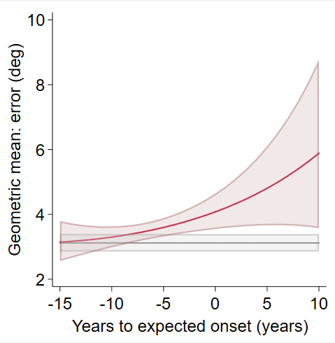 | B.  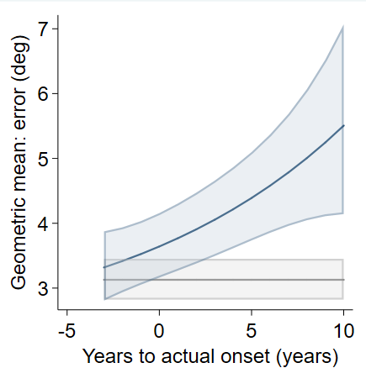 | C.  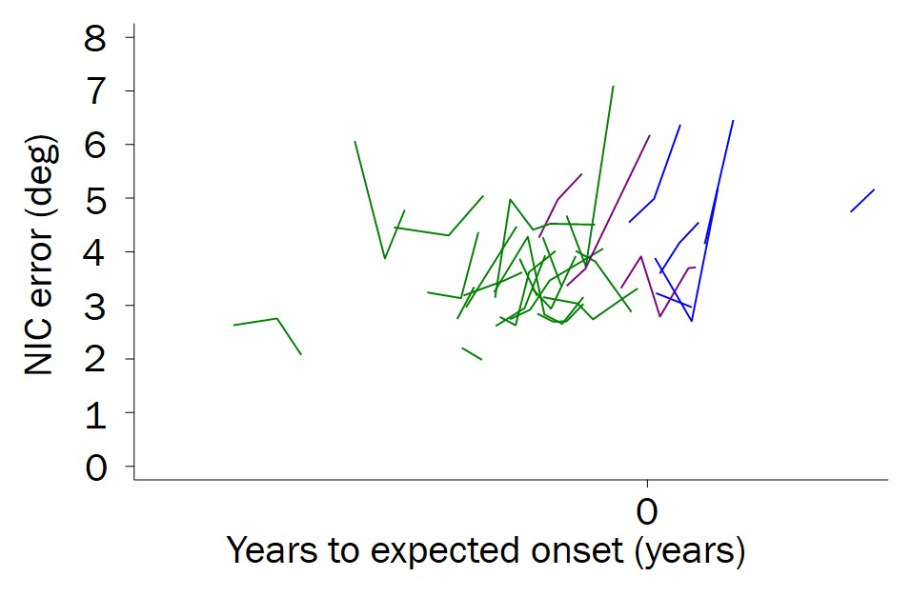
Figure-e2. Relationship between NIC performance and proximity to symptom onset, 4s delay. Predicted NIC mean (from models adjusted for age, sex and NART). A. Against EYO. B. Against AYO. C: Individual VSTM data plotted against EYO. NIC=nearest item control. Each line represents a participant. Converters =presymptomatic carriers who converted to a symptomatic stage at their last visit. NIC= nearest item control; PMC=presymptomatic mutation carrier; EYO=estimated years to/from symptom onset; AYO=actual years to/from symptom onset. Shaded area indicates 95% confidence intervals.

  - Longitudinal rates of change (N=48)
Table e1 shows the estimated rates of change in the VSTM measures over time by group.
    - Effect of delay, memory load and block on VSTM performance in longitudinal analysis
Delay: performance was significantly worse for long than short delay for gross localisation error (24% greater with 4s vs 1s, p<0.001); NIC (14% greater with 4s vs 1s, p<0.001); identification (OR=0.75 for 4s vs 1s, p<0.001) and swap error rate (coefficient=0.024 for 4s vs 1s, p<0.048).
Memory load (number of items): performance significantly worse for high memory-load than low memory load for gross localisation error (2.3 times greater with 3 vs 1 item, p<0.001) and identification (OR=0.24 for 3 items vs 1 item, p<0.001). Swap and localisation error with NIC are only assessed in the 3-item condition.
Block: performance was significantly better in block 2 than block1 for gross localisation error (12% smaller for block 2 vs block 1, p<0.001); NIC (6% smaller for block 2 vs block 1, p<0.001) and swap error (coefficient=-0.068 for block 2 vs block 1, p<0.001) and identification also showed a trend for better performance in block 2 (OR=1.12 for block 2 vs block 1, p=0.055).

    - Effect of demographic variables on VSTM performance in longitudinal analysis
Age: There was weak evidence that older age at baseline tended to be associated with larger localisation error (0.8% larger error per 1 year increase in age, p=0.110); greater NIC error (0.7% greater error per 1 year increase in age, p=0.055); and lower identification performance (OR=0.98 per 1 year increase in age, p=0.070). There was no significant effect of age on swap error rate (coefficient=0.001, p=0.341).
Gender: Gender did not show significant associations with localisation error (3.9% smaller for males vs females, p=0.629); NIC error (4.9% smaller for males vs females , p=0.398); identification performance (OR=0.81 for males vs females, p=0.200); or swap error rate (coefficient=0.026 for males vs females, p=0.279).
NART: there was little evidence of an effect of NART on localisation error (0.4% smaller per point increase, p=0.345); NIC (0.2% smaller per point increase, p=0.439); identification performance (OR=1.01 per point increase, p=0.120); or swap error rate (coefficient=-0.002 per point increase, p=0.127).

Table e1- Mean rates of change in VSTM outcomes by group at baseline for the longitudinal sample, N=48.

 | Controls  (N=19) |  | Early PMC  (N=12) |  |  | Late PMC  (N=11) |  | Symptomatic carriers  (N=6)
 | Mean [95% CI] | p value | Mean [95% CI] | p value | Mean [95% CI] |  | p value | Mean [95% CI] | p value
Identification performance: Odds ratio for correct response
Overall | 1.00 [0.92, 1.08] | 0.913 | 1.01 [0.93, 1.09] | 0.850 | 0.94 [0.86, 1.03] |  | 0.217 | 0.85 [0.75, 0.96] | 0.011
Localisation error: %
Overall | 0.4 [-2.1, 3.1] | 0.737 | 0.3 [-2.4, 3.1] | 0.826 | 4.1 [0.9, 7.4] |  | 0.011 | 7.0 [0.6, 13.8] | 0.033
3-items | 0.4 [-2.2, 3.1] | 0.761 | 1.4 [-1.5, 4.3] | 0.363 | 4.0 [0.7, 7.5] |  | 0.017 | 7.3 [0.5, 14.6] | 0.036
3-items, 1s delay | 0.8 [-2.2, 3.9] | 0.606 | 0.0 [-3.3, 3.4] | 0.994 | 1.4 [-2.3, 5.3] |  | 0.456 | 9.9 [1.7, 18.8] | 0.018
3-items, 4s delay | 0.0 [-3.0, 3.1] | 0.986 | 2.7 [-0.7, 6.2] | 0.117 | 6.9 [2.9, 11.0] |  | 0.001 | 4.8 [-3.4, 13.6] | 0.260
1-item | 0.6 [-3.2, 4.4] | 0.770 | -3.3 [-7.3, 0.8] | 0.111 | 4.4 [-0.5, 9.5] |  | 0.077 | 5.5 [-4.7, 16.9] | 0.299
1-item, 1s delay | 0.9 [-3.1, 5.1] | 0.647 | -4.6 [-8.8, -0.2] | 0.039 | 1.7 [-3.4, 7.0] |  | 0.520 | 8.1 [-3.3, 20.8] | 0.173
1-item, 4s delay | 0.2 [-3.8, 4.3] | 0.934 | -2.0 [-6.3, 2.4] | 0.365 | 7.2 [1.8, 12.8] |  | 0.008 | 3.0 [-7.7, 15.0] | 0.597
Nearest item control error: %
Overall | 0.6 [-1.6, 2.7] | 0.607 | 2.3 [-0.1, 4.8] | 0.057 | 2.7 [0.1, 5.5] |  | 0.045 | 7.6 [2.3, 13.1] | 0.004
1s delay | 0.9 [-1.5, 3.4] | 0.458 | 1.4 [-1.4, 4.3] | 0.328 | 1.5 [-1.6, 4.8] |  | 0.350 | 6.0 [-0.3, 12.8] | 0.062
4s delay | 0.2 [-2.3, 2.7] | 0.886 | 3.3 [0.4, 6.2] | 0.026 | 4.1 [0.8, 7.5] |  | 0.014 | 9.3 [2.5, 16.6] | 0.007
Swaps: √proportion
Overall | -0.001 [-0.014, 0.013] | 0.937 | -0.010 [-0.026, 0.006] | 0.231 | 0.001 [-0.018, 0.019] |  | 0.943 | -0.016 [-0.043, 0.011] | 0.237
Block 1, 4s delay | -0.014 [-0.035, 0.005] | 0.148 | -0.011 [-0.036, 0.013] | 0.364 | 0.014 [-0.014, 0.041] |  | 0.325 | -0.017 [-0.059, 0.026] | 0.443
Marginal means from model adjusted for age at baseline, sex and NART at baseline. 95 % CI=confidence intervals, PMC=presymptomatic mutation carrier; Bold = significant at p<0.05.

    - Motor function in longitudinal analysis
Following the greater localisation error in PMC, we considered whether these differences might be due to motor function difficulties. In order to evaluate this, we calculated the distance from the participant selected location within the stimulus to its centre every time a correct fractal was selected. This was quantified as the deviation from the centre. For early PMC, there was no evidence of a difference in rate of change of mean deviation from the centre compared to controls (p=0.429). Late PMC showed a significantly slower increase in the deviation from the centre compared to controls (p=0.024). Symptomatic carriers also showed a trend towards a slower increase compared to controls (p=0.054). Delay and item number also had significant effects on the deviation whereby longer delay and higher load were associated with smaller deviation from the centre (both p<0.001). While participants were not explicitly asked to select the centre of the stimuli when making a choice, the significant effect of delay and load as well as the smaller deviation for late PMC compared to controls, suggest that the faster decline in VSTM observed in the localisation metric for late PMC cannot be entirely explained by a motor impairment.

  - Baseline results for subgroups of participants included in the longitudinal analysis (N=48)
    - Demographics and traditional neuropsychology
Nineteen controls and 29 carriers with longitudinal data were available for the VSTM binding task. Early PMC carriers were on average younger than the control group and 12.6 years before EYO. Late PMC gene carriers were on average 5.8 years before EYO. Baseline anxiety and depression scores were slightly lower for the late PMC carriers compared to controls. As expected, symptomatic mutation carriers were older, had lower MMSE and higher global CDR and were on average 2.7 years after expected onset at the baseline visit (Table e2).
There was evidence that the early PMC group had higher scores for backwards digit span compared to controls and late PMC carriers had lower values for performance IQ compared to the controls. Symptomatic individuals were on average, significantly worse than controls on arithmetic, RMT for words and Stroop and tended to have lower performance IQ scores (Table e2).
    - VSTM performance
Symptomatic carriers had 41% lower odds of correctly identifying the target (OR=0.59, p=0.003), 53% greater localisation error (p=0.002) and made a greater proportion of swap errors (p<0.001) in comparison to controls. There was also a trend for symptomatic participants to have greater error at localising the nearest fractal (p=0.080) (nearest item control: NIC) (Table e1). Late PMC were significantly worse than controls (p=0.015) at localising the NIC at baseline but no significant differences were seen from controls for the other measures (Table e2). Early PMC had similar performance to controls on all measures (Table e2, Fig.e3).
A significant interaction of group with block was observed for the identification measure (p=0.020) with symptomatic carriers showing a much larger difference from controls in block 2 than in block 1. A trend towards an interaction of group with increasing memory load was seen for the localisation measure (p=0.067), whereby symptomatic carriers showed greater differences from controls in the 3-item vs the 1-item condition. There were no significant interactions with group for the proportion of swap errors (delay: p=0.117; block: p=0.273). However, following Liang and colleagues (Liang et al. 2016) we investigated performance in the 4s delay, block 1 condition. Significant differences from controls were only seem for the symptomatic carriers (Table e2, Fig.e3).

Table e2. Baseline demographics, neuropsychology and VSTM performance by group for participants in the longitudinal analysis (N=48)
 | Controls  (N=19) | Early PMC (N=12) | Late PMC (N=11) | Symptomatic  carriers (N=6) | p values
 |  |  |  |  | 3-way comparison | Early PMC vs controls | Late PMC vs controls | Symptomatic carriers vs controls
Demographics
Sex: N (%) Male | 9 (47.4) | 3 (25.0) | 7 (63.6) | 4 (66.7) | 0.211 | 0.274 | 0.466 | 0.645
Age (yrs) | 41.2 (9.4) | 34.8 (6.4) | 37.0 (5.0) | 50.0 (11.8) | 0.004 | 0.041 | 0.183 | 0.029
EYO (yrs) | NA | -12.6 (4.7) | -5.8 (1.8) | 2.7 (4.3) | NA | NA | NA | NA
AYO (yrs) | NA | NA | NA | -2.0 (2.4) | NA | NA | NA | NA
Education (yrs) | 14.2 (2.7) | 14.3 (2.5) | 13.3 (2.5) | 15.0 (3.0) | 0.592 | 0.802 | 0.404 | 0.388
MMSE | 29.6 (0.7) | 29.3 (0.9) | 29.5 (0.8) | 25.3 (3.7) | 0.008 | 0.240 | 0.540 | 0.002
CDR global | 0.0 (0.0) | 0.0 (0.0) | 0.0 (0.0) | 0.6 (0.2) | <0.001 | NA | NA | <0.001
Anxiety | 6.9 (3.9) | 7.8 (4.8) | 3.9 (3.9) | 6.0 (4.7) | 0.102 | 0.982 | 0.023 | 0.701
Depression | 3.5 (3.4) | 3.1 (4.2) | 1.3 (1.6) | 1.7 (1.8) | 0.255 | 0.500 | 0.049 | 0.270
Neuropsychology
Performance IQ | 113.5 (7.5) | 106.5 (15.0) | 101.4 (10.1) | 104.3 (12.1) | 0.028 | 0.091 | 0.005 | 0.076
Verbal IQ | 106.7 (15.9) | 96.9 (14.6) | 95.4 (13.5) | 102.7 (20.3) | 0.208 | 0.107 | 0.063 | 0.587
Arithmetic total/24 | 17.2 (5.4) | 13.9 (5.0) | 14.3 (4.6) | 11.2 (6.3) | 0.080 | 0.097 | 0.149 | 0.018
RMT faces | 42.5 (4.2) | 41.1 (4.2) | 43.8 (4.5) | 41.2 (4.3) | 0.366 | 0.271 | 0.375 | 0.677
RMT words | 47.6 (2.8) | 48.7 (2.2) | 46.5 (2.8) | 38.0 (4.0) | <0.001 | 0.400 | 0.197 | <0.001
Digit span forwards/8 | 6.8 (1.2) | 6.8 (1.0) | 7.4 (1.1) | 6.3 (1.5) | 0.253 | 0.627 | 0.158 | 0.426
Digit span backwards/7 | 4.8 (1.1) | 5.7 (1.3) | 5.4 (1.1) | 4.8 (1.6) | 0.225 | 0.049 | 0.214 | 0.865
BPVS | 140.9 (9.5) | 135.0 (14.4) | 139.8 (10.1) | 140.5 (11.1) | 0.279 | 0.084 | 0.713 | 0.822
GNT/30 | 20.3 (4.3) | 17.8 (5.8) | 19.2 (5.4) | 22.0 (4.6) | 0.579 | 0.392 | 0.635 | 0.463
NART/50 | 28.6 (9.0) | 24.1 (8.6) | 27.7 (10.7) | 29.7 (12.1) | 0.511 | 0.155 | 0.846 | 0.774
VOSP OD /20 | 17.9 (2.1) | 17.8 (1.8) | 18.3 (1.3) | 18.2 (1.2) | 0.916 | 0.478 | 0.877 | 0.820
Stroop (s) | 49.8 (12.8) | 47.6 (8.7) | 52.6 (14.1) | 73.3 (25.8) | 0.060 | 0.816 | 0.589 | 0.019
VSTM performance
Identification (% correct)
Overall | 91.3 (4.6) | 89.9 (6.3) | 92.0 (3.9) | 83.7 (5.3) | 0.007 | 0.275 | 0.736 | 0.003
Block 1 | 88.9 (6.5) | 89.8 (5.9 | 91.3 (4.3) | 85.0 (5.5) | 0.433 | 0.859 | 0.299 | 0.479
Block 2 | 93.6 (5.4) | 90.2 (8.8) | 92.7 (5.3) | 82.3 (6.1) | <0.001 | 0.097 | 0.544 | <0.001
Localisation error (deg)
Overall | 5.1 (1.1) | 5.8 (2.0) | 5.7 (1.5) | 9.6 (1.6) | 0.018 | 0.639 | 0.144 | 0.002
1-item, (all delays) # | 2.3 (0.7) | 2.3 (0.3) | 2.5 (0.8) | 3.1 (1.7) | 0.490 | 0.887 | 0.314 | 0.330
3-items, (all delays) # | 5.9 (1.4) | 6.8 (2.5) | 6.6 (1.8) | 11.6 (1.8) | <0.001 | 0.402 | 0.108 | <0.001
Nearest item control (deg)
Overall: all delays | 3.3 (0.6) | 3.5 (0.8) | 3.7 (0.6) | 4.0 (0.8) | 0.065 | 0.383 | 0.015 | 0.080
Swap error proportion (%)
Overall | 9.4 (3.1) | 12.2 (4.6) | 10.2 (5.9) | 25.8 (7.7) | <0.001 | 0.428 | 0.914 | <0.001
Block 1, 1s delay | 12.1 (6.3) | 12.9 (9.0) | 9.9 (5.0) | 24.2 (14.9) | 0.282 | 0.431 | 0.561 | 0.021
Block 1, 4s delay | 13.9 (5.9) | 18.3 (9.4) | 15.0 (10.8) | 30.1 (18.5) | 0.032 | 0.667 | 0.714 | <0.001
Unadjusted mean values are given with SD unless otherwise stated. SD = standard deviation; NA= not applicable; PMC= presymptomatic mutation carrier; EYO=years to/from predicted symptom onset (a negative value indicates a younger age than their estimated age at symptom onset); AYO=actual years to/from onset (negative values indicate years post onset; Anxiety and depression measures scores were taken from the HADS= hospital anxiety and depression scale; IQ=intelligence quotient; Digit spans forwards and backwards are taken from the WMS-R= Wechsler Memory Scale; RMT=recognition memory test; GNT=graded naming test. #localisation measures are separated by item-number to allow for comparison with NIC findings. Neuropsychology data were available at baseline for: 47 participants for performance IQ, verbal IQ and Stroop; for all 48 participants for the remaining tests. Bold = significant at p<0.05.

A. Identification performance  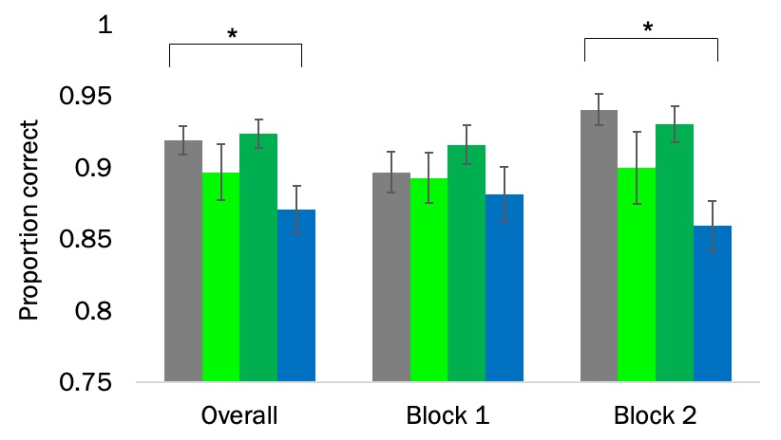 | B. Swap error proportion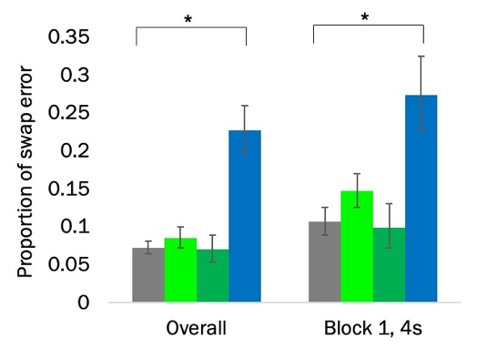
C. Localisation and NIC performance
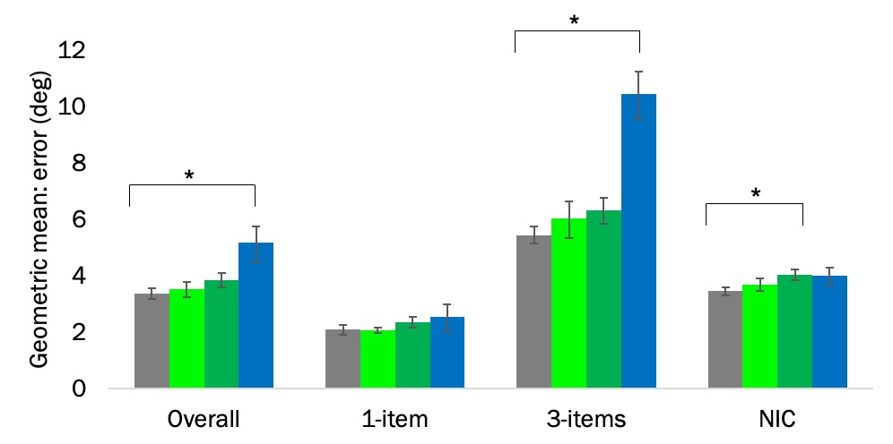
Figure-e3. Cross-sectional adjusted mean performance by group for the longitudinal sample (from model adjusted for age, sex and NART at baseline). A. Identification performance (across all conditions); B. Swap error proportion across all conditions and in the 4s delay, block 1 condition. C. Localisation and nearest item control (NIC) performance by item-number. Note that the NIC is by definition calculated with 3-items only. Error bars show +/- standard error of the mean. PMC=presymptomatic mutation carrier. *= significant at p<0.05.

