Inhibition of miR-937-3p by targeting SNCB ameliorates rotenone-induced toxicity in SH-SY5Y cells by reducing alpha-synuclein aggregation and apoptosis
Haewon Jeong ^{1,2,!}, Mahesh Ramalingam ^{1,!}, Jiyun Choi ¹, Jinsu Hwang ^{1,3}, Geupil Jang ^{4,*}, Hyong-Ho Cho ⁵, Byeong C. Kim ⁶, Sujeong Jang ^{1,2,}* and Han-Seong Jeong ^{1,2,}*
¹ Department of Physiology, Chonnam National University Medical School, Hwasun 58128, Jeollanam-do, Republic of Korea; haewon258@gmail.com (H.J.); jiyunchoi10@gmail.com (J.C.); wlstn0128@naver.com (J.H.); melanimahesh@gmail.com (M.R.)
² STEMCELL BIO Incorporation, Hwasun 58128, Jeollanam-do, Republic of Korea
³ Healthcare Advanced Chemical Research Institute, Korea Testing and Research Institute (KTR), Hwasun 58141, Jeollanam-do, Republic of Korea
⁴ School of Biological Sciences and Technology, Chonnam National University, Gwangju 61186, Republic of Korea; y3k@jnu.ac.kr (G.J.)
⁵ Department of Otolaryngology-Head and Neck Surgery, Chonnam National University Hospital, Chonnam National University Medical School, Gwangju 61469, Republic of Korea; victocho@hanmail.net (H.-H.C.)
⁶ Department of Neurology, Chonnam National University Hospital, Chonnam National University Medical School, Gwangju 61469, Republic of Korea; byeckim@gmail.com (B.C.K.)
!Equally contributed
* Correspondence: sujeong.jjang@gmail.com (S.J.); jhsjeong@hanmail.net (H.-S.J.); yk3@jnu.ac.kr (G.J.)

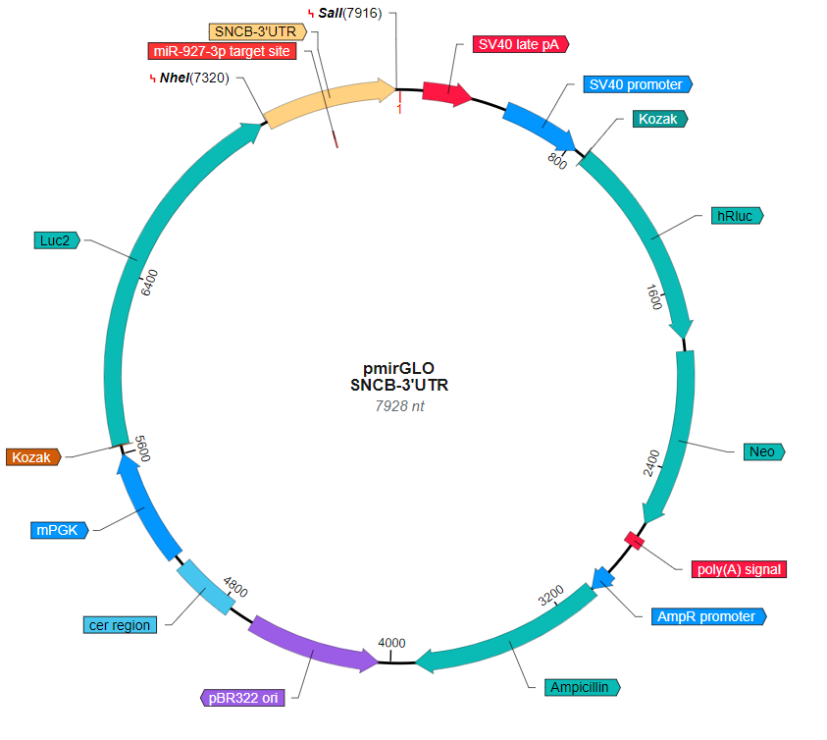
Figure S1. Plasmid vector map, including the WT-SNCB 3'-UTR used in the luciferase assay.

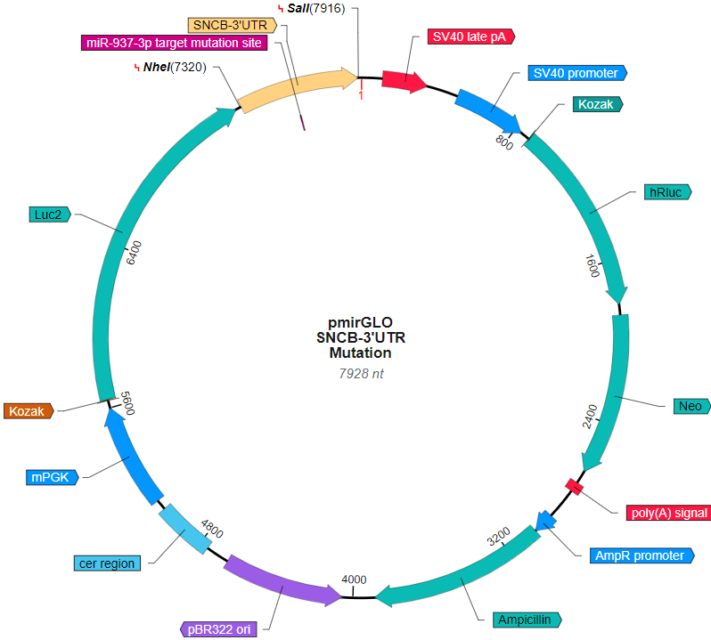
Figure S2. Plasmid vector map, including the Mut-SNCB 3'-UTR used in the luciferase assay.

Figure S3. Gene Ontology analysis of 94 target proteins from three databases: TargetScan, miRWalk, and miRmap. BP, Biological process, orange color bar; CC, Cellular component, green color bar; MF, Molecular function, blue color bar.

Figure S4. Cell viability test at different rotenone concentrations. Cells were incubated with different concentrations of ROT (0, 0.1, 0.3, 0.5, 0.7, 1, 3, and 5 μM) for 24 or 48 h and subjected to a CCK-8 assay. Data are presented as the mean ± SEM with n=4 and analyzed through one-way ANOVA followed by Bonferroni post hoc test. Statistical significance: *** p < 0.001 compared with 0 μM ROT group for 24 h; ### p < 0.001 compared with 0 μM ROT group for 48 h.

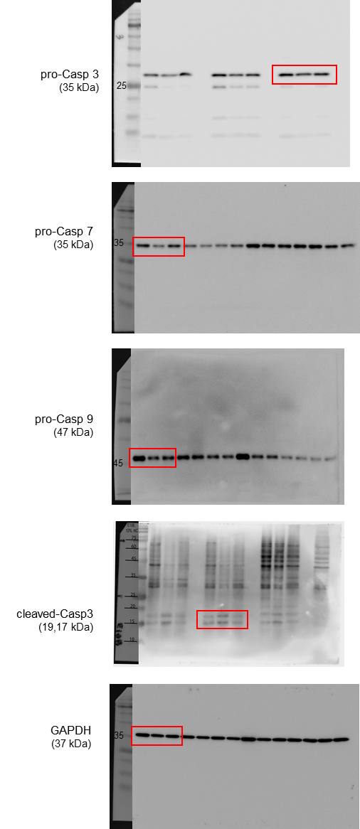
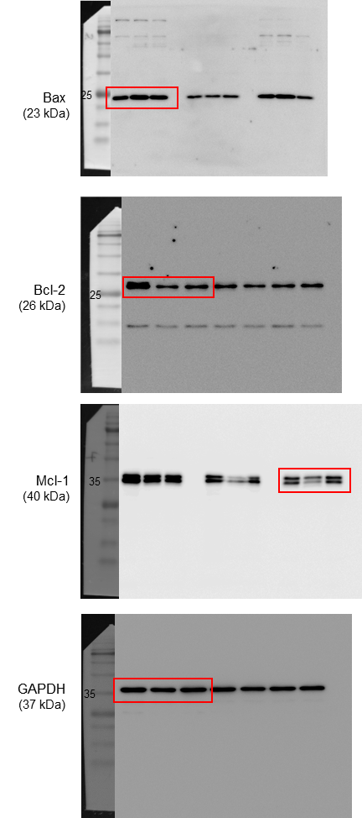
Figure S5. Original western blotting analysis image in Fig. 3 of this manuscript.

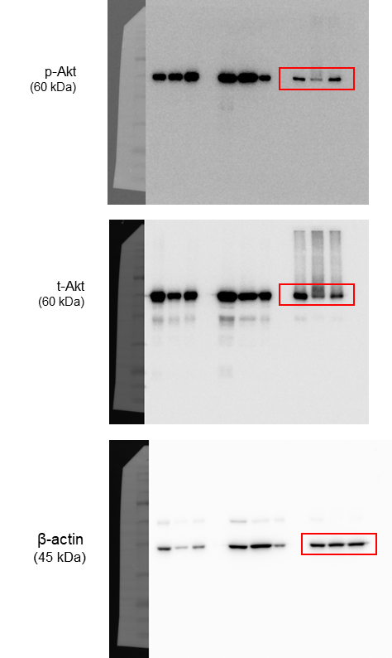

Figure S6. Original western blotting analysis image in Fig. 4 of this manuscript.

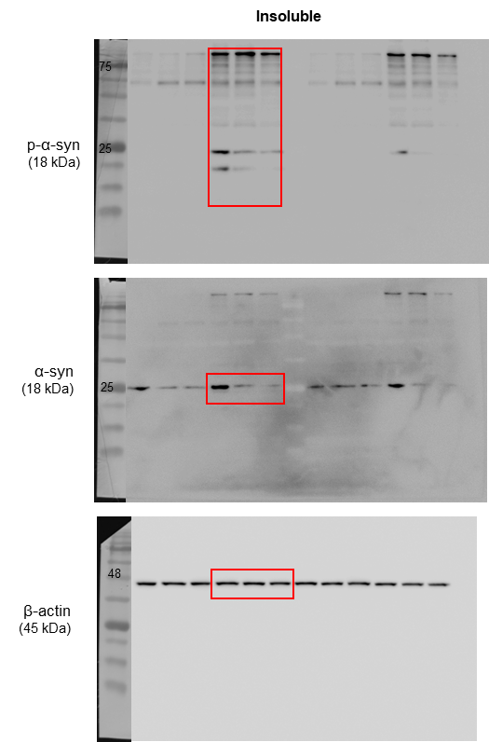
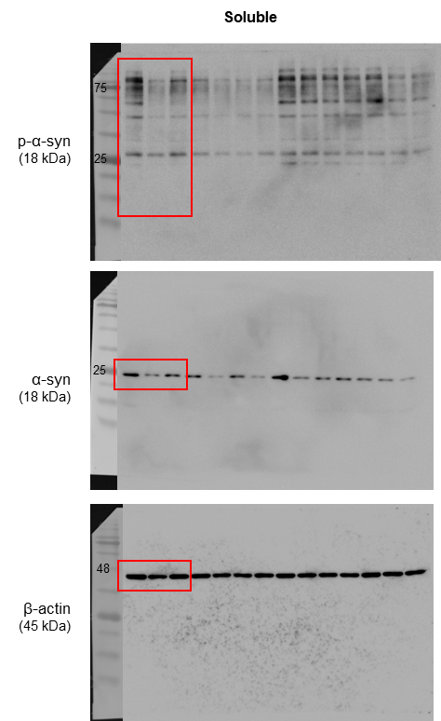
Figure S7. Original western blotting analysis image in Fig. 5 of this manuscript.

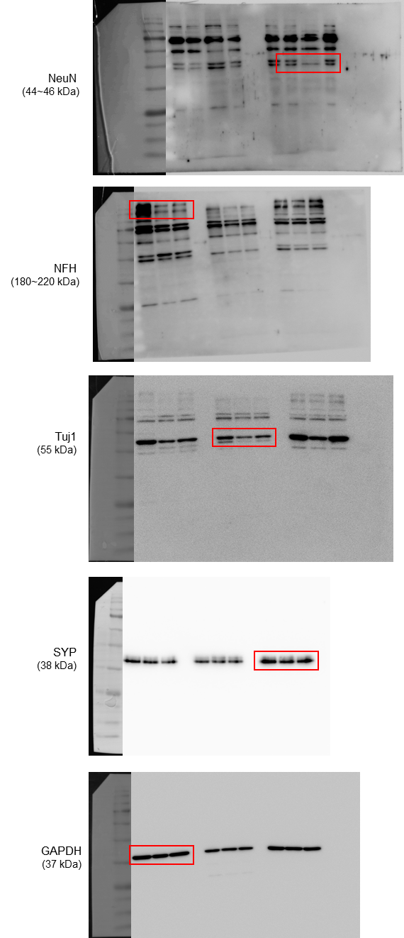
Figure S8. Original western blotting analysis image in Fig. 6 of this manuscript.

