Supplementary Figure S1. MHC II was immunoprecipitated from spleen (A) cDCs or (B) B cells isolated from C57BL/6 or Marchf1-/- mice. Eluates were digested with trypsin and analysed by mass spectrometry using Absolute QUAntification (AQUA methodology). Standard curves for different Ub chain linkage specific peptides were generated with known concentrations of heavy isotope labelled peptides added into a similar protein matrix. Peptide sequences and their respective monoisotopic precursor masses and charge states are indicated: K48-linked Ub peptide: LIFAGK(GG)QLEDGR; light m/z 487.600052+++, heavy m/z 490.9361+++, K63-linked Ub peptide: TLSDYNIQK(GG)ESTLHLVLR; light m/z 561.805025++++, heavy m/z 564.3071++++; light m/z 748.737608+++, heavy m/z 752.0737+++; K11-linked Ub peptide: TLTGK(GG)TITLEVEPSDTIENVK; light m/z 801.426876++, heavy m/z 804.0983+++. Endogenous (light) peptide intensities were quantified relative to heavy isotope labelled peptide concentrations using the standard curves. Each graph shows one experiment with three biological and three technical replicates.

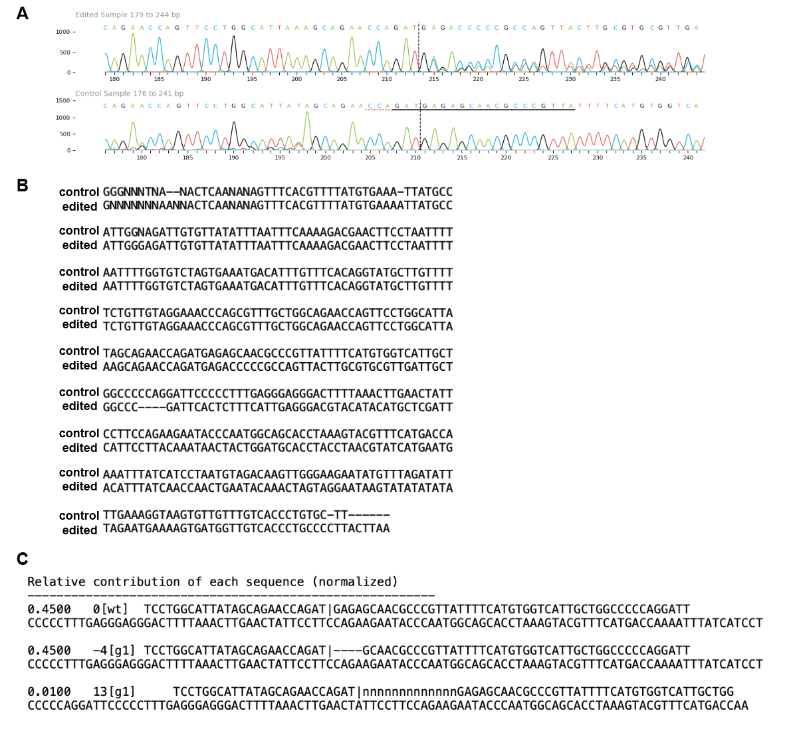
Supplementary Figure S2. A and B. Output of Sanger sequencing for UBE2N knockout Mutu DC clonal cell line generated by CRISPR/Cas9 sgRNA-mediated deletion of Ube2n. C. ICE CRISPR analysis of the Sanger sequencing data in A and B.

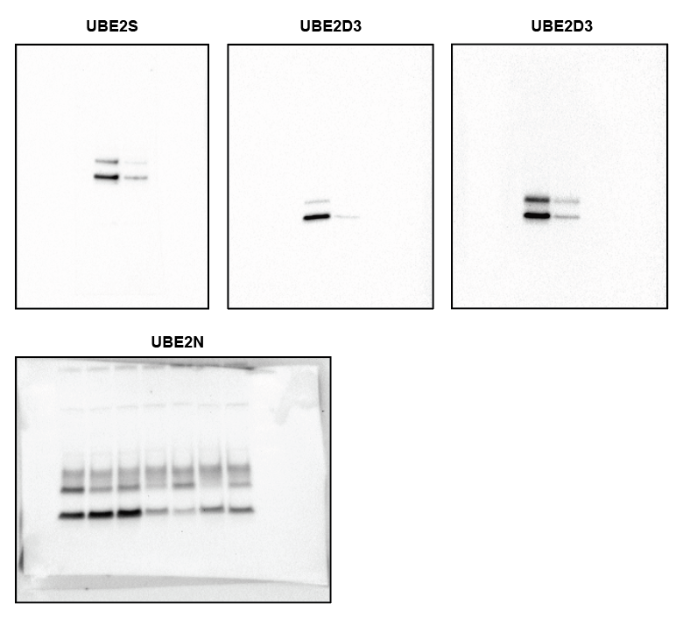

Supplementary Figure S3. Uncropped western blots for Figure 2A.

