Sánchez-Pavón et al. Supplementary Figures:

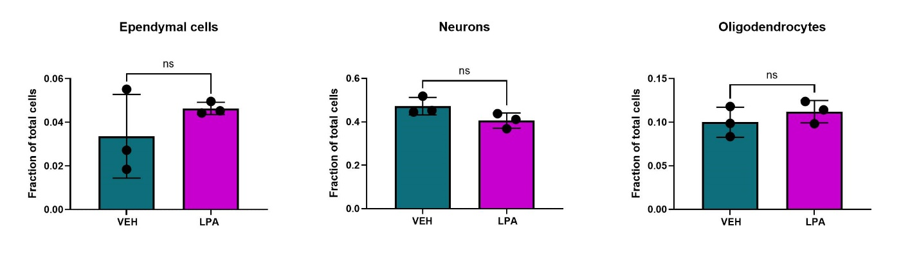Online Resource 1. Proportions of cell types from snRNA-seq data. Bars represent mean +/- s.d. and circles represent the value from individual mice.

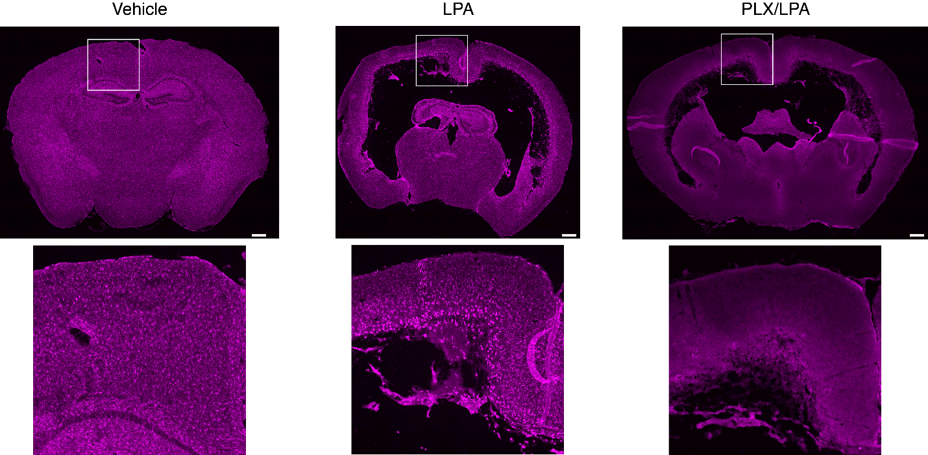
Online Resource 2. Microglial depletion shown as IBA1 staining of mouse brain at 7 days after the initiation of PLX3397 treatment. Scale bars are 500µm. Boxed areas are enlarged for clear visualization.
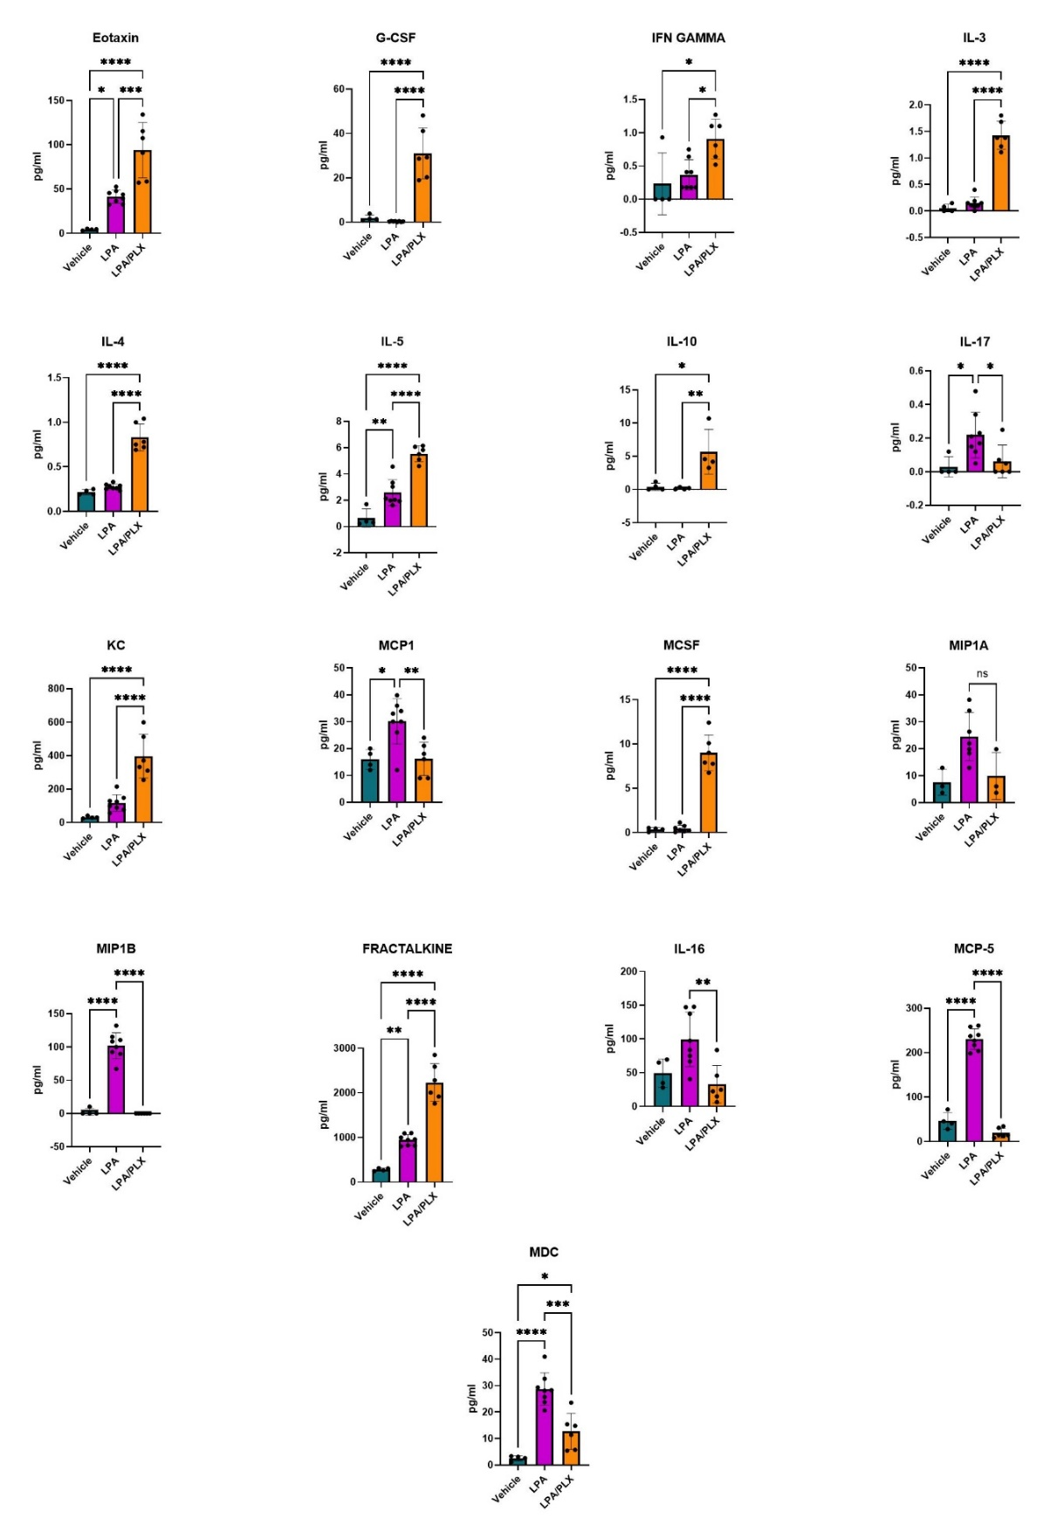
Online Resource 3. Quantification of chemokines and cytokines in CSF as measured by the mouse cytokine/chemokine 45-Plex Discovery Assay (MD45). p-values from ANOVA followed by post-test with Tukey’s correction for multiple comparisons: *p < 0.05, **p < 0.01, ***p < 0.001, ****p < 0.0001.

