Main Concept | # | Research strategy
A  (Population) | #1 | TITLE-ABS-KEY (‘cancer’ OR ‘chemotherapy’ OR ‘child’ OR ‘hematology’ OR ‘osteosarcome’ OR ‘leukemia’)
B  (Intervention) | #2 | TITLE-ABS-KEY ('art therapy' OR ‘drawing’ OR ‘filial therapy’ OR ‘occupational therapy’ OR ‘play-based’ OR 'play therapy')
C  (Outcomes) | #3 | TITLE-ABS-KEY ('anxiety' OR ‘depression’ OR 'fatigue' OR 'pain' OR ‘stress’ OR ‘symptoms’)
D  (Study Type) | #4 | TITLE-ABS-KEY ('controlled clinical trial' OR 'randomized controlled trial')
Limitations: (Language [English] AND publication years [2014.01.01-2024.12.31])
1 AND 2 AND 3 AND 4
(‘cancer’ OR ‘chemotherapy’ OR ‘child’ OR ‘hematology’ OR ‘osteosarcome’ OR ‘leukemia’) AND ('art therapy' OR ‘drawing’ OR ‘filial therapy’ OR ‘occupational therapy’ OR ‘play-based’ OR 'play therapy') AND ('anxiety' OR ‘depression’ OR 'fatigue' OR 'pain' OR ‘stress’ OR ‘symptoms’) AND ('controlled clinical trial' OR 'randomized controlled trial')
Combined search results: 1.613
Cochrane (March 15th, 2025)

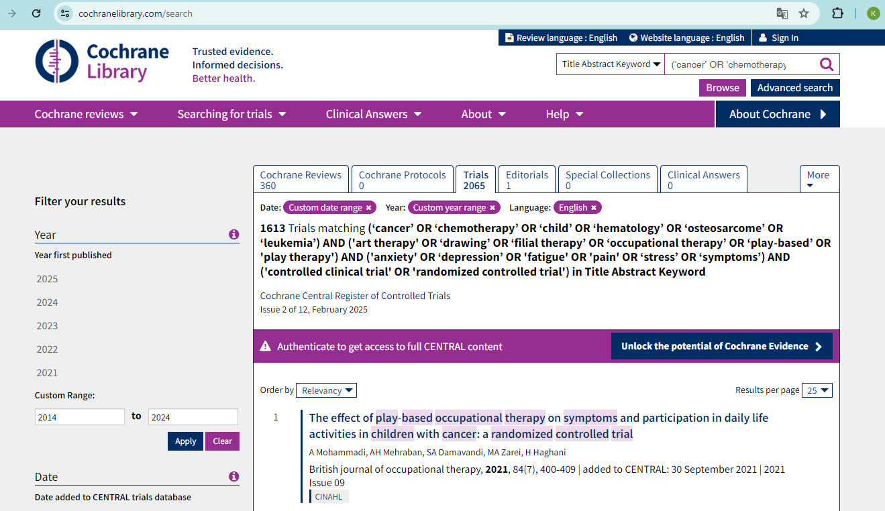
MEDLINE (March 15th, 2025)
Main Concept | # | Research strategy
A  (Population) | #1 | MM (‘cancer’ OR ‘chemotherapy’ OR ‘child’ OR ‘hematology’ OR ‘osteosarcome’ OR ‘leukemia’) OR AB (‘cancer’ OR ‘chemotherapy’ OR ‘child’ OR ‘hematology’ OR ‘osteosarcome’ OR ‘leukemia’) OR TI (‘cancer’ OR ‘chemotherapy’ OR ‘child’ OR ‘hematology’ OR ‘osteosarcome’ OR ‘leukemia’)
B  (Intervention) | #2 | MM ('art therapy' OR ‘drawing’ OR ‘filial therapy’ OR ‘occupational therapy’ OR ‘play-based’ OR 'play therapy') OR AB ('art therapy' OR ‘drawing’ OR ‘filial therapy’ OR ‘occupational therapy’ OR ‘play-based’ OR 'play therapy') OR TI ('art therapy' OR ‘drawing’ OR ‘filial therapy’ OR ‘occupational therapy’ OR ‘play-based’ OR 'play therapy')
C  (Outcomes) | #3 | MM ('anxiety' OR ‘depression’ OR 'fatigue' OR 'pain' OR ‘stress’ OR ‘symptoms’) OR AB ('anxiety' OR ‘depression’ OR 'fatigue' OR 'pain' OR ‘stress’ OR ‘symptoms’) OR TI ('anxiety' OR ‘depression’ OR 'fatigue' OR 'pain' OR ‘stress’ OR ‘symptoms’)
D  (Study Type) | #4 | MM ("randomized controlled trial" OR PT ("controlled clinical trial" OR "randomized controlled trial") OR TI ("controlled clinical trial" OR "randomized controlled trial") OR AB ("controlled clinical trial" OR "randomized controlled trial")
Limitations: -
1 AND 2 AND 3 AND 4
( MM (‘cancer’ OR ‘chemotherapy’ OR ‘child’ OR ‘hematology’ OR ‘osteosarcome’ OR ‘leukemia’) OR AB (‘cancer’ OR ‘chemotherapy’ OR ‘child’ OR ‘hematology’ OR ‘osteosarcome’ OR ‘leukemia’) OR TI (‘cancer’ OR ‘chemotherapy’ OR ‘child’ OR ‘hematology’ OR ‘osteosarcome’ OR ‘leukemia’)) AND ( MM ('art therapy' OR ‘drawing’ OR ‘filial therapy’ OR ‘occupational therapy’ OR ‘play-based’ OR 'play therapy') OR AB ('art therapy' OR ‘drawing’ OR ‘filial therapy’ OR ‘occupational therapy’ OR ‘play-based’ OR 'play therapy') OR TI ('art therapy' OR ‘drawing’ OR ‘filial therapy’ OR ‘occupational therapy’ OR ‘play-based’ OR 'play therapy')) AND ( MM ('anxiety' OR ‘depression’ OR 'fatigue' OR 'pain' OR ‘stress’ OR ‘symptoms’) OR AB ('anxiety' OR ‘depression’ OR 'fatigue' OR 'pain' OR ‘stress’ OR ‘symptoms’) OR TI ('anxiety' OR ‘depression’ OR 'fatigue' OR 'pain' OR ‘stress’ OR ‘symptoms’)) AND ( MM ("randomized controlled trial" OR PT ("controlled clinical trial" OR "randomized controlled trial") OR TI ("controlled clinical trial" OR "randomized controlled trial") OR AB ("controlled clinical trial" OR "randomized controlled trial"))
Combined search results: 287

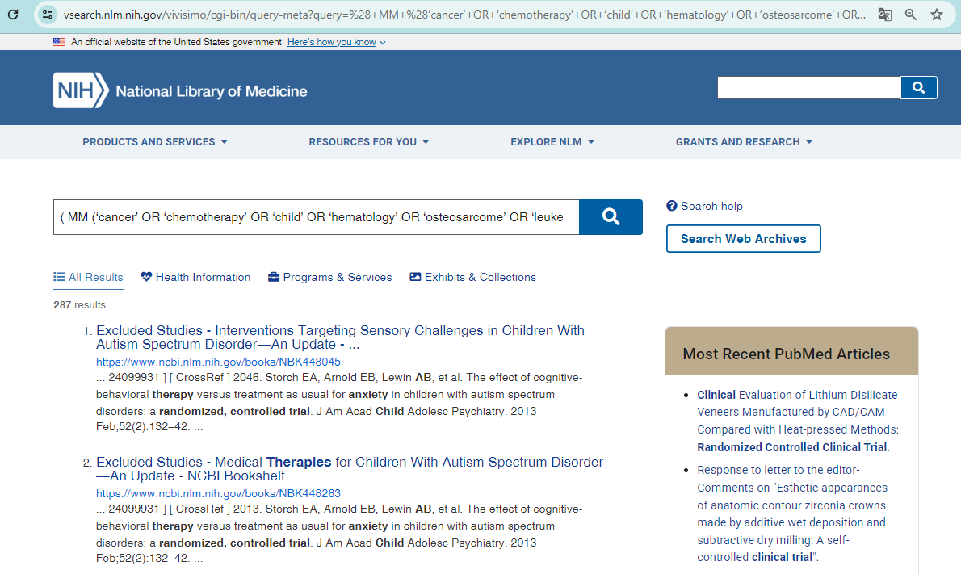

Main Concept | # | Research strategy
A  (Population) | #1 | (Title/Abstract (‘cancer’ OR ‘chemotherapy’ OR ‘child’ OR ‘hematology’ OR ‘osteosarcome’ OR ‘leukemia’))
B  (Intervention) | #2 | (Title/Abstract ('art therapy' OR ‘drawing’ OR ‘filial therapy’ OR ‘occupational therapy’ OR ‘play-based’ OR 'play therapy'))
C  (Outcomes) | #3 | ((Title/Abstract ('anxiety' OR ‘depression’ OR 'fatigue' OR 'pain' OR ‘stress’ OR ‘symptoms’))
D  (Study Type) | #4 | ("randomized controlled trial"[Publication Type])
Limitations: (Language [English] AND publication years [2014.01.01-2024.12.31] publication type [Scholarly Journals])
1 AND 2 AND 3 AND 4
(Title/Abstract ("cancer" OR "chemotherapy" OR "child" OR "hematology" OR "osteosarcoma" OR "leukemia")) AND (Title/Abstract ("art therapy" OR "drawing" OR "filial therapy" OR "occupational therapy" OR "play-based" OR "play therapy")) AND (Title/Abstract ("anxiety" OR "depression" OR "fatigue" OR "pain" OR "stress" OR "symptoms")) AND ("randomized controlled trial"[Publication Type])
Combined search results: 434
Proquest (March 15th, 2025)

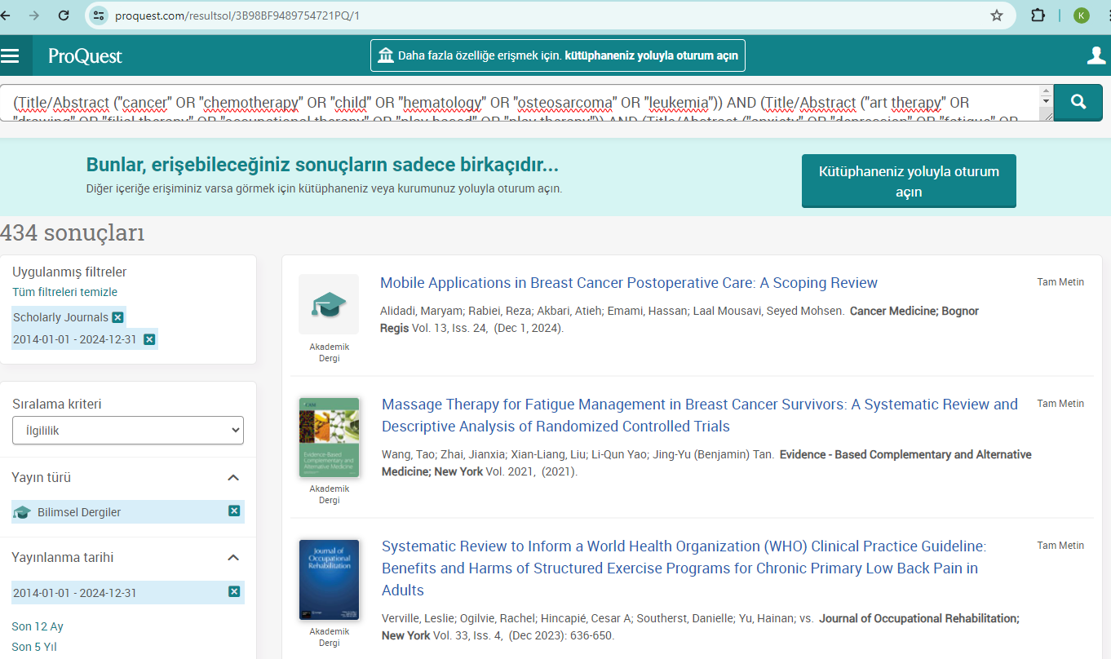

PubMED (March 15th, 2025)

Main Concept | # | Research strategy
A  (Population) | #1 | ("cancer"[Title/Abstract] OR "chemotherapy"[Title/Abstract] OR "child"[Title/Abstract] OR "hematology"[Title/Abstract] OR "osteosarcoma"[MeSH Terms] OR "leukemia"[MeSH Terms])
B  (Intervention) | #2 | ("art therapy"[MeSH Terms] OR "drawing"[Title/Abstract] OR "filial therapy"[Title/Abstract] OR "play-based"[Title/Abstract] OR "play therapy"[MeSH Terms] OR "occupational therapy"[Title/Abstract])
C  (Outcomes) | #3 | ("anxiety"[Title/Abstract] OR "depression"[Title/Abstract] OR "fatigue"[MeSH Terms] OR "pain"[MeSH Terms] OR "stress"[MeSH Terms] OR "symptoms"[Title/Abstract])
D  (Study Type) | #4 | ("randomized controlled trial"[Publication Type] OR "randomized controlled trial"[Title/Abstract] OR "controlled clinical trial"[Title/Abstract])
Limitations: (Language [English] AND publication years [2014.01.01-2024.12.31] article type [Randomized Controlled Trial])
1 AND 2 AND 3 AND 4
("cancer"[Title/Abstract] OR "chemotherapy"[Title/Abstract] OR "child"[Title/Abstract] OR "hematology"[Title/Abstract] OR "osteosarcoma"[MeSH Terms] OR "leukemia"[MeSH Terms]) AND ("art therapy"[MeSH Terms] OR "drawing"[Title/Abstract] OR "filial therapy"[Title/Abstract] OR "play-based"[Title/Abstract] OR "play therapy"[MeSH Terms] OR "occupational therapy"[Title/Abstract]) AND ("anxiety"[Title/Abstract] OR "depression"[Title/Abstract] OR "fatigue"[MeSH Terms] OR "pain"[MeSH Terms] OR "stress"[MeSH Terms] OR "symptoms"[Title/Abstract]) AND ("randomized controlled trial"[Publication Type] OR "randomized controlled trial"[Title/Abstract] OR "controlled clinical trial"[Title/Abstract])
Combined search results: 41
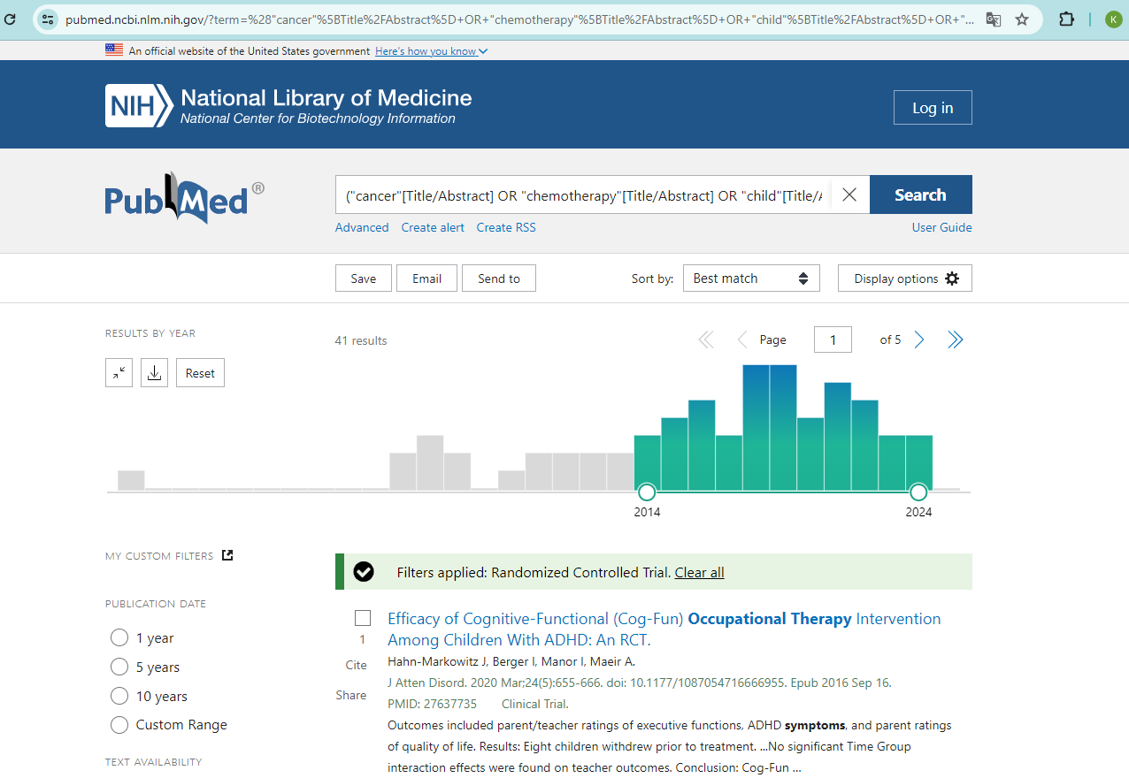

Scopus (March 15th, 2025)

Main Concept | # | Research strategy
A  (Population) | #1 | TITLE-ABS-KEY (‘cancer’ OR ‘chemotherapy’ OR ‘child’ OR ‘hematology’ OR ‘osteosarcome’ OR ‘leukemia’)
B  (Intervention) | #2 | TITLE-ABS-KEY ('art therapy' OR ‘drawing’ OR ‘filial therapy’ OR ‘occupational therapy’ OR ‘play-based’ OR 'play therapy')
C  (Outcomes) | #3 | TITLE-ABS-KEY ('anxiety' OR ‘depression’ OR 'fatigue' OR 'pain' OR ‘stress’ OR ‘symptoms’)
D  (Study Type) | #4 | TITLE-ABS-KEY ('controlled clinical trial' OR 'randomized controlled trial')
Limitations: (Language [English] AND publication years [2014-2024] AND document type [Article])
1 AND 2 AND 3 AND 4
(‘cancer’ OR ‘chemotherapy’ OR ‘child’ OR ‘hematology’ OR ‘osteosarcome’ OR ‘leukemia’) AND ('art therapy' OR ‘drawing’ OR ‘filial therapy’ OR ‘occupational therapy’ OR ‘play-based’ OR 'play therapy') AND ('anxiety' OR ‘depression’ OR 'fatigue' OR 'pain' OR ‘stress’ OR ‘symptoms’) AND ('controlled clinical trial' OR 'randomized controlled trial')
Combined search results: 176
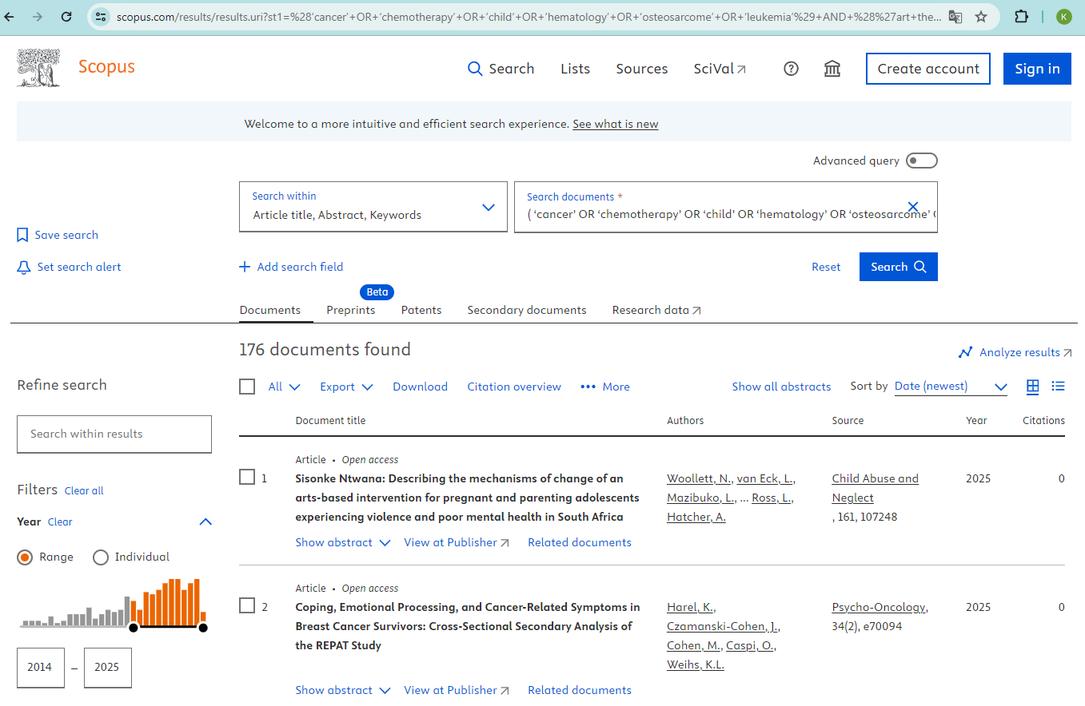

Web Of Science (March 15th, 2025)

Main Concept | # | Research strategy
A  (Population) | #1 | (‘cancer’ OR ‘chemotherapy’ OR ‘child’ OR ‘hematology’ OR ‘osteosarcome’ OR ‘leukemia’)
B  (Intervention) | #2 | ('art therapy' OR ‘drawing’ OR ‘filial therapy’ OR ‘occupational therapy’ OR ‘play-based’ OR 'play therapy')
C  (Outcomes) | #3 | ('anxiety' OR ‘depression’ OR 'fatigue' OR 'pain' OR ‘stress’ OR ‘symptoms’)
D  (Study Type) | #4 | ('controlled clinical trial' OR 'randomized controlled trial')
Limitations: (Language [English] AND publication years [2014.01.01-2024.12.31] document types [Article-Nor Review Article])
1 AND 2 AND 3 AND 4
(‘cancer’ OR ‘chemotherapy’ OR ‘child’ OR ‘hematology’ OR ‘osteosarcome’ OR ‘leukemia’) AND ('art therapy' OR ‘drawing’ OR ‘filial therapy’ OR ‘occupational therapy’ OR ‘play-based’ OR 'play therapy') AND ('anxiety' OR ‘depression’ OR 'fatigue' OR 'pain' OR ‘stress’ OR ‘symptoms’) AND ('controlled clinical trial' OR 'randomized controlled trial')
Combined search results: 993

