Table 1 Speech Graph Attributes (SGA) and Graph Spectral Measures (GSM), adapted from ^{21, 25, 35}.
Attribute | Definition
General Attributes
Nodes (N) | Number of elements in N | 
Edges (E) | Number of elements in E | 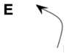
Connectivity Attributes
Largest connected component (LCC) | The maximal subgraph in which all pairs of nodes are reachable from one another in the underlying undirected subgraph. | 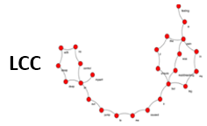
Largest strongly connected component (LSC) | The maximal subgraph in which all pairs of nodes are reachable from one another in the directed subgraph. | 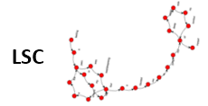
Average total degree (ATD) | The Total Degree is the sum of “in and out” edges, and the Average Total Degree is the sum of Total Degrees of all nodes divided by the number of nodes.
Recurrence Attributes
Repeated Edges (RE) | Sum of all edges linking the same pair of nodes | 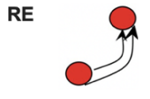
Parallel edges (PE) | Sum of all parallel edges linking the same pair of nodes given that the source node of an edge could be the target node of the parallel edge. | 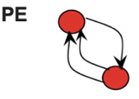
Cycles of 1, 2, or 3 nodes (L1, L2, L3) | Calculated as the trace of the adjacency matrix to the 1, 2 or 3 power, divided by 1, 2 or 3 respectively | 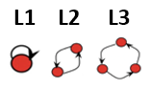
Global Measures
Density | D = 2E/N(N − 1); E is the number of edges, N is the number of nodes.
Diameter | Length of the longest shortest path between the node pairs of a network.
Average shortest path (ASP) | Average length of the shortest path between pairs of nodes of a network.
Segregation Measure
Clustering coefficient (CC) | Average CC is the sum of the Clustering Coefficients of all nodes in the CC Map divided by number of elements in the CC Map.
Graph Spectral Measures
Spectral Radius | The largest eigenvalue
Spectral Gap | The difference between the largest and second largest eigenvalues
Fiedler Value | The second-smallest eigenvalue, also called algebraic connectivity
Eigenratio | The ratio of the spectral radius to the Fiedler Value
Table 4. Demonstrated differences in dream reports of late and congenitally blind groups versus sighted controls.

Domain | Speech Graph Attributes | Essential Trends in LB and CB
Domain | Speech Graph Attributes | Structure | Semantics
General | Nodes  | ↓ | ↓ lexical diversity
General | 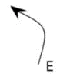  Edges | ↑ | ↑
Connectivity | LSC | ↑ | ↑
Connectivity | LCC | NS | NS
Connectivity | ATD | ↑ | ↑
Segregation | CC | ↑ | ↑
Recursiveness | PE | ↑ | ↑
Recursiveness | RE | ↑ | ↑
Recursiveness | L1 | NS | ↑
Recursiveness | 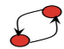  L2 | ↑(only in LB) | ↑
Recursiveness | 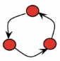  L3 | ↑ (only in LB) | ↑
Global | Density | ↑ (a stats trend in LB) | ↑
Global | Diameter | NS | N/A
Global | Diameter of LCC | N/A | NS
Global | ASP | NS | N/A
Global | ASP of LCC | N/A | NS

Notes: here trends of SGA analysis for structural graphs are described for a 30-word moving window approach and a whole text approach together, if not indicated otherwise.

Abbreviations and symbols: ATD; Average total distance, ASP; Average shortest path, CB; Congenitally Blind, CC; Clustering Coefficient, G; graphs, LB; Late Blind, LCC; Largest Connected Component, LSC; Largest strongly connected component, L1; Cycles of one node, L2; Cycles of two nodes, L3; Cycles of three nodes, N/A; not applicable, PE; parallel edges, RE; repeated edges, SC; Sighted Controls, SGA; Speech Graph Attributes, ↑; higher, ; nodes.

