Appendix

Section 1. Creation and content validation of knowledge questionnaires
At the time the survey was being constructed (May 2022), the only knowledge questionnaires for AMD risk factors were developed by Zhang et al ¹. and Thapa et al²( Tables 5A and 5B). However, there was no evidence that these instruments had been formally validated. Hence, a new knowledge of AMD risk factors questionnaire based on previous literature and clinical guidelines for AMD was developed³⁻⁷, and content validation undertaken ⁸.
Content validation is a means of ensuring that the instrument “includes all necessary items, avoids unnecessary items, and is generally appropriately framed and presented” ⁹. To achieve this, an anonymous survey in Qualtrics was initially prepared with the i) 13-item Knowledge and Perceptions of Lifestyle and Individual Risk Factors and ii) an 8-item instrument named Knowledge and Perceptions of Dietary Risk Factors. Each item in both instruments was assessed by five AMD researchers in the Centre for Public Health, Queen’s University Belfast (CPH QUB) for relevance and clarity. The relevance scale was as follows: 1(not relevant); 2(item need some revision); 3(relevant but need some revision); 4(very relevant). The clarity scale was: 1(not clear); 2(item need some revision); 3(clear but need some minor revision); 4(very clear). Then followed open-ended comment boxes whereby participants could provide suggestions on how to improve clarity and relevance, and suggestions for additional dietary and lifestyle factors.

Section 2. Analysis for content validation
First, the response for the relevance scale was dichotomized by combining values 1 and 2, and 3 and 4 together, yielding two categorical outcomes that are “not relevant” or “relevant” respectively¹⁰. The dichotomous categories were then applied to all responses. Items that were not considered relevant by 4/5 of the experts were considered to have low content validity and therefore removed or altered according to respondent feedback from open-ended responses¹¹. A similar method was used for the clarity scale: items that were not considered clear by 4/5 of the experts were deleted or altered following suggestions from the open-ended responses.
Out of the 13 items in the instrument that assessed knowledge of the lifestyle and individual factors, three items were considered irrelevant and subsequently removed. Three items were considered unclear [1. Obesity (BMI 30kg/m2 or over), 2. Smoking and 3.Being Caucasian]. As per suggestions of the respondent, “Obesity (BMI 30kg/m2 or over)” was altered to “Being extremely overweight”, “Smoking” clarified to “Currently a cigarette smoker”, and “Being Caucasian” altered to “Being a white European”. Cardiovascular disease was suggested as an additional lifestyle and individual risk factor. All the items in the dietary risk factor questionnaire were considered relevant and clear by at least 4/5 of the respondents.

T5A. Awareness of AMD risk factors developed by Thapa et al².
Are you aware of AMD?
Do you know smoking aggravates AMD?
Do you know sunlight exposure aggravates AMD?
Do you know green vegetables and fish protect against AMD?
Do you know that certain vitamin help slow AMD progression?

T5B. Risk factors from Zhang et al.’s interview-based study¹.
Unprotected exposure to sunlight | Alcohol | Diabetes
Lack of vitamins/nutrients | Obesity | Computer use
Age | Genetics | Race
Hypertension | Sex/gender
Hyperlipidaemia | Smoking

Section 3. Preparing scoring system for knowledge, and cooking and food skills questionnaires
After content validation, a scoring method was made based on responses to the question “How do you think the dietary behaviours/lifestyle and individual factors below impact risk of AMD?” based on guidelines relevant in the UK setting, or if unavailable, the available literature at the time of survey construction (2022). Guidelines referred to included the National Institute for Health and Care Excellence (NICE) ⁵, British Medical Journal (BMJ) ⁶, Clinical Knowledge Summaries (CKS)¹³, American Academy of Ophthalmology (AAO) ⁷, and Royal College of Ophthalmologists (RCOP) ⁴ (Tables 5C and 5D). Since the target population would be relatives of AMD patients, the items were specified further for risk factors for incident AMD. Hence, in the lifestyle and individual risk factors questionnaire, “Being Caucasian” and cardiovascular disease were removed since guidelines (AAO and CKS respectively) considered them as risk factors for AMD progression rather than incident AMD. In the dietary questionnaire, “Eating fruits”, “Eating vegetables” and “Intake of carotenoids from supplements” were removed as guidelines (BMJ and AAO) considered them as risk factors of AMD progression. There was no source for scoring from guidelines on the item “Alcohol intake”; one published commentary stated that no recommendation could be made as regards alcohol intake, hence this item was removed from the instrument¹². Missing values were also addressed during or before exploratory factor analysis (EFA). If the participant missed an item in the diet quality questionnaire, it was assumed that the food was not consumed. Similarly, if an item in the food score and cooking questionnaire was not selected, it was assumed that the participant did not perform other food and cooking methods. Total confidence in food prepping and cooking skills were calculated from the sum across each item in the respective instruments. However, if there were no responses across the food and cooking skills instrument, the food and cook scores were considered missing. For other instruments, missing data (n=30) were imputed using the mifa function from the mifa package in R (V 0.2.0) and then proceeded to EFA analysis¹³.

T5C. The scoring system of the knowledge questionnaire on the risk of dietary risk factors on developing AMD is based on current best practice guidelines.
How do you think the dietary behaviours below impact risk of AMD? | INCREASES RISK | DECREASES RISK | NO EFFECT | DON'T KNOW | Source
Intake of carotenoids (a substance found highly in foods like fruits and vegetables) | -1.5 |  |  |  | NICE:a diet low in carotenoids is a risk factor of AMD. They do not say carotenoids decrease risk of AMD. Hence, this is reflected in the scoring.
Eating fish |  | +1 |  |  | BMJ
Intake of saturated fats (these are a specific type of fat high in red meat, cheese and milk) | +1 |  |  |  | NICE
Intake of omega-3 and omega-6 fats (these are also specific types of fat) | -1.5 |  |  |  | NICE:a diet low in carotenoids is a risk factor of AMD. They do not say carotenoids decrease risk of AMD. Hence, this is reflected in the scoring.
Note: NICE= National Institute for Health and Care Excellence⁵; BMJ= British Medical Journal⁶. Max score= 2, Min score= -3 .

T5D. The scoring system of the knowledge questionnaire based on the risk of individual and lifestyle risk factors for developing AMD is based on current best practice guidelines.
How do you think the lifestyle and individual factors below impact risk of AMD? | INCREASES RISK | DECREASES RISK | NO EFFECT | DON'T KNOW | Source
Physical activity | -1.5 |  |  |  | NICE: lack of exercise increases AMD risk
High blood pressure (or hypertension) | +1 |  |  |  | NICE
Being extremely overweight | +1 |  |  |  | NICE
Ageing | +1 |  |  |  | NICE, RCOP
Family history of AMD | +1 |  |  |  | NICE
Currently a cigarette smoker | +1 |  |  |  | NICE
Genetic background |  |  | -1.5 |  | RCOP and AAO acknowledge the effect of genetics in development of AMD. AAO highlight that some genetic risk factors require further investigation. RCOP highlight that not all those with AMD have genetic risk variants.

Note: National Institute for Health and Care Excellence⁵; RCOP= Royal College of Ophthalmologists⁴; AAO= American Academy of Ophthalmology⁷. Max score= 5; Min score= -

Section 4. Analysis via exploratory factor analysis
The questionnaires were validated via exploratory factor analysis (EFA) and reliability tests, and subsequently reduced the number of items in the EFA-validated instruments. EFA is a means of measuring the correlation between items in the questionnaire and whether items could be grouped to capture a specific unobservable factor¹⁴. The extent to which an item is related to the unobservable factor is termed “factor loading” (FL). According to de Winter et al., the minimum sample for validation via EFA is 18 provided that the FL of at least 6 items or more in a questionnaire is at least 0.6 with minimal lower variation¹⁵. FL of EFA was attained via quartimax rotation to fit the questionnaire items into a simple structure¹⁶. Cronbach’s alpha was used to measure the reliability of the final model.

Section 5. Exploratory factor analysis results
Since the minimum sample size of 18 was surpassed¹⁵, EFA was undertaken. Both the responses from other instruments and demographic features of the sample were used as predictors for imputation. EFA provided a model with six or seven items for each instrument with all attaining either perfect simple structure¹⁷ or with minimal lower variation from 0.6 (minimum item FL=0.529; mean total FL of all instruments ≥ 7.02). Subsequently, item reduction was performed for all instruments apart from the single-item Food Choice Questionnaire to attain a perfect simple structure with at least six items [Social influence questionnaire: from eight to seven items (F8A); cues to action questionnaire 10 to six (F8B); food skills 19 to six (F8C); and cooking skills from 14 to seven items (F8D)]. All instruments reported strong reliability upon EFA (Cronbach’s alpha ≥0.8). Furthermore, since only one instrument captures a factor, there were no cross-loadings.

F8A.Validated social influences questionnaire, Cronbach’s alpha (CA) and factor loadings (FL)
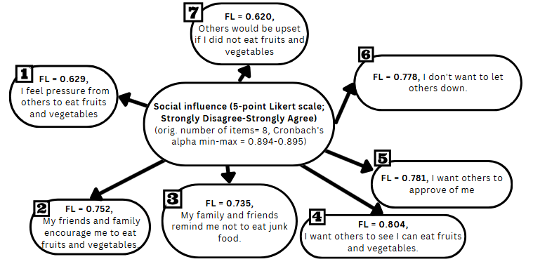

F8B.Validated cues to action questionnaire, Cronbach’s alpha (CA) and factor loadings (FL)

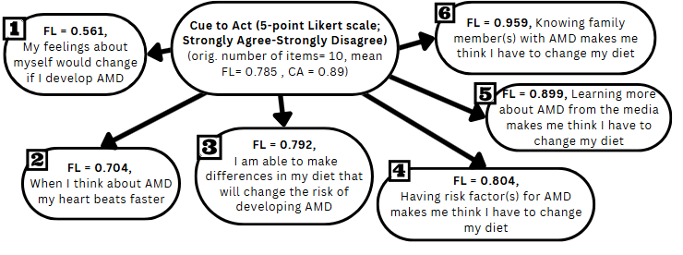

F8C.Validated food skills questionnaire, Cronbach’s alpha (CA) and factor loadings (FL)
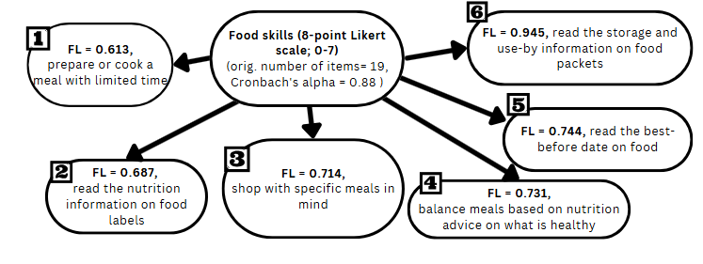

F8D.Validated cooking skills questionnaire, Cronbach’s alpha (CA) and factor loadings (FL)
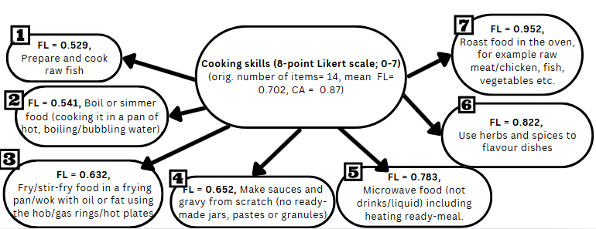

T6. The original items and scoring system for diet quality taken from Trial to Encourage Adoption and Maintenance of a MEditerranean Diet (TEAM-MED) study^{18, 19}.

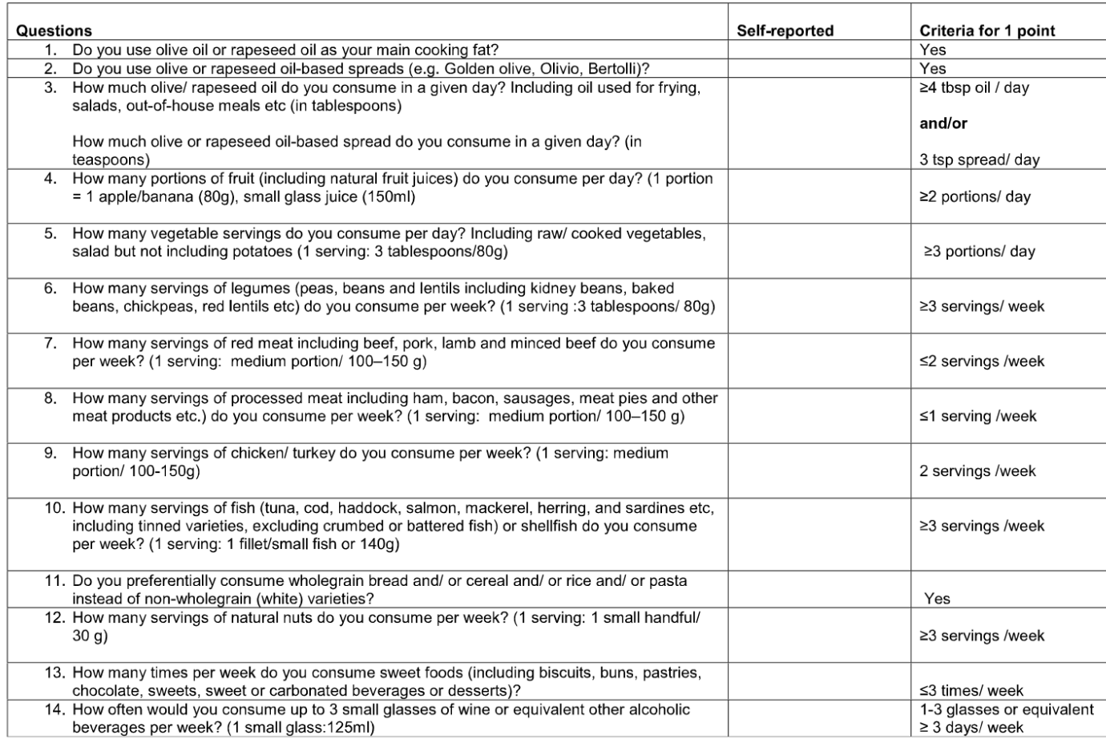
Note: The tense was altered to past tense as the timeframe of dietary intake was specified to over the last month (i.e., the last four weeks). The scoring system was unchanged. Range 0-14.

T7. Fish intake and COM-B model
COM-B model for fish intake | CAPABILITY |  | OPPORTUNITY |  | MOTIVATION
COM-B categories | PSYCHOLOGICAL | PHYSICAL | SOCIAL | PHYSICAL | AUTOMATIC | REFLECTIVE
Food choice questionnaire | °Familiarity  C=-0.128; -0.121 |  |  | °Affordability  C=-0.044; -0.024  °Convenience  C=-0.038; -0.005 | °Mood  C=-0.041; -0.04  °Sensory appeal  C=0.122; 0.141 | °Weight control  C=0.022; 0.027  °Natural content  C=-0.025; -0.005  °Health  C=0.21; 0.217  °Environmental friendliness  C=-0.086; -0.077  °Animal friendliness  C=-0.065; -0.043  °Fairly traded  C=-0.237; -0.212
Cooking and Food skills Questionnaire |  | °Cooking skills score  C= 0.016  °Food skills confidence score  C=-0.116
Social norms/ Theory of Planned Behaviour |  |  | °Perceived social norms  C= -0.055; -0.038
Cues to Action Questionnaire |  |  |  |  |  | °Cues to action  C=-0.041; -0.04
Knowledge Questionnaire | °Knowledge score diet  C=0.007  °Knowledge score individual/lifestyle  C=0.211
Intervention types | Ed, En, Tr | En, Tr | En, Er, Mo, Re | En, Er, Re, Tr | Co, En, Er, In, Mo, Pe, Tr | Co, Ed, In, Mo, Pe
Emboldened are significantly correlated with fish intake. C=Correlation. Underlined and italicised indicate relevant behaviour change intervention types. Ed= Education; En= Enablement; Er= Environmental restructuring; Co= Coercion; In= Incentivisation; Mo= Modelling; Pe= Persuasion; Re= Restriction; Tr= Training.

References
1. Zhang CX, Zhang GM, Ma N, Xia S, Yang JY, Chen YX. Awareness of Age-related Macular Degeneration and Its Risk Factors among Beijing Residents in China. Chin Med J (Engl). 2017;130(2):155-9.
2. Thapa R, Bajimaya S, Paudyal G, Khanal S, Tan S, Thapa SS, et al. Population awareness of diabetic eye disease and age related macular degeneration in Nepal: the Bhaktapur Retina Study. BMC Ophthalmology. 2015;15(1):188.
3. Zhang C-X, Zhang G-M, Ma N, Xia S, Yang J-Y, Chen Y-X. Awareness of Age-related Macular Degeneration and Its Risk Factors among Beijing Residents in China. Chinese medical journal. 2017;130(2):155-9.
4. Royal College of Ophthalmologists. Commissioning Guidance - Age Related Macular Degeneration Services 2021 [Available from: https://www.rcophth.ac.uk/resources-listing/commissioning-guidance-age-related-macular-degeneration-services/.
5. National Institute of Health and Care Excellence. Age-related macular degeneration 2018 [Available from: https://www.nice.org.uk/guidance/ng82/evidence/full-guideline-pdf-170036251098.
6. Mahmood S. Age-related macular degeneration 2021 [updated 2021. Available from: https://bestpractice.bmj.com/info/.
7. Flaxel CJ, Adelman RA, Bailey ST, Fawzi A, Lim JI, Vemulakonda GA, et al. Age-Related Macular Degeneration Preferred Practice Pattern®. Ophthalmology. 2020;127(1):P1-p65.
8. Stevens R, Bartlett H, Walsh R, Cooke R. Age-related macular degeneration patients’ awareness of nutritional factors. British Journal of Visual Impairment. 2014;32(2):77-93.
9. Andrade C, Menon V, Ameen S, Kumar Praharaj S. Designing and Conducting Knowledge, Attitude, and Practice Surveys in Psychiatry: Practical Guidance. Indian Journal of Psychological Medicine. 2020;42(5):478-81.
10. Zamanzadeh V, Ghahramanian A, Rassouli M, Abbaszadeh A, Alavi-Majd H, Nikanfar AR. Design and Implementation Content Validity Study: Development of an instrument for measuring Patient-Centered Communication. J Caring Sci. 2015;4(2):165-78.
11. Gilbert G, Prion S. Making Sense of Methods and Measurement: Lawshe's Content Validity Index. Clinical Simulation in Nursing. 2016;12:530-1.
12. Su X, Wong TY. Revisiting the Alcohol Consumption Association With Age-Related Macular Degeneration: What Should We Tell Patients in 2021? JAMA Ophthalmology. 2021;139(12):1307-8.
13. Nassiri V, Lovik A, Molenberghs G, Verbeke G, Busch T, Busch MT. Package ‘mifa’. 2022.
14. Fontaine JRJ. Equivalence. In: Kempf-Leonard K, editor. Encyclopedia of Social Measurement. New York: Elsevier; 2005. p. 803-13.
15. de Winter JCF, Dodou D, Wieringa PA. Exploratory Factor Analysis With Small Sample Sizes. Multivariate Behavioral Research. 2009;44(2):147-81.
16. Wrigley C, Saunders DR, Neuhaus JO. Application of the Quartimax Method of Rotation to Thurstone's Primary Mental Abilities Study. Psychometrika. 1958;23(2):151-70.
17. Hirose K, Terada Y. Sparse and Simple Structure Estimation via Prenet Penalization. Psychometrika. 2023;88(4):1381-406.
18. Moore SE. Peer support to encourage adoption and maintenance of a Mediterranean diet: Queen's University Belfast; 2016.
19. McEvoy CT, Moore S, Erwin C, Kontogianni M, Wallace SM, Appleton KM, et al. Trial to Encourage Adoption and Maintenance of a MEditerranean Diet (TEAM-MED): a randomised pilot trial of a peer support intervention for dietary behaviour change in adults from a Northern European population at high CVD risk. British Journal of Nutrition. 2021:1-13.

