Appendix I: Supplemental Results
Population demography between urban and rural habitats
For the PCA specifically, while the urban samples were mostly clustered together tightly, the rural samples display more variability, with samples spread along both PC1 and PC2 (Figure 2b). Further, we did not observe separation related to coat color within the urban samples in the PCA or DAPC. The admixture proportions estimated using PCAngsd (1) at best K of 2 revealed a near complete split between all urban and rural individuals. Of the 46 individuals, 41/46 (89%) were successfully assigned to their ‘home’ cluster of collection (e.g., an urban squirrel assigned to the cluster comprised mostly of urban squirrels; Figure 2b).
We explicitly evaluated several demographic scenarios for the population differentiation between urban and rural habitats to explore the demographic history for each habitat. The urban-to-rural migration rate was lower than the rural-to-urban migration rate, with approximately 5.6 times more individuals migrating from the rural habitat to urban habitats per generation. The estimated effective population size for the rural habitat was approximately 1.6 times that of the effective population size for the urban habitat (Figure 2c, Table S1). There was overlap in the confidence intervals for the estimated split time between the populations and the timing of the population bottleneck in the urban environment, which could indicate that the split with the ancestral population and the bottleneck occurred at the same time.
Genetic differentiation
We estimated F_{ST} along 50kb sliding windows (10kb steps) of each autosome, to remove any sex bias, using ANGSD (2). The habitat comparison included all individuals, while the morph comparison included melanic and gray individuals from within the urban habitat to reduce the effect of habitat on the coat-coloration comparison, given that there were no melanic individuals in the rural habitat. Overall, the mean F_{ST} for each comparison was consistent with the above population structure results, with habitat differentiation (0.018) greater than morph differentiation (0.006). For the habitat comparison the top 1% of F_{ST} windows had an average F_{ST} value of 0.117 (range: 0.091-0.283) and contained 24,814 SNPs on or within 50kbps of 671 genes. In the coat-coloration comparison, the F_{ST} window that yielded the highest value of F_{ST} (0.472) included the 24-bp deletion on the Mc1R gene. Aside from this Mc1R locus, the second highest genomic window and the only other window with F_{ST} > 0.2 corresponded to a region on chromosome 12 that contains a single gene (SMYD3 F_{ST} = 0.250; Figure 2d).
Of the 746 outlier SNPs that were shared between the PCA approach and the F_{ST} approach for the habitat comparison, many of these outliers were located on or within 50kbp of genes. A total of 62% of the outliers were located on two chromosomes, chromosome 5 (20%) and chromosome 6 (42%). The genes associated with outliers on chromosome 5 included ARTNL1 and REEP3, and the genes in outlier regions on chromosome 6 included TMEM167A and FAM172A (see Table S4 for full gene function details).
Signatures of selective sweeps
To disentangle selection from neutral processes such as gene flow and drift, we generated ancestral recombination graphs (ARGs) (3, 4). We used ARG-based methods to distinguish between a scenario where our outlier regions were driven by selection acting to reduce within-population genetic diversity in a more recent selective sweep, or selection acting against introgression of these regions (i.e., resistance to gene flow), reducing local gene flow during the divergence of the populations (4–6). We estimated local trees by inferring ARGs using the ARGweaver program (4) and used these trees to calculate three statistics (5) (population enrichment score; RTH’ a relative measure of time to most recent common ancestor (TMRCA); and cross coalescence times (CC)). We expect areas of the genome that have undergone a selective sweep to show shallow genealogies (low RTH’ values) comprising most individuals of that population (high population enrichment score) (7, 8).
For the habitat comparison (urban vs. rural) we generated ARGs for the 46 samples. We observed in 389 of the 533 (73%) F_{ST} outlier windows a significant enrichment score for at least one population (urban or rural) with 139 outlier regions (26%), showing significant enrichment for both populations (Table S2). The urban population had a greater number of enriched regions (318) and of these instances, 7 (2%) outlier regions had significantly increased CC times compared to the background, and 90 (29%) outlier regions had significantly reduced RTH′ (Figure S5, Table S2). The rural population had fewer enriched regions (210), and of these, 7 (3%) outlier regions did have significantly increased CC times compared to the background, and 30 (14%) outlier regions had significantly reduced RTH′ (Figure S1, Table S2). These observations suggest that recent selective sweeps contribute more to differentiation between urban and rural habitats than resistance to gene flow.
For the morph comparison (gray vs. melanic), we generated ARGs for the 26 individuals from the urban habitat (no melanics in the rural habitat). We summarized the inferred genealogies within peaks associated with the genes Mc1R and SMYD3 and compared it to flanking regions using the same metrics as above with statistical significance threshold values adjusted for the smaller sample size. We found that the enrichment scores for both melanics and grays were not elevated along Mc1R (Figure S6, Table S3), suggesting no support for either a local selective sweep or resistance to gene flow in this region. The peak F_{ST} regions overlapping SMYD3 did have significant enrichment scores and had significantly elevated CC times, consistent with resistance to gene flow within this region (Figure S6, Table S3).

Estimating the selection coefficient for the coat color allele
The results of all three models show strong selection against the melanic morph in the rural environment, but no selection in the urban environment. The consistency between all three approaches is noteworthy (Figure 3, Table 1) and suggests remarkably strong selection in rural forests. Model 3 also reveals a significant positive correlation (Pearson’s r = 0.367, p < 0.001, Figure S12) between selection coefficients of both morphs across simulations, due to the effect of uncertainty of the proportions of both morphs at 1700CE. Simulations that began with a higher frequency of melanic morphs at 1700CE required stronger selection favoring gray individuals in both urban and rural environments to reach contemporary allele frequencies.

Appendix II: Supplemental Methods
Sampling and DNA extraction:
These squirrels were collected from a variety of sources, including roadkill, hunting, and/or live trapping (details of the sampling are given in Table S4). All samples were collected with salvage, trapping, and IACUC approval. They were stored in 70% EtOH in the field and shipped to Yale University to be stored in a freezer at -20°C until DNA extraction.
Whole genome raw data processing and SNP genotyping
We examined raw sequences as a preliminary check for read quality and adapter contamination using FastQC v.0.11.9 (9). We subsequently trimmed Illumina adapter contamination (ILLUMINACLIP) and low-quality reads (SLIDINGWINDOW:4:25) using Trimmomatic v.0.39 (10). Following trimming, each sample underwent an initial alignment to the S. carolinensis reference genome (11) using the Burrows-Wheeler Aligner (12), using both unpaired and paired reads during alignment (in separate runs). We then sorted and merged the unpaired and paired read files by sample using SAMtools v.1.16 (13). Reads were only aligned against scaffolds longer than 1MB (89 total scaffolds; extracted from the complete genome file using SeqKit v.2.3.0 (14)) and initial alignment quality was verified using Qualimap v.2.2.2 (15). We identified duplicate aligned reads (MarkDuplicates) and added read groups to each BAM file (AddOrReplaceReadGroups) using Picard Tools v.2.25.6 (16). Finally, to minimize potential mapping errors from the initial alignment, we performed local realignment around indels (IndelRealigner) using GATK v.3.8.1 (17). We used MultiQC v.1.12 for the data processing phase to summarize the analyses across all samples (18).
To determine an appropriate linkage filtering extent, we randomly sampled 1% of pairwise SNP comparisons over a maximum genomic distance of 1Mb to generate an estimate of linkage decay (per chromosome/scaffold). For each chromosome/scaffold, the filtering extent spanned the genomic distance where the upper confidence interval of the linkage estimate (r²) remained above or equal to 0.2 (Supplementary Figure S7). Once this distance was identified for each chromosome/scaffold, we pruned linked sites (r² >= 0.2) within the linkage extent to generate a list of unlinked sites. The pruned dataset was used for all downstream analyses unless otherwise noted.
Mc1R-𝚫24 allele genotyping
The 46 WGS samples were assessed visually for the 𝚫24 allele in Integrative Genomics Viewer (19) by comparing the cleaned raw sequences to the gray squirrel reference genome (11). The remaining 150 samples were genotyped for the 𝚫24 allele using PCR. We developed primers (forward primer: 5′-CAG TGC GTA GAA GAT GGA GAT G-3′ and reverse primer: 5′-CTG GTG AGC TTG GTG GAA A-3′) to amplify a 302-bp region of the MC1R gene that included the region where the 24-bp deletion occurs. All PCR reactions were carried out on a DNA thermocycler in a total volume of 25µL using approximately 5ng of template DNA, GoTaq Green 2x PCR buffer, 25 mM MgCl2, 10 mM dNTPs, 10 µM primers, and 0.25 µL Taq DNA polymerase, and using the following PCR parameters: initial denaturation 94°C for 2 minutes followed by 35 cycles of 94°C for 30 seconds, 60°C for 45 seconds, and 72°C for 1 minute. The final extension was 72 °C for 5 minutes. PCR products were visualized on 3% agarose gel and the banding pattern was used to determine the Mc1R-𝚫24 allele genotype. Individuals that are homozygous for the 24-bp deletion will appear on a gel as having a single 278-bp band; individuals that are heterozygous for the 24-bp deletion will have two bands, one 302-bp and one 278-bp long; and individuals that are homozygous for no deletion will have a single 302-bp band (Figure S3). The genotype information was used in downstream analysis to estimate F_{ST} of the Mc1R-𝚫24 allele. We performed an exact test of Hardy-Weinberg equilibrium (HWE) for the Mc1R indel in the urban environment and confirmed no deviation from HWE (p = 0.364) (Figure S2).
Population demography
We calculated pairwise relatedness using the unlinked sites, with the Hedrick and Lacy method (20) implemented in NgsRelate (21) to verify that each squirrel sample belonged to an unrelated individual (See Supplemental Results Figure S8). We calculated relatedness both overall and separately for urban and rural habitats to mitigate the potential influence of population structure on the pairwise estimates.
We performed population modeling by inferring demographic parameters from the joint site frequency spectrum (SFS) using coalescent simulations. First, we randomly selected one percent of SNPs from the vcf file containing all sites (i.e., monomorphic, linked/unlinked sites) for each autosome using jvarkit (https://github.com/lindenb/jvarkit). Next, we constructed the joint SFS for the two habitats from the downsampled file using easysfs (https://github.com/isaacovercast/easySFS). We then used fastsimcoal2 (22) on the joint, folded SFS with a fixed mutation rate of 2.2x10⁻⁹, the maximum number of simulations per run of 200000, and the maximum number of expectation-maximization cycles of 50 per run. First, we tested four models for migration of individuals between the habitats on a single two-population bifurcating tree topology: 1) two-way migration (bidirectional movement of individuals between habitats); 2) rural one-way migration (unidirectional movement of individuals from urban habitat to rural habitat); 3) urban one-way migration (unidirectional movement of individuals from rural to urban habitat); and 4) no migration. For each demographic model, we performed 100 independent runs to determine the parameter estimates leading to the maximum likelihood. We identified the best fitting demographic model on the basis of their Akaike’s information criterion (AIC) score (23). Following that, we tested three models involving a bottleneck within each habitat on this single tree topology 1) a bottleneck in both the urban and rural habitat; 2) a bottleneck in the urban habitat only; and 3) a bottleneck in the rural habitat only. All three bottleneck tree topologies also included the best fitting migration model. We identified the best fitting bottleneck tree topology based on AIC score, and then selected the best run using maximum likelihoods (24). We performed another 100 runs using the estimates from the best run as input parameters to generate confidence intervals. We assumed a generation time of 2.2 years when converting generations to years.
Genetic differentiation
First, we estimated genomic differentiation based on F_{ST} in ANGSD. Using the folded two-dimensional SFS generated for each subpopulation, we estimated F_{ST} using the estimator from (25) along a sliding window of 50kb in 10kb steps for each chromosome/scaffold. All sites (i.e., invariant and linked/unlinked variant sites) were retained for this analysis. Second, we scanned for signals of local adaptation to urban and rural environments based on PCA. Using pcadapt (26) in R which uses robust Mahalanobis distance (27) to evaluate all top K PCs for estimating z-scores, we defined outliers as loci excessively correlated with one or more ordination axes for K = 2. We compared the number of outliers identified by pcadapt with the top 1% of F_{ST} windows and found the overlapping SNPs. These overlapping SNPs were used in subsequent outlier analyses.
We had unequal sample sizes in the urban and rural habitats (44 rural, 152 urban) and the gray morph was overrepresented within our urban sample (Figure S3). To account for this in our F_{ST} estimation, we generated a random sampling percentage of melanic individuals drawn from the posterior distribution of percent melanic in the city center from (28). Then we randomly sampled 40 individuals from the urban individuals, matching the sampling percentage of melanic morphs, and then randomly sampled 40 individuals from the rural habitat and calculated F_{ST} using hierfstat in R (29). We repeated the sampling for 10,000 iterations and then calculated the mean F_{ST} and 95% confidence intervals.
Signatures of selective sweeps
To identify selective sweeps within outlier regions of interest in both habitat and morph comparisons, we followed the protocol outlined in (5) which uses the ancestral recombination graph (ARG) that describes genealogical relationships and changes to those relationships along the genome due to historical recombination events. Briefly, we applied standard filtering and executed ARGweaver (4) on the entire dataset to evaluate differences between habitats, and on the urban habitat separately to evaluate differences between morphs due to the presence of both color morphs only within the urban habitat. This produced an inferred local tree for every position along the sequenced genome scaffolds. Genealogical information was summarized using three metrics: 1) population enrichment score; 2) time to most recent common ancestor (TMRCA); and 3) cross-coalescence time (CC). We expect an elevated enrichment score in areas under divergent selection, but these could be the product of either recent selective sweeps, or they could be older islands that resist gene flow. These two scenarios can be distinguished using TMRCA which we expect to be low when recent selective sweeps produce shallow clades, and CC times, which measures the age of the most recent gene flow events and should be significantly elevated (i.e., pushed back in time) in populations experiencing resistance to gene flow, but unaffected in populations experiencing a local selective sweep. A subpopulation’s enrichment score was estimated as the probability of observing a given number of individuals from a population in a clade under a hypergeometric distribution. A high enrichment score is obtained when the local tree contains a subtree enriched for individuals from that subpopulation. We used the modified statistic RTH’ as a relative measure of the TMRCA. RTH’ is calculated as the coalescence time of the subtree containing half of the haploid samples of a species/population (TMRCAH) divided by the coalescence time of the youngest subtree that contains at least half of all samples. An outlier region was considered to exhibit a reduction in RTH’ in a given subpopulation if the region contained a 5kb window with an RTH′ that fell below its empirical significance threshold. For each subpopulation comparison we computed the distribution of normalized recent cross coalescence times in every outlier region and compared this distribution to the one observed in a flanking region. Average values for each measure were computed in nonoverlapping 5kb windows tiling all chromosomes, and a significance threshold was determined for each measure separately by considering the distribution of values observed in the 462,239 windows that cover regions of the chromosomes that do not contain F_{ST} peaks for the habitat comparison, and 489,782 windows within the urban habitat only for the morph comparison. We applied thresholds associated with an empirical p-value of 0.01.
We infer possible local selective sweeps for a given subpopulation in each outlier region if the following conditions hold: 1) the subpopulation has a significantly high enrichment score in the outlier region; 2) the subpopulation has a significantly low RTH′ in the outlier region; and 3) the subpopulation does not have significantly elevated cross-coalescence times relative to the flanking regions. In contrast, we infer possible resistance to gene flow for a given subpopulation in each outlier peak if the following conditions hold: 1) the subpopulation has a significantly high enrichment score in the outlier region; 2) the subpopulation does not have a significantly low RTH′ in the outlier region; and 3) the subpopulation has significantly elevated cross-coalescence times relative to the flanking regions.
Model 1: migration-selection balance
For the model of migration-selection balance (30, 31), the change in the deleterious allele frequency in a population is given by:
$Δq=\frac{-spq[q+h(p-q)]}{1-sq(2hp+q})+mQ-Mq$
Where s is the selection coefﬁcient against the deleterious allele, q is the frequency of the deleterious allele in the population, p is the frequency of non-deleterious alleles (or 1−q), h is the dominance coefﬁcient, m is the migration rate of individuals into the population, Q is the frequency of the deleterious allele outside the population, and M the emigration rate of individuals from the population. Using observed values of q and Q and estimates of m, M, and h, you solve for s by setting Δq equal to 0. To estimate s for the Mc1R-𝚫24 allele, we sampled the proportion of melanic individuals using the posterior distribution of the hierarchical model integrating camera trap and point count observations along the urbanization gradient in (28). We sampled the migration estimates from the 100 runs used to generate the 95% confidence intervals of our demographic model. We estimated uncertainty in s using a bootstrapping approach for 10,000 iterations in both the urban and rural environments, and calculated the mean and 95% confidence intervals. In addition, we estimated for a range of dominance coefficients (h = 1, 0.9, 0.8, 0.7), and reported the results of h = 1 in the main text and the remaining results in Figure S10.
Model 2: Translocation simulations
Eighteen melanic squirrels and 20 grays were translocated into a rural environment, and 18 melanic and 20 grays into an urban environment. All squirrels were sexually mature, c.2 yrs old, and tagged to track their location for 500 days, and to identify the day of their deaths (28). Five squirrels remained alive at the end of the study. Identification of death was sometimes uncertain due to the inaccessibility of the tag when movement was no longer detected. Therefore 8 deaths were ‘confirmed’, 19 were ‘missing’, 36 were ‘possible’ and 8 were ‘probable’. We assumed the day on which the last movement was detected was indeed the death day for all four of these classes. Whilst this biases our initial death rate estimates to be too high (and therefore our reproduction probability estimates were too low) this bias applies equally to grays and melanics, thus cancelling out when estimating selection coefficients.
A forward simulation was performed across 500 days in which 18 agents (representing melanic rural squirrels) were assigned a daily death probability (from a uniform prior between 0 and 0.04), and their deaths simulated by randomly sampling from the binomial distribution. Their simulated death days were recorded, and a single summary statistic calculated to compare the simulated death days to the observed death days (sum of the absolute difference between log(true death days) and log(simulated death days). Simulations with the wrong number of survivors after 500 days were penalized. This was repeated for the other three translocation data sets (melanic urban, gray rural, gray urban). A total of 10 million (x 4) simulations were generated, and the best (lowest summary statistic) 5000 simulations were retained. This Approximate Bayesian Computation (ABC) framework provided posterior distributions for the daily death rate for each of the four data sets.
Next, we converted these posterior distributions of daily death rate to estimate the probability of reproducing. We assumed reproduction could occur at any point between day 5 and day 50, such that for each of the best 5000 posterior samples of the death rate (p), the probability of reproduction (r) = (1 - p)^{d}, where d was randomly sampled from 5 to 50 (uniform prior). Finally, we calculated the selection coefficient (s) as
$s = 1 – \frac{r_{1}}{r_{2}}$,

where r is the relative reproductive probabilities, with r₁ being the lower of the two reproductive probabilities for each morph and r₂ being the higher of the two. These were then converted to positive values for simulations where r₂ belonged to grays, and negative values where r₂ belonged to melanics, thus ensuring the interpretation of the selection coefficient is always with respect to grays.
Model 3: Allele frequency simulations
We used a beta prior (with shape parameters 4 and 2) for the initial proportion of melanics (parameter B) reflecting historical observations of the melanic morph being more common than the gray morph prior to urbanization. From 1750CE (start of deforestation) to modern time we modelled positive selection favoring grays that linearly increases from 0 to the value of parameter Sr (modern rural selection strength). At 1875 a founder event occurred (parameter F), representing the new urban squirrel population as cities were established, and from 1875 to modern time we modelled selection that linearly increases from 0 to the value of parameter Su (modern urban selection strength). Because of the potentially conflicting selection pressures on melanism in the city from predation and road mortality, we made no assumptions about the overall direction of selection and used a uniform prior from -1 to 1 for Su. Generation times (parameter G) used a uniform distribution between 2 and 4 years.

Supplemental Tables:
Supplemental tables can be found in the file supplementary_tables.xlsx

Supplemental Figures:
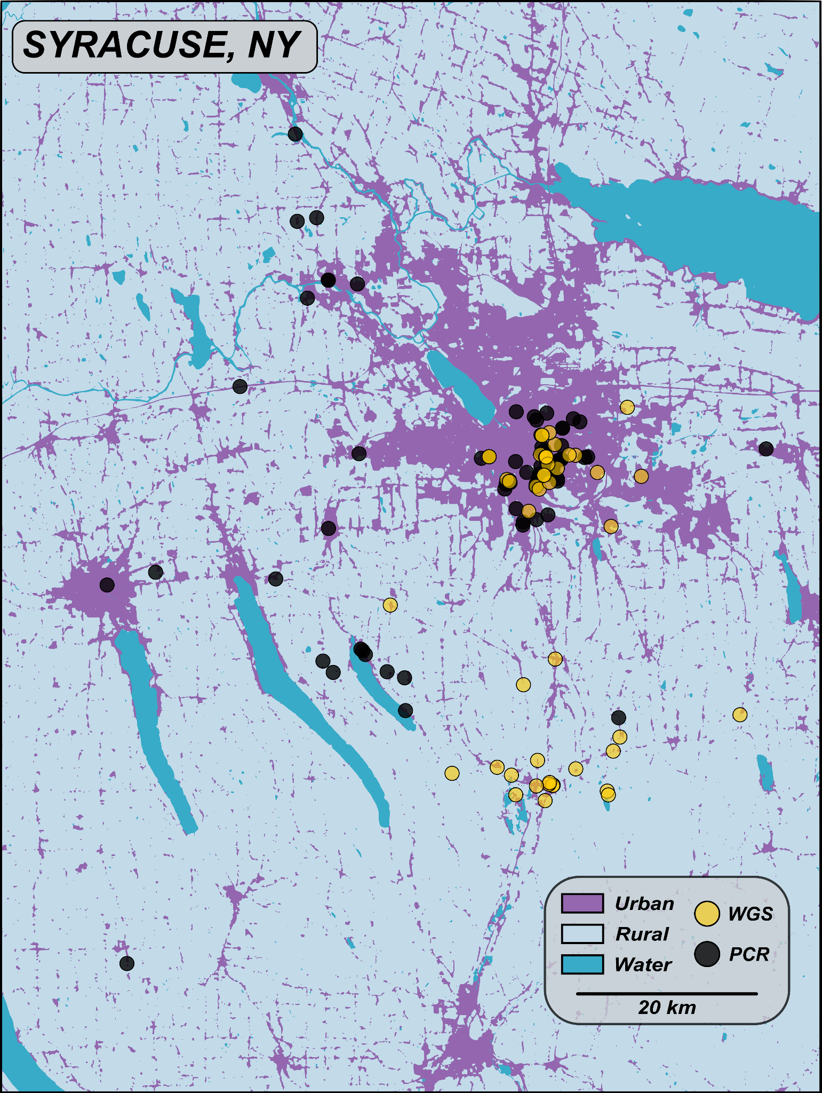
Figure S1. Sample sites of 196 squirrels from urban and rural habitats in and around the general Syracuse, NY area. Yellow circles represent 46 samples with low-coverage whole-genome sequencing (WGS), and black circles represent the remaining 150 samples that were genotyped for the indel variation at Mc1R using polymerase chain reaction (PCR).
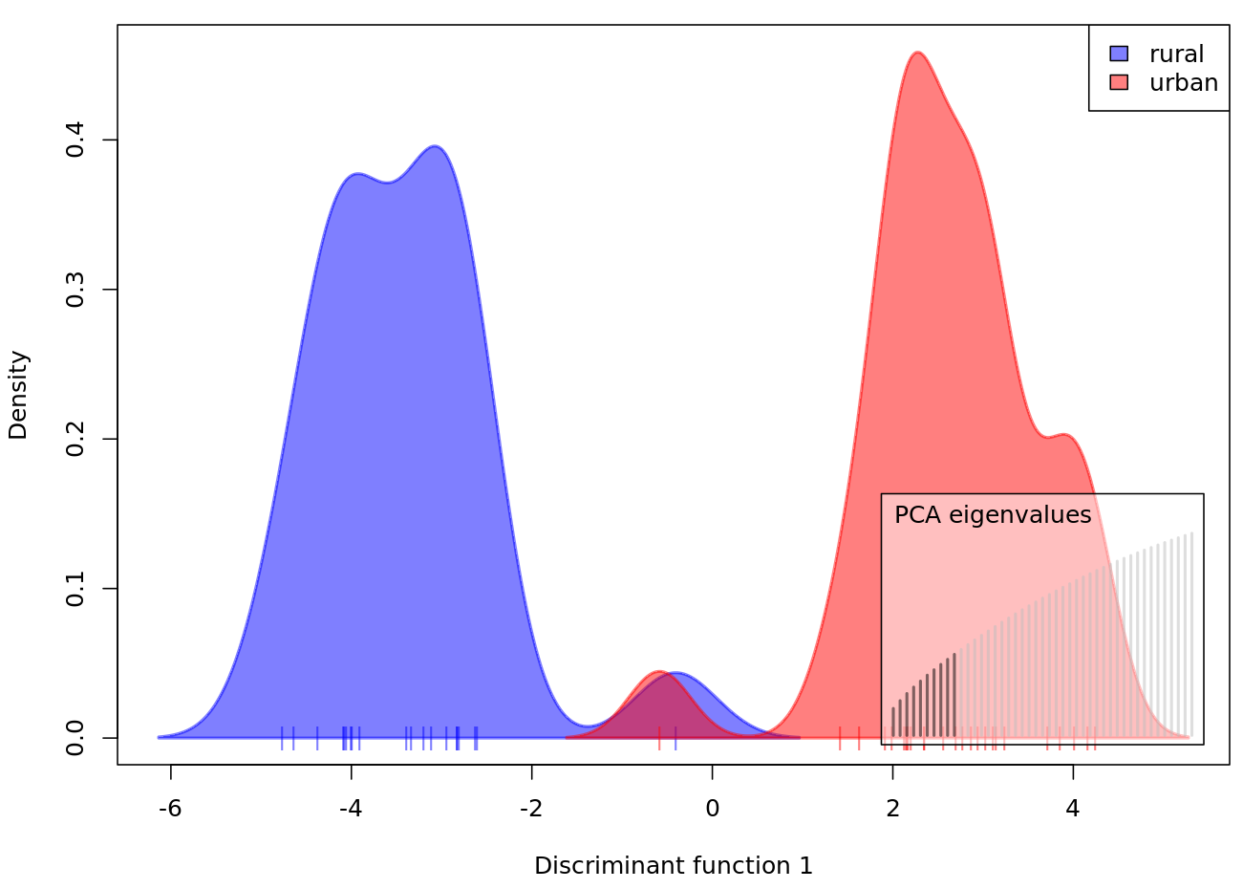
Figure S2. Discriminant analysis of principal components using 46 whole-genome sequenced individuals from urban and rural habitats.

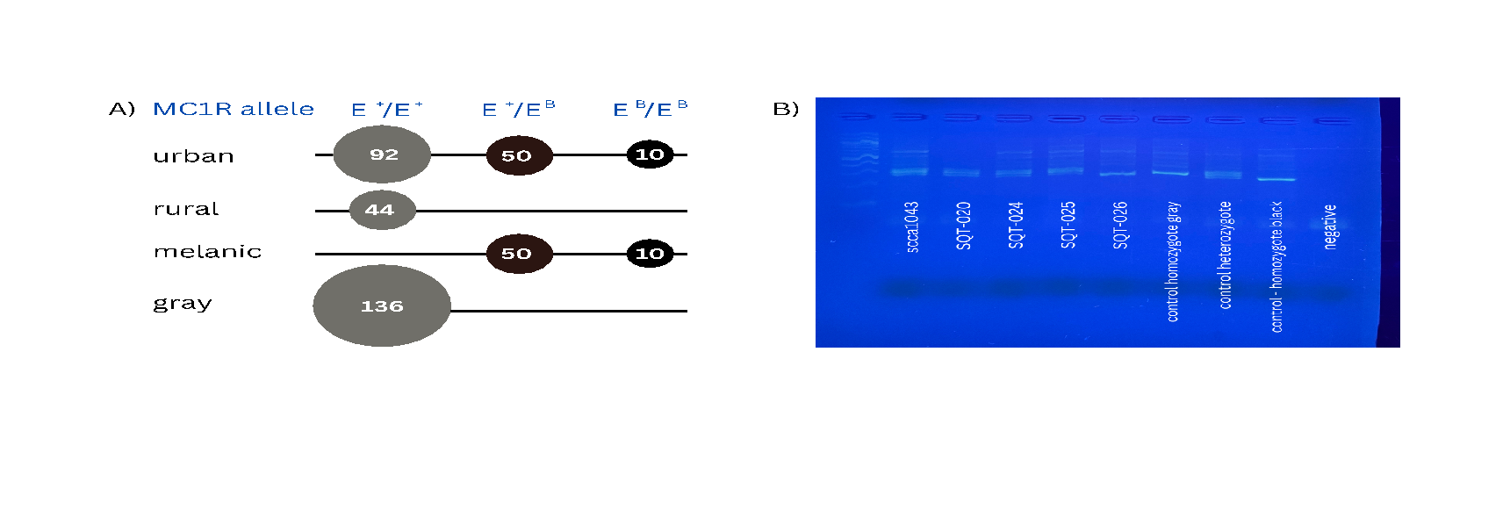
Figure S2. A) Mc1R genotypes for all 196 genotyped individuals. B) example PCR gel used to detect Mc1R genotype. Individuals that are homozygous for the 24-bp deletion (melanic) appear on a gel as having a single 278-bp band; individuals that are heterozygous for the 24-bp deletion (melanic) will have two bands (302-bp and 278-bp); and individuals that are homozygous for no deletion (gray) will have a single 302-bp band. Exact test of Hardy-Weinberg equilibrium (HWE) for the urban environment using HWExact in R (32) confirmed no deviation from HWE (p = 0.364).

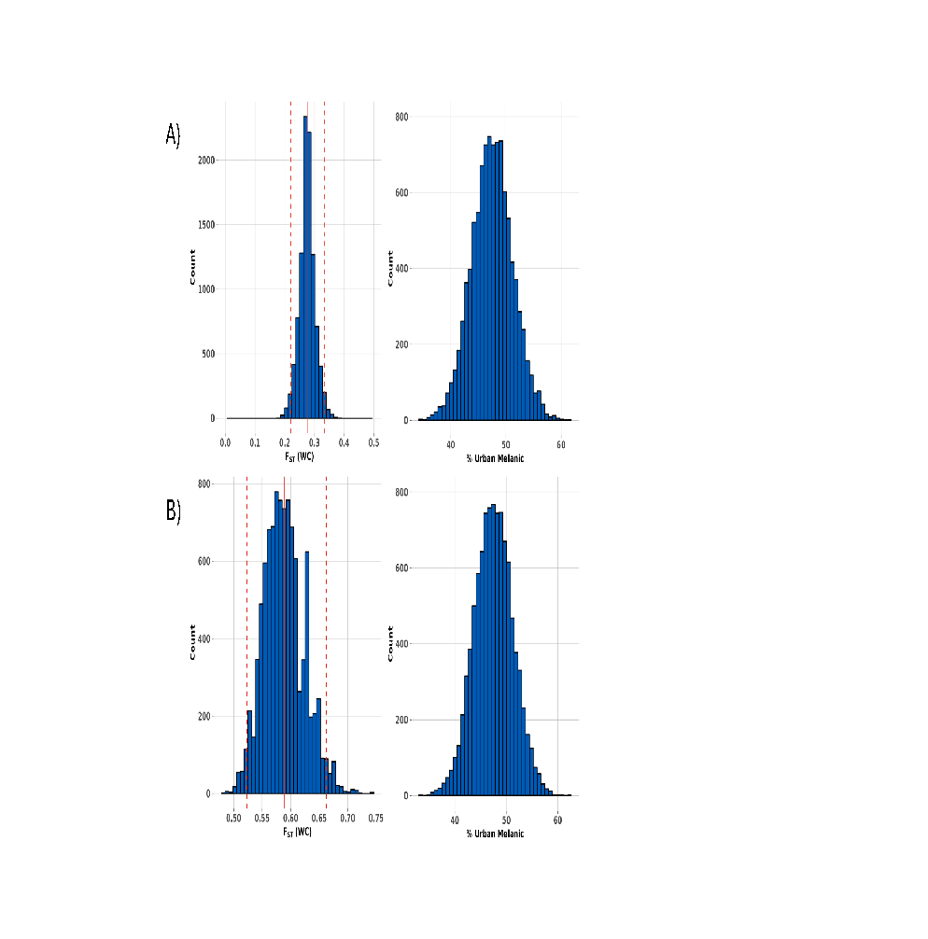
Figure S3. A) Bootstrap calculations of pairwise weighted F_{ST} for Mc1R-𝚫24 allele in urban vs. rural habitat. Calculation used Mc1R-𝚫24 genotypes for all 196 genotyped individuals and F_{ST} was calculated using heirfstat in R (27). Urban individuals were sampled to generate a random sampling percentage drawn from posterior distribution of percent melanic at city center based on (26). B) Bootstrap calculations of pairwise weighted F_{ST} for Mc1R-𝚫24 allele in urban habitat comparing melanic and gray morphs. Calculation used Mc1R-𝚫24 genotypes for 152 urban individuals. Urban individuals were sampled to generate a random sampling percentage drawn from posterior distribution of percent melanic at city center based on (26).

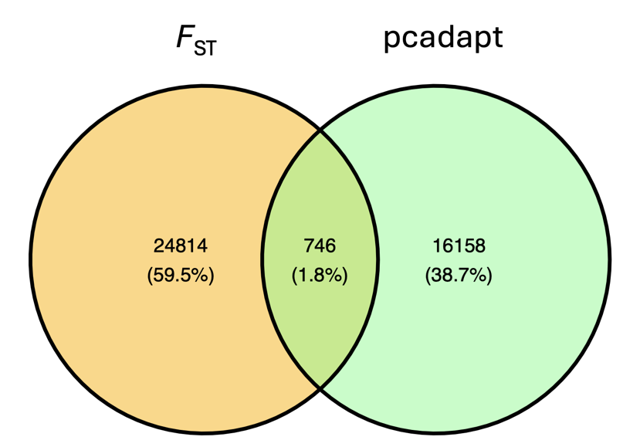

Figure S4. Venn diagram of outlier detection methods. Values indicate how many SNPs were found in the top 1% of F_{ST} estimates genome-wide (yellow) and how many SNPs were significantly associated with one or more ordination axes on the PCA (green). Overlap indicates the number of common SNPs detected using both methods.

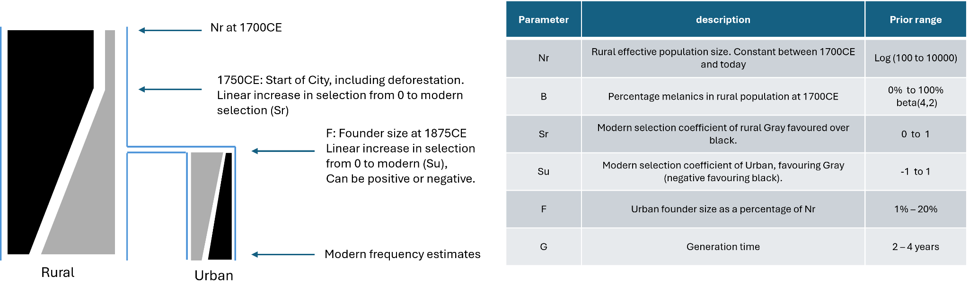
Figure S5: Diagram of Model 3, including parameter ranges and description of informative priors.
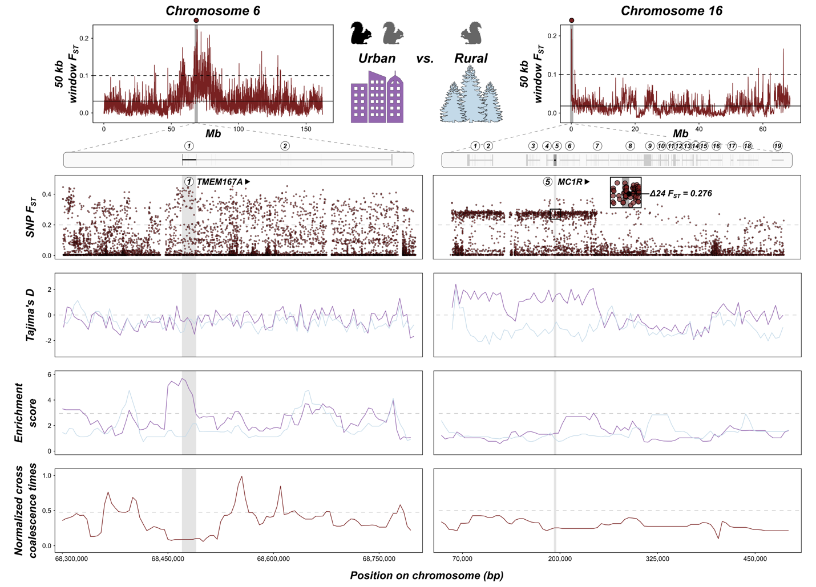
Figure S5. Analysis of selective sweeps for outlier peaks on chromosome 6 (TMEM167A) and 16 (Mc1R) for the habitat comparison. Top row shows 50kb window F_{ST} peaks and nearby genes. Second row shows F_{ST} values for each SNP and includes the calculated value for the 24-bp deletion on Mc1R. Third row shows 10kb window Tajima’s D values for urban (purple) and rural (blue) groups. Fourth row shows enrichment score measured in 10bk windows inferred from ancestral recombination graphs (ARGs), and fifth row shows the normalized cross coalescence time inferred in 10kb windows from the ARGs with the grey dotted line indicating p = 0.01 significant thresholds based on background flanking regions.

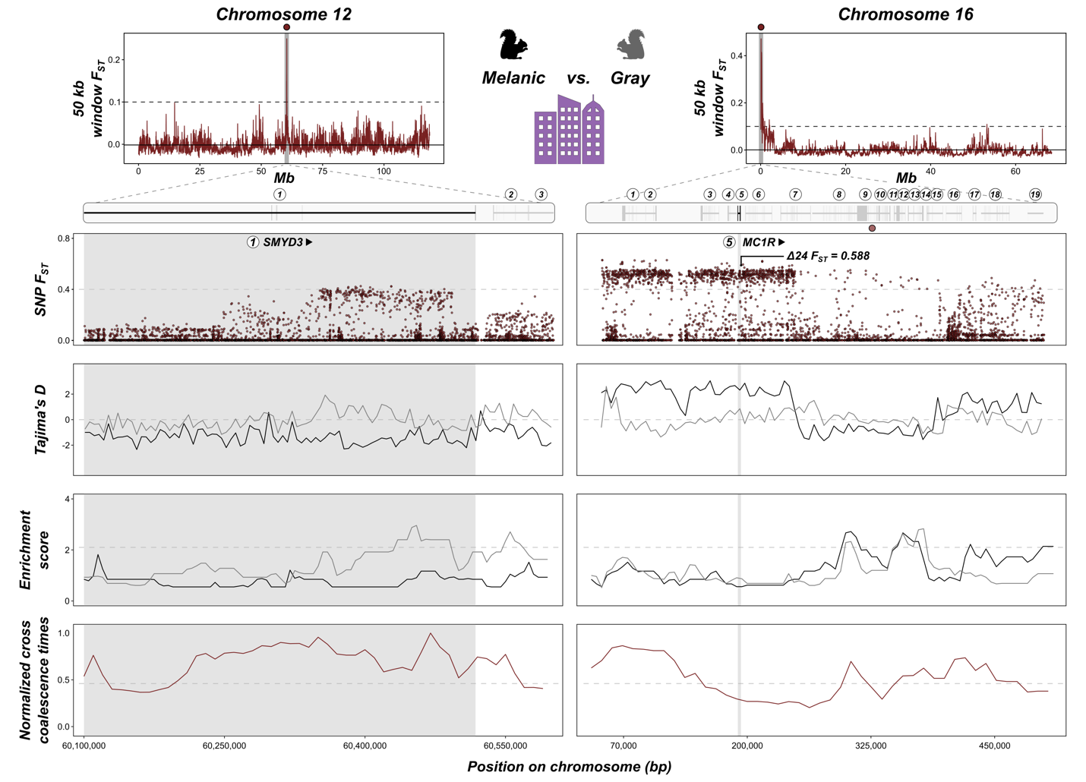
Figure S6. Analysis of selective sweeps for outlier peaks on chromosome 12 (SMYD3) and 16 (Mc1R) for the morph comparison. Top row shows 50kb window F_{ST} peaks and nearby genes. Second row shows F_{ST} values for each SNP and includes the calculated value for the 24-bp deletion on Mc1R. Third row shows 10kb window Tajima’s D values for urban (purple) and rural (blue) groups. Fourth row shows enrichment score measured in 10bk windows inferred from ancestral recombination graphs (ARGs), and fifth row shows the normalized cross coalescence time inferred in 10kb windows from the ARGs with the grey dotted line indicating p = 0.01 significant thresholds based on background flanking regions.

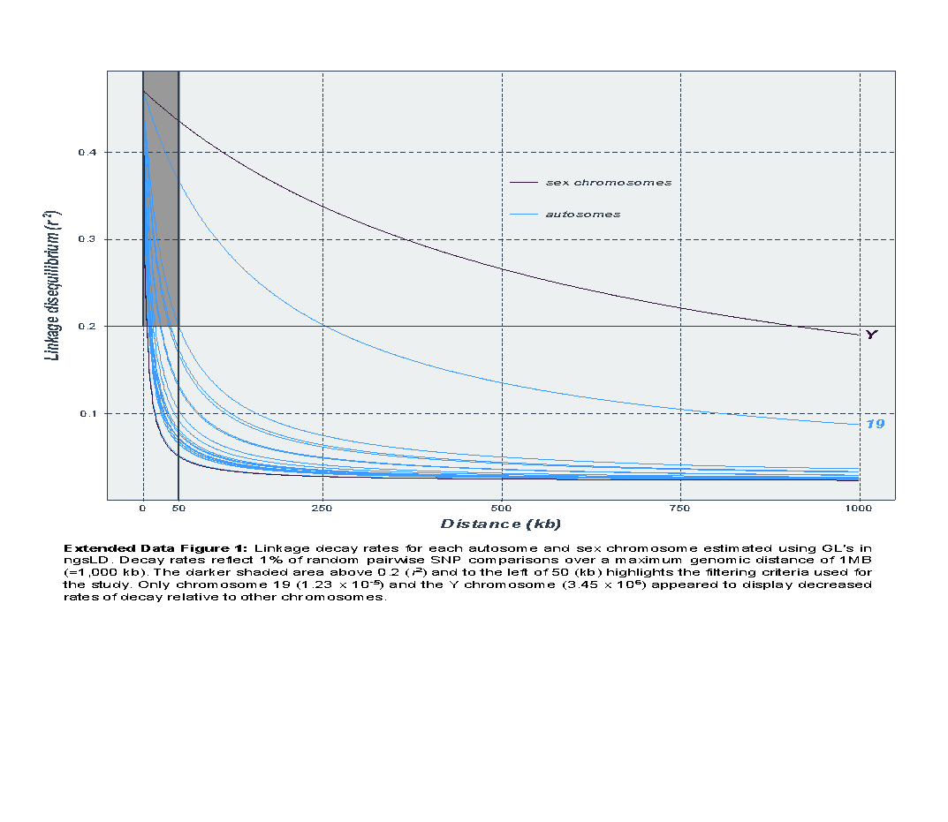
Figure S7. Linkage decay rates for each autosome and sex chromosome estimated using genotype likelihoods in ngsLD. Decay rates reflect 1% of random pairwise SNP comparisons over a maximum genomic distance of 1Mb. The shaded area represents the filtering criteria used for the study.

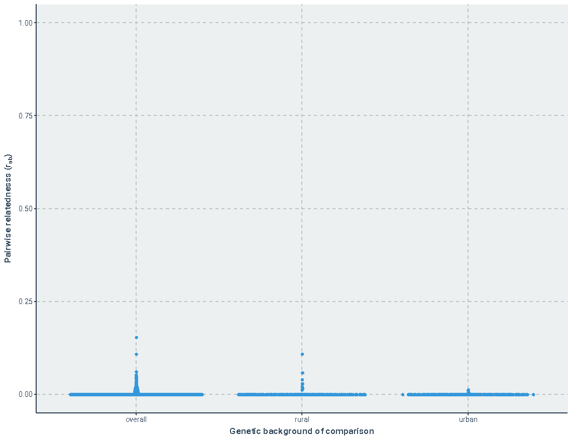
Figure S8. Pairwise relatedness values for 46 whole-genome samples. Pairwise relatedness was estimated using the unlinked sites, with the Hedrick and Lacy method for each habitat (rural, urban) and overall.

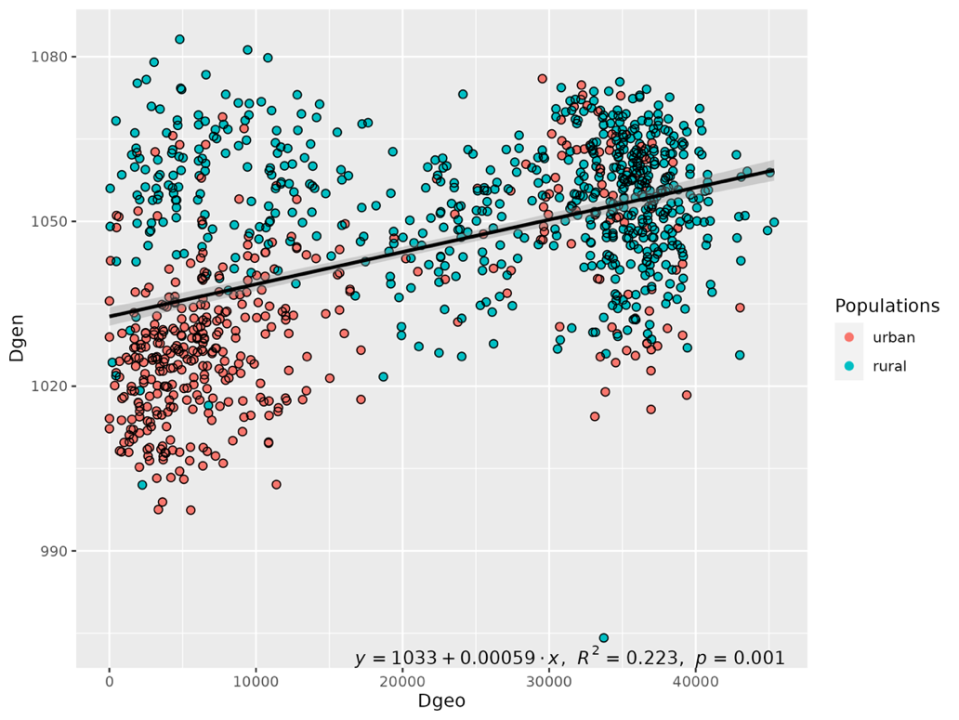
Figure S9. Isolation-by-distance (IBD) graph for 46 whole-genome sequenced individuals in urban and rural habitats. IBD was tested using the Mantel test between a matrix of genetic distances and a matrix of geographic distances using adegenet.

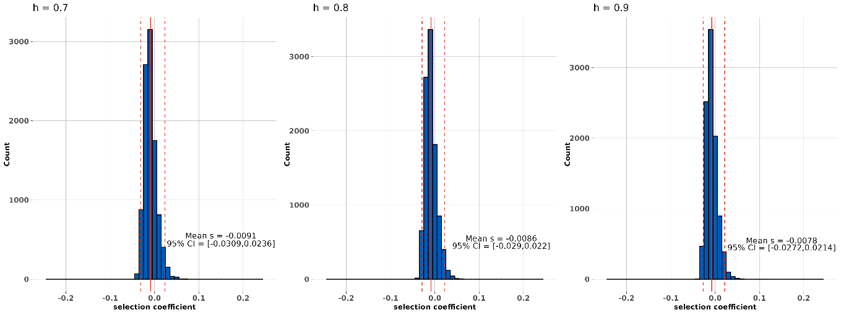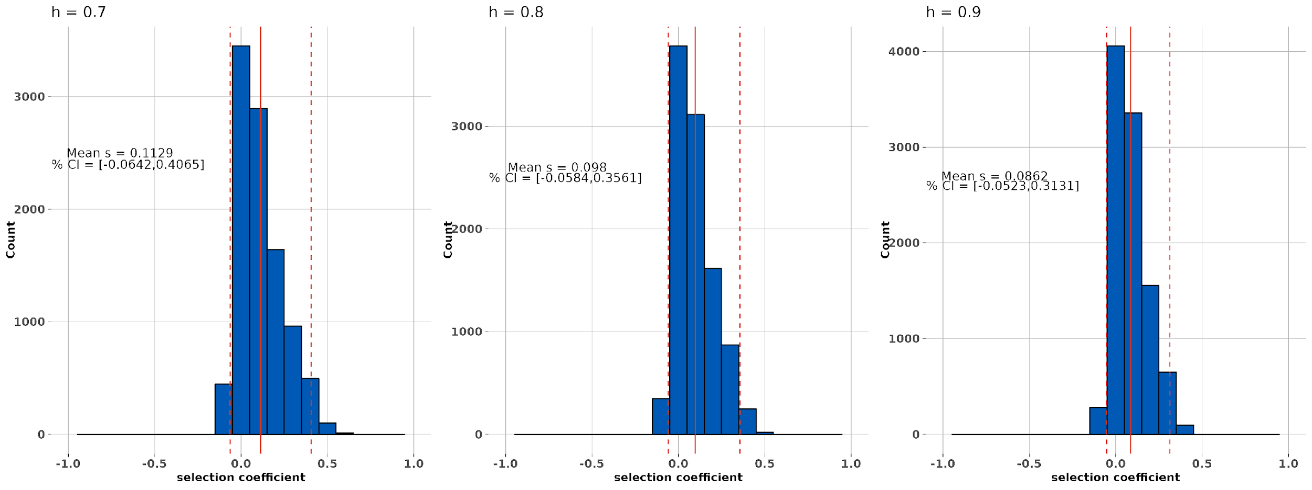

A)
B)
Figure S10. Estimates of selection on the Mc1R-𝚫24 allele using model 1 using three different dominance coefficients. Results for rural (A) and urban (B) respectively.

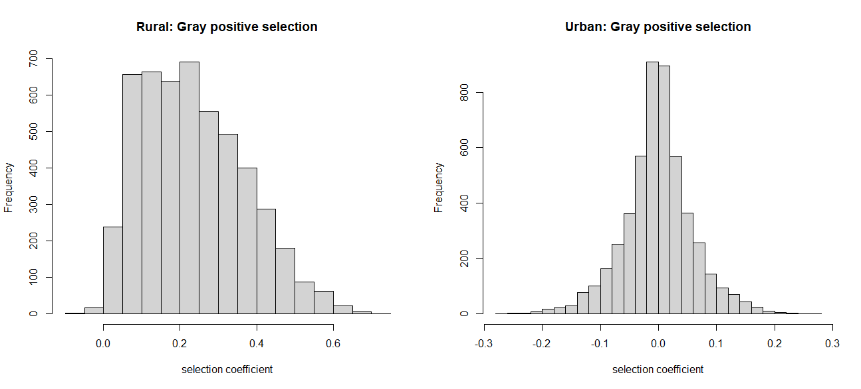
Figure S11. Estimates of selection against the Mc1R-𝚫24 allele using model 2. Histograms of 5000 samples from the respective posterior distributions.

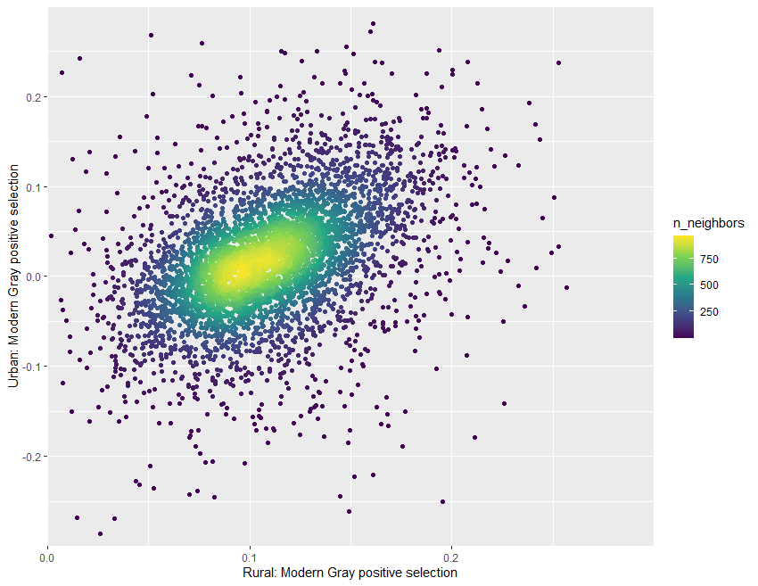
Figure S12. Estimates of selection against the Mc1R-𝚫24 allele using Model 3. Points illustrate 5000 samples from the joint posterior distribution. Generated using the R package ggpointdensity to illustrate regions of high point neighborhood density. The significant positive correlation is a consequence of uncertainty in the frequency of melanics at 1700CE, such that simulations starting with higher frequencies of melanics required stronger selection in both rural and urban environments to achieve modern frequencies.
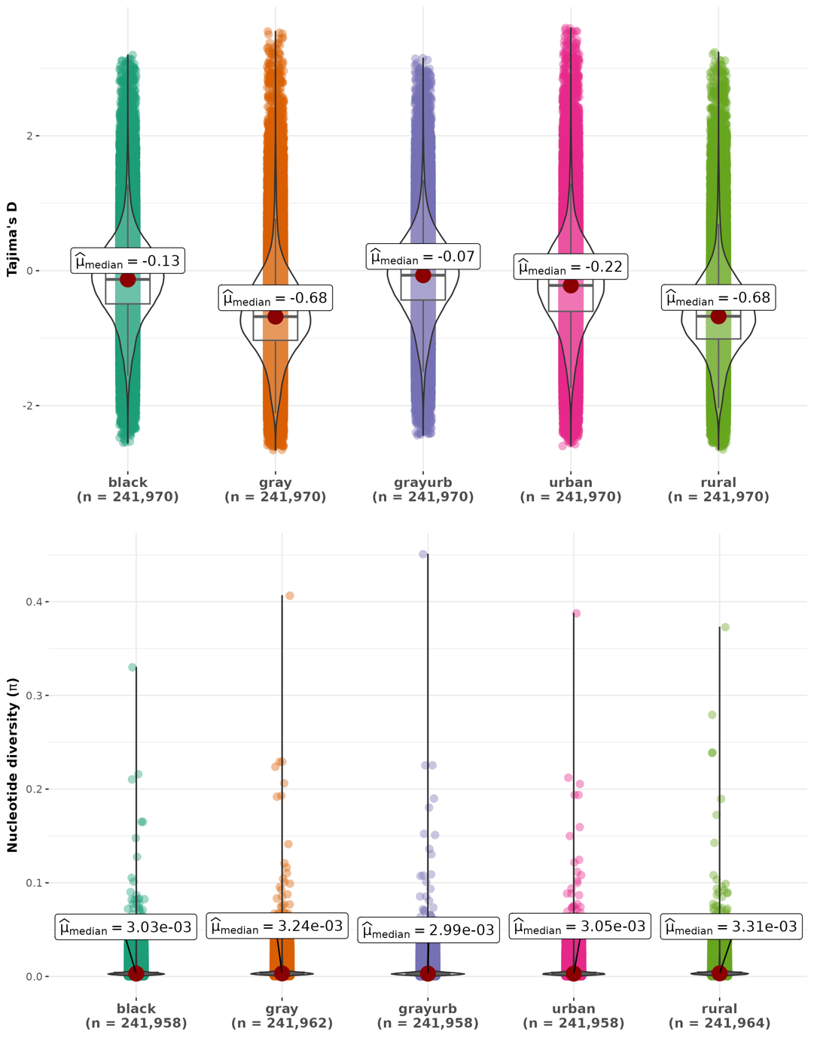
Figure S10. Nucleotide diversity and Tajima’s D estimated in 5kb windows in 1kb steps using whole-genome sequenced individuals. Samples were grouped according to color morph (black or gray), habitat (urban or rural) and also all gray samples from the urban environment were grouped (grayurb) to minimize the effect of habitat on the gray morph values.

References
1. J. Meisner, A. Albrechtsen, Inferring Population Structure and Admixture Proportions in Low-Depth NGS Data. Genetics 210, 719–731 (2018).
2. T. S. Korneliussen, A. Albrechtsen, R. Nielsen, ANGSD: Analysis of Next Generation Sequencing Data. BMC Bioinformatics 15, 356 (2014).
3. A. L. Lewanski, M. C. Grundler, G. S. Bradburd, The era of the ARG: An introduction to ancestral recombination graphs and their significance in empirical evolutionary genomics. PLOS Genet. 20, e1011110 (2024).
4. M. D. Rasmussen, M. J. Hubisz, I. Gronau, A. Siepel, Genome-Wide Inference of Ancestral Recombination Graphs. PLoS Genet. 10, e1004342 (2014).
5. H. A. Hejase, et al., Genomic islands of differentiation in a rapid avian radiation have been driven by recent selective sweeps. Proc. Natl. Acad. Sci. 117, 30554–30565 (2020).
6. M. J. Hubisz, A. L. Williams, A. Siepel, Mapping gene flow between ancient hominins through demography-aware inference of the ancestral recombination graph. PLOS Genet. 16, e1008895 (2020).
7. L. Campagna, Z. Mo, A. Siepel, J. A. C. Uy, Selective sweeps on different pigmentation genes mediate convergent evolution of island melanism in two incipient bird species. PLOS Genet. 18, e1010474 (2022).
8. T. N. Nguyen, M. Repenning, C. Suertegaray Fontana, L. Campagna, Genomic islands of speciation harbor genes underlying coloration differences in a pair of Neotropical seedeaters. Evolution 78, 1161–1173 (2024).
9. S. Andrews, FastQC. (2010). Deposited 2010.
10. A. M. Bolger, M. Lohse, B. Usadel, Trimmomatic: a flexible trimmer for Illumina sequence data. Bioinformatics 30, 2114–2120 (2014).
11. D. Mead, et al., The genome sequence of the eastern grey squirrel, Sciurus carolinensis Gmelin, 1788. Wellcome Open Res. 5, 27 (2020).
12. H. Li, R. Durbin, Fast and accurate short read alignment with Burrows – Wheeler transform. Bioinformatics 25, 1754–1760 (2009).
13. H. Li, et al., The Sequence Alignment/Map format and SAMtools. Bioinformatics 25, 2078–2079 (2009).
14. W. Shen, S. Le, Y. Li, F. Hu, SeqKit: A Cross-Platform and Ultrafast Toolkit for FASTA/Q File Manipulation. PLOS ONE 11, e0163962 (2016).
15. K. Okonechnikov, A. Conesa, F. García-Alcalde, Qualimap 2: advanced multi-sample quality control for high-throughput sequencing data. Bioinformatics 32, 292–294 (2016).
16. Broad Institute, Picard Toolkit. (2019). Deposited 2019.
17. A. McKenna, et al., The Genome Analysis Toolkit: A MapReduce framework for analyzing next-generation DNA sequencing data. Genome Res. 20, 1297–1303 (2010).
18. P. Ewels, M. Magnusson, S. Lundin, M. Käller, MultiQC: summarize analysis results for multiple tools and samples in a single report. Bioinformatics 32, 3047–3048 (2016).
19. J. T. Robinson, et al., Integrative genomics viewer. Nat. Biotechnol. 29, 24–26 (2011).
20. S. Hendricks, et al., Title: Recent advances in conservation and population genomics data analysis.
21. T. S. Korneliussen, I. Moltke, NgsRelate: a software tool for estimating pairwise relatedness from next-generation sequencing data. Bioinformatics 31, 4009–4011 (2015).
22. L. Excoffier, et al., fastsimcoal2 : demographic inference under complex evolutionary scenarios. Bioinformatics 37, 4882–4885 (2021).
23. H. Akaike, A new look at the statistical model identification. IEEE Trans. Autom. Control 19, 716–723 (1974).
24. L. Excoffier, I. Dupanloup, E. Huerta-Sánchez, V. C. Sousa, M. Foll, Robust Demographic Inference from Genomic and SNP Data. PLoS Genet. 9, e1003905 (2013).
25. G. Bhatia, N. Patterson, S. Sankararaman, A. L. Price, Estimating and interpreting F _{ST} : The impact of rare variants. Genome Res. 23, 1514–1521 (2013).
26. K. Luu, E. Bazin, M. G. B. Blum, pcadapt : an R package to perform genome scans for selection based on principal component analysis. Mol. Ecol. Resour. 17, 67–77 (2017).
27. P. C. Mahalanobis, On the Generalized Distance in Statistics. Proc. Natl. Inst. Sci. India 2, 49–55 (1936).
28. B. J. Cosentino, J. P. Vanek, J. P. Gibbs, Rural selection drives the evolution of an urban–rural cline in coat color in gray squirrels. Ecol. Evol. 13, e10544 (2023).
29. J. Goudet, T. Jombart, hierfstat: Estimation and Tests of Hierarchical F-Statistics. (2022). Deposited 2022.
30. J. B. S. Haldane, A mathematical theory of natural and artificial selection. (Part VI, Isolation.). Math. Proc. Camb. Philos. Soc. 26, 220–230 (1930).
31. S. Wright, Evolution in Mendelian populations. Genetics 16, 97–159 (1931).
32. J. Graffelman, Exploring Diallelic Genetic Markers: The HardyWeinberg Package. J. Stat. Softw. 64 (2015).

