Achieving over 200 Wh kg⁻¹ Sodium-Ion Pouch Cell by Quantitative Engineering of Hard Carbon Pores
Zhihao Chen,^{1,#} Jialong Shen,^{1,#} Wenjie Deng,^{1,#} Yingshan Huang,¹ Peizhao Shan,⁴ Yuhang Lou,¹ Ling Li,¹ Guanyin Gao,¹ Yaxiong Yang,⁵ Shengnan He,⁵ Hongge Pan,⁵ Xianhong Rui,³ Yong Yang,⁴ Hai Yang,^{1,*} & Yan Yu^{1,2,*}

¹ Hefei National Research Center for Physical Sciences at the Microscale, iChEM (Collaborative Innovation Center of Chemistry for Energy Materials), Department of Materials Science and Engineering, University of Science and Technology of China, Hefei, Anhui 230026, China. E-mail: yanyumse@ustc.edu.cn
² National Synchrotron Radiation Laboratory, Hefei, Anhui 230026, China
³ School of Materials and Energy, Guangdong University of Technology, Guangzhou, 510006, China
⁴ State Key Laboratory for Physical Chemistry of Solid Surfaces, and Department of Chemistry, College of Chemistry and Chemical Engineering, Xiamen University, Xiamen 361005, Fujian, China
⁵ Institute of Science and Technology for New Energy, Xi’an Technological University, Xi’an 710021, China

# These authors contributed equally to this work.
* Corresponding authors

Supplementary Fig. 1: Electrochemical profiles of the NaNi_{1/3}Fe_{1/3}Mn_{1/3}O₂ (NFM111)||HC full cell measured in three-electrode cell within 1.2−4.2 V (reference electrode: Na metal). For a typical full cell, the voltage difference between the cathode and anode determines its discharge voltage. It is desirable for most of the discharge process to occur within the plateau region of HC, with only a small portion in the sloping capacity region, in order to enhance the energy density of the battery.

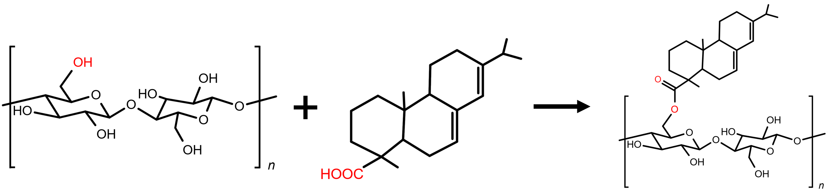
Supplementary Fig. 2: Schematic diagram of the esterification reaction between cellulose and rosin acid. The esterification reaction of the primary hydroxyl group in C6 position of cellulose with rosin acid is taken as an example because the esterification reactivity of C6−OH is the highest. Additionally, the hydroxyl groups on hemicellulose and lignin can also undergo esterification reactions with rosin acid.

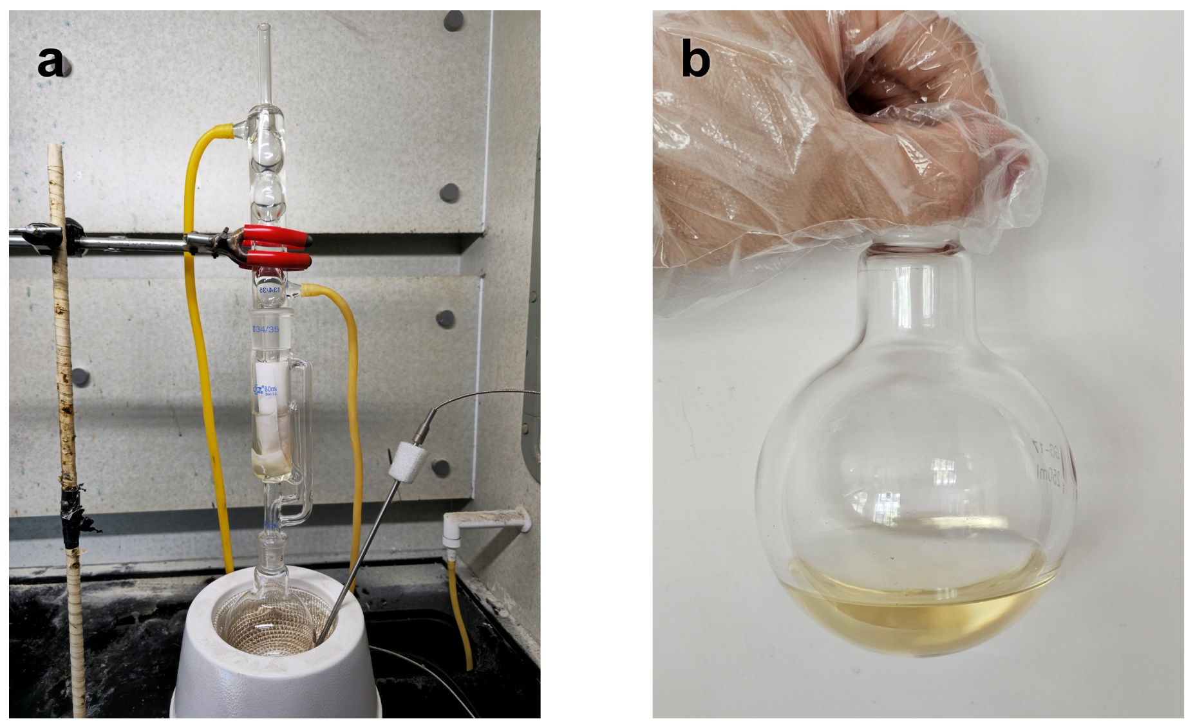
Supplementary Fig. 3: Optical photographs of Soxhlet extractor (a) and rosin extract (b). Soxhlet extraction uses the principles of solvent reflux and siphoning to continuously extract solid matter using a pure solvent. The solvent we used was a benzene-ethanol mixture (2:1 by volume ratio).

Supplementary Fig. 4: Low field (LF) ¹H NMR transverse (T₂) relaxation distribution of pine wood and RF wood.

Supplementary Fig. 5: FTIR spectra of pine wood and RF wood after heart treatment at 200 °C. The intensified C=O stretch and the weakened O−H stretch in Pine HC confirm the occurrence of the esterification reaction. The enhanced C−H stretch is due to the introduction of more methyl and methylene groups by the rosin.

Supplementary Fig. 6: XRD patterns of pine wood and RF wood after heart treatment at 200 °C. The diffraction peaks of cellulose in both samples did not show significant differences. However, the calculated cellulose crystallinity of pine wood decreased from 55.6% to 35.8% compared to RF wood based on Segal method, suggesting that the esterification process disrupted the intra- and intermolecular hydrogen bonds of cellulose, resulting in lower crystallinity¹. Furthermore, the reduction in crystallinity can lead to decreased thermal stability of the polymer chains.

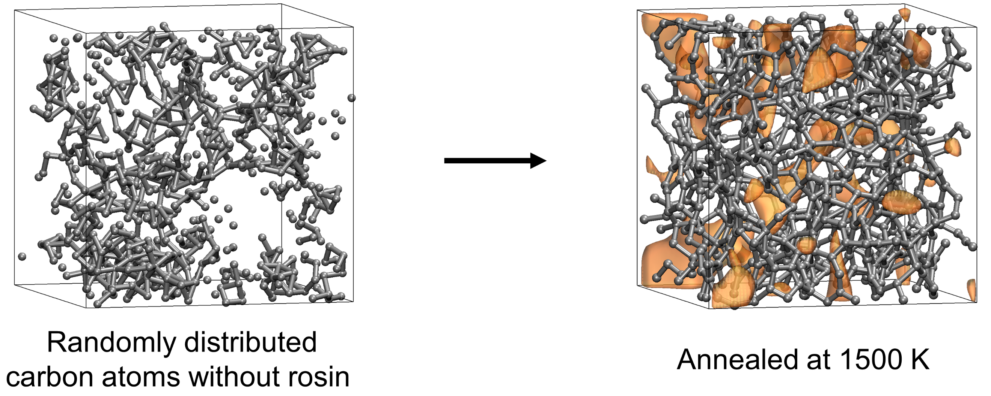
Supplementary Fig. 7: Snapshots of pyrolysis of carbon matrix without rosin. The pores in the carbon matrix are shown in orange. To control the variables, we used the same initial carbon matrix model, only removing rosin. After 1500 K annealing, aromatic cyclic rearrangement occurs between carbon atoms, and the initial large pores disappear, leaving only a few pores.

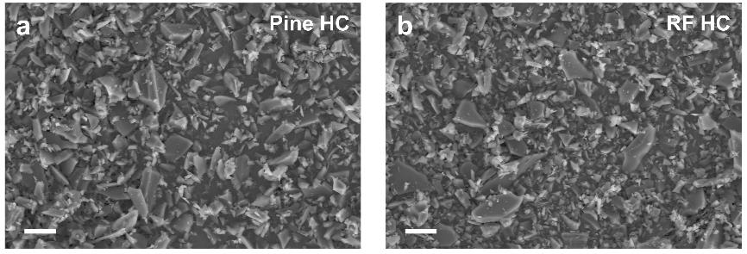
Supplementary Fig. 8: SEM images of Pine HC and RF HC. Scale bars, 10 μm.

Supplementary Fig. 9: XRD patterns and L_{a}, L_{c} parameters of Pine HCs and RF HC.

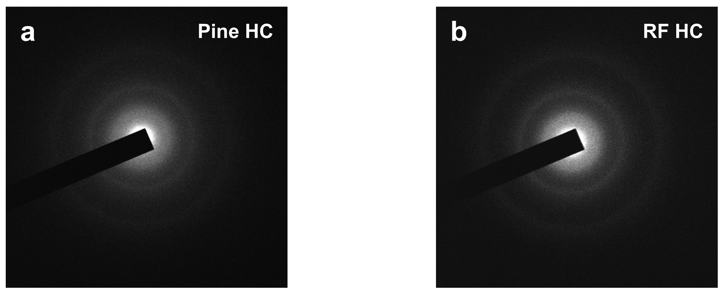
Supplementary Fig. 10: SAED of Pine HC and RF HC.

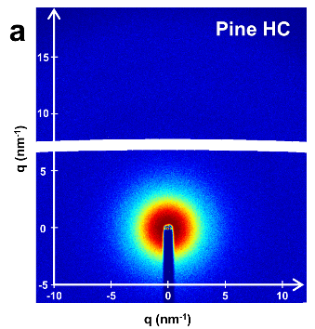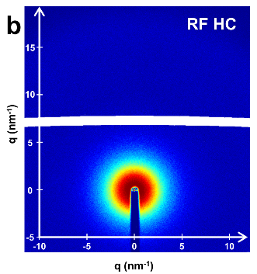
Supplementary Fig. 11: 2D WAXS patterns of Pine HC and RF HC.

Supplementary Fig. 12: a-f, Raman spectra and I_{D}/I_{G} values of Pine HCs and RF HC.

Supplementary Fig. 13: a,b, XPS spectra of Pine HC-10%, Pine HC, and RF HC.

Supplementary Fig. 14: a-d, SAXS profiles of Pine HCs and RF HC.

Supplementary Fig. 15: N₂ adsorption/desorption isotherms of Pine HCs and RF HC.

Supplementary Fig. 16: a-c, Charge-discharge profiles of multiple half-cell for Pine HC electrode at 30 mA g⁻¹.

Supplementary Fig. 17: a-c, Galvanostatic charge-discharge profiles of Pine HC-1% (a), Pine HC-6% (b), and Pine HC-10% (c) at 30 mA g⁻¹. d, Comparison of galvanostatic charge-discharge profiles of Pine HCs and RF HC. e, Comparison of the plateau and slope capacity ratio in the 2nd discharge profiles. As the rosin content increases, the sodium storage capacity and initial Coulombic Efficiency (ICE) of Pine HCs first increase and then decrease.

Supplementary Fig. 18: a,b, Charge-discharge profiles of Pine HC (a) and RF HC (b) with various current densities ranging from 30 to 300 mA g⁻¹.

Supplementary Fig. 19: Cycling performance of Pine HC at a current density of 100 mA g⁻¹.

Supplementary Fig. 20: a, The GITT profiles of Pine HC and RF HC. b, The corresponding Na⁺ ion diffusion coefficients.

Supplementary Fig. 21: a,b, CV curves of Pine HC (a) and RF HC (b) at different scan rates. c,d, Capacitive contribution of Pine HC (c) and RF HC (d) at different scan rates.

Supplementary Fig. 22: a-h, Charge-discharge profiles of poplar wood (a), camphor wood (b), cypress wood (c), oak wood (d), apricot wood (e), litchi wood (f), bamboo (g), wheat straw (h), and corncob (i)-derived HCs modified with rosin at 30 mA g⁻¹.

Supplementary Fig. 23: Charge-discharge profiles of NFM111||Pine HC pouch cell during the formation process.

Supplementary Fig. 24: Charge-discharge profiles of NFM111||Pine HC pouch cell at a current rate of 1C.

Supplementary Fig. 25: Charge-discharge profiles of NVP||Pine HC pouch cell during the formation process.

Supplementary Fig. 26: Charge-discharge profiles of NFPP||Pine HC pouch cell during the formation process.

Supplementary Fig. 27: Charge-discharge profiles of PBA||Pine HC pouch cell during the formation process.

Supplementary Fig. 28: a, Cycling performance of the NVP||Pine HC pouch cell at a current rate of 0.5C. b, the corresponding charge-discharge profiles.
NVP mass loading: 16.2 mg cm⁻²; N/P ratio: 1.11; Area: 4.3×5.6 cm².

Supplementary Fig. 29: a, Cycling performance of the NFPP||Pine HC pouch cell at a current rate of 0.5C. b, the corresponding charge-discharge profiles.
NFPP mass loading: 15.7 mg cm⁻²; N/P ratio: 1.12; Area: 4.3×5.6 cm².

Supplementary Fig. 30: a, Cycling performance of the PBA||Pine HC pouch cell at a current rate of 0.5C. b, the corresponding charge-discharge profiles.
PBA mass loading: 10.8 mg cm⁻²; N/P ratio: 1.19; Area: 4.3×5.6 cm².

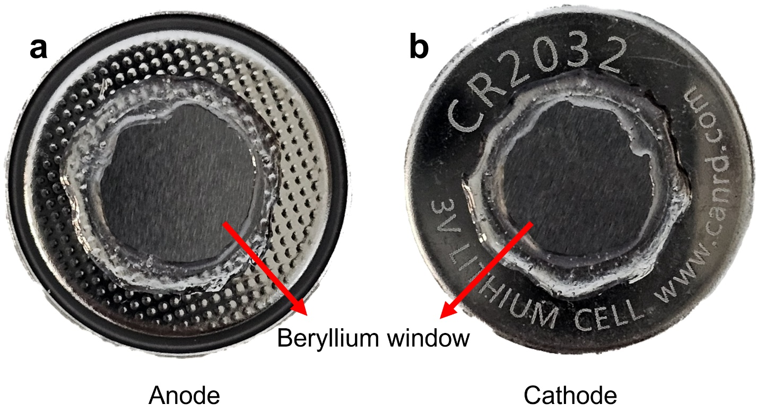
Supplementary Fig. 31: a,b, Optical photograph of the in situ cell. Both the anode (a) and cathode (b) cases feature a 5 mm diameter window, which is sealed with beryllium window to ensure airtightness while permitting X-rays transmission. A 5 mm diameter hole was made through the sodium metal foil, separator, and stainless steel spacer within the in situ cell.

Supplementary Fig. 32: The in situ XRD patterns of Pine HC electrode during the first charge-discharge process at 30 mA g⁻¹.

Supplementary Fig. 33: The in situ Raman spectra of Pine HC electrode during the first charge-discharge process at 30 mA g⁻¹.

Supplementary Fig. 34: In situ SAXS profiles of Pine HC electrode during the first desodiation. Curves with various color correspond to different states of charge.

Supplementary Fig. 35: Ex situ ²³Na ssNMR spectra of Pine HC electrodes during the first sodiation. Asterisk (※) marks are the spinning sideband.

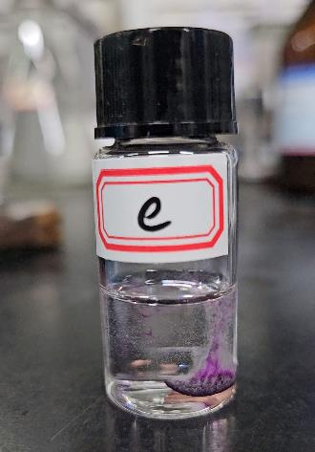
Supplementary Fig. 36: The phenomenon of the reaction between 1% phenolphthalein ethanol solution and sodiated Pine HC and corresponding reaction equation.

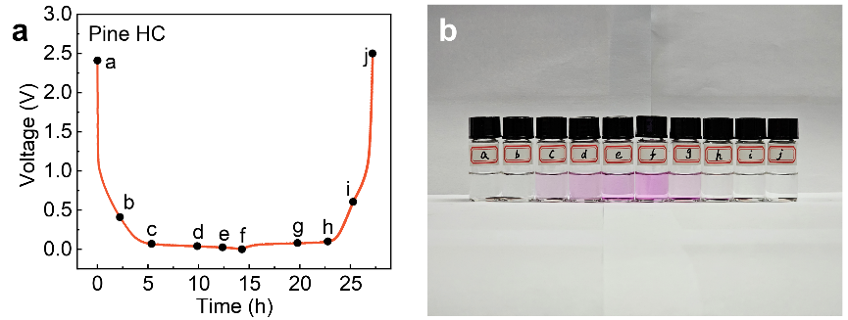
Supplementary Fig. 37: a, The 2nd charge-discharge curves of Pine HC anode. b, Optical photo of 1% phenolphthalein ethanol solution after reaction with Pine HC electrode at corresponding voltage.

Supplementary Fig. 38: a-d, In situ SAXS profiles of RF HC (a), Pine HC-1% (b), Pine HC-6% (c), and Pine HC-10% (d) electrodes for the first sodiation.

Supplementary Fig. 39: The calculated filled volume fraction from in situ SAXS experiments.

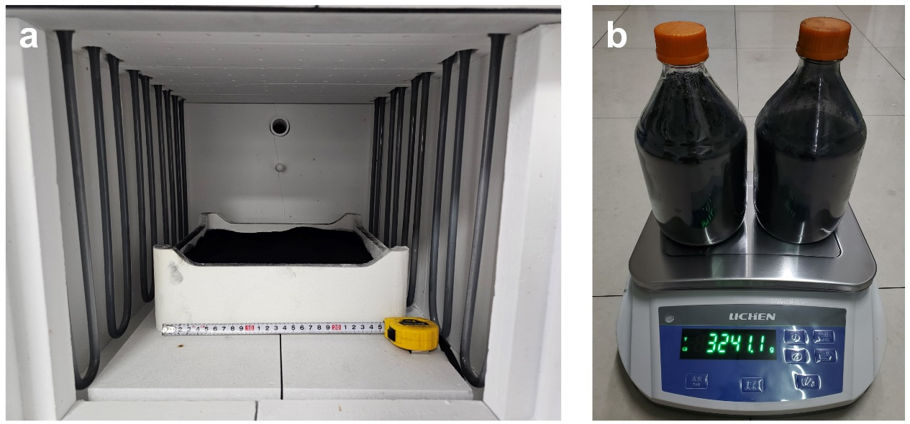
Supplementary Fig. 40: a,b, Large-scale preparation of Pine HC (3kg) using pine sawdust as the precursor.

Supplementary Fig. 41: Comparison of charge-discharge profiles of Pine HC and commercial HC in half-cell.

Supplementary Fig. 42: a,b, Initial charge-discharge profiles of three-electrode NFM111||Pine HC (a) and NFM111||Commercial HC (b) pouch cells with an N/P ratio of 1.12.

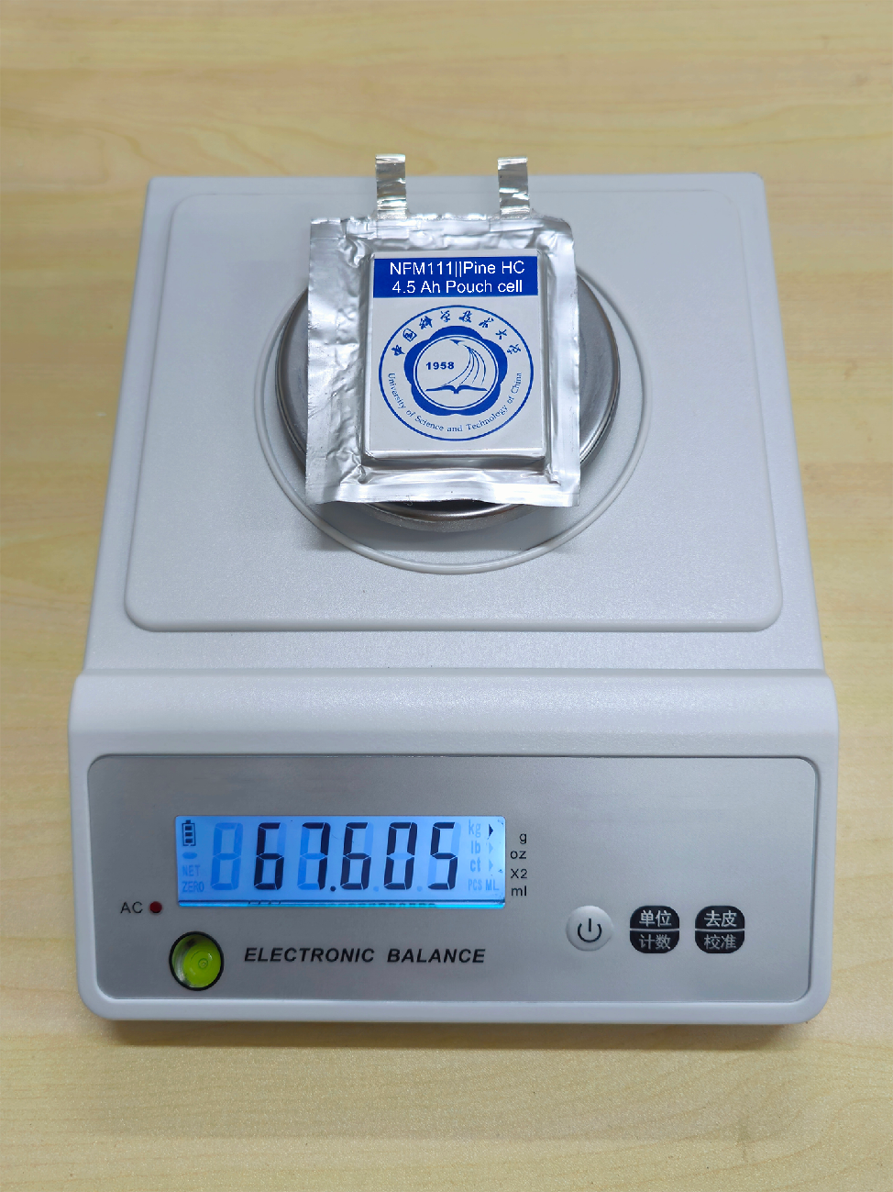
Supplementary Fig. 43: The weight of the 4.5 Ah-laminated NFM111||Pine HC pouch cell.

Supplementary Fig. 44: Charge-discharge profiles of the 4.5 Ah-laminated NFM111||Pine HC pouch cell at 90% DOD.

Supplementary Table 1: Rosin content obtained by Soxhlet extraction.
Sample | Pine wood (g) | Rosin (g) | Rosin content  (%)
1 | 3.5972 | 0.1140 | 3.17
2 | 3.2492 | 0.1133 | 3.49
3 | 3.4314 | 0.1118 | 3.26

Supplementary Table 2: ¹³C chemical shift assignments of pine wood and RF wood.
Chemical shift (ppm) |  | Carbon group |  | Belonging*
180−170 |  | C=O |  | R, H
158−117 |  | Aromatic |  | L
110−58 |  | C1−C6 |  | C
56 |  | CH₃O |  | L
50−12 |  | CH₃, CH₂ |  | R
*Rosin, cellulose, hemicellulose, and lignin were labeled as R, C, H, and L, respectively.

Supplementary Table 3: The functional groups assignments of pine wood and RF wood.
Wavenumber (cm⁻¹) |  | Functional groups |  | Belonging
3564 |  | O−H stretching |  | H₂O
2944 |  | C−H stretching |  | CH₄
2340 |  | C=O stretching |  | CO₂
2180 |  | C=O stretching |  | CO
1742 |  | C=O |  | Aldehydes/acid
1108 |  | C−O−C/C−C |  | Ethers/alkanes

Supplementary Table 4: Pore parameters of carbon matrix with/without rosin after pyrolysis by AIMD simulations.
Samples | Carbon matrix with rosin | Pure carbon matrix
Free volume (Å³) | 1829.95 | 1287.54
Free volume ratio | 22.87% | 16.09%
Surface area (Å³) | 3969.95 | 3671.18

Supplementary Table 5: Structure parameters (d₀₀₂, d₁₀₀, L_{a}, L_{c}, and n) of RF HC and Pine HC samples based on XRD patterns.
Sample | d₀₀₂ (nm) | d₁₀₀ (nm) | L_{a} (nm) | L_{c} (nm) | n=L_{c}/d₀₀₂+1
Pine HC-10% | 0.377 | 0.208 | 5.157 | 1.119 | 3.968
Pine HC-6% | 0.380 | 0.208 | 4.995 | 1.135 | 3.987
Pine HC | 0.378 | 0.208 | 4.917 | 1.132 | 3.995
Pine HC-1% | 0.376 | 0.207 | 5.146 | 1.127 | 3.997
RF HC | 0.373 | 0.206 | 5.189 | 1.126 | 4.019

Supplementary Table 6: SAXS fitting parameters of Pine HC and RF HC samples based on the Teubner-Strey model.
Sample | ρ_{s}  (g cm⁻³) | ΔSLD  (*10⁻⁶ Å⁻²) | d (nm) | 𝜉 (nm) | D (nm) | S_{SAXS}  (m² g⁻¹)
Pine HC-10% | 2.41 | 20.5 | 11.58 | 0.47 | 2.73 | 4392
Pine HC-6% | 2.42 | 20.6 | 8.75 | 0.45 | 2.45 | 3650
Pine HC | 2.40 | 20.4 | 5.40 | 0.46 | 1.91 | 2916
Pine HC-1% | 2.36 | 20.1 | 4.73 | 0.48 | 1.66 | 2333
RF HC | 2.32 | 19.7 | 4.2 | 0.53 | 1.24 | 1528

Supplementary Table 7: Pore structure parameters of RF HC and Pine HC samples based on nitrogen adsorption measurement and true density test.
Sample | S_{BET}  (m² g⁻¹) | Open pore volume  (cm³ g⁻¹) | True density  (g cm⁻³) | Closed pore volume  (cm³ g⁻¹) | Total pore volume  (cm³ g⁻¹)
Pine HC-10% | 52.4 | 0.051 | 1.81 | 0.110 | 0.161
Pine HC-6% | 30.3 | 0.029 | 1.90 | 0.084 | 0.113
Pine HC | 16.7 | 0.013 | 1.97 | 0.065 | 0.078
Pine HC-1% | 14.9 | 0.012 | 2.02 | 0.053 | 0.065
RF HC | 9.0 | 0.009 | 2.09 | 0.036 | 0.045

Supplementary Table 8: Comparison of the specific capacity and ICE of previously reported HC anodes with Pine HC.
Sample | Specific capacity (mAh g⁻¹) | ICE | Reference
CHC | 341 | 68.0% | ²
CHC-0.25 | 325 | 68.0% | ³
LCS-73 | 356 | 82.8% | ⁴
HTCNCC1500 | 314 | 90.4% | ⁵
H-TPGC | 298 | 90.5% | ⁶
G1500 | 345 | 86.9% | ⁷
PCLC-1 | 312 | 85.3% | ⁸
CAC1300 | 308 | 82.3% | ⁹
HC-1300 | 350 | 84.1% | ¹⁰
HC-1300-P1.10 | 328 | 72.0% | ¹¹
HCK-10 | 332 | 68.0% | ¹²
M11005 | 299 | 88.9% | ¹³
MPC-1000 | 318 | 71.2% | ¹⁴
F-CHC | 335 | 87.2% | ¹⁵
Pine HC | 336 | 92.2% | This work

Supplementary Table 9: Comparison of the electrochemical performance* of other biomass-derived HCs before and after rosin modification.
Biomass | Basic |  |  | Rosin-modified
Biomass | Slope capacity (mAh g⁻¹) | Plateau capacity (mAh g⁻¹) | ICE | Slope capacity (mAh g⁻¹) | Plateau capacity (mAh g⁻¹) | ICE
Poplar wood | 78.5 | 213.0 | 82.6% | 86.7 | 234.7 | 85.4%
Camphor wood | 84.9 | 232.1 | 85.5% | 86.1 | 251.3 | 88.0%
Cypress wood | 77.7 | 218.0 | 80.0% | 93.5 | 237.9 | 84.2%
Oak wood | 80.3 | 214.9 | 79.1% | 94.4 | 235.1 | 85.1%
Apricot wood | 77.9 | 210.0 | 81.8% | 90.2 | 248.0 | 86.5%
Litchi wood | 76.3 | 228.2 | 83.6% | 91.5 | 251.3 | 86.8%
Bamboo | 68.8 | 176.1 | 76.0% | 72.4 | 219.9 | 81.9%
Wheat straw | 80.8 | 189.3 | 81.5% | 83.8 | 226.2 | 84.8%
Corncob | 67.99 | 164.66 | 73.2% | 72.7 | 203.78 | 81.0%
*Current density: 30 mA g⁻¹.

Supplementary Table 10: Cost accounting for large-scale preparation of Pine HC using pine sawdust as raw material.
 | Pine HC | Commercial HC  (Kuraray Type 2)
Raw material | Pine sawdust | \
Precursor price range# ($ kg⁻¹) | 0.26−0.38 | \
Average yield | 25% | \
Production fixed cost range*  ($ kg⁻¹) | 2.0−2.5 | \
Total cost ($ kg⁻¹) | 3.04−4.02 | \
Average cost ($ kg⁻¹) | 3.53 | \
Price ($ kg⁻¹) | \ | 27.5
#The precursor price was consulted at Huadong Timber Market (Jinhua, Zhejiang).
*The calculation of the production fixed cost for Pine HC is based on techno-economics studies that producing activated carbon from biomass materials.¹⁶⁻¹⁸ These studies estimated fixed production costs excluding raw material costs to be between $1.50-2.50 kg⁻¹. Taking inflation and energy prices differences into account, the fixed production costs for Pine HC were assumed to be $2.0-2.5 kg⁻¹.

Supplementary Table 11: Comparison of electrochemical performance between Pine HC and commercial HC.
 | Pine HC | Commercial HC  (Kuraray Type 2)
Half cell:
Initial Coulombic efficiency | 92.2% | 88.5%
Reversible capacity (mAh g⁻¹) | 336.1 | 289.2
Average voltage (V) | 0.14 | 0.19
Pouch type full cell:
Initial Coulombic efficiency | 85.6% | 82.1%
Reversible capacity (mAh g⁻¹) | 272.1 | 229.6
Average discharge voltage (V) | 3.09 | 2.98
Energy density (W h kg⁻¹) | 315.8 | 283.4

Supplementary Table 12: The detailed parameters of laminated NFM111||Pine HC pouch cell with an energy density of 202 W h kg⁻¹.
Parameter | NFM111||Pine HC pouch cell
Specific capacity (Pine HC) | 365 mAh g⁻¹
Anode mass loading (94 wt%) | 7.64 mg cm⁻²
Area capacity (single face) | 2.79 mAh cm⁻²
Active area (40 folds, double face) | 2088.0 cm² (4.5×5.8 cm²)
Specific capacity (NFM111) | 200 mAh g⁻¹
Cathode mass loading (95 wt%) | 13.71 mg cm⁻²
Area capacity (single face) | 2.74 mAh cm⁻²
Active area (39 folds, double face) | 1878.2 cm² (4.3×5.6 cm²)
N/P ratio | 1.02
Current collector (9 μm Al foil) | 5.12 g
Separator (Liaoyuan Hongtu, 12 μm) | 1.53 g
E/C ratio | 3.47 g Ah⁻¹
Package + tabs | 1.67 g
Cell weight | 67.61 g
Cell capacity | 4.45 Ah
Cell energy | 13.66 Wh
Energy density | 202 Wh kg⁻¹

References
1. Nam, S., French, A.D., Condon, B.D. & Concha, M. Segal crystallinity index revisited by the simulation of X-ray diffraction patterns of cotton cellulose Ibeta and cellulose II. Carbohydr. Polym. 135, 1-9 (2016).
2. Tang, Z. et al. Engineering surface oxygenated functionalities on commercial hard carbon toward superior sodium storage. Chem. Eng. J. 441, 135899 (2022).
3. Guo, S. et al. Biomass hard carbon of high initial coulombic efficiency for sodium-ion batteries: Preparation and application. Electrochim. Acta 410, 140017 (2022).
4. Chen, H., Sun, N., Zhu, Q., Soomro, R.A. & Xu, B. Microcrystalline Hybridization Enhanced Coal-Based Carbon Anode for Advanced Sodium-Ion Batteries. Adv. Sci. 9, 2200023 (2022).
5. Xie, F. et al. Achieving high initial Coulombic efficiency for competent Na storage by microstructure tailoring from chiral nematic nanocrystalline cellulose. Carbon Energy 4, 914-923 (2022).
6. He, X.X. et al. Achieving All-Plateau and High-Capacity Sodium Insertion in Topological Graphitized Carbon. Adv. Mater. 35, e2302613 (2023).
7. Guo, Z. et al. Investigating the Superior Performance of Hard Carbon Anodes in Sodium-Ion Compared With Lithium- and Potassium-Ion Batteries. Adv. Mater. 35, e2304091 (2023).
8. Chen, H., Sun, N., Wang, Y., Soomro, R.A. & Xu, B. One stone two birds: Pitch assisted microcrystalline regulation and defect engineering in coal-based carbon anodes for sodium-ion batteries. Energy Stor. Mater. 56, 532-541 (2023).
9. Wang, K.F. et al. Altering Thermal Transformation Pathway to Create Closed Pores in Coal-Derived Hard Carbon and Boosting of Na⁺ Plateau Storage for High-Performance Sodium-Ion Battery and Sodium-Ion Capacitor. Adv. Funct. Mater. 32, 2203725 (2022).
10. Xu, T., Qiu, X., Zhang, X. & Xia, Y. Regulation of surface oxygen functional groups and pore structure of bamboo-derived hard carbon for enhanced sodium storage performance. Chem. Eng. J. 452, 139514 (2023).
11. Alvin, S., Chandra, C. & Kim, J. Extended plateau capacity of phosphorus-doped hard carbon used as an anode in Na- and K-ion batteries. Chem. Eng. J. 391, 123576 (2020).
12. Dong, R. et al. Tailoring Defects in Hard Carbon Anode towards Enhanced Na Storage Performance. Energy Mater. Adv. 2022, 9896218 (2022).
13. Zhen, Y. et al. Ultrafast synthesis of hard carbon anodes for sodium-ion batteries. Proc. Natl. Acad. Sci. U. S. A. 118, e2111119118 (2021).
14. Xia, J.L. et al. Hard Carbon Nanosheets with Uniform Ultramicropores and Accessible Functional Groups Showing High Realistic Capacity and Superior Rate Performance for Sodium-Ion Storage. Adv. Mater. 32, e2000447 (2020).
15. Chen, Y. et al. Sustainable and scalable fabrication of high-performance hard carbon anode for Na-ion battery. J. Power Sources 557, 232534 (2023).
16. Moon, H. et al. Bio-Waste-Derived Hard Carbon Anodes Through a Sustainable and Cost-Effective Synthesis Process for Sodium-Ion Batteries. ChemSusChem 16, e202201713 (2023).
17. León, M., Silva, J., Carrasco, S. & Barrientos, N. Design, Cost Estimation and Sensitivity Analysis for a Production Process of Activated Carbon from Waste Nutshells by Physical Activation. Processes 8, 945 (2020).
18. Stavropoulos, G.G. & Zabaniotou, A.A. Minimizing activated carbons production cost. Fuel Process. Technol. 90, 952-957 (2009).

